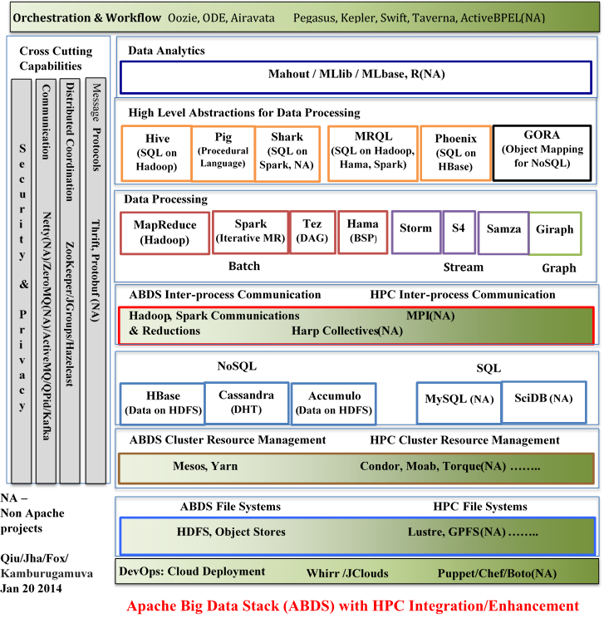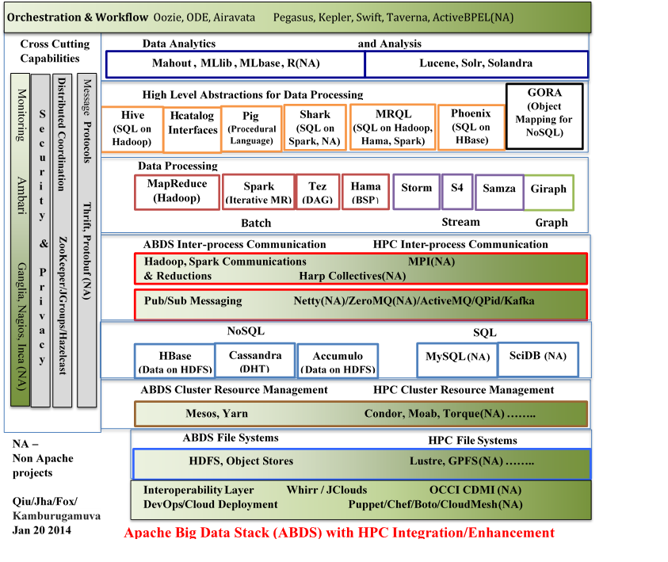

**Pub/Sub Messaging Netty(NA)/ZeroMQ(NA)/ActiveMQ/QPid/Kafka**

**ABDS Inter-process Communication**

**HPC Inter-process Communication**

**Hadoop, Spark Communications MPI(NA)  
& Reductions Harp Collectives(NA)**

**Graph**

**High Level Abstractions for Data Processing**

**Data Processing**

**Giraph**

**Tez  
(DAG)**

**MRQL  
(SQL on Hadoop, Hama, Spark)**

**Hive   
(SQL on Hadoop)**

**Mahout , MLlib , MLbase, R(NA)**

**MapReduce  
(Hadoop)**

**Spark  
(Iterative MR)**

**Storm**

**S4**

**Samza**

**Hama  
(BSP**)

**Pig (Procedural Language)**

**Shark  
(SQL on Spark, NA)**

**Phoenix  
(SQL on HBase)**

**GORA   
(Object  
Mapping for NoSQL)**

**Lucene, Solr, Solandra**

**Hcatalog  
Interfaces**

**Data Analytics and Analysis**

**Thrift, Protobuf (NA)**

**ZooKeeper/JGroups/Hazelcast**

**Security & Privacy**

Monitoring Ambari Ganglia, Nagios, Inca (NA)

**Distributed Coordination**

Message **Protocols**

**Batch**

**Stream**

**ABDS File Systems**

**HDFS, Object Stores Lustre, GPFS(NA) ……..**

**HPC File Systems**

**Mesos, Yarn Condor, Moab, Torque(NA) ……..**

**ABDS Cluster Resource Management**

**HPC Cluster Resource Management**

**Cassandra  
(DHT)**

**NoSQL**

**SQL**

**HBase  
(Data on HDFS)**

**Accumulo  
(Data on HDFS)**

**MySQL (NA)**

**SciDB (NA)**

**Interoperability Layer Whirr / JClouds OCCI CDMI (NA)  
DevOps/Cloud Deployment Puppet/Chef/Boto/CloudMesh(NA)**

**NA –   
Non Apache   
projects  
   
Qiu/Jha/Fox/  
Kamburugamuva  
Jan 20 2014**

**Apache Big Data Stack (ABDS) with HPC Integration/Enhancement**

**Cross Cutting  
Capabilities**

**Orchestration & Workflow** Oozie, ODE, Airavata Pegasus, Kepler, Swift, Taverna, ActiveBPEL(NA)