Collaboration as a Web Service

Geoffrey Fox, Xi Rao, Ahmet Uyar, Wenjun Wu
Pervasive Technology Laboratories
Indiana University
gcf@indiana.edu

Introduction
Web Services has become increasingly popular recently because of its prospect of linking various applications running over the Internet by providing standard interfaces and communication channels. The idea of providing a standard interface to audio/video conferences over the Internet and collaboration services seems us very attractive. So we are designing a collaboration framework to manage audio/video conferences and data sharing applications through web services.

Our web service (Figure 1) will provide functionalities to create, modify and end real time conferences, one-to-one sessions and playback of recorded meetings. These sessions may include one or more of following services; audio streaming, video streaming, application sharing, whiteboard sharing, chat, and maybe more. It is important to note that our web service application will not actually handle either the audio/video communication or data sharing. It will only handle the creation, modification and ending of these sessions. Audio/video conferencing will be implemented by an MCU based on RTP and data sharing services will be implemented on a messaging server such as JMS or Narada. All of these services will be accessed through a WSDL interface.

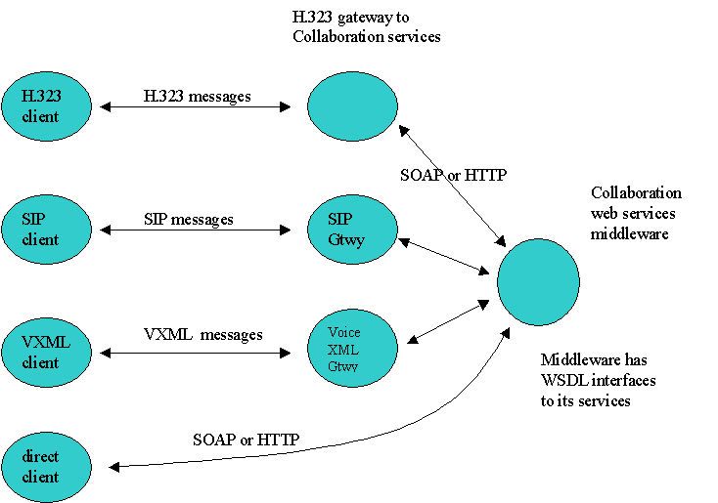
Figure 1: Collaboration web services architecture

When designing a new audio/video conferencing system, we must support some important standards currently in use to be able to interact with existing multimedia applications. These standards are Session Initiation Protocol (SIP) from IETF and H.323 audio and video conferencing protocol from ITU. We are planning to support both of them through gateways. These gateways will accept protocol dependent messages from SIP or H.323 clients and convert it to soap or http messages and invoke the WSDL methods on the server. These gateways will only be used to establish and control the multimedia session, and then audio/video packages will be directly exchanged between clients and the MCU using RTP protocol (Figure 2). In addition we are also planning to support voice-enabled clients through Voice XML. Voice XML clients will be supported through a voice XML gateway similar to SIP and H.323 gateways. Therefore, a cell phone user will be able to join an audio session.

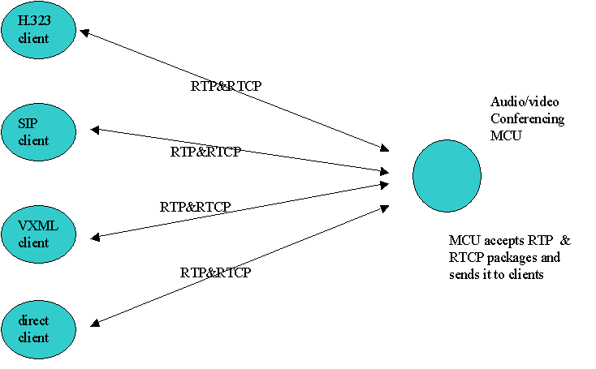
Figure 2: Audio/Video conferences

We are planning to provide data sharing services (Figure 3) using a messaging server such as JMS or Narada. We will not use and support a standard protocol such as T.120 for data sharing. Since, data-sharing systems based on messaging systems has much more advantages than those based on RPC. These data sharing services will include whiteboard sharing, application sharing(shared export, shared display, static shared archive and native shared object), and chat. Initiation, modification, and ending of sessions will be managed by our web service application through its WSDL interface.

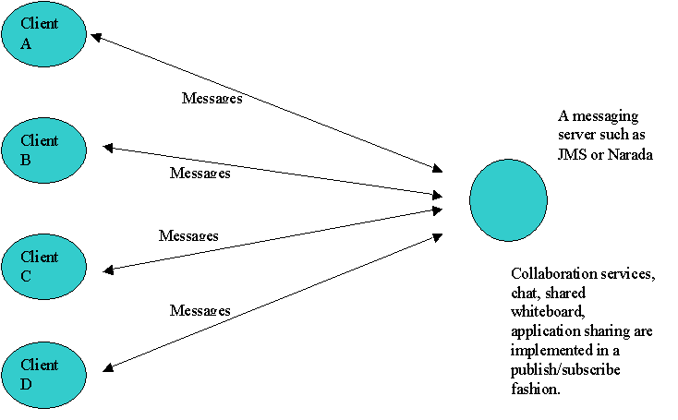
Figure 3: Data sharing services implemented on a publish/subscribe-messaging server

How it works
First a user will communicate with the collaboration server to initiate a session with another peer or join a meeting, and then he/she will send and receive audio/video packages through MCU and exchange messages through the messaging server for data sharing applications such as chat, whiteboard sharing and application sharing. When it is time to end the session, the client will send a message to web service application to quit.

Some Concepts and Functionalities
We are getting a lot of ideas from current systems and standards. Here are some entities and functionalities that we are planning to support by our middleware through WSDL interfaces. This is neither a complete nor a definite list of the functionalities of our system.

PEERS or USERS
We will have a concept of peer or user in our system. A peer should implement the protocol of our web service to interact with it. In addition, any SIP and H.323 client is a peer in our system by default. JXTA represents a peer with a jxta URN and sip represents a user with a sip address. Both JXTA URN and SIP addresses are similar in some sense. So we should define an addressing scheme to represent users. Users may also have some properties such as privilege code; participant, presenter, host etc. It may also have name and so on.

MEETINGS
We should have a concept of meeting to advertise meetings and set the various properties of it. This meeting object should have properties such as start/stop time, host, multimedia information etc.

PEERGROUPS
We may also have a concept of peergroup particularly for meetings. It can also be used for some other applications. So it is better to define it rather general.

ADVERTISEMENTS
Peers advertise their services to others on the server, so that another user can discover its capabilities. In addition, we should also have such a concept of advertisement of meetings, recorded sessions, etc.

QUERY
This method will be used to query the sessions and properties of those sessions, such as multimedia properties, start/stop times, etc.

JOIN
This method will be used to join sessions. It will be similar to INVITE method in SIP.

LEAVE
This method will be used to leave a session. A user simply sends a LEAVE message when he/she no longer wants to be in the session. It is similar to BYE method is SIP.

SIGNIN
This method will be used to sign into the system. When a user signs in, he/she lets the system know about its current location and maybe capabilities and willingness to be involved in conferences and sessions. It is similar to REGISTER method of SIP.

REGISTER
This method will be used to register users, to get an account in the system. Current H.323 and SIP users may not need to register since they already registered with their servers.

RESPONSE CODES
SIP uses response codes to describe the nature of responses. For example, 200 means OK, 1XX means in progress, 3XX means redirection, 4XX means problem etc.
So we should define such response codes for our system too. Probably it will be very similar to SIP response codes.

SESSION DESCRIPTION
SIP does not mandate any session description protocol to be used, but in practice mostly SDP is used. For session description, we may choose to use SDP or develop our own session description protocol. SDP may not be able to satisfy all our needs. It is a fairly old protocol and it was mainly developed to be used by MBone tools. Moreover, it is not XML.

ADMINISTRATIVE METHODS
We should have at least CREATE, DELETE and MODIFY methods to create, delete and modify meetings, users etc. They are to be used by administrative people.

Comparison of some functionality in SIP, H.323 and JXTA

Services and Entities |  | SIP | H.323 | JXTA
Entities | USER | Users are identified by their sip URI’s similar to email addresses. A sip user agent must implement at least some part of sip spec. | Users are identified by email addresses, phone numbers, E.164 numbers etc. | Every peer is an user, which implements one or all JXTA protocols. Every peer has a JXTA ID which is a URN complaint to RFC 2141.
Entities | MEETING | There is no entity called meeting in SIP but it is possible to arrange meetings. | Gatekeeper keeps track of meetings. | There is no notion of meeting. It should be implemented by applications running on jxta.
Entities | PEER  GROUP | There is no such explicit concept (implied by sum of users) | There is no such explicit concept (implied by sum of users) | a collection of peers that have a common set of interests
Service 1 | QUERY | OPTIONS method is used to query the other party’s capabilities such as supported codecs and methods. | H.245 is used for this. A user can get the media and transport capabilities of the other party. | A user looks up the other party’s advertisements to find out the services it provides.
Service 2  Call  Procedure | JOIN | INVITE method is used to initiate sessions. | H.323 uses Q.931 for call establishment. This is not one step. First user A establishes a connection with user B. Then they negotiate the media they want to use. | First, a user discovers a pipe advertisement of the other party and use it to connect that user.
Service 2  Call  Procedure | LEAVE | BYE method is used to end sessions. Just send a BYE message. | Q.931 Call Termination  First, Discontinue transmitting media, then send the endSessionCommand and send complete message. | A user does not need to close a session, it just does not send any data.
Service 3 | SIGNIN | REGISTER method is used to provide a new location. User registers with a proxy (registrar). | H.323 uses RAS.  User registers with a gatekeeper and provides his/her current location. | In startup a user informs at least one rendezvous peer.
Service 4 | REGISTER | Not a part of SIP specification. Administrators should handle it. | Handled by RAS protocol. Currently we do not know the details. | There is no global server to register. A user can register with its jxta client.
RESPONSE CODES |  | SIP Uses response codes to provide specific information on the response messages. | H.323 uses more than one protocol for signaling namely Q.931, H.245 and RAS.  All of them have their own response procedures. | This concept is not relevant.
SESSION DESCRIPTION |  | SIP does not mandate any protocol to describe sessions, but in practice mostly SDP is used. | H.323 uses H.245 (Media Capability) | There is no standard way of describing capabilities

Future Implementation
Although in current implementation, the data sharing applications such as shared display, shared whiteboard, and chat exchange messages through a messaging server and audio/video applications exchange packages through an MCU, in future we believe that audio/video applications should also use a publish/subscribe messaging system to exchange packages or messages. This messaging system (Figure 4) can support two kinds of messaging; one is low performance messaging similar to today’s messaging systems such as JMS, and the other is high-performance messaging. Low-performance messaging system will use XML messages and will be used for applications such as chat, shared whiteboard etc. On the other hand, high-performance publish/subscribe messaging system will use binary messages and will be used for time sensitive applications such as audio/video applications and shared display. We believe that moving from today’s audio/video standards to publish/subscribe system is necessary, because of the many advantages of publish/subscribe messaging systems.

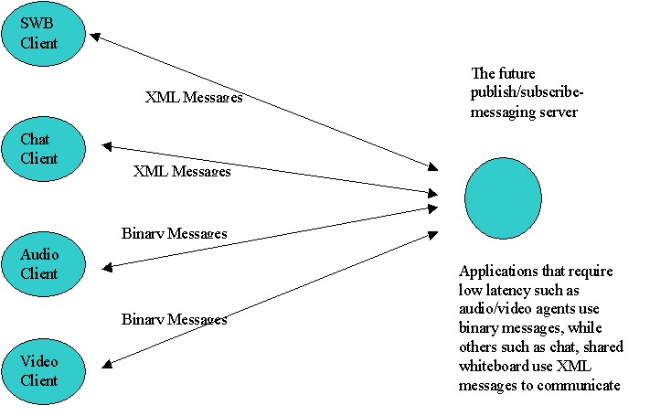
Figure 4: Future Collaboration services architecture

Resources:
1. Session Initiation Protocol (SIP), rfc 2543, http://www.ietf.org/rfc/rfc2543.txt
2. Session Description Protocol (SDP), rfc 2327, http://www.ietf.org/rfc/rfc2327.txt
3. JXTA v1.0 protocol specification, http://spec.jxta.org/v1.0/docbook/JXTAProtocols.html
4. H.323 vs. SIP: A Comparison, http://www.packetizer.com/iptel/h323_vs_sip/
5. Real Time Transfer Protocol (RTP), rfc 1889, http://www.ietf.org/rfc/rfc1889.txt
6. Java Message Service (JMS), http://java.sun.com/products/jms
7. Web Services Description Language (WSDL) 1.1, http://www.w3.org/TR/wsdl
8. Simple Object Access Protocol (SOAP) 1.1, http://www.w3.org/TR/SOAP/
9. Voice eXtensible Markup Language (VoiceXML™), http://www.w3.org/TR/voicexml/

