Application Web Services

Introduction
This short report gives an overview of web services, with a particular focus on how to deploy and use an application as a web service. This is a work in progress and part of the Global Grid Forum’s Application Metadata Working Group [1] and Grid Computing Environments Research Group [2], so revisions and refinement will occur.

An application here means specifically some code developed by the scientific community. Examples would be finite element codes, grid generation codes, and visualization tools. These might be written in Fortran or C, may be parallelized with MPI, and so on. We will treat all these applications as black boxes and will describe here how to wrap these applications in XML proxies. The wrappers can then be converted into Java data classes for manipulation with web technologies. We refer to this as proxy wrapping, as distinguished from direct service wrapping.

Applications services are deployed into a computational web portal, a browser-based system that provides a user interface to applications and various services. A typical web portal allows a user to log in securely to some computing resource, submit jobs, view results, and manage files on the remote resources. The web interface is desirable since it allows the user to potentially log in from anywhere with no software on the client besides the web browser.

We believe the process we introduce here for transforming applications into services is generally applicable to any portal designed to support multiple codes, particularly when the applications to be deployed are not known a priori by the portal developer. To make our arguments concrete, we refer to our computational web portal project, Gateway [3], in many examples.

Web Service Review

Web services refer to the invocation of remote methods (functions) using an XML-based protocol and method interface definitions. The protocol (usually SOAP [4]) is attached to an HTTP message and contains, for instance, the name of the method and necessary parameters needed to invoke the remote service. The SOAP service is typically deployed as an application in a web browser. For example, Apache Axis [5] runs as a Java servlet in an Apache Tomcat server. The method interface (in WSDL [6]) is an agreed-upon set of methods, parameters and return types for a particular service and is implemented in some Web-friendly programming language (such as Java or Python) and can be used as a guideline for writing clients, or it may be used to generate client stubs: classes that can be used locally by a client but that are actually wrappers around SOAP invocation calls to a remote service.

Core Portal Web Services

While it is possible (and in future versions desirable) to write at least part of an application in a web-friendly language such as Java, this is typically not the case for most legacy applications. C/C++ and Fortran codes can be wrapped inside Python (using SWIG [7]) or Java (using the Java Native Interface, JNI) but this is an invasive procedure that requires access to some application source code, which is often not available.

We therefore do not develop application-specific web services directly with WSDL and SOAP. Instead, we use SOAP and WSDL (along with Java) to develop general purpose core web services that perform the following tasks:
- Run an arbitrary application on some computer as an external process. Running the application on the same computer as the SOAP server is straightforward. Executing an application on a different machine requires one of the following: a) yet another SOAP server on that second machine, b) some remote shell capability (rsh or ssh), or c) some computational grid technology such as Globus. The latter cases introduce complicated installation and security issues, so for now we will assume that the SOAP service runs on the same machine that will execute the application.
- Move, copy, rename, delete files on some computer (either directly in Java or else as an external call to Unix commands).
- Upload, download, or crossload files between computers. Upload/download refers to file transfers between the user’s desktop and some remote destination. Because browsers do not directly support SOAP clients, this is not entirely a web service. Crossload refers to transfers of files between computers using web services. File transfer may be implemented entirely in Java or may use some external helper application (such as rcp).
- Generate a batch script request for a particular queuing system, such as PBS.
- Monitor the execution of a job running in a queuing system. This may be done by periodic status queries (running qstat on a host) or may be event-driven (such as by an email handling system). The monitoring service may also allow the queued job to be deleted or suspended.
- Authenticate and authorize users. This is currently highly dependent on the desired underlying security mechanism (Kerberos or Globus GSI for example).
- Provide information services. Here the web services are a set of WSDL interfaces that wrap heterogeneous backend information services. These might include general purpose LDAP servers, Globus MDS, XML databases, and UDDI.

To use these services, one needs to develop clients for each service using the WSDL interface. These clients generate SOAP requests to the associated service. A client might typically be a JSP page. SOAP clients and servers can be on the same Tomcat server or on separate servers.

Proxy Service Wrapping versus Direct Service Wrapping

We refer to the above as a proxy wrapper approach. The web service is not actually the application but is instead a proxy that invokes the application. The proxy wrapper is implemented in a web friendly language that can easily be converted to a web service. We may similarly label the alternate approach of directly interacting with the application as the direct wrapping approach. The advantage of the proxy wrapping approach is that any application or legacy service (such as Kerberos client commands) can be wrapped in this manner. Thus we can define rules (in XML) for describing an arbitrary application. We can then use these rules to define a particular application service, and bind the application service to underlying core portal services. Thus allows us to build a general purpose framework for working with applications, but sacrifices highly sophisticated interfaces for a particular application.

Alternate Web Service Protocols

“Web Services” are very loosely defined. SOAP services, for example, can be invoked without using WSDL and WSDL method invocations do not need SOAP as the transport protocol. There are several instances when the latter is desirable. First, the system might rely on high-performance messaging (relatively small communication-to-execution ratios). This can always be alleviated by increasing the scope of the service to reduce the frequency of communication. Second, a service for high-performance file transfer will need to use some other protocol besides SOAP over HTTP for the actual data transfer, although SOAP may be used for setting up the call to the underlying service (such as high performance FTP). Thirdly, one may already have a legacy distributed object system that makes use of a protocol such as CORBA’s IIOP. Direct support within WSDL for this protocol is not currently available and would need to be developed. In the interim, protocol bridges between SOAP and IIOP are a relatively simple solution. Finally, one may wish to use a protocol with features not currently found in SOAP. This may include reliable protocols that guarantee once-and-only-once execution of a service. Again, an interim solution for this is to use SOAP clients and servers to initialize the use of the more feature-rich protocol.

Application Service Lifecycle and XML Descriptors
Applications can exist in four stages, as defined by the Application Metadata Working Group:
- Application abstraction: a general description of how to run the application (it takes 1 input file, generates 4 output files, lives on computers A, B, and C).
- Prepared instance: this is a specific instance of the application. A user has provided most or all of the information needed to run an application, but has not yet actually submitted it.
- Submitted instance: This is job that has been committed to a set of resources (submitted to a queue, for example). Queuing systems represent several substates of existence.
- Completed instance: The application has finished and we preserve metadata about it.

The important point here is that all of this can be described by a set of XML descriptions languages: application descriptions, host descriptions, and queue descriptions. We actually have two sets of XML for each description: one set for stage (1) above, and one set for stages (2)-(4) above. That is, the XML descriptions for (1) describe user options, while the descriptors for (2)-(4) contain a user’s actual choices. We dub the first set as descriptors and the second set as instances.

We will first examine the descriptors associated with stage (1). Creating an XML instance of these schemas is done by the person deploying the web service.

We now use Gateway as an example of deploying an application web service, although the process should be similar with other proxy-based portals. Figure 1 below illustrates (based on an earlier version of the Application Descriptor) how to deploy an application on a particular host as a service. This form is used to edit the Application Descriptor XML file.

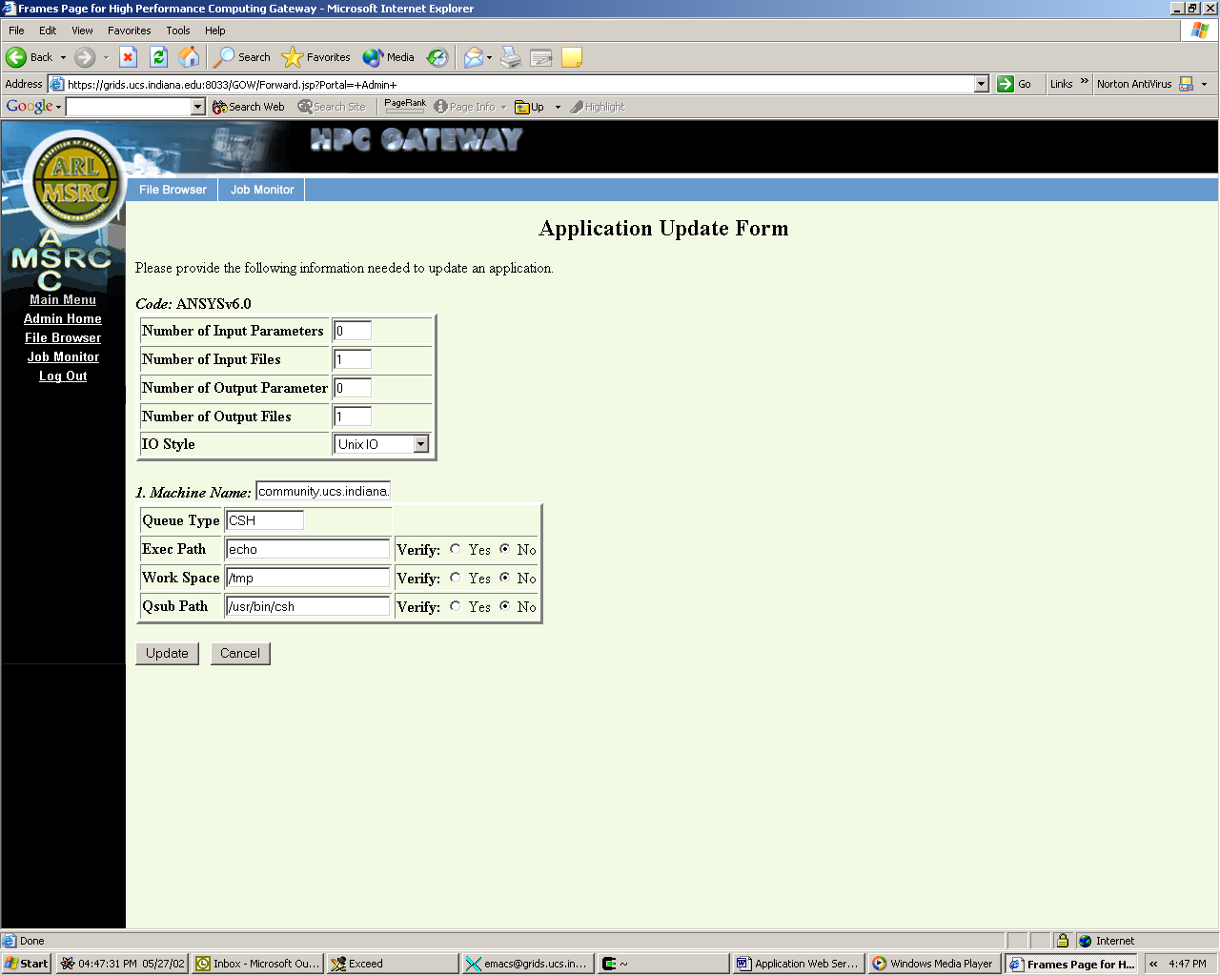
Figure 1 HTML forms for deploying an application.

Deploying Application Web Services
We now review how to deploy an application as a Web service. The essential idea is that the Application Web Service (AWS) presents an XML interface that can be used to build application clients and is composed of core web service clients. Initially we can think of all of these parts (XML interface to AWS, AWS service implementation consisting of SOAP clients, the corresponding SOAP services, the AWS client interface) as all living on a single server, but these pieces can eventually be decoupled and each live on a separate Tomcat server.

Initially, portal developers such as the Gateway group develop all parts: the SOAP services and clients, the general Application Web service (consisting of several core web service clients) and the AWS clients in JSP. A Tomcat server is then installed on some host resource.

A particular application web service is now ready to be deployed. This amounts to filling in a set of web forms to create an instance of the Application Descriptor XML file (following the schema in Appendix A). The person responsible for making the application a service just fills in the forms and optionally confirms all of the information. The Application Descriptor is created (or appended to if it already exists) and the service is deployed.

More sophisticated systems can be built. An additional general capability of Web services is that they may be discovered dynamically (through UDDI or similar systems) and may be scripted in a workflow (through WSFL, for example). Thus the next step is that the AWS is initially decoupled from the specific instances of the core web services that it uses. The AWS is composed of services that are scripted in WSFL. The AWS then discovers and binds to particular core web services dynamically.

Using Application Web Services
We described above how to deploy an application web service but not how to use it. A user has of an AWS has a separate user interface that is created from the AWS descriptors. These AWS descriptors give the user various choices and are used to generate forms needed to collect the information needed to run the code. The user’s particular choices constitute a separate XML document, the Application Instance. This contains all the metadata about a particular invocation of the application (such as the particular input file that was used, the particular set of resources, and so on).

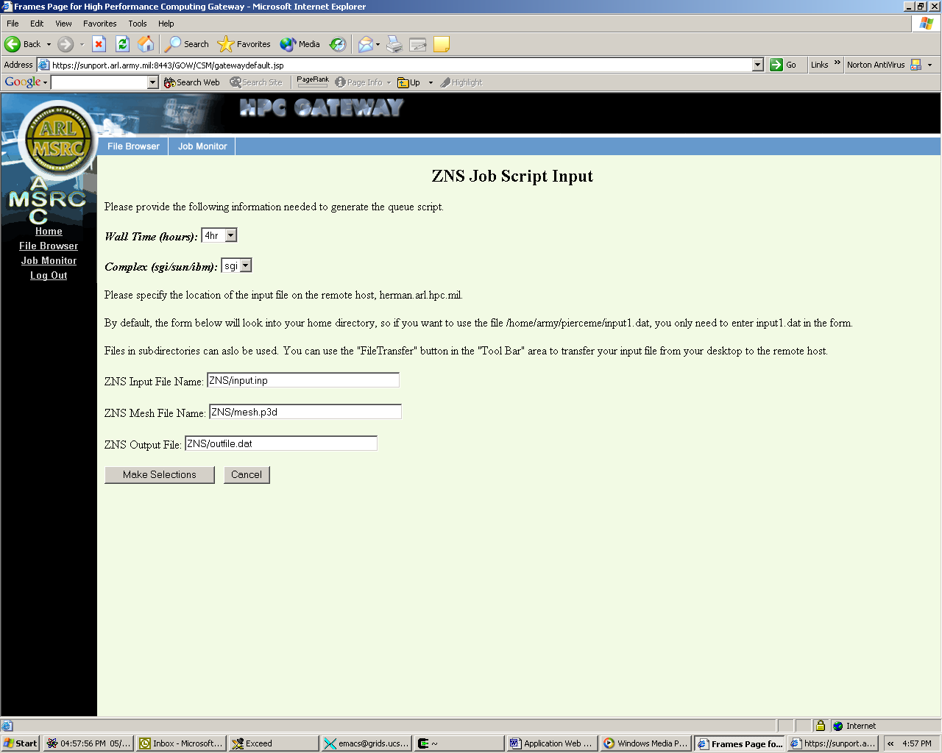
Figure 2 An input form for the application ZNS.

The Application Instance serves as the guideline for building the user interface. In principal, this can be separated into client and server pieces. The client and server share the Application Instance interface, and the client collects information from the user about the application, which it then passes to the Application Instance server implementation (using SOAP, for example) where the application is invoked. Currently, we do not make this separation: the user interface also handles the application invocation directly.

Users fill out forms like the one below. These forms are generated from the Application Descriptor for a particular application but result in Application Instance XML documents.

Portlets and Portals
As we have stated previously, the application web service defines an interface that describes how to create a client for that service. This client may be deployed on the same host computer as the application web service, but this is not required. Instead, the AWS interface definition should be viewed as a way to create clients (and associated user interfaces) on any host computer, just as WSDL defines how to create a client to invoke a remote method.

Previous web portals such as Gateway, as illustrated in Figures 1 and 2, did not distinguish between the code that processes the user interface and code that executes service requests. In the AWS architecture these can be decoupled, with one server responsible for creating and managing the user interface and user interaction. The user interface server implements clients to remote servers, which are invoked through SOAP.

The consequence of this is that user interfaces to both core web services (such as a job monitor or an LDAP browser) and application web services can be developed by a number of different groups, reusing a service deployed on some set of resources. The problem of how to manage all of these interfaces then arises. We believe that the next generation of computational portals will need to aggregate and manage these various user interfaces as components (or “portlets”).

The key idea now is that a computational web portal actually is just a skeleton for holding and managing web interfaces to services, which may be delivered from either local or remote sources. The portal administrator picks the portlets that he or she wishes to make available, and the user customizes his interface to add the selected services. Thus a user may decorate his portal with the user interfaces to the core service “Job Monitoring on Computer A” and to “ANSYS Application Service,” while another user may create a portal out of a completely different set of published user interfaces.

The portlet idea is already being realized by Jetspeed [8], an open source project from Apache. A common Java portlet API is currently being defined by the JSR 168 [9], and WSRP [10] ( Web Services for Remote Portlets) is defining a web services based portlet framework.

References
[1] Application Metadata Working Group Web Site: http://ecs.erc.msstate.edu/AMD-WG/index.jsp.

[2] Grid Computing Environments Working Group Web Site: http://www.computingportals.org/.

[3] Gateway Computational Portal: http://www.gatewayportal.org.

[4] Simple Object Access Protocol (SOAP) 1.1: http://www.w3c.org/TR/SOAP/

[5] Apache Axis: http://xml.apache.org/axis/.

[6] Web Service Description Language (WSDL) 1.1: http://www.w3.org/TR/wsdl.

[7] Simple Wrapper Interface Generator (SWIG): http://www.swig.org/

[8] Jetspeed: http://jakarta.apache.org/jetspeed/site/index.html

[9] Portlet API Java Specification Request 168: http://www.jcp.org/jsr/detail/168.jsp

[10] Web Services for Remote Portlets (WSRP): http://www.oasis-open.org/committees/wsrp/

Appendix A
The following are the initial versions of schema for descriptors, as described above.

<?xml version="1.0"?>
<xsd:schema targetNamespace="http://grids.ucs.indiana.edu:8046/GOW/Schema/Appl" xmlns:appl="http://grids.ucs.indiana.edu:8046/GOW/Schema/Appl" xmlns:xsd="http://www.w3.org/2001/XMLSchema">
<xsd:annotation>
<xsd:documentation>
This schema is used to describe an application.
</xsd:documentation>
</xsd:annotation>
<!--
ApplDesc is the root element, with any number of applications.
-->
<xsd:element name="ApplDesc" type="appl:ApplDescType"/>
<xsd:complexType name="ApplDescType">
<xsd:sequence>
<xsd:element name="Application"
type="appl:ApplicationType"
maxOccurs="unbounded"/>
</xsd:sequence>
</xsd:complexType>
<!--
Each application's info is contained by the tag ApplicationType.
Applications have some specific required elements and optionally
can be described by additional Parameters. Examples of
parameters would include environmental variables that
might need to be set.
-->
<xsd:complexType name="ApplicationType">
<xsd:sequence>
<xsd:element name="ApplicationName" type="xsd:string"/>
<xsd:element name="Version" type="xsd:string"
minOccurs="0"/>
<xsd:element name="OptionFlag"
type="appl:OptionFlagType" minOccurs="0"
maxOccurs="unbounded"/>
<xsd:element name="InputPort"
type="appl:InputPortType"
minOccurs="0" maxOccurs="unbounded"/>
<xsd:element name="OutputPort"
type="appl:OutputPortType"
minOccurs="0" maxOccurs="unbounded"/>
<xsd:element name="ErrorPort"
type="appl:ErrorPortType" minOccurs="0"
maxOccurs="unbounded"/>
<xsd:element name="Parameter"
type="appl:ParameterType" minOccurs="0"
maxOccurs="unbounded"/>
<xsd:element name="HostBinding"
type="appl:HostBindingType"
maxOccurs="unbounded"/>
</xsd:sequence>
</xsd:complexType>
<!--
Code option flags. These might be followed by arguments, depeding
on the flag.
-->
<xsd:complexType name="OptionFlagType">
<xsd:sequence>
<xsd:element name="flagName" type="xsd:string"/>
<xsd:element name="flagValue" type="xsd:boolean"
minOccurs="0"/>
</xsd:sequence>
</xsd:complexType>
<!--
InputPortType is used to describe the input methods (ie a file
on local disk).
0 InputHandle is a short name for a particular input type
0 InputDescription is a long description of what type
of input is expected (ie an ANSYS Prep7 file). Put
instructions to users here.
0 Mechanism is the way that file file takes input (such
as by Unix-style standard input with a "<".
-->
<xsd:complexType name="InputPortType">
<xsd:sequence>
<xsd:element name="InputHandle" type="xsd:string"/>
<xsd:element name="InputDescription"
type="xsd:string"/>
<xsd:element name="InputMechanism"
type="appl:mechanism"/>
</xsd:sequence>
</xsd:complexType>
<!--
OutputPortType is used to describe the output files (ie a file
on local disk). You need one of these tags for each
output file the code generates.
0 OutputHandle is a short name for a particular output type
0 OutputDescription is a long description of a particular
output file and is application-specific.
-->
<xsd:complexType name="OutputPortType">
<xsd:sequence>
<xsd:element name="OutputHandle" type="xsd:string"/>
<xsd:element name="OutputDescription"
type="xsd:string"/>
<xsd:element name="OutputMechanism"
type="appl:mechanism"/>
</xsd:sequence>
</xsd:complexType>
<!--
ErrorPortType is used to describe the error files that may be
generated.
0 ErrorHandle is a short name for a particular error type
0 ErrorDescription is a long description of what type
of error.
-->
<xsd:complexType name="ErrorPortType">
<xsd:sequence>
<xsd:element name="ErrorHandle" type="xsd:string"/>
<xsd:element name="ErrorDescription"
type="xsd:string"/>
<xsd:element name="ErrorMechanism"
type="appl:mechanism"/>
</xsd:sequence>
</xsd:complexType>
<xsd:simpleType name="mechanism">
<xsd:restriction base="xsd:string">
<xsd:enumeration value="StandardIO"/>
<xsd:enumeration value="CArgument"/>
</xsd:restriction>
</xsd:simpleType>
<!--
ParameterType is used for name/value pairs.
-->
<xsd:complexType name="ParameterType">
<xsd:sequence>
<xsd:element name="Value" type="xsd:string"/>
</xsd:sequence>
<xsd:attribute name="Name" type="xsd:string"/>
</xsd:complexType>
<!--
Extend to include host information from HostDesc.xml
-->
<xsd:complexType name="HostBindingType"/>
</xsd:schema>

<?xml version="1.0"?>
<xsd:schema targetNamespace="http://grids.ucs.indiana.edu:8046/GOW/Schema/Host" xmlns:xsd="http://www.w3.org/2001/XMLSchema" xmlns:host="http://grids.ucs.indiana.edu:8046/GOW/Schema/Host">
<xsd:annotation>
<xsd:documentation>
This schema describes host machine bindings for applications.
</xsd:documentation>
</xsd:annotation>
<!--
HostDesc is the root element, with any number of applications.
HostDesc contains a description of a host machine. It contains
several required fields and can be extended by an arbitrary
number of parameters. Optionally, you can provide commands
for remote copy and execution (rsh, rcp, globusrun). This must
be set up externally.

Hosts also contain one or more bindings for queue execution. This
could be a queuing system (PBS, GRD) or it could be
-->
<xsd:element name="HostDesc" type="host:HostDescType"/>
<xsd:complexType name="HostDescType">
<xsd:sequence>
<xsd:element name="HostName" type="xsd:string"/>
<xsd:element name="HostIP" type="xsd:string"/>
<xsd:element name="WorkDir" type="xsd:string"/>
<xsd:element name="QueueType" type="xsd:string"/>
<xsd:element name="QsubPath" type="xsd:string"/>
<xsd:element name="ExecPath" type="xsd:string"/>
<xsd:element name="RemoteCopy" type="xsd:string"
minOccurs="0"/>
<xsd:element name="RemoteExec" type="xsd:string"
minOccurs="0"/>
<xsd:element name="Parameter"
type="host:ParameterType"
minOccurs="0"/>
</xsd:sequence>
</xsd:complexType>
<xsd:complexType name="ParameterType">
<xsd:sequence>
<xsd:element name="Value" type="xsd:string"/>
</xsd:sequence>
<xsd:attribute name="Name" type="xsd:string"/>
</xsd:complexType>
</xsd:schema>

<?xml version="1.0"?>
<xsd:schema targetNamespace="http://grids.ucs.indiana.edu:8046/GOW/Schema/Queue" xmlns:queue="http://grids.ucs.indiana.edu:8046/GOW/Schema/Queue" xmlns:xsd="http://www.w3.org/2001/XMLSchema" elementFormDefault="unqualified" attributeFormDefault="unqualified">
<xsd:annotation>
<xsd:documentation>
This schema describes queuing systems on a host.
</xsd:documentation>
</xsd:annotation>
<!--
QueueDesc is the root element and describes a queuing system
parameters. An instance of this schema describes a particular
queuing system (such as PBS). Queue systems that need
additional values not explicitly stated in the
-->
<xsd:element name="QueueDesc" type="queue:QueueDescType"/>
<xsd:complexType name="QueueDescType">
<xsd:sequence>
<xsd:element name="MemoryOptions"
type="queue:MemOptType"/>
<xsd:element name="JobName" type="xsd:string"/>
<xsd:element name="NumberOfCPUs" type="xsd:string"/>
<xsd:element name="Walltime" type="xsd:string"/>
<xsd:element name="Email" type="xsd:string"/>
<xsd:element name="QueueOptions"
type="queue:QueueOptType" minOccurs="0"/>
<xsd:element name="AccountOptions" type="xsd:string"
minOccurs="0"/>
<xsd:element name="Parameter"
type="queue:ParameterType" minOccurs="0"/>
</xsd:sequence>
</xsd:complexType>
<!--
This allows us to describe the queue's memory options (ie
1 GB, 4 GB, etc.)
-->
<xsd:complexType name="MemOptType">
<xsd:sequence>
<xsd:element name="MemOption" type="xsd:string"
minOccurs="0" maxOccurs="unbounded"/>
</xsd:sequence>
</xsd:complexType>
<!--
This allows different subqueues to be supported (ie default,
priority, large, medium, small).
-->
<xsd:complexType name="QueueOptType">
<xsd:sequence>
<xsd:element name="QOption" type="xsd:string"
minOccurs="0" maxOccurs="unbounded"/>
</xsd:sequence>
</xsd:complexType>
<xsd:complexType name="ParameterType">
<xsd:sequence>
<xsd:element name="Value" type="xsd:string"/>
</xsd:sequence>
<xsd:attribute name="Name" type="xsd:string"/>
</xsd:complexType>
</xsd:schema>

Appendix B
This appendix contains instance descriptions for applications, hosts, and queues.
<?xml version="1.0"?>
<xsd:schema targetNamespace="http://grids.ucs.indiana.edu:8046/GOW/Schema/ApplI" xmlns:appl="http://grids.ucs.indiana.edu:8046/GOW/Schema/ApplI" xmlns:xsd="http://www.w3.org/2001/XMLSchema">
<xsd:annotation>
<xsd:documentation>
This schema is used to describe an application instance.
</xsd:documentation>
</xsd:annotation>
<!--
ApplInstance is the root element and describes exactly one application
running on one host.
-->
<xsd:element name="ApplInstance" type="appl:ApplInstanceType"/>
<!--
Each application's info is contained by the tag ApplicationType.
An application instance can have several input and output files, but
only binds to one host.
-->
<xsd:complexType name="ApplInstanceType">
<xsd:sequence>
<xsd:element name="ApplicationName"
type="xsd:string"/>
<xsd:element name="Version" type="xsd:string"
minOccurs="0"/>
<xsd:element name="OptionFlag"
type="appl:OptionFlagType" minOccurs="0"
maxOccurs="unbounded"/>
<xsd:element name="InputPort"
type="appl:InputPortType" minOccurs="0"
maxOccurs="unbounded"/>
<xsd:element name="OutputPort"
type="appl:OutputPortType" minOccurs="0"
maxOccurs="unbounded"/>
<xsd:element name="ErrorPort"
type="appl:ErrorPortType" minOccurs="0"
maxOccurs="unbounded"/>
<xsd:element name="Parameter"
type="appl:ParameterType" minOccurs="0"
maxOccurs="unbounded"/>
<xsd:element name="HostBindingInstance"
type="appl:HostBindingType"/>
</xsd:sequence>
</xsd:complexType>
<!--
Code option flags. These might be followed by arguments
-->
<xsd:complexType name="OptionFlagType">
<xsd:sequence>
<xsd:element name="flagName" type="xsd:string"/>
<xsd:element name="flagValue" type="xsd:string"
minOccurs="0"/>
</xsd:sequence>
</xsd:complexType>
<!--
InputPortType is used to describe the input methods (ie a file
on local disk).
0 InputHandle is a short name for a particular input type
0 Inputdescription is a long description of what type
of input is expected (ie an ANSYS Prep7 file). Put
instructions to users here.
0 InputLocation is a URI that describes where the input file
is. If this is other than a local file, you must define
also the service that will perform this function.
0 Input mechanism: this is either Standard Input (with a "<") or
as a C-style command line arguement.
0 InputServiceBinding is a place holder for describing
the service you want to use to get the file.
-->
<xsd:complexType name="InputPortType">
<xsd:sequence>
<xsd:element name="InputHandle" type="xsd:string"/>
<xsd:element name="InputDescription"
type="xsd:string"/>
<xsd:element name="InputLocation" type="xsd:string"/>
<xsd:element name="InputMechanism"
type="appl:mechanism"/>
<xsd:element name="InputServiceBinding"
type="xsd:string" minOccurs="0"/>
</xsd:sequence>
</xsd:complexType>
<!--
OutputPortType is used to describe the output files (ie a file
on local disk). You need one of these tags for each
output file the code generates.
0 OutputHandle is a short name for a particular output type
0 OutputDescription is a long description of a particular
output file and is application-specific.
0 OutputLocation is a URI that describes where the output file
is to be written.
0 OutputServiceBinding is a placeholder for the service
you want to move the output files, if other than to local
disk.
-->
<xsd:complexType name="OutputPortType">
<xsd:sequence>
<xsd:element name="OutputHandle" type="xsd:string"/>
<xsd:element name="OutputDescription"
type="xsd:string"/>
<xsd:element name="OutputLocation"
type="xsd:string"/>
<xsd:element name="OutputMechanism"
type="appl:mechanism"/>
<xsd:element name="OutputServiceBinding"
type="xsd:string" minOccurs="0"/>
</xsd:sequence>
</xsd:complexType>
<!--
ErrorPortType is used to describe the error files that may be
generated.
0 ErrorHandle is a short name for a particular error type
0 ErrorDescription is a long description of what type
of error.
0 ErrorLocation is a URI that describes where the error file
is to be written.
0 ErrorServiceBinding is a placeholder for the service
you want to move the error files, if other than to local
disk.
-->
<xsd:complexType name="ErrorPortType">
<xsd:sequence>
<xsd:element name="ErrorHandle" type="xsd:string"/>
<xsd:element name="ErrorDescription"
type="xsd:string"/>
<xsd:element name="ErrorLocation" type="xsd:string"/>
<xsd:element name="ErrorMechanism"
type="appl:mechanism"/>
<xsd:element name="ErrorServiceBinding"
type="xsd:string" minOccurs="0"/>
</xsd:sequence>
</xsd:complexType>
<xsd:simpleType name="mechanism">
<xsd:restriction base="xsd:string">
<xsd:enumeration value="StandardIO"/>
<xsd:enumeration value="CArgument"/>
</xsd:restriction>
</xsd:simpleType>
<!--
ParameterType is used for name/value pairs.
-->
<xsd:complexType name="ParameterType">
<xsd:sequence>
<xsd:element name="Value" type="xsd:string"/>
</xsd:sequence>
<xsd:attribute name="Name" type="xsd:string"/>
</xsd:complexType>
<!--
Extend to include host information from HostInstance.xml
-->
<xsd:complexType name="HostBindingType"/>
</xsd:schema>

<?xml version="1.0"?>
<xsd:schema targetNamespace="http://grids.ucs.indiana.edu:8046/GOW/Schema/Host" xmlns:xsd="http://www.w3.org/2001/XMLSchema" xmlns:host="http://grids.ucs.indiana.edu:8046/GOW/Schema/Host">
<xsd:annotation>
<xsd:documentation>
This schema describes host machine bindings for applications.
</xsd:documentation>
</xsd:annotation>
<!--
HostDesc is the root element, with any number of applications.
HostDesc contains a description of a host machine. It contains
several required fields and can be extended by an arbitrary
number of parameters. Optionally, you can provide commands
for remote copy and execution (rsh, rcp, globusrun). This must
be set up externally.

Hosts also contain one or more bindings for queue execution. This
could be a queuing system (PBS, GRD) or it could be
-->
<xsd:element name="HostDesc" type="host:HostDescType"/>
<xsd:complexType name="HostDescType">
<xsd:sequence>
<xsd:element name="HostName" type="xsd:string"/>
<xsd:element name="HostIP" type="xsd:string"/>
<xsd:element name="WorkDir" type="xsd:string"/>
<xsd:element name="QueueType" type="xsd:string"/>
<xsd:element name="QsubPath" type="xsd:string"/>
<xsd:element name="ExecPath" type="xsd:string"/>
<xsd:element name="RemoteCopy" type="xsd:string"
minOccurs="0"/>
<xsd:element name="RemoteExec" type="xsd:string"
minOccurs="0"/>
<xsd:element name="QueueBinding"
type="host:QueueBindingType"/>
<xsd:element name="Parameter"
type="host:ParameterType" minOccurs="0"/>
</xsd:sequence>
</xsd:complexType>
<xsd:complexType name="ParameterType">
<xsd:sequence>
<xsd:element name="Value" type="xsd:string"/>
</xsd:sequence>
<xsd:attribute name="Name" type="xsd:string"/>
</xsd:complexType>
<!--
Extend to include host information from QueueInstance.xml
-->
<xsd:complexType name="QueueBindingType"/>
</xsd:schema>

<?xml version="1.0"?>
<xsd:schema targetNamespace="http://grids.ucs.indiana.edu:8046/GOW/Schema/Queue" xmlns:queue="http://grids.ucs.indiana.edu:8046/GOW/Schema/Queue" xmlns:xsd="http://www.w3.org/2001/XMLSchema">
<xsd:annotation>
<xsd:documentation>
This schema describes queuing systems on a host.
</xsd:documentation>
</xsd:annotation>
<!--
QueueInstance is the root element and describes a queuing system
parameters. An instance of this schema describes a particular
queuing system (such as PBS). Queue systems that need
additional values not explicitly stated in the
-->
<xsd:element name="QueueInstance"
type="queue:QueueInstanceType"/>
<xsd:complexType name="QueueInstanceType">
<xsd:sequence>
<xsd:element name="MemoryOption" type="xsd:string"/>
<xsd:element name="JobName" type="xsd:string"/>
<xsd:element name="NumberOfCPUs" type="xsd:string"/>
<xsd:element name="Walltime" type="xsd:string"/>
<xsd:element name="Email" type="xsd:string"/>
<xsd:element name="QueueOptions" type="xsd:string"
minOccurs="0"/>
<xsd:element name="AccountOptions" type="xsd:string"
minOccurs="0"/>
<xsd:element name="Parameter"
type="queue:ParameterType" minOccurs="0"/>
</xsd:sequence>
</xsd:complexType>
<xsd:complexType name="ParameterType">
<xsd:sequence>
<xsd:element name="Value" type="xsd:string"/>
</xsd:sequence>
<xsd:attribute name="Name" type="xsd:string"/>
</xsd:complexType>
</xsd:schema>

