Wizards

A Wizard is one of the visible parts of the project. In fact it can be considered as the interface for compiling and posting the news group messages.

Creating a wizard is a standardized process in our system which requires some certain steps:

1 – Writing an XML Schema which has all the necessary elements regarding with the current project.

2 – Producing the Object Models of the XML Schema elements and attributes. This is done by using Castor Source Generator, which creates Java classes to correspond to the elements of the schema.

3 – Obtaining user data. This step requires us to prepare HTML forms which have form elements to represent the schema elements. We use JSP technology which allows us to interact with HTML forms and data objects at the same time. In that way we immediately assign the user entries to the data objects.

4 – Generating the XML document. Using Castor’s marshalling framework we create an XML document which contains the user inputs.

5 – Publishing this XML document to the JMS Server by News Group Message Generator.

Figure – Life Cycle of a Wizard

These steps and the technologies used are explained in the following pages.

XML

XML is regarded as the messaging and communication format for our system. That means all messages (either a user message or a system message) should be in this pattern, so the first task in this level is creation of xml-formatted messages.

It can be considered as a reasonable thing to expect the system to create its own messages in xml format by using some parsers since user will not be aware of these communication among the processes or system parts, but obviously it is not a bright idea to expect the ordinary user to compose his/her mail in a very technical format and any kind of mistakes in typing the mail could have caused validation errors.

One way to overcome this problem is to provide the users with a message sample and expect them to change the related fields for each message.

<?xml version="1.0" encoding="UTF-8"?>
<okc xmlns="http://grids.ucs.indiana.edu/okc/schema/admin/ver/2"
xmlns:cg="http://grids.ucs.indiana.edu/okc/schema/cg/ver/1"
version="2">
<event>
<comment>This is comment</comment>
<sender>Ozgur Balsoy</sender>
<distribution>Community Grids Research Group</distribution>
<organization>Community Grids Laboratory,Indiana University</organization>
<update createuri="gxos://okctest/users/balsoy/12october2001/1"/>
<keywords>okc web server</keywords>
<message whitespace="preserve">This is where you write your message content.</message>
<filingdate>10/12/2001</filingdate>
<cg:category main="facility" sub="okc"/>
<cg:category main="research" sub="okc"/>
<cg:category main="research" sub="gxos"/>
<cg:messagetype>Weeklyreport</cg:messagetype>
</event>
</okc>

Sample Message

More information about the message format.
- Keep the 'okc' and 'event' elements untouched.
- Put your comment about this message in 'comment'
- Replace my name with yours in 'sender'
- Keep 'distribution' and 'organization' untouched.
- Put your grids account name or any account name you prefer in 'createuri' attribute of 'update' element after gxos://okctest/users/ and put the date info after your account name. Type the month's name in small letters. The last number is the message number you send on that day. If you send a second report on the same day, increase it, i.e. gxos://okctest/users/your_preferred_account_name/ddmmmmmmyyyy/sequence_number
- Keywords you want to associate with this report of yours. This can be used later for searches.
- Put your report in 'message' element. Highlight any important keywords with 'keyword' tag
- Put the date in mm/dd/yyyy format in 'filingdate'
- Put an overall category name in 'main' of 'cg:category' i.e. research, facility, or anything you come up with. In 'sub', put a one-word sub category, especially a category regarding your work.
- Put 'Weeklyreport' in 'cg:messagetype'.

Figure – An example user message XML and the steps to create a custom message

This method has a number of problems in its own apart from the possible expected mistakes from the users.

In this stage we had to solve the problem of creating valid, well-formed user messages and so we developed the concept of Wizard.

Wizard would be the interface between newsgroups and users. Taking the responsibility of creating a well-formed XML document from the user, it would serve as a medium for transferring user data into desired formats of our system.

The first thing to do at this stage is obviously successfully getting user data. This can be done by using HTML forms in web pages and then this data should be transformed into XML.

Data Binding

This step brings the fact into the scene that the data we acquire from the user need to be mapped into the object representation of a programming language so that we could work on the data, store it, modify it or create a new format for these data.

This process is basically called data binding and that means mapping the elements of a given data format into a specific representation of a programming language. This language in our case is Java.

In most cases the content of an XML document can represent a number of different data types such as strings, integers, real numbers etc. These data types are grouped together to represent some special meaning for the domain in which the XML data is defined. Interacting with XML content as a data model represented as objects, types or data structures is an easy task for a programming language and this would improve the code readability and maintainability.

This means that instead of dealing with such things as parse trees or record sets we interact with integers, booleans, strings and other programming data types and structures.

So basically data binding gives us the opportunity to :

- Represent data in the natural format of the programming language of our choice.
- Keep the original meaning of the data.

Data Binding and XML

XML data binding simply means to represent elements and attributes of the XML document into a programmatic data model that can preserve the meaning of the data and keeps the original logical hierarchy and represent the components in the native format of the programming language. In Java the data models are objects.

An object model in Java is a set of classes and a group of primitive types which are bound together in a sense to represent real world or conceptual objects. Depending of the complexity of the object the object model can consist of hundred of classes or only one class.

Data Objects

Our data object type will be Java Beans. A Java Bean is simply a Java Class that is constructed according to the Java Bean design pattern. Basically we e follow some basic rules while writing our java classes so that the desired information can be obtained about our data objects.

For instance in most cases just following the method naming conventions of the design pattern for Java Beans is sufficient for tools to obtain information about the fields -properties- of our classes. The main guideline is that all publicly accessible fields have proper getter and setter access methods. A getter method is basically a method that returns us the value of the field while a setter method allows us to set the value of the field.

.
.
public void setCoursename(String coursename) {
this.coursename = coursename;
}
public String getCoursename() {
return coursename;
}
.
.

Creating Data Object Models

There are a number of XML parsers which can help us in creating data object models of our XML documents and data, but most of them require a significant amount of coding and that could affect our systems performance negatively. Also most of the parsers are not really compatible for system transitions. This is a very important setback for us since we do not want to rewrite all the code for each small change in any of the parts.

Two of the most famous APIs for this process are W3C DOM and SAX. DOM is a tree-based while SAX is event-based but both of the APIs are structure centric and they only deal with the structural representation of the XML document. The structure of the XML document is basically composed of elements, attributes and character data.

If XML documents are intended to be manipulated in a way that represents the structure of the XML document then DOM and SAX can be used successfully. But as in our case most of the time the applications do not need to know the structure of the data or if the data is represented as an element or an attribute. What we need to know is that the data is structured and has a certain meaning in the content of the XML document.

Although DOM and SAX provide us the representation of the data these representations are too generic that makes the accessing to this data a long task. Higher-level XML manipulation adds complexity to this difficulty.

Basically the main problem for us with DOM and SAX is that these APIs are very tedious for a large scale XML based project. It is not logical to write code for hundreds of elements. So we use another framework which allows us to specify how an XML schema should map into an object model and automatically handle the data binding for us. This framework is called CASTOR which is an open source data-binding framework for Java that supports binding XML as well as relational databases, and LDAP.

CASTOR

Castor is an open source data binding framework for Java[tm]. It's basically the shortest path between Java objects, XML documents, SQL tables and LDAP directories. Castor provides Java to XML binding, Java to SQL/LDAP persistence, and then some more. (castor.org)

To use this framework we need to create an XML Schema that represents all our needs in elements or attributes.

XML Schema

The first step for creating the wizard is to create an XML Schema according to the needs. In this schema all the elements and attributes are defined. Thus any relationships between these elements are formalized. Creating a valid XML document at the end of the process is also guaranteed by using a Schema at the beginning.

Using XML Schema provides us a great flexibility of reusing the same global element by creating a reference to it. We have used this feature in our schemas to avoid redundancy. Also XML Schema is used for the validation purposes where it is necessary. XML Schema provides a common ground for different developers of our project.

As an example we can consider the Course Schema which is developed for the Training and Registration System.

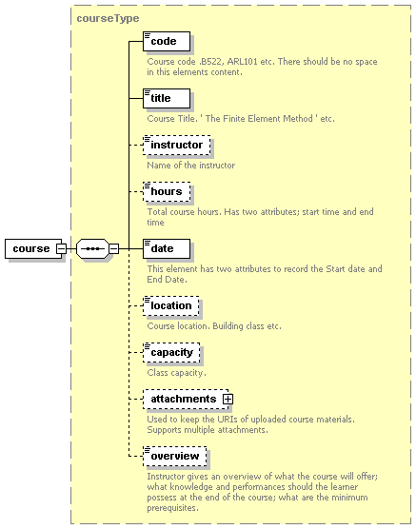

Figure - Course Schema Diagram

While preparing a schema the main point to remember is that the elements or attributes of the schema should include all the possible needs of the users. Course schema is prepared for a specific department and includes the requirements of this group.

As in XML, XML Schema consists of elements and attributes. For instance the hours element in the above figure is represented in the schema as:

<xs:element name="hours" minOccurs="0">
<xs:annotation>
<xs:documentation>
Total course hours. Has two attributes; start time and end time
</xs:documentation>
</xs:annotation>
<xs:complexType>
<xs:simpleContent>
<xs:extension base="xs:string">
<xs:attribute name="starttime" type="xs:string" use="optional"/>
<xs:attribute name="endtime" type="xs:string" use="optional"/>
</xs:extension>
</xs:simpleContent>
</xs:complexType>
</xs:element>

This element has two attributes stattime and endtime to keep the entries of starting and ending times of a particular class.

<xs:attribute name="starttime" type="xs:string" use="optional"/>
<xs:attribute name="endtime" type="xs:string" use="optional"/>

Defining the data fields in the schema in this way gives us the opportunity to use CASTOR to generate data object representations of these elements and attributes.

Creating data object models with CASTOR

Castor provides us a source code generator to generate Java Source Code for a particular XML Schema. It is a valuable time saving tool when it comes to writing XML enabled applications.

The source code generator is invoked from the command line giving the name of the schema file and output directory name as parameters.

>java org.exolab.castor.builder.SourceGenerator -i course-v1.xsd –package schema.course

Using Source Code Generator not only Java Object Model is created but also all necessary XML binding information needed by the marshalling framework to properly marshal, unmarshal, and validate instances of the given schema is produced.

As an example we can take a look at the source code for hours element.

.
/**
**/
public java.lang.String getContent()
{
return this._content;
} //-- java.lang.String getContent()

/**
**/
public java.lang.String getEndtime()
{
return this._endtime;
} //-- java.lang.String getEndtime()

/**
**/
public java.lang.String getStarttime()
{
return this._starttime;
} //-- java.lang.String getStarttime()
.
.

JSP

Once we have our schema and data object model which represents the elements in the schema we need to provide an interface for users to enter their data. We use JSP to produce web pages on demand.

These pages consist of some form elements which are created according to the schema elements. Each form element in the HTML form corresponds to an element in the XML Schema.

As an example the form for creating a course is given here:

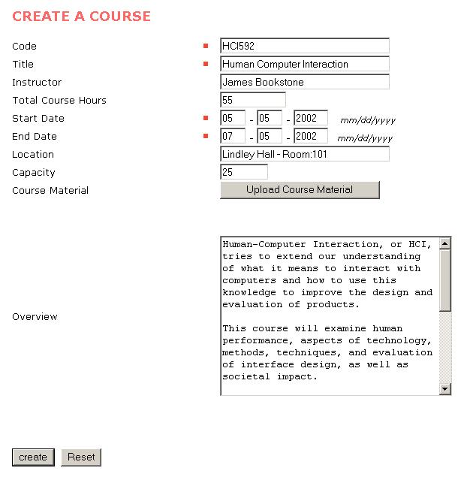

Figure - HTML Form for creating a course

AS it can be seen from the figure user input is obtained using form elements. Form elements allow us to create a mapping between XML Schema elements and HTML Form elements.

XML Schema allows us to determine the types of the elements so we have to make sure that user enters appropriate type of data to the textboxes or textareas. Using Java Script methods we create fast and reliable form checking.

JSP combines the Java Programming Language with HTML and this provides a great flexibility. According to the request made by the user or an application we can create web pages on demand or we can choose which fields are going to be visible in the client side.

Next step in our XML Document creation process is posting the form. When user hits the Submit button (Create in our example) or posts the form, the data entered to the form fields are posted. We use HTML request to get this data and assign them to the corresponding data objects.

When we create the Java classes using Castor, we would have an object that corresponds to the root element of the XML Schema. This object contains all sub elements as objects.

We declare this object at the top of the JSP page

<jsp:useBean id="courseObj" scope="session" class="schema.course.Course"/>

This declaration allows us to reach all the sub elements using courseObj. Using this object we set the values of the necessary objects.
.
.
course.setCode(code);
course.setTitle(title);
course.setInstructor(instructor);
.
.

Since the Java Beans are used in JSP we can also get the values of the fields by just calling the getter methods.

.
.
String currentCode = course.getCode();
String currentTitle = Course.getTitle();
String currentInstructor = course.getInstructor();
.
.

Publishing the message

When we have the Java objects of the user data we can send it to the next part of the system. This is publishing XML message to the JMS Server so that the message can be distributed to the related topic. Our system uses a message publisher to do this job. Java Messaging Service is used for publishing the messages.

NewsgroupMessageGenerator ngmg = new NewsgroupMessageGenerator(distribution);

Created XML message is passed as an argument to the method NewsgroupMessageGenerator, this method creates a connection to the JMS server and publishes the message.

.
ngmg.setMessage(msg);
.
.
ngmg.createNewsgroupHeaderMessage();
ngmg.constructBody();
ngmg.publish();
.

References:
1 – http://www.castor.org
2 – Professional XML 2nd Edition, Jonathan Pinnock, Stephen Mohr
3 – W3C XML Schema documentation

