DRYADLINQ CTP EVALUATION

Performance of Key Features and Interfaces in DryadLINQ CTP

Hui Li, Yang Ruan, Yuduo Zhou, Judy Qiu

November 4, 2011

SALSA Group, Pervasive Technology Institute, Indiana University

<http://salsahpc.indiana.edu/>

Table of Contents

1 Introduction 4

2 Overview 5

2.1 Task Scheduling 6

2.2 Parallel Programming Model 6

2.3 Distributed Grouped Aggregation 6

3 Pleasingly Parallel Application in DryadLINQ CTP 7

3.1 Introduction 7

Pairwise Alu Sequence Alignment Using Smith Waterman GOTOH 7

DryadLINQ Implementation 8

3.2 Task Granularity Study 8

Workload Balancing 9

Scalability Study 11

3.3 Scheduling on Inhomogeneous Cluster 12

Workload Balance with Different Partition Granularities 12

3.4 Conclusion 14

4 Hybrid Parallel Programming Model 14

4.1 Introduction 14

4.2 Parallel Matrix-Matrix Multiplication Algorithms 15

Row Partition Algorithm 15

Row-Column Partition Algorithm 16

Block-Block Decomposition in Fox-Hey Algorithm 16

4.3 Multi-Core Technologies 19

4.4 Performance Analysis in Hybrid Parallel Model 20

Performance on Multi Core 20

Performance on a Cluster 20

Performance of a Hybrid Model with Dryad and PLINQ 21

Performance Comparison of Three Hybrid Parallel Models 21

4.5 Timing Analysis for Fox-Hey on Windows HPC cluster 23

4.6 Conclusion 25

5 Distributed Grouped Aggregation 25

5.1 Introduction 25

5.2 Distributed Grouped Aggregation Approaches 25

Hash Partition 26

Hierarchical Aggregation 27

Aggregation Tree 28

5.3 Performance Analysis 29

Performance in Different Aggregation Strategies 29

Comparison with other implementations 31

Chaining Tasks within BSP Job 32

5.4 Conclusion: 32

6 Programming Issues in DryadLINQ CTP 32

Class Path in Working Directory 32

Late Evaluation in Chained Queries within One Job 33

Serialization for Two Dimension Array 33

7 Education Session 33

Concurrent Dryad jobs 34

Acknowledgements 35

References: 35

# 1 Introduction

We are in the data deluge era when progress in science requires the processing of large amounts of scientific data [1]. One important approach is to apply new languages and runtimes to new data-intensive applications [2] to enable the preservation, movement, access, and analysis of massive data sets. Systems such as MapReduce and Hadoop allow developers to write applications for distributing tasks to remote environments containing the desired data, which instantiates the paradigm of “moving the computation to data”. The MapReduce programming model has been applied to a wide range of applications and attracts enthusiasm from distributed computing communities due to its ease of use and efficiency in processing large-scale distributed data.

MapReduce, however, has its limitations. For instance, its rigid and flat data-processing paradigm does not directly support relational operations that have multiple related inhomogeneous data sets. This causes difficulties and inefficiency when using MapReduce to simulate relational operations such as *join*, which is very common in database systems. For example, the classic implementation of PageRank is notably inefficient since the simulation of *joins* with MapReduce causes a lot of network traffic during the computation. Further optimization of PageRank requires developers to have sophisticated knowledge of web graph structure.

Dryad [3] is a general-purpose runtime for supporting data-intensive applications on a Windows platform. It models programs as a directed, acyclic graph of the data flowing between operations and addresses some limitations existing in MapReduce. DryadLINQ [4] is the declarative programming interface for Dryad, and it automatically translates LINQ programs written by the .NET language into distributed computations executing on top of the Dryad system. For some applications, writing DryadLINQ distributed programs is as simple as writing sequential programs. DryadLINQ and Dryad runtime optimize job execution planning. This optimization is handled by the runtime but is transparent to users. For example, when implementing PageRank with the *GroupAndAggregate*() operator, DryadLINQ can dynamically constructs a partial aggregation tree based on data locality to reduce network traffic over cluster nodes. This report is based on our evaluation of DryadLINQ, which was published as a Community Technology Preview (CTP) in December 2010.

The overall performance issues of data parallel programing models like MapReduce are well understood. Dryad simplifies usage by leaving the details of scheduling, communication, and data access to underlying runtime systems that hide the low-level complexity of parallel programming. However, such an abstraction may come at a price in terms of performance when applied to a wide range of applications that port to multi-core and heterogeneous systems. We have conducted extensive experiments on DryadLINQ/Dryad CTP and its usage [5] to identify the classes of applications that fit well. Here, we include a comprehensive evaluation of Dryad as a technical report.

***This report investigates key features and interfaces of the DryadLINQ CTP with a focus on their efficiency and scalability.*** After implementing three different scientific applications, which include Pairwise Alu sequence alignment, matrix multiplication, and PageRank with large and real-world data, the following were evident: 1) compared with Dryad (2009,11), DryadLINQ CTP provides better task scheduling strategy, data model, and interface to solve the workload balance issue for pleasingly parallel applications; 2) porting multi-core technologies like PLINQ and TPL to DryadLINQ tasks can increase system utilization; 3) the choice of distributed grouped aggregation with DryadLINQ CTP has a substantial impact on the performance of data aggregation/reduction applications.

***This report explores DryadLINQ CTP programming models and can be applied to three different types of classic scientific applications including pleasingly parallel, hybrid distributed and shared memory, and distributed grouped aggregation.*** The Smith Waterman-Gotoh algorithm (SWG) [6] is a pleasingly parallel application, which consists of Map and Reduce steps. We implement it with *ApplyPerPartition* operator, which can be considered as a distributed version of “Apply” in SQL. In Matrix Multiplication applications, we explore a hybrid parallel programming model to combine inter-node distributed memory with intra-node shared memory parallelization. This is implemented by porting multicore technologies such as PLINQ and TPL into a user-defined function within DryadLINQ queries. PageRank is a communication-intensive application that requires joining two input data streams and performing the grouped aggregation over partial results. We implemented the PageRank application with three distributed grouped aggregation approaches. After our study was conducted, an education component illustrated how Professor Judy Qiu integrates Dryad/DryadLINQ into class projects for computer science graduate students at Indiana University.

The report is organized as follows. Section 1 introduces key features of DryadLINQ CTP. Section 2 studies the task scheduling in DryadLINQ CTP with a SWG application. Section 3 explores hybrid parallel programing models with Matrix Multiplication. Section 4 introduces distributed grouped aggregation exemplified by PageRank. Section 5 investigates the programming issues of DryadLINQ CTP. Section 6 explains the applicability of DryadLINQ to education and training. Note that in the report: “Dryad/DryadLINQ CTP” refers to the Dryad/DryadLINQ community technical preview released in 2010.12; “Dryad/DryadLINQ (2009.11)” refers to the version released in 2009.11.11; “Dryad/DryadLINQ” refers to all Dryad/DryadLINQ versions. Experiments are conducted on three Windows HPC clusters: STORM, TEMPEST, and MADRID [Appendix A, B, and C]. STORM consists of heterogeneous multicore nodes while TEMPEST and MADRID are homogeneous production systems of 768 and 128 cores each.

# 2 Overview

Dryad, DryadLINQ, and the Distributed Storage Catalog (DSC) [7] are sets of technologies that support the processing of data-intensive applications on a Windows HPC cluster. The software stack of these technologies is shown in Figure 1. Dryad is a general-purpose distributed runtime designed to execute data-intensive applications on a Windows cluster. A Dryad job is represented as a directed acyclic graph (DAG), which is called a “Dryad” graph. The Dryad graph consists of vertices and channels. A vertex in the graph represents an independent instance of the data processing for a particular stage. Graph edges represent channels transferring data between vertices. A DSC component works with the NTFS to provide the data management functionalities, such as file replication and load balancing for Dryad and DryadLINQ.

DryadLINQ is a library for translating .NET written Language-Integrated Query (LINQ) programs into distributed computations executing on top of the Dryad system. The DryadLINQ API takes advantage of standard query operators and adds query extensions specific to Dryad. Developers can apply LINQ operators such as *join* and *groupby* to a set of .NET objects. Specifically, DryadLINQ supports a unified data and programming model in the representation and processing of data. DryadLINQ data objects are collections of.NET type objects, which can be split into partitions and distributed across the computer nodes of a cluster. These DryadLINQ data objects are represented as either DistributedQuery <T> or DistributedData <T> objects and can be used by LINQ operators. In summary, DryadLINQ greatly simplifies the development of data parallel applications.

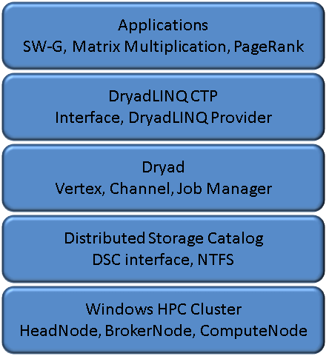  
Figure1: Software Stack for DryadLINQ CTP

## 2.1 Task Scheduling

Task scheduling for DryadLINQ CTP is a key feature investigated in this report. A DryadLINQ provider translates LINQ queries into distributed computation and automatically dispatches tasks to a cluster. This process is handled by the runtime and is transparent to users. The task scheduling component also automatically handles fault tolerance and workload balance issues.

We have studied DryadLINQ CTP’s load balance issue and investigated its relationship to task granularity along with its impact on performance. In batch job scheduling systems, like PBS, programmers manually group/ungroup (or partition/combine) input and output data for the purpose of controlling task granularity. Hadoop provides a user interface to define task granularity as the size of input records in HDFS. Similarly, Dryad (2009,11) allows developers to create a partition file. DryadLINQ CTP has a simplified data model and flexible interface in which *AsDistributed*, *Select*, and *ApplyPerPartition* operators (which can be considered as the distributed versions of *Select* and *Apply* in SQL) enable developers to tune the granularity of data partitions and run pleasingly parallel applications like sequential ones.

## 2.2 Parallel Programming Model

Dryad is designed to process coarse granularity tasks for large-scale distributed data and schedules tasks to computing resources over compute nodes rather than cores. To achieve high utilization of the multi-core resources of a HPC cluster for DryadLINQ jobs, one approach is to explore inner-node parallelism using PLINQ since DryadLINQ can automatically transfer a PLINQ query to parallel computations. Another approach is to apply multi-core technologies in .NET, such as Task Parallel Library (TPL) or thread pool for user-defined functions within the lambda expression of DryadLINQ query.

In a hybrid parallel programming model, Dryad handles inter-node parallelism while PLINQ, TPL, and thread pool technologies leverage inner-node parallelism on multi-cores. Dryad/DryadLINQ has been successful in executing as a hybrid model and applied to data clustering applications, such as General Topographical Mapping (GTM) interpolation and Multi-Dimensional Scaling (MDS) interpolation [8]. Most of the pleasingly parallel applications can be implemented in a straightforward fashion using this model with increased overall utilization of cluster resources. However, more compelling machine learning or data analysis applications usually have either squared or quadratic computation complexity, which has high requirements of system design for scalability.

## 2.3 Distributed Grouped Aggregation

The *groupby* operator in parallel databases is often followed by aggregate functions, which groups input records into partitions by keys and merges the records for each group by certain attribute values; this computing pattern is called Distributed Grouped Aggregation. Example applications include sales data summarizations, log data analysis, and social network influence analysis.

MapReduce and SQL for databases are two programming models to perform distributed grouped aggregation. MapReduce has been applied to the process of a wide range of flat distributed data, but is inefficient in processing relational operations, which have multiple inhomogeneous input data stream such as *join*. However, a full-featured SQL database has extra overhead and constraints that prevent it from processing large-scale input data.

DryadLINQ is between SQL and MapReduce and addresses some of their limitations. DryadLINQ provides SQL-like queries for processing efficient aggregation for homogenous input data streams and multiple inhomogeneous input streams and does not have sufficient overhead since SQL eliminates some of the functionalities of a database (transactions, data lockers, etc.). Further, DryadLINQ can build an aggregation tree (some databases also provides this kind of optimization) to decrease data transformation in the hash partitioning stage. In this report, we investigated the usability and performance of three programming models using Dyrad/DryadLINQ as illustrated in Figure 2: a) the pleasingly parallel mode, b) the hybrid programming model, and d) distributed grouped aggregation.

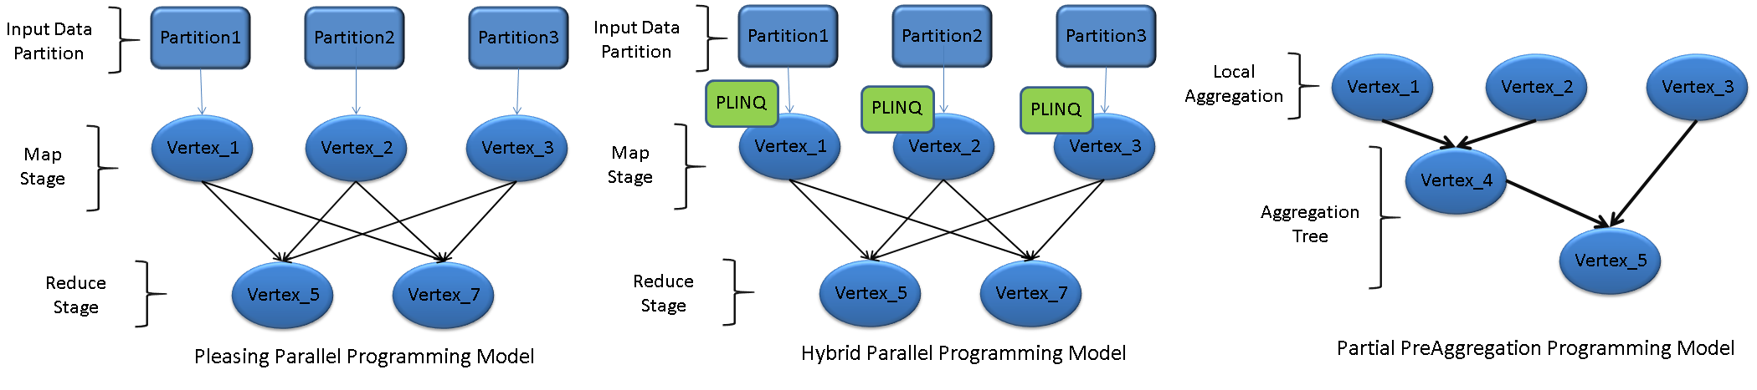

Figure 2: Three Programming Models for Scientific Applications in DryadLINQ CTP

# 3 Pleasingly Parallel Application in DryadLINQ CTP

## 3.1 Introduction

A pleasingly parallel application can be partitioned into parallel tasks since there is neither essential data dependency nor communication between those parallel tasks. Task scheduling and granularity have a great impact on performance and are evaluated in Dryad CTP using the Pairwise Alu Sequence Alignment application. Furthermore, many pleasingly parallel applications share a similar execution pattern. The observation and conclusion drawn from this work applies to a large class of similar applications.

### Pairwise Alu Sequence Alignment Using Smith Waterman GOTOH

The Alu clustering problem [9] is one of the most challenging problems for sequencing clustering because Alus represent the largest repeat families in human genome. There are approximately 1 million copies of Alu sequences in the human genome in which most insertions can be found in other primates and only a small fraction (~ 7000) are human-specific. This indicates that the classification of Alu repeats can be deduced solely from the 1 million human Alu elements. Notably, Alu clustering can be viewed as a classic case study for the capacity of computational infrastructure because it is not only of great intrinsic biological interests, but also a problem of a scale that will remain as the upper limit of many other clustering problems in bioinformatics for the next few years, e.g. the automated protein family classification for a few millions proteins predicted from large meta-genomics projects.

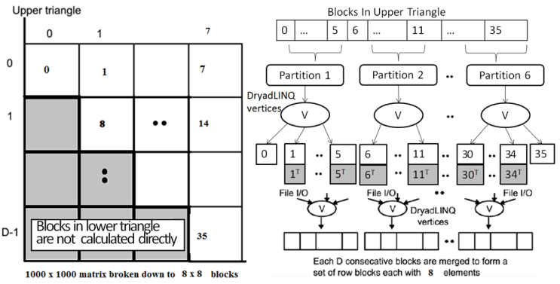

Figure 3: Task Decomposition (left) and the Dryad Vertex Hierarchy (right) of the DryadLINQ Implementation of SWG Pairwise Distance Calculation Application

An open source version, NAligner [10], of the Smith Waterman-Gotoh algorithm (SWG) [11] was used to ensure low start-up effects by each task process for large numbers (more than a few hundred) at a time. The needed memory bandwidth is reduced by storing half of the data items for symmetric features.

### DryadLINQ Implementation

The SWG program runs in two steps. In the map stage input data is divided into partitions being assigned to vertices. A vertex calls external pair-wise distance calculations on each block and runs independently. In the reduce stage, this vertex starts a few merge threads to collect output from the map stage, merges them into one file, and then sends meta data of the file back to the head node. To clarify our algorithm, let’s consider an example of 10,000 gene sequences that produces a pairwise distance matrix of size 10,000 × 10,000. The computation is partitioned into 8 × 8 blocks as a resultant matrix D, where each sub-block contains 1250 × 1250 sequences. Due to the symmetry feature of pairwise distance matrix D(i, j) and D(j, i), only 36 blocks need to be calculated as shown in the upper triangle matrix of Figure 3 (left).

Dryad divides the total workload of 36 blocks into 6 partitions, each of which contains 6 blocks. After the partitions are distributed to available compute nodes an *ApplyPerPartition()* operation is executed on each vertex. A user-defined *PerformAlignments()* function processes multiple SWG blocks within a partition, where concurrent threads utilize multicore internal to a compute node. Each thread launches an operating system process to calculate a SWG block in order. Finally, a function calculates the transpose matrix corresponding to the lower triangle matrix and writes both matrices into two output files on local file system. The main program performs another *ApplyPerPartition()* operation to combine the metadata of files as shown in Figure 3. The pseudo code for our implementation is provided as below:

Map stage:

DistributedQuery<OutputInfo> outputInfo = swgInputBlocks.AsDistributedFromPartitions()

ApplyPerPartition(blocks => PerformAlignments(blocks, swgInputFile, swgSharePath,

outputFilePrefix, outFileExtension, seqAlignerExecName, swgExecName));

Reduce stage:

var finalOutputFiles = swgOutputFiles.AsDistributed().ApplyPerPartition(files => PerformMerge(files, dimOfBlockMatrix, sharepath, mergedFilePrefix, outFileExtension));

## 3.2 Task Granularity Study

This section examines the performance of different task granularities. As mentioned above, SWG is a pleasingly parallel application for dividing the input data into partitions. The task granularity was tuned by saving all SWG blocks into two-dimensional arrays and converting to distributed partitions using *AsDistributedFromPartitions* operator.

Figure 4: Execution Time for Various SWG Partitions

Executed on Tempest Cluster, with input of 10,000 sequences, and a 128×128 block matrix

The experiment was performed on a 768 core (32 nodes with 24 cores per node) Windows cluster called “TEMPEST” [Appendix B]. The input data of SWG has a length of 8192, which requires about 67 million distance calculations. The sub-block matrix size is set to 128 × 128 while we used *AsDistributedFromPartitions()* to divide input data into various partition sets {31, 62, 93, 124, 248, 372, 496, 620, 744, 992}. The mean sequence length of input data is 200 with a standard deviation as 10, which gives essentially homogeneous distribution ensuring a good load balance. On a cluster of 32 compute nodes, Dryad job manager takes one node for its dedicated usage and leaves 31 nodes for actual computations. As shown in Figure 4 and Table 1 (in Appendix F), smaller number of partitions delivered better performance. Further, the best overall performance is achieved at the least scheduling cost derived from 31 partitions for this experiment. The job turnaround time increases as the number of partition increases for two reasons: 1) scheduling cost increases as the number of tasks increases, 2) partition granularity becomes finer with increasing number of partitions. When the number of partitions reaches over 372, each partition has less than 24 blocks making resources underutilized on a compute node of 24 cores. For pleasingly parallel applications, partition granularity and data homogeneity are major factors that impact performance.

### Workload Balancing

The SWG application handled input data by gathering sequences into block partitions. Although gene sequences were evenly partitioned in sub-blocks, the length of each sequence may vary. This causes imbalanced workload distribution among computing tasks. Dryad (2009.11) used a static scheduling strategy binding its task execution plan with partition files, which gave poor performance for skewed/imbalanced input data [2]. We studied the scheduling issue in Dryad CTP using the same application.

|  |  |
| --- | --- |
|  |  |
| Figure 5: SWG Execution Time for Skewed and Randomized Distributed Input Data | Figure 6: SWG Execution Time for Skewed Data with Different Partition Amount |

A set of SWG jobs was executed on the TEMPEST cluster with input size of 10000 sequences. The data were randomly generated with an average sequence length of 400, corresponding to a normal distribution with varied standard deviations. We constructed the SWG sub-blocks by randomly selecting sequences from the above data set in contrast to selecting sorted sequences based on their length. Figure 5 has line charts labeled with error bars, where randomized data shows better performance than skewed input data. Similar results were presented in the Dryad (2009.11) report as well. Since sequences were sorted by length for a skewed sample, computational workload in each sub-block was hugely variable, especially when the standard deviation was large. On the other hand, randomized sequences gave a balanced distribution of workload that contributed to better overall performance. Dryad CTP provides an interface for developers to tune partition granularity. The load imbalance issue can be addressed by splitting the skewed distributed input data into many finer partitions.   
Figure 6 shows the relationship between number of partitions and performance. In particular, a parabolic chart suggests an initial overhead that drops as partitions and CPU utilization increase. Fine-grained partitions enable load balancing as SWG jobs start with sending small tasks to idle resources. Note that 124 partitions gives best performance in this experiment. With increasing partitions, the scheduling cost outweighs the gains of workload balancing. Figures 5 and 6 imply that the optimal number of partitions also depends on heterogeneity of input data.

DryadLINQ CTP divides input data into partitions by default with twice the number of compute nodes. It does not achieve good load balance for some applications, such as inhomogeneous SWG data. We have shown how to address the load imbalance issue. Firstly, the input data can be randomized and partitioned to increase load balance. However, it depends on the nature of randomness and good performance is not guaranteed. Secondly, a fine-grained partition can help tuning load balance among compute nodes. There’s a trade off in drastically increasing partitions, as the scheduling cost becomes a dominant factor of performance.

We found a bug in *AsDistributed()* interface, namely a mismatch between partitions and compute nodes in the default setting of Dryad CTP. Dryad provides two APIs to handle data partition, *AsDistributed()* and *AsDistributedFromPartitions()*. In our test on 8 nodes (1 head node and 7 compute nodes), Dryad chose one dedicated compute node for the graph manager which left only 6 nodes for computation. Since Dryad assigns each compute node 2 partitions, *AsDistributed()* divides data into 14 partitions disregarding the fact that the node for the graph manager does no computation. This causes 2 dangling partitions. In the following experiment, input data of 2000 sequences were partitioned into sub blocks of size 128×128 and 8 computing nodes were used from the TEMPEST cluster.

Figure 7: Mismatch between Partitions and Compute Nodes in Default Settings of Dryad CTP

Figure 7 shows the execution time for 12 customized partitions on the left and the default partitions by *AsDistributed()* on the right. It is observed that input data are divided into 14 partitions over 6 compute nodes. The 2 dangling partitions colored in green slow down the whole calculation by almost 30%.

In summary, Dryad and Hadoop control task granularity by partitioning input data. DryadLINQ CTP has a default partition number twice that of the compute nodes. Hadoop partitions input data into chunks, each of which has a default size of 64MB. Hadoop implements a high-throughput model for dynamic scheduling and is insensitive to load imbalance issues. Dryad and Hadoop provide an interface allowing developers to tune partition and chunk granularity, with Dryad providing a simplified data model and interface on the .NET platform.

### Scalability Study

Scalability is another key feature for parallel runtimes. The DryadLINQ CTP scalability test includes two sets of experiments conducted on the TEMPEST Cluster of 768 cores. A comparison of parallel efficiency for DryadLINQ CTP and DryadLINQ 2009 are discussed below.

The first experiment has an input size between 5,000 and 15,000 sequences with an average length of 2,500. The sub-block matrix size is 128 × 128 and there are 31 partitions, which is the optimal value found in previous experiments. Figure 8 shows performance results, where the red line represents execution time on 31 compute nodes, the green line represents execution time on a single compute node, and the blue line is parallel efficiency defined as the following:

$$Parallel Efficiency= \frac{Execution Time on One Node}{Execution Time on Multinodes×Number of Nodes} (Eq. 1)$$

Parallel efficiency is above 90% for most cases. An input size of 5000 sequences over a 32-node cluster shows a sign of underutilization for a slightly low start. When input data increases from 5000 to 15000, parallel efficiency jumps from 81.23% to 96.65%, as scheduling cost becomes less critical to the overall execution time as the input size increases.

Figure 8: Performances and Parallel Efficiency on TEMPEST

The SWG jobs were also performed on 8 nodes of the MADRID cluster [Appendix D] using Dryad 2009 and 8 nodes on the TEMPEST cluster [Appendix C] using Dryad CTP. The input data is identical for both tests, which are 5,000 to 15,000 gene sequences partitioned into 128×128 sub blocks. Parallel efficiency (Eq. 1) is used as a metric for comparison. By computing 225 million pairwise distances both Dryad CTP and Dryad 2009 showed high utilization of CPUs with parallel efficiency of over 95% as displayed in Figure 9.

Figure 9: Parallel Efficiency on Dryad CTP and Dryad 2009

In the second set of experiments we calculated speed up to 10,000 input sequences (31 partitions with 128×128 sub block size) but varied the number of compute nodes in input sequence numbers 2, 4, 8, 16, and 31 (due to the cluster limitation of 31 compute nodes). The SWG application scaled up well on a 768-core HPC cluster. These results are presented in Table 4 of Appendix F. The execution time ranges between 40 minutes to 2 days. The speedup, as defined in equation 2, is almost linear with respect to the number of compute nodes as shown in Figure 10, which suggests that pleasingly parallel applications perform well on DryadLINQ CTP.

$$Speedup= \frac{Execution time on one node}{Execution Time on multiple nodes} (Eq. 2)$$

Figure 10: Speedup for SWG on Tempest with Varied Size of Compute Nodes

## 3.3 Scheduling on an Inhomogeneous Cluster

Adding a new hardware or integrating distributed hardware resources is common but may cause inhomogeneous issues for scheduling. In Dryad 2009, the default execution plan is based on an assumption of a homogeneous computing environment. This motived us to investigate performance issues on an inhomogeneous cluster for Dryad CTP. Task scheduling with attention to load balance is studied in this section.

### Workload Balance with Different Partition Granularities

An optimal job-scheduling plan needs awareness of resource requirements and CPU time for each task, which is not practical in many applications. One approach is to split the input data set into small pieces and keep dispatching them to available resources.

This experiment was performed on STORM [Appendix A], an inhomogeneous HPC cluster. A set of SWG jobs is scheduled with different partition sizes, where input data contain 2048 sequences being divided into 64×64 sub blocks. These sub blocks are divided by *AsDistributedFromPartitions()* to form a set of partitions : {6, 12, 24, 48, 96, 192}. A smaller number of partitions implies a large number of sub blocks in each partition. As Dryad job manager keeps dispatching data to available nodes, the node with higher computation capability can process more SWG blocks. The distribution of partitions over compute nodes is shown in Table 5 of Appendix F; when the partition granularity is large, the distribution of SWG blocks among the nodes is proportional to the computational capacity of the nodes.

Dryad CTP assigns a vertex to a compute node and each vertex contains one or more partitions. To study the relationship between partition granularity and load balance, the computation and scheduling time on 6 compute nodes for 3 sample SWG jobs were recorded separately. Results are presented in Figure 11 with compute nodes along the X-axis (e.g. cn01 ~ cn06) and elapsed time from the start of computation along the Y-axis. A red bar marks the time frame of a particular compute node doing computation, and a blue bar refers to the time frame for scheduling a new partition. Here are a few observations:

* When the number of partitions is small, workload is not well balanced, leading to significant variation in computation time on each node. Note that faster nodes stay idle and wait for slower ones to finish, as shown on the left graph in Figure 11.
* When the number of partitions is large, workload is distributed in proportion to the capacity of compute nodes. Too many small partitions cause high scheduling costs, thus slowing down overall computation, as illustrated on the right graph in Figure 11.
* Load balance favors a small number of partitions while scheduling costs favor a large number of jobs. An optimal performance is observed in the center graph in Figure 11.

192 Partitions

24 Partitions

6 Partitions

Figure 11: Scheduling Time vs. Computation Time of the SWG Application on Dryad CTP

The optimal partition is a moderate number with respect to both load balance and scheduling cost. As shown in Figure 12, the optimal number of partitions is 24. Note that 24 partitions performed better than the default partition number, 14.

Figure 12: SWG Job Turnaround Time for Different Partition Granularities

Figure 13 shows that overall CPU usage drops as the number of partitions increases, due to increasing scheduling and data movement, which do not demand high CPU usage.

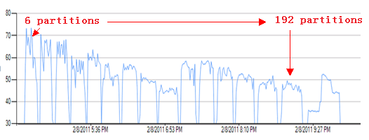

Figure 13: Cluster CPU Usage for Different SWG Partition Numbers

## 3.4 Conclusion

SWG is a pleasingly parallel application used to evaluate the performance of Dryad CTP. The scalability test shows that if input data is homogeneous and the workload is balanced, then the optimal setting with low scheduling costs has the same number of partitions as compute nodes, viz. 31. In the partition granularity test where data is inhomogeneous and causes an imbalanced workload, the default Dryad CTP setting of 62 partitions gave better results due to a finer balance between workload distribution and scheduling. A comparison between Dryad CTP and Dryad 2009 shows that Dryad CTP has achieved over 95% parallel efficiency in scale-up tests. Compared to the 2009 version Dryad CTP also presents an improved load balance with a dynamic scheduling function. Our evaluation demonstrates that load balance, task granularity, and data homogeneity are major factors that impact the performance of pleasingly parallel applications using Dryad. Further, we found a bug involving mismatched partitions vs. compute nodes in the default setting of Dryad CTP.

# 4 Hybrid Parallel Programming Model

## 4.1 Introduction

Matrix-matrix multiplication is a fundamental kernel [12], which can achieve high efficiency in both theory and practice. The computation can be partitioned into subtasks, which makes it an ideal candidate application in hybrid parallel programming studies using Dryad/DryadLINQ. However, there is not one optimal solution that fits all scenarios. *Different trade-offs of partition granularity largely correspond to computation and communication costs and are affected by memory/cache usage and network bandwidth/latency*. We investigated the performance of three matrix multiplication algorithms and three multi-core technologies in .NET, which run on both single and multiple cores of HPC clusters. The three matrix multiplication decomposition approaches are: 1) row decomposition, 2) row/column decomposition, and 3) block/block decomposition (Fox-Hey algorithm [13][14]). The multi-core technologies include: PLINQ, TPL [15], and Thread Pool, which correspond to three multithreaded programming models. In a hybrid parallel programming model, Dryad invokes inter-node parallelism while TPL, Threading, and PLINQ support inner-node parallelism. It is imperative to utilize new parallel programming paradigms that may potentially scale up to thousands or millions of multicore processors.

Matrix multiplication is defined as A * B = C (Eq. 3) where Matrix A and Matrix B are input matrices and Matrix C is the result matrix. The **p** in Equation 3 represents the number of columns in Matrix A and number of rows in Matrix B. Matrices in the experiments are square matrices with double precision elements.

(Eq. 3)



## 4.2 Parallel Matrix-Matrix Multiplication Algorithms

### Row-Partition Algorithm

The row-partition algorithm divides Matrix A into row blocks and distributes them onto compute nodes. Matrix B is copied to every compute node. Each Dryad task multiplies row blocks of Matrix A by all of matrix B and the main program aggregates a complete matrix C. The data flow of the Row Partition Algorithm is shown in Figure 14.

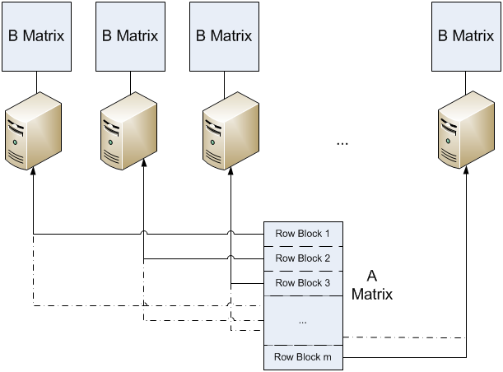

Figure 14: Row-Partition Algorithm

The blocks of Matrices A and B are first stored using *DistributedQuery* and *DistributedData* objects defined in DryadLINQ. Then an *ApplyPerPartition* operator invokes a user-defined function *rowsXcolumnsMultiCoreTech* to perform subtask computations. Compute nodes read file names for each input block and get the matrix remotely. As the row partition algorithm has a balanced distribution of workload over compute nodes, an ideal partition number equals the number of compute nodes. The pseudo code is as follows:

results = aMatrixFiles.Select(aFilePath => rowsXcolumns(aFilePath, bMatrixFilePath));

### Row-Column Partition Algorithm

The Row-Column partition algorithm [16] divides Matrix A by rows and Matrix B by columns. The column blocks of Matrix B are distributed across the cluster in advance. The whole computation is divided into several iterations. In each iteration one row block of Matrix A is broadcast to all compute nodes and multiplies by the one-column blocks of Matrix B. The output of each compute node is sent to the main program to form a row block of Matrix C. The main program then collects the results of multiple iterations to generate the complete output of Matrix C.



Figure 15: Row-Column Partition Algorithm

The column blocks of Matrix B are distributed by the *AsDistributed()* operator across the compute nodes. In each iteration an *ApplyPerPartition* operator invokes a user-defined function *aPartitionMultiplybPartition* to multiply one column block of Matrix B by one row block of Matrix A. The pseudo code is provided as below:

string[] aMatrixPartitionsFiles = splitInputFile(aMatrixPath, numIterations);

string[] bMatrixPartitionsFiles = splitInputFile(bMatrixPath, numComputeNodes);

DistributedQuery<matrixPartition> bMatrixPartitions = bMatrixPartitionsFiles.AsDistributed().HashPartition(x => x, numComputeNodes).

Select(file => buildMatrixPartitionFromFile(file));

for (int iterations = 0; iterations<numIterations;iterations++)

{

DistributedQuery<matrixBlock> outputs = bMatrixPartitions.ApplyPerPartition(bSubPartitions => bSubPartitions.Select(bPartition => aPartitionMultiplybPartition(aMatrixPartitionsFiles[iterations], bPartition)));

}

### Block-Block Decomposition in the Fox-Hey Algorithm

The block-block decomposition in the Fox-Hey algorithm divides Matrix A and Matrix B into squared sub-blocks. These sub-blocks are dispatched to a virtual topology on a grid with the same dimensions for the simplest case. For example, to run the algorithm on a 2X2 processes mesh, Matrices A and B are split along both rows and columns to construct a matching 2X2 block data mesh. In each step of computation, every process holds a current block of Matrix A by broadcasting and a current block of Matrix B by shifting upwards and then computing a block of Matrix C. The algorithm is as follows:

|  |
| --- |
|  |
| For k = 0: s-1   1. The process in row I with A(i, (i+k)mod s) broadcasts it to all other processes I the same row i. 2. Processes in row I receive A(I, (i+k) mod s) in local array T. 3. For i =0;s-1 and j=0:s-1 in parallel   C(i,j) = c(I,j)+T*B(i,j)  End   1. Upward circular shift each column of B by 1:   B(I,j) 🡨 B((i+1)mod s, j)  End |
|  |



Figure 16: Different Stages of the Fox-Hey Algorithm in 2x2 Block Decompositions

Figure 16 shows the case where Matrices A and B are both divided into a block mesh of 2x2. Correspondingly, 4 compute nodes are divided into a grid labeled C(0,0), C(0,1), C(1,0), C(1,1). In step 0, Matrix A broadcasts the active blocks in column 0 to compute nodes in the same row of the virtual grid of compute nodes (or processes), i.e. A(0,0) to C(0,0), C(0,1) and A(1,0) to C(1,0), C(1,1). The blocks in Matrix B will be scattered onto each compute node. The algorithm computes Cij = AB on each compute node. In Step 1, Matrix A will broadcast the blocks in column 1 to the compute nodes, i.e. A(0,1) to C(0,0), C(0,1) and A(1,1) to C(1,0), C(1,1). Matrix B distributes each block to its target compute node and performs an upward circular shift along each column, i.e. B(0,0) to C(1,0), B(0,1) to C(1,1), B(1,0) to C(0,0), B(1,1) to C(0,1). Then a summation operation on the results of each iteration forms the final result in Cij += AB.

Figure 17 illustrates a one-to-one mapping scenario for Dryad implementation where each compute node has one sub-block of Matrix A and one sub-block of Matrix B. In each step, the sub-blocks of Matrix A and Matrix B will be distributed onto compute nodes. Namely, the Fox-Hey algorithm achieves much better memory usage compared to the Row Partition algorithm which requires one row block of Matrix A and all of Matrix B for multiplication. In our future work, the Fox-Hey algorithm will be implemented in a general and powerful mapping schema to maximize cache usage, where the relationship between sub-blocks and the virtual grid of compute nodes will be many to one.



Figure 17: Structure of the 2D Decomposition Algorithm on Iteration i with n+1 Nodes

The pseudo code of basic Fox-Hey algorithm is given below:

string[] aPartitionsFile = splitInputFile(aMatrixPath, nProcesses);

string[] bPartitionsFile = splitInputFile(bMatrixPath, nProcesses);

IEnumerable<aMatrixCMatrixInput> inputAC = buildBlocksInputOfAMatrixCMatrix(rowNum, colNum, 0, nProcesses);

DistributedQuery<aMatrixCMatrixInput> inputACquery = inputAC.AsDistributed().HashPartition(x => x, nProcesses * nProcesses);

DistributedQuery<bMatrixInput> inputBquery = bPartitionsFile.AsDistributed().Select(x => buildBMatrixInput(x, 0, nProcesses)).SelectMany(x => x);

for (int iterations = 0; iterations < nProcesses; iterations++){

inputACquery = inputACquery.ApplyPerPartition(sublist => sublist.Select(acBlock => acBlock.updateAMatrixBlockFromFile(aPartitionsFile[acBlock.ci], iterations,nProcesses)));

inputACquery = inputACquery.Join(inputBquery, x => x.key, y => y.key, (x, y) => x.taskMultiplyBBlock(y.bMatrix));

inputBquery = inputBquery.Select(x => x.updateIndex(nProcesses));

}

The Fox-Hey algorithm was originally implemented with MPI [17], which maintained intermediate status and data in processes during parallel computation. However, Dryad uses a data-flow runtime that does not support intermediate status of tasks during computation. To work around this, new values are assigned to *DistributedQuery<T>* objects by an updating operation as shown in the following pseudo code.

DistributedQuery<Type> inputData = inputObjects.AsDistributed();

inputData = inputData.Select(data=>update(data));

## 4.3 Multi-Core Technologies

The sequential code of Matrix Multiplication is given below. In addition, we provide three implementations to illustrate three multithreaded programming models.

while (localRows.MoveNext())

{

double[] row_result = newdouble[colNum];

for (int i = 0; i < colNum; i++)

{

double tmp = 0.0;

for (int j = 0; j < rowNum; j++)

tmp += localRows.Current.row[j] * columns[i][j];

row_result[i] = tmp;

}

yieldreturn row_result;

}

1) The Parallel.For version of Matrix Multiplication

while (localRows.MoveNext())

{

blockWrapper rows_result = new blockWrapper(size,colNum,rowNum);

Parallel.For(0, size, (int k) =>

{

for (int i = 0; i < colNum; i++)

{

double tmp = 0.0;

for (int j = 0; j < rowNum; j++)

tmp += localRows.Current.rows[k * rowNum + j] * columns[i][j];

rows_result.block[k * colNum + i] = tmp;

}

});

yieldreturn rows_result;

}

2) The ThreadPool version of Matrix Multiplication

while (localRows.MoveNext())

{

blockWrapper rows_result = new blockWrapper(size, rowNum, colNum);

ManualResetEvent signal = new ManualResetEvent(false);

for (int n = 0; n < size; n++)

{

int k = n;

ThreadPool.QueueUserWorkItem(_ =>

{

for (int i = 0; i < colNum; i++)

{

double tmp = 0;

for (int j = 0; j < rowNum; j++)

tmp += localRows.Current.rows[k * rowNum + j] * columns[i][j];

rows_result.block[k * colNum + i] = tmp;

}

if (Interlocked.Decrement(ref iters) == 0)

signal.Set();

});

}

signal.WaitOne();

yieldreturn rows_result;

}

3) The PLINQ version of Matrix Multiplication

while (localRows.MoveNext())

{

double[][] rowsInput = initRows(localRows.Current.block);

IEnumerable<double[]> results = rowsInput.AsEnumerable().AsParallel().AsOrdered()

.Select(x => oneRowMultiplyColumns(x, columns));

blockWrapper outputResult = new blockWrapper(size,rowNum,colNum, results);

yieldreturn outputResult;

}

## 4.4 Performance Analysis in Hybrid Parallel Model

### Performance on Multi Core

The baseline test of Matrix Multiplication was executed on the TEMPEST cluster [Appendix B] with the three aforementioned multithreaded programming models for parallelism, which are: Task Parallel Library (TPL), Thread Pool and PLINQ. Figure 18 shows performance results on a 24-core compute node with matrix size between 2,400 and 19,200 dimensions. The speed-up charts were calculated using Equation 3. T(P) standards for job turnaround time for Matrix Multiplication using multi-core technologies, where P is the number of cores across the cluster. T(S) refers to the job turnaround time of sequential Matrix Multiplication on one core.

Speed-Up = T(S)/T(P) (Eq. 4)

Figure 18: Speedup Charts for TPL, Thread Pool, and PLINQ Implementations of

Matrix Multiplication on One Node

The parallel efficiency remains around 17 to 18 for TPL and Thread Pool. However, TPL outperforms Thread Pool as data size increases. PLINQ consistently achieves the best speed-up with values larger than 22, making parallel efficiency over 90% on 24 cores. We conclude that the main reason is due to PLINQ’s memory/cache usage being optimized for large data size on multicore systems by observing metrics of context switches and system calls of the heat map from the HPC cluster manager.

### Performance on a Cluster

We evaluated 3 different matrix multiplication algorithms implemented with Dryad CTP on 16 compute nodes of the TEMPEST cluster using one core per node. The data size of input matrix ranges from 2400 x 2400 to 19200 x 19200. A variance of the speed-up definition is given in Equation 5 where T(P) stands for job turnaround time on P compute nodes. T(S’) is an approximation of job turnaround time for the sequential matrix multiplication program where a fitting function [Appendix E] is used to calculate CPU time for large input data.

Speed-up = T(S’)/T(P) (Eq. 5)

As shown in Figure 19, the performance of the Fox-Hey algorithm is similar to that of the Row Partition algorithm, increasing quickly as the input data size increases. The Row-Column Partition Algorithm performs the worst since it is an iterative algorithm that needs explicit evaluation of DryadLINQ queries in each iteration to collect an intermediate result. In particular, it invokes resubmission of a Dryad task to the HPC job manager during each iteration.

### Performance of a Hybrid Model with Dryad and PLINQ

Porting multi-core technologies into Dryad tasks can potentially increase the overall performance due to extra processor cores. The hybrid model invokes Dryad for inter-node tasks and spawns concurrent threads through PLINQ. Three matrix multiplication algorithms were executed on 16 compute nodes of the TEMPEST cluster [Appendix B]. Compared to Figure 19, the speed-up charts of Figure 20 show significant performance gains by utilizing multicore technologies like PLINQ, where a factor of 9 is ultimately achieved as data size increases.

|  |  |
| --- | --- |
|  |  |
| Figure 19: Speedup of Three Matrix Multiplication Algorithms Using Dryad on a Cluster | Figure 20: Speedup of Three Matrix Multiplication Algorithms Using a Hybrid Model with Dryad and PLINQ |

Since the computational complexity in matrix multiplication is O(n3), which increases faster than that of the growth of communication cost O(n2), Figures 19 and 20 show that the speed-up increases with the size of input data. The Row Partition algorithm delivers the best performance for a hybrid model, as shown in Figure 20. Compared to the other 2 iterative algorithms, job submission occurs only once with the Row Partition algorithm. The Row-Column partition algorithm and the Fox-Hey algorithm both have 4 iterations and finer task granularity, leading to extra scheduling and communication overhead.

### Performance Comparison of Three Hybrid Parallel Models

We studied three matrix multiplication algorithms in hybrid parallel programming models with Task Parallel Library (TPL), Thread, and PLINQ on multicore processors. Figure 21 shows the performance results of a 19200 by 19200 matrix on 16 nodes of the TEMPEST cluster with 24 cores on each node. In all 3 matrix multiplication algorithms PLINQ achieves better speed-up than TPL and Thread, which supports earlier performance results shown in Figure 18.

Figure 21: The Speedup Chart of TPL, Thread, and PLINQ for Three Matrix Multiplication Algorithms

When a problem size is fixed, parallel efficiency drops when multicore parallelism used. This can be illustrated by the Row Partition algorithm running with or without PLINQ on 16 nodes (each has 24 cores), where the parallel efficiency is 17.3/16 = 108.1% when using one core per node (Figure 19), but becomes 156.2/384 = 40.68% over 384 cores (Figure 21). This is because the task granularity of Dryad on each core becomes finer and the node execution time decreases, while the overhead of scheduling, communication, and disk I/O remains the same or even increases.

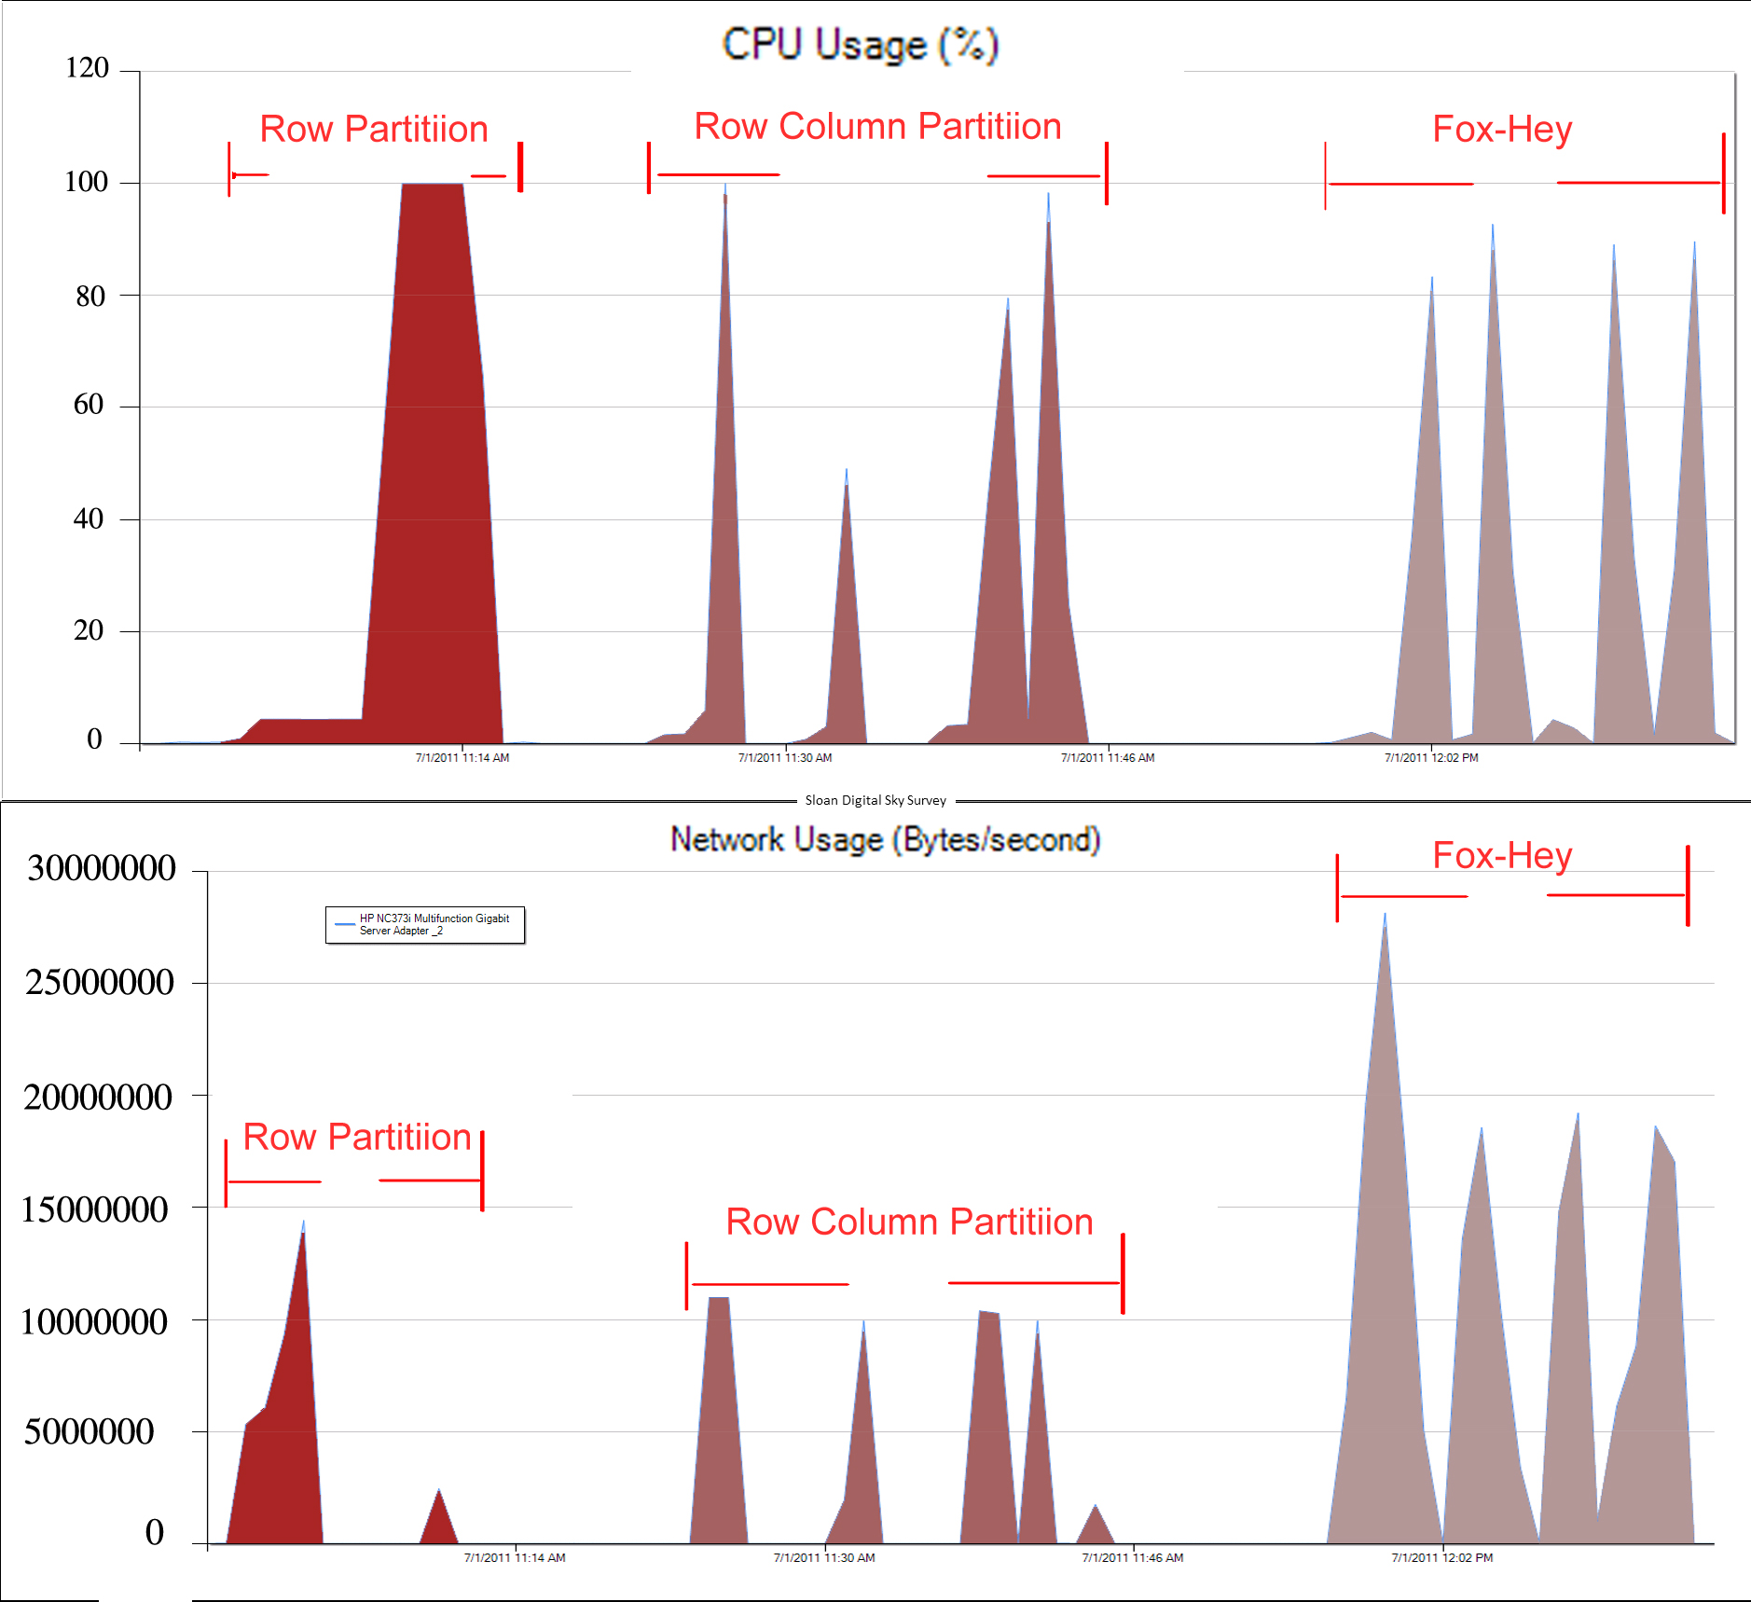

Figure 22: The CPU Usage and Network Activity on One Compute Node for Multiple Algorithms

Figure 22 shows charts of CPU utilization and network activity on one node of the TEMPEST cluster for three 19200 x 19200 matrix multiplication jobs using PLINQ. It is observed that the Row Partition Algorithm with PLINQ can reach a CPU utilization rate of 100% for a longer time than the other two approaches. Further, its aggregated network overhead is less than that of the other two approaches as well. Thus, the Row Partition algorithm with PLINQ has the shortest job turnaround time. The Fox-Hey algorithm delivers good performance in the sequential implementation due to its cache and paging advantage with finer task granularity.

Figure 23 shows the CPU and network utilization of the Fox-Hey algorithm on square matrices of 19,200 and 28,800 dimensions. Not only do they CPU and Network utilization increase with size of input data, but the rate of increase in CPU utilization is faster than that of network utilization, which follows the ratio of computation complexity O(n^3) vs. communication complexity O(n^2). The overall speed-up will continue to increase as we increase the data size.

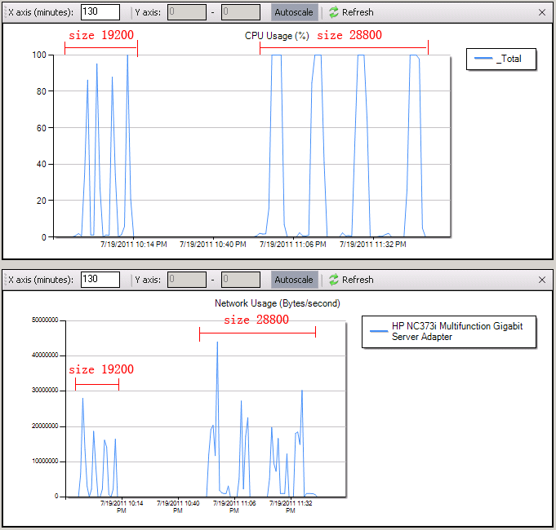

Figure 23: The CPU Usage and Network Activity for the Fox-Hey Algorithm-DSC with Different Data Sizes

## 4.5 Timing Analysis for Fox-Hey on the Windows HPC cluster

We designed a timing model for the Fox-Hey algorithm to conduct detailed evaluation. Tcomm/Tflops represents the communication overhead per double point operation using Dryad on the TEMPEST cluster. Assume the M*M matrix multiplication jobs are partitioned to run on a mesh of $\sqrt{N}*√N$ compute nodes. The size of sub-blocks in each node is m*m, where $m=M/√N$. The “broadcast-multiply-roll” cycle of the algorithm, as shown in Figure 16, is repeated $\sqrt{N}$ times.

For each such cycle in our initial implementation it takes $\sqrt{N}-1$ steps to broadcast subblocks of matrix A to the other $\sqrt{N}-1$ nodes in the same row of mesh processors, as the network topology of TEMPEST is simply a star rather than a mesh. In each step the overhead of transferring data between two processors includes: 1) the startup time (latency $T_{lat}$), 2) the network time $T_{comm}$ to transfer m*m data, and 3) the disk IO time $T_{io}$ for writing data onto the local disk and reloading data from disk to memory. The extra disk IO overhead is common in cloud runtimes, such as Hadoop [18]. In Dryad, the data transfer usually goes through a file pipe over NTFS. Therefore, the time for broadcasting a sub-block is:

$\left(\sqrt{N}-1\right)*(T_{lat}+m^{2}*(T_{io}+T_{comm}))$.

Note that in an optimized implementation of pipelining it is possible to remove factor $\left(\sqrt{N}-1\right)$ of broadcast time.

Since the process to “roll” sub-blocks of Matrix B can be parallelized to complete within one step, the overhead is:

${T_{lat}+m}^{2}*{(T}_{io}+T_{comm})$.

The actual time required to compute the sub-matrix product (include the multiplication and addition) is:

2 $m^{3}*T_{flops}$*.

Therefore, the total computation time of the Fox-Hey matrix multiplication is defined as the following:

$T=\sqrt{N}*\left(\sqrt{N}*\left(T_{lat}+m^{2}*\left(T_{io}+T_{comm}\right)\right)+2*m^{3}*T_{flops}\right)$. (1)

By substituting $m with\frac{M}{\sqrt{N}},$ the equation becomes

$T=N*T_{lat}+M^{2}*{(T}_{io}{+T}_{comm})+2*{(M}^{3}/N)*T_{flops}$ (2)

The last term in equation (2) is the expected “perfect linear speedup” while the other terms represent communication overheads. In the following paragraph we investigate $T_{flops}$ and $T_{io}{+T}_{comm}$ by fitting measured performance as a function of matrix size.

Figure 24: Execution Time of Sequential and PLINQ Execution of the Fox-Hey Algorithm

$T_{1node_1core}=5.3s+5.8us{*M}^{2}+35.78*{10}^{-3}us*M^{3}$ (3)

$T_{16nodes_1core}=21s+3.24us{*M}^{2}+1.33*{10}^{-3}us*M^{3}$ (4)

$T_{16nodes_24cores}=61s+1.55us{*M}^{2}+4.96*{10}^{-5}us*M^{3}$ (5)

The timing equation for the sequential algorithm running on a one-core single node is shown in equation (3). Figure 24 and equation (4) represent the timing of the Fox-Hey algorithm running with one core per node on 16 nodes. Figure 24 and equation (5) represent the timing of the Fox-Hey/PLINQ algorithm that executes with 24 cores per node on 16 nodes. Equation (6) is the value of $\frac{T_{flops-single core}}{T_{flops-24 cores}}$ for large matrices. As 26.8 is close to 24, i.e. the number of cores per node, it approximately verifies the correctness of the cubic term coefficient of equation (4) & (5). Equation (7) is the value of $\frac{{{(T}_{comm}+T_{io})}_{single core}}{{{(T}_{comm}+T_{io})}_{24 cores}}$ for large matrices. The value is 2.08, while the ideal value is expected to be 1.0. We have investigated the differences between the ideal values and the measurements of equations (6) and (7), and find that a dominant issue is the effect of the cache, which improves performance in the parallel 24-core case and is not included in above formulae. The constant term in equation (3), (4), and (5) accounts for the cost of initialization of the computation, such as runtime startup and the allocation of memory for matrices.

$\frac{T_{flops-single core}}{T_{flops-24 cores}}=\frac{1.33*10^-3}{4.96*10^-5}≈26.8$ (6)

$\frac{{{(T}_{comm}+T_{io})}_{single core}}{{{(T}_{comm}+T_{io})}_{24 cores}}=\frac{3.24}{1.55}≈2.08$ (7)

$\frac{T_{io}}{T_{comm}}≈5$ (8)

Equation (8) represents the value of $\frac{T_{io}}{T_{comm}}$ for large submatrix sizes. The value illustrates that though the disk IO cost has more effect on communication overhead than does network cost, they are of the same order for large sub-matrix sizes, thus we assign the sum of them as the coefficient of the quadratic term in equation (2). Besides, one must bear in mind that the so-called communication and IO overhead actually include other overheads, such as string parsing and index initialization, which are dependent upon how one writes the code.

## 4.6 Conclusion

We investigated hybrid parallel programming models with three matrix multiplication applications. We showed how integrating multicore technologies into Dryad tasks can increase the overall utilization of a cluster. Further, different combinations of multicore technologies and parallel algorithms perform differently due to task granularity, caching, and paging issues. We also find that the parallel efficiency of jobs decreases dramatically after integrating these multicore technologies given that the task granularity becomes too small per core. Increasing the scale of input data can alleviate this issue.

# 5 Distributed Grouped Aggregation

## 5.1 Introduction

Distributed Grouped Aggregation is a core primitive operator in many data mining applications, such as sales data summarizations, log data analysis, and social network influence analysis. We investigated the usability and performance of a programming interface for a distributed grouped aggregation in DryadLINQ CTP. Three distributed grouped aggregation approaches were implemented: Hash Partition, Hierarchical Aggregation, and Aggregation Tree.

PageRank is a well-known web graph ranking algorithm. It calculates the numerical value of a hyperlinked set of web pages, which reflects the probability of a random surfer accessing those pages. The process of PageRank can be understood as a Markov Chain that needs recursive calculation to converge. In each iteration the algorithm calculates a new access probability for each web page based on values calculated in the previous computation. The iterations will not stop until the values between two subsequent rank vectors are smaller than a predefined threshold. Our DryadLINQ PageRank implementation uses the ClueWeb09 data set [22], which contains 50 million web pages.

We used the PageRank application to study the features of input data that affect the performance of distributed grouped aggregation implementations. In the end, the performance of Dryad distributed grouped aggregation was compared with four other execution engines: MPI, Hadoop, Haloop [19], and Twister [20][21].

## 5.2 Distributed Grouped Aggregation Approaches

Figure 26 shows the workflow of the three distributed grouped aggregation approaches implemented with DryadLINQ.

The Hash Partition approach uses a hash partition operator to redistribute records to compute nodes so that identical records are stored on the same node and form the group. Then the operator usually aggregates certain values of the records in each group. The hash partition approach is simple in implementation, but causes a lot of network traffic when the number of input records becomes very large.

A common way to optimize this approach is to apply partial pre-aggregation, which first aggregates the records on local compute nodes and then redistributes aggregated partial results across a cluster based on their keys. The optimized approach is better than a direct hash partition because the number of records transferring across a cluster is drastically reduced after the local aggregation operation. Further, there are two ways to implement partial aggregation: hierarchical aggregation and tree aggregation. A hierarchical aggregation usually consists of two or three synchronized aggregation stages. An aggregation tree is a tree graph that guides a job manager to perform partial aggregation for many subsets of input records.

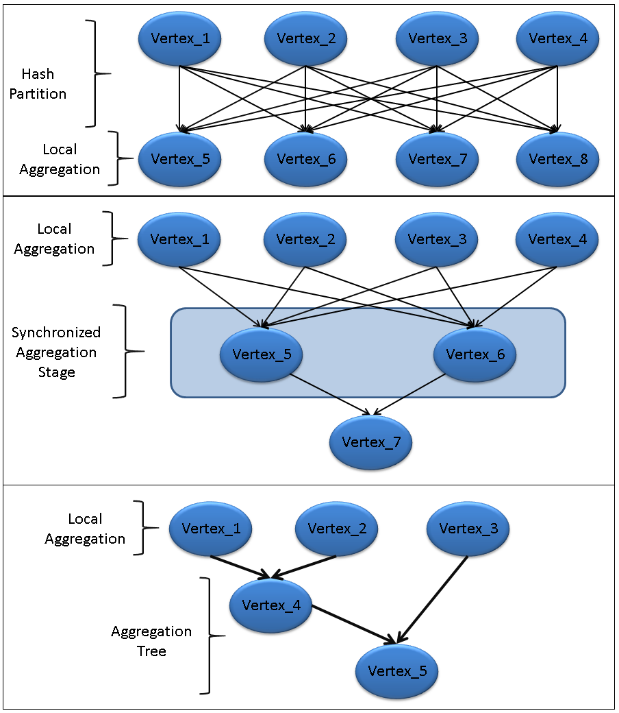

Figure 26: Three Distributed Grouped Aggregation Approaches

DryadLINQ can automatically translate a distributed grouped aggregation query into an optimized aggregation tree based on data locality information. Further, Dryad can adaptively change the structure of the aggregation tree, which greatly simplifies the programming model and enhances its performance.

### Hash Partition

The implementation of PageRank below used *GroupBy* and *Join* operators in DyradLINQ.

**PageRank implemented with GroupBy() and Join()**

for (int i = 0; i < iterations; i++)

{

newRanks = pages.Join(ranks, page => page.source, rank => rank.source,

//join page objects with rank objects where they have the same source url

(page, rank) => page.links.Select(dest =>newRank(dest, rank.value / (double)page.numLinks)))

//calculate the partial rank value for each destination url to which the source url points

.SelectMany(list => list).GroupBy(rank => rank.source)

//group partial rank objects by their url id across a cluster

.Select(group =>newRank(group.Key, group.Select(rank => rank.value).Sum() * 0.85 + 0.15 / (double)_numUrls));

//aggregate partial rank values for each url for final rank values

ranks = newRanks;

}

**Page** objects are used to store the structure of a web graph. Each element **Page** <url_id, <destination_url_list>> contains a unique identifier number page.key and a list of identifiers specifying all pages in the web graph that **page** links to. We construct the DistributedQuery<Page> **pages** objects from adjacency matrix files with function BuildPagesFromAMFile(). The **rank** object <url_id, rank_value> is a pair containing the identifier number of a page and its current estimated rank value. In each iteration the program joins the **pages** with **ranks** to calculate the partial rank values. Basically, it combines records from **pages** and **ranks** tables using a common keyword url_id. Then GroupBy() operator redistributes the calculated partial rank values across cluster nodes and returns the IGrouping objects, DistributedQuery<IGrouping<url_id, rank_value>>, where each IGroup represents a group of partial rank objects with all destination urls from one source URLs. The grouped partial rank values are summed up as the final rank values and are used as input rank values for the next iteration [23].

In the above implementation, GroupBy() operator can be replaced by HashPartition() and ApplyPerPartition() as follows[24]:

**PageRank implemented with HashPartition() and ApplyPerPartition()**

for (int i = 0; i < _iteration; i++)

{

newRanks = pages.Join(ranks, page => page.source, rank =>rank.source,

// join page objects with rank objects where they have the same source url

(page, rank) => page.links.Select(dest =>new Vertex(dest, rank.value / (double)page.numLinks)))

//calculate the partial rank value for each destination url which the source url points to

.SelectMany(list => list).HashPartition(record => record.source)

//hash partition partial rank objects so that the objects with same url are sent to same node

.ApplyPerPartition(list => list.GroupBy(record => record.source))

//group partial rank objects by their url id on local machine

.Select(group =>newRank(group.Key, group.Select(rank =>rank.value).Sum() * 0.85 + 0.15 / (double)_numUrls));

//aggregate grouped partial rank values for each url for final rank values

ranks = newRanks.Execute();

}

### Hierarchical Aggregation

The PageRank implementation using hash partition would not be efficient when the number of output tuples is much less than that of input tuples. In this scenario, we implemented PageRank with hierarchical aggregation, which consists of three synchronized aggregation stages: 1) user-defined Map tasks, 2) DryadLINQ partitions, and 3) final PageRank values. In stage one, each user-defined Map task calculates the partial results of some pages that belong to the sub-web graph represented by the adjacency matrix file. The output of a Map task is a partial rank value table, which is merged into the global rank value table in a later stage.

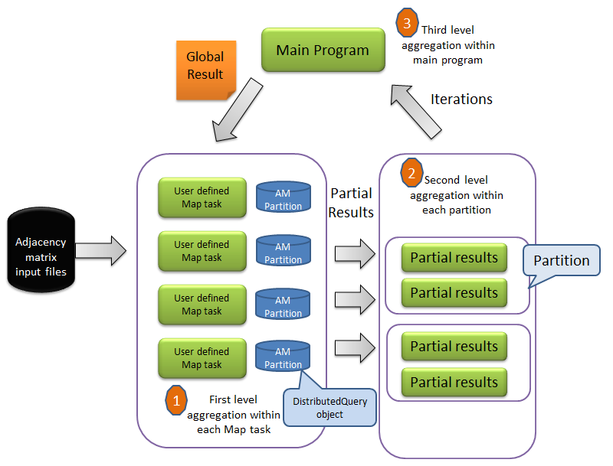

Figure 27: Hierarchical Aggregation in DryadLINQ PageRank

**Hierarchical Aggregation with User Defined Aggregation function**

DistributedQuery<amPartition> webgraphPartitions = Directory.GetFiles(inputDir).AsDistributed().Select(fileName => buildWebGraphPartition(fileName));

//construct partial rank values using adjacency matrixfiles stored in inputDir

for (int i = 0; i < numIteration; i++)

{

DistributedQuery<double[]> partialRVTs = null;

partialRVTs = webgraphPartitions.ApplyPerPartition(subWebGraphPartitions =>

calculateMultipleWebgraphPartitionsWithPLINQ(subWebGraphPartitions, rankValueTable, numUrls));

//calculate partial rank values with user-defined function

rankValueTable = mergeResults(partialRVTs);

//merge calculated parital rank values with user-defined aggregation function

//synchronized step to merge all partial rank value tables

}

### Aggregation Tree

The hierarchical aggregation implementation may not perform well in an inhomogeneous computation environment, which varies in network bandwidth, CPU, and memory capacities. As hierarchical aggregation has several global synchronization stages, the overall performance was determined by the slowest task. In this scenario, the aggregation tree approach is a better choice. It can construct a tree graph to guide the aggregation operations for many subsets of input tuples, which reduces intermediate data transfer. In the ClueWeb data set, URLs are stored in alphabetical order. Web pages that belonged to the same domain were likely being saved within one adjacency matrix file. By applying partial grouped aggregation to each adjacency matrix file in the hash partition stage, intermediate data transfer can be greatly reduced. The following implementation of PageRank uses the GroupAndAggregate() operator.

**PageRank implemented with GroupAndAggregate**

for (int i = 0; i < numIteration; i++)

{

newRanks = pages.Join(ranks, page => page.source, rank =>rank.source,(page, rank) =>

// join page objects with rank objects where they have the same source url

page.links.Select(targetPage =>newRank(targetPage, rank.value / (double)page.numLinks)))

// calculate the partial rank value for each destination url which the source url points to

.SelectMany(list => list).GroupAndAggregate(partialRank =>partialRank.source, g =>

newRank(g.Key, g.Sum(x => x.value)*0.85+0.15 / (double)numUrls));

group calculated partial rank values by the url id and aggregate the grouped partial ranks values

ranks = newRanks;

}

The GroupAndAggregate operator supports optimization of the aggregation tree. To analyze partial aggregation in detail, we simulated GroupAndAggregate with the HashPartition and ApplyPerPartition operators as seen below. There are two steps of ApplyPerPartition: one is to perform pre-partial aggregation on each sub-web graph; the other is to aggregate the partially aggregated results for global results.

**PageRank implemented with two steps of ApplyPerPartition**

for (int i = 0; i < numIteration; i++)

{

newRanks = pages.Join(ranks, page => page.source, rank =>rank.source,

// join page objects with rank objects where they have the same source url

(page, rank) => page.links.Select(dest =>newVertex(dest, rank.value / (double)page.numLinks)))

.SelectMany(list => list)

// calculate the partial rank value for each destination url which the source url points to

.ApplyPerPartition(subGroup => subGroup.GroupBy(e => e.source))

.Select(subGroup =>new Tuple<int, double>(subGroup.Key,subGroup.Select(rank =>rank.value).Sum()))

// group the partial rank objects by their url id on local machine

.HashPartition(e => e.Item1)

.ApplyPerPartition(subGroup => subGroup.GroupBy(e => e.Item1))

// group the partial rank objects by their url id over the cluster

.Select(subGroup =>newRank(subGroup.Key, subGroup.Select(e => e.Item2).Sum() * 0.85 + 0.15 / (double)_numUrls));

// aggregate the grouped partial rank value for each url for final rank values

ranks = newRanks.Execute();

}

## 5.3 Performance Analysis

### Performance in Different Aggregation Strategies

We conducted performance measurements of PageRank with three aggregation approaches: hash partition, hierarchical aggregation, and tree aggregation. In the experiments, we split the entire ClueWeb09 graph into 1,280 partitions, each of which was processed and saved as an adjacency matrix (AM) file. The characteristics of input data are described below:

|  |  |  |  |  |
| --- | --- | --- | --- | --- |
| No of AM Files | File Size | No of Web Pages | No of Links | Ave Out-degree |
| 1,280 | 9.7 GB | 49.5 million | 1.40 billion | 29.3 |

The program ran on 17 compute nodes from the TEMPEST cluster. Figure 28 shows that tree aggregation is faster than hash partition due to the optimization of partial aggregation. Hierarchical aggregation outperforms the other two approaches because of coarse task granularity.

Figure 28: Time to Compute PageRank per Iteration by Three Aggregation Approaches

Using Clue-web09 Data on 17 Compute Nodes of TEMPEST

Figure 29 provides CPU utilization and network utilization information of the three aggregation approaches obtained from the HPC cluster manager. It is apparent that hierarchical aggregation requires much less network bandwidth than the other two.

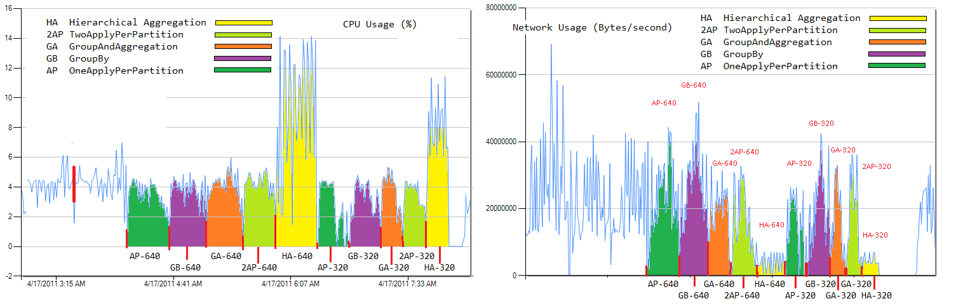

Figure 29 CPU (left) and Network Utilization (right) of Different Aggregation Strategies

The hierarchical aggregation and aggregation tree approaches work well when the number of output tuples was much smaller than input tuples. The hash partition worked well when the number of output tuples was larger than input tuples. To describe how the ratio between input and output tuples affects the performance of different aggregation approaches, we define the data reduction proportion (DRP).

$DRP=\frac{number of output tuples}{number of input tuples}$ (Eq. 6)

|  |  |
| --- | --- |
|  |  |
| Figure 30: Time required for PageRank Jobs for Two Aggregation Approaches with Different DRP | Figure 31: Time Per Iteration for Two Aggregation Approaches with Different Numbers of Output Tuples (from 100,000 to 1,000,000) When the Number of Input Tuples is 4.3 Billion |

Assume M input tuples are evenly distributed among N compute nodes. In a hash partition approach, tuples with the same key are hashed into one group, which requires M aggregation operations. In a partial aggregation approach, the average number of input tuples with the same key is about M/N on each node, which requires M/N aggregation operations on each node and generates N partial aggregated tuples in total. Further, it needs N more aggregation operations to form the final aggregated tuple. Thus, the total number of aggregation operations for the M tuples is (M/N)*N+N. The average number of aggregation operations of each tuple from the two approaches is as follows:

$\left\{\begin{aligned}O\left(\frac{M}{M}\right)=O\left(1\right) \\ O\left(\frac{M+N}{M}\right)=O\left(1+N*DRP\right) \end{aligned}\right.$ (Eq. 7)

In many applications, DRP is much smaller than the number of compute nodes, which suggests that the overhead of applying partial aggregation is small compared to the hash partition. Taking the word count application as an example, documents with millions of words may consist of only several thousand words that occur frequently. Word count is very suitable for applying partial aggregation. In PageRank, as the web graph structure obeys Zipf’s law, DRP is higher. Thus, the partial aggregation approach may not deliver good performance when applied to PageRank [23].

To quantify the impact of DRP on different aggregation approaches, we ran PageRank with web graphs of different DRP values. As shown in Figure 30, when DRP is smaller than 0.017, the partial aggregation performs better than hash partition aggregation. When DRP is bigger than 0.017, there is not much difference between these two aggregation approaches. The results of Figures 30 and 31 indicate the changes in performance when the input tuples are fixed with varying output tuples.

In summary, partial pre-aggregation requires more memory than hash partition; hash partition has larger communication overhead than partial pre-aggregation; and detailed implementation of partial pre-aggregation such as accumulator *fullhash* and iterator *fullhash/fullsort,* has different requirements for memory and network bandwidth.

### Comparison With Other Implementations

We implemented a PageRank application with five runtimes: DryadLINQ, Twister, Hadoop, Haloop, and MPI using ClueWeb data, which is listed in Table 8 of Appendix F. Parallel efficiency T(S)/(P*T(P)) (refer to Eq. 1) is used to compare the performance of five implementations. T(P) stands for job turnaround time of parallel PageRank, where P represents the number of cores. T(S) is the time of sequential PageRank on one core.

Figure 32 shows that all parallel efficiency charts are noticeably smaller than 5%. PageRank is a communication-intensive application, where the computation complexity of PageRank is O(N2) while its communication complexity is O(N2). As the communication overhead per float point calculation of PageRank is high, the bottlenecks of PageRank applications are network, memory, and CPU. Therefore, a major challenge is to reduce synchronization cost among tasks.

MPI, Twister, and Haloop outperform Dryad and Hadoop implementations for the following reasons: 1) MPI, Twister, and Haloop cache static data in memory between iterations; and 2) Haloop uses chained tasks without the need to restart task daemons for each iteration. Dryad is faster than Hadoop, but is slower than MPI and Twister. Dryad can chain DryadLINQ queries together and thereby save in communication cost, but it has higher scheduling overhead for each Dryad vertex. Hadoop has the lowest performance in writing intermediate data to HDFS between interactions.

Figure 32: Parallel Efficiency of Five PageRank Implementations

### Chaining Tasks Within BSP Jobs

Dryad can chain the execution of multiple DryadLINQ queries together using late evaluation technology. The chained DryadLINQ queries will not get evaluated until the program explicitly accesses queries. Figure 33 shows that after chaining DryadLINQ queries, performance increases by 30% for 1280 adjacency matrix files of PageRank over 10 iterations.

Although DryadLINQ chains the execution of queries, it does not support the execution of jobs that consist of Bulk Synchronous Parallel [26] (BSP) style tasks very well. For example, in DryadLINQ hierarchical aggregation PageRank, the program has to be resubmitted to a Dryad job on the HPC scheduler for every synchronization step that calculates the global PageRank value table.

Figure 33: Performance Difference Between Chained and Unchained DryadLINQ Queries

## 5.4 Conclusion:

We investigated three distributed grouped aggregation approaches with DryadLINQ CTP. Programmability and performance of these approaches were studied using the PageRank application. The results show correlations with different ratio of data reduction proportion (DRP).

DryadLINQ supports iterative tasks by chaining the execution of LINQ queries. However, for BSP-style applications that need explicitly to evaluate LINQ query in each synchronization step, it requires resubmission of a Dryad job to the HPC scheduler at each synchronization step, which limits its overall performance.

# 6 Programming Issues in DryadLINQ CTP

## Class Path in Working Directory

We found the following issue when running DryadLINQ CTP SWG jobs: Dryad can automatically transfer files required by a user program to remote working directories on each compute node. In order to save storage space in compute nodes, Dryad does not copy all DLL and shared libraries to working directory for each task. Instead, it stores only one copy of shared libraries in the job working directory shared by all Dryad tasks. When running jobs, the Dryad vertex can add the job working directory into the class path of DryadLINQ program. So all Dryad tasks can refer to DLLs and shared libraries without a problem. However, when Dryad tasks invoke a third party executable binary file as process, the process is not aware of the class path that the Dryad vertex maintains, and it throws out an error : “required file cannot be found.”

## Late Evaluation in Chained Queries within One Job

DryadLINQ can chain the execution of multiple queries by applying late evaluation technology. This mechanism allows further optimization of the execution plan of DryadLINQ queries. As shown in the following code, DryadLINQ queries within different iterations are chained together and will not get evaluated until the Execute() operator is invoked explicitly. The integer parameter “iterations” is supposed to increase by one at each iteration. However, when applying late evaluation, DryadLINQ only evaluates the iterations parameter at the last iteration (which is nProcess -1 in this case) and uses that value for further execution of all the queries including previous iterations. This imposes an ambiguous variable scope issue, which should be mentioned in the DryadLINQ programming guide.

for (int iterations = 0; iterations < nProcesses; iterations++)

{

inputACquery = inputACquery.ApplyPerPartition(sublist => sublist.Select(acBlock => acBlock.updateAMatrixBlockFromFile(aPartitionsFile[acBlock.ci], iterations,nProcesses)));

inputACquery = inputACquery.Join(inputBquery, x => x.key, y => y.key, (x, y) => x.taskMultiplyBBlock(y.bMatrix));

inputBquery = inputBquery.Select(x => x.updateIndex(nProcesses));

}

inputACquery.Execute();

## Serialization for a Two Dimensional Array

DryadLINQ and Dryad Vertex can automatically serialize and unserialize the standard .NET objects. However, when using a two dimensional array, objects in matrix multiplication, and PageRank applications, the program will throw out an error message when a Dryad task tries to access unserialized two dimensional array objects on remote compute nodes. We investigated the serialization code being automatically generated by DryadLINQ and found it may not be able to unserialize two dimensional array objects correctly. The reason for this needs further investigation.

private void SerializeArray_2(Transport transport, double[][]value)

{

if ((value == null)){

transport.Write(((byte)(0)));

return;

}

transport.Write(((byte)(1)));

int count = value.Length;

transport.Write(count);

for (int i=0; (i<count);i=(i+1)){

SerializeArray_4(transport, value[i]);

}

}

# 7 Education Session

Dryad/DryadLINQ has applicability in a wide range of applications in both industry and academia, which include: image processing in WorldWideTeleScope, data mining in Xbox, High Energy Physics (HEP), SWG, CAP3, and PhyloD in bioinformatics applications. An increasing number of graduate students in the computer science department, especially masters students, have shown interest and a willingness to learn Dryad/DryadLINQ in classes taught by Professor Judy Qiu at Indiana University.

In the CSCI B649 Cloud Computing for Data Intensive Science course, 8 Master’s students selected topics related to Dryad/DryadLINQ as a term-long project. The following are three projects completed by the end of the Fall 2010 semester:

1. Efficiency and Programmability of matrix multiplication with DryadLINQ;
2. The Study of Implementing PhyloD application with DryadLINQ;
3. Large Scale PageRank with DryadLINQ

Projects 2 and 3 were accepted as posters at the CloudCom2010 conference hosted in Indianapolis, IN.

In the 2011 Spring semester, two students in CSCI B534 Distributed Systems studied Dryad/DryadLINQ as a term-long project and contributed small, but solid results for this report.

## Concurrent Dryad jobs

These two courses provide an excellent educational setting for us to study how students would utilize a cluster to understand the theories and applications of large-scale computing:

1. Ordinary classes contain 30-40 students, which can form 10 – 15 groups;
2. Student groups do experiments in a simulation environment where each group runs jobs on 1 to 8 compute nodes;
3. Students may not submit jobs until the due date is approaching. In another words, when a deadline is forthcoming, there are many jobs in the queue waiting to be executed while at other times the cluster may be left idle.

Based on the above observations, it is critical to run multiple Dryad jobs simultaneously on a HPC cluster, especially in an educational setting. In the Dryad CTP, we managed to allow each job to reside in a different node group as shown in Figure 34. In this way, a middle-sized cluster with 32 compute nodes can sustain up to 16 concurrent jobs. However, this feature is not mentioned in either Programming or Guides.

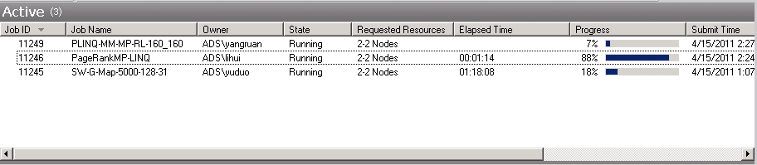

Figure 34: Concurrent Job Execution in the Dryad CTP Version

Although concurrent jobs are enabled, the overall resource utilization of Dryad is not perfect. Figure 35 shows the CPU usage on each node while the jobs execution is displayed in Figure 34. Dryad jobs are assigned to compute node STORM-CN01 through STORM-CN06. Each compute node group contains 2 compute nodes, where only one of the nodes does actual computation. The reason is that every Dryad job requires an extra node acting as a job manager. CPU usage of this particular node is low and seldom exceeds 3%. In a cluster of 8 nodes, the overall usage of three concurrent jobs is only about 37%.

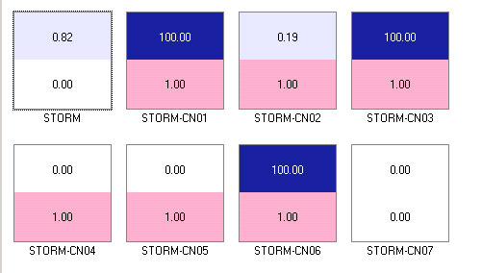

Figure 35: CPU Usage for Concurrent Job Execution

# Acknowledgements

First, we want to thank John Naab and Ryan Hartman for system support of the STORM, TEMPEST and MADRID HPC clusters, which were critical for our experiments. Second, we thank Thilina Gunarathne and Stephen Wu for their generosity in sharing the SWG application and data for our task scheduling analysis. We would also like to thank Ratul Bhawal and Pradnya Kakodkar, two masters students who enrolled in Professor Qiu’s B534 course in Spring 2011 for their small but solid contributions to this report. This work is partially funded by Microsoft.

# References:

G. Bell, T. Hey, and A. Szalay, "Beyond the data deluge," Science, vol. 323, no. 5919, pp. 1297-1298, 2009

1. Jaliya Ekanayake, Thilina Gunarathne, Judy Qiu, Geoffrey Fox, Scott Beason, Jong Youl Choi, Yang Ruan, Seung-Hee Bae, Hui Li. *Applicability of DryadLINQ to Scientific Applications*, Technical Report. SALSA Group, Indiana University. October 16, 2009.
2. Michael Isard, Mihai Budiu, Yuan Yu, Andrew Birrell, Dennis Fetterly. (2007). *Dryad: distributed data-parallel programs from sequential building blocks*. SIGOPS Oper. Syst. Rev. 41(3): 59-72.
3. Yu, Y., M. Isard, Fetterly, D., Budiu, M., Erlingsson, U., Gunda, P.K., J., Currey. (2008). *DryadLINQ: A System for General-Purpose Distributed Data-Parallel Computing Using a High-Level Language*. Symposium on Operating System Design and Implementation (OSDI). San Diego, CA.
4. Hui Li, Yang Ruan, Yuduo Zhou, Judy Qiu and Geoffrey Fox, Design Patterns for Scientific Applications in DryadLINQ CTP, to appear in Proceedings of The Second International Workshop on Data Intensive Computing in the Clouds ( DataCloud-2) 2011, The International Conference for High Performance Computing, Networking, Storage and Analysis (SC11), Seattle, WA, November 12-18, 2011
5. Gotoh, O. (1982). *An improved algorithm for matching biological sequences*. Journal of Molecular Biology 162: 705-708.
6. *DryadLINQ and DSC Programmers Guilde*. Microsoft Research. 2011
7. Seung-Hee Bae, Jong Youl Choi, Judy Qiu, Geoffrey C. Fox,. (2010). *Dimension reduction and visualization of large high-dimensional data via interpolation*. Proceedings of the 19th ACM International Symposium on High Performance Distributed Computing. Chicago, Illinois, ACM: 203-214.
8. Batzer MA and Deininger PL (2002). *Alu repeats and human genomic diversity*. Nature Reviews Genetics 3(5): 370-379.
9. *JAligner*. Retrieved December, 2009, from http://jaligner.sourceforge.net.
10. Smith, T. F. and M. S. Waterman (1981). *Identification of common molecular subsequences*. Journal of Molecular Biology 147(1): 195-197.
11. Johnsson, S. L., T. Harris, K. K. Mathur. 1989, *Matrix Multiplication on the connection machine*. Proceedings of the 1989 ACM/IEEE conference on Supercomputing. Reno, Nevada, United States, ACM.
12. Geoffrey Fox, Tony Hey and Steve Otto, *Matrix algorithms on a hypercube I: Matrix multiplication*, parallel computing, pp. 17-31, 1987.
13. Fox, G. C., *What Have We Learnt from Using Real Parallel Machines to Solve Real Problems*. Third Conference on Hypercube Concurrent Computers and Applications. G. C. Fox, ACM Press. 2: 897-955. 1988.
14. Daan Leijen and Judd Hall (2007, October). *Parallel Performance: Optimize Managed Code For Multi-Core Machinesl*. Retrieved November 26, 2010, from http://msdn.microsoft.com/en-us/magazine/cc163340.aspx.
15. Jaliya Ekanayake (2010). *Architecture and Performance of Runtime Environments for Data Intensive Scalable Computing*. School of Informatics and Computing. Bloomington, Indiana University.
16. Argonne National Laboratory. *MPI Message Passing Interface*. Retrieved November 27, 2010, from http://www-unix.mcs.anl.gov/mpi
17. Apache Hadoop. Retrieved November 27, 2010, from <http://hadoop.apache.org/>.
18. Yingyi Bu, Bill Howe, Magdalena Balazinska, Michael D. Ernst,. (2010). *HaLoop: Efficient Iterative Data Processing on Large Clusters*. The 36th International Conference on Very Large Data Bases. Singapore, VLDB Endowment. 3.
19. J.Ekanayake, H.Li, B.Zhang, T.Gunarathne, S.Bae, J.Qiu, G.Fox. *Twister: A Runtime for iterative MapReduce*. Proceedings of the First International Workshop on MapReduce and its Applications of ACM HPDC 2010 conference June 20-25, 2010. Chicago, Illinois, ACM.
20. Ekanayake, J., S. Pallickara, Shrideep, Fox, Geoffrey. *MapReduce for Data Intensive Scientific Analyses*. Fourth IEEE International Conference on eScience, IEEE Press: 277-284. 2008.
21. ClueWeb Data: http://boston.lti.cs.cmu.edu/Data/clueweb09/
22. PageRank wiki: http://en.wikipedia.org/wiki/PageRank
23. Y. Yu, M. Isard, D.Fetterly, M. Budiu, U.Erlingsson, P.K. Gunda, J.Currey, F.McSherry, and K. Achan. Technical Report MSR-TR-2008-74, Microsoft.
24. Yu, Y., P. K. Gunda, M. Isard. (2009). *Distributed aggregation for data-parallel computing: interfaces and implementations*. Proceedings of the ACM SIGOPS 22nd symposium on Operating systems principles. Big Sky, Montana, USA, ACM: 247-260.
25. BSP, Bulk Synchronous Parallel <http://en.wikipedia.org/wiki/Bulk_Synchronous_Parallel>

# Appendix

#### Appendix A

STORM Cluster

8-node inhomogeneous HPC R2 cluster

|  |  |  |  |  |  |  |  |  |
| --- | --- | --- | --- | --- | --- | --- | --- | --- |
|  | STORM | STORM-CN01 | STORM-CN02 | STORM-CN03 | STORM-CN04 | STORM-CN05 | STORM-CN06 | STORM-CN07 |
| CPU | AMD 2356 | AMD 2356 | AMD 2356 | AMD 2356 | AMD 8356 | AMD 8356 | Intel E7450 | AMD 8435 |
| Cores | 8 | 8 | 8 | 8 | 16 | 16 | 24 | 24 |
| Memory | 16G | 16G | 16G | 16G | 16G | 16G | 48G | 32G |
| Mem/Core | 2G | 2G | 2G | 2G | 1G | 1G | 2G | 1.33G |
| NIC (Enterprise) | N/a | N/a | N/a | N/a | N/a | N/a | N/a | N/a |
| NIC (Private) | BCM5708C | BCM5708C | BCM5708C | BCM5708C | BCM5708C | BCM5708C | BCM5708C | BCM5708C |

#### Appendix B

TEMPEST Cluster

33-node homogeneous HPC R2 cluster

|  |  |  |
| --- | --- | --- |
|  | TEMPEST | TEMPEST-CNXX |
| CPU | Intel E7450 | Intel E7450 |
| Cores | 24 | 24 |
| Memory | 24.0GB | 50.0 GB |
| Mem/Core | 1 GB | 2 GB |
| NIC (Enterprise) | HP NC 360T | n/a |
| NIC (Private) | HP NC373i | HP NC373i |
| NIC (Application) | Mellanox IPolB | Mellanox IPoIB |

#### Appendix C

MADRID Cluster

9-node homogeneous HPC cluster

|  |  |  |
| --- | --- | --- |
|  | MADRID-HEADNODE | MADRID-10X |
| CPU | AMD Opteron 2356 2.29GHz | AMD Opteron 8356 2.30GHz |
| Cores | 8 | 16 |
| Memory | 8GB | 16GB |
| Memory/Core | 1GB | 1GB |
| NIC | BCM5708C | BCM5708C |

#### Appendix D

Binomial fitting function for sequential SWG jobs

$$Seq\left(x\right)=0.0201x^{2}-0.1828x+4.6609 \\ R^{2}=1$$

#### Appendix E

Trinomial fitting chart for sequential matrix multiplication jobs

#### Appendix F

Tables mentioned in the report.

Table 1: Execution Time for Various SWG Partitions on Tempest Cluster

|  |  |  |  |  |  |  |  |  |  |  |
| --- | --- | --- | --- | --- | --- | --- | --- | --- | --- | --- |
| **Partition Number** | **31** | **62** | **93** | **124** | **248** | **372** | **496** | **620** | **744** | **992** |
| **Test 1** | 1324.54 | 1345.41 | 1369.01 | 1379.01 | 1761.09 | 1564.79 | 1866.14 | 2280.37 | 2677.57 | 3578.50 |
| **Test 2** | 1317.45 | 1356.68 | 1386.09 | 1364.43 | 1735.46 | 1588.92 | 1843.70 | 2286.76 | 2736.07 | 3552.58 |
| **Test 3** | 1322.01 | 1348.89 | 1368.74 | 1384.87 | 1730.47 | 1568.59 | 1857.00 | 2258.25 | 2709.61 | 3568.21 |
| **Average** | **1321.33** | **1350.33** | **1374.61** | **1376.10** | **1742.34** | **1574.10** | **1855.61** | **2275.13** | **2707.75** | **3566.43** |

Table 2: Execution Time for Skewed and Randomized Data

|  |  |  |  |  |  |  |
| --- | --- | --- | --- | --- | --- | --- |
| **Std. Dev.** | **1** | **50** | **100** | **150** | **200** | **250** |
| **Skewed** | 2582 | 3076 | 3198 | 3396 | 3878 | 4488 |
| **Randomized** | 2582 | 2489 | 2458 | 2413 | 2498 | 2622 |

Table 3: Average Execution Time of Tempest

|  |  |  |  |  |  |
| --- | --- | --- | --- | --- | --- |
| **No. of Nodes** | **Input length** | | | | |
| **5000** | **7500** | **10000** | **12500** | **15000** |
| **1** | 13854.71 | 31169.03 | 55734.36 | 89500.57 | 131857.4 |
| **32** | 550.255 | 1096.925 | 1927.436 | 3010.681 | 4400.221 |
| **Parallel**  **Efficiency** | **81.22%** | **91.66%** | **93.28%** | **95.90%** | **96.66%** |

Table 4: Execution Time and Speed-up for SWG on Tempest with Varied Size of Compute Nodes

|  |  |  |  |  |  |  |
| --- | --- | --- | --- | --- | --- | --- |
| **Num. of Nodes** | **1** | **2** | **4** | **8** | **16** | **31** |
| **Average Execution Time** | 55734.36 | 27979.78 | 14068.49 | 7099.70 | 3598.99 | 1927.44 |
| **Relative Speed-up** | 1 | 1.99 | 3.96 | 7.85 | 15.49 | 28.92 |

Table 5: Blocks Assigned to Each Compute Node

|  |  |  |  |  |  |  |
| --- | --- | --- | --- | --- | --- | --- |
| **Node Name** | **Partition Number** | | | | | |
| **6** | **12** | **24** | **48** | **96** | **192** |
| **STORM-CN01** | 687 | 345 | 502 | 502 | 549 | 563 |
| **STORM-CN02** | 681 | 683 | 510 | 423 | 547 | 575 |
| **STORM-CN03** | 685 | 684 | 508 | 511 | 548 | 571 |
| **STORM-CN04** | 688 | 685 | 689 | 775 | 599 | 669 |
| **STORM-CN05** | 667 | 681 | 685 | 679 | 592 | 635 |
| **STORM-CN06** | 688 | 1018 | 1202 | 1206 | 1261 | 1083 |

Table 6 Characteristic of PageRank input data

|  |  |  |  |  |
| --- | --- | --- | --- | --- |
| No of am files | File size | No of web pages | No of links | Ave out-degree |
| 1280 | 9.7GB | 49.5million | 1.40 billion | 29.3 |

Table 7 DRP of different number of AM files of three aggregation approaches

|  |  |  |  |
| --- | --- | --- | --- |
| Input size | hash aggregation | partial aggregation | hierarchical aggregation |
| 320 files 2.3G | 1: 306 | 1:6.6:306 | 1:6.6:2.1:306 |
| 640 files 5.1G | 1: 389 | 1:7.9:389 | 1:7.9:2.3:389 |
| 1280 files 9.7G | 1: 587 | 1:11.8:587 | 1:11.8:3.7:587 |

Table 8: Job turnaround time for different PageRank implementations

|  |  |
| --- | --- |
| **Parallel Implementations** | **Average job turnaround time for 3 runs** |
| MPI PageRank on 32 node Linux Cluster (8 cores/node) | 101 sec |
| Twister PageRank on 32 node Linux Cluster (8 cores/node) | 271 sec |
| Haloop PageRank on 32 node Linux Cluster (8 cores/node) | 1954 sec |
| Dryad PageRank on 32 node HPC Cluster (24 cores/node) | 1905 sec |
| Hadoop PageRank on 32 node Linux Cluster (8 cores/node) | 3260 sec |
| **Sequential Implementations** |  |
| C PageRank on Linux OS (use 1 core) | 831 sec |
| Java PageRank on Linux OS (use 1 core) | 3360 sec |
| C# PageRank on Windows Server (use 1 core) | 8316 sec |

Table 9: Parallel Efficiency of Dryad CTP and Dryad 2009 on same input data

|  |  |  |  |  |  |
| --- | --- | --- | --- | --- | --- |
| **Dryad CTP** | | | | | |
| **# of Nodes** | **Input size** | | | | |
| **5000** | **7500** | **10000** | **12500** | **15000** |
| **7 Nodes** | 2051 | 4540 | 8070 | 12992 | 18923 |
| **1 Node** | 13855 | 31169 | 55734 | 89501 | 131857 |
| **Parallel**  **Efficiency** | **96.50%** | **98.07%** | **98.66%** | **98.41%** | **99.54%** |
| **Dryad 2009** | | | | | |
| **# of Nodes** | **Input size** | | | | |
| **5000** | **7500** | **10000** | **12500** | **15000** |
| **7** | 2523 | 5365 | 9348 | 14310 | 20615 |
| **1** | 17010 | 36702 | 64141 | 98709 | 142455 |
| **Parallel**  **Efficiency** | **96.31%** | **97.73%** | **98.02%** | **98.54%** | **98.72%** |

Table 10: Execution Time for SWG with Data Partitions

|  |  |  |  |  |  |  |  |  |  |
| --- | --- | --- | --- | --- | --- | --- | --- | --- | --- |
| **Number of Partitions** | **6** | **12** | **24** | **36** | **48** | **60** | **72** | **84** | **96** |
| **Execution Time 1** | 1105 | 1135 | 928 | 981 | 952 | 1026 | 979 | 1178 | 1103 |
| **Execution Time 2** | 1026 | 1063 | 868 | 973 | 933 | 1047 | 968 | 1171 | 1146 |
| **Execution Time 3** | 1030 | 1049 | 861 | 896 | 918 | 1046 | 996 | 1185 | 1134 |
| **Execution Time 4** | 1047 | 1060 | 844 | 970 | 923 | 1041 | 985 | 1160 | 1106 |
| **Average Time** | **1052** | **1076** | **875** | **955** | **931** | **1040** | **982** | **1173** | **1122** |
| **Speed-Up** | 79.78688 | 77.95291 | 95.89923 | 87.89089 | 90.10821 | 80.7075 | 85.47434 | 71.52603 | 74.79243 |