Advantages to Geoscience and Disaster Response from the QuakeSim Implementation of Interferometric Radar Maps in a GIS Database System.
Jay Parker (1), Andrea Donnellan (1), Margaret Glasscoe (1), Geoffrey Fox (2), Jun Wang (2), Marlon Pierce (2), Yu Ma(2)
(1) Jet Propulsion Laboratory, California Institute of Technology, 4800 Oak Grove Drive, Pasadena, CA 91109, USA (email: Jay.W.Parker@jpl.nasa.gov; phone: +1-818-354-6790; fax: +1-818-393-4965)
(2) Indiana University, 2719 East 10th Street, Bloomington, IN 47408, USA
© 2013. All rights reserved.
Short title: Advantages from Implementation of Radar Maps in GIS System
Abstract:
High-resolution maps of earth surface deformation are available in public archives for scientific interpretation, but primarily as bulky downloads. The NASA UAVSAR archive of airborne radar interferograms delivers very high resolution (approximately seven meter ground pixels) and so makes problems of remote file handling the more pressing. Data exploration, requiring data selection and exploratory analysis have been tedious. QuakeSim has implemented an archive of UAVSAR data in a web service and browser system based on GeoServer (http://geoserver.org). This supports a variety of services that supply consistent maps, raster image data, and GIS objects including standard earthquake faults. Browsing the database is supported by initially displaying GIS-referenced thumbnail images of the radar displacement maps. Access is also provided to image metadata and links for full file downloads, when desired. One of the most widely used features is the QuakeSim Line-Of-Sight profile tool, which calculates the radar-observed displacement (from an unwrapped interferogram product) along a line specified through a web browser. Displacement values along a profile are updated to a plot on the screen as the user interactively redefines the endpoints of the line and the sampling density. The profile and also a plot of the ground height are available as ascii text files for further examination, without any need to download the full radar file. Additional tools allow the user to select a polygon overlapping the radar displacement image, specify a downsampling rate, and extract a modest sized grid of observations for display or for inversion, for example with the QuakeSim Simplex inversion tool which estimates a consistent fault geometry and slip model.
Keywords: radar interferometry, disaster response, earthquakes, geographic information systems (GIS)
1.Introduction
Interpretation of geodetic measurements and images is an international activity. Hazardous local expressions of tectonic movements include earthquakes, volcanic eruptions and landslides. All of these expressions have a catastrophic phase that is preceded by a slow subtle build up which in many cases can be characterized by detectable deformation at the Earth’s surface, revealed in geodetic images such as interferometric radar. Post-event deformation is important to monitor, as it may give warning of secondary effects such as triggered earthquakes, landslides, or localized strain that can damage regional infrastructure such as bridges and dams. Applications may be broadly categorized as geoscience (providing insight in the physical processes causing the deformation) and disaster response (developing a risk reduction strategy based on accumulated geodetic information and infrastructure maps).
Repeat-pass interferometry from air or space produces high-resolution maps of surface deformation, a rich source of precision measurements that can distinguish models of underground sources including volcanic inflation and earthquake processes. But with typical data archives of hundreds to thousands of files, describing maps that exceed 100 megapixels and contain multiple gigabytes of data, systems must be developed that enable visual browsing of available images and preliminary detailed examination of subsets of images without full-file downloads, particularly from mobile platforms in times of crisis. Such a system should also support Geographical Information Systems (GIS) operations so that for example InSAR data profiles can be compared to local infrastructure locations. NASA’s QuakeSim project aims to bring together geodetic benchmark (GPS) data, geodetic mapped images based on interferometric radar, and other data into a public web environment that includes interpretive tools. These tools include stress-strain models, pattern analysis, fault models, and forecast probability maps, and fault slip estimation based on inversion of surface deformation, all integrated in an interactive map-overlay display.
The largest data set available through QuakeSim is the collection of interferograms collected by UAVSAR (Unpiloted Aerial Vehicle - Synthetic Aperture Radar), a NASA L-band imaging radar carried under a Gulfstream III Aircraft [Rosen et al, 2006]. New data are accumulating as the project proceeds, indicating need for an automated update process. As of October 2013 there are over 400 strip images of data (roughly 20 x 100 km in extent) which have been made available, frequently overlapping each other when displayed on a map, sometimes ten strips covering a given point on the ground. Spatially coincident strips are distinguished by the pairs of collection times and the aircraft viewing direction. So selecting a strip of interest with a map tool is unwieldy; displaying strip metadata in a table has also proved unhelpful.
Early users of UAVSAR data attempted to download all the data that appear remotely useful, so as to explore and identify promising strips using local tools. But as data piles up, the download times become prohibitive; even one strip with associated data is painful to download to a mobile device or across a limited wireless connection.
In order to support interpretation, even at the early exploration stage, radar images must be displayed with georeferenced features such as faults, seismicity and regional infrastructure as optional layers on a common map.
2.UAVSAR
The UAVSAR system uses a GPS-guided flight technique to precisely revisit a past flight track [Hensley et al, 2005], and so create a high definition georeferenced interferogram (with pixel size roughly 7 m) that represents the change in the terrain between the repeat visits, typically months apart. Repeat-pass interferograms are common products for orbital platforms, but the necessary flight precision is much harder to attain for aircraft due to winds and turbulence. Another system demonstrating comparable ability is the E-SAR of the German Aerospace Center (DRL) [de Macedo et al, 2008]. The UAVSAR interferogram products include georegistered data images of the unwrapped interferogram (which measures the surface deformation toward the radar), a complex-valued "wrapped" interferogram, the correlation (an indicator of pixel data quality) [Hensley et al., 2009], the digital elevation map (DEM) used in processing, and the reflectivity map for each pass. Additional helpful products include Keyhole Markup Language (KML) images of each data type at full and reduced resolution. Typical deformation image files may be 120 MB, sensitive enough to detect fault slip at sub-cm levels.

2.1 El Mayor Cucapah M7.2 April 4 2010 event
In order to capture deformation due to an earthquake, a flight path must be established and data collected in an initial flight before the main shock; hence it is a matter of earthquake forecasting and a degree of luck. The first such event captured by UAVSAR is the EL Mayor-Cucapah M7.2 earthquake, which occurred in Baja California Norte, Mexico, April 10, 2010, nearly seven months after data collection along a strip at the southern edge of California (USA) on October 21, 2009. UAVSAR was tasked to collect repeat-pass data April 13, 2010, nine days after the April 4 event. Although the rupture was in Mexico, the resulting deformation map of the strip across the border reveals surface motion as high as 80 cm away from the radar’s point of view. [Fig 1a]. A closer look shows regions of offset in the fringe pattern, indicating slip on previously unknown faults, most approximately perpendicular to the main rupture. [Fig1b].
a)
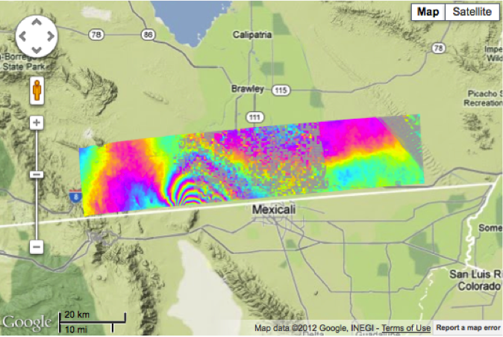
b)
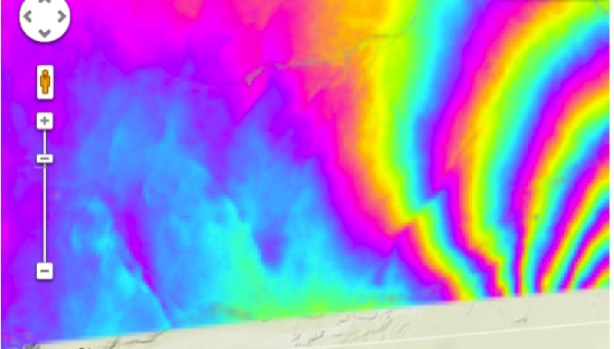
Figure 1 a) QuakeSim map-based display of El Mayor-Cucapah coseismic deformation viewed by UAVSAR. One cycle of color indicates 12 cm deformation with respect to the radar point of view. Rapidly changing color region indicates 80 cm deformation (radar direction) at south edge of image. b) Zoom of Figure 1a image centered west of rapidly changing color region. Several dislocations appear in this image, some trending northwest, others northeast.
2.2 Semi-global image set
UAVSAR flights have been concentrated in California due to its susceptibility to damaging earthquakes, but images available through Quakesim [Donnellan et al, 2012a, Donnellan et al, 2012b; http://quakesim.org] cover volcanic regions of the Pacific Northwest, Alaska, Hawaii, Central America and Iceland. Slow landslide features may be found in images of Colorado [Delbridge et al, 2012] as well as California. Other data collections focus on more specialized science objectives, such as monitoring subsidence in the islands of the Sacramento-San Joaquin Delta of California [Jones et al, 2011].
A key part of the science process is the data exploration phase. Most often the investigator seeks images indicating a particular kind of deformation, such as fault dislocations or landslides. This requires careful examination of images, with location of known structures and times of collection in view. Usually it takes a skilled eye to determine if seeming deformation is due to the process of interest, or some interfering feature such as subsidence or image distortion from atmospheric water, in which a local change in atmospheric refractive index may masquerade as a deformation of the reflecting surface. Background information such as fault locations or hillside slope helps exploration, such as indicating whether to mark a strip of image data for download and further analysis.
2.3 Data transfer times drive need for subletting, cross-sections
When an image is selected for further analysis, including download to a local platform for detailed study with specialized tools, more than the deformation image is usually needed. A typical case required 7 GB for a complete data image including layers such as correlation data. Such a complete download requires 1.5 hours for typical 1 MB/s link. Often a wireless link will be much slower perhaps 70 kB/s: in that case a prohibitive 1 day is necessary. A GIS database system helps in two main ways: first, the user may request one pixel to represent a local block of pixels (downsampling the image, either by averaging or by selecting the center pixel). Second, the user may specify a KML polygon, so that the script will return only pixels within that polygon. Such reductions in data transfer drastically reduce the time to download a partial image. These reduced-information images are also suited for inversions that estimate the amount and character of slip on a fault based on a deformation map: reducing pixels from 120 million to ten thousand makes little difference in the final estimate, but makes the computation time far more tractable.
3. GIS database web service
QuakeSim has developed an interface and tools for exploration and rapid analysis of geodetic imaging data that relies on a GIS server with database management. Currently this implementation uses GeoServer [Deoliveira, 2008, Xia et al, 2009; http://geoserver.org], which publishes UAVSAR images in GeoTiff format (as a first instance) and metadata in a PostgreSQL database. Ideally such a system can be mirrored at several sites, optimally located at or near a major data archive, and replicated with modification to serve the needs of a specialized community or research group. Today the QuakeSim GIS server is a centralized resource, chiefly available through requests created by the QuakeSim browser interface, for example when the user makes a mouse cursor click on a map [Wang et al, 2012]. GeoServer is advantageous because it is an open, standard-conforming, community effort that has attained stability. It is designed to manage geospatial data, including subsetting operations. It is well suited for controlling a database such as the PostgreSQL database that holds the UAVSAR and other data in the QuakeSim implementation. It is designed for web service connections, for display and computing. Customized functions and control are written for QuakeSim in JavaScript.
3.1 Application to E-DECIDER
The NASA E-DECIDER (Earthquake Data Enhanced Cyber-Infrastructure for Disaster Evaluation and Response [Glasscoe et al, 2011, http://e-decider.org] project provides mapped geospatial data and data products through web services for decision support and disaster response. Its intended users are government agencies and first responders.
E-DECIDER uses some QuakeSim resources such as its UAVSAR image interface and elastic models, and also includes optical geodetic imaging, tilt and deformation gradient., It also incorporates HAZUS data, developed by the Federal Emergency Management Agency for estimating disaster loss, including “what if” scenario earthquakes.
The GIS server approach provides advantages for E-DECIDER users, beginning with built-in tools that can translate GIS representations of data and data products to common formats such as Keyhole Markup Language (KML), compatible with commonly used map layering interfaces such as Google Earth and Google Maps. Such a system assembles layers with familiar map-based displays and supplies that interactive view via web services. HAZUS GIS integration supplies many views of infrastructure and land use; in fact it is straightforward to integrate any kind of GIS information, so long as it is OGC-standard compliant. . Figure 2 illustrates three varieties of local infrastructure and valuation freely available as GIS data and supported in the GIS server system.
a) b)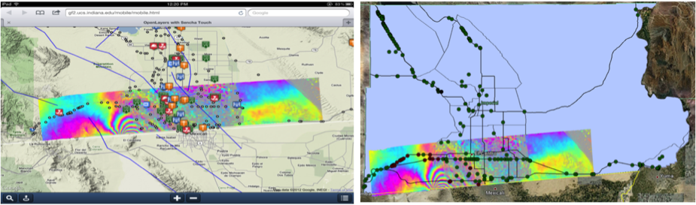
c)
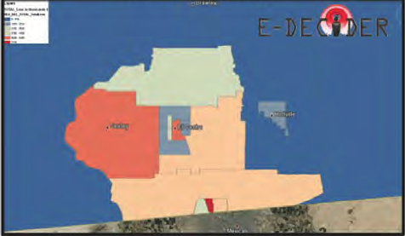
Figure 2a: UAVSAR deformation image combined with local faults and facilities locations such as fire stations, police. 2b: Deformation image combined with roads, bridges in Imperial County. 2c: Districts colored by the estimated damage from earthquake based on HAZUS data.
3.2 Advantages realized in QuakeSim, E-DECIDER
Both QuakeSim and E-DECIDER have found common advantages in the GIS server. The most obvious is the ability to provide coordinated content in a browser map environment. Users can select any available layers, change view, and capture the produced content as an image or derived data table. The database interface is programmed to examine data sources and update itself when those have new or modified data; the centralized design means all users see the same synchronized set of data. Similarly the system has one central arbiter of quality control The system supports multiple data access modes, such as discovering data by location or by metadata features. New data and images can be made equally available to all. While internal data images are in GeoTIFF, the data is distributed with multiple service protocols including KML, GeoJSON, WMS (Web Map Service), WFS (Web Feature Service) and WCS (Web Coverage Service). The goal is to produce a range of standards-compliant GIS products for different types of user groups. With a software as a service model, complex GIS processing and domain-specific analysis tools are more accessible for general users.
3.3 The QuakeSim GeoServer processes
The workflow of importing a new interferogram is initialized through product release notification from JPL’s UAVSAR team or by users requests on specific images. The new repeat-pass interferogram (RPI) products may be an updated version of the existing images, or a customized product by users specific requests. QuakeSim adopts a simple version control system that enables all versions to be available, and each version has its own annotation files to record the processing parameters.
QuakeSim geoprocessing handles data format conversion and metadata processing. RPI products are stored as single band binary file (Figure 3). The first step of data conversion is to generate a header file by extracting image projection parameters from the annotation file; GeoTiff is created with the Geospatial Data Abstraction Library (GDAL, http://www.gdal.org). Metadata processing enables georeferencing and interferogram interpretation. The last step is to extract a tight bounding box to build a spatial index for UAVSAR images. GeoTiff images are registered directly with GeoServer; bounding box and metadata, which are stored in geospatial database (PostGreSQL/PostGIS, http://postgis.net/), are then published through GeoServer.
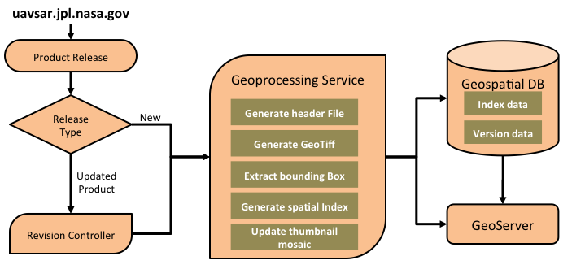
Figure 3: The QuakeSim UAVSAR product workflow. Product releases from uavsar.jpl.nasa.gov are detected and processed by the Geoprocessing Service, producing value-added entries in the Geospatial Database managed by GeoServer.
3.4 Task division
GeoServer provides various GIS core capabilities using Open Geospatial Consortium standards (OGC; www. opengeospatial.org/standards), including Web Map Service (WMS), Web Feature Service (WFS), Web Coverage Service (WCS) and Web Processing Service (WPS). QuakeSim has built a web service API layer to extend these generic interfaces to meet the specific needs of on-line QuakeSim/E-DECIDER applications. Through the web service layer, web developer can directly access the following functionality as building blocks powered by GeoServer through simple URL calls:
- Displaying thumbnails and high-resolution UAVSAR images on Google Maps and other on-line mapping service.
- Performing spatial queries on various data layers published through GeoServer, such as UAVSAR images, faults system and critical infrastructures. Users are able to query data by point, line, polygon and rectangle regions.
- Providing data access in native or other data format, such as KML/KMZ, GeoJSON for different applications.
- Extracting pixel values from UAVSAR Images by location (longitude, latitude); this enables users to investigate line-of-sight displacements through QuakeSim’s InSAR profile tool.
- Generating dynamic web contents for QuakeTables (QuakeSim's data inventory). Users can browse through large amount of UAVSAR data and fault collections from QuakeTables’ on-line interface.

4. Discussion: User experience
For a typical user exploring the data, say for evidence of an aseismic fault slip, the TOOLS: INSAR PROFILES menu on the QuakeSim page brings up a map with many colorful strips. As a typical application, after zooming to the region around California’s Salton Sea (in the far south), the user clicks on one of the strips. Usually a table with perhaps ten interferograms appears at right, showing the pairs of acquisition dates. Selecting any one of these items results in a zoomed image of that deformation map. The table remains available for rapid browsing of all the strips represented in the table. Once the user finds an image of interest, clicking on that image brings up two icons, a red and a blue dropper indicating the endpoints of a profile line. The user moves these to desired endpoints, as the display shows scattered point plots of the deformation (Ground Range Change) and the Topographic Height, based on a public Digital Elevation Map. Options at right allow precise positioning of the endpoints (either by Lat/Lon coordinate or by precise azimuth and distance from the first point) and the frequency of sampling (Sampling Distance (meters)). The Toggle Fault Display option allows fault traces from a local model to be displayed along with the image.
Below each scatter plot a link labeled "Download LOS Data" instantly downloads the numeric values which produced the plot [Fig 4]. By saving the values each time and adjusting endpoints, the user may perform more complex analysis, such as accumulating cross sections along parallel lines.

a)
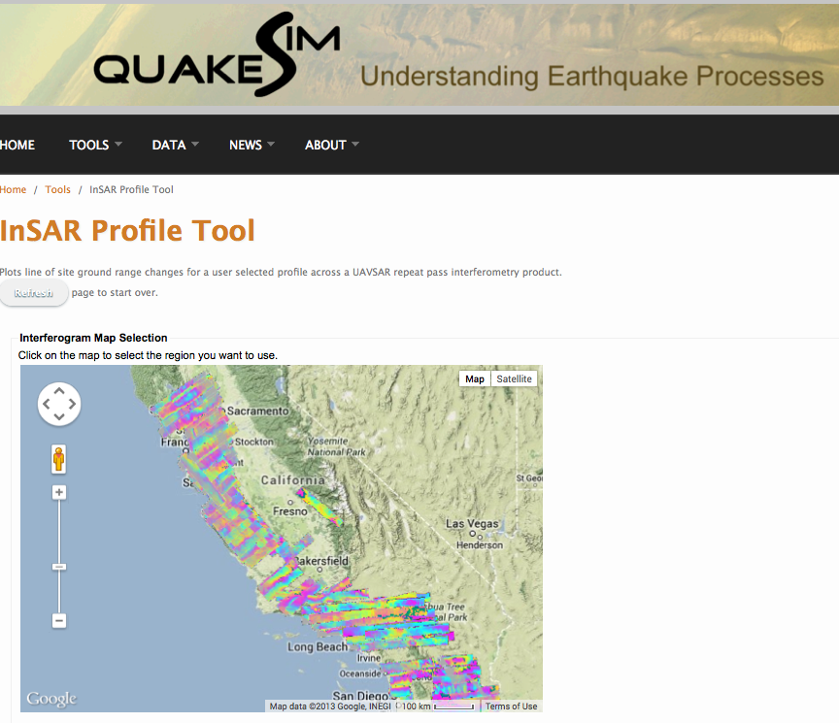
b)
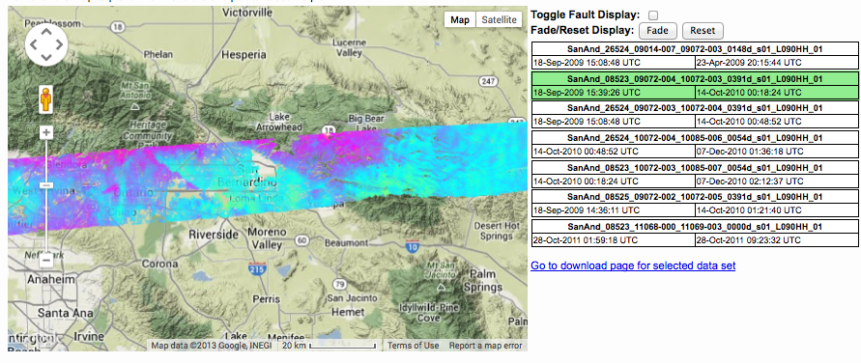

c)
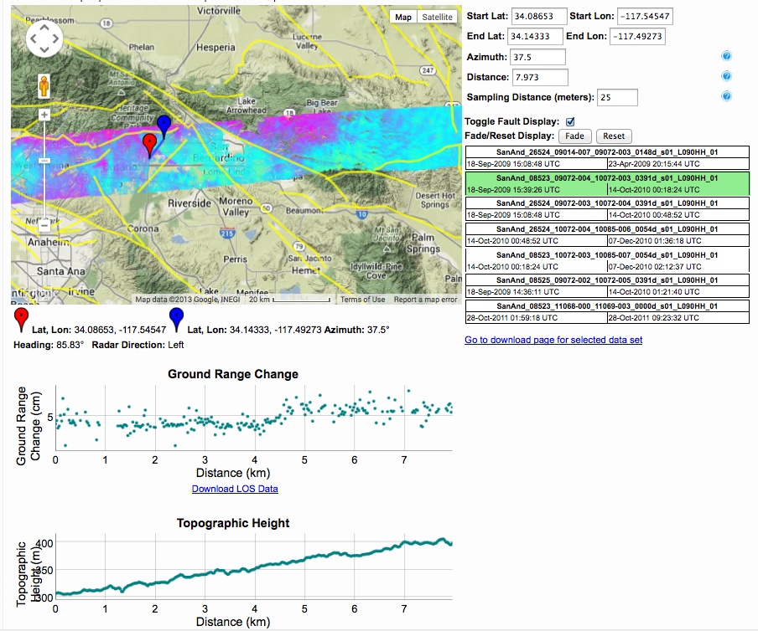

Figure 4: InSAR profile tool, QuakeSim. a) Web map display of strips of available UAVSAR interferogram data, each strip at thumbnail resolution for speed of display updates. GeoServer translates user mouse click on map to b) list of interferograms (all that share the selected geographic point) shown in table at right. Mouse selection of one table item results in single interferogram display on map. When user arranges blue and red endpoints on the map GeoServer translates that to c) graph of InSAR Line of Sight displacement values, next to plot of Height values (from DEM) along same path. The user may set the sampling distance (a measure of resolution; larger sampling distance speeds the response). Below plots are links that trigger downloading the data behind the plot in tabular form.
5. Future development
Geodetic analysis suggests several kinds of mathematical functions of image data which could be coded as applications available to the user. For example the ability to downsample 2-d pixelated data and restrict the domain to a user-specified polygon interior could be made a stand-alone function, or tied with QuakeSim’s Simplex inversion tools. Interpolation of GPS deformation and InSAR deformation images could be supported.
Additional data types could be stored in the database and served in helpful ways. QuakeSim could store available regional water vapor maps, and profiles of water vapor path delay could be created along the same user-specified line, for comparison with UAVSAR data profiles (if the two show the same feature, it’s probably water vapor, not surface deformation).
6. Conclusion
A GIS database and server is clearly a suitable way to store georeferenced data, including InSAR, but this has not previously been utilized in a public environment. Modern GIS databases bring invaluable extras to a system: translation to KML and other data types that can be viewed and compared by a discipline-based community or a research group. Such a system provides a clean way to break the data transfer bottleneck during exploration and quick analysis; full data download is also supported after exploration indicates a need. One useful implementation is the GeoServer-based system that supports the QuakeSim and E-DECIDER programs including public web-based interactive tools on the Web. Public data providers and private research environments may practically deploy similar systems to provide lightweight data exploration and initial analysis through a GIS database system with map overlay web services.
Acknowledgments
The research was carried out at the Jet Propulsion Laboratory, California Institute of Technology, under a contract with the National Aeronautics and Space Administration.
References
de Macido , KAC., Scheiber, R., Moreira, A., "An Autofocus Approach for Residual Motion Errors With Application to Airborne Repeat-Pass SAR Interferometry," IEEE Trans. Geosci. Remote Sens., 46, p3151-3162, October 2008, doi 10.1109/TGRS.2008.924004
Delbridge, B. G., Burgmann, R., Fielding, E. J., Hensley, S., Schulz, W. H., "The Slumgullion Natural Laboratory: Landslide-wide kinematics revealed by combining satellite and airborne interferometric synthetic aperture radar with continuous GPS observations," AGU Fall Meeting abstr IN13C-1510 (2012)
Deoliveira, Justin. "GeoServer: uniting the GeoWeb and spatial data infrastructures." In Proceedings of the 10th International Conference for Spatial Data Infrastructure, St. Augustine, Trinidad. 2008.
Donnellan, A.; Parker, J.; Granat, R.; De Jong, E.; Suzuki, S.; Pierce, M.; Fox, G.; Rundle, J.; McLeod, D.; Al-Ghanmi, R.; Ludwig, L.G., "QuakeSim: Integrated modeling and analysis of geologic and remotely sensed data," Aerospace Conference, 2012 IEEE , pp.1,9, 3-10 March 2012 doi: 10.1109/AERO.2012.6187219, 2012a.
Donnellan A, Parker JW, Glasscoe MT, De Jong E, Pierce M, Fox GC, McLeod D, Rundle JB, Grant Ludwig L. A Distributed Approach to Computational Earthquake Science: Opportunities and Challenges. Computing in Science and Engineering. vol.14, no.5, pp. 31-42, doi: 10.1109/MCSE.2012.59 2012b
Glasscoe, M. T., Blom, R. G., Bawden, G. W., Fox, G., Pierce, M., Rundel, J. B., Wang, J., Ma, Y, Yoder, M. R., Sachs, M. K., Parker, J. W., "E-DECIDER: Earthquake Disaster Decision Support and Response Tools - Development and Experiences", AGU Fall Meeting, abstr. IN11A-1269, (2011).
Hensley, S., Wheeler, K., Sadowy, G., Miller, T., Shaffer, S., Mullerschoen, R., Jones, C., Zebker, H., Madsen, S., and Rosen, P., "Status of a AUAVSAR Designed for Repeat Pass Interferometry for Deformation Measurements," Microwave Symposium Digest, 2005 IEEE MTT-S International, 12-17 June 2005, doi: 10.1109/MWSYM.2005.1516963
Hensley, S.; Zebker, H.; Jones, C.; Michel, T.; Muellerschoen, R.; Chapman, B., "First deformation results using the NASA/JPL UAVSAR instrumnt," Synthetic Aperture Radar, 2009. APSAR 2009. 2nd Asian-Pacific Conference on, pp.1051,1055, 26-30 Oct. 2009 doi: 10.1109/APSAR.2009.5374246
Jones, C., Bawden, G., Deverel, S., Dudas, J., Hensley, S., "Characterizing land surface change and levee stability in the Sacramento-San Joaquin Delt using UAVSAR radar imagery," Geoscience and Remote Sensing Symposium (IGARSS), 2011 IEEE International, 24-29 July 2011, doi: 10.1109/IGARSS.2011.6049546.
Rosen, PA, Hensley, S., Wheeler, K, Sadowy, G, Miller, T, Shaffer, S, Muellershoen, R, Jones, C., Zebker, H, Madsen, S, UAVSAR: A New NASA Airborne SAR System for Science and Technology Research, Radar, 2006 IEEE Conference on , vol., no., pp.8 pp.,, 24-27 April 2006 doi: 10.1109/RADAR.2006.1631770
Wang J, Pierce M, Ma YM, Fox GC, Donnellan A, Parker JW, Glasscoe MT. Using Service-Based Geographical Information System to Support Earthquake Research and Disaster Response. Computing in Science and Engineering. vol.14, no.5, pp. 21-30, doi: 10.1109/MCSE.2012.59 2012
Xia, D, Xie, X, Xu, Y, Web GIS server solutions using open-source software, 2009 IEEE International Workshop on Open-source Software for Scientific Computation (OSSC), pp. 135-138, IEEE 2009.

