# SPIDAL Architecture

## General Study of Big Data Applications

Collect applications and their features. Summarize key properties. Identify and classify requirements and compare to NIST Reference Architecture. Full report dates from October 2013 with minor changes and will be released for public comment in April. Piyush Mehrotra of NASA has joined as co-chair and will gather more NASA applications.

1. Geoffrey Fox and Wo Chang, *Big Data Use Cases and Requirements*, in 1st Big Data Interoperability Framework Workshop: Building Robust Big Data Ecosystem ISO/IEC JTC 1 Study Group on Big Data March 18 - 21, 2014. San Diego Supercomputer Center, San Diego. http://grids.ucs.indiana.edu/ptliupages/publications/NISTUseCase.pdf.
2. Geoffrey Fox co-chair, *NIST Big Data Use Case & Requirements.* 2015; to be released in April 2015 for public comment. Available from: <http://bigdatawg.nist.gov/V1_output_docs.php>.

*Template with 26 features used to record Big Data Applications in NIST process*

## General Analysis of Features of Big Data Applications

Identify around 50 features of Big Data divided into four views or dimensions: Problem Architecture (or Structure), Execution mode, Data source, storage and access, and the Processing algorithms used. Use this to match applications to suitable systems (hardware, software) and group applications together. Later used to understand needed benchmarks by probing all facets of Big data problems.

1. 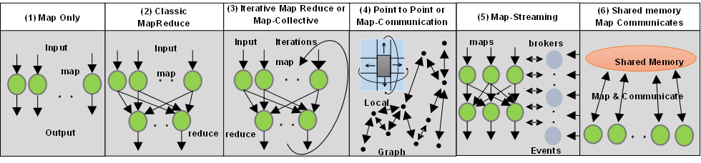Geoffrey C. Fox, Shantenu Jha, Judy Qiu, and Andre Luckow, *Towards an Understanding of Facets and Exemplars of Big Data Applications*, in 20 Years of Beowulf: Workshop to Honor Thomas Sterling's 65th Birthday October 14, 2014. Annapolis <http://grids.ucs.indiana.edu/ptliupages/publications/OgrePaperv9.pdf>.

*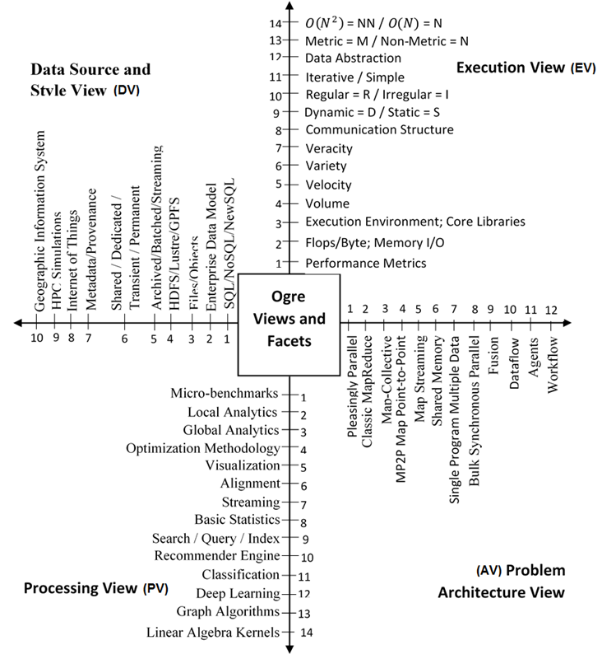6 System Architectures identified in Ogre Problem Architecture Classification*

*50 Big Data Features or Facets organized into four views*

## General Big Data Application Activity Further/Ongoing work:

1. Understand Public comments on NIST Collection
2. Accumulate further examples (part of NIST Public Working Group)
3. Improve 26-feature Template
4. Refine facets

# SPIDAL Kernels

This work refines and exemplifies the facets. Study core machine learning and other kernels including those related to data systems. Catalog existing benchmark sets and label them with Ogre facets. Consider kernels identified in SPIDAL and relate them to Facets. Identify those facets not covered so far. Reference 3) studies SPIDAL clustering algorithms GML1 and GML2

## Big Data Benchmarking

1. Geoffrey C. Fox, Shantenu Jha, Judy Qiu, and Andre Luckow, *Ogres: A Systematic Approach to Big Data Benchmarks*, in Big Data and Extreme-scale Computing (BDEC) January 29-30, 2015. Barcelona. <http://www.exascale.org/bdec/sites/www.exascale.org.bdec/files/whitepapers/OgreFacets.pdf>.
2. Saliya Ekanayake Towards a Systematic Approach to Big Data Benchmarking Indiana University PhD Thesis Proposal February 4 2015 <http://dsc.soic.indiana.edu/publications/proposal_final_v3.docx>
3. Geoffrey C. Fox , Shantenu Jha, Judy Qiu, Saliya Ekanayake, and Andre Luckow, *Towards a Comprehensive Set of Big Data Benchmarks*. February 15, 2015. <http://grids.ucs.indiana.edu/ptliupages/publications/OgreFacetsv9.pdf>.

|  |  |  |  |  |  |
| --- | --- | --- | --- | --- | --- |
| **Algorithm** | | **Applications** | **Problem Arch View** | **Execution View** | **Processing View** |
| **Graph Analytics GA** | | | | | |
| **1** | **Community detection** | Social networks, webgraph | 3, 4, 7 | 9S, 10I, 11, 12G | 3, 9ML, 13 |
| **2** | **Subgraph/motif finding** | Webgraph, biological/social networks | 4, 7 | 9D, 10I, 12G | 3, 9ML, 13 |
| **3** | **Finding diameter** | Social networks, webgraph | 4, 7 | 9D, 10I, 12G | 3, 9ML, 13 |
| **4** | **Clustering coefficient** | Social networks | 4, 7 | 9S, 10I, 11, 12G | 3, 9ML, 13 |
| **5** | **Page rank** | Webgraph | 3, 4, 7 | 9S, 10I, 11, 12V | 3, 9ML, 12, 13 |
| **6** | **Maximal cliques** | Social networks, webgraph | 4, 7 | 9D, 10I, 12G | 3, 9ML, 13 |
| **7** | **Connected component** | Social networks, webgraph | 4, 7 | 9D, 10I, 12G | 3, 9ML, 13 |
| **8** | **Betweenness centrality** | Social networks | 6 | 9D, 10I, 12G, 13N | 9ML, 13 |
| **9** | **Shortest path** | Social networks, webgraph | 6 | 9D, 10I, 12G, 13N | 9ML, 13 |
| **Spatial Queries and Analytics SQA** | | | | | |
| **1** | **Spatial relationship based queries** | GIS/social networks/pathology informatics (add GIS in data view) | 2 | 12P | 6 |
| **2** | **Distance based queries** | 1 | 12P | 2 |
| **3** | **Spatial clustering** | 3, 7, 8 | 12P | 3, 9ML,EM |
| **4** | **Spatial modeling** | 1 | 12P | 2 |
| **Core Image Processing IP** | | | | | |
| **1** | **Image preprocessing** | Computer vision/pathology informatics | 1 | 13M | 2 |
| **2** | **Object detection & segmentation** | 1 | 13M | 2, 9ML |
| **3** | **Image/object feature computation** | 1 | 13M | 2, 9ML |
| **4** | **3D image registration** | 1 | 13M | 2, 9ML |
| **5** | **Object matching** | 1 | 13N | 2, 9ML |
| **6** | **3D feature extraction** | 1 | 13N | 2, 9ML |
| **General Machine Learning GML** | | | | | |
| **1** | **DA Vector Clustering** | Accurate Clusters | 3, 7, 8 | 9D, 10I, 11, 12V, 13M, 14N | 9ML, 9EM, 12 |
| **2** | **DA Non-metric Clustering** | Accurate Clusters, Biology, Web | 3, 7, 8 | 9S, 10R, 11, 12BI, 13N, 14NN | 9ML, 9EM, 12 |
| **3** | **Kmeans; Basic, Fuzzy and Elkan** | Fast Clustering | 3, 7, 8 | 9D, 10I(Elkan), 11, 12V, 13M, 14N | 9ML, 9EM |
| **4** | **Levenberg-Marquardt Optimization** | Non-linear Gauss-Newton, use in MDS | 3, 7, 8 | 9D, 10R, 11, 12V, 14NN | 9ML, 9NO, 9LS, 9EM, 12 |
| **5** | **DA, Weighted SMACOF** | MDS with general weights | 3, 7, 8 | 9S, 10R, 11, 12BI, 13N, 14NN | 9ML, 9NO, 9LS, 9EM, 12, 14 |
| **6** | **TFIDF Search** | Find nearest neighbors in document corpus | 1 | 9S, 10R, 12BI, 13N, 14N | 2, 9ML |
| **7** | **All-pairs similarity search** | Find pairs of documents with TFIDF distance below a threshold | 3, 7, 8 | 9S, 10R, 12BI, 13N, 14NN | 9ML |
| **8** | **Support Vector Machine SVM** | Learn and Classify | 3, 7, 8 | 9S, 10R, 11, 12V, 13M, 14N | 7, 8, 9ML |
| **9** | **Random Forest** | Learn and Classify | 1 | 9S, 10R, 12BI, 13N, 14N | 2, 7, 8, 9ML |
| **10** | **Gibbs sampling (MCMC)** | Solve global inference problems | 3, 7, 8 | 9S, 10R, 11, 12BW, 13N, 14N | 9ML, 9NO, 9EM |
| **11** | **Latent Dirichlet Allocation LDA with Gibbs sampling or Var. Bayes** | Topic models (Latent factors) | 3, 7, 8 | 9S, 10R, 11, 12BW, 13N, 14N | 9ML, 9EM |
| **12** | **Singular Value Decomposition SVD** | Dimension Reduction and PCA | 3, 7, 8 | 9S, 10R, 11, 12V, 13M, 14NN | 9ML, 12 |
| **13** | **Hidden Markov Models (HMM)** | Global inference on sequence models | 3, 7, 8 | 9S, 10R, 11, 12BI | 2, 9ML, 12 |

*The members of SPIDAL library and the Ogre facets that they support. There are no SPIDAL library members directly addressing Data Source & Style View (except spatial analytics and GIS) and so that view is omitted.*

## SPIDAL Kernels Big Data Benchmarking Further/Ongoing work:

1. Package Existing Kernels
2. Examine Intel DaaL/Mahout/MLlib
3. Document SPIDAL use of Github
4. Implement missing algorithms
5. Consider implications of GPU’s and Xeon Phi “Knights landing”

# SPIDAL Communities

## Remote Sensing -- Kansas

1. Stefan Lee Jerome Mitchell David J. Crandall and Geoffrey C. Fox *Estimating Bedrock And Surface Layer Boundaries And Confidence Intervals In Ice Sheet Radar Imagery Using MCMC* The International Conference on Image Processing (ICIP) Paris France October 27-29 2014 <http://dsc.soic.indiana.edu/publications/ICIPpaper.pdf>
2. Jerome E. Mitchell, David J. Crandall, Geoffrey C. Fox, Maryam Rahnemoonfar and John D. Paden *A Semi-Automatic Approach for Estimating Bedrock and Surface Layers from Multichannel Coherent Radar Depth Sounder Imagery* SPIE Remote Sensing Conference 23 - 26 September 2013 in Dresden, Germany, in Proc. SPIE 8892, Image and Signal Processing for Remote Sensing XIX. October 17, 2013: Vol. 8892. pages. 88921E-88921E-6. <http://dx.doi.org/10.1117/12.2028992> <http://dsc.soic.indiana.edu/publications/articleSPIEfinal.pdf>

*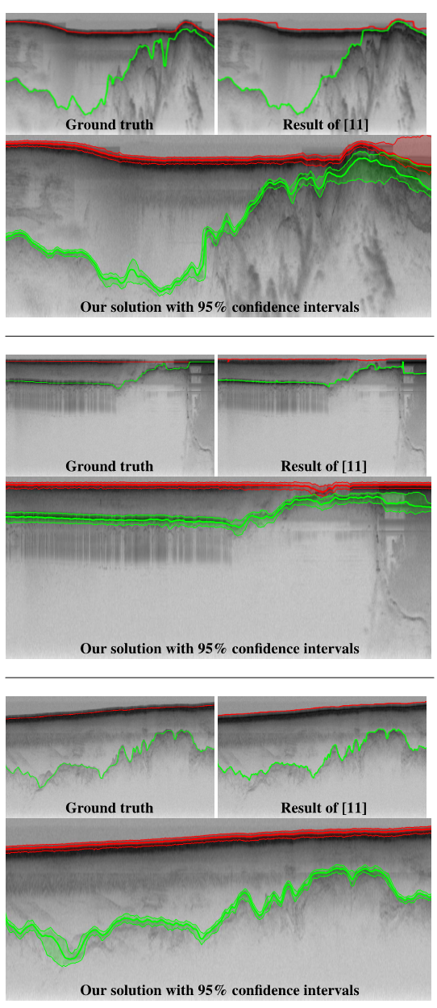Kansas radar images measuring glacier beds with results of new machine learning algorithms identifying top (red) and bottom (green) of glacier. Results of earlier work are labelled [11]. Ground Truth is human generated analysis*

## Pathology Informatics – Stony Brook

Link to “SPATIAL DATA ANALYSIS LIBRARY” description in Tools

# MIDAS Architecture

Study major software components relevant for Big Data from both HPC and commodity Big Data processing. The total commodity big data at 10 zettabytes is much larger than science data (with LHC analysis at “just” 100 petabytes) and has motivated much high quality software we call ABDS – Apache Big Data Stack. As HPC has leadership position in some areas – especially those associated with performance – suggest we need to merge software systems giving HPC-ABDS software stack with currently over 300 entries arranged into 21 “layers” with those where HPC and ABDS have important integration issues identified. The recent announcements that HPC essential for deep learning have supported these ideas. Interoperation of cloud, supercomputer, multicore, GPU, Xeon Phi systems is clearly important.



## Identifying HPC-ABDS Software Stack

1. *HPC-ABDS Kaleidoscope of over 300 Apache Big Data Stack and HPC Technologies*; Available from: <http://hpc-abds.org/kaleidoscope/>.
2. Judy Qiu, Shantenu Jha, Andre Luckow, and Geoffrey C.Fox, *Towards HPC-ABDS: An Initial High-Performance Big Data Stack, in Building Robust Big Data Ecosystem* ISO/IEC JTC 1 Study Group on Big Data. March 18-21, 2014. San Diego Supercomputer Center, San Diego. http://grids.ucs.indiana.edu/ptliupages/publications/nist-hpc-abds.pdf.
3. Geoffrey Fox, Judy Qiu, and Shantenu Jha, High Performance *High Functionality Big Data Software Stack*, in Big Data and Extreme-scale Computing (BDEC). 2014. Fukuoka, Japan. http://www.exascale.org/bdec/sites/www.exascale.org.bdec/files/whitepapers/fox.pdf.
4. Shantenu Jha, Judy Qiu, Andre Luckow, Pradeep Mantha, and Geoffrey C. Fox, *A Tale of Two Data-Intensive Approaches: Applications, Architectures and Infrastructure*, in 3rd International IEEE Congress on Big Data Application and Experience Track. June 27- July 2, 2014. Anchorage, Alaska. http://arxiv.org/abs/1403.1528.
5. Geoffrey Fox, Judy Qiu, Shantenu Jha, Supun Kamburugamuve and Andre Luckow *HPC-ABDS High Performance Computing Enhanced Apache Big Data Stack* Invited talk at 2nd International Workshop on Scalable Computing For Real-Time Big Data Applications (SCRAMBL'15) at.CCGrid2015, the 15th IEEE/ACM International Symposium on Cluster, Cloud and Grid Computing, held in Shenzhen, Guangdong, China [http://dsc.soic.indiana.edu/publications/HPC-ABDSDescribedv2.pdf](http://dsc.soic.indiana.edu/publications/HPC-#ABDSDescribedv2.pdf)
6. Big Data and Open Source Software Class <http://bigdataopensourceprojects.soic.indiana.edu/> at Indiana University covers “Theory and Practice” of HPC-ABDS

*Comparison of typical Cloud and Supercomputer Software Layered Stacks*



## HPC-ABDS Further/Ongoing work:

1. Continue development of online Class
2. Develop a set of examples of HPC-ABDS for benchmark and tutorial purposes. Specify with DevOps technologies (Ansible, Heat)
3. Relate DevOps specified examples to NIST Big Data Reference Architecture (Interest of NIST Public working group)

# MIDAS: Using HPC-ABDS Technologies

## Batch Parallel Programming

This covers integration of Hadoop into Pilot Jobs framework (ref. 1) and link to MIDAS in Software Tools) and the Harp scientific (high performance) plug in for Hadoop in ref 2) which benchmarks GML5.

1. Shantenu Jha, Andre Luckow, Pradeep Mantha, *A Valid Abstraction for Data-Intensive Applications on HPC, Hadoop and Cloud Infrastructures?* 2015. [Online]. Available: <http://arxiv.org/abs/1501.05041>.
2. Bingjing Zhang, Yang Ruan, and Judy Qiu, *Harp: Collective Communication on Hadoop*, in IEEE International Conference on Cloud Engineering (IC2E). March 9-12, 2015. Tempe AZ. <http://grids.ucs.indiana.edu/ptliupages/publications/HarpQiuZhang.pdf>.

## Streaming Data



*Apache Storm processing data from Internet of Things (IoT)*

Reference 1) studies performance of Storm and different publish-subscribe systems showing RabbitMQ preferable to Kafka in cases real-time response needed.

1. Supun Kamburugamuve, Leif Christiansen, Geoffrey Fox *A Framework for Real-Time Processing Processing of Sensor Data in the Cloud* to be published in Journal of Sensors <http://dsc.soic.indiana.edu/publications/iotcloud_hindavi_two_column_final_2.docx>
2. Xiaoming Gao (Advisor Judy Qiu) *Scalable Architecture for Integrated Batch and Streaming Analysis of Big Data* Indiana University PhD Thesis Exam January 21 2015 <http://dsc.soic.indiana.edu/publications/Xiaoming%20Gao%20Thesis%20v5.pdf>
3. Geoffrey Fox, Supun Kamburugamuve, Hengjing He, *Current and Planned IoT Cloud Research at Digital Science Center* Technical Report March 5 2015 <http://dsc.soic.indiana.edu/publications/intelligent_iot_cloud_controller.pdf>
4. Xiaoming Gao, Emilio Ferrara, Judy Qiu *Parallel Clustering of High-Dimensional Social Media Data Streams* presented at CCGrid2015, the 15th IEEE/ACM International Symposium on Cluster, Cloud and Grid Computing, held in Shenzhen, Guangdong, China <http://dsc.soic.indiana.edu/publications/Parallel%20Clustering%20of%20High-Dimensional%20Social%20Media%20Data%20Streams_v11.pdf>

## MIDAS Ongoing work

1. Apply Storm-RabbitMQ to Robotics
2. Improve Storm to add quality of service and support of parallel computing
3. Extend Tweet clustering to use Harp
4. Look at further examples of Harp
5. Integrate Pilot Jobs with Streaming and Harp
6. Support GPU and Xeon Phi

**Hyperlink Abstracts to papers**

5.1 citation 1) Shantenu Jha, Andre Luckow, Pradeep Mantha, *A Valid Abstraction for Data-Intensive Applications on HPC, Hadoop and Cloud Infrastructures?* 2015. [Online]. Available: http://arxiv.org/abs/1501.05041.

HPC environments have traditionally been designed to meet the compute demand of scientific applications and data has only been a second order concern. With science moving toward data-driven discoveries relying more on correlations in data to form scientific hypotheses, the limitations of HPC approaches become apparent: Architectural paradigms such as the separation of storage and compute are not optimal for I/O intensive workloads (e.g. for data preparation, transformation and SQL). While there are many powerful computational and analytical libraries available on HPC (e.g. for scalable linear algebra), they generally lack the usability and variety of analytical libraries found in other environments (e.g. the Apache Hadoop ecosystem). Further, there is a lack of abstractions that unify access to increasingly heterogeneous infrastructure (HPC, Hadoop, clouds) and allow reasoning about performance trade-offs in this complex environment. At the same time, the Hadoop ecosystem is evolving rapidly and has established itself as de-facto standard for data-intensive workloads in industry and is increasingly used to tackle scientific problems. In this paper, we explore paths to interoperability between Hadoop and HPC, examine the differences and challenges, such as the different architectural paradigms and abstractions, and investigate ways to address them. We propose the extension of the Pilot-Abstraction to Hadoop to serve as interoperability layer for allocating and managing resources across different infrastructures. Further, in-memory capabilities have been deployed to enhance the performance of large-scale data analytics (e.g. iterative algorithms) for which the ability to re-use data across iterations is critical. As memory naturally fits in with the Pilot concept of retaining resources for a set of tasks, we propose the extension of the Pilot-Abstraction to in-memory resources.