

Trident Composer User’s Guide

Microsoft Project Trident: A Scientific Workflow Workbench

Version 1.0 – November 6, 2009

Abstract

Microsoft Project Trident: A Scientific Workflow Workbench simplifies the process of designing and running scientific data analysis workflows. The paper discusses how to use Trident Composer—one of the primary Trident Workbench applications—to construct and run data analysis workflows.

**Note:**

* Many of the resources discussed in this paper are provided with the Project Trident package.

For a complete list of documents and software discussed in this paper, see “Resources” at the end of this document.

* For Project Trident updates and news, see:   
  <http://research.microsoft.com/en-us/collaboration/tools/trident.aspx>

Disclaimer: The information contained in this document represents the current view of Microsoft Corporation on the issues discussed as of the date of publication. Because Microsoft must respond to changing market conditions, it should not be interpreted to be a commitment on the part of Microsoft, and Microsoft cannot guarantee the accuracy of any information presented after the date of publication.

This White Paper is for informational purposes only. MICROSOFT MAKES NO WARRANTIES, EXPRESS, IMPLIED OR STATUTORY, AS TO THE INFORMATION IN THIS DOCUMENT.

Complying with all applicable copyright laws is the responsibility of the user. Without limiting the rights under copyright, no part of this document may be reproduced, stored in or introduced into a retrieval system, or transmitted in any form or by any means (electronic, mechanical, photocopying, recording, or otherwise), or for any purpose, without the express written permission of Microsoft Corporation.

Microsoft may have patents, patent applications, trademarks, copyrights, or other intellectual property rights covering subject matter in this document. Except as expressly provided in any written license agreement from Microsoft, the furnishing of this document does not give you any license to these patents, trademarks, copyrights, or other intellectual property.

Unless otherwise noted, the example companies, organizations, products, domain names, e-mail addresses, logos, people, places and events depicted herein are fictitious, and no association with any real company, organization, product, domain name, email address, logo, person, place or event is intended or should be inferred.

© 2009 Microsoft Corporation. All rights reserved.

Microsoft, MSDN, and Windows are either registered trademarks or trademarks of Microsoft Corporation in the United States and/or other countries.

The names of actual companies and products mentioned herein may be the trademarks of their respective owners.

Document History

|  |  |
| --- | --- |
| Date | Change |
| April 14, 2009 | Version 0.9 draft publication |
| November 6, 2009 | Version 1.0 – Add “Import saved workflow from file system” |

Contents

PART 1: Introduction and Overview 4

Terminology 4

Composer Overview 6

Exploring the Composer Primary UI 7

Composer Pane 9

Monitor Pane 10

Provenance Pane 11

Managing the Workflow Display in the Composer Pane 12

Importing Trident Components 16

PART 2: How to Create a Workflow 24

SimpleFilter: A Simple Workflow 25

Step 1: Create a New Workflow 25

Step 2a: Add an Unpack Data Activity 26

Step2b: Use Type Initializers to Initialize Properties 27

Step 3: Add the Boxcar Filter Activity 28

Step 4: Add the Display Data Activity 29

Step 5: Run the Workflow 30

Step 6: Monitor the Workflow 31

Step 7: Debug the Activity 31

Step 8 : Save workflow to filesystem 32

Demux: Add a ParallelActivity Activity to SimpleFilter 33

Step 1: Add the Demux Data Activity 33

Step 2: Add ParallelActivity to the Workflow 33

Validate: Add an If Else Conditional to Demux 35

Step 1: Add an If Else Activity to the Workflow 35

Step 2 Add a Condition to the If Else Activity 36

Step 3: Assign a TerminateActivity Activity to the Else Branch 38

Step 4: Move Demux Data to If True 38

Demux 2: Add a Replicator Activity to SimpleFilter 38

Step 1: Start the Demux 2 Workflow 40

Step 2: Add a Replicator Activity to the Workflow 40

Step 3. Add Child Activities to Replicator 41

SimpleFilter 2: Add a For Loop Activity to SimpleFilter 42

Step 1: Create the Basic SimpleFilter 2 Workflow 43

Step 2: Implement the For Loop Activity 43

Step 3: Implement SimpleFilter 2 as a Monte Carlo Simulation 44

Troubleshooting 45

Resources 47

# PART 1: Introduction and Overview

As a scientist, you know that many important scientific questions must be addressed as a whole, by multiple disciplines. For example, some important oceanography problems require large-scale multidisciplinary experiments such as the Neptune project. This integrated approach to science has considerable promise, but it also presents considerable challenges.

After your project begins generating data, you will probably face two key issues:

* How to analyze a wide variety of data from a large number of sources.

The issues are often not well understood, so you need a tool that lets you easily experiment with different analytical schemes.

* How to analyze terabytes or even petabytes of data.

That’s often too much for a single computer; you need a tool that can run analyses on a high-performance cluster.

Microsoft® Project Trident: A Scientific Workflow Workbench effectively addresses both these issues, and provides a number of useful related features. You don’t have to be an experienced programmer to use Trident Workbench. Instead, you use a visual designer to “snap” together data processing components—called activities—to create a data analysis pipeline called a workflow. You then use Trident Workbench to run the workflow. You can even direct Trident Workbench to run the workflow automatically, on a daily or weekly basis. For large data sets, Trident Workbench can run workflows on Windows® HPC Server 2008.

This paper describes how to use Trident Composer—one of the primary Trident Workbench applications—to create and run data analysis workflows.

* For description of how to use the other primary Trident Workbench application, Trident Management Studio, see “Trident Management Studio User’s Guide.”
* For a general introduction to Trident, see “Project Trident: An Introduction.”
* For directions on how to install Trident, see “Project Trident: Installation Guide.”

# Terminology

This section defines the key terms that are used in this paper.

activity

A component of a workflow.

basic activity

An activity that performs a particular task.

composite activity

An activity that serves as a container for other activities.

condition activity

Used with an **If Else** activity to control which workflow branch is selected.

For Loop activity

A composite activity that runs a child activity a specified number of times, with a specified sequence of index values.

If Else

A composite activity that runs either of two child activities, depending on whether the condition activities evaluate to True or False.

job

A workflow instance. It can either be running or scheduled to run at a specified time.

ParallelActivity activity

A composite activity that runs a set of child activities in parallel.

Replicator activity

A composite activity that processes a collection of data items by running a specified child activity once for each item.

SequenceActivity activity

A composite activity that runs a set of activities in sequence.

subsection

A group of adjacent activities that Composer treats as a unit.

root activity

The composite activity that hosts the workflow proper. For Trident Workbench, the root activity is always a **SequentialActivity** activity.

Trident Registry

A database that contains Trident workflows, activities, type initializers, and so on.

type initializer

A module that provides a user interface (UI) for initializing properties with complex data types.

Web service activity

An activity that represents a Web service.

workflow

A structured collection of activities that perform a data analysis procedure.

workflow input or output

A specially marked input or output property. Trident Workbench stores the value of these properties in the Registry each time the workflow runs.

workflow runtime

A Windows Workflow Foundation component that manages running workflows and provides an interface between workflows and their host applications.

XOML file

A file that contains an XML-based declarative version of the workflow. XOML is similar to XAML.

# Composer Overview

This section briefly describes the key parts of the Composer UI and how they are used to create, execute, and manage workflows.

Figure 1 shows the primary Composer UI.



Figure 1. Composer primary UI

## Exploring the Composer Primary UI

### Status Bar

The status bar displays the status of executing workflows.

### Primary Toolbars

The four primary toolbars are always accessible, but only one toolbar is displayed at a time. To select a toolbar, click the related tab: File, View, Connection, and Help, as shown in the following list. Working panes can also have toolbars, which are discussed later.

|  |  |
| --- | --- |
| Item | Description |
| **File Toolbar** | Supports several workflow-related operations. |
| New | Creates a new workflow. |
| Open | Opens workflows stored as files. |
| Save | Saves a workflow to the Trident Registry, which is a database that contains Trident workflows, activities, type initializers, and so on. |
| Save As | Saves a workflow to the Trident Registry with a different name or in a different category. It can also save the workflow to the file system. |
| Import | Imports a Trident element. Click the arrow on the right to import one of the following:   * **Workflow:** Imports a workflow’s XOML file, and the associated assemblies. * **Activity:** Imports a custom activity DLL. * **Web service activity:** Imports a Web service activity. * **Workflow Package:** Imports a .tpw file containing an exported workflow from a different Trident Registry. * **Custom type initializer:** Imports a custom type initializer.   Click the **Import** button itself to import a workflow. For more details on importing Trident elements, see “Trident Management Studio User’s Guide.” |
| Monitor Settings | Specifies settings for monitoring data. By default, monitored data is displayed in the **Monitor** pane. You can use this button to enable logging, which stores the data in a specified file. |
| Exit | Closes Composer and allows you to either terminate running jobs or run them in the background. |
| **View Toolbar** |  |
| Hide Parameter Binding | Hides or shows the lines binding an activity’s output properties to the corresponding input properties on a subsequent activity. |
| **Connection Toolbar** | Manages connections to Trident Registries. |
| Saved Connections | Opens a saved connection. |
| Advanced | Creates a new connection. |
| **Help Toolbar** |  |
| About | Displays a dialog box with basic information such as the Trident version number. |

### Workflow Catalog

Workflows and activities are stored in the Trident Registry. The Workflow Catalog is a basic Registry management tool. It is divided into three parts, as described in the following list.

|  |  |
| --- | --- |
| Catalog element | Description |
| Search | Allows you to search the Registry for workflows and activities. |
| Workflows | Contains a tree-structured list of stored workflows.   * The workflows listed under **Trident Workflow** are available to any user. * The workflows listed under **My Workflow** can be accessed only by the workflow author. |
| Activities | Shows a tree-structured list of stored activities. |

For a more powerful and flexible registry management tool, use Management Studio.

### Working Panes

Composer has three working panes, which you select by clicking the appropriate tab, as described in the following list.

|  |  |
| --- | --- |
| Working pane | Description |
| Composer | Provides a design surface for creating, modifying, and executing workflows. |
| Monitor | Tracks the progress of an executing workflow. |
| Provenance | Contains details about the most recently executed workflow. |

The easiest way to learn about the working panes is to load and execute one of the stored workflows, Ocean Current, which analyzes ocean current data and displays the results. These panes are described in the following sections.

## Composer Pane

To view the working elements of the Composer pane, double-click **Ocean Current** in **My Workflow** to load the workflow into the Composer pane, as shown in Figure 2.



Figure 2. Composer pane

Most of the **Composer** pane is a design surface that displays a graphical representation of the currently loaded workflow. The **Composer** pane’s toolbar contains the controls described in the following list.

|  |  |
| --- | --- |
| Composer control | Description |
| Job Name | Displays the current job name.  Job names are used primarily for scheduled workflows. You don’t have to assign a job name to create or run a workflow in Composer. For information, see “Trident Management Studio User’s Guide.” |
| Node | Provides a list of execution nodes.  This example uses the local computer, NodeName. |
| Execute | Runs the workflow. |
| Debug | Runs the workflow in debugging mode, to debug custom activities. |
| Zoom | Expands or shrinks the workflow graphic.  Workflows can extend beyond either edge of the pane. **Zoom** expands the workflow so you can work with an individual activity, or it shrinks the workflow so you can see the overall structure. |
| Pan | Displays a “hand” cursor that you can use to move the workflow in the pane.  Click and hold the cursor within the pane, and then use the mouse to move the workflow back and forth. You can also move the workflow by using the scroll bar at the bottom of the pane. |
| Fit-to-Screen | Adjusts the workflow graphic to fit the pane.  It also adjusts the **Zoom** control slider to the related setting. |
| Data Type Color Palette | Displays a dialog box that lists the colors associated with different property icon data types. |
| Properties | Displays the selected activity or workflow property sheet at the pane’s right side. |
| Close | Closes the workflow. |

For details about working in the Composer pane, see “Managing the Workflow Display in the Composer Pane” later in this paper.

For a description of how to use Composer to create or modify a workflow, see “Part 2: How to Create a Workflow,” later in this paper.

## Monitor Pane

To view the elements of the Monitor pane, open **Ocean Current** and click the **Execute** button to run the workflow. Composer automatically displays the **Monitor** pane in the working pane, to track the workflow’s progress.

Figure 3 shows an example of the **Monitor** pane for Ocean Current.

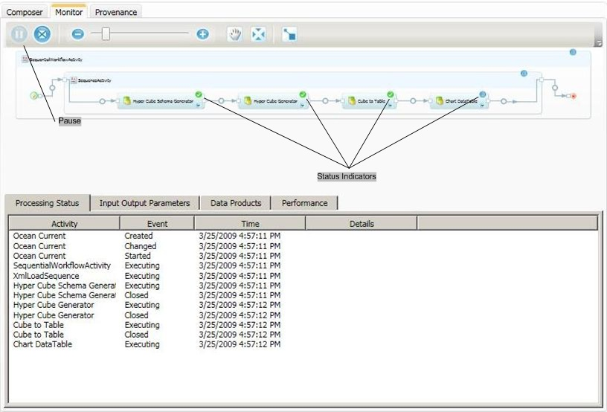

Figure 3. Monitor pane

The Monitor pane has three components, as described in the following list.

|  |  |
| --- | --- |
| Item | Description |
| **Monitor Toolbar** | Similar to the **Composer** toolbar, with exceptions listed here. |
| Pause | Pauses and restarts the workflow. |
| N/A items | No **Properties** or **Close** buttons. |
| **Workflow Display** |  |
| Central workflow graphic | You can use the toolbar to adjust the graphic’s size and location, as with the **Composer** pane, but you can’t modify the workflow.  A green dot on an activity icon indicates a completed activity and a blue dot indicates an activity in progress. |
| **Workflow Information** | Displays information about the running workflow. Select one of the four displays by clicking the appropriate tab. |
| Process Status | Displays a running summary of the workflow status (Figure 3). |
| Input Output Parameters | Displays information about the input and output data for the various activities. |
| Data Products | Displays information about stored data.  This example displays its output as a graph, so **Data Products** doesn’t have any content. |
| Performance | Charts CPU and memory usage as the execution proceeds. |

**Tip:** If you are running Ocean Current now, it has probably stopped at the Chart Data Table activity, which displays a graph in a separate window. You must close this window to complete the workflow. You might have to move or minimize Composer to close the window, because it doesn’t appear on the Windows taskbar.

## Provenance Pane

The **Provenance** tab summarizes the most recently executed workflow. Figure 4 shows the **Provenance** pane after the completion of the Ocean Currents workflow. Note that Figure 4 has been made anonymous by replacing the account name of the user who executed the workflow with “Name.”

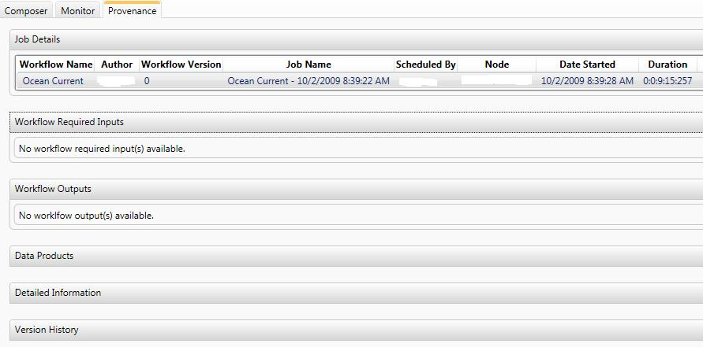

Figure 4. Provenance pane

The **Provenance** pane has six sections, which can be displayed or collapsed by clicking an arrow on the right side of the section heading. These sections are described in the following list.

|  |  |
| --- | --- |
| Provenance section | Description |
| Job Details | Displays basic information, such when a job started and who ran it. |
| Workflow Required Inputs | Shows the required input properties. |
| Workflow Outputs | Shows the workflow outputs. |
| Data Products | Shows the data products, if any.  Ocean Current doesn’t produce any data products, so this section is blank in the example. |
| Detailed Information | Shows details about the workflow, including a graphic similar to that displayed IN the **Composer** and **Monitor** panes. |
| Version History | Displays version history, and is not currently used. |

## Managing the Workflow Display in the Composer Pane

The workflow’s root activity—which is always a **SequentialActivity** activity—is at the far left of the Composer pane. The activities that make up the workflow proper are represented by shaded blue rectangles, referred to as “activity boxes” in this paper. The activities are displayed in execution order from left to right, with control flow indicated by blue arrows, as shown in Figure 5.



Figure 5. Activities and their properties in the Composer pane

### How to Insert an Activity or Workflow

The open circle in the center of each blue control-flow arrow is an insertion point, where you can insert individual activities or entire workflows.

To insert an activity or workflow in the Composer pane

1. Left-click an item in the Workflow Catalog or in the Activities list.

2. Drag it to the appropriate insertion point in the Composer pane.

3. When the cursor changes to an arrow over the insertion point, release the mouse button.

When you insert a workflow, Composer removes the root **SequentialActivity** activity and inserts only its child activities.

After you drop the item, the Composer pane updates the workflow display to show the inserted item. If you insert a workflow, the collection of activities is inserted as a subsection, as discussed in “Managing the Workflow Display” later in this paper.

### How to Display Input and Output Properties

Each activity has a set of properties, which can be displayed below the activity box.

To collapse or expand an activity’s property set in the Composer pane

* Click the Expand/Collapse icon in the lower right corner of the activity box.

#### Input Properties

On the left side of an activity’s property set:

* Each input property has an icon whose color indicates the data type.

Click the **Data Type Color Palette** icon in the toolbar to remind yourself of the relationship between type and color.

* Filled and unfilled icons indicate required and optional input properties, respectively.
* To see a tooltip description, move the pointer over the property’s icon.
* To display a property sheet on the right side of the pane, right-click within a property set, and then click **Properties**.

You use the property sheet to specify input property values. For details, see “Part 2: How to Create a Workflow” later in this paper.

#### Output Properties

On the right side of the property set:

* The icons use the same color scheme as input properties, but they are always unfilled.

### How to Designate Workflow Inputs and Outputs

By default, property values exist only for the duration of the activity. To have Trident Workbench automatically store a property value, designate it as a workflow input or output. The property behaves in the same way as a standard input or output property. However, each time you run a job, Trident Workbench stores the value in the Registry.

To designate a workflow input or output in the Composer pane

1. Right-click the specific property icon.

2. Click **Mark as workflow input** for input properties.

—Or—

Click **Mark as workflow output** for output properties.

To view the stored values in the Monitor pane

1. Open the **Monitor** pane, and click the **Input Output Parameters** tab.

2. Click the arrow that opens the **Workflow** section.

You can also view stored workflow properties in the Provenance pane.

### How to Specify Data Flow

To specify data flow between two activities, you bind output properties on an upstream activity to the corresponding input properties on the downstream activity. The activities do not have to be adjacent.

Composer indicates binding by a line connecting the two properties. For example, the Hyper Cube Schema Generator activity shown in Figure 5 has two output properties, which are bound to the corresponding Hyper Cube Generator input properties.

To specify data flow in the Composer pane

1. Left-click the output property’s icon and hold down the mouse button.

2. Drag the cursor to the input property’s icon.

3. When the cursor changes to an arrow over the icon, release the mouse button.

**Note:** Composer allows you to bind properties only if they have compatible data types. If the types are not compatible, the cursor does not change to an arrow over the property icon, and releasing the mouse button has no effect.

### Managing the Workflow Display

Workflows vary in size and are often too large to display conveniently. Composer provides several ways to manage the display.

To manage the workflow display in the Composer pane

* Use the **Zoom** or **Fit-to-Screen** buttons to expand or shrink the display.

—Or—

* Use the scrollbar or **Pan** to move the workflow back and forth.

—Or—

* Create subsections.

The first two options have already been discussed. Subsections allow you to simplify a workflow by creating groups of two or more adjacent activities. A subsection can be collapsed to the size of a single activity, which allows you to create a much more compact workflow representation. You can expand a subsection when you want to work on the individual activities.

To select the activities for a subsection in the Composer pane

1. Hold the SHIFT key and click the activity boxes in sequence.

An orange border surrounds the selected activities, as shown in Figure 6.

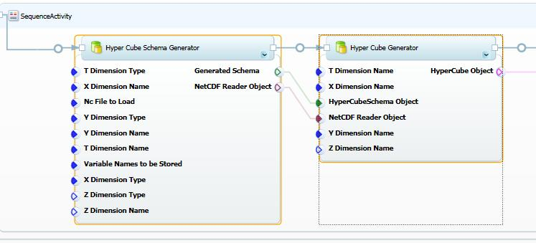  
Figure 6. Selecting subsection activities in the Composer pane

2. To create the subsection, right-click one of the selected activities, and then click **Create Subsection**.

3. Specify a subsection name and an optional description in the **Subsection** dialog box.

The subsection is initially in the expanded state, as shown in Figure 7.

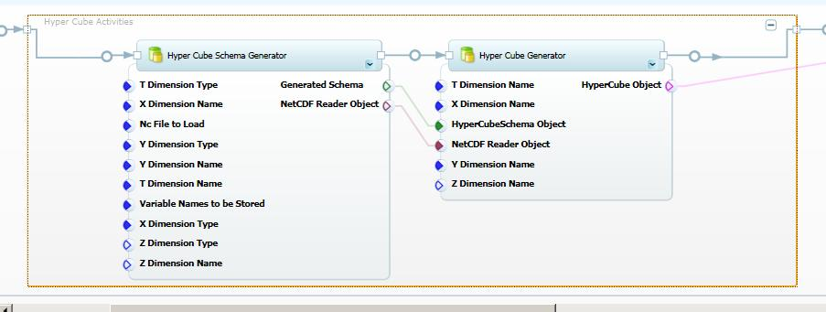

Figure 7. Expanded subsection in the Composer pane

To collapse a subsection and shrink the size of the workflow, click the “**–**” (minus sign) button in the upper right corner of the subsection box. To expand the subsection, click the “**+**” (plus sign) button. Figure 8 shows a collapsed subsection.

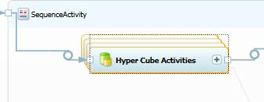

Figure 8. Collapsed subsection in the Composer pane

## Importing Trident Components

Trident Workbench includes a standard set of activities and workflow. However, many projects will require tasks such specialized data processing that are not handled by the standard set of activities. You can handle this situation by importing custom activities into Workbench that provide the required functionality. There are two basic types of custom activity:

* Standard activities are .NET objects, packaged as DLLs.

You can implement standard activities yourself, or obtain them from colleagues or the Web.

* A Web service activity incorporates Web service methods into a Trident workflow.

Rather than implement and distribute custom activity DLLs, scientists might prefer to expose custom processing functionality or data through a Web service, and perform the actual processing on their computer.

You can also import packaged Trident workflows, which you can obtain from colleagues or Web sites, such as MyExperiment.

This section describes how to import standard and Web service activities and workflow packages into Workbench. For details on how to export a workflow package, see “Management Studio User’s Guide.”

### How to Import a Standard Activity

A standard activity is a .NET object packaged in a DLL. The DLL can contain any number of activities, and might also contain related components such as type initializers. There are two ways to obtain a custom activity DLL:

* Implement it yourself.

Activities are straightforward to implement. For details, see “Trident Programming Guide.”

* Obtain a DLL that has implemented by another scientist.

Scientists who have implemented custom activities can post them on Web sites such as the Trident site on Microsoft Connect, or provide them directly to interested colleagues.

After you obtain the activity DLL, you must import it into Workbench. You can use either Composer or Management Studio to import custom activity DLLs; the process is similar for both applications. This section discusses how to use Composer.

#### Step 1: Select the Activity DLL

Use the Import Activity capability in Composer to import custom DLLs.

To select a custom activity DLL

1. On the Composer toolbar, right-click the arrow on the right edge of the **Import** button.

2. Click **Activity** in the list of options, as shown in Figure 9.

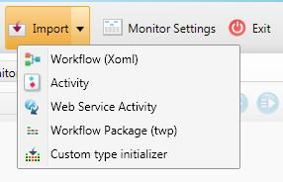  
Figure 9. The Composer Import button

3. In the **Import Activity** dialog box, shown in Figure 10, click **Browse** to select the appropriate DLL.

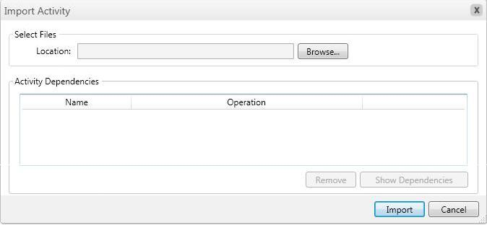

Figure 10. Import Activity dialog box

#### Step 2: Import the DLL

After you select the DLL, the **Import Activity** dialog box displays the activity DLL and all dependent DLLs. Figure 11 shows the list in **Import Activity** after UnpackData DLL is selected, which is discussed later in this paper. TridentWorkflowCommon is a standard Trident DLL that is referenced by all custom activities.

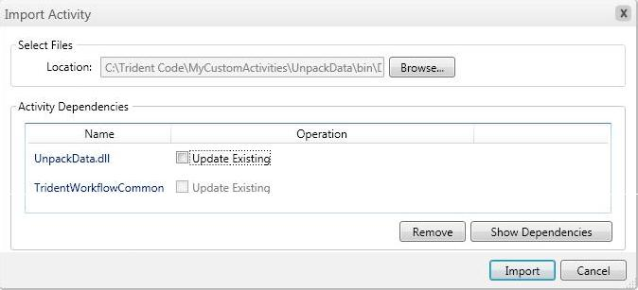

Figure 11. Import Activity with an activity DLL

If the Trident Registry already contains an earlier version of the activity, you can either remove the existing version or keep it and create a new version.

To replace the current version of the activity

1. In the **Import Activity** dialog box, click **Update Existing** to the right of the name of the old DLL.

2. In the **Select Existing Files** dialog box, shown in Figure 12, select the replacement DLL, and then click **OK** to return to **Import Activities**.

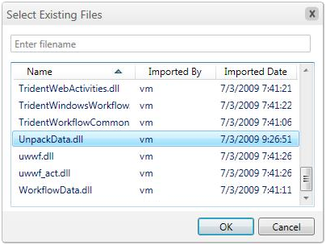  
Figure 12. Select Existing Files dialog box

3. Click **Import** to import the DLL.

Workbench replaces the old activity with the new one. The Workflow Catalog entry does not change.

To obtain more information about an activity, use Management Studio, which provides more detailed data such as when the DLL was imported. For details, see “Trident Management Studio User’s Guide.”

In some cases, you might want to keep the old version of an activity. In that case, you can import the activity as a new version.

To import a new version of the activity

1. In the **Import Activity** dialog box, leave **Update Existing** unchecked.

2. Browse to select the new DLL, and then click **Import** to import the DLL

Workbench imports the specified activity as a separate version, and the Workflow Catalog includes all versions. Workbench identifies later versions by appending the date and time that the activity was imported to the activity name, as shown in Figure 13.

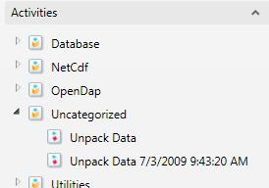

Figure 13. Workflow Catalog with two versions of Unpack Data

### How to Import a Web Service Activity

Scientists can expose processing functionality or remote access to data sets as a Web service, which can be accessed from any Internet-connected computer by using .NET programming techniques. Trident allows you to incorporate Web service functionality into your workflows by creating a Web service activity.

A Web service activity is a simple custom activity that acts as a wrapper for a Web service method. The method’s inputs and outputs are exposed as input and out properties, and you can incorporate the activity into a workflow in exactly the same way as a standard activity. The only limitation is that the computer running the workflow must have an Internet connection, so that the activity can communicate with the Web service.

The following steps describe how to import a Web service activity by using Composer.

#### Step 1: Select the Web Service Method

You can create a Web service activity to represent any Web service method.

To select a Web service method

1. On the Composer toolbar, right-click the arrow on the right edge of the **Import** button, and click **Web Service Activity**.

2. In the **Web Service Import** **Wizard**, enter the WSDL URL for the service.

3. Click **Connect** to connect to the service.

4. From the **Pick a Web Method** list in the wizard, select the method that you want to represent.

The **Selected Web Method Info** box shows the method’s input and output parameters.

5. Click **Next** to configure the activity.

Figure 14 shows the Welcome page in the **Web Service Import Wizard**, depicting a fictitious URL and method name.

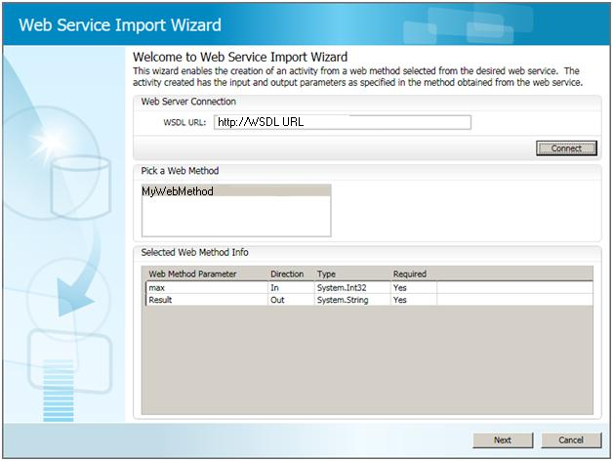

Figure 14. Web Service Wizard Welcome page

#### Step 2: Configure the Activity

The next page in the wizard is **Configure Activity Details**, shown in Figure 15, which allows you to optionally specify:

* An activity name, which is the name that is displayed in Workbench.

By default, Workbench uses the Web service method name.

* An activity icon.

By default, Workbench uses the default activity icon.

* The workflow category folder.

By default, the activity is placed under Web Service Activities.

* Activity property names.

By default, Workbench sets property names to the corresponding Web service method parameter names.

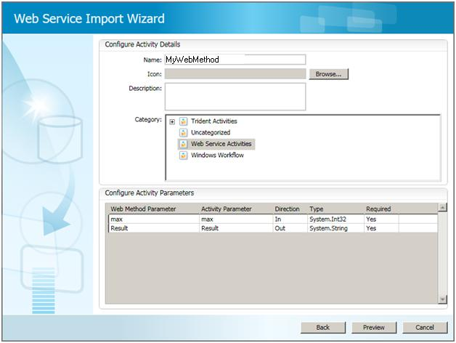

Figure 15. Configure Activity Details page

#### Step 3: Import the Activity

You can now generate the wrapper DLL and import the activity into Workbench.

To import the activity

1. In the **Web Service Import Wizard**, click **Preview** to display the Preview page.

Figure 16 shows how MyWebMethod would appear in composer.

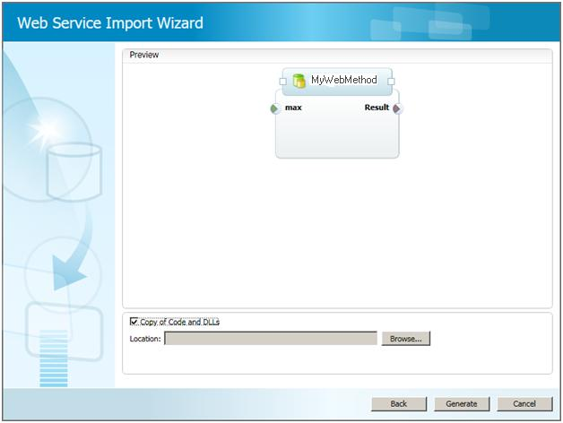   
**Figure 16. Preview page**

2. If the names in the preview are acceptable, click **Generate**, and then click **Import** to generate the wrapper DLL and import it into Workbench.

By default, the wizard simply creates a DLL and puts it in the Trident Registry database.

3. Optionally, if you check **Copy of Code and DLLs**, the wizard puts a copy of the DLL and a .cs file containing the associated code in a folder on your hard drive.

You can use the .cs file to create a modified version of the activity. For details, see “Trident Programming Guide.”

### How to Import a Workflow Package

Trident workflow packages OPC-formatted files that contain all the DLLs required to run the workflow. You can obtain packages directly from colleagues, or from Web sites such as MyExperiment. After you have obtained a Trident workflow package, you can import it into your Trident Registry, and run the workflow yourself.

To import a Trident workflow package

1. Run Composer.

2. On the Composer toolbar, click the arrow on the edge of the **Import** button and click **Workflow Package** to open the Import Workflow Package page, shown in Figure 17.

3. Use the **Name** and **Category** fields to assign a name to the workflow and specify which category it should be stored under.

4. Use the **Select Files** field to specify the location of the package’s .twp file.

5. Click **Import** to import the workflow into the Trident Registry.

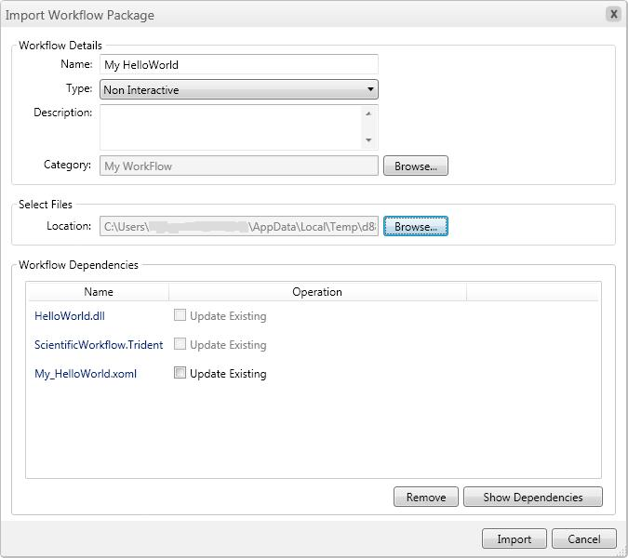

Figure 17. Workflow Package page

Import saved workflow from file system

1. On the Composer toolbar, click the arrow on the right edge of the Import button.

2. Click **Workflow.**

3. On the Import workflow form

a. Give the workflow a name, for example, “ Myworkflow1”

b. Specify ‘Type of workflow’, default is Non-interactive, if this workflow has activities which shows any user interface, change the workflow type to Interactive.

c. Specify workflow description (optional)

d. Select the category to import the workflow by clicking browse button next to the category label.

e. Select the category (for example, MyWorkflow) and select ok on ‘Select category’ dialog.

1. Select the XOML file saved, by clicking browse button next to ‘Location:’ label.
2. From the open dialog, select the single XOML file, for example C:\myworkflow1\myworkflow1.xoml
3. If you have kept all the dependency dlls on the same folder, all the required dlls will be shown as dependencies like in **Figure 19**

4. Click Import. You will be able to see the newly imported workflow in workflow catalog as shown in the following **Figure 18**

<Guid>e2b47212-d1f3-4092-a496-f7bd8caba1ef</Guid>

Figure 18 Workflow Catalog

If you get any “Could not deserialize object” error during import, you are missing one of the activity dll or one of it’s dependencies. Copy the missing dll to the folder where you saved the workflow and try importing again.

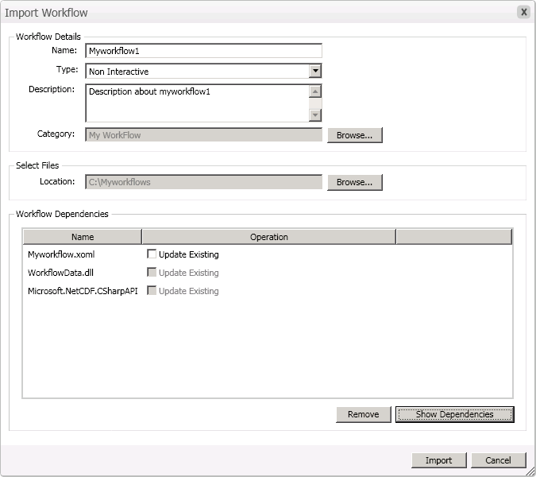

Figure 19 Import workflow

# PART 2: How to Create a Workflow

This section shows how to use Composer to create a moderately complex workflow, which applies a “boxcar” sliding window filter to a time series. There are five related workflows, as discussed in the following sections:

|  |  |
| --- | --- |
| **SimpleFilter** | A simple sequential workflow with three activities. |
| **Demux** | Modifies Simple to include **ParallelActivity** activity, which runs two activities at the same time. |
| **Validate** | Modifies Demux to include an **If Else** activity, which selects one of two branches based on whether the input data is valid. |
| **Demux 2** | Modifies Demux to use a **Replicator** activity, which takes a collection with any number of activities, and runs the activities in sequence. |
| **SimpleFilter 2** | Adds a **For Loop** activity to SimpleFilter, which runs the boxcar filter multiple times with varying filter widths. |

You can download the activities for the examples from the Trident site on Microsoft Connect. Each activity is in a separate DLL. The sample package also includes a type initializer DLL and the InputDataGenerator console application, which generates the data files used by the tutorials in this section. Import the activity and type initializer DLLs into Workbench by following the instructions in “Importing Activities”, earlier in this paper. For details on how several of the activities are implemented, see “Trident Programming Guide.”

All the examples are based on either one or another of two input data files:

* TimeSeries1 contains a single time series.
* TimeSeries2 contains two multiplexed time series.

Before starting the workflow examples, you must create the data files by running the InputDataGenerator console application, which is a project in the MyCustomActivities solution. The executable file is located in the project’s bin\debug folder included with the samples. For more details on this application and the data files, see “Trident Programming Guide.”

To create the input data files

1. From the project’s bin\debug folder, run InputDataGenerator.exe.

The InputDataGenerator application creates data files named TimeSeries1 and TimeSeries2, and places them in the InputDataGenerator project’s bin\debug folder.

2. Copy the data files to an appropriate folder.

The examples in Part 2 assume that the input data files are in C:\TridentInput.

# SimpleFilter: A Simple Workflow

Scientific data is often in the form of a digital time series, which must be filtered to enhance the signal. This section shows how to construct simple workflow for filtering a time series. It shows how to:

* Start a new workflow.
* Add activities to a workflow.
* Set activity properties.
* Specify data flow between activities.

## Step 1: Create a New Workflow

Creating a new workflow takes a single click.

To create a new workflow

1. Run Composer.

2. Click the **New** button.

Composer displays the new workflow, as shown in Figure 20. The workflow initially contains a root **SequentialActivity** activity.

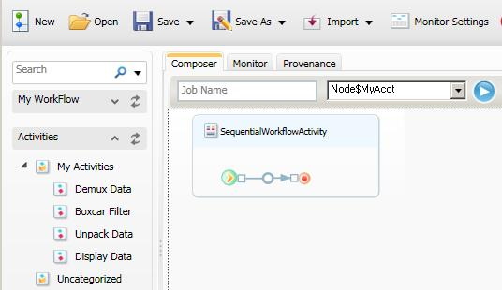

Figure 20. A new workflow containing a root activity

## Step 2a: Add an Unpack Data Activity

The first activity in the workflow, *Unpack Data*, reads stored binary data from an input file and converts it into a .NET array (**double[ ]**).

**Note:** All the activities in these tutorials are stored in the **Activities** catalog under **My Activities**, which is not part of the default Workflow catalog. For a discussion of how to add folders to the catalog, see “Trident Management Studio User’s Guide.”

To add *Unpack Data* to the workflow

1. Open the **Activities** catalog.

2. Drag *Unpack Data* from My Activities and drop it on the **SequentialActivity** insertion point.

3. Right-click the *Unpack Data* property set, and then click **Properties** to display the **Property** sheet.

Figure 21 shows the resulting working pane.

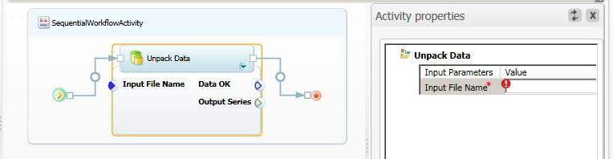

Figure 21. Workflow with *Unpack Data*

Initially, the *Input File Name* property is flagged with a red exclamation point, which indicates a required input property without an assigned value. You cannot save or run a workflow until all required properties have been set. In this case, enter the input file name, C:\TridentInput\Timeseries1. Setting a required property’s value removes the exclamation point, as shown in Figure 22.

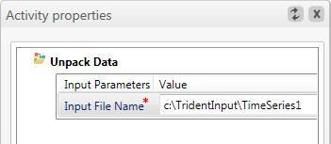

Figure 22. Required property with an assigned value

**Note:** The property sheet does not validate assigned values. The asterisk indicates only that the property has been set, not whether it is correct. It does not, for example, check whether C:\TridentInput\TimeSeries represents an actual file.

*Unpack Data’s* output is assigned to the *Output Series* property. The *Data OK* property is not used in this workflow.

## Step2b: Use Type Initializers to Initialize Properties

The version of UnpackData used in Step 2 requires you to manually enter the fully qualified name of the input file, which can be somewhat cumbersome. In addition, manual data entry works only for primitive data types such a **string** or **int**. If, for example, the *InputSeries* type was a **FileInfo** object instead of a **string**, there’s no straightforward way to initialize the object by using a text box.

Type initializers allow the user to enter the data for complex data types by displaying an appropriate UI. For example, a **FileInfo** type initializer might display a UI that runs the **File** **Open** dialog box, to allow you to specify the appropriate file. When the user closes the UI, the initializer passes the initialized object back to Composer.

You can implement a type initializer for any data type, and then import it into Workbench. If a data type has a type initializer, the property sheet displays an ellipsis button to the right of the property’s edit box, as shown in Figure 23.

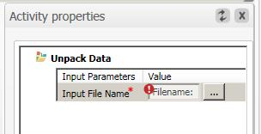

Figure 23. Property with a type initializer

In this case, it is a **FileInfo** type initializer. An example of a FileInfo initializer, FileInfoInitializer, is included with the activity examples. You can use the initializer with your workflow by using the primary toolbar’s Import button to import it into the Trident Registry. The procedure is similar to importing an activity.

To use a type initializer

1. Click the ellipsis (…) button to open the UI.

In this example, the **FileInfo** type initializer opens the dialog box shown in Figure 24. Other initializers will have a UI suitable to the data type.

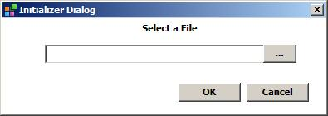  
**Figure 24. FileInfo type initializer UI**

2. Enter the data.

If you click the dialog box’s ellipsis button, the initializer opens an **Open File** dialog box, which you can then use to locate and specify the appropriate file. You can also enter the file name manually in the text box.

For more information on type initializers, see “Trident Programming Guide.”

## Step 3: Add the Boxcar Filter Activity

The *Boxcar Filter* activity takes the output array from *Unpack Data* and applies a boxcar filter to the series.

To add *Boxcar Filter* to the workflow

1. Drag the *Boxcar Filter* activity from My Activities, and drop it on the insertion point immediately to the right of *Unpack Data*.

2. Double-click the activity’s property set to display its property sheet.

Figure 25 shows the Composer working pane for this step.

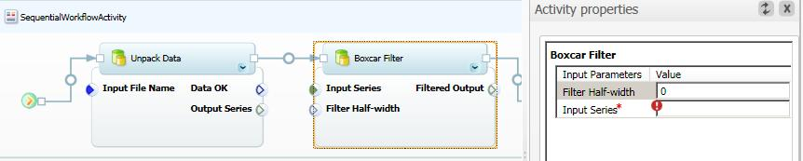

Figure 25. Workflow with *Boxcar Filter*

You can set input properties in either of two ways:

* Assign a value to the property, as discussed in the previous section

—Or—

* Bind the property to an upstream activity’s output property.

You define how data flows from one activity to the next by binding output properties to appropriate input properties. Every activity property corresponds to the name of a dependency property on the activity object. The name has the form *ObjectName*.*PropertyName*, where *ObjectName* is created by Composer when you add the activity to the workflow. The *Unpack Data* object in this example is named UnpackData_2, and the dependency property name is OutputSeries.

You can bind any output property to a corresponding input property, as long as the data types are compatible. Binding properties assign the name of the output dependency property to the input property, so the activity can use the name to access the data.

For *Boxcar Filter*:

* *Input Series* is a required property that represents the time series to be filtered, and it must be bound to an output property.
* *Filter Half-width* is an optional property that specifies the filter’s half-width, and it can be set explicitly.

You could also set *Filter Half-width* by binding it to an appropriate output property. However, because it is an optional property, this example leaves it blank, and *Boxcar Filter* uses the default value.

To bind Output Series to Input Series

1. Right-click the *Output Series* icon on *Unpack Data* and hold down the right mouse button.

2. Drag the cursor to the *Input Series* icon on *Boxcar Filter*, and then when the cursor changes to an arrow, release the button.

After the data is successfully bound:

The two properties are connected by a line.

The Input Series entry in the property pane is set to the appropriate dependency property name, UnpackData_2.OutputSeries.

Figure 26 shows the resulting Composer pane.

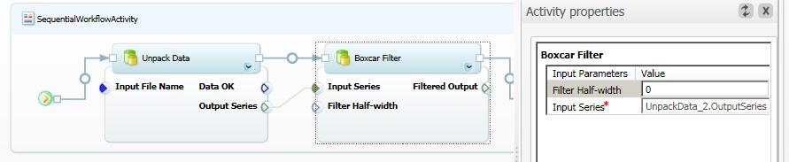

Figure 26. Workflow with data binding

## Step 4: Add the Display Data Activity

The final activity in this workflow is *Display Data*, which displays the filtered time series.

To add *Display Data* to the workflow

1. Drop *Display Data* on the insertion point to the right of *Boxcar Filter*.

2. Bind *Boxcar Filter’s Filtered Output* property to *Display Data’s* *Filtered Series 1* property.

Figure 27 shows the resulting Composer pane.

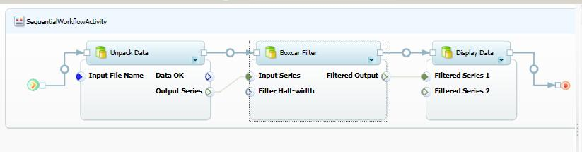

Figure 27. Completed workflow

*Display Data* also has an optional *Filtered Series 2* input, which allows you to also display a second series. If you don’t bind any data to this property, *Display Data* displays the series that is bound to *Filtered Series 1*.

## Step 5: Run the Workflow

You must specify workflow properties before running the workflow.

To run the completed workflow

1. Click **Execute**.

If you haven’t done so already, Composer will ask you to specify the workflow’s name and category by displaying the **Workflow Properties** dialog box, which is shown in Figure 28. If you have neglected to set any required input properties, you can do so here.

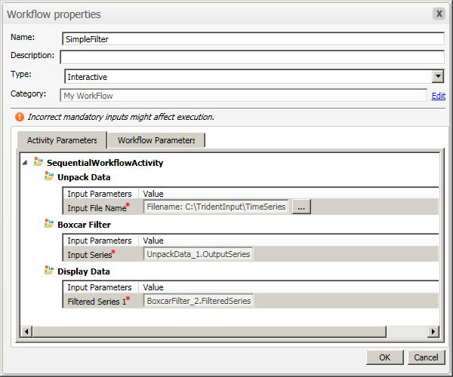   
Figure 28. Workflow properties dialog box

2. Set the following fields:

Name: Name the example SimpleFilter.

Type: Specify interactive type.

Category: Click **Edit** at the right side of the box, and select the My Workflow folder.

3. Click **OK** to start the workflow.

**Important:** There are two interactive types:

* **Interactive workflows** run in the user account, and can display UI such as graphs.

If your workflow displays a UI, you must run it as an interactive workflow. For example, Ocean Currents displays a graph, so it must be an interactive workflow. If, for example, you try to run Ocean Currents as non-interactive, the workflow hangs when it reaches the Display DataTable Chart activity, which displays the graph.

* **Non-interactive workflows** run as a service, so they cannot display a UI.

Services tend to be more reliable than applications running in a user account, so the non-interactive type might be preferable if your workflow does not display a UI.

## Step 6: Monitor the Workflow

After the workflow starts, Composer displays the **Monitor** pane, to allow you to monitor the workflow’s progress. Figure 29 shows the Monitor pane for SimpleFilter.

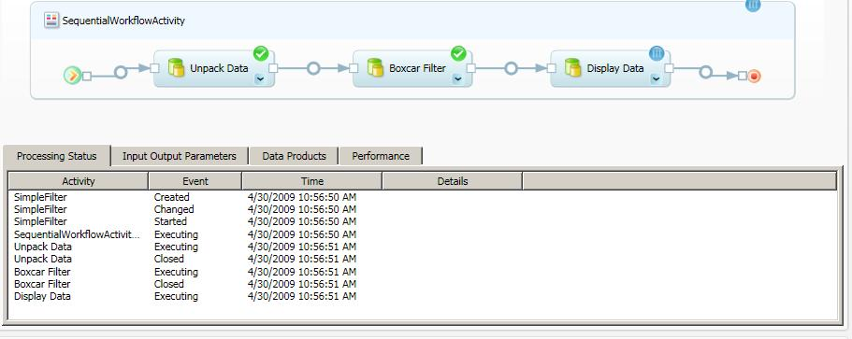

Figure 29. Monitor pane for SimpleFilter

In Figure 29, the workflow shown earlier in Figure 28 has successfully completed the first two activities and is currently running *Display Data*, as indicated by the icons in the upper pane and the events in the lower pane.

## Step 7: Debug the Activity

Activities are DLLs, hosted by the Trident application. In general, debugging hosted DLLs is somewhat complicated. However, the Composer working pane toolbar includes a **Debug** button that simplifies the process. This section describes how to debug HelloWorld Sample, but the basic procedure can be used for any activity.

To debug HelloWorld Sample

Refer Trident_Quickstart.doc for how to create HelloWorld activity using Visual Studio

1.Open the HelloWorld project in Visual Studio as Administrator.   
It is important to run the visual studio as Administrator otherwise you will not see the opened Visual Studio in list of possible debuggers, during step 5.

2. Open the Trident Workflow Composer and Double click My HelloWorld the workflow.

3. After opening the workflow in Composer, click **Debug** to run My HelloWorld in debugging mode.

4. When the system displays the Visual Studio **Just-In-Time Debugger** dialog box,

If Visual Studio displays a message box asking whether you wanted to Debug TridentWorkflowHost.exe, click **Yes**.

5. The system should display a second Visual Studio **Just-In-Time Debugger** dialog box, indicating an unhandled exception.6. Select **HelloWorld - ...** from the list of possible debuggers, and click **Yes**.

This action displays a Microsoft Visual Studio dialog box stating that no symbols are loaded for any call stack frame.

6. Ignore the warning and click **OK** to enter the debugger.

The warning applies to the host application—TridentWorkflowHost.exe—not the HelloWorld activity.

7. Set a breakpoint in HelloWorld activity project in Visual Studio, if you have not already done so.

See “Implement HelloWorld Sample,” earlier in this paper for directions.

8. In Visual Studio, press F5 to continue execution until the workflow runtime reaches your activity.

The breakpoint should now be highlighted in Visual Studio.

9. Press F10 to step over the current line of code.

You can now examine variables, step through the method, and so on.

## Step 8 : Save workflow to filesystem

1. Open Workflow composer.
2. Double click the workflow needs to be saved from left pane to open it, if it is not already open.
3. Click on the arrow at the right corner of ‘SaveAs’ button in the toolbar.
4. Select the filesystem option from dropdown menu.
5. Select the folder to save the workflow (for example c:\Myworkflows1) .
6. After giving filename for the workflow (for example: MyWorkflow1), click on Save.
7. Copy all activity dlls and dependency dlls to the same folder manully, where you saved the workflow (for example c:\MyWorkflow1). Depedency assemblies are required for re-importing the workflow later .

# Demux: Add a ParallelActivity Activity to SimpleFilter

Scientists commonly use multiplexing to pack several time series into a single data file. This section modifies the SimpleFilter workflow from the previous section to create the DeMux workflow, which handles a multiplexed file that contains two time series. This example shows how to:

* Insert activities into an existing workflow.
* Bind multiple data streams.
* Use the **ParallelActivity** activity to run two activities in parallel.

## Step 1: Add the Demux Data Activity

The *Demux Data* activity takes a multiplexed data array from *Unpack Data* and demultiplexes it to produce two separate time series.

To add the Demux Data activity

1. Delete the *Boxcar Filter* activity.

Deleting an activity also deletes any data bindings.

2. Drag *Demux Data* from My Activities and drop it on the insertion point between *UnpackData* and *Display Data*.

3. Bind *Demux Data* activity’s *Input Series* property.

4. Set the *Unpack Data* activity’s *Input* *File Name* property to C:\TridentInput\TimeSeries2, which contains the multiplexed time series.

Figure 30 shows the resulting workflow.

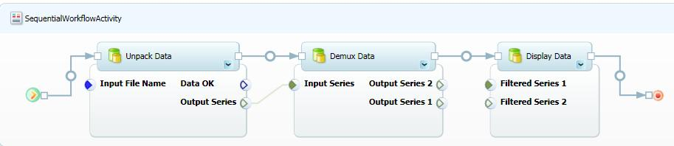

Figure 30. Adding the *Demux Dat*a activity

## Step 2: Add ParallelActivity to the Workflow

In this example, there are now two series to filter, but *Boxcar Filter* takes only one input series. You could implement another filter activity that takes two input series, but Trident supports a simpler approach.

**ParallelActivity** is a Trident composite activity—based on the WF **Parallel** activity—that allows you to run multiple activities in parallel. Strictly speaking, only one activity is running at any given time, but for most purposes you can consider them to be concurrent. For more information, see the Windows Workflow Foundation documentation for the **Parallel** activity.

To add a ParallelActivity activity to the workflow

* Drag **ParallelActivity** from the catalog and drop on the insertion point between *Demux Data* and Display data.

**ParallelActivity** is in the Windows Workflow 3.0 folder.

Figure 31 shows the resulting workflow.

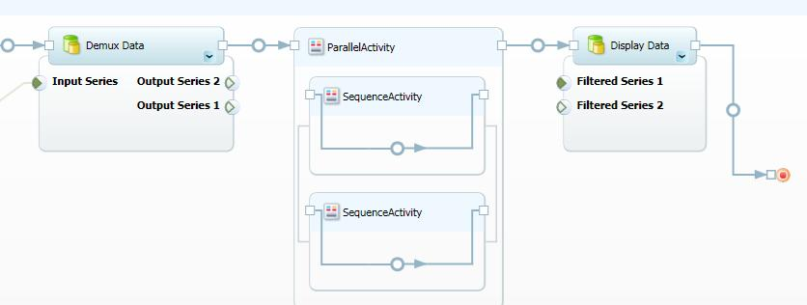

Figure 31. Adding a ParallelWorkflow

**ParallelActivity** hosts two **SequenceActivity** activities. For this example, each **SequenceActivity** activity will host a single *Boxcar Filter* activity. To run more than two activities in parallel, drop a **ParallelActivity** activity into either or both of the **SequenceActivity** activities.

To add *Boxcar Filters* to the workflow

1. Drag a *Boxcar Filter* activity from the catalog and drop it on the upper **SequenceActivity** activity’s insertion point.

2. Drag a *Boxcar Filter* activity from the catalog and drop it on the lower **SequenceActivity** activity’s insertion point.

3. Bind *Demux Data’s* *Output Series 2* property to the upper *Boxcar Filter’s* *Input Series* property.

4. Bind *Demux Data’s Output Series 1* property to the lower *Boxcar* *Filter’s* *Input* *Series* property.

5. Bind the upper *Boxcar* *Filter’s Filtered Output* property to *Display Data’s Filtered Series 1* property.

6. Bind the lower *Boxcar Filter’s Filtered Output* property to *Display Data’s Filtered Series 2* property.

Figure 32 shows the resulting workflow, which is ready to run.

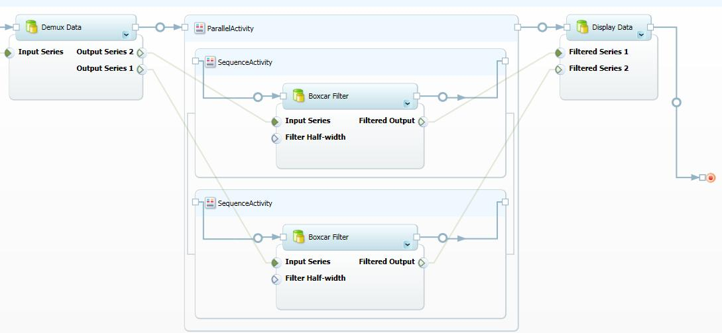

Figure 32. Workflow with two Boxcar Filter activities

Other ways to run multiple activities as a group include the Trident **Replicator** and **For Loop** activities, which are discussed later.

# Validate: Add an If Else Conditional to Demux

Applications usually validate data before trying to process it. This section modifies the Demux workflow to create the Validate workflow, which validates the input data. This section shows how to:

* Use an **If Else** activity to manage control flow.
* Use condition activities to control the **If Else** activity’s behavior.
* Use a **Terminate** activity to terminate a workflow.

## Step 1: Add an If Else Activity to the Workflow

**If Else** is a composite activity that allows you direct the workflow into either of two branches, based on user-defined conditions. *Unpack Data* tests the data in the input file, and sets the *Data OK* property to indicate whether the data is valid. The **If Els**e activity uses the *Data OK* value to direct the workflow into one of two branches.

To add an If Else activity to the workflow

* Drop an **If Else** activity on the insertion point between *Unpack Data* and *Demux* *Data*.

**If Else** is under **Trident Activities**\**Control Flow**.

Figure 33 shows the resulting workflow.

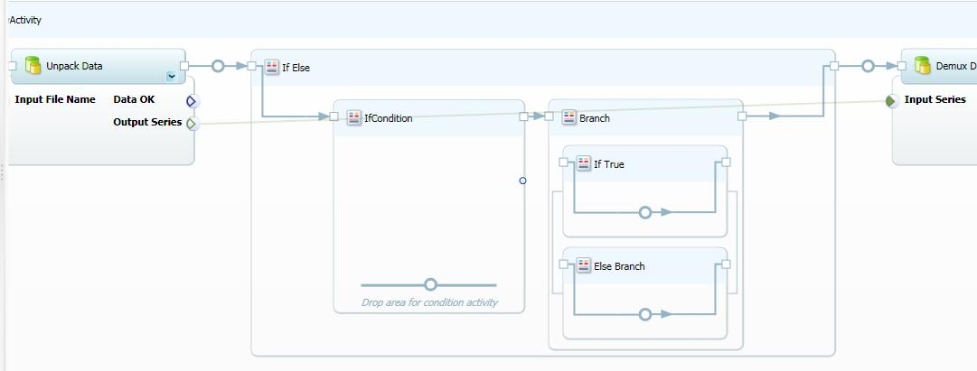

Figure 33. Workflow with an If Else activity

## Step 2 Add a Condition to the If Else Activity

The **If Else** activity has insertion points for three activities:

* **If Condition** is where you drop condition activities.

Condition activities determine which branch of the workflow is to be run. They take one or two inputs and have a single Boolean output.

* **If True** is where you drop the activity to be run if the condition evaluates to **True**.
* **Else Branch** is where you drop the activity to be run if the condition evaluates to **False**.

Most condition activities compare two input properties and set the output to **True** or **False**. For example, **String Equal** compares two strings, and sets the output property to **True** if the strings are equal and **False** otherwise. You can set the input properties manually, or bind them to a property from an upstream activity. For example, you could use the property sheet to set one of the **String Equal** inputs to “My String” and bind the other to an output property of an upstream activity.

The ability to bind properties to conditions allows you to chain conditionals and construct composite conditions. For example:

1. Bind an upstream property to **String Equal** to test for a specified string value.

2. Bind an upstream property to **Integer Equal** to test for a specified integer value.

3. Bind the outputs of **String Equal** and **Integer Equal** to an **AND** activity, which evaluates to **True** if both inputs are set to **True**, and **False** otherwise.

4. Bind the output of the **AND** activity to the small circle on the right edge of **If Condition**.

This specifies that the output of the **AND** activity controls which branch is to be run.

If both upstream properties satisfy the tests, **If Else** runs **If True**. Otherwise, it runs **Else Branch**. Figure 34 shows this composite conditional in Composer.

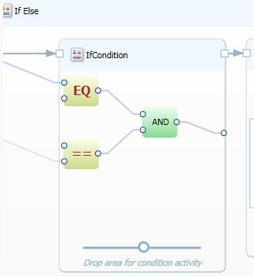

Figure 34. Composite conditional

Validate uses an **AND** conditional activity to test whether the *Unpack Data* activity’s *Data OK* property is set to **True**.

To include an AND conditional activity

1. Drop an **AND** conditional activity in **If Condition**.

The condition activities are located under **Trident Activities**\**Control Flow**\**Condition**. The **AND** activity is named **Condition AND**.

2. Bind *Data OK* to one of the **AND** activity’s input properties.

3. Open the **AND** activity’s property sheet and set the other input property to **True**.

4. Bind the **AND** activity’s output property to the circle at the right edge of **If Condition**.

The Workflow runs **If True** if the data is valid, and runs **Else Branch** otherwise. Figure 35 shows the results in the Composer pane.

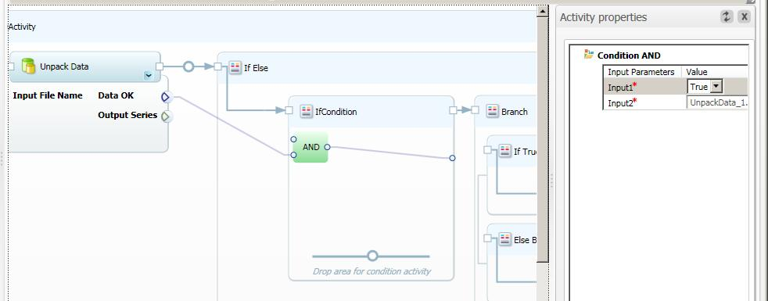

Figure 35. Adding an AND conditional to Validate

## Step 3: Assign a TerminateActivity Activity to the Else Branch

If *Data OK* is **False**, **If Else** runs the **Else Branch**. The simplest approach to handling invalid data is to terminate the workflow gracefully by running a **TerminateActivity** activity.

To add TerminateActivity to the Else Branch

* Drop a **TerminateActivity** activity on the **Else Branch** insertion point.

**TerminateActivity** is located under **Windows Workflow 3.0**. It has no properties; it simply terminates the workflow.

## Step 4: Move Demux Data to If True

If *Data OK* is **True**, **If Else** runs **If True**, which runs the remainder of the workflow. The simplest approach is to put Demux Data in **If True** and bind it to the next activity.

To assign Demux Data to If True

1. Delete the *Demux Data* activity.

2. Drop a new instance of *Demux Data* on the **If True** insertion point.

This breaks the data binding, so you need to rebind *Demux Data’s* properties.

3. Bind *Unpack Data’s* *Output Series* property to *Demux Data’s* *Input Series* property.

4. Bind *Demux Data’s* Output Series 2 property to the upper *Boxcar Filter’s Input Series* property.

5. Bind *Demux Data’s* *Output Series 1* property to the lower *Boxcar* *Filter’s* *Input* *Series* property.

Figure 36 shows the complete workflow in the Composer pane.

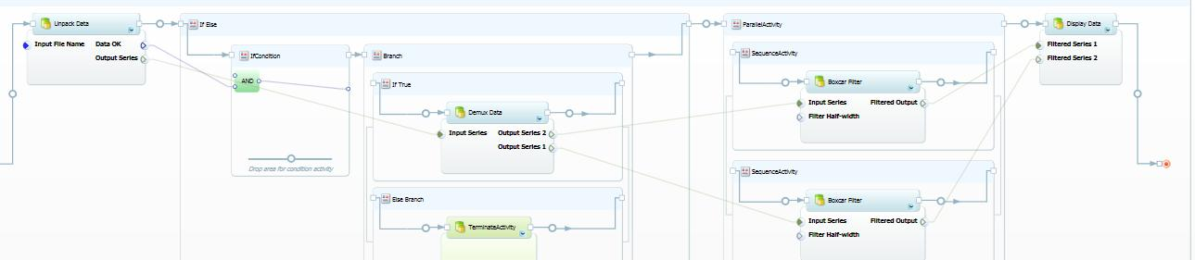

Figure 36. The complete Validate workflow

# Demux 2: Add a Replicator Activity to SimpleFilter

The Demux workflow uses a **ParallelActivity** activity to run two instances of the BoxcarFilter activity. However, **ParallelActivity** has a fixed number of child activities—two in this case. What if your data files contain varying numbers of series? With Demux, you must modify the workflow to change the number of series it handles.

One solution is the Trident **Replicator** activity, which is based on the WF **Replicator** activity. **Replicator** works in much the same way as a **foreach** operator. The input is a collection—represented by an **IList** interface—which can contain any number of items. **Replicator** contains a child activity which processes the data. To process the input collection, **Replicator** creates a separate instance of the child activity for each item in the input collection and runs each instance.

Figure 37 shows the Trident Replicator activity, as it appears in Composer.

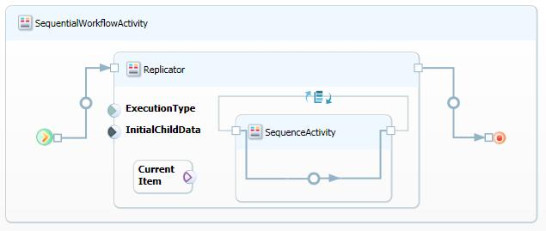

Figure 37. Trident Replicator activity

**Replicator** has four key elements:

ExecutionType Input Property

This property specifies the **ExecutionType** setting, and must be set to either **Sequence** or **Parallel**.

InitialChildData Input Property

This property is an **IList** type that represents the input collection. You bind the output property associated with the collection to **InitialChildData**.

Current Item

This component represents the item being processed. You bind it to the appropriate input property on the child activity.

Child Activity

Trident **Replicator’s** child activity is a **SequenceActivity**.

**Tip: Replicator** does not have an output property, so it is often the workflow’s terminal activity. Technically, you can bind the output of the child activity to a downstream activity, but that activity receives the data from only the last instance of the child activity. If you want to use a downstream activity to process **Replicator** output, one option is to write the child activities’ output data to storage, and then read the stored data.

## Step 1: Start the Demux 2 Workflow

Demux 2 is a modified version of the Demux workflow that uses a **Replicator** activity to process input files that contain an arbitrary number of multiplexed time series. To accommodate the **Replicator** activity, the workflow uses slightly modified versions of two of the Demux activities, *Demux Data* and *Boxcar Filter*, which are named *Demux Data 2* and *Boxcar Filter 2*.

DemuxData 2

*DemuxData 2* demultiplexes the array from *Unpack Data*, as before, but it packages the results into a collection of **double [ ]** arrays, and assigns the collection to its single output property, *OutputSeries*.

BoxcarFilter 2

**BoxcarFilter 2** applies a boxcar filter to a **double [ ]** array and outputs the filtered array, as before. However, the *InputSeries* input property is an **object** type instead of **double [ ]**, so that the property can be bound to **CurrentItem**.

The first part of Demux 2 is nearly identical to Demux. The only difference is that *Demux Data 2* replaces *Demux Data*.

To start the Demux 2 workflow

1. Open Composer and start a new workflow.

2. Drop an *UnpackData* activity on the insertion point, and set the *Input File Name* property.

3. Drop a *DemuxData 2* activity on the insertion point to the right of *UnpackData*.

4. Assign C:\TridentInput\TimeSeries2 to the *UnpackData* activity’s *Input File Name* property.

5. Bind the *UnpackData* activity’s *Output Series* property to the *Demux Data 2* activity’s *Input Series* property.

Figure 38 shows the resulting workflow.

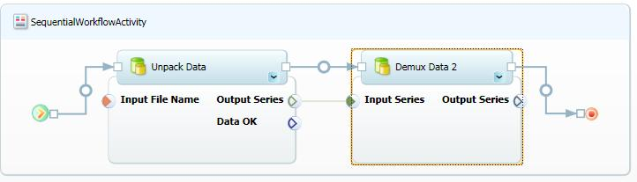

Figure 38. Demux 2 workflow with two activities

## Step 2: Add a Replicator Activity to the Workflow

The *Output Series* property represents the demultiplexed time series as a collection of **double** arrays. The next step is to add a **Replicator** to the workflow to filter and display each series.

To add a Replicator to Demux 2

1. Drop a **Replicator** activity on the insertion point to the right of *Demux Data 2*.

The **Replicator** activity is in the Workflow Catalog’s **Trident Activities\Control Flow** folder.

2. Bind the *Demux Data 2* activity’s *Output Series* property to the **Replicator** activity’s **InitialChildData** property.

Figure 39 shows the resulting workflow.

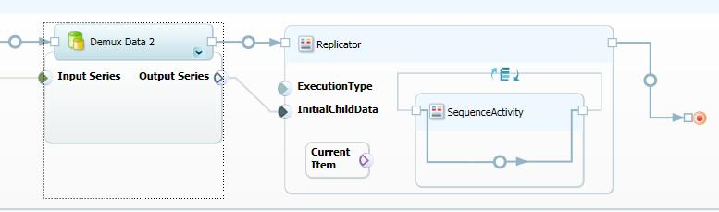

Figure 39. Demux 2 with a Replicator activity

## Step 3. Add Child Activities to Replicator

The final task is to filter and display the time series.

To filter and display the time series

1. Drop a *Boxcar Filter 2* activity on the **Replicator** insertion point.

2. Drop a *Display Data* activity on the insertion point to the right of *Boxcar Filter 2*, but still within **Replicator**.

This displays each series in a separate window.

3. Bind **Current Item** to the *Boxcar Filter 2* activity’s *Input Series* property.

4. Bind the *Boxcar Filter 2* activity’s *Filtered Output* property to the *Display Data* activity’s *Filtered Series 1* property.

Figure 40 shows an excerpt of the resulting workflow, which is ready to run.

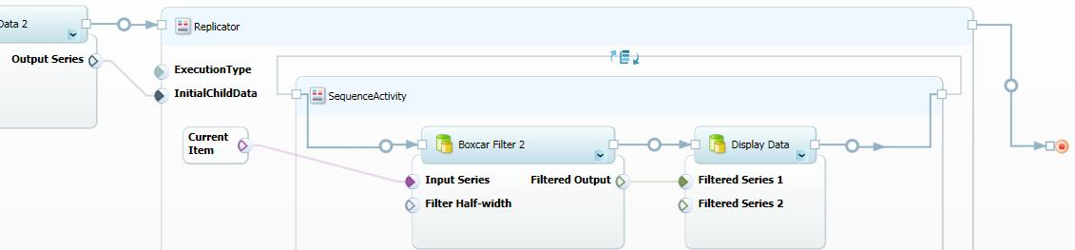

Figure 40. The completed Demux 2 workflow

# SimpleFilter 2: Add a For Loop Activity to SimpleFilter

SimpleFilter filters and displays a single filtered time series, with the amount of smoothing that is controlled by the *Boxcar Filter* activity’s *Filter Half-width* property. However, you often don’t know in advance how much smoothing is appropriate for a particular series. You could run SimpleFilter multiple times and set *Filter Half-width* to a variety of values. A more efficient approach is to use a **For Loop** activity to do the task automatically.

The **For Loop** activity works in much the same way as a **for** operator. You specify start, end, and step values for the index, and **For Loop** then runs its child activity once for each index value.

Figure 41 shows the **For Loop** activity in Composer.

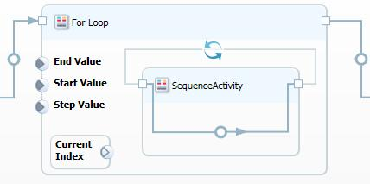

Figure 41. For Loop activity

The activity has the following key components:

Start Value Input Property

The starting index.

Step Value Input Property

How much to increment the index for each iteration.

End Value Input Property

The final index value.

Current Index

This component represents the loop’s current index value. If you want to use the index value, bind **Current** **Index** to the appropriate input property on the child activity. Otherwise, ignore **Current Index** value, and **For Loop** simply runs the child activity a specified number of times.

Child Activity

The Trident **For Loop** activity’s child activity is a **SequenceActivity**.

**Tip:** Like **Replicator**, **For Loop** does not have an output property, so it is often the workflow’s terminal activity. You can bind the output of the child activity to a downstream activity, but that activity receives the data from only the last instance of the child activity. If you want to use a downstream activity to process **For Loop** output, one option is to write the child activity output data to storage, and then have the downstream activity read the stored data.

SimpleFilter 2 is a modified version of SimpleFilter—based on the same activities—that uses a **For Loop** activity to run *Boxcar Filter* automatically multiple times with a range *Filter Half-width* values. The final step in this section shows how to use **For Loop** to implement a simple Monte Carlo simulation that runs SimpleFilter with randomly selected *Filter Half-width* values.

## Step 1: Create the Basic SimpleFilter 2 Workflow

SimpleFilter 2 consists of an *Unpack Data* activity followed by a **For Loop** activity.

To create the basic workflow

1. Open Composer and start a new workflow.

2. Drop an *UnpackData* activity on the insertion point, and assign C:\TridentInput\TimeSeries1 to *UnpackData* activity’s *Input File Name* property.

3. Drop a **For Loop** activity on the insertion point to the right of *Unpack Data.*

**For Loop** is in the Workflow Catalog’s Trident Activities\Control Flow folder.

Figure 42 shows the resulting workflow.

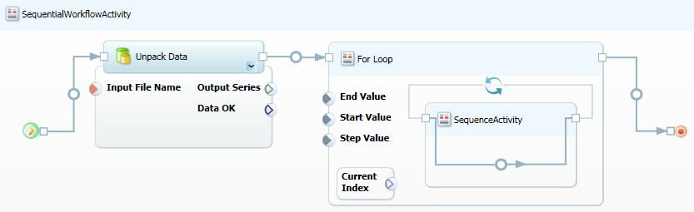

Figure 42. The basic SimpleFilter 2 workflow

## Step 2: Implement the For Loop Activity

The **For Loop** activity hosts the *Boxcar Filter* and *Display Data* activities. The loop parameters are set to produce five iterations, with *Filter Half-width* values ranging from 10 to 50.

To implement the For Loop activity

1. Drop a *Boxcar Filter* activity on the **For Loop** activity’s insertion point.

2. Drop a *Display Data* activity on the insertion point to the right of the *Boxcar Filter* activity, but still within the **For Loop** activity.

3. Bind the *Unpack Data* activity’s *Output Series* property to the *Boxcar Filter* activity’s *Input Series* property.

4. Bind the *Boxcar Filter* activity’s *Filtered Output* property to the *Display Data* activity’s *Filtered Series 1* property.

5. Bind **Current Index** to the *Boxcar Filter* activity’s *Filter Half-width* property, and set the index parameters as follows:

**Start Value**: 1.

**Step Value**: 2.

**End Value**: 10.

Figure 43 shows the completed workflow.

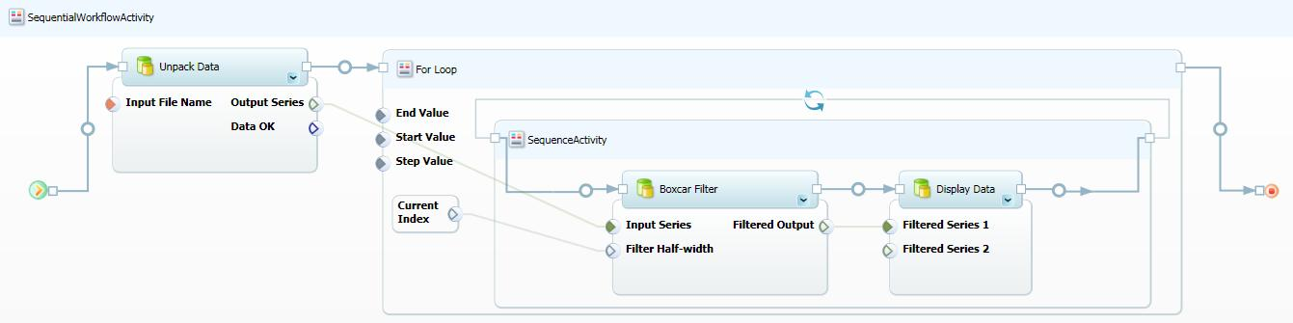

Figure 43. SimpleFilter2 workflow

## Step 3: Implement SimpleFilter 2 as a Monte Carlo Simulation

Monte Carlo simulations are a simple way to explore a solution space. This example shows how to use Trident to implement a simple Monte Carlo simulation, using a modified version of SimpleFilter 2. Instead of using the **Current Index** value to specify a series of *Filter Half-width* values, this example randomly varies *Filter Half-width* over a specified range. It’s probably not the best way study a time series, but the procedure can be readily adapted to more suitable problems.

To implement SimpleFilter 2 as a Monte Carlo simulation

1. Remove the binding between **Current Index** and *Filter Half-width* by right-clicking the binding and clicking **Delete Parameter Bindings**.

2. Set the loop parameters to run the simulation five times:

**Start Value**: 1

**Step Value**: 1

**End Value**: 5

3. Drop an **Integer Random Generator** activity on the insertion point to the left of *Boxcar Filter*.

**Integer Random Generator** is in the Workflow Catalog’s Trident Activities\Utilities folder.

4. Bind the **Integer Random Generator** activity’s **Output** property to the *Boxcar Filter* activity’s *Filter Half-width* property.

5. Set the **Integer Random Generator** activity’s **Max Value** property to 50, which varies *Filter Half-width* between 0 and 50.

Figure 44 shows the **For Loop** from the resulting workflow. The rest is identical to the previous version of Simple Filter 2. The loop runs five times and displays each filtered series in a separate window.

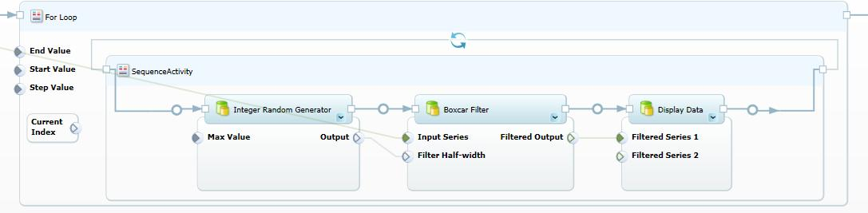

Figure 44. Simple Filter 2 Monte Carlo simulation

# Troubleshooting

This section describes methods for troubleshooting issues.

The workflow hangs when it tries to display a UI

The workflow stalls when it reaches an activity that displays a UI.

Cause 1

If the workflow displays a UI—such as a graph of the final results— the UI window usually must be closed before the workflow can proceed.

Solution 1: The window might not have a Taskbar icon, and it might be covered by other windows. Check to make sure that the UI is not concealed by another window, including the Composer or Management Studio windows. If so, minimize the windows, and close the UI window. The workflow should proceed.

Cause 2

The workflow is running in non-interactive mode. Workflows that display a UI must run in interactive mode.

Solution 2: Terminate the workflow. The associated TridentWorkflowHost.exe should be killed from Windows TaskManager.

To restart the services

1. Open a command window with elevated privileges.

2. Stop the services by running the following command, which stops both services:

net stop tridentexecutionservice

3. Restart the services by running the following command, which restarts both services:

net start tridentexecutionservice

4. Change the workflow’s **Type** property to Interactive, and then run the workflow again.

**Tip:** It is sometimes easier to reboot your system, which automatically stops and restarts the services.

Terminated workflow is still consuming CPU resources

If you are not running any workflows but the system seems sluggish or is doing an unusually large number of disk seeks, run Task Manager to determine whether any of the Trident services or applications are still consuming significant CPU resources. If so, the misbehaving services or applications must be shut down and restarted.

Cause 1

You attempted to run a workflow that displays a UI in non-interactive mode. If you terminate such a workflow—either directly or by closing Trident Workbench—the services might still continue to consume resources.

Solution 1: Stop and restart the Trident services. For details, see the earlier troubleshooting item, “The workflow hangs when it tries to display a UI.”

Cause 2

TridentWorkflowHost.exe is still consuming CPU resources after the workflow terminates.

Solution 2: Use Task Manager to close the TridentWorkflowHost.exe process.

To restart the process

1. Click the **Start** button and open **All Programs**\**Startup**.

2. Click **TridentExecutorTray** to restart **TridentExecutorTray**.**exe**.

# Resources

This section provides links to additional information about Trident Workbench and related topics.

Microsoft Research Web site

<http://research.microsoft.com>

Dependency Properties Overview

<http://msdn.microsoft.com/en-us/library/ms752914.aspx>

Flowchart

<http://en.wikipedia.org/wiki/Flowcharts>

Project Trident Web site

<http://research.microsoft.com/en-us/collaboration/tools/trident.aspx>   
Provides all documentation for Project Trident, including:  
 “Trident Management Studio User’s Guide”   
“Trident Programming Guide”

Windows Workflow Foundation on MSDN®

<http://msdn.microsoft.com/en-us/library/ms735967.aspx>

Windows Workflow Foundation Essentials

<http://www.devx.com/codemag/Article/36317/1763/page/1>

Windows Workflow Foundation: Step by Step

<http://www.microsoft.com/learning/en/us/Books/10023.aspx>