1. NaradaBrokering
NaradaBrokering is an open source technology supporting a suite of capabilities for reliable/robust flexible messaging; given the message based service architecture of Grids, this project is aimed at providing for the transport of messages between services and between services and clients. NaradaBrokering is designed around a scalable distributed network of cooperating message routers and processors.
Special features available in the current release include
- Publish-subscribe metaphor with general XML based topics
- 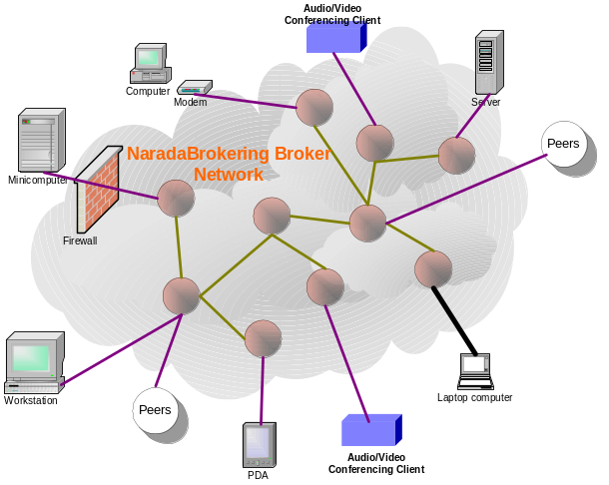Support for multiple protocols including TCP/IP (both blocking and non-blocking), UDP, Multicast, SSL, HTTP, RTP, HHMS (optimized for PDA and cell-phone access) and GridFTP with protocol chosen independently at each link
- The protocols can be chosen to tunnel through many firewalls and authenticating proxies.
- Interface to reliable storage and guaranteed order-preserving message delivery
- Support for message compression and decompression.
- Fragmentation and Coalescing of large files (>1 Gigabytes).
- JMS compliance and support for JXTA interactions.

Functionality | WebSphereMQ | Pastry | NaradaBrokering
Max number of nodes | Medium | Very large | Very large
Robust Messaging | Yes | Yes | Yes
Robust delivery of >1 Gigabyte files | Yes | No | Yes
Support for routing P2P Interactions | No | Yes | Yes (JXTA)
A/V Conf. and raw RTP clients | NA | NA | Yes
Proxies/firewalls tunneling | Yes | No | Yes
Dynamic Topics | No | No | Yes
XPath queries/subscriptions | No | No | Yes
Performance Monitoring | No | No | Yes
End-to-End security | Yes | No | Yes. (Dec 2003)
Support for Workflow | Yes. | No. | No.
Support for distributed caching | No. | Yes (Squirrel) | No.
Maturity of Software | Extremely mature | Fair | Fair
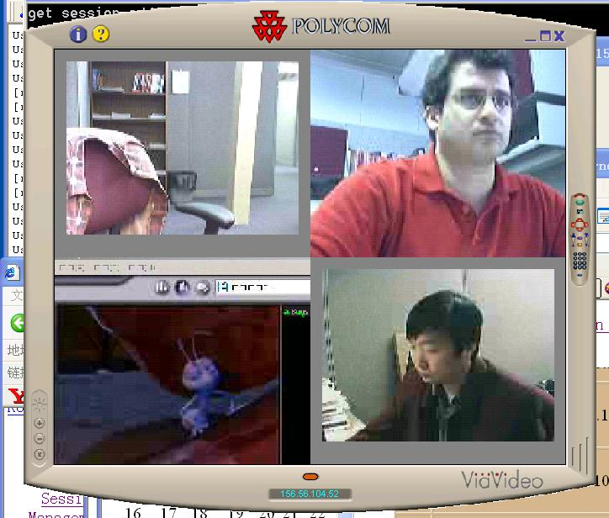
The NaradaBrokering software has been used extensively in several projects described below:.

2. GlobalMMCS
The GlobalMMCS technology is a new collaboration environment built around systematic use of Web (Grid) services and NaradaBrokering messaging. In particular it converts SIP, H323 and Access Grid protocols to a common Web service protocol XGSP. GlobalMMCS uses NaradaBrokering in all its communication whether it is in form of control packets or RTP based multimedia streams. It features Web/Grid services for session control, media type conversion, audio mixing and video mosaicing.
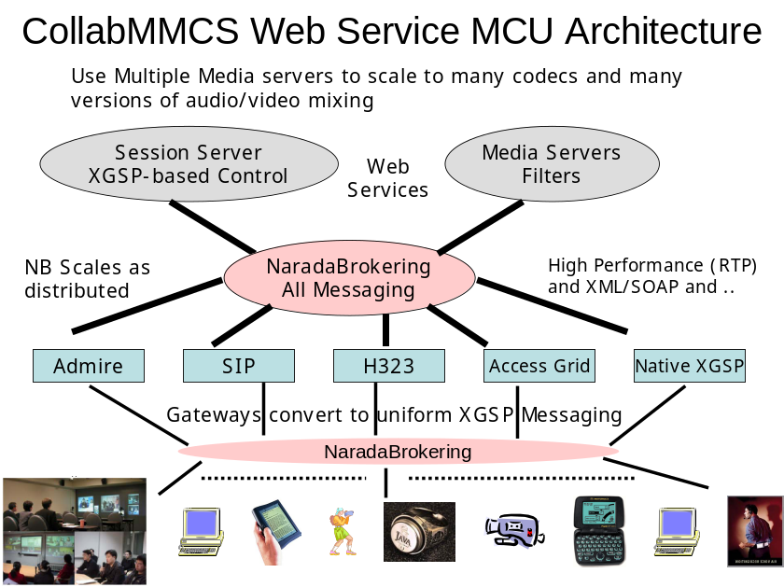
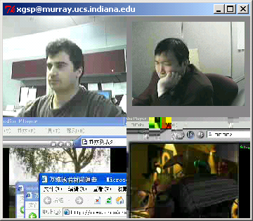
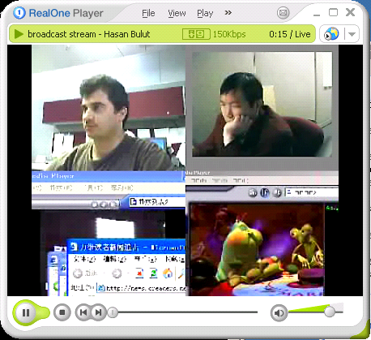
Functionality | Polycom ( H.323) | AccessGrid | GlobalMMCS
Protocol Support | Only H.323 clients | Only MBONE clients | H.323, SIP, MBONE
Server Architecture | Expensive H.323 Hardware/Software MCU | No conf. servers,  Needs multicast support in the network | Software Servers solution.  Based on Web Services
Network and  Communication  Environment | Internet / ISDN  Firewall transversal under the support of VPN | High performance with multicast support  No firewall tunneling | Publish/Subscribe with Firewall transversal (VPN optional)
A/V Interaction  Capability | Client shows a few video streams | A client shows up to 50 streams | A client shows up to 50 streams
Conferencing scalability | Usually less than 20~30 sites | Limited to the area of multicast networks | >1000 sites distributed over Internet
Integ. of streaming & conferencing | Only supports conferencing | Only supports conferencing | Any A/V source can be Streamed
Archive & Replay | No built in H.323 service | Voyager: allows replay of multiple streams | Multiple A/V streaming archive & replay
Other Collaboration Tools | Limited although T120 could support other apps | Limited to PowerPoint and chat | XGSP allows full integration of all tools

3. Universal Accessibility Service with NaradaBrokering
Universal access refers to the capability that all users are able to access information systems (grids) independent of their access device and their physical capabilities. The Carousel project addresses this for mobile devices such as smartphones and PDAs. We provide the collaborative service which is accessible from the heterogeneous types of mobile devices through NaradaBrokering.

3.1 Participating Collaborative Session with Mobile device
Carousel project allows users to participate a collaborative session with the mobile device wherever there are. The mobile users in the collaborative session share the application such as Microsoft PowerPoint or Web site browsed by Internet Explorer running on PCs. During the session, the mobile users also interact with other participants by exchanging text messages.

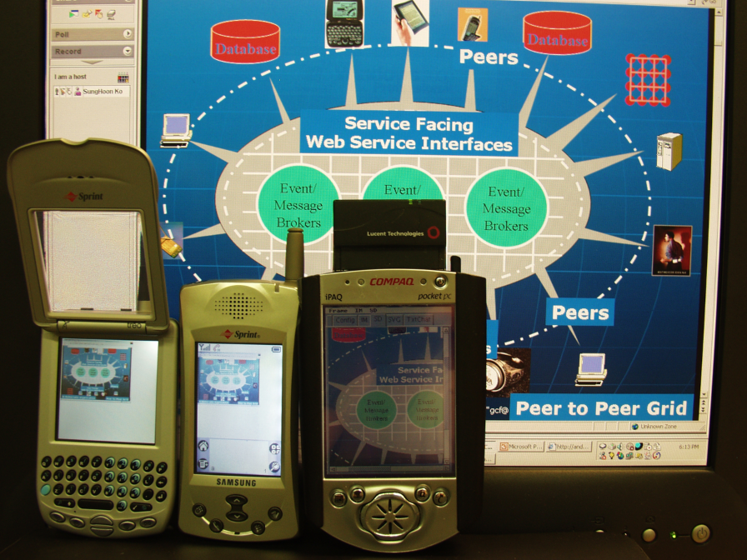
3.2 Support 3G Network Communication with NaradaBrokering
We are developing optimized protocol, HHMP (Hand-Held Message Protocol) for emerging 3G (Third-Generation) Network communication. This service provides seamless access from the mobile devices to NaradaBrokering.

3.3 MVC based dynamic sharing
Moreover, as an advanced sharing application technology, we support shared export which provides collaboration with more abstract data. Instead of sharing the framebuffer images as in shared display, the shared export exchanges abstract data such as vector graphics. We integrated W3C’s 2D vector graphics format, SVG (Scalable Vector Graphics) and also provide the interface for mobile devices of collaborative SVG. Our collaborative SVG is designed based on the MVC (Model-View-Control) model therefore the presentation view of each user can be controlled individually. With the collaborative SVG service, mobile device also shares the display under its individual control in high-quality graphics.

4. NaradaBrokering-enhanced GridFTP
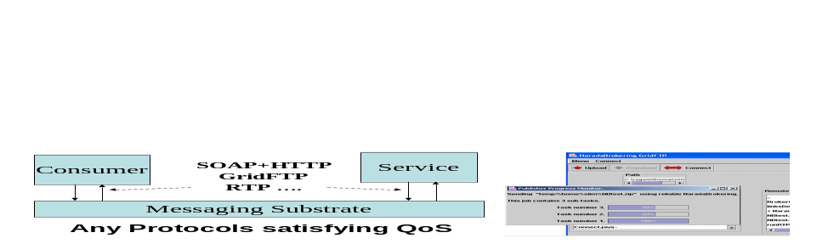We have integrated GridFTP with the NaradaBrokering system. The advantage of this approach is that the source code of the GridFTP client need not be changed and existing client code can be used with NB system without any modification. Due to its integration with the NaradaBrokering system, files can be recovered after failures or even prolonged disconnects. Files can be partially transmitted and if there is a failure the transmission begins at a point closer to point where the failure occurred.

5. Anabas Web Conferencing
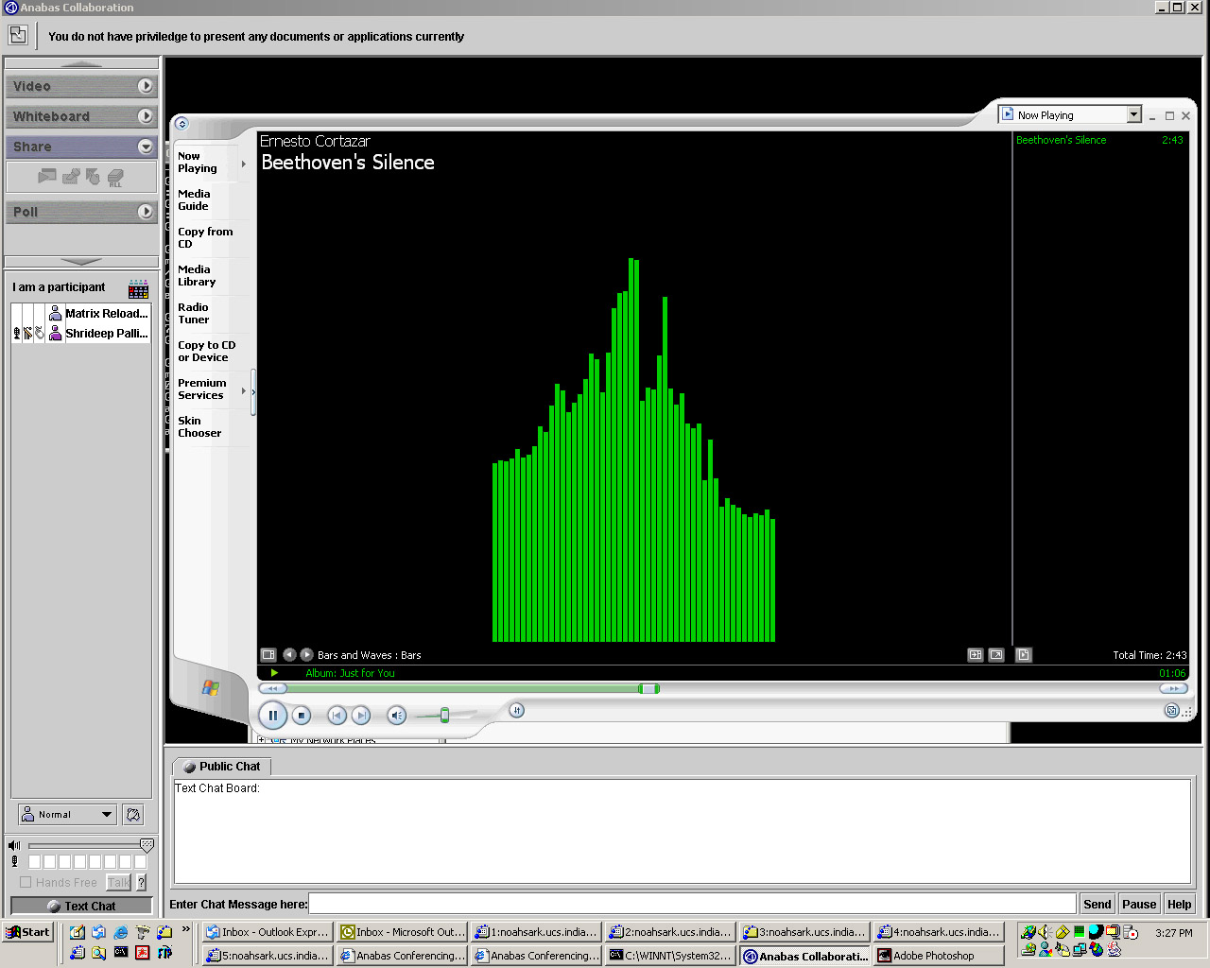
NaradaBrokering has also been deployed in real-time settings by providing back end support for the Anabas conferencing software running in JMS emulation mode. Several online seminars have been conducted using this Anabas-NaradaBrokering combination and the number of users collaborating concurrently has been in the excess of 30 users several times. Anabas uses NaradaBrokering to support shared display, text chats and all session control functions. Note shared display involves sharing large – sometime multi-megabit files specifying complete frame-buffer. The messaging system must handle this, the very dynamic video frames and the short text buffers of control and text chat.

6. Applications as Web Services

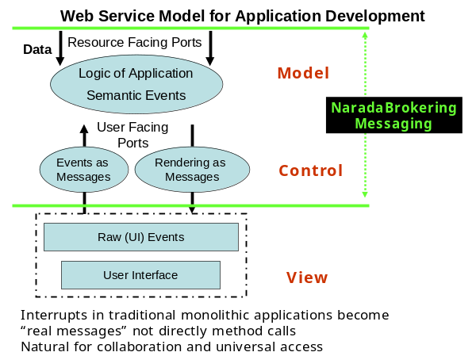
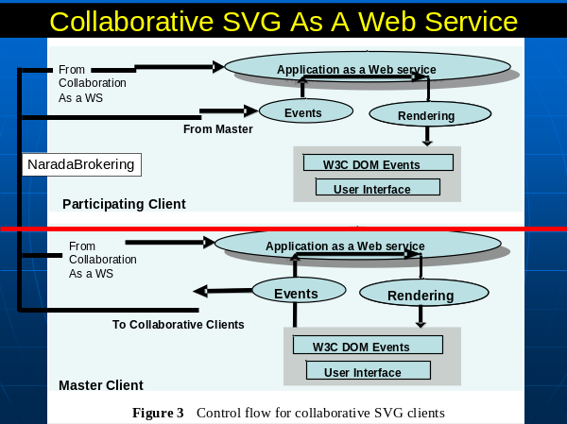
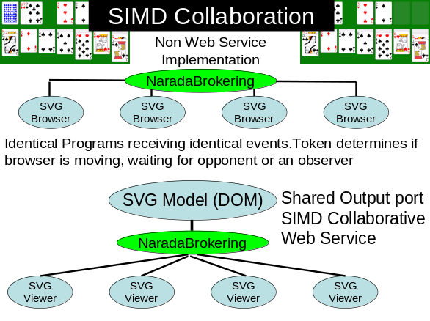
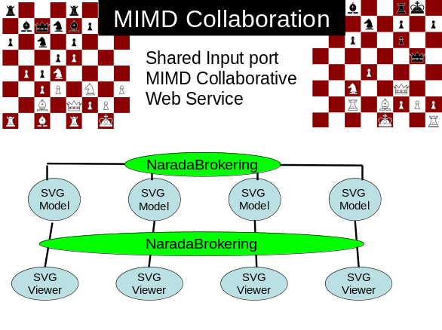
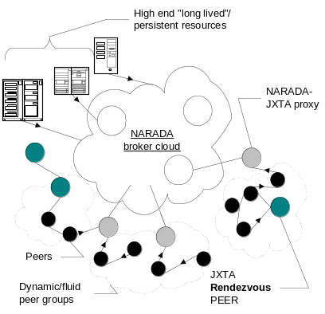
One can use the Web service model to build “ordinary” applications in the Model-View-Control paradigm with NaradaBrokering playing the role of the “control”. Conventionally a user-interaction generates an interrupt to which one posts listeners. This is replaced by a “view” module sending messages to a “model” Web service where a subscriber plays role of listener. This way of building application has significant advantages over traditional bundled applications. We can retarget applications to multiple clients as with the PDA and universal access described in sec. 3. We can support multiple O/S more easily as only the view need be ported. Further it allows us to “automatically” build collaborative applications by sharing either the input or output ports of the web service. We have applied this to the Java SVG (Scalable Vector Graphics) browser and to PowerPoint; the former is a complete Web service implementation using user-interaction events; the latter uses higher-level semantic events like “slide change”. We believe a complete Web Service architecture desktop can be built this way and that it will revolutionize client computing.

7. Federation in Peer-to-Peer Grids

NaradaBrokering can be used for federation between different distributed systems by acting as a dsitributed gateway intercepting messages between different syles of Grids and peer-to-peer networks. We have demonstrated this with the JXTA P2P network where we have modified their rendezvous peers to act as such gateways. This allows NaradaBrokering to federate many JXTA peer groups together.

