Summary Report on SC13 Birds of a Feather session on Community MOOC’s for Computing Technologies and Applications
Judy Qiu, Geoffrey Fox Indiana University
This Birds of a Feather session addressed the possible value of Massive Open Online Courses (MOOC) for training and education in computing technologies and applications (HPC, Clouds, Software, Algorithms, Applications, Infrastructure, Systems Administration, Computational Science). It explored community interest in building and using such MOOC’s in a new “X-MOOC” repository. It described early experiences in this area in both delivering content and in supporting computing laboratories associated with MOOC’s.
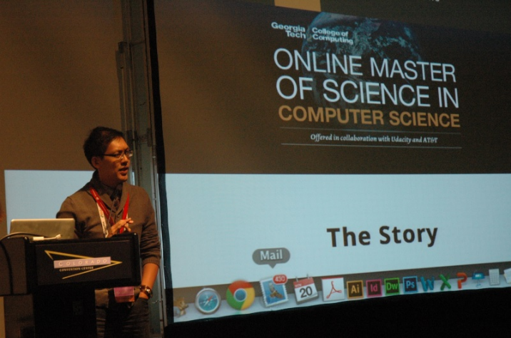
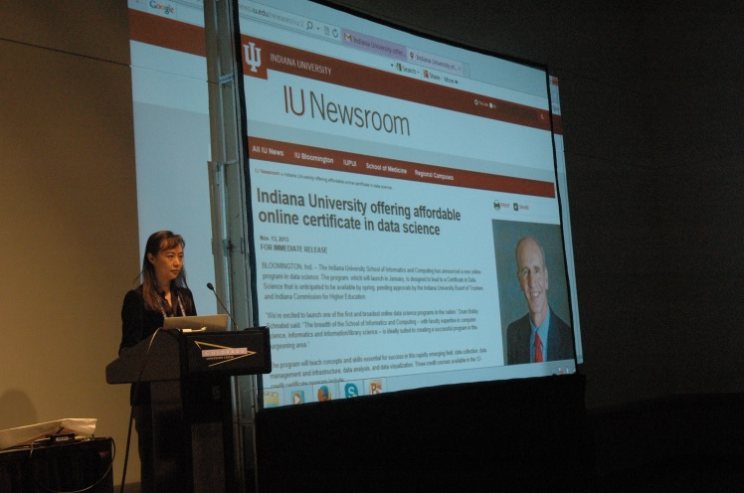
Richard Vuduc (Georgia Tech) and Judy Qiu (Indiana University) presenting at SC13 BOF
The event included presentations by Judy Qiu and Geoffrey Fox from Indiana University and Josie Giles and Richard Vuduc of Georgia Tech. Both universities will be offering online classes using MOOC format in the Spring 2014 semester. They address a data science certificate from Indiana University with courses developed using Google’s open source Course Builder software and a full Computer Science Masters online degree from Georgia Tech in partnership with Udacity. The initial experiences and planning were described. These presentations were followed by a discussion with the 36 BOF participants which included substantial industry as well as academic and government involvement. It was agreed that MOOC’s and their technology were promising but needed more experience.
We have set up a Google group MOOCs for the 36 BOF participants which will allow us to build on this initial community and keep the momentum up. In particular we hope to exchange good practices in developing MOOCs, thereby generating an expertise and resource pool for the advancement of online education in the SC technology arena.

