Microsoft Word Author Guidelines for CVPR Proceedings

Object Detections by a Super-Resolution Method and Convolution Neural Networks
Paper ID ****< 2072 >

Abstract

Recently with many of blur-less or slightly blurred images, convolutional neural networks classify objects with around 90 percent regression rates, even if there are variable sized images. However, small object regions or cropping of images make object detection or classification difficult and decreases the detection rates. In many methods related to convolutional neural network (CNN), Bilinear or Bicubic algorithms are popularly used to interpolate region of interests. To overcome the limitations of these algorithms, we introduce a super-resolution method applied to the cropped regions or candidates, and this leads to improve recognition rates for object detection and classification. Large object candidates comparable in size of the full image have good results for object detections using many popular conventional methods. However, for smaller region candidates, using our super-resolution preprocessing and region candidates, allows a CNN to outperform conventional methods in the number of detected objects when tested on the VOC2007 and MSO datasets.

Introduction
Since Krizhevsky et al. [1] introduced specifically designed CNN architectures, there have been many methods to increase the rate of object classification on convolution neural networks (CNN). [2], [3], [4], [5], [6], [7] have shown performances to be increased. Nowadays, with many of blur-less or slightly blurred images, CNNs classify objects with around a 90 percent regression rates.
Recently, there has been research focused on reducing the misdetection and detection failures on convolution neural networks with the help of generative adversarial network (GAN). Furthermore, GANs have been extended by using reinforcement learning, [8].
Frameworks such as Caffe and Tensorflow can help to design CNN models for any specific computer visioning. Also, from a computer infrastructure point of views, graphics processing unit (GPU), such as those from Nvidia substantially increase performance. These advances allow one to design systems for vision detection and classification designed to run in real time.
However, even as there have been improvements of convolutional neural networks in multiple ways, there are still misdetections and detection failures for object classifications. For example, randomly 100 images from [9] were selected and preprocessed at three times lower resolution than the original images to build cropped images. Then they were interpolated by Bilinear and Bicubic algorithms, and finally, they were tested by [3]. Figure 1 shows the detection failure of the second person from left side of the image. The second person from the left side in Figure 1 is missed by the algorithm. We will compare several different algorithms and propose an advanced method in later sections.

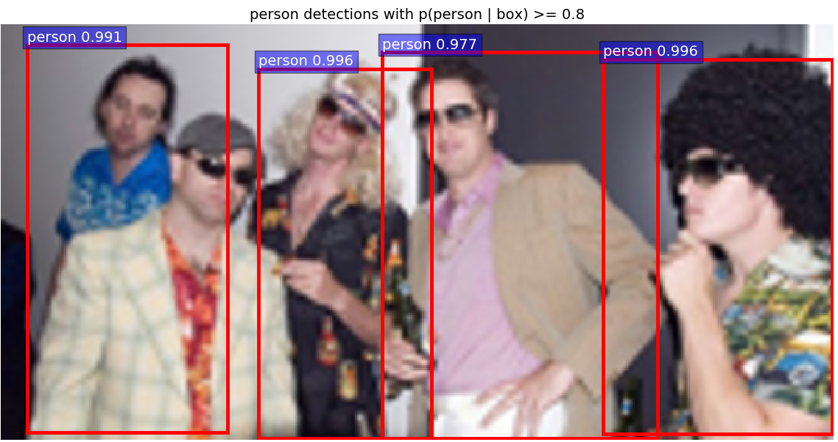

Figure 1: An example of object classification of “person” by CNN

Alex Krizhevsky et al. in [1] described the number of categories and designed their network with 1,000 object classes from ImageNet. [2], [5] classified 22 object classes from PASCAL VOC 2007 [9]. There is a 200 class data set in ILSVRC2013, ILSVRC2017 contains several datasets and especially, the ImageNet dataset contains 1000 classes and Omniglot contains 1623 classes. But research is often done with VOC2007 20+1 classes even though there are datasets with more than several hundred classes.
Recently, the most popular image size on CNN has been around 256x256. Spatial Pyramid Pooling network, Faster R-CNN, and ConvNet are examples testing the relevance of the image size. Advances in camera systems and the popularity of mobile devices cause consumers to demand higher resolution images. Moreover, in medical and geometrical satellite imaging systems the demand for object classification is strong. In [11], [12], [13], they show that the recurrent neural network model is capable of extracting information from an image by selecting a sequence of regions and processing a selected region at high resolution.
In practical applications, there are many low quality image processing systems such as surveillance camera systems, car black-box systems, or even mobile phone cameras for taking pictures of long distance. For example, in surveillance systems it may not easy to increase the capacities for better image qualities because of their storage capacities, dark conditions on camera image sensors, and night visioning. In car black box systems, moving vibrations and the requirements of low electric power consumption may cause bad image compressions or lack of fast zooming or focusing devices. Especially, mobile phone pictures are blurred or have small target objects according to the limit of the software zooming algorithms.
Thus, we will introduce our research to improve object classification rates with improvements through super resolution algorithms and convolution neural networks.

Related work
To support fast implementation such as video data, the number of classes in CNN is preferred to be kept small. The number of classes to detect or classify objects is a major factor on the design of systems. The number of neurons, even in a hidden layer, are required to increase to handle many classes and it causes the system to slow down because of several hidden layers associated with heavy computations. Papers such as [2], [14] have shown new methods or new parameters related to lower layers of neural networks. The paper [14] introduced a new feature extraction algorithm for object recognition. The paper [2] also improved CNN in region proposal. Their new methods speed up the detection allowing the image data set to run in almost real time.
Keiming He et al. [5] had the best results for training and testing with the maximum image side of 392 because they had image dataset from VOC 2007 and ImageNet. Also they showed results indicating scale matters in the classification processing. Thus, they suggested the spatial pyramid pooling model to support various image sizes in convolution layers which work with various image sizes while the standard fully connected layer requires a fixed image size. With Caltech101 image dataset, they found objects that had better performances among several scaled datasets. They noticed that this is mainly why the detected objects usually occupy large regions of the whole images. They evaluated cropped or warped images and got lower accuracy rates than the same model on the undistorted full image.
In [15] Generative Adversarial Networks (GANs) are described as generative models that use supervised learning to approximate an intractable cost function and can simulate many cost functions, including the one used for maximum likelihood. More specifically, a generative model g trained on training data X sampled from some true distribution D is one which, given some standard random distribution Z, produces a distribution D′ which is close to D according to some closeness metric (a sample z ∈ Z maps to a sample g(z) ∈ D′).
There are several points of researches related to the GANs which are training auto-encoder based GANs [4], learning semi-supervised and generating images that humans find visually realistic [16], and training for semi-supervised text classification [17]. Also, there are GAN extensions related to super resolution methods and reinforcement learning.
Image super resolution (SR) means a deep learning method which infers a high resolution image from a low resolution image. In [18] SR algorithms are introduced in two groups: single image based and multiple image based ones. That is, in multiple image SR algorithm, to restore an image a couple of low resolution images of the same scene are fed as input and a registration algorithm to find the transformation between them is added while single image SR algorithm employs a training step to learn the relationship between a set of high resolution image and their low resolution counterparts and the relationship is used to predict the missing high resolution details of input images. They can be applied for video data to improve action recognition.
As single image SR, [19], [20], [21] present methods using mixture of experts (MoE) which are anchor based local learning approach, sparse coding, and deep convolution neural networks, respectively. Christian Ledig et al. in [22] proposed a GAN method using generator networks and discriminator networks to recover photo realistic natural images with minimizing the mean squared reconstruction error.
In SR and CNN algorithms, image interpolations are used to resize images or to crop/ warp image patches. Especially, small region of interest in a big image resolution is processed with a cropping or warping to fit into bounding boxes or region proposal and it results in decreased object detection rate.
Current CNNs, which are using the sliding window method, are able to process variable size images as their input. However, the fully connected layer can work only with a fixed size of feature maps. This is why the CNNs at the first time had applied a fixed size of input images. Kaiming He et al. [5] introduced variable size of images as the input of their CNNs and warped or cropped images to get fixed feature maps. Cropped or warped images might have the poor object recognition results. This caused us to implement super resolution instead of interpolation methods.

Proposed Image Resolution Enhancing Algorithm
CNN requires a target image as a fixed size one before processing hidden layers. Thus with a given input image, the network resizes it to the fixed-size of image. In [2], the Bilinear interpolation algorithm is applied to extend the image size to fit as an input for a neural network. As future research, the extended image size directly given by the super-resolution will be used. In this paper, we use the super resolution method to increase the image size to around 492x324.
Thus, we will first describe the super resolution method to improve the images before the input layer of CNN, then, how the preprocessed image can be classified by CNN.

Super Resolution Image Scale-up
Most work on image processing focuses on improving the deep hidden neural networks. In this section, however, we will describe more on pre-processing of image samples which have not enough qualities than on improving of hidden layers. For example, a cropped image whose size of 166x110 is extracted from a normal image is too small to feed into the input layer of our CNN.
In the expert method, component regressors,$W_{i}$, and as an anchor point, $v_{j}$ have relations such as:
$$\min_{\{v_{1}, v_{2}, , …, v_{k}; w_{1}, w_{2}, …, W_{k}\}}{Σ_{j=1}^{N}\sum_{i=1}^{K}{c_{ji}|\left|h_{j}- W_{i}l_{j}\right||^{2}}},$$
where $l_{j}$ means a low resolution path, $h_{j}$ is the corresponding high resolution patch, $v_{j}$ is the nearest anchor point for $l_{j}$ and $c_{ji}$ is a continuous scalar value which represents the degree of membership of $l_{j}$.
However, to keep the computational efficiency and the competitive image quality of anchor-based local learning method of multiple regressors, a mixture of experts which is one of conditional combined mixture models [23, 24] is proposed. Like [24] we define the model of mixture of experts for super-resolution images, describing the expectation and maximization (EM) algorithm, and also train and test this model.
In a mixture of expert model, a maximum likelihood estimation should be solved iteratively by the EM algorithm. At every iteration, the posterior probabilities are calculated for patches and then we get the expectation of the log likelihood as a result of the E-step. During the M-step, anchor points and regressors are updated which is a softmax regression problem. After training, super resolution images can be constructed by collecting all the patches from regressed low resolution patches and averaging the overlapped pixels.
To differentiate the performance of super resolution method from interpolation methods, Bilinear, Bicubic interpolated images will be built in addition to the images processed by super resolution method.

Object detection
We implemented the convolution neural network based on the Faster R-CNN [3] because it supports variable image sizes as the input data of CNN and sliding widow proposal scanning for the convolution network. Above all, the detection speed is fast enough to be almost real-time. As mentioned earlier, Faster R-CNN uses region proposal to detect an object. But the size ratio of region proposal to the whole image is critical for the object to be detected. It means we can distinguish our proposed method compared to other interpolated data.
The CNN is implemented based on Intel® Xeon CPU 2.30GHz and 4 NVIDIA Tesla K80 GPU boards. Each GPU board has memory of 12GB and two GPUs.
Our CNN has several convolutional layers to support a region proposal network in addition to the conventional CNN [1], [7]. Also, these convolution layers are shared with object detection networks as in [5]. Thus, our model works as a deep CNN which has more convolution and pooling layers too.
As multiple-scale prediction schemes for regression references, there are schemes based on multiple-images, on multiple-filters, and on multiple-anchors in [3]. With multi-image schemes, images are resized at multiple scales and feature maps are computed for each scale. Even though this scheme is time-consuming, our super resolution method can resize images to get better prediction scores. However, for less usage of computational resources, for fast detections, and for feature sharing in fully convolution layer, we choose the multi-anchors scheme.
Additionally, to control the memory usages of CAFFE, we impose constraints on the number of images. In our deep CNN model allowing multiple scaled image sizes, the number of region proposals is w (width of the image) x h (height of the image) x k (the number of anchors of a region proposal). The memory space for the region proposal network needs to be limited. Therefore, we constrain the number of simultaneous images in hidden layers to be less than or equal to 20 images.
For model training, we use pre-trained model parameters taken from the Faster R-CNN implementation. Faster R-CNN was trained, validated and tested with the PASCAL VOC 2007 dataset of 9000 images. As the result, we consider that the parameters should be fitted well enough for our model.
For each proposal from an image, an object is roughly considered and the proposal size is selected to be the predefined window size. Thus, this patch of an image may be interpolated. If instead of interpolation methods the super resolution method is adopted, any variable sizes of input images with variable sizes or shapes can be supported with better cropped or warped regions.
We will not adopt super resolution method to improve the patch image qualities now. We will keep this for future research.

Performance Evaluation
Before any other processing, we considered several image file formats to get better image quality for pre-processing, training, and testing images. Therefore, we picked two image data formats and with a few images we processed the whole procedures of our proposed model. While most of image datasets are built images based on the JPG file format, this did not seem to offer as good results in super resolution processing compared with the BMP format. As the result of this simple testing, we decided to convert images from a file format of JPG into BMP format as a pre-processing procedure. Then, the image is taken to is further processed with Bilinear, Bicubic interpolations, and the super resolution method.
Also, we scale down image size by 3 times smaller in each width and height to build images with lower quality, instead of

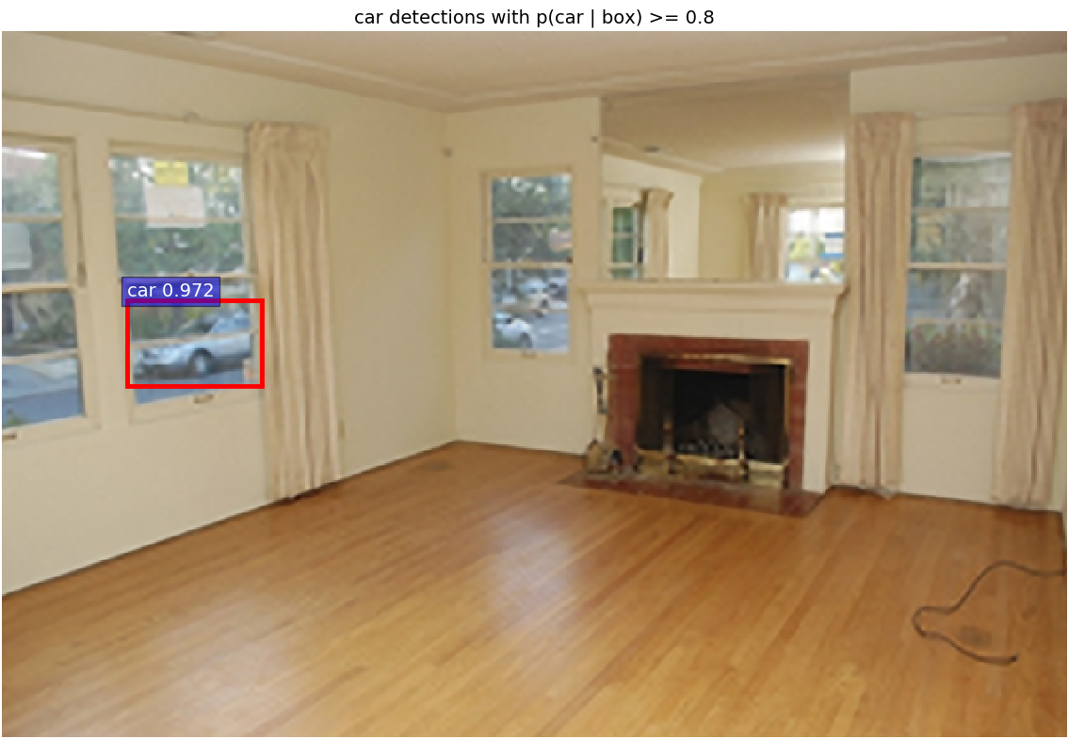 | 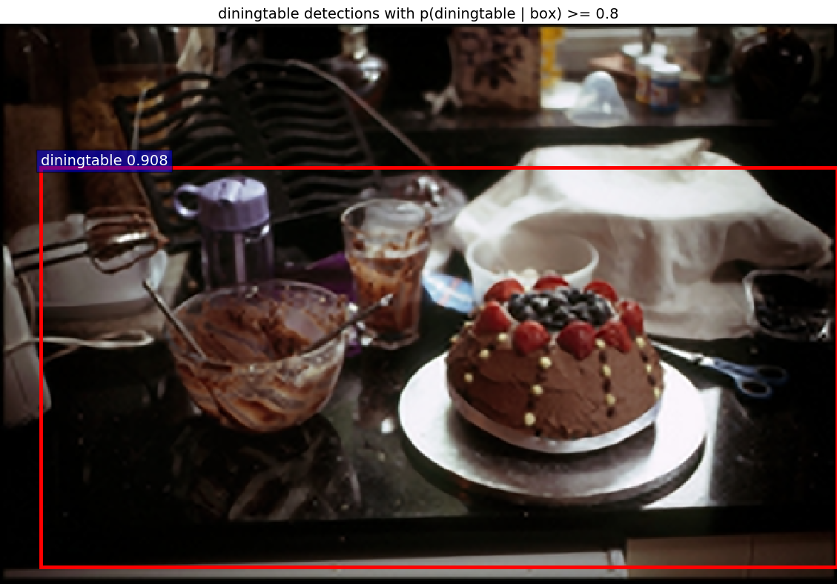
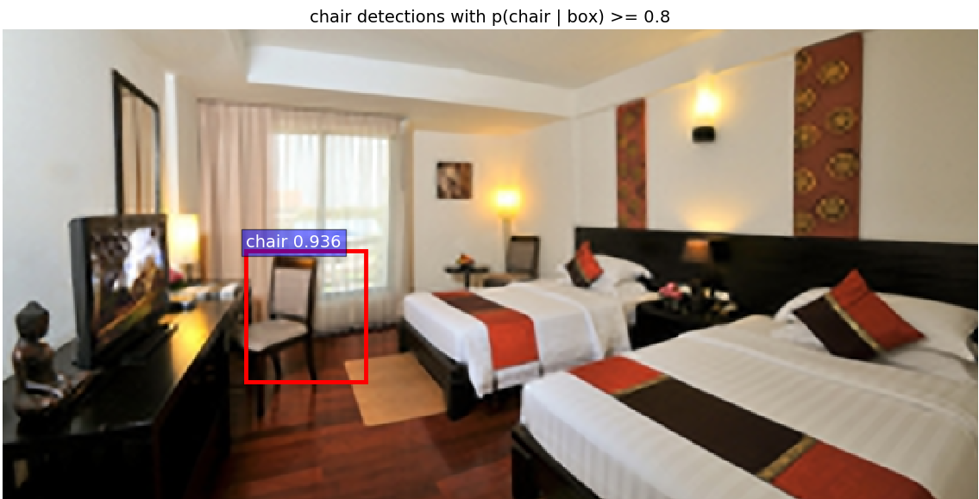 | 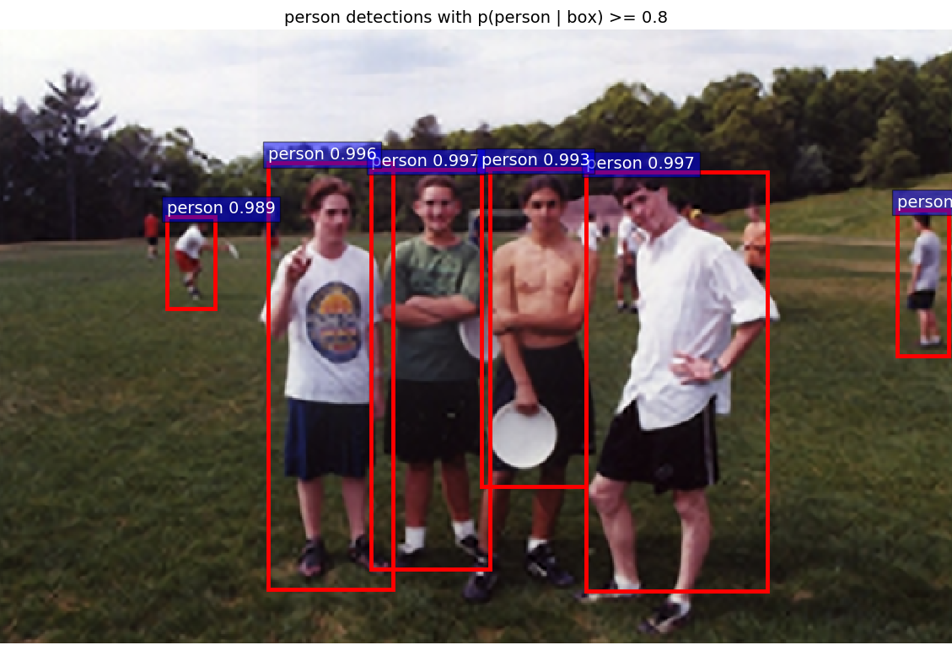
Figure 2: Images which have objects detected but were originally labeled either without any object or with a fewer number of objects.
collecting images by cropping or warping images.
In our model, we implement the super resolution procedure based on [19]. Unlike training with less than 50 images in which most of super resolution models are published, we have trained our model based on their initial parameters and with 100 PASCAL VOC2007 images. There is not overfitting with this number of images for training. With random images from PASCAL VOC2007 [9], [25] and test images from [26] we have tested our super resolution model. We could not find any differences between them. Therefore we will testify object classification part with 520 images randomly extracted from VOC2007 and 1224 images from MSO [27].
In Figure 2, we found the dataset has a different number of objects compared to our intuition. For example, top-left image is labeled with no object but our proposed model detected an object or objects, like as shown in the image. Thus, we decide not to use the given label from dataset.

Comparison of output pictures
Many images from the PASCAL VOC 2007 have multiple objects, as shown in the results given in Table 1 with 3 different pre-processing models, which are bilinear, Bicubic interpolation and a super resolution. Our model is set as learning rate of 0.001 and detection scores with 0.8 or higher.

The first column shows that by bilinear interpolation there are the number of detected objects in each given class. For the second column every rows show that the number of Bicubic interpolated and the number of object-detected images with the regression rate. And so are the same in the third column with super resolution.
As shown Table 1, our model detected more objects than the other two models but the average detected scores are not much different. It means that our model made better images as the input image and fed into the CNN then as the results there are more number of detections. Especially, Figure 3 and Figure 4 show the cumulative number of detected objects and compare them.

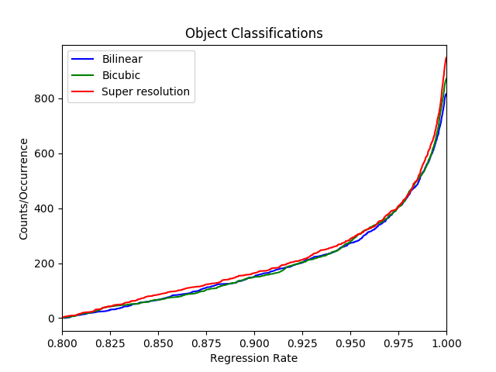
Figure 3: Distribution diagram of the number of classified objects for bilinear, Bicubic and super resolution models on VOC 2007 dataset.
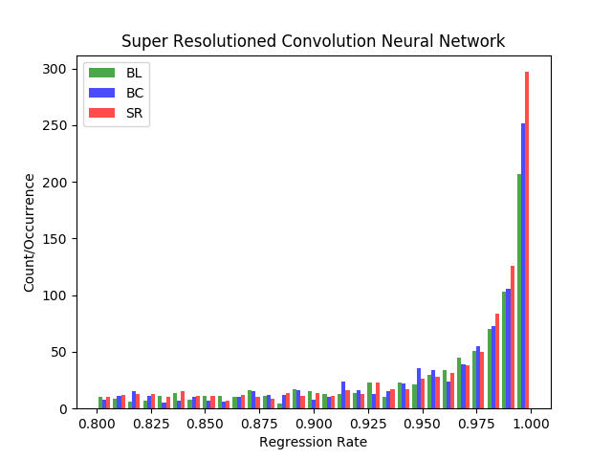
Figure 4: Histogram for convolution network models with 3 different image pro-pressing on randomly extracted images from VOC 2007 dataset

With image dataset of MSO, we present results in Table 2, Figure 5, and Figure 6. Like VOC2007 dataset, our proposed model detected more number of objects than the two other models. Unlike the case of the VOC2007, MSO dataset has zero object images. However, the average detection scores of our model are given as similar with the one of VOC2007.
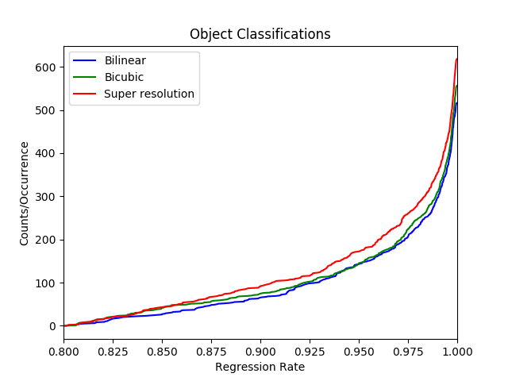
Figure 5: Diagram of the number of classified objects for bilinear, Bicubic and super resolution models on MSO dataset
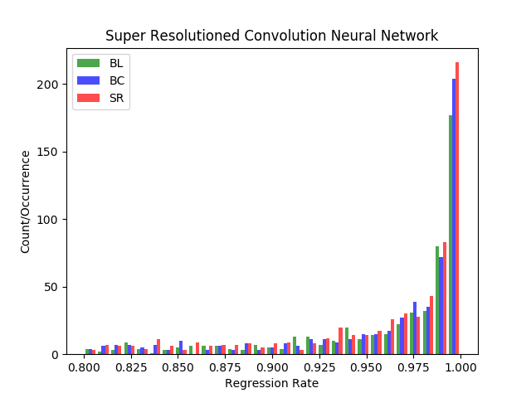
Figure 6: Histogram for convolution network models with 3 different image pro-pressing on randomly extracted images from MSO dataset

Big vs. small ROI pictures and their regression rates
As mentioned in previous section, if objects are big enough compared to the size of the image which is containing the object proposal, objects from interpolated images with Bilinear or Bicubic methods are good enough or sometimes may have better performance than objects from our proposed model. However, our proposed model has much better results with objects from small bounding boxes or small ratio of objects to the size of the image which contains the object. In Figure 7, our proposed model detects a chair which is a pretty small object in a given image but the other two models did not detect ‘chair’ object. Even though the other chair is detected in all of three models, our proposed model has a little bit higher score.

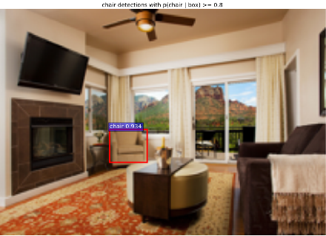
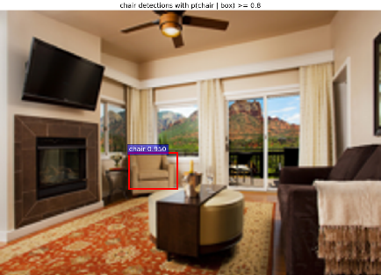
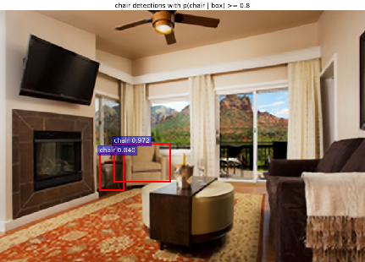

Figure 7: Comparison of small object detection through Bilinear, Bicubic, and SR models

Conclusion
We proposed a model which is composed with super resolution processing and a convolution neural network. In this model, several kinds of classes from two different datasets are scored when objects are detected. Our model has benefits on the number of object detections, especially in case of small object detections.
In this proposal, we did not implement that only bounding box areas are processed with super resolution method. But we can pretty sure that this can save the computational resources and thus we can adopt this in real-time processing for better object detection or classification.
Our proposed model appears powerful in scenarios such as relatively small objects in big pictures, warping on region proposals, and object detection from cropped image.

References
[1] | Alex Krizhevsky Sutskever, Geoffrey E. HintonIlya. (2012). ImageNet Classification with Deep Convolution Neural Networks. In Advances in Neural Information Processing Systems (NIPS), (1097-1105).
[2] | Girshick Ross. Fast R-CNN. arXiv: 1504.08083v2[cs.CV] 27 Sep 2015.
[3] | Shaoqing Ren He, Ross Girshick, and Jian Sun Kaiming. (2016). Faster R-CNN: Towards Real-time Object Detection with Region Proposal Networks. arXiv:1506.01497v3[cs.CV] 6 Jan2016.
[4] | David Berthelot Schumm, Luke MetzThomas. BEGAN: Boundary Equilibrium Generative Adversarial Networks. arXiv:1703.10717v2[cs.LG].
[5] | Keiming He Zhang, Shaoqing Ren, and Jian Sun Xiangyu. (2015). Spatial Pyramid Pooling in Deep Convolutional Networks for Visual Recogniton. arXiv:1406.4729v4.
[6] | Ross Girshick, Jeff Donahua, Trevor Darrell, Jitendra Malik, Region-Based Convolution Networks for Accurate Object Detection and Segmentation, IEEE Transactions on Pattern Analysis and Machine Intelligence Vol. 38, NO.1, 2016.
[7] | Karen Simonyan, Zisserman Andrew. (2015). Very Deep Convolutional Networks for Large-Scale Image Recognition. ICLR.
[8] | Ian J. Goodfellow Pouget-Abadie, Mehdi Mirza, Bing Xu, David Warde-Farley, Sherjil Ozair, Aaron Courvill, Yoshua BengioJean. (2014). Generative Adversarial Nets. arXiv:1406.2661v1.
[9] | M. Everingham Van Gool, C. K. I. Williams, J. Winn, and A. ZissermanL. (2007). The PASCAL Visual Object Classes Challenge 2007 (VOC2007) Results.
[10] | Achanta R., Estrada F., Wils P., Süsstrunk S. (2008) Salient Region Detection and Segmentation. In: Gasteratos A., Vincze M., Tsotsos J.K. (eds) Computer Vision Systems. ICVS 2008. Lecture Notes in Computer Science, vol 5008. Springer, Berlin, Heidelberg
[11] | Volodymyr Mnih Heess, Alex Graves, and Koray Kavukcuoglu Nicolas. (2014). Recurrent Models of Visual Attention. arXiv:1406.6247v1[cs.LG] 24 Jun 2014.
[12] | Jimmy Lei BaMnih, and Koray KavukcuogluVolodymyr. (2015). Multiple Object Recognition with Visual Attention. arXiv:1412.7755v2[cs.LG]23Apr2015.
[13] | Karol Gregor Danihelka, Alex Graves, Danilo Jimenez Rezende, Daan WierstraIvo. (2015). DRAW: A Recurrent Neural Network For Image Generation. arXiv:1502.04623v2[cs.CV]20May2015.
[14] | J.R.R. Uijlingsvan de Sande, T. Gevers, and A.W.M. Smeulders K.E.A. (2012). Selective Search for Object Recognition. IJCV.
[15] | Ghosh Nachum and Debiprasad Ofir. https://www.quora.com. "What-are-Generative-Adversarial-Networks-GANs".
[16] | Tim Salimans Goodfellow, Wojciech Zaremba, Vicki CheungIan. (2016). "Improved Techniques for Training GANs". arXiv:1606.03498v1.
[17] | Takeru Miyato M Dai, Ian Goodfellow Andrew. (2017). "Adversarial Training Methods for Semi-Supervised Text Classification". ICLR.
[18] | Nasrollahi Kamal, Guerrero Escalera Sergio, Rasti Pejman, Anbarjafari Gholamerza, BaroXavier, J. Escalante Hugo, & Moeslund B. Thomas. (2015). "Deep Learning based Super-Resolution for Improved Action Recognition". In International Conference on Image Processing Theory, Tools and Applications (IPTA) IEEE Signal Processing Society.
[19] | Kai Zhang Wang, Wangmeng Zuo, Hongzhi Zhang, Lei ZhangBaoquan. (2016). "Joint Learning of Multiple Regressors for Single Image Super Resolution". IEEE Singnal Processing Letters. Vol. 23 No. 1.
[20] | Zhaowen Wang Liu, Jianchao Yang, Wei Han, Thomas HuangDing. (2015). "Deep Networks for Image Super Resolution with Sparse Prior". ICCV.
[21] | Chao Dong Change Loy, Kaiming He, Xiaoou Tang Chen. (2015). "Image Super Resolution Using Deep Convolution Networks". arXiv:1501.00092v3.
[22] | Christian Ledig Theis, Ferenc Huszar, Jose Caballero, Andrew Cunningham, Alejandro Acosta, Andrew Aitken, Alykhan Tejani, Johannes Totz, Zehan Wang, Wenzhe ShiLucas. "Photo-Realistic Single Image Super Resolution Using a Generative Adversarial Network". arXiv:1609.04802v5[cs.CV]. (2017).
[23] | Bishop Christopher. (2006). Pattern Recognition and Machine Learning. Springer
[24] | Zhang Zhang, Baoquan Wang, Wangmeng Zuo, Hongzhi ZhangKai. (2016). "Joint Learning of Multiple Regressors for Single Image Super-Resolution". IEEE Signal processing letters, Vol. 23, No.1
[25] | Olga Russakovsky Deng, Hao Su, Jonathan Krause, Sanjeev Satheesh, Sean Ma, Zhiheng Huang, Andrej Karpathy, Aditya Khosla, Michael Bernstein, Alexander C. Berg and Li Fei-Fei Jia. (2014). "ImageNet Large Scale Visual Recognition Challenge". arXiv:1409.0575.
[26] | Olga Russakovsky Deng, Hao Su, Jonathan Krause, Sanjeev Satheesh, Sean Ma, Zhiheng Huang, Andrej Karpathy, Aditya Khosla, Michael Bernstein, Alexander C. Berg and Li Fei-Fei Jia, “ImageNet Large Scale Visual Recognition Challenge 2017".
[27] | Zhang Ma, Shuga Sameki, Mehrnoosh Sclaroff, Stan Betke, Margrit Lin, Zhe Shen, Xiaohui Price, Brian Much, Radom Jianming. (2015). "Salient Object Subitizing". IEEE Conference on Computer Vision and Pattern Recognition (CVPR).

Table 1: Detected objects on 3 different pre-processing and convolution neural networks with PACAL VOC2007. #tp is number of true positives correctly predicted. The column labelled mean is average probability from method.

 | Bilinear |  | Bicubic |  | Ours
Class | #tp | mean | #tp | mean | #tp | mean
aeroplane | 25 | 0.9569 | 29 | 0.9472 | 27 | 0.9787
bicycle | 16 | 0.9602 | 17 | 0.9697 | 18 | 0.9520
bird | 18 | 0.9204 | 25 | 0.9178 | 30 | 0.9500
boat | 16 | 0.9330 | 18 | 0.9260 | 20 | 0.9276
bottle | 19 | 0.9222 | 17 | 0.9208 | 15 | 0.9331
bus | 26 | 0.9626 | 25 | 0.9639 | 26 | 0.9588
car | 93 | 0.9662 | 100 | 0.9671 | 104 | 0.9710
cat | 11 | 0.9427 | 10 | 0.9665 | 11 | 0.9739
chair | 25 | 0.9273 | 34 | 0.9368 | 45 | 0.9320
cow | 11 | 0.9149 | 12 | 0.9216 | 16 | 0.9385
Dining table | 7 | 0.9317 | 7 | 0.9420 | 12 | 0.9193
dog | 37 | 0.9559 | 36 | 0.9657 | 35 | 0.9565
horse | 30 | 0.9560 | 34 | 0.9574 | 37 | 0.9694
motorbike | 13 | 0.9467 | 13 | 0.9630 | 16 | 0.9581
person | 405 | 0.9546 | 432 | 0.9575 | 466 | 0.9590
Potted plant | 10 | 0.9467 | 12 | 0.9194 | 18 | 0.8767
sheep | 15 | 0.9275 | 13 | 0.9380 | 14 | 0.9227
sofa | 7 | 0.9191 | 8 | 0.9175 | 8 | 0.9475
train | 7 | 0.9193 | 4 | 0.9276 | 4 | 0.9572
TV monitor | 25 | 0.9653 | 25 | 0.9729 | 26 | 0.9479
Total | 816 | 0.9415 | 871 | 0.9450 | 948 | 0.9465
mis-classified | 25 |  | 21 |  | 39

Table 2: Detected objects on 3 different pre-processing and convolution neural networks with MSO dataset. #tp is number of true positives correctly predicted. The column labelled mean is average probability from method.

 | Bilinear |  | Bicubic |  | Ours
Classes | #tp | mean | #tp | mean | #tp | mean
aeroplane | 5 | 0.9650 | 6 | 0.9300 | 9 | 0.9263
bicycle | 1 | 0.9992 | 2 | 0.9112 | 1 | 0.9978
bird | 50 | 0.9512 | 59 | 0.9521 | 75 | 0.9627
boat | 1 | 0.8301 | 1 | 0.9771 | 1 | 0.9713
bottle | 23 | 0.9074 | 24 | 0.9062 | 21 | 0.9117
bus | 3 | 0.9954 | 3 | 0.9954 | 3 | 0.9871
car | 16 | 0.9641 | 19 | 0.9558 | 18 | 0.9499
cat | 11 | 0.9639 | 10 | 0.9829 | 11 | 0.9540
chair | 19 | 0.9299 | 20 | 0.9270 | 22 | 0.9393
cow | 5 | 0.9452 | 6 | 0.9488 | 7 | 0.9584
Dining table | 3 | 0.9410 | 4 | 0.8927 | 4 | 0.9072
dog | 42 | 0.9559 | 47 | 0.9636 | 50 | 0.9478
horse | 11 | 0.9728 | 11 | 0.9726 | 15 | 0.9362
motorbike | 4 | 0.9487 | 4 | 0.9529 | 4 | 0.9588
person | 302 | 0.9715 | 318 | 0.9718 | 340 | 0.9719
Potted plant | 4 | 0.9023 | 5 | 0.8756 | 9 | 0.9035
sheep | 1 | 0.8780 | 1 | 0.9353 | 4 | 0.9064
sofa | 3 | 0.9204 | 3 | 0.9099 | 6 | 0.9261
train | 6 | 0.9746 | 7 | 0.9529 | 8 | 0.9522
TV monitor | 6 | 0.9720 | 6 | 0.9804 | 10 | 0.9248
Total | 516 | 0.9444 | 556 | 0.9447 | 618 | 0.9447
mis-classified | 86 |  | 82 |  | 92

