A Collaborative Sensor Grids Framework

Geoffrey Fox^{1,2}, Alex Ho², Rui Wang², Edward Chu² and Isaac Kwan²
¹Community Grids Laboratory, Indiana University, Suite 224, 501 North Morton Street, Bloomington IN 47404
²Anabas Inc, Suite 106C, 501 North Morton Street,
Bloomington, IN 47404
gcf@indiana.edu, alexho@anabas.com, rui.wang@anabas.com, edward.chu@anabas.com, isaac.kwan@anabas.com

Abstract

Integrating sensors and grid computing provides a way to gather, process and model real-time information from the environment for informed decision-support and timely actions, proactive or reactive, to events. We create a collaborative sensor grid framework to support the integration of a sensor grid with collaboration and other grids. The framework includes a grid builder tool for discovering and managing grid services and remote, distributed sensors. It provides a real-time collaborative client to enable distributed stakeholders to have a consistent view of displayed sensor streams. We illustrate the versatility of the framework by constructing a robot-based customizable application for shared situational awareness.

1. Introduction

Increased use of sensors in commercial and military environments is being driven by the need for better intelligence data and advancement in technology, which provides smaller, less costly and more capable sensors. It is not sufficient and in many situations not productive to just overwhelm decision-makers at all levels with lots of sensor data for their missions on hand. Our collaborative sensor grid framework supports seamless integration of loosely-coupled and custom-developed sensor data management, visualization and presentation tools, and real-time collaboration capability for sharing situational awareness. Real-time information about the environment can be gathered, processed, correlated and shared to facilitate quick and relevant decision-making on a large scale.

Our research is motivated to design and develop an enabling framework to support the development, deployment, management and real- time visualization and presentation of collaborative, geo-coded sensor grid applications with extensibility, scalability and security. Our Collaborative Sensor Grid (CSG) framework uses a “publish and subscribe” communication paradigm over a distributed message broker architecture based on a NaradaBrokering (NB) transport network [1]. This approach has already been successfully used in GPS Sensor Grid for Earthquake Science [2-4]. A key component of the CSG framework is the Grid Builder tool which supports the building of grid of grids - a compositional model of assembling a multitude of subgrids into a mission-specific grid application. In CSG the Grid Builder facilitates the assemblage of important subgrids, namely a real-time multimedia collaboration grid and hierarchical, executable sensor grid for a collaborative sensor grid. The earlier work combined simulation and sensor grids without the powerful management features of the Grid Builder. A particular design objective for the CSG client is to provide an intuitive user interface for enabling UDOP (User Defined Operation Picture) and COP (Common Operation Picture) capabilities, which are essential for agile formulation and sharing of visual, situational awareness and effective decision-support.

In Section 2 we provide an overview of the CSG system architecture and describe some physical sensors that we implemented and used in a Lego Mindstorm NXT robot-based UDOP (User-defined Operating Picture)/COP (Common Operating Picture) application. In Section 3 we describe how the Grid Builder tool facilitates the discovery and management of distributed sensors. Visualization and presentation for displaying sensor data in the collaboration grid are illustrated in section 4. Finally, section 5 summarizes the paper with conclusions and future work.

2. Collaborative Sensor Grids

2.1. System Architecture and Sensors

The CSG framework comprises a Grid Builder module, a sensor grid and collaboration grid. Figure 1 illustrates the architectural relationship among them.

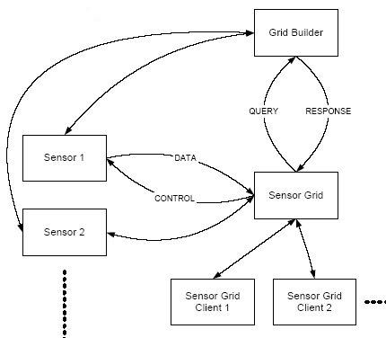

Figure 1: A Collaborative sensor grid architecture

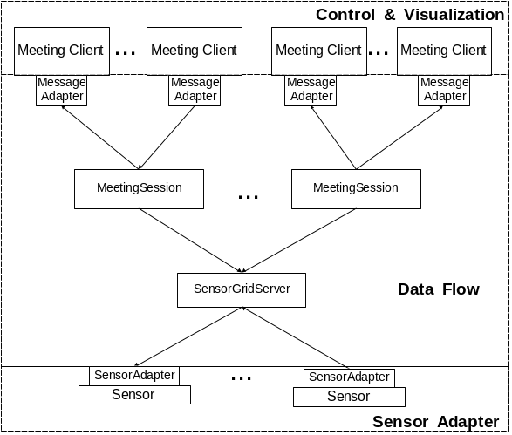

Figure 2: Implementation architecture of a collaborative sensor grid
Each sensor grid client in Figure 1 is a representation of a collaborative session or “meeting” within which the meeting participants shared real-time streaming sensor information.

As shown in Figure 2, multiple collaborative sessions could interact with any combination of deployed sensors via the sensor grid. A collaborative sensor grid is abstracted into 3 parts:
- sensor adapter,
- data flow, and
- control and visualization – these are the “V” and “C” in a classic MVC model.

Our approach uses a scalable, hierarchical and collaborative architecture. Hybrid, large-scale distributed sensor nodes are loosely coupled by a message-oriented middleware system called NaradaBrokering (NB) [1], which is a content distribution infrastructure based on the publish/subscribe paradigm.

Sensor grids are a combination of sensor networks and grid computing. The underlying service model and robust publish-subscribe messaging provides greater management capabilities [5, 6] and scalability than traditional sensor nets [7-13]. For example, a geo-spatial sensor grid can be used to provide real time position data [2, 3] with on the fly data conversions and hidden Markov model analysis [4, 14]. In our specific example, we used a mobile tablet computer (i.e., Nokia N800, an Internet Tablet PC) which has considerable computing power with supports for both Wi-Fi and Bluetooth connections. Different types of sensors are integrated in our collaborative sensor grid application. They provide various sources of real-time information as follows:

(1) GPS sensor: It is a portable GPS receiver, which receives geospatial location information (e.g., latitude, longitude, etc) from satellites and transfers such information to the Nokia N800 via Bluetooth connection.

(2) Video/Audio: Those sensors, which are actually the built-in webcam and microphone in the Nokia N800 tablet, provide video/audio streams that can be published to the sensor grid. We have previously shown that publish subscribe software technology, in particular NaradaBrokering; can support large scale collaborative audio-video streams [15-17].

(3) RFID sensor: The Mantis RFCode M220 reader and RFCode M100 active tags are used. The reader senses information about RFID tags such as the signal strength, motion, temper and panic and encapsulates the information in tag event messages.

While RFID positioning result is not included in this paper, we developed a new RFID positioning algorithm that gave encouraging initial results over LANDMARC (LocAtioN iDentification based on dynaMic Active Rfid Calibration) [18] and LEMT (Location Estimation using Model Trees) [19, 20]. LANDMARC’s indoor accuracy was: 50 % of errors were within 1 meter while the maximum error distance was around 2 meters with 4 RFID readers [18]. LEMT’s indoor accuracy was: 40% of errors were within 0.5meter and 80% of errors were within 1.5 meters with a considerable number of readers and reference tags [19, 20]. According to our initial test results with a new algorithm that we devised and record in the appendix, errors were around 0.5 meter with one reader and one tag only.

(4) Lego Robot: We used the Lego Mindstorm NXT robots for our application. Two types of robots were assembled. One is a humanoid called Alpha Rex and the other a vehicle called Tribot. In our initial system demonstration, we implemented seven sensor types on the two robots. We equipped the Alpha Rex with sound, ultrasonic, light and temperature sensors and the Tribot with sound, ultrasonic, compass and accelerometer. Their detected information is sent to the PC via the Bluetooth module in the robots. The robot can also act as instructed by taking programmable commands from any collaborative session participants.

The two robots also carried external payloads. In this case, the Alpha Rex carried a GPS and an Nokia N800. The Tribot carried a GPS, a Nokia N800 and a Mantis RFID reader. Unlike most RFID use cases in which the reader is stationary, we made the RFID reader a mobile unit by having the Tribot carrying it around a test environment within which there were stationary RFID tags.

Sensor Type | Attributes
GPS | - Time  - Latitude  - Longitude  - ID
Video/Audio | - Video stream  - Audio stream
RFID | - Tag ID  - Group code  - Motion or stationary  - Signal strength
Lego Robot | - Sound  - Light  - Touch  - Ultrasonic  - Temperature  - Compass  - Accelerometer

Table 1: Sensor Types and Attributes

2.2. Distributed Transport Network

Our approach uses a scalable, hierarchical and collaborative architecture. Hybrid, large-scale distributed sensor nodes are loosely coupled by a message-oriented middleware system called NaradaBrokering (NB) [1], which is a content distribution infrastructure based on the publish/subscribe paradigm. This is overlaid with a fault tolerant management system [5, 6].

The NaradaBrokering fabric itself comprises a distributed network of cooperating broker nodes. One reason for choosing NaradaBrokering as the middleware fabric for Sensor Grids is that it places no restrictions on the type of the content: it has been deployed in systems where the content has been GIS data, multimedia codecs, images, text, bit maps and objects among others [2-4, 15, 21]. NaradaBrokering places no constraints on the size, rate and scope of the interactions encapsulated within the streams, or on the number of entities within the system. Also, NaradaBrokering has other useful features such as: secure end-to-end delivery of streams, robust stream disseminations, efficient ordering and synchronization of streams, support for rich Quality of Services, support for multiple transport protocols and support for Web Services, etc.

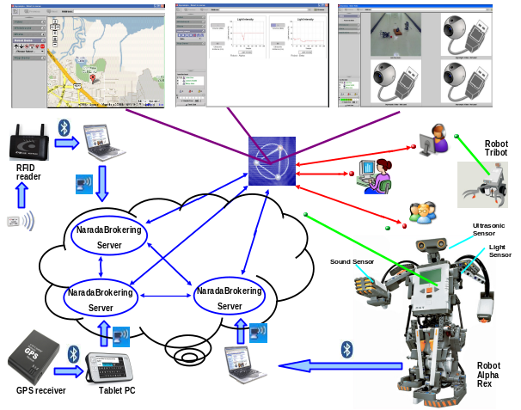
Figure 3: Lego Mindstorm NXT robot-based collaborative sensor grid application architecture

Our sample application of Collaborative Sensor Grid framework is depicted in Figure 3. There are different types of sensors distributed globally. Each sensor (GPS, Video/Audio, RFID, etc) gathers information from the environment and publishes it in real-time. A sensor adapter retrieves data from a connected sensor and communicates to the sensor grid. The adapter provides among other capabilities a service interface to each sensor which facilitates the Grid integration and the Web service based management framework [5, 6]. A sensor adapter processes raw sensor data and may publish refined information encoded in certain message format to the sensor grid. A “sensor grid client”, in our case, a collaborative session client, is running on a computer for presenting such information. It can subscribe to specific topics of the sensor grid in order to receive relevant messages. Different information from different types of sensors will be presented to users through a collaborative session client. In Section 4, we will describe a specific collaborative session client, the Anabas Impromptu for Sensors, that includes multiple collaborative applications called sharedlets and explain how to use Impromptu for Sensors to compose a UDOP and sharing it as a COP among remote, distributed users.

High-speed, reliable physical network is always a key requirement for this system. There are two types of network connections in the architecture: Bluetooth and WiFi. Bluetooth is generally used for the connection between a sensor and its respective sensor adapter since most sensors are Bluetooth enabled. It is efficient and reliable for transporting data in a short range. For the connection between sensor adapters and sensor grid, WiFi 802.11 protocol is typically used.

A Sensor Grid may consist of sensor units arranged hierarchically. It communicates with a collaboration grid server where meeting sessions reside. Primary functions of a sensor grid server are to manage and broker sensor message flows. It optimizes bandwidth usage by only forwarding messages to collaborative sessions that need them. This server is stateful and has memory of connections of sensor and meeting sessions. An overview of the sensor data flow architecture is shown in Figure 4. Since the sensor grid and collaboration grid are distributed systems by themselves, this structure makes the system scalable for a large-scaled deployment. The underlying transport layer is in essence a distributed NB network, which has demonstrated high scalability and reliability. With the integration of collaboration grid, users also have a consistent view of extracted, processed and organized information from all those sensors.

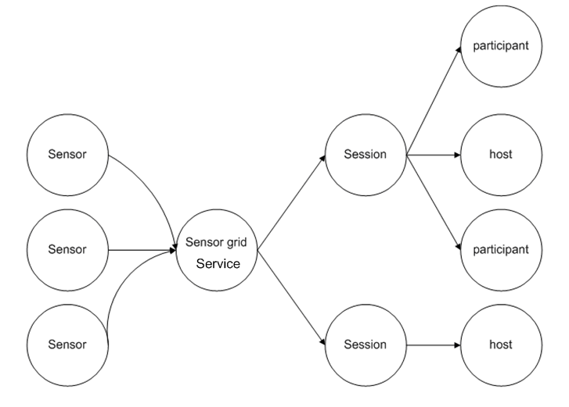
Figure 4: Overview of the sensor data flow

2.3. Implementation of Sensor Grids

We adopted a general procedure to implement Sensor Grids based on the architecture described before. The major steps include:
- Establishing the Bluetooth connection between a sensor and a sensor adapter;
- On the sensor adapter, a filter service extracts useful information from raw data through the established connection;
- Refined data is encoded in messages and published to a sensor grid topic;
- On a computer for presentation, a client program subscribes to the specific sensor grid topics in order to receive relevant sensor messages;
- Retrieved messages are parsed to get information that users are interested;
- The information is presented in a defined collaborative session client for sharing.

We take implementing the GPS sensor grid as a concrete example here:

First, we use a portable tablet Nokia N800 for hosting a GPS sensor adapter, which connects a GPS receiver device (I-Blue) via Bluetooth. The sensor adapter extracts useful information such as latitude, longitude and time from incoming raw data. Then it publishes encoded messages to a sensor grid topic (Streams/GPS/Location1) with a certain frequency (e.g. every 3 seconds).

Next, on the computer for presenting GPS information to users, a collaborative session client subscribes to the same topic (Streams/GPS/Location1) in the sensor grid to retrieve real-time data of the GPS location. We use the Google Maps API to show the GPS current location on the map based on its geospatial location information (latitude and longitude). Also, the GPS ID is marked on the map to distinguish it from other GPS sensors.

Finally, the map application is integrated with Impromptu for Sensors as a sharedlet. A user can have a global view of all GPS sensors or select a single GPS location to view its details. The sharedlet also provides functions specific to geographic information such as zoom in, zoom out, and panning the map to different directions.

For other sensors like Video/Audio, RFID and Lego Robot, they are implemented following the same pattern. Major differences between implementing different types of sensors lie in the filter for extracting sensed information from raw data and the presentation interface for such information.

One issue to mention is that several filters may process sensed information collaboratively as a workflow. For example, after a sensor adapter receives raw data from GPS stations it generates and publishes messages through a port in a binary format called RYO. One filter on the client side can decode captured RYO messages into text format. Another filter can convert text format to Geography Markup Language (GML) format, since different users may be interested in geographic information in different formats [4, 5]. Further research is ongoing to study the issue of workflow in Sensor Grids.

3. Sensor Grid Management

Sensor services need to be managed over the network so that users, in this case, collaborative session clients, can find out new sensors, monitor the status of existing sensors and recover from failure by replacing malfunctioning sensors. We extended a generic management framework [22] that is capable of managing any type of service with modest external state [5, 6] for Sensor Grids. Web service based protocols are implemented in the framework to provide interoperable management. A hierarchical bootstrapping mechanism is deployed to scale the management framework over a wide-area. The framework can tolerate failures within the framework itself while service failure is handled by executing user-defined failure handling policies. The unit of management framework consists of a set of manageable services, their associated service mangers, message nodes (to provide a scalable messaging substrate) and a scalable, fault-tolerant data structure called a registry. The system provides fault tolerance to Grid resources including sensors and to the NaradaBrokering messaging subsystem.

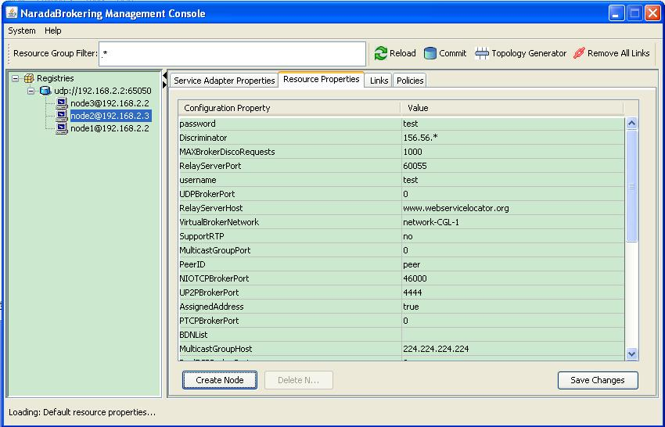
Figure 5: Grid Builder tool interface

In order to make a sensor service manageable by the management tool, we implemented a specific sensor service adapter and a sensor manager using the WS Management protocol. The interface of the Grid Builder tool that implements the management framework is shown in Figure 5. The user can easily view a list of discovered sensor services in the left panel and select one to get more detailed information about it such as its location, the host address and its UUID, etc. The user can also deploy a sensor service on a remote sensor node through the application. Thus, in case one necessary sensor service becomes unavailable due to some reasons, it is still possible to find an alternative sensor to start the same service.

The process of finding new sensors is based on WS-Discovery specification, in which the message exchange between a sensor service adapter and a sensor manager is described as below:

1) Initially a sensor sends a multicast Hello message when it joins a network;
2) The sensor manager multicasts a Probe message with Type and/or Scope to discover existing sensors;
3) A sensor may receive a multicast Probe message and send a unicast Probe Match (PM) if it matches that Probe;
4) The sensor manager multicasts a Resolve message with Name to discover existing sensors;
5) A sensor may receive a multicast Resolve message and send a unicast Resolve Match (RM) if it matches that Resolve;
6) When a sensor leaves a network, it sends a multicast Bye message
- The sensor manager will add/remove a sensor when it receives a multicast Hello/Bye message.

The Grid Builder tool follows the idea of constructing grid of grids, which assembles a multitude of subgrids into a mission-specific grid application. In the CSG framework, the Grid Builder tool facilitates the assemblage of two important subgrids, namely a real-time multimedia collaboration grid and hierarchical, executable sensor grid. For example, many types of sensors have controls for changing their respective behavior and to perform actions. However, the specific action and its corresponding control operation vary from sensors to sensors. To facilitate the control of sensors in an end-user application, the CSG client will support sets of customable controls to be defined by users with Grid Builder. This information will be transmitted to the respective sensor sharedlets in order to construct appropriate buttons for sensor control. We provided some initial sensor sharedlet controls for certain generic sensor types, which will be shown in the next section.

4. Visualization and Presentation

A particular design objective for the CSG client is to provide an intuitive user interface for enabling UDOP (User Defined Operation Picture) and COP (Common Operation Picture) capabilities, which are essential for agile formulation and sharing of visual, situational awareness and effective decision-support.

To have the basic support of sensors, users must be able to visualize sensors’ data and to control sensors. Some basic principles for visualizing sensor are:

- Groups of geo-located sensors can be visualized by their geospatial locations;
- Each sensor can be visualized particularly based on its property;
- Sensors can be grouped and visualized on a single canvas
- Multiple canvas can be viewed concurrently
- The state can be captured

Also, each sensor should accept control which can be none. And those control functions should be generated according to sensor’s controllable capability. Multiple sensors can be controlled simultaneously.

We used Anabas Impromptu for Sensors as the collaboration solution for sharing information from sensors among distributed users. It is a system for real time sharing of sensor streams, visualization, VoIP, Video over IP and supports multiple chat rooms. Its portal consists of multiple sharedlets, each of which can be a standalone, shared application. Different sharedlets were developed for handling and displaying different types of real time information in Impromptu for Sensors.

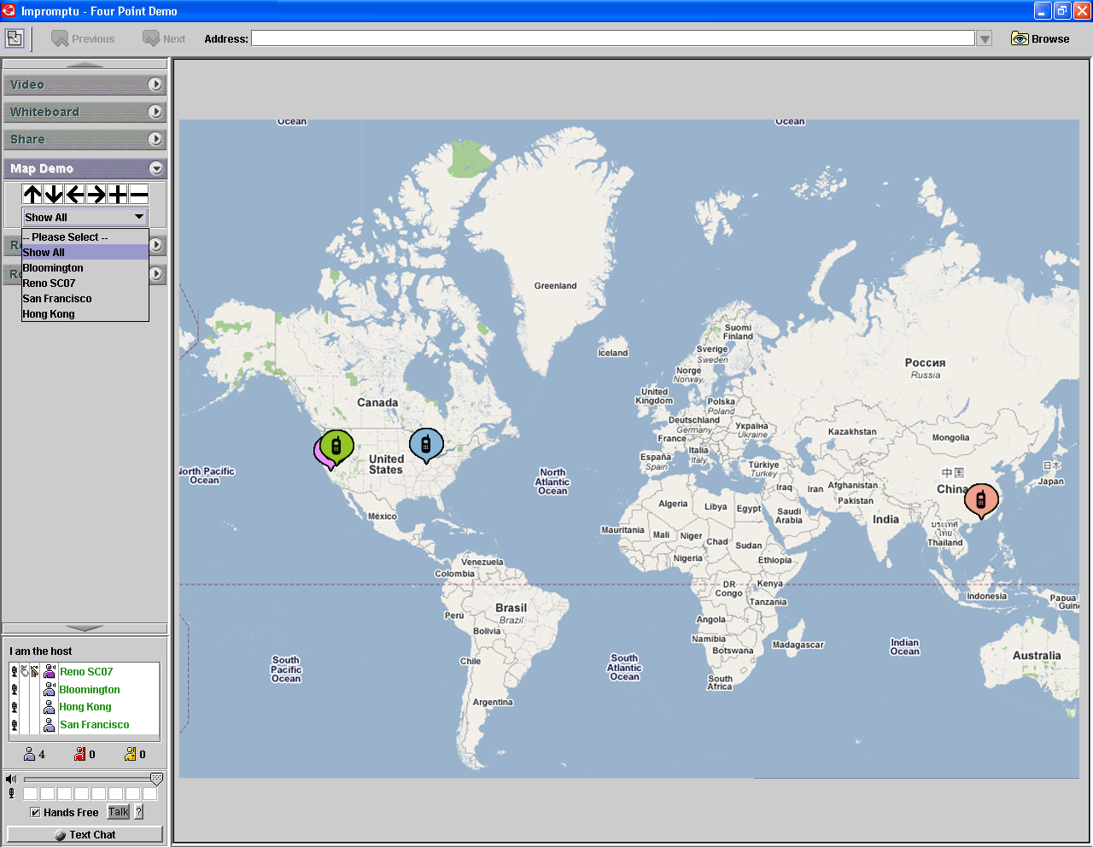

Figure 6: A maps sharedlet integrating real-time GPS sensor streams with Google map.

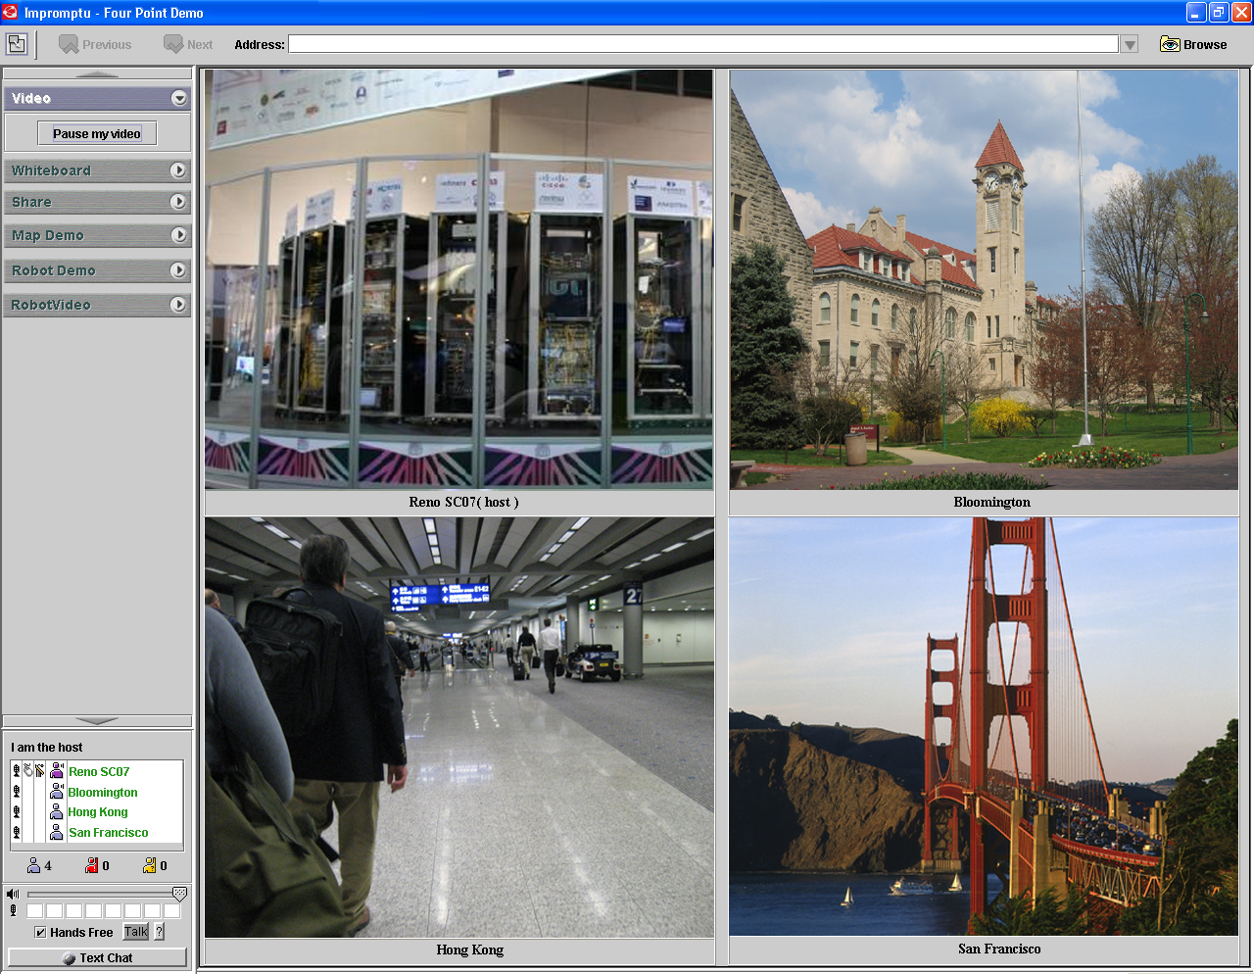
Figure 7: Video Sensors sharedlet interface

Figure 6 and Figure 7 show the display for 4 GPS and 4 video (Webcam) sensors, respectively. The GPS sharedlet includes a Google Map with four different GPS locations marked on. Users can use the supported control to zoom in, zoom out, and move the map around via the sensor control tool menu. In the Video sharedlet, there are four windows streaming real time videos from those locations without any user control.

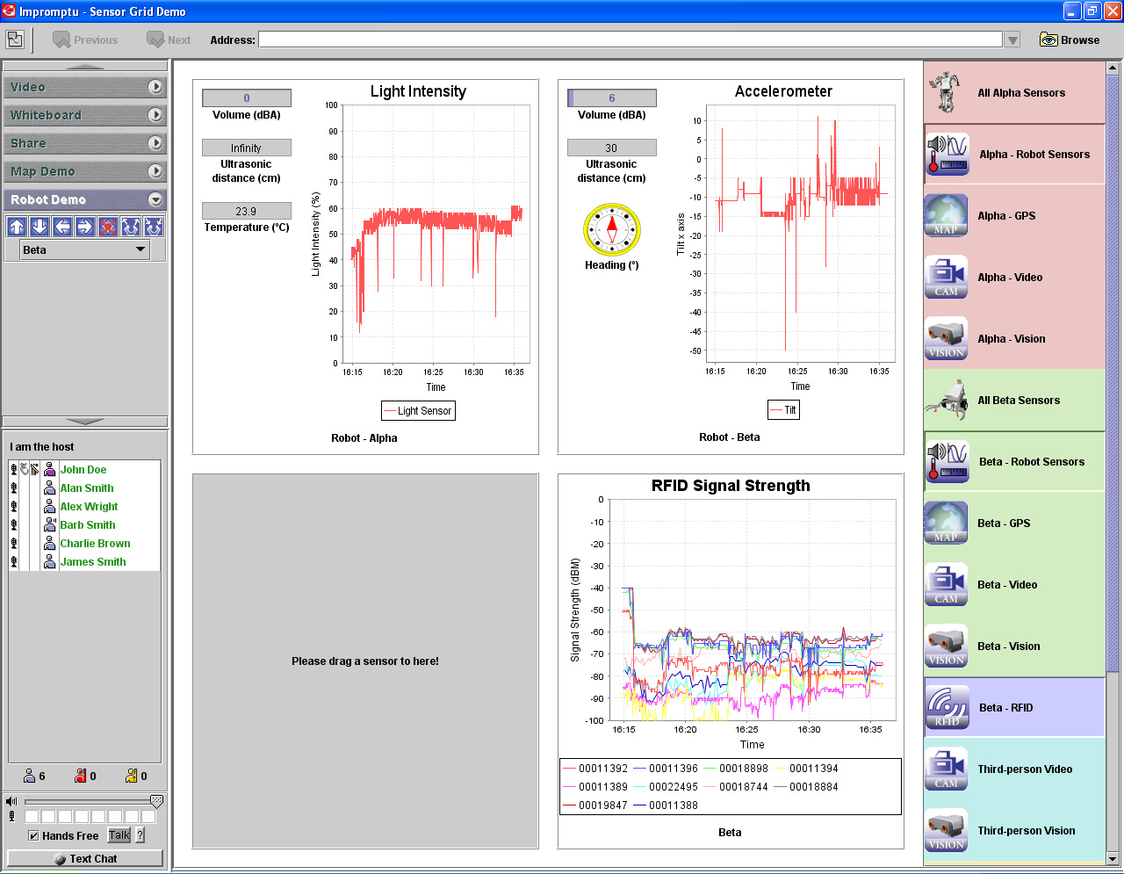
Figure 8: A UDOP composed by selecting from an extensible list of sensors

Figure 8 presents a case that a user was in the process of defining a UDOP simply by dragging/selecting sensor information of relevancy from an extensible list of real-time sensor streams from the right hand side panel to one of four visualization windows. In this case, the user selected to show the real-time streams from sensors carried by an Alpha Rex on the upper left window, real-time streams from sensors carried by a Tribot on the upper right window, and real-time stream from the RFID reader carried by the Tribot as an external payload on the lower right.

In Figure 9, the user selected to define an operating picture that places visualization of robot Alpha Rex sensor streams in the upper left window with its geo-spatial information (Bloomington, Indiana) in upper right window; while at the same time, visualizing robot Tribot’s sensor streams in lower left window and its geo-spatial information (San Francisco) in lower right window.

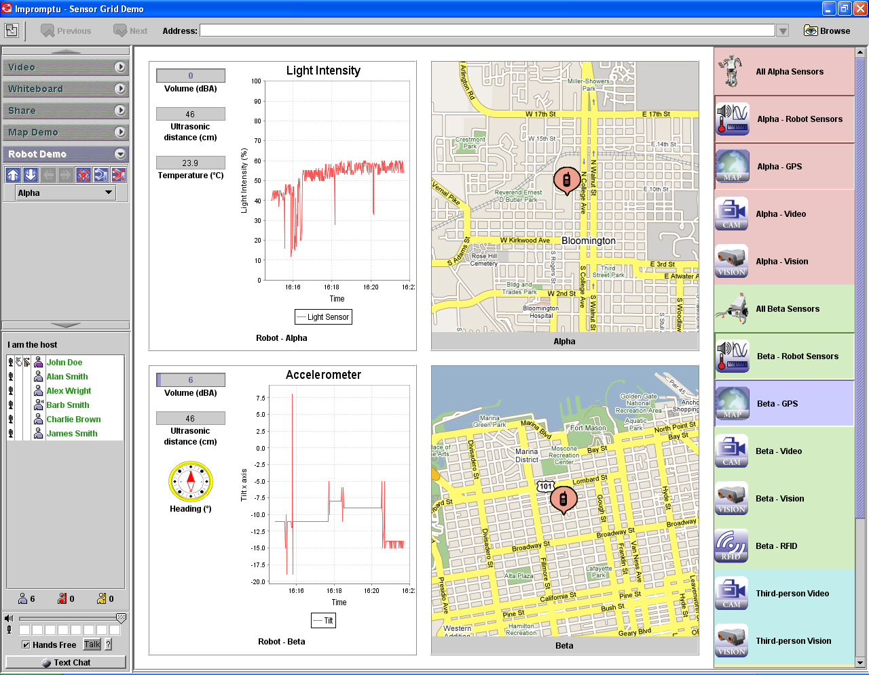
Figure 9: Another User-defined Operating Picture

Simply by double clicking on the lower left window, the 4 sensor streams delivered from the Tribot is expanded and the expanded view becomes the current UDOP and will be shared automatically as a COP for all collaborative session participants, in this case, 6 of them as seen on the participant list in the lower left hand side control panel . In Figure 10, it is shown that the sound sensor detected sound level at 6 dBA, ultrasonic sensor measured a distance of 6 cm, compass sensor pointed to North and accelerometer indicated X-axis tilt values as the Tribot cruised in the environment.

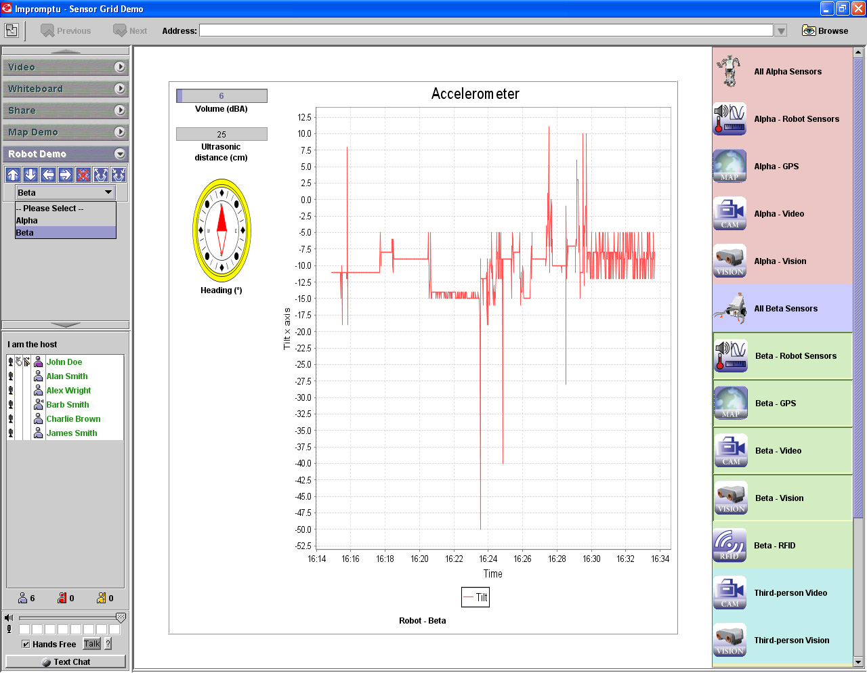
Figure 10: A UDOP sharing 4 sensor streams delivered by a Tribot robot

Figure 11 is a UDOP similar to that of Figure 10 but sharing in this case the visualization of information from the 4 sensor streams delivered from the sensors carried by an Alpha Rex robot. It shows sound volume at 5 dBA, ultrasonic value of 44 cm and temperature measured at 23.9 degree Celsius with light intensity fluctuating as the robot roamed around.

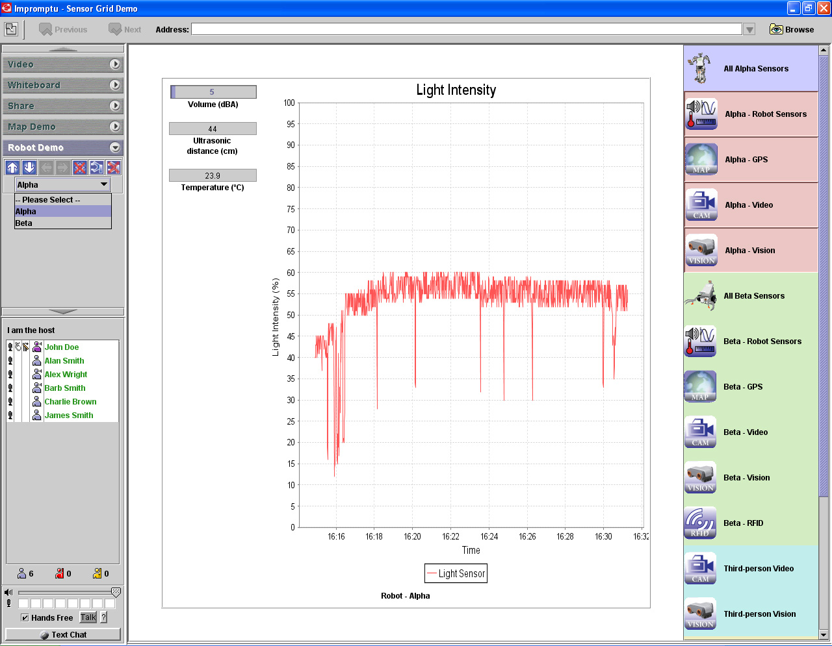
Figure 11: Another easily composed UDOP

Figure 12 is another user-defined operating being shared instantly by the Impromptu for Sensor client as a common operating picture. In this case, the user chose to share an expanded view of the RFID signal strength as detected by the RFID reader carried by the Tribot robot.

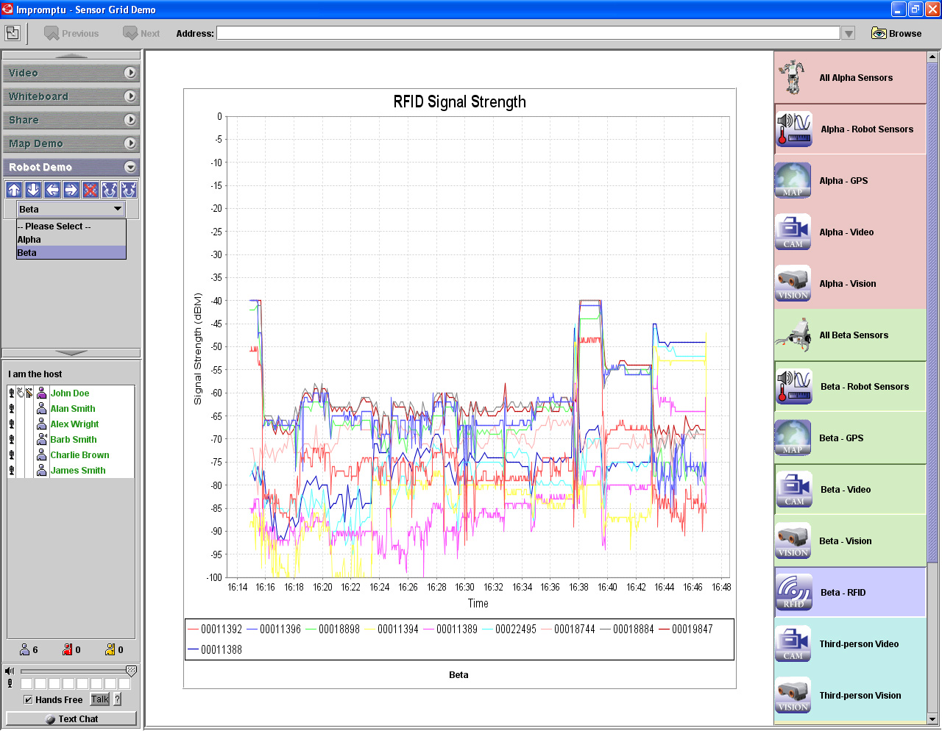
Figure 12: A UDOP sharing RFID signal strength

I

5. Conclusions and Future Work

We have developed a framework to support easy and rapid development, deployment, management, visualization of collaborative, geospatially located sensor grids with flexibility, extensibility and scalability. Based on the framework, we created sensor grid applications for several types of commonly available sensors, used a Grid Builder tool for discovering and managing those sensors, and provided a rich, informative, easy to use (drag & drop and double clicking metaphors) user interface for presenting real-time sensor data to users according to the UDOP model. Also, we used advanced collaborative technology built on top of message-oriented middleware to enable distrusted users to have a consistent view of such information. The Impromptu for Sensors client immediately and automatically shares a UDOP as a COP for all collaborative session participants.

There are still many important issues for future work. First, currently the Grid Builder tool is standalone. It will be integrated with Impromptu for Sensors as a sharedlet. Not only it will make the interface more consistent but also it will link the collaboration grid with the sensor grid in an integrated fashion. Second, it is expected that a user can customize controls for new types of sensors. Predefined controls may not be suitable for those. More interactions between users and the system can be useful. Last, information from different sensors can be synthesized and processed through a workflow to make it more meaningful to users. This is illustrated by the current GPS sensor and simulation grid seen in the Earthquake science example [2-4, 14].

Acknowledgements
We thank Bill McQuay of AFRL, Shrideep Pallickara and Marlon Pierce of the Community Grids Laboratory and Gary Whitted of Ball Aerospace for important suggestions

References

- The open source NaradaBrokering Project. http://www.naradabrokering.org

- Galip Aydin, “Service Oriented Architecture for Geographic Information Systems Supporting Real Time Data Grids”, Indiana University PhD, January 15, 2007 http://grids.ucs.indiana.edu/ptliupages/publications/GalipAydin-Thesis.pdf

- Galip Aydin, Zhigang Qi, Marlon E. Pierce, Yehuda Bock, and Geoffrey C. Fox, “Building a Sensor Grid for Real Time Global Positioning System Data”, in Proceedings of Workshop on Principles of Pervasive Information Systems Design Toronto May 13, 2007 http://grids.ucs.indiana.edu/ptliupages/publications/Pervasive2007Toronto_PierceSensorGrid-final.pdf

- Andrea Donnellan, Jay Parker, Robert Granat, Geoffrey Fox, Marlon Pierce, John Rundle, Dennis McLeod, Rami Al-Ghanmi, Lisa Grant, Walter Brooks QuakeSim: Efficient Modeling of Sensor Web Data in a Web Services Environment November 30 2007 to be published in 2008 IEEE Aerospace Conference March 1-8 2008, Big Sky MT http://grids.ucs.indiana.edu/ptliupages/publications/F1224_3.pdf

- Harshwardhan Gadgil, Geoffrey Fox, Shrideep Pallickara, and Marlon Pierce, Scalable, Fault-tolerant Management of Grid Services, in Proceedings of IEEE Cluster 2007. http://grids.ucs.indiana.edu/ptliupages/publications/mgmt-cluster-final.pdf

- Harshawardhan Gadgil, Geoffrey Fox, Shrideep Pallickara, Scalable, Fault-tolerant Management in a Service Oriented Architecture, Poster in pages 235-236 of proceedings for IEEE International Symposium in High-Performance Distributed Computing (HPDC), June, 2007 http://grids.ucs.indiana.edu/ptliupages/publications/mgmtArchitecturePaper-POSTER.pdf
- Donald F. (Rick) McMullen, Marlon Pierce, Carol Deng, Kia Huffman Real-time Web 2.0: Evolution of Middleware for Grid-based Instruments and Sensors Web 2.0 Workshop at The 21st Open Grid Forum - OGF21 Grand Hyatt Seattle Seattle, Washington October 15-19, 2007 http://www.ogf.org/gf/event_schedule/index.php?id=1022

- ESTO / AIST Sensor Web PI Meeting - February 13-14, 2007, San Diego http://esto.nasa.gov/sensorwebmeeting/

- UbITA 2007 Workshop on u-City (Ubiquitous City) http://ubita.org/ October 31-November 2 2007 Konkuk University Korea

- ROADNet: Real-time Observatories, Applications and Data Management Network http://roadnet.ucsd.edu/index.html

- Center for Embedded Networked Sensing CENS http://research.cens.ucla.edu/

- INGRID 2007 - Instrumenting the Grid workshop http://www.ingrid07.cnit.it/

- Microsoft eScience 2007 meeting at RENCI UNC October 21-23 2007 http://research.microsoft.com/workshops/escience2007/default.aspx

- Robert Granat, Galip Aydin, Zhigang Qi, and Marlon Pierce, GPS Sensor Web Time Series Analysis Using SensorGrid Technology American Geophysical Union AGU Fall Meeting, Moscone Conventon Center, San Francisco, CA, USA, 11–15 December 2006. http://www.agu.org/meetings/fm06/

- Wenjun Wu, Geoffrey Fox, Hasan Bulut, Ahmet Uyar, Tao Huang Service Oriented Architecture for VoIP conferencing. Special Issue on Voice over IP - Theory and Practice of the International Journal of Communication Systems Volume 19, Issue 4 , Pages 445 - 461 Edited by John Fox and P. Gburzynski http://grids.ucs.indiana.edu/ptliupages/publications/soa-voip-05.doc

- Ahmet Uyar and Geoffrey Fox Investigating the Performance of Audio/Video Service Architecture I: Single Broker Proceedings of the IEEE International Symposium on Collaborative Technologies and Systems CTS05 May 2005, St. Louis Missouri, USA. Pages 120-127. http://grids.ucs.indiana.edu/ptliupages/publications/SingleBroker-cts05-submitted.PDF

- Ahmet Uyar and Geoffrey Fox Investigating the Performance of Audio/Video Service Architecture II: Broker Network Proceedings of the IEEE International Symposium on Collaborative Technologies and Systems CTS05 May 2005, St. Louis Missouri, USA. Pages 128-135 http://grids.ucs.indiana.edu/ptliupages/publications/BrokerNetwork-cts05-final.PDF

- L.M. Ni, Y. Liu, Y.C. Lau, and A.P. Patil. LANDMARC: Indoor location sensing using active RFID. In Proceedings of IEEE International Conference in Pervasive Computing and Communications (PerCom), pg 407–415, Dallas, TX, USA, March 2003.

- J Yin, Q Yang and LM Ni. Learning Adaptive Temporal Radio Maps for Signal-Strength-Based Location Estimation. IEEE Transactions on Mobile Computing, 2007.

- J. Yin, Q. Yang, L. Ni. Adaptive Temporal Radio Maps for Indoor Location Estimation. In Proceedings of IEEE International Conference on Pervasive Computing and Communications (PerCom), pages 85–94, Kauai Island, HW, USA, March 2005.

- Clemson and Indiana University Team, Feature - Testing the waters: coastal ecologists look to open source software to manage distributed sensor data, International Science Grid This Week http://www.isgtw.org/?pid=1000863 6 February 2008

- Harshawardhan Gadgil SCALABLE, FAULT-TOLERANT MANAGEMENT OF GRID SERVICES: APPLICATION TO MESSAGING MIDDLEWARE Indiana University PhD April 5 200 http://grids.ucs.indiana.edu/ptliupages/publications/hgadgil-THESIS.pdf

Appendix: RFID Positioning Algorithm

The signal strength (expressed as power per unit square) received by a RFID reader from a RFID tag is inversely proportional to the square of the distance between the reader and the tag. So we have 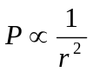.However, the output of the signal strength received by a RFID reader is in dBm. To express an arbitrary power P as x dBm, we have: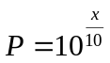
Assume that the signal strength received by a RFID reader from a RFID tag depends on their distance and their surrounding disturbance according to a multiplicative model as follow:
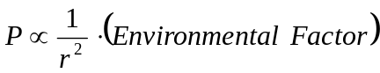.
Suppose that there are a reference tag and a target tag, which follow multiplicative models as below respectively:
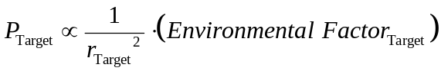
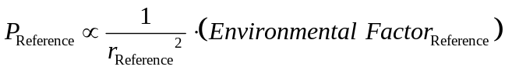
We further assume that the effect of the environmental factors on the 2 tags is similar. We can cancel the environmental factors as follows:
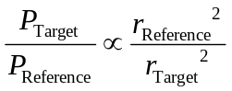
A linear model is obtained in the logarithmic space:
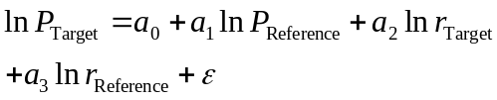

By rearranging, we have:
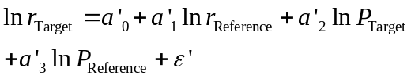
Substituting, we get:
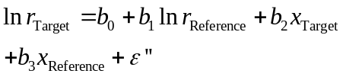
which is the linear model on which our RFID positioning result is based.

