Experience with Online Teaching with Open Source MOOC Technology
Geoffrey Fox 10 June 2014
Abstract: This memo describes experiences with online teaching in Spring Semester 2014. We discuss the technologies used and the approach to teaching/learning.
Scenario: We have taught from December 2013 to now, a course that was originally called X-Informatics but later renamed Big Data: Applications and Analytics. This course has four separate offerings so far
- A MOOC with no credit and no tuition. This started first and continues with a total of 1637 enrolled students as of June 9 2014; about 6 new students enroll every day. This class is online only and does not offer instructor or AI grading. A largely meaningless “piece of paper” is available to those who complete class.
- An Informatics Undergraduate class I400 offered spring 2014 semester with 55 residential students and regular tuition and credit. This had regular instructor/AI grading.
- An Informatics Graduate class I590 offered spring 2014 semester with 22 residential students and regular tuition and credit; most students were Computer Science Masters students. This had regular instructor/AI grading.
- A Data Science Certificate Graduate class I590 offered spring 2014 semester with 12 non-residential students and (discounted to ~instate value) tuition but regular credit. This class was online only. This had regular instructor/AI grading.
For offering 1) link is https://bigdatacourse.appspot.com/preview
For offering 2, 3, 4) link is https://bigdatacoursespring2014.appspot.com/preview
Most of the the web material is hosted on Dropbox/Box@IU/Google resources to reduce traffic and hence cost; Google App Engine for base site and YouTube for videos. The videos can be watched either through YouTube directly or embedded in the App Engine web page.
Google Course Builder is an app built for Google App Engine that offers free hosting upto a certain quota
The building blocks of these classes were
A online course resource built with Google Course Builder and enhancements CGL Mooc Builder http://moocbuilder.soic.indiana.edu/ built by us and available as open source that allow convenient assembly of the different course components. These components include
5-15 minute video segments called lessons and containing curricula material (instructor desktop often containing PowerPoint slides).
Lessons are assembled into units totaling around 45 minutes – 2 hours and roughly equivalent to a traditional class.
Units linked into sections that together make up a coherent description of a major topic in course; for example “introduction” “Big Data and the Higgs Boson” and “Cloud Technology” are sections in these classes
The offerings 2), 3) and 4) share the same online site with 14 sections; 33 units and 220 lessons totaling 28.7 hours of video. The average lesson length was 7.8 minutes with 52 minute average for units and sections averaging just over 2 hours with a maximum length of 5 hours 18 minutes. Offering 1) was similar but had earlier versions of material.
Each lesson had a video located on YouTube and an abstract (called lesson overview in figure 1 below). This interface show all lessons (13) for this unit and that each unit has its own abstract and slides available. There are also a list of follow-up resources associated with units and illustrated at bottom of figure 1. In the middle of figure 1, one sees the link to YouTube hosting of this lesson and 3 discussion links; one for each offering 2), 3) and4). These are described later.
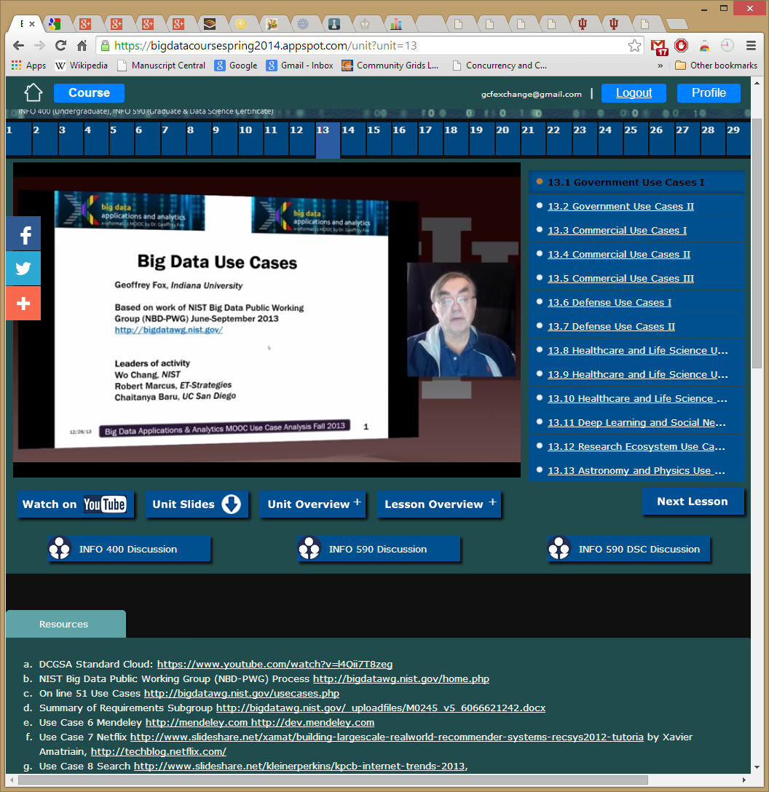
Figure 1: A typical lesson (the first in unit 13) showing features discussed in text. Note links to all units across the top (29 of 33 units shown)
Note that we have a course – section – unit – lesson hierarchy (supported by Mooc Builder) with abstracts available at each level of hierarchy. The home page has overview information (shown in figure 2) plus a list of all sections and a syllabus with latter shown in figure 3.
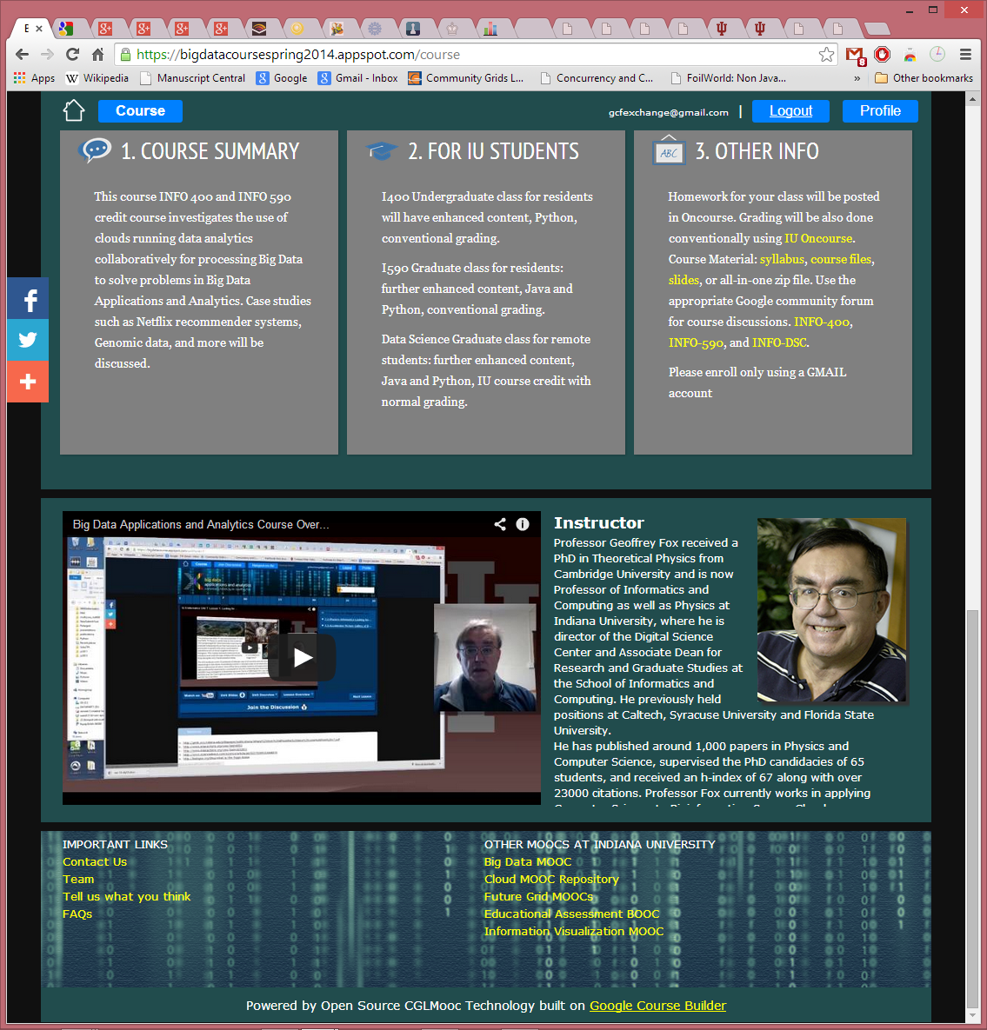 Figure 2: Course Home Page with Overview material
Figure 3: Course Home Page showing Syllabus
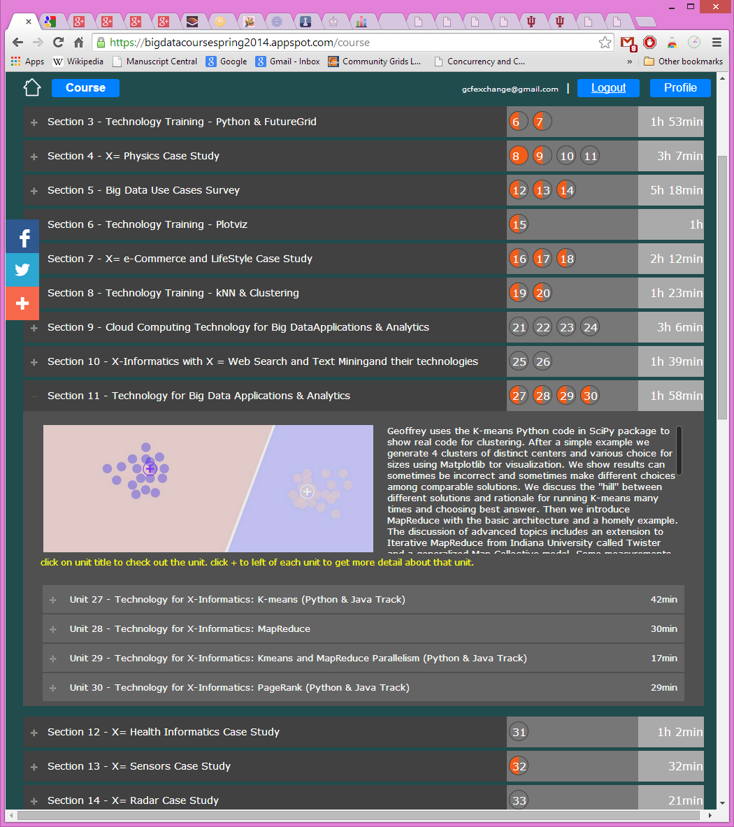 Figure 4: List of Sections with one (Section 11) expanded to show abstract and constituent units.
Figure 4 shows a partial list of sections showing how one can interactively browse the hierarchy. The next level would expose a unit as shown in figure 1.
Homeworks. These are online within Google Course Builder for the MOOC 1) with peer assessment. In the credit offerings 2-4), all graded material (homework and projects) is conducted traditionally through Indiana University Oncourse. Oncourse was additionally used to assign which videos should be watched each week and the discussion forum topics described later (these were just “special homeworks in Oncourse). In the non-residential class 4), the students were on a variable schedule (as typically working full time and many distractions; one for example had faculty position interviews) and considerable latitude was given for video and homework completion dates.
Discussion Forums: each offering had a separate set of electronic discussion forums which were used for class announcements (replicating Oncourse) and for assigned discussions. Figure 5 illustrates an assigned discussion on the implications of the success of e-commerce for the future of “real malls”. The students were given “participation credit” for posting here and these were very well received. Our next offering will make greater use of these forums. Based on student feedback we will encourage even greater participation through students both posting and commenting. Note I personally do not like specialized (walled garden) forums and the class forums were set up using standard Google Community Groups with a familiar elegant interface. These community groups also link well to Google Hangouts described later.
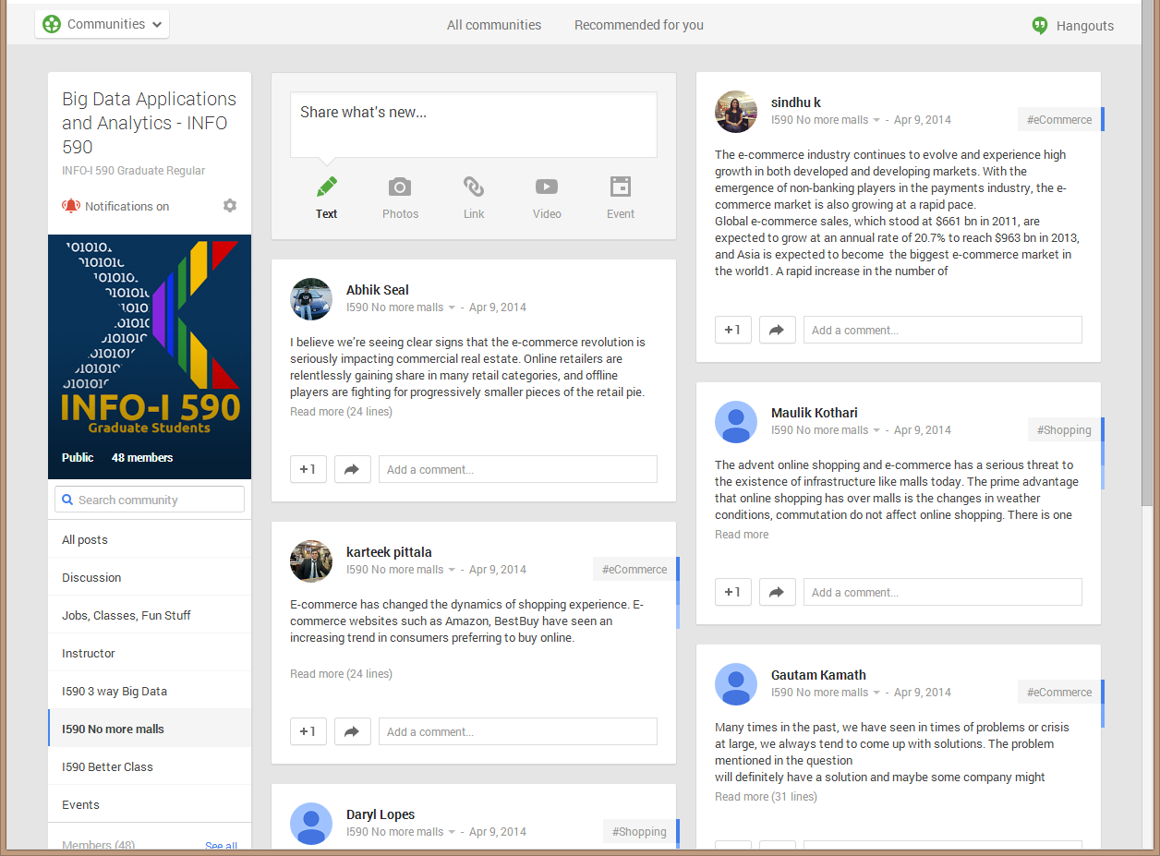
Figure 5: The community group for one of classes and one forum (“No more malls”) described in text
As well as interesting topics, all class announcements were made in the “Instructor” forum repeating information posted at Oncourse. Of course no sensitive material such as returned homework was posted on this site.
Hangouts: For the purely online offering 4), we supplemented the asynchronous material described above with real-time interactive Google Hangout video sessions illustrated in figure 6. Given varied time zones and weekday demands on students, these were held at 1pm Eastern on Sundays. Google Hangouts are conveniently scheduled from community page and offer interactive video and chat capabilities that were well received. Other technologies such as Skype are also possible. Hangouts are restricted to 10-15 people which was sufficient for this course. Not all of 12 students attended a given class. The Hangouts focused on general data science issues and the mechanics of the class.
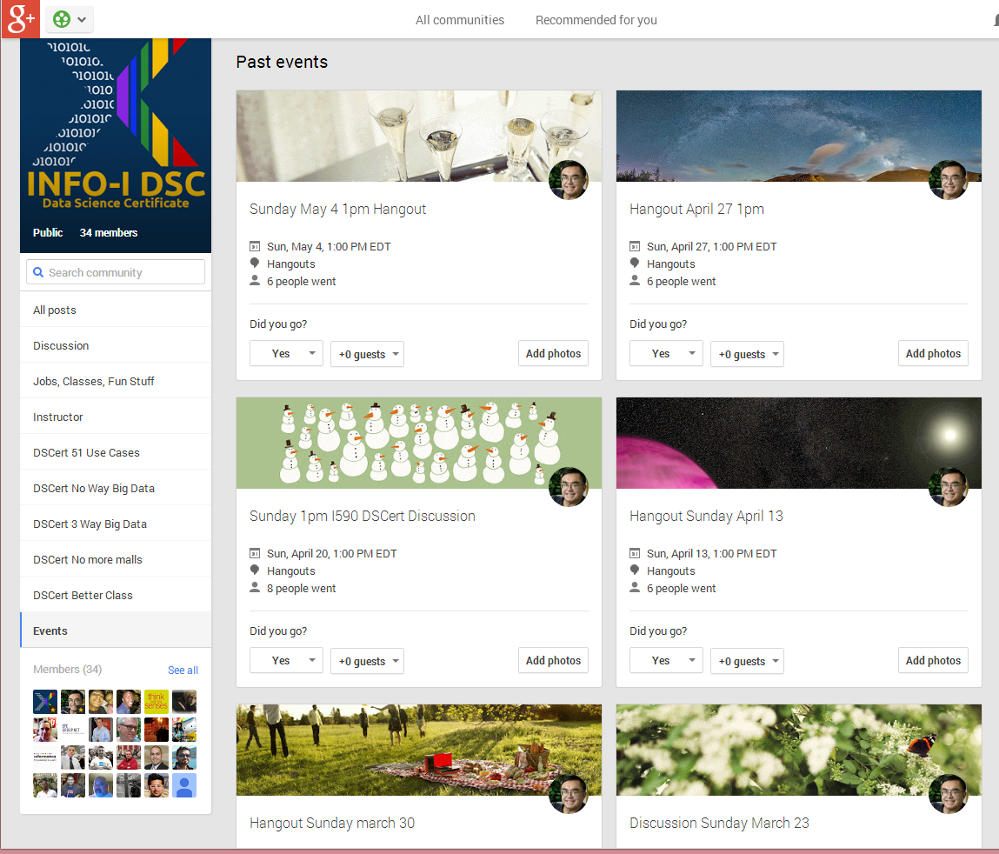
Figure 6: Community Events for Online Data Science Certificate Course 4).
In class Sessions: The residential sections 2) and 3) had regular in class sessions; one 90 minute session per class each week. This was originally two sessions but reduced to one partly because online videos turned these into “flipped classes” with less need for in class time and partly to accommodate more students (77 total graduate and undergraduate). These classes were devoted to discussions of course material, homework and largely the discussion forum topics. This part of course was not greatly liked by the students – especially the undergraduate section which voted in favor of a model with only the online components (including the discussion forums which they recommended expanding). In particular the 9.30am start time was viewed as too early and intrinsically unattractive.
Workflow: The above approach has no revolutionary ideas and is perhaps even prosaic. It did however get developed by several false starts and here we capture the actions that would be taken by a faculty copying the above strategy.
Let’s assume we start with a traditional class with therefore an existing curriculum and content. Then we start by dividing material into sections and units. This should be easy as unit is roughly material for a traditional class.
Now we take a unit and prepare it for online recording. I did this in low-end style using a high quality web-cam (Logitech HD Pro Webcam C920, 1080p at ~$73 from Amazon) on my laptop with attention to appropriate lighting and a black backdrop. I then took the slides for unit and inserted PowerPoint dividers separating this into lessons. This is convenient for recording as you know any video will be divided at these separators so you can take a deep breath at each divider. The lesson is recorded using Adobe Presenter. In my case this was either done as PowerPoint in full screen mode or an application (browser or IPython window perhaps). I recorded one or two units at each session. The final Presenter material is then edited – we used Camtasia – into lessons to be uploaded to YouTube. The next step is to write the necessary abstracts and assemble the online course using Mooc Builder. Obviously the material needs to be checked. I note students found the video quality and organization of web site as quite good.
Operationally when the course is in session, the instructor needs to monitor Oncourse and the Class community group and set each week, the class homework, videos to watch and discussion topic.
Analytics
Course Builder at time does not support good student analytics. The only measure available to me was the ability to look up a student’s peer reviewed assignments. We developed some analytics capability as part of the MOOC builder that offers basic demographics data such as Age, Country, Education, and Enrollment Number per day. There are intrinsic difficulties due to multiple web sites and currently for example it’s hard to link YouTube access to the Google App Engine access.
Summary
We described an approach that can either offer an unsupervised Mooc, a purely online credit class or a flipped class. We showed how an extended Google Course Builder, the traditional IU Oncourse system and Google community groups could be integrated. The relatively new features: Course Builder and YouTube videos and Community groups were well received by students. For the instructor the weakest part of the system were the analytics available to monitor student use of online resources. Some Demographics analytics are available as part of Mooc Builder that may be useful for gaining insights.
Acknowledgements
Sidd Maini led the design and construction of CGL Mooc Builder available at http://moocbuilder.soic.indiana.edu/. He supervised carefully temporary students who helped in the video editing and course assembly,

