Teaching, Learning and Collaborating through Cloud Computing Online Classes

Judy Qiu∗, Supun Kamburugamuve∗, Hyungro Lee∗, Jerome Mitchell∗, Rebecca Caldwell†, Gina Bullock‡, Linda Hayden§
∗School of Informatics, Computing, and Engineering, Indiana University Bloomignton
xqiu, skamburu, lee212, jeromitc @indiana.edu
{ }
†Winston-Salem State University
caldwellr@wssu.edu
‡North Carolina Agricultural and Technical State University
glbulloc@ncat.edu
§Elizabeth City State University
haydenl@mindspring.com

Abstract—A knowledge of parallel and distributed computing is important for students needing to address big data problems in later jobs in industry or academia. However, many campuses do not offer courses in these important areas due to curriculum limitations, a lack of faculty expertise, and limited instructional computing resources. MOOCs and Clouds provide an opportunity to scale learning environments and to help institutions needing advanced curriculum. In this paper, we discuss a course offered at Indiana University and use it as a model for improving curriculum at institutions who cannot easily provide the needed courses themselves
Keywords—Online Education, Cloud Computing, Parallel and Distributed Computing.

- INTRODUCTION
Parallel and distributed computing is becoming ever more important with the exponential growth of data production in areas such as the web and the Internet of Things. Further modern computers are equipped with multiple processors that need to be utilized efficiently. On the other hand, clouds are becoming the standard computing platform for running both applications as well as data analytics. With these trends it becomes increasingly important for the next generation of software engineers and researchers to be familiar with distributed and cloud computing paradigms and how they can be applied in practice and often in parallel fashion. Unlike academia where one focuses on the fundamental computer science problems, cloud computing involves many technologies and software tools that are widely used by industry and academia for real-world applications that are now part of everyday life for billions of people. These include Internet-scale web search, e-mail, online commerce, social networks, geo-location and map services, photo sharing, automated natural language translation, document preparation and collaboration, media distribution, teleconferencing and online gaming. However, the underlying fundamentals of these techniques are coming from different computer science disciplines including distributed and parallel computing, databases and computer systems architecture. A well-rounded course of cloud computing should cover each of these areas and explain them in the context of cloud computing. To gain practical experience on cloud computing, a student has
In order to facilitate such a learning environment, Indiana University Bloomington developed the Cloud Computing on- line course 1 and its instructor is Prof. Judy Qiu. This course has been taught for several years both in-class for residential students and for online students. The course is offered as part of the curriculum for Computer Science graduate program at Indiana University and students from the Data Science graduate program. Intelligent System Engineering and Library science are also given the opportunity to take the course.
A primary goal of the course is to maintain the same standard as the residential course for the online course. It is especially challenging due to limitations on the face to face interactions with the online students, diverse background of students and the deep technical knowledge required by the course. The students are expected to have general programming experience with Linux and proficiency in the Java (2-3 years) programming language and scripting. A background in parallel and cluster computing is considered a plus but not required. The statistics present in this paper is related to the latest version of the online course which saw the largest attendance so far with about 160 students, where 100 were residential students and the rest were online students. The popularity of the cloud computing topic follows from major corporations including Microsoft, Amazon, Google, IBM, Facebook and Twitter, which provide infrastructure, tools or applications in Clouds. Business, government, academia and individuals use public or private cloud-based solutions for storage and applications.
The course has been taken as a model by other institutions to introduce cloud computing to their own students. This is facilitated by the availability of online course materials. This provides a unique opportunity for collaboration between Eliza- beth City State University (ECSU) and Indiana University (IU) in remote sensing of the environment using Cloud Computing technology and involve faculty and students from Minority Serving Institutions (MSI) by exploiting enhancements using Cloud Computing technology. Computational Science and Data Science are important areas that have the capability to host both parallel computation (using MPI and Hadoop) and learning resources (online MOOC), making it an attractive

to master many different technologies that are based on these

principles.
1http://cloudmooc.appspot.com/preview

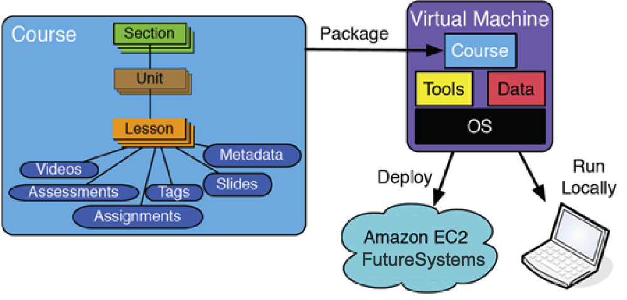

Fig. 1. Model for the MOOC Course Content and Delivery using Cloud

focus for universities without a major research history look- ing to participate on an equal footing with research intense universities.
The rest of paper is organized with section II introducing the curriculum development and course structures, followed in section III by a discussion of the audience and in section IV by evaluations of the course outcome and knowledge growth for students, and section V scaling the model to HBCU institutions. Finally, in section VI we summarize the challenges, impact and future work in modernizing curriculum and workforce development.

- COURSE ORGANIZATION
The course is aimed at teaching the basic principles of parallel and distributed computing and explore the application of these in practice in cloud environments. This is a graduate level course with large emphasis on programming and expects prior knowledge of programming in order to be successful. The course follows the cloud computing text book [1]. By the end of this course, students are expected to learn key concepts in cloud computing and have enough hands-on programming to be able to solve data analysis problems on their own. The organization of the course is shown in Fig. 1.

- Course Content
The course uses the Google Course builder as the content hosting platform. Google Course builder provides an easy way to host course content. Its source code is distributed under the Apache License version 2 and is free to modify and redistribute. An individual instructor can develop a course quickly with the features provided by this out of the box software. Since Course builder is open source, an instructor can modify the source code to create a more personalized version of the course. The final completed course should be deployed in Google infrastructure using the Google App Engine.
The course content is mainly lecture videos hosted in YouTube. Text version of the content is also possible. The course should be structured as a set of units. Each unit contains a set of lessons. Each lesson is a video plus some text description. Each lesson can be followed by a simple activity. The instructor creates an activity as a JavaScript file. The activity contains simple multiple-choice questions or text based answer questions with specific answers. Between units there can be course assessments. These assessments can be like midterm exam final exam etc. They also have the same
format as activities followed by lessons and features multiple- choice questions and simple text based answer questions. The activities and assessments can be graded and the scores are displayed in the student profile.
The course consists of six units starting with cloud com- puting fundamentals and then move on to infrastructure as a service (IaaS), Platform as a service (PaaS) and cloud data storage and internet of things applications. Each unit consists of multiple lectures with videos.
The videos were recorded by the instructor with the help of a professional staff for video recording and editing. It took a lot of effort and time to get the videos properly recorded in the first time of offering the course. After the initial videos were finalized it was relatively easy to add more content or update the videos for later offerings of the course.

- Forums
We experimented with several options for class forums which is a vital part of the course. Because the large class size, an instructor is not always possible to solve problems encountered by individual student in person. In previous years the course was run with Google Forums2, Indiana University internal forums and Piazza3 forums and we found Piazza as the best platform.

- Projects
The course was offered with a comprehensive set of cloud application projects that are interlinked together. The overall goal is to build a web search engine from scratch and students can use various tools in-order to build the system one component at a time using cloud based data analytic platforms. The projects use Hadoop [2], HDFS [3] and HBase [4] as main technologies. The data set used by the projects is ClueWeb09 [5] available for educational purposes. We only use a moderate size data set from the original because of the resource constrains.
The projects are packaged into a virtual machine and a student can download this to run the projects on their home machine or on a cloud provider if they choose to do so. The course expects students to run the projects on their own local machines at the start and then move to production distributed environments. Each project is accompanied by a video that explains the project in detail and show some of the steps required to build and run the project.
The projects starts with a small activity that involves configuring Hadoop and running a simple Hadoop program. The first building block of the search engine expects students to write a pagerank [6] algorithm in Hadoop to assign an importance to web pages. Next the HBase distributed storage is introduced to the students and the course expects them to write a program to load the data into HBase as well as create an inverted index from word to page to facilitate the search. The next step is to combine the results from pagerank and use the inverted index to do actual searches. Apart from these projects the students are expected to implement a standard machine learning algorithm using the Harp [7] machine learning platform developed at Indiana

2https://groups.google.com 3https://piazza.com/

University. These projects are aimed at teaching students about complex data analytics and how to use parallel processing to speed up a sequential algorithm.

- Student Evaluations
Students are evaluated based on their performance on eight programming projects, written assignments and two exams. The exams are focused on the core concepts of cloud comput- ing and related underlying principles. The exams are conducted online using the Canvas platform and the Adobe connect video conferencing.

- Online Meetings
To facilitate the questions from students regarding both course content as well as projects, online meet ups were conducted every week. These were one hour sessions mainly steered by associate instructors but participated in by the instructor. In early course offerings, with only a small number of students the Google Hangouts platform was the choice for online meetings. But with larger classes we switched to Adobe Connect platform, provided by Indiana University for online courses. Every such online meeting is recorded and available through YouTube for later viewing by the students. We find that such videos are helpful in the subsequent runs of the course as well.

- Content Repository
The developer of the course found the need to share content among different courses run by different instructors. In-order to do so, a MOOC platform should be able to share course content among different courses. As part of this course, we have developed technology on top of Edx MOOC platform to share content among different courses and we are planning to move the content of this course which is currently in Google Course Builder to the Edx platform. This development will allow different instructors from different universities to easily share course content and quickly create new courses that modify the old one.

- Assignments & Exams
Assignments were mainly focused on testing the basic knowledge about the subject matter. Assignments were given weekly or bi-weekly and had a turnaround time of week.

- COURSE AUDIENCE
The course was targeted towards a wide audience coming from different backgrounds. As shown in Fig. 2, we found that the student distribution ranged from Informatics, Computer Science, Data Science, Engineering, Information and Library Science, to Industry with diverse knowledge and background about the subject matter and in general of the field.

- Survey
At the beginning of the class, we performed a survey about the course to understand students’ background and expectations. The course is offered to the five different programs and therefore collecting survey data is necessary to estimate students’ level. Figs 2, 3, and 4 show that this course needs to explore several Hadoop-oriented technologies in dealing with Big Data
on Cloud Computing but minimum depth of fields is desired as most students expressed their lack of experiences on new technologies which is reasonable in their first year of graduate study. We also observed that students were eager to have a wide range of knowledge and experiences about parallel computing with particular software such as Apache Hive, Spark, Pig and Lucene being of interest.

- Online Support for Learning
Since the course is offered for a large number of online and residential students from different time zones and different professions, providing interactive support of course materials, especially about hands-on projects with code implementations is one of the challenging tasks for instructors. The web- based tool Piazza (http://piazza.com) is mainly used for the communication between instructors and students and among students and our statistics indicate that 84% of questions received responses within 61 minutes in average. Fig. 5 shows an overall activities on Piazza in enabling online collaboration of the class. Video conferencing tool Adobe Connect (now replaced by Zoom) is also provided for weekly class lab session and office hours to instruct how to complete course assignments with step-by-step tutorials and provide individual feedback. Our experience indicates that these tools ensure ef- fective learning of students and productive course management for instructors. Fig. 6 is a sample screenshot that we captured during the normal video sessions. The chat window at the bottom allows us to have a public and one-to-one conversation among participants and the main window flips to either a presentation mode or screen sharing for lectures and tutorials. Also recordings for these sessions have been made for self- study in case that students need to re-visit materials covered in those sessions.

- Hands-on Experiences
The course is organized with biweekly projects to encour- age active developments in source code writing and connect between an literature in a textbook and the latest technologies. The fundamental pedagogy underlying these hands-on projects is to embrace new experiences in learning both theory and practice with minimal barriers, for example, learning a new programming language or preparing computing environments with recent software tools, which takes effort and time to achieve. Fig. 7 gives an indication of the standards of students’ programming ability associated with project developments of the class. Many students have at least 1 or 2 years language experiences among Java, C#, C++, C and Python which are abundant to start basic code developments in most assignments. One of the inconvenient activities in teaching from previous classes is building a controlled experimental environment over different computing platforms. We built a virtual machine image to avoid such hassles and the choice of computing environments is given to students based on their confidence level. The VM image is able to run on the student’s desktop via VirtualBox or the Hadoop cluster on OpenStack Kilo (cloud computing resource at Indiana University, https://futuresystems.org) in parallel job executions including project tasks such as Hadoop PageRank, BLAST, WordCount, and Harp Mini Batch K-means.

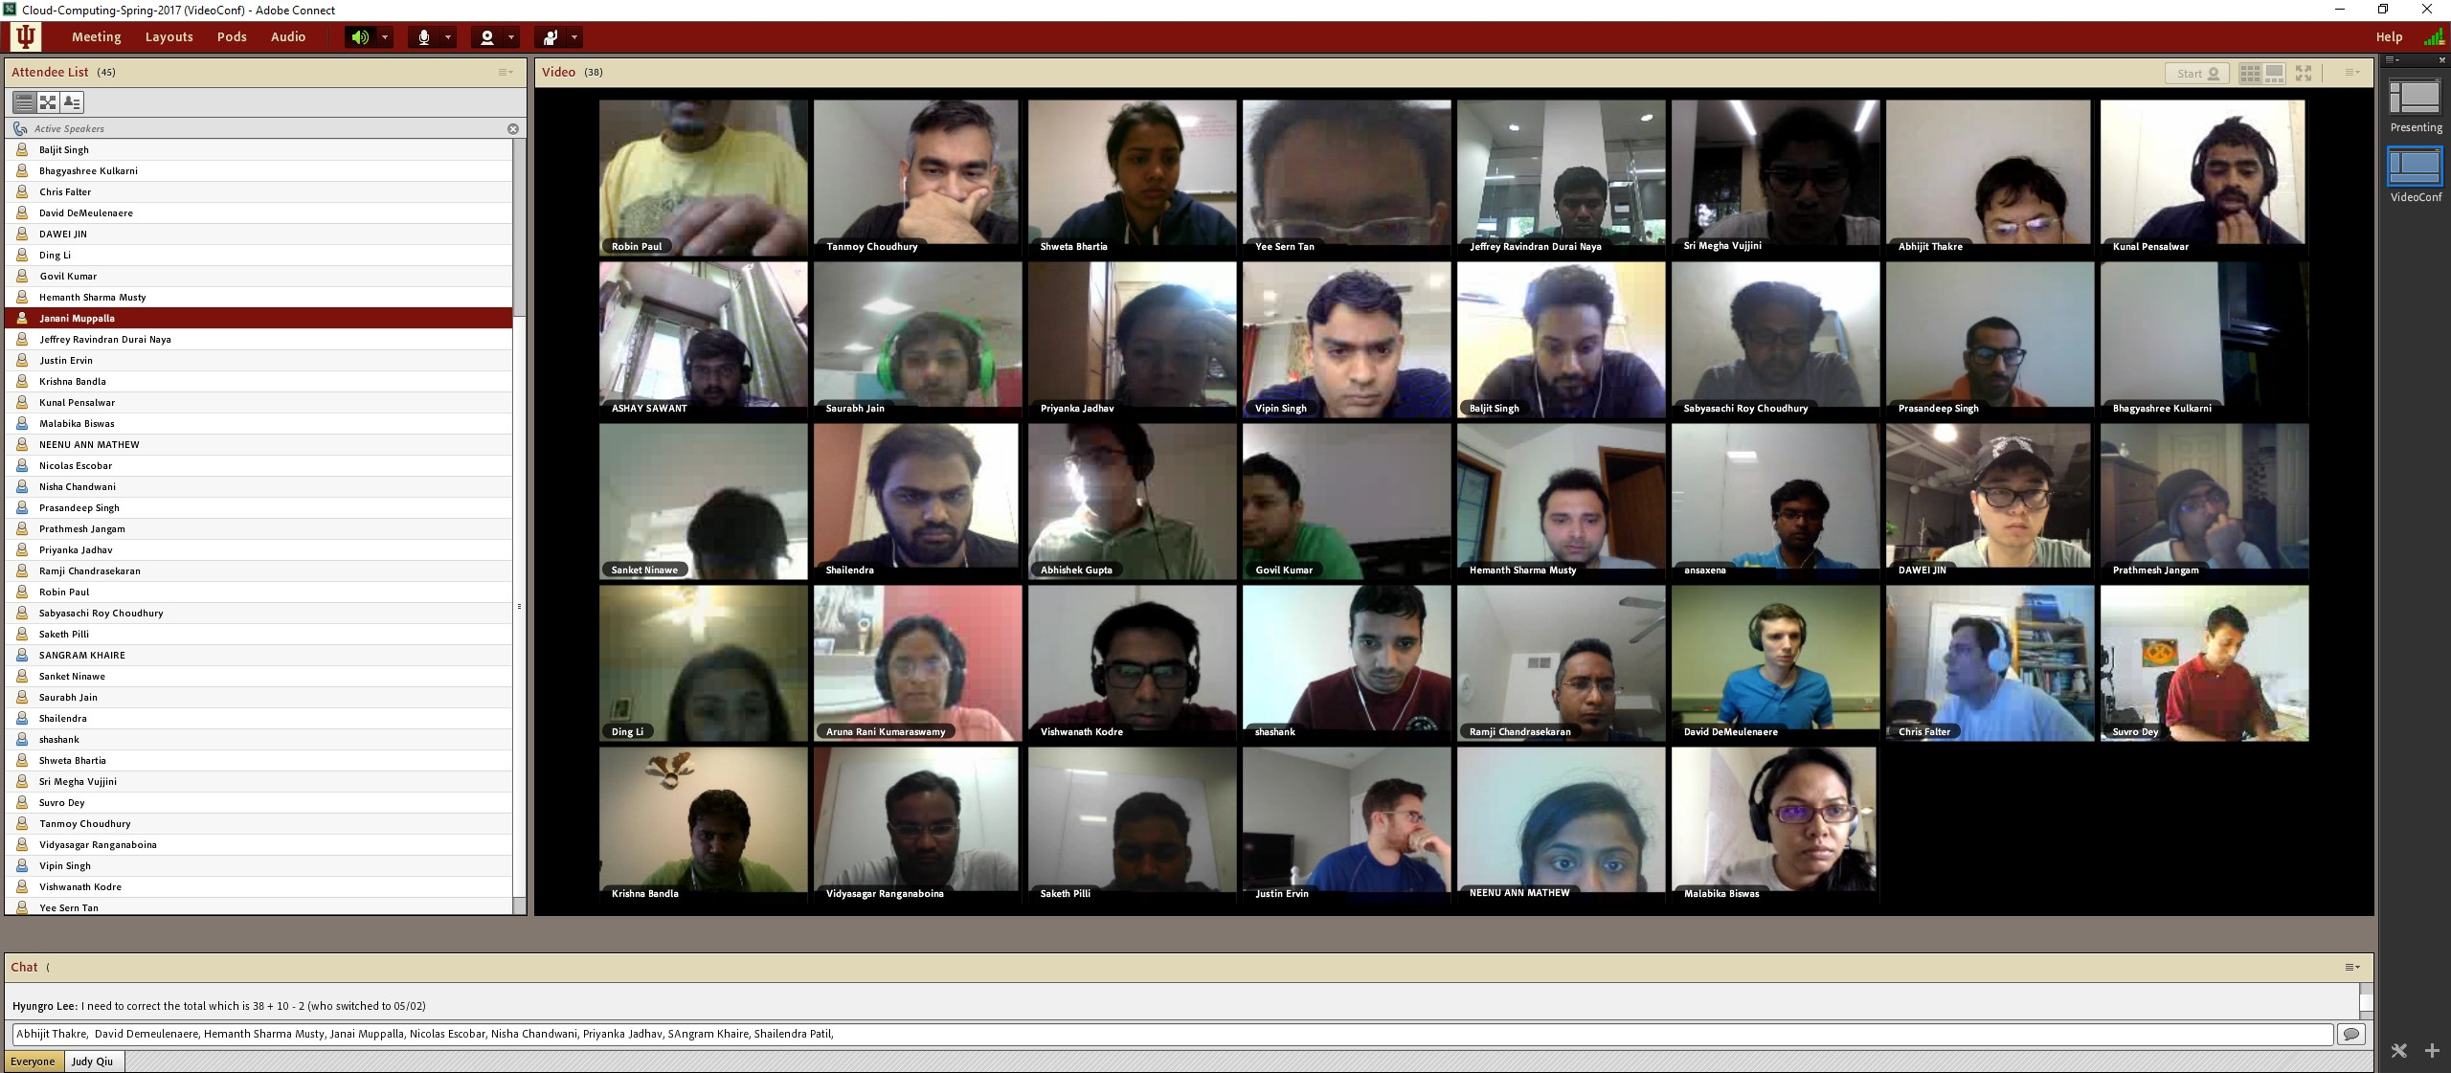

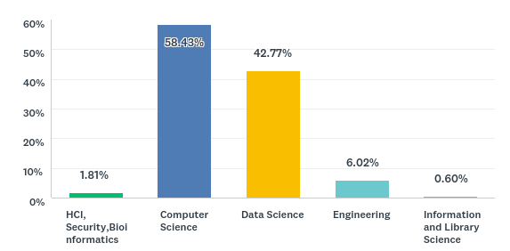
Fig. 2. Department names where the course is cross-listed among five different programs: Informatics, Computer Science, Data Science, Intelligent Systems Engineering, Information and Library Science
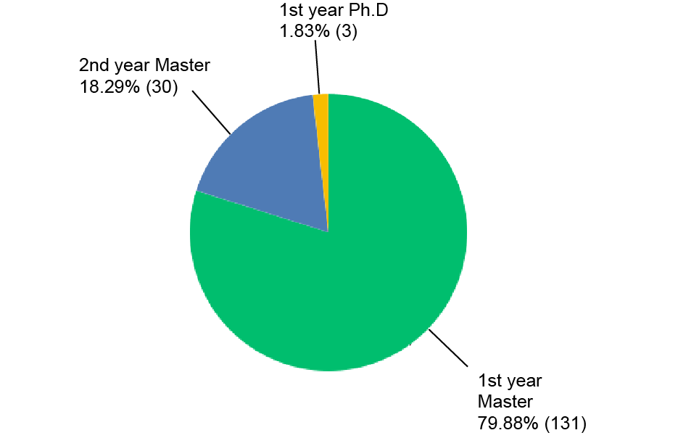

Fig. 3. Student’s Level in Programs, 81% students in their first year, 19% students in their second year
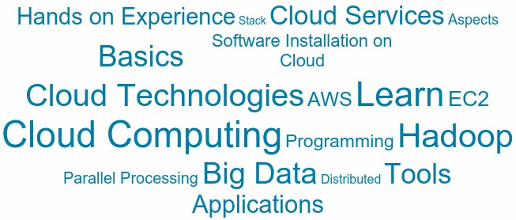

Fig. 4. Students’ Interests about the course in Cloud Word View
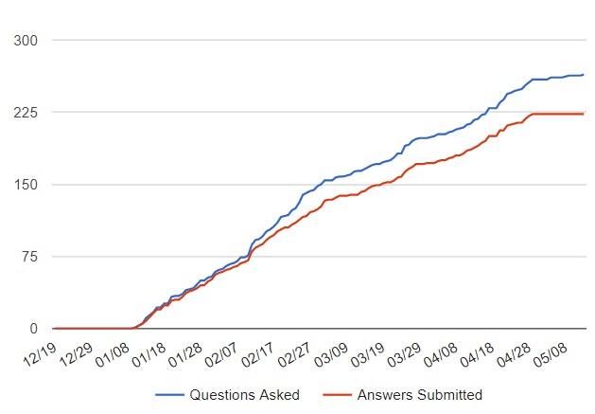

Fig. 5. Questions and responses received on Piazza over the semester
Fig. 6. Supporting remote students through video conferencing
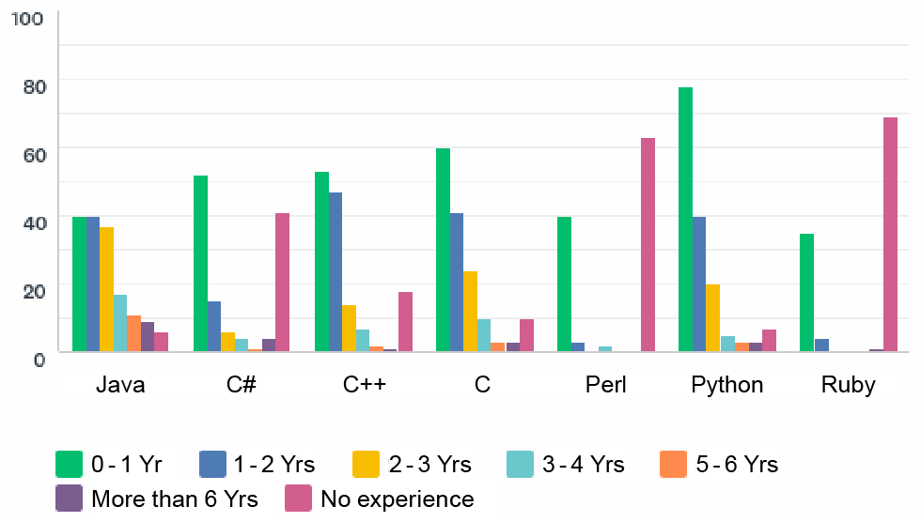

Fig. 7. Student Programming Language Experience. The y axis shows the number of student proficient in a given language for a given number of years.

- COURSE OUTCOMES AND EVALUATIONS
In addition to institutional class evaluations, we conducted a post course survey to gather feedback on the course and measure the growth of the student knowledge. For the cloud computing course we wanted to know the preference of stu- dents in using a VM instead of a distributed environment for the projects. As Fig 9 shown, the majority preferred the VM. Such a preference can be stemming from the fact a VM is easier to setup and run programs rather than using a distributed cluster.
The survey asked the students to rate their growth in differ- ent cloud technologies related to the projects. Fig 10 illustrates the knowledge growth of students as seen by themselves in different areas in a scale of 1 to 5. Fig 11 shows the average score of projects related to these areas. It is hard to master these cloud technologies in a semester as they require vast

Fig. 8. What Do Students Already know? - Prior Knowledge at the First Day of Class; IaaS (i.e. AWS, Azure, GCE, OpenStack) is one of well skilled background knowledge whereas MapReduce, Iterative MR Model (i.e. Twister, Harp), and Data Analytics are desired skill sets to learn during the course.

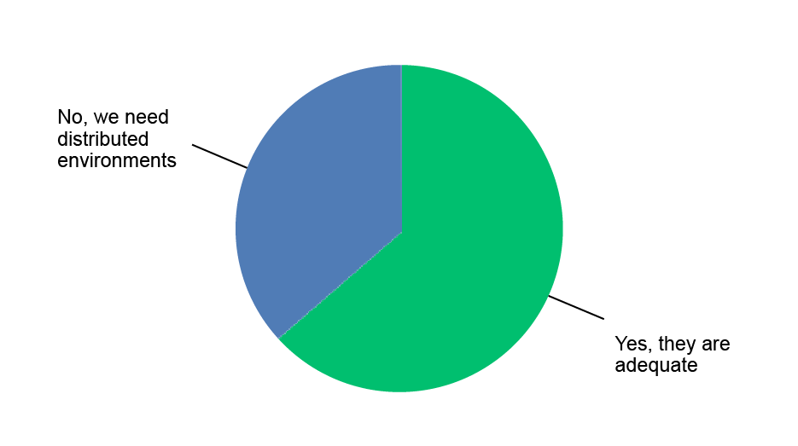

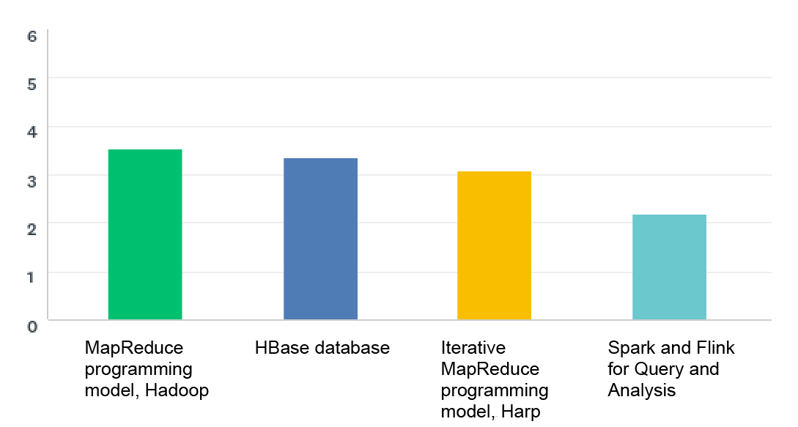
Fig. 9. Survey on single VM environment and preference

Fig. 10. Student knowledge growth in different cloud technologies on a scale of 1 to 5. The averages are shown.

knowledge and experience. So having an average knowledge after the course seems reasonable.
We are evaluating the course each year and adding new content as well as changing the projects and assignments to facilitate the integration of new knowledge and technologies. The course also offers students with extra motivation to take on research projects with the instructor to further enhance their knowledge in the field.

- ADMI CLOUD
The Association of Computer and Information Science/Engineering Departments at Minority Institutions

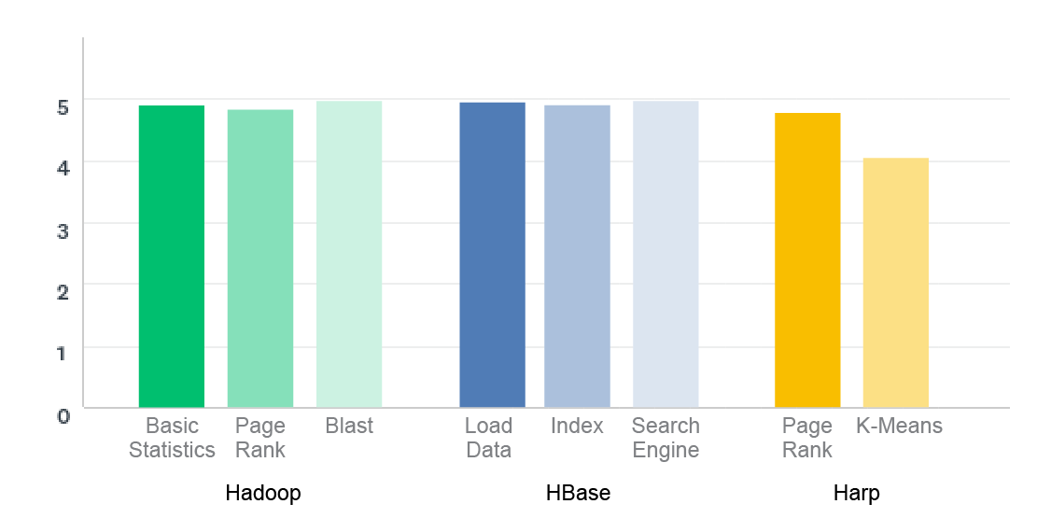

Fig. 11. Student grades in projects related to Hadoop, HBase and Harp. The marks are scaled to 5. Project 1,2 and 3 shows the marks for each project given in the specific area.
(ADMI) cloud attempts to develop curriculum and research for a remote sensing course with shared modules at a minority serving institution. Although the faculty is not well versed in parallel and distributed computing, training seminars were introduced, which allowed them to become familiar. Also, support throughout the year is granted to ensure successful course completion. In order to provide a scalable model in the targeted universities, it is essential to involve MSI faculty so they can teach classes and mentor/perform research, with the central responsibility being the modular Remote Sensing curriculum using the Cloud Computing electronic site. This technique is well-established and often termed teach the teachers or train the trainers and is studied in the context of professional development for teachers [8] [9] [10] [11] [12].
The pilot course was hosted by Prof. Linda Hayden at the Elizabeth City State University Department of Mathematics and Computer Science with the course focus on RS 506 The Principles of Microwave Remote Sensing. RS 506 introduces spaceborne remote sensing of the Earth’s atmosphere, land, and oceans. The primary methods and applications of microwave remote sensing are considered, with both active (radar) and passive (radiometry) techniques discussed.
There are computer science and computational science (domain science) undergraduate research activities involving Clouds. The computer science focus will include a set of topics leveraging research from Indiana University program- ming models (Hadoop and MPI), storage, cloud environments, performance, and integration with sensor devices. The domain science approach utilizes polar science applications. Clouds provide an venue to store domain data and support multidis- ciplinary work.
For example, the polar science community has built non- instrusive radars capable of surveying the polar ice sheets. As a result, they have collected terabytes of data from past surveys. They are increasing their repository every year as signal processing techniques improve and the cost of hard drives decreases, enabling new generation of high resolution ice thickness and accumulation maps. Manually extracting fea- tures from an enormous corpus of data is time consuming and requires sparse hand-selection, so developing image processing techniques to automatically aid in the discovery of knowledge of high importance.
Cloud Computing components can be added to their pro- grams to enhance existing curricula for multiple classes. It will support economic development by preparing students for the many jobs becoming available in the Computer and Data Science area. Not only will this model work for MSIs, but it can be extended and made available to other interested universities that do not yet offer this content for students in their computing majors.

- DISCUSSION AND FUTURE WORK
The course has been offered for many years to the res- idential computer science graduate students at the Indiana University and has observed high enrollments each time. The course offers a mix of core concepts of distributed and parallel computing along with their practical applicability. This combination has been proven to be successful in teaching a diverse group of students who are primarily looking towards

industry which increasingly demands engineers with experi- ence in distributed and parallel computing domains. Faculty and IU support have helped develop a curriculum for remote sensing materials and this will allow other institutions within the HBCU community to reuse existing materials in order to foster a community of learning.
Clouds and online MOOCs offer cutting-edge technologies to enhance traditional computational science curriculum and research with next-generation learning metaphors. This project builds off existing Indiana University activities, involving REUs for HBCU and other undergraduates, two cloud-related courses offered in Computer Science and Data Science pro- grams. The project activities will include course development and delivery using MOOCs for a cloud-enhanced classes taught by ECSU and other institutions and IU faculty with a mix of virtual and residential modes. The course outcomes will be evaluated to understand the best practices of such shared curriculum across multiple disciplines and institutions. We systematically introduce multiple courses, curricula, teacher training, research support and electronic resources across the ADMI MSI and other teaching university networks.

ACKNOWLEDGMENT
The authors are grateful for the generous support from NSF EAGER Grants 1550784 and 1550720. We would like to thank the students who participated in the surveys to provide feedback on the course. We would like to extend our gratitude to associate instructors who worked on this course over the years.
REFERENCES
- K. Hwang, J. Dongarra, and G. C. Fox, Distributed and cloud com- puting: from parallel processing to the internet of things. Morgan Kaufmann, 2013.
- T. White, Hadoop: The Definitive Guide, 1st ed. Sebastopol, CA, USA: O’Reilly Media, Inc., 2009.
- K. Shvachko, H. Kuang, S. Radia, and R. Chansler, “The hadoop distributed file system,” in 2010 IEEE 26th Symposium on Mass Storage Systems and Technologies (MSST), May 2010, pp. 1–10.
- L. George, HBase: the definitive guide: random access to your planet- size data. ” O’Reilly Media, Inc.”, 2011.
- J. Callan, M. Hoy, C. Yoo, and L. Zhao, “Clueweb09 data set,” 2009.
- L. Page, S. Brin, R. Motwani, and T. Winograd, “The pagerank citation ranking: Bringing order to the web.” Stanford InfoLab, Tech. Rep., 1999.
- B. Zhang, Y. Ruan, and J. Qiu, “harp: Collective communication on hadoop,” in 2015 IEEE International Conference on Cloud Engineering.
- J. Van Orshoven, R. Wawer, and K. Duytschaever, “Effectiveness of a train-the-trainer initiative dealing with free and open source software for geomatics,” in Proceedings (J.-H. Haunert, B. Kieler and J. Milde, Eds.) of the 12th AGILE International Conference on Geographic information Science, 2009.
- B. Fishman, S. Best, J. Foster, and R. Marx, “Fostering teacher learning in systemic reform: a design proposal for developing professional development.” 2000.
- J. H. van Driel, D. Beijaard, and N. Verloop, “Professional development and reform in science education: The role of teachers’ practical knowledge,” Journal of Research in Science Teaching, vol. 38, no. 2, pp. 137–158, 2001. [Online]. Available: http://dx.doi.org/10.1002/1098- 2736(200102)38:2¡137::AID-TEA1001¿3.0.CO;2-U
- D. Hestenes, “Toward a modeling theory of physics instruction,” American Journal of Physics, vol. 55, no. 5, pp. 440–454, 1987. [Online]. Available: http://dx.doi.org/10.1119/1.15129
- H. Borko, “Professional development and teacher learning: Mapping the terrain,” Educational Researcher, vol. 33, no. 8, pp. 3–15, 2004. [Online]. Available: http://dx.doi.org/10.3102/0013189X033008003

