Cloud Computing Paradigms for Pleasingly Parallel Biomedical Applications
Thilina Gunarathne, Tak-Lon Wu, Jong Youl Choi, Seung-Hee Bae, Judy Qiu
School of Informatics and Computing / Pervasive Technology Institute
Indiana University, Bloomington.
[tgunarat, taklwu, jychoi, sebae, xqiu]@indiana.edu

Abstract

Cloud computing offers exciting new approaches for scientific computing that leverage major commercial players’ hardware and software investments in large scale data centers. Loosely coupled problems are very important in many scientific fields and with the ongoing move towards data-intensive computing, they are on the rise. There exist several different approaches to leveraging clouds and cloud-oriented data processing frameworks to perform pleasingly parallel (also called embarrassingly parallel) computations. In this paper we present three pleasingly parallel biomedical applications: 1) assembly of genome fragments; 2) sequence alignment and similarity search; and 3) dimension reduction in the analysis of chemical structures, which are implemented utilizing a cloud infrastructure service-based utility computing models of Amazon Web Services and Microsoft Windows Azure as well as utilizing MapReduce-based data processing frameworks Apache Hadoop and Microsoft DryadLINQ. We review and compare each of these frameworks, performing a comparative study among them based on performance, cost and usability. High latency, eventually consistent cloud infrastructure service-based frameworks that rely on off-the-node cloud storage were able to exhibit performance efficiencies and scalability comparable to the MapReduce based frameworks with local disk-based storage for the applications considered. In this paper, we also analyze variations in cost among the different platform choices (e.g., EC2 instance types), highlighting the importance of selecting an appropriate platform based on the nature of the computation.

Introduction
Scientists are overwhelmed by the increasing amount of data processing needs that have arisen from the massive amount of data now flowing through virtually every field of science. Preprocessing, processing and analyzing these large amounts of data is a unique and challenging problem; however, it also opens up many opportunities for both computational and computer scientists. Jim Gray has noted that increasingly, scientific breakthroughs will be powered by computing capabilities that support the ability of researchers to analyze massive data sets. Aptly, he dubbed data intensive scientific discovery “the fourth scientific paradigm of discovery .”
Cloud computing offerings by major commercial players provide on-demand computational services over the web, which can be purchased within a matter of minutes by simply using a credit card. The utility computing model of these cloud computing offerings opens up exciting new opportunities for computational scientists to perform their computations because this type of model is well-suited to the scientists’ occasional needs for resource-intensive computing. Another interesting feature is the ability to increase the throughput of their computations by horizontally scaling computing resources without incurring any additional overhead costs. For example, 100 hours of 10 cloud compute nodes cost the same as 10 hours in 100 cloud compute nodes. This is facilitated by the virtually unlimited resource availability of cloud computing infrastructures, which are backed by the world’s largest data centers owned by major commercial players such as Amazon, Google and Microsoft. We expect that the economies of scale enjoyed by cloud providers would translate into lower costs for users. Cloud computing platforms also offer a rich set of distributed cloud infrastructure services including storage, messaging and database services with cloud-specific service guarantees. These services can be leveraged to build and deploy scalable distributed applications on cloud environments. At the same time, we can notice the emergence of cloud-oriented data processing technologies and frameworks such as MapReduce framework. MapReduce frameworks allow users to effectively perform distributed computations in increasingly brittle environments, such as commodity clusters and computational clouds. Apache Hadoop and Microsoft DryadLINQ are two such distributed parallel data processing frameworks that support MapReduce type computations.
A pleasingly parallel application is an application that can be parallelized, thus requiring minimal effort to divide the application into independent parallel parts. Each independent parallel part has very minimal or no data, synchronization or ordering dependencies with the others. These applications are good candidates for computing clouds and compute clusters with no specialized interconnections. There are many scientific applications that fall under this category. Examples of pleasingly parallel applications include Monte Carlo simulations, BLAST searches, parametric studies and image processing applications such as ray tracing. Most of the data cleansing and pre-processing applications can also be classified as pleasingly parallel applications. Recently, the relative number of pleasingly parallel scientific workloads has grown due to the emergence of data-intensive computational fields such as bioinformatics.
In this paper, we introduce a set of frameworks that have been constructed using cloud-oriented programming models to perform pleasingly parallel computations. Using these frameworks, we present implementations of biomedical applications such as the Cap3 sequence assembly, BLAST sequence search and GTM Interpolation. We analyze the performance, cost and usability of different cloud-oriented programming models using the above-mentioned implementations. We use Amazon Web Services and Microsoft Windows Azure cloud computing platforms and Apache Hadoop MapReduce and Microsoft DryaLINQ as the distributed parallel computing frameworks.

Cloud technologies and application architecture
Processing large data sets using existing sequential executables is a common use case encountered in many scientific applications. Many of these applications exhibit pleasingly parallel characteristics in which the data can be independently processed in parts. In the following sections we explore cloud programming models and the frameworks that we developed to perform pleasingly parallel computations.

Classic Cloud architecture

Amazon Web Services. Amazon Web Services (AWS) are a set of cloud computing services by Amazon, offering on-demand computing and storage services including, but not limited to, Elastic Compute Cloud (EC2), Simple Storage Service (S3) and Simple Queue Service (SQS).
EC2 provides users the option to lease virtual machine instances that are billed hourly and that allow users to dynamically provision resizable virtual clusters in a matter of minutes through a web service interface. EC2 supports both Linux and Windows virtual instances. EC2 follows an approach that uses infrastructure as a service; it provides users with ‘root’ access to the virtual machines, thus providing the most flexibility possible. Users can store virtual machine snapshots as Amazon Machine Images (AMIs), which can then be used as templates for creating new instances. Amazon EC2 offers a variety of hourly billed instance sizes with different price points, giving users a richer set of options to choose from, depending on their requirements. One particular instance type of interest is the High-CPU-Extra-Large instances, which cost the same as the Extra-Large(XL) instances but offer greater CPU power and less memory than XL instances. Table 1 provides a summary of the EC2 instance types used in this paper. The clock speed of a single EC2 compute unit is approximately 1 GHz to 1.2 GHz. The Small instance type with a single EC2 compute unit is only available in a 32-bit environment, while the larger instance types also support a 64-bit environment.
SQS is a reliable, scalable, distributed web-scale message queue service that is eventually consistent and ideal for small, short-lived transient messages. SQS provides a REST-based web service interface that enables any HTTP capable client to use it. Users can create an unlimited number of queues and send an unlimited number of messages. SQS does not guarantee the order of the messages, the deletion of messages or the availability of all the messages for a request, though it does guarantee eventual availability over multiple requests. Each message has a configurable visibility timeout. Once it is read by a client, the message will be hidden from other clients until the visibility time expires. The message reappears upon expiration of the timeout as long as it is not deleted. The service is priced based on the number of API requests and the amount of data transfer.
S3 provides a web-scale distributed storage service where users can store and retrieve any type of data through a web services interface. S3 is accessible from anywhere in the web. Data objects in S3 are access controllable and can be organized in to buckets. S3 pricing is based on the size of the stored data, amount of data transferred and the number of API requests.
Table 1 : Selected EC2 instance types | Table 2 : Microsoft Windows Azure instance types
  Instance Type | Memory | EC2 compute units | Actual CPU cores | Cost per hour
  Large (L) | 7.5 GB | 4 | 2 X (~2Ghz) | 0.34$
  Extra Large (XL) | 15 GB | 8 | 4 X (~2Ghz) | 0.68$
  High CPU Extra Large (HCXL) | 7 GB | 20 | 8 X (~2.5Ghz) | 0.68$
  High Memory 4XL (HM4XL) | 68.4 GB | 26 | 8 X (~3.25Ghz) | 2.00$
  Instance Type | CPU Cores | Memory | Local Disk Space | Cost per hour
  Small | 1 | 1.7 GB | 250 GB | 0.12$
  Medium | 2 | 3.5 GB | 500 GB | 0.24$
  Large | 4 | 7 GB | 1000 GB | 0.48$
  Extra Large | 8 | 15 GB | 2000 GB | 0.96$

Microsoft Azure Platform. Windows Azure Compute only supports Microsoft Windows based virtual machine instances and offers a limited variety of instance types compared to Amazon EC2. As shown in Table 2, Azure instance type configurations and the cost scales up linearly from Small, Medium, Large to Extra-Large. All Azure instances are available in a 64-bit environment. It has been speculated that the clock speed of a single CPU core in Azure is approximately 1.5 GHz to 1.7 GHz. During our performance testing using the Cap3 program (Section ), we found that 8 Azure small instances perform comparably to a single Amazon High-CPU-Extra-Large instance with 20 EC2 compute units. Azure Compute follows the platform of a service approach and offers the .net runtime as the platform. Users can easily deploy their programs through a web application as an Azure deployment package as well as directly from Visual Studio IDE. Azure Storage Blob service and Azure Queue service respectively provide functionality similar to Amazon S3 and Amazon SQS services described above.

Classic Cloud processing model
Figure 1 depicts the Classic Cloud processing model. Varia and Chappell describe similar architectures that are implemented using Amazon and Azure processing models respectively. The Classic Cloud processing model follows a task processing pipeline approach with independent workers. It uses the cloud instances (EC2/Azure Compute) for data processing and uses Amazon S3/Windows Azure Storage for the data storage. For the task scheduling pipeline, it uses an Amazon SQS or an Azure queue as a queue of tasks where every message in the queue describes a single task. The client populates the scheduling queue with tasks, while the worker-processes running in cloud instances pick tasks from the scheduling queue. The configurable visibility timeout feature of Amazon SQS and Azure Queue service is used to provide a simple fault tolerance capability to the system. The workers delete the task (message) in the queue only after the completion of the task. Hence, a task (message) will get processed by some worker if the task does not get completed with the initial reader (worker) within the given time limit. Rare occurrences of multiple instances processing the same task or another worker re-executing a failed task will not affect the result due to the idempotent nature of the independent tasks.

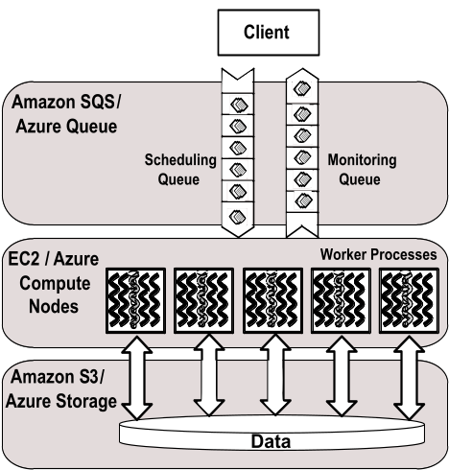  Figure 1: Classic Cloud processing model | 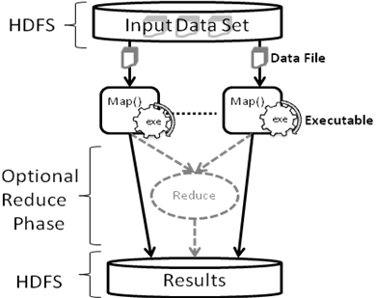  Figure 2: Hadoop MapReduce processing model
For the applications discussed in this paper, a single task comprises of a single input file and a single output file. The worker processes will retrieve the input files from the cloud storage through the web service interface using HTTP and will process them using an executable program before uploading the results back to the cloud storage. In this implementation user can configure the workers to use any executable program in the virtual machine to process the tasks, provided that it takes input in the form of a file. Our implementation uses a monitoring message queue to monitor the progress of the computation. One interesting feature of the Classic Cloud framework is the ability to extend it to use the local machines and clusters side by side with the clouds. Although it might not be the best option due to the data being stored in the cloud, one can start workers in computers outside of the cloud to augment compute capacity.

Apache Hadoop MapReduce
Apache Hadoop is an open source implementation of the Google MapReduce technology. Apache Hadoop MapReduce uses HDFS distributed parallel file system for data storage, which stores the data across the local disks of the compute nodes while presenting a single file system view through the HDFS API. HDFS is designed for deployment on commodity clusters and achieves reliability through replication of data across nodes. Hadoop optimizes the data communication of MapReduce jobs by scheduling computations near the data using the data locality information provided by the HDFS file system. Hadoop follows a master node with many client workers approach and uses a global queue for the task scheduling, achieving natural load balancing among the tasks. Hadoop performs data distribution and automatic task partitioning based on the information provided in the master program and based on the structure of the data stored in HDFS. MapReduce architecture reduces the overheads of data transfer by overlapping data communication with the computations. Hadoop performs duplicate execution of slower executing tasks and handles tasks failures by rerunning of the failed tasks.
As shown in Figure 2, the pleasingly parallel application framework on Hadoop is developed as a set of map tasks which process the given data splits (files) using the configured executable program. Input to a map task comprises of key, value pairs, where by default Hadoop parses the contents of the data split to read them. Most of the legacy data processing applications expect a file path as the input instead of the contents of the file, which is not possible with the Hadoop built-in input formats and record readers. We implemented a custom InputFormat and a RecordReader for Hadoop to provide the file name and the HDFS path of the data split respectively as the key and the value for the map function, while preserving the Hadoop data locality based scheduling.

DryadLINQ
Dryad is a framework developed by Microsoft Research as a general-purpose distributed execution engine for coarse-grain parallel applications. Dryad applications are expressed as directed acyclic data-flow graphs (DAG), where vertices represent computations and edges represent communication channels between the computations. DAGs can be used to represent MapReduce type computations and can be extended to represent many other parallel abstractions too. Similar to the MapReduce frameworks, the Dryad scheduler optimizes the data transfer overheads by scheduling the computations near data and handles failures through rerunning of tasks and duplicate task execution. In the Dryad version we used for this paper, data for the computations need to be partitioned manually and stored beforehand in the local disks of the computational nodes via Windows shared directories. Dryad is available for academic usage through the DryadLINQ API, which is a high level declarative language layer on top of Dryad. DryadLINQ queries get translated in to distributed Dryad computational graphs in the run time. DryadLINQ can be used only with Microsoft Windows HPC clusters. The DryadLINQ implementation of the framework uses the DryadLINQ “select” operator on the data partitions to perform the distributed computations. The resulting computation graph looks much similar to the figure 2, where instead of using HDFS, Dryad will use the Windows shared local directories for data storage. Data partitioning, distribution and the generation of metadata files for the data partitions is implemented as part of our pleasingly parallel application framework.

Usability of the technologies
Table 3: Summary of cloud technology features
 | AWS/ Azure | Hadoop | DryadLINQ
Programming patterns | Independent job execution, More structure possible using client side driver program. | MapReduce | DAG execution, Extensible to MapReduce and other patterns
Fault Tolerance | Task re-execution based on a configurable time out | Re-execution of failed and slow tasks. | Re-execution of failed and slow tasks.
Data Storage and Communication | S3/Azure Storage. Data retrieved through HTTP. | HDFS parallel file system. TCP based Communication | Local files
Environments | EC2/Azure virtual instances, local compute resources | Linux cluster, Amazon Elastic MapReduce | Windows HPCS cluster
Scheduling and Load Balancing | Dynamic scheduling through a global queue, providing natural load balancing | Data locality, rack aware dynamic task scheduling through a global queue, providing natural load balancing | Data locality, network topology aware scheduling. Static task partitions at the node level, suboptimal load balancing
Implementing the above-mentioned application framework using the Hadoop and DryadLINQ data processing frameworks was easier than implementing them from the scratch using cloud infrastructure services as the building blocks. Hadoop and DryadLINQ take care of scheduling, monitoring and fault tolerance. With Hadoop, we had to implement a Map function, which copy the input file from HDFS to the working directory, execute the external program as a process and finally upload the result file to the HDFS. It was also necessary to implement a custom InputFormat and a RecordReader to support file inputs to the map tasks. With DryadLINQ, we had to implement a side effect-free function to execute the program on the given data and copy the result to the output-shared directory. But significant effort had to be spent on implementing the data partition and the distribution programs to support DryadLINQ.
EC2 and Azure Classic Cloud implementations involved more effort than the Hadoop and DryadLINQ implementations, as all the scheduling, monitoring and fault tolerance had to be implemented from scratch using the cloud infrastructure services’ features. The deployment process was easier with Azure as opposed to EC2, in which we had to manually create instances, install software and start the worker instances. On the other hand the EC2 infrastructure gives developers more flexibility and control. Azure SDK provides better development, testing and deployment support through Visual Studio integration. The local development compute fabric and the local development storage of the Azure SDK make it much easier to test and debug Azure applications. While the Azure platform is heading towards providing a more developer-friendly environment, it still lags behind in terms of the infrastructure maturity Amazon AWS has accrued over the years.

Evaluation Methodology
In the performance studies, we use parallel efficiency as the measure by which to evaluate the different frameworks. Parallel efficiency is a relatively good measure for evaluating the different approaches we use in our studies, as we do not have the option of using identical configurations across the different environments. At the same time, we cannot use efficiency to directly compare the different technologies. Even though parallel efficiency accounts for the system dissimilarities that affect the sequential and the parallel run time, it does not reflect other dissimilarities, such as memory size, memory bandwidth and network bandwidth. Parallel efficiency for a parallel application on P number of cores can be calculated using the following formula:
--- Equation 1
In this equation, T_{p} is the parallel run time for the application. T₁ is the best sequential run time for the application using the same data set or a representative subset. In this paper, the sequential run time for the applications was measured in each of the different environments, having the input files present in the local disks, avoiding the data transfers.
The average run time for a single computation in a single core is calculated for each of the performance tests using the following formula. The objective of this calculation is to give readers an idea of the actual performance they can obtain from a given environment for the applications considered in this paper.
--- Equation 2
Due to the richness of the instance type choices Amazon EC2 provides, it is important to select an instance type that optimizes the balance between performance and cost. We present instance type studies for each of our applications for the EC2 instance types mentioned in Table 1 using 16 CPU cores for each study. EC2 Small instances were not included in our study because they do not support 64-bit operating systems. We do not present results for Azure Cap3 and GTM Interpolation applications, as the performance of the Azure instance types for those applications scaled linearly with the price. However, the total size of memory affected the performance of BLAST application across Azure instance types; hence we perform an instance type study for BLAST on Azure.
Cloud virtual machine instances are billed hourly. When presenting the results, the ‘Compute Cost (hour units)’ assumes that particular instances are used only for the particular computation and that no useful work is done for the remainder of the hour, effectively making the computation responsible for the entire hourly charge. The ‘Amortized Cost’ assumes that the instance will be used for useful work for the remainder of the hour, making the computation responsible only for the actual fraction of time during which it was executed. The horizontal axes of the EC2 cost figures (Figure 3 and 7) and the vertical axis labeling of the EC2 compute time figures (Figures 4 and 8) are labeled in the format ‘Instance Type’ – ‘Number of Instances’ X ‘Number of Workers per Instance’. For an example, HCXL – 2 X 8 means two High-CPU-Extra-Large instances were used with 8 workers per instance.
When presenting the results used in this paper, we considered a single EC2 Extra-Large instance, with 20 EC2 compute units as 8 actual CPU cores while an Azure Small instance was considered as a single CPU core. In all of the test cases, it is assumed that the data was already present in the framework’s preferred storage location. We used Apache Hadoop version 0.20.2 and DryadLINQ version 1.0.1411.2 (November 2009) for our studies.
In Gunarathne et al, we investigated the sustained performance of Amazon AWS and Windows Azure cloud infrastructures for MapReduce type applications over a week’s time during different times of the day. Performance variations we observed were very minor, with standard deviations of 1.56% for Amazon AWS and 2.25% for Windows Azure, with no noticeable correlations with the day of the week or the time of the day. Hence, we assume that the performance results we obtained for this paper would not depend on such variables.

Cap3
Cap3 is a sequence assembly program which assembles DNA sequences by aligning and merging sequence fragments to construct whole genome sequences. Sequence assembly is an integral part of genomics as the current DNA sequencing technology, such as shotgun sequencing, is capable of reading only parts of genomes at once. The Cap3 algorithm operates on a collection of gene sequence fragments presented as FASTA formatted files. It removes the poor regions of the DNA fragments, calculates the overlaps between the fragments, identifies and removes the false overlaps, joins the fragments to form contigs of one or more overlapping DNA segments and finally through multiple sequence alignment generates consensus sequences.
The increased availability of DNA sequencers are generating massive amounts of sequencing data that needs to be assembled. Cap3 program is often used in parallel with lots of input files due to the pleasingly parallel nature of the application. The run time of the Cap3 application depends on the contents of the input file. Cap3 is less memory intensive than the GTM Interpolation and BLAST applications we discuss below. Size of a typical data input file for the Cap3 program and the result data file range from hundreds of kilobytes to few megabytes. Output files resulting from the input data files can be collected independently and do not need any combining steps.

Performance with different EC2 cloud instance types
Figure 3 and Figure 4 present benchmark results for the Cap3 application on different EC2 instance types. These experiments processed 200 FASTA files, each containing 200 reads using 16 compute cores. According to these results, we can infer that memory is not a bottleneck for the Cap3 program and that performance depends primarily on computational power. While the EC2 High-Memory-Quadruple-Extra-Large instances show the best performance due to the higher clock-rated processors, the most cost effective performance for the Cap3 EC2 ClassicCloud application is gained using the EC2 High-CPU-Extra-Large instances.

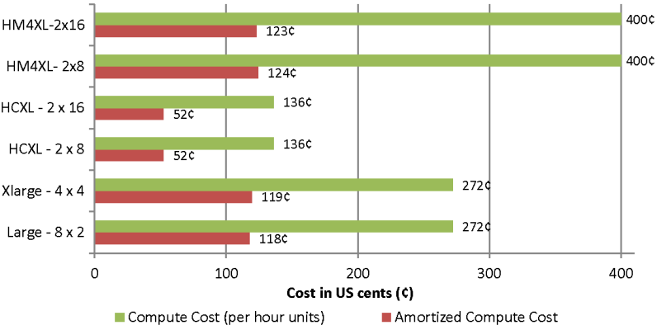  Figure 3 : Cap3 cost with different EC2 instance types | 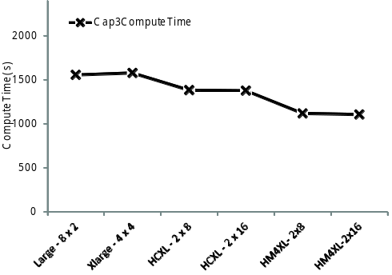  Figure 4 : Cap3 compute time with different instance types

Scalability study
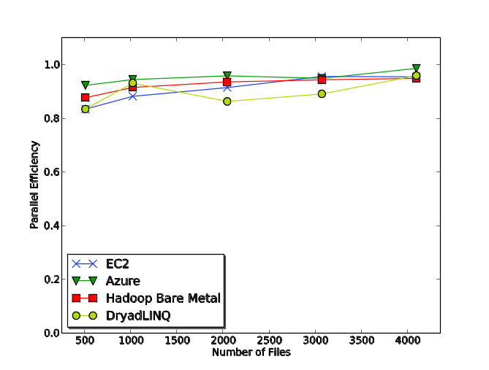  Figure 5 : Cap3 parallel efficiency | 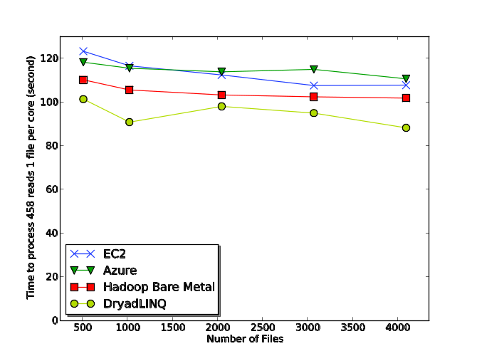  Figure 6 : Cap3 execution time for single file per core
We benchmarked the Cap3 Classic Cloud implementation performance using a replicated set of FASTA-formatted data files, each file containing 458 reads, and compared this to our previous performance results for Cap3 DryadLINQ and Cap3 Hadoop. 16 High-CPU-Extra-Large instances were used for the EC2 testing and 128 small Azure instances were used for the Azure Cap3 testing. The DryadLINQ and Hadoop bare metal results were obtained using a 32 node X 8 core (2.5 Ghz) cluster with 16 GB of memory on each node.
Load balancing across the different sub tasks does not pose a significant overhead in the Cap3 performance studies, as we used a replicated set of input data files making each sub task identical. We performed a detailed study of the performance of Hadoop and DryadLINQ in the face of inhomogeneous data in one of our previous studies . In this study, we noticed better natural load balancing in Hadoop than in DryadLINQ due to Hadoop’s dynamic global level scheduling as opposed to DryadLINQ’s static task partitioning. We assume that cloud frameworks will be able perform better load balancing similar to Hadoop because they share the same dynamic scheduling global queue-based architecture.
Based on Figures 5 and 6, we can conclude that all four implementations exhibit comparable parallel efficiency (within 20%) with low parallelization overheads. When interpreting Figure 6, it should be noted that the Cap3 program performs ~12.5% faster on Windows environment than on the Linux environment. As mentioned earlier, we cannot use these results to claim that a given framework performs better than another, as only approximations are possible, given that the underlying infrastructure configurations of the cloud environments are unknown.

Cost comparison
Table 4 : Cost Comparison
 | Amazon Web Services | Azure
Compute Cost | 10.88 $ (0.68$ X 16 HCXL) | 15.36$ (0.12$ X 128 Azure Small)
Queue messages (~10,000) | 0.01 $ | 0.01 $
Storage (1GB, 1 month) | 0.14 $ | 0.15 $
Data transfer in/out (1 GB) | 0.10 $ (in) | 0.10$ (in) + 0.15$ (out)
Total Cost | 11.13 $ | 15.77 $
Below, we estimate the cost of assembling 4096 FASTA files using Classic Cloud frameworks on EC2 and on Azure. For the sake of comparison, we also approximate the cost of the computation using one of our internal compute clusters (32 node 24 core, 48 GB memory per node with Infiniband interconnects), with the cluster purchase cost (~500,000$) depreciated over the course of 3 years plus the yearly maintenance cost (~150,000$), which include power, cooling and administration costs. We executed the Hadoop-Cap3 application in our internal cluster for this purpose. The cost for computation using the internal cluster was approximated to 8.25$ US for 80% utilization, 9.43$ US for 70% utilization and 11.01$ US for 60% utilization. For the sake of simplicity, we did not consider other factors such as the opportunity costs of the upfront investment, equipment failures and upgradability. There would also be additional costs in the cloud environments for the instance time required for environment preparation and minor miscellaneous platform-specific charges, such as the number of storage requests.

BLAST
NCBI BLAST+ is a very popular bioinformatics application that is used to handle sequence similarity searching. It is the latest version of BLAST , a multi-letter command line tool developed using the NCBI C++ toolkit, to translate a FASTA formatted nucleotide query and to compare it to a protein database. Queries are processed independently and have no dependencies between them. This makes it possible to use multiple BLAST instances to process queries in a pleasingly parallel manner. We used a sub-set of a real-world protein sequence data set as the input BLAST queries and used NCBI’s non-redundant (NR) protein sequence database (8.7 GB), updated on 6/23/2010, as the BLAST database. In order to make the tasks coarser granular, we bundled 100 queries in to each data input file resulting in files with sizes in the range of 7-8 KB. The output files for these input data range from few bytes to few Megabytes.
We implemented distributed BLAST applications for Amazon EC2, Microsoft Azure, DryadLINQ and for Apache Hadoop using the frameworks that were presented in section . All of the implementations download and extract the compressed BLAST database (2.9GB compressed) to a local disk partition of each worker prior to beginning processing of the tasks. Hadoop-BLAST uses the Hadoop-distributed cache feature to distribute the database. We added a similar data preloading feature to the Classic Cloud frameworks, in which each worker will download the specified file from the cloud storage at the time of startup. In the case of DryadLINQ, we manually distributed the database to each node using Windows-shared directories. The performance results presented in this paper do not include the database distribution times.

Performance with different cloud instance types
Figure 7 and Figure 8 present the benchmark results for BLAST Classic Cloud application on different EC2 instance types. These experiments processed 64 query files, each containing 100 sequences using 16 compute cores. While we expected the memory size to have a strong correlation to the BLAST performance, due to the querying of a large database, the performance results do not show a significant effect related to the memory size, as High-CPU-Extra-Large (HCXL) instances with less than 1GB of memory per CPU core were able to perform comparatively to Large and Extra-Large instances with 3.75GB per CPU core. However, it should be noted that there exists a slight correlation with memory size, as the lower clock rated Extra-Large (~2.0Ghz) instances with more memory per core performed similarly to the HCXL (~2.5Ghz) instances. The High-Memory-Quadruple-Large (HM4XL) instances (~3.25Ghz) have a higher clock rate, which partially explains the faster processing time. Once again, the EC2 HCXL instances gave the most cost-effective performance, thus offsetting the performance advantages demonstrated by other instance types.
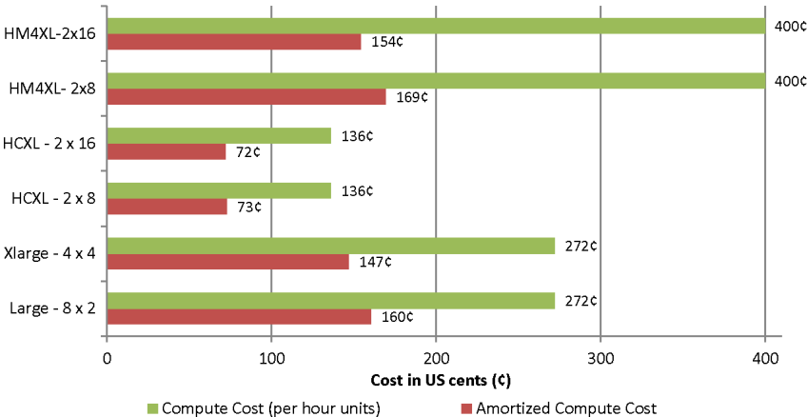  Figure 7 : Cost to process 64 query files using BLAST in EC2 | 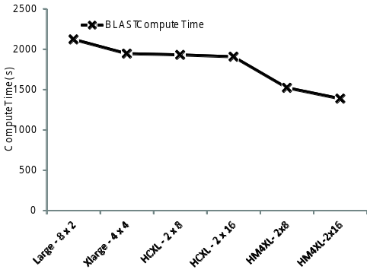  Figure 8 : Time to process 64 query files using BLAST in EC2
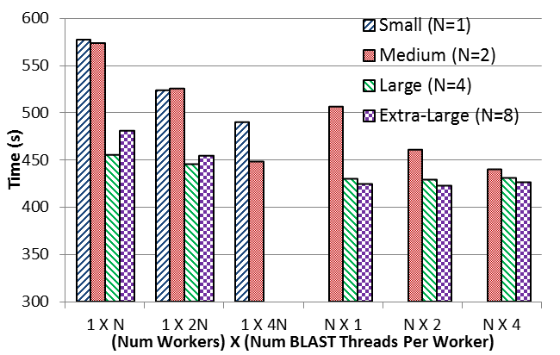
Figure 9 presents the benchmark results for BLAST Classic-Cloud application on different Azure instance types. These experiments processed 8 query files, each containing 100 sequences using 8 small, 4 medium, 2 large and 1 Extra-Large instances respectively. Although the features of Azure instance types scale linearly, the BLAST application performed better with larger total memory sizes. When sufficient memory is available, BLAST can load and reuse the whole BLAST database (~8GB) in to the memory. BLAST application has the ability to parallelize the computations using threads. The horizontal axis of Figure 9 depicts ‘Number of workers (processes) per instance’ X ‘Number of BLAST threads per worker’. The ‘N’ stands for the number of cores per instance in that particular instance type. According to the results, Azure Large and Extra-Large instances deliver the best performance for BLAST. Using pure BLAST threads to parallelize inside the instances delivered slightly lesser performance than using multiple workers (processes). The costs to process 8 query files are directly proportional to the run time, due to the linear pricing of Azure instance types.
Figure 9 : Time to process 8 query files using BLAST in Azure

Scalability
For the scalability experiment, we replicated a query data set of 128 files (with 100 sequences in each file), one to six times to create input data sets for the experiments, ensuring the linear scalability of the workload across data sets. Even though the larger data sets are replicated, the base 128-file data set is inhomogeneous. The Hadoop-BLAST tests were performed on an iDataplex cluster, in which each node had two 4-core CPUs (Intel Xeon CPU E5410 2.33GHz) and 16 GB memory and was inter-connected using Gigabit Ethernet. DryadLINQ tests were performed on a Windows HPC cluster with 16 cores (AMD Opteron 2.3 Ghz) and 16 GB of memory per node. 16 High-CPU-Extra-Large instances were used for the EC2 testing and 16 Large instances were used for the Azure testing.

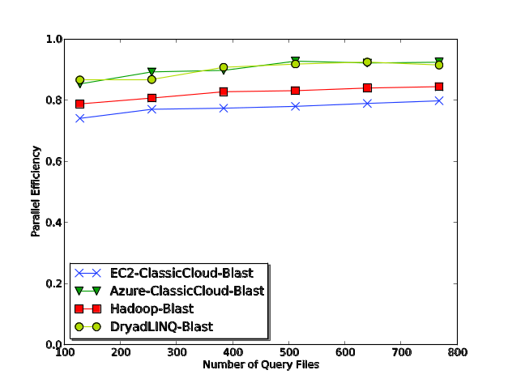  Figure 10 : BLAST parallel efficiency | 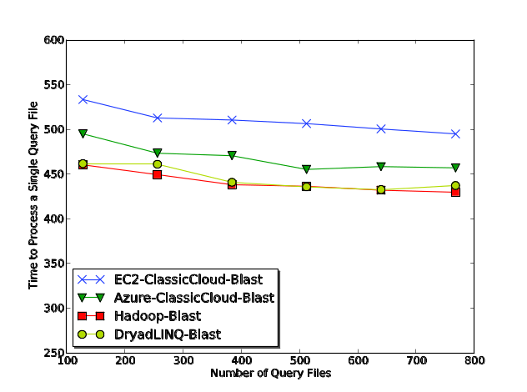  Figure 11 : BLAST average time to process a single query file
Figure 10 depicts the absolute parallel efficiency of the distributed BLAST implementations, while Figure 11 depicts the average time to process a single query file in a single core. From those figures, we can conclude that all four implementations exhibit near-linear scalability with comparable performance (within 20% efficiency), while BLAST on Windows environments (Azure and DryadLINQ) exhibit the better overall efficiency. The limited memory of the High-CPU-Extra-Large (HCXL) instances shared across 8 workers performing different BLAST computations may have contributed to the relatively low efficiency of EC2 BLAST implementation. According to figure 8, use of EC2 High-Memory-Quadruple-Extra-Large instances would have given better performance than HCXL instances, but at a much higher cost. The amortized cost to process 768*100 queries using Classic Cloud-BLAST was ~10$ using EC2 and ~12.50$ using Azure.

GTM Interpolation
Generative Topographic Mapping (GTM) is an algorithm for finding an optimal user-defined low-dimensional representation of high-dimensional data. This process is known as dimension reduction, which plays a key role in scientific data visualization. In a nutshell, GTM is an unsupervised learning method for modeling the density of data and finding a non-linear mapping of high-dimensional data in a low-dimensional space. To reduce the high computational costs and memory requirements in the conventional GTM process for large and high-dimensional datasets, GTM Interpolation has been developed as an out-of-sample extension to process much larger data points with minor trade-off of approximation. GTM Interpolation takes only a part of the full dataset, known as samples, for a compute-intensive training process and applies the trained result to the rest of the dataset, known as out-of-samples. With this interpolation approach in GTM, one can visualize millions of data points with modest amount of computations and memory requirement.
The size of the input data for the interpolation algorithm consists of millions of data points and usually ranges in gigabytes, while the size of the output data in lower dimensions are orders of magnitude smaller than the input data. Input data can be partitioned arbitrarily on the data point boundaries in order to generate computational sub tasks. The output data from the sub tasks can be collected using a simple merging operation and do not require any special combining functions. The GTM Interpolation application is highly memory intensive and requires a large amount of memory proportional to the size of the input data.

jks
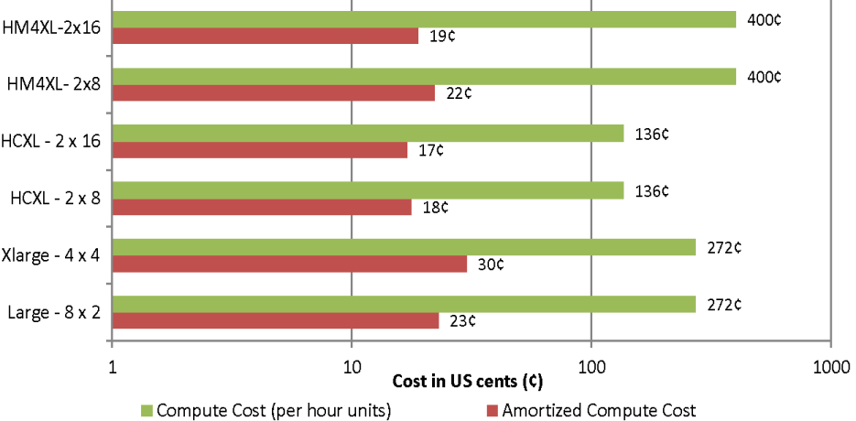  Figure 12 : GTM cost with different instance types | 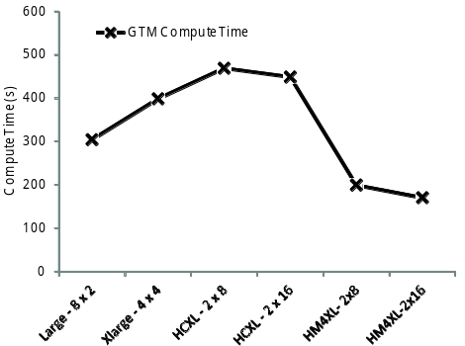  Figure 13 : GTM Interpolation compute time with different instance types

Application performance with different cloud instance types
According to Figure 13 : GTM Interpolation compute time with different instance types, we can infer that memory (size and bandwidth) is a bottleneck for the GTM Interpolation application. The GTM Interpolation application performs better in the presence of more memory and a smaller number of processor cores sharing the memory. The high memory quadruple Extra-Large instances give the best performance overall, but the High-CPU-Extra-Large instances still appear to be the most economical choice.

GTM Interpolation speedup
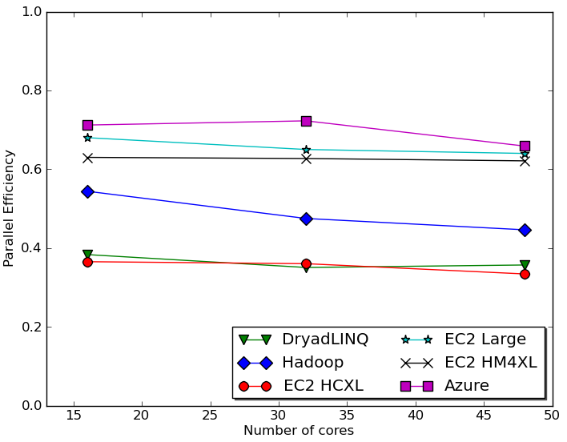  Figure 14: GTM Interpolation parallel efficiency | 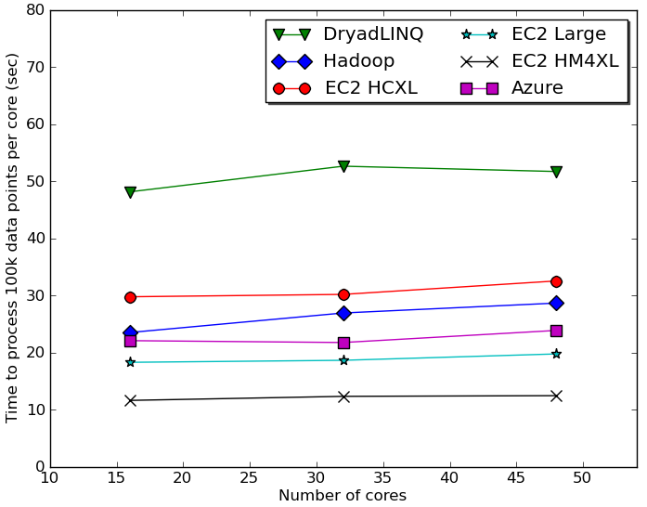  Figure 15 : GTM Interpolation performance per core
We used the PubChem data set of 26 million data points with 166 dimensions to analyze the GTM Interpolation applications. PubChem is an NIH funded repository of over 60 million chemical molecules, their chemical structures and their biological activities. A pre-processed subset of 100,000 data points were used as the seed for the GTM Interpolation. We partitioned the input data into 264 files, with each file containing 100,000 data points. Figures 14 and 15 depict the performance of the GTM Interpolation implementations.
DryadLINQ tests were performed on a 16 core (AMD Opteron 2.3 Ghz) per node, 16GB memory per node cluster. Hadoop tests were performed on a 24 core (Intel Xeon 2.4 Ghz) per node, 48 GB memory per node cluster which was configured to use only 8 cores per node. Classic Cloud Azure tests we performed on Azure Small instances (single core). Classic Cloud EC2 tests were performed on EC2 Large, High-CPU-Extra-Large (HCXL) as well as on High-Memory-Quadruple-Extra-Large (HM4XL) instances separately. HM4XL and HCXL instances were considered 8 cores per instance while ‘Large’ instances were considered 2 cores per instance.
Characteristics of the GTM Interpolation application are different from the Cap3 application as GTM is more memory-intensive and the memory bandwidth becomes the bottleneck, which we assume to be the cause of the lower efficiency numbers. Among the different EC2 instances, Large instances achieved the best parallel efficiency and High-Memory-Quadruple-Extra-Large instances gave the best performance while High-CPU-Extra-Large instances were the most economical. Azure small instances achieved the overall best efficiency. The efficiency numbers highlight the memory-bound nature of the GTM Interpolation computation, while platforms with less memory contention (fewer CPU cores sharing a single memory) performed better. As noted, the DryadLINQ GTM Interpolation efficiency is lower than the others. One reason for the lower efficiency would be the usage of 16 core machines for the computation, which puts more contention on the memory.
The computational tasks of GTM Interpolation applications were much finer grain than those in the Cap3 or BLAST applications. Compressed data splits, which were unzipped before handing over to the executable, were used due to the large size of the input data. When the input data size is larger, Hadoop and DryadLINQ applications have an advantage of data locality-based scheduling over EC2. The Hadoop and DryadLINQ models bring computation to the data optimizing the I/O load, while the Classic Cloud model brings data to the computations.

Related Research
There exist many studies that benchmark existing traditionally-distributed scientific applications on the cloud. In contrast, we focused on implementing and analyzing the performance of biomedical applications using cloud services/technologies and cloud-oriented programming frameworks. In one of our earlier studies , we analyzed the overhead of virtualization and the effect of inhomogeneous data on the cloud-oriented programming frameworks. Ekanayake and Fox analyzed the overhead of MPI running on virtual machines under different VM configurations and under different MPI stacks.
In addition to the biomedical applications discussed in this paper, we have also developed distributed pairwise sequence alignment applications using MapReduce programming models . There are other biomedical applications developed using MapReduce programming frameworks, such as CloudBurst , which performs parallel genome read mappings. CloudBLAST performs distributed BLAST computations using Hadoop and implements an architecture similar to the Hadoop-BLAST used in this paper. AzureBlast presents a distributed BLAST implementation for Azure Cloud infrastructure developed using Azure Queues, Tables and Blob Storage with an architecture similar to our Classic-Cloud AzureBlast implementation.
CloudMapReduce is an effort to implement a MapReduce framework utilizing the Amazon cloud infrastructure services. Amazon Web Services also offer MapReduce as an on-demand cloud service through the Elastic MapReduce service. We are currently working to develop a MapReduce framework for Windows Azure, TwisterAzure , using Azure cloud infrastructure services, which will also support iterative MapReduce executions
Walker presents a more detailed model for buying versus leasing decisions for CPU power based on lease-or-buy budgeting models, pure CPU hours, Moore’s law, etc.. Our cost estimation in Section is based on the pure performance of the application in different environments, the purchase cost of the cluster and the estimate of the maintenance cost. Walker also highlights the advantages of the mobility user’s gain through the ability to perform short-term leases from cloud computing environments, allowing them to adopt the latest technology. Wilkening et al presents a cost-based feasibility study for using BLAST in EC2 and concludes that the cost in clouds is slightly higher than the cost of using compute clusters. They benchmarked the BLAST computation directly inside the EC2 instances without using a distributed computing framework and also assumed the local cluster utilization to be 100%.

Conclusion
We have demonstrated the feasibility of Cloud infrastructures for three loosely-coupled scientific computation applications by implementing them using cloud infrastructure services as well as cloud-oriented programming models, such as Hadoop MapReduce and DryadLINQ.
Cloud infrastructure services provide users with scalable, highly-available alternatives to their traditional counterparts, but without the burden of managing them. While the use of high latency, eventually consistent cloud services together with off-instance cloud storage has the potential to cause significant overheads, our work in this paper has shown that it is possible to build efficient, low overhead applications utilizing them. Given sufficiently coarser grain task decompositions, Cloud infrastructure service-based frameworks as well as the MapReduce-based frameworks offered good parallel efficiencies in almost all of the cases we considered. Computing Clouds offer different instance types at different price points. We showed that selecting an instance type that is best suited to the user’s specific application can lead to significant time and monetary advantages.
While models like Classic Cloud bring in operational and quality of services advantages, it should be noted that the simpler programming models of existing cloud-oriented frameworks like MapReduce and DryadLINQ are more convenient for the users. Motivated by the positive results presented in this paper, we are working on developing a fully-fledged MapReduce framework with iterative-MapReduce support for the Windows Azure Cloud infrastructure using Azure infrastructure services as building blocks, which will provide users the best of both worlds. The cost effectiveness of cloud data centers, combined with the comparable performance reported here, suggests that loosely-coupled science applications will be increasingly implemented on clouds and that using MapReduce frameworks will offer convenient user interfaces with little overhead.

Acknowledgment
We would also like extend our gratitude to our collaborators David Wild and Bin Chen. We appreciate Microsoft for their technical support on Dryad and Azure. This work is supported by the National Institutes of Health under grant 5 RC2 HG005806-02. This work was made possible using the compute use grant provided by Amazon Web Service which is titled "Proof of concepts linking FutureGrid users to AWS". We would like to thank Joe Rinkovsky, Jenett Tillotson and Ryan Hartman for their technical support.

References

