I399 Team Collaboration
Enhancing Small Team Collaboration
Lucas Butler
Julian Chang
Joseph McGinn
Abstract
Our world is continuously developing more and more complex ideas and products. To be able to put together these complex ideas and products, teams and groups are needed as the end result is too complicated for just one individual to put together. Schools are becoming aware of this and are now putting an emphasis on putting students in teams to work on projects. Having students work on research topics in teams is a common part of the curriculum, as it is a good way to establish a foundation for future research work. This paper discusses the research for more efficient online tools to aid students in research collaboration. With the new upcoming Web 2.0 technologies, online tools are becoming increasingly available for students to take advantage of and collaborate in more efficient ways. Although the technology is made to be collaborative and interactive, this does not mean that the users will collaborate and interactive. Our goal is to find the best tools for students so that they can collaborate efficiently and effectively. We issued surveys to find the general preference of students on what they want from online collaboration tools. Using that information, we developed a system to find the best online tools from a list of thirty new tools. Through interviews, the best three tools were chosen as a result: Vyew, Stixy, and FMYI.
Keywords:
Online Collaboration, Small Team Research
Introduction and Statement of Research Problem
The purpose of this research is to find the most useful online collaboration tools for the use of student research groups. A research method course (i399) is currently being offered at Indiana University in the School of Informatics and Computing. Google Sites is the current online tool used for collaboration in this course. However, other tools exist that may be more efficient or appropriate based on various team dynamics. Providing the most optimal tool for team collaboration can enhance the group research experience.
Background and Related Work
For many college students, small group work is pretty much an expected component of their coursework. Small group work is used extensively across academic disciplines and is believed by the course instructors to provide multiple benefits to students. These benefits include developing an extensive understanding and retention of small group concepts course content, becoming more proficient in social and interpersonal communication skills, and becoming adequately prepared for future vocational and career endeavors.
What is collaboration? According to Valance’s “Conditions for successful online document collaboration”:
Collaboration is a slippery term; its meaning can change according to purposes, requirements and/or justifications. It is essential that collaboration is clearly defined and articulated prior to considering its use as a pedagogic tool. Two broad views of collaboration are possible. According to those who have definite end-states in sight, collaboration is a, “mutually beneficial and well-defined relationship entered into by two or more organizations to achieve common goals” (Mattessich, Murray-Close, & Monsey, 2007). Wikipedia (2007) similarly defines collaboration as “a structured, recursive process where two or more people work together toward a common goal.” Alternatively, other commentators point to the intellectual pursuit inherent in collaborative interactions. Towndrow (2007) indicates that collaboration “requires individuals to work together towards the achievement of outcomes such that the end result is greater than the sum of its individual parts” (p. 102). Successful collaboration, however, need not focus exclusively on final outcomes. Taken as an extension of human activity, collaborative interactions can have their own benefits at any given stage leading up to a final product or artifact.”
This type of collaboration is the kind that schools want students to be able to harness. When individuals come together, each person has a unique perspective that can be add to the overall experience. Collaboration is used every day in the work force.
Collaboration tools have been around for a long time, but are not as popular as to the preferred method of meeting in person. According to “Conditions for successful online document collaboration”, there are two possible explanations to account for the failure of some online technologies in fulfilling their potential:
1. Negative experiences in using collaboration tools are not always technological in nature. Socio-dynamic problems between group members are often the reason for the lack of success of group work in collaborative spaces. In this vein, the impact of culture and provides examples of Chinese students having great difficulty attempting to “give face” (protecting interpersonal harmony by not saying or doing anything that causes any participating individual or group to appear in a bad light) when using online spaces for communication and collaboration.

2. Instructors using collaboration tools may fail to acknowledge the challenges posed by technology-based collaboration. “They seem to assume there is an inherent causal relationship between the interactive nature of a system (i.e., the extent to which it allows for interaction) and the actual interactivity among learners who make use of it”.

Not all individuals or groups automatically possess the knowledge, attitudes and sensibilities to work together effectively online. Individuals, irrespective of specific task objectives, collaborate best when they start on the basis of shared knowledge and interests. This precondition can be met in two ways: (i) when online collaborators build on the edifice of prior face-to-face working relationships; and (ii) when inputs from collaborating partners are balanced in terms of vision and effort.
In their report[2], Douglas Roehler and Adam Levy made an initiative to select new collaborative, analyzing a campus survey “designed to provide more data about current capabilities, desired tool functionality, and identify concerns that need to be addressed in implementation.” U-M recognized that the lack of standard in tools used across the campus has resulted in costly repetition of the same services. In this report, it is concluded that students prefer using Google tools compared to Microsoft tools. But the faculty still prefer to use Microsoft tools over Google tools.
In Professor Geoffrey Fox’s i399 class titled “Research Methods for Informatics and Computing”, the class is recommended to use Google tools as their main foundation for collaborating online. This suite includes Google Groups, Google Docs, and Google Sites. Google Groups is primarily used as a communication medium. Users part of the same Google Group can email each other by specifically emailing the group link. Google Docs is a way for the group to do collaborative document editing. Google Sites is used for publishing the group’s information on what they’ve done and what they’re planning to do.
Besides Google tools, there are more common and traditional tools such as email, calendars, and instant messaging. These tools are the basic standard of collaboration when it comes to using online tools. Online tools are now a necessity, as more and more people that are not in the same general area are collaborating. Online tools provide a way for people at a large distance from each other to work together.
A newer tool that has been popular for collaboration is Facebook. Facebook is a social-networking website that enables users to see their relationships in text, and communicate with each other seeing those objects in mind. Events can be created to gather people in one place.
This report plans to focus on light, web-based tools as opposed to downloadable applications. The reason for this is for the ease-of-use and accessibility for the students. Downloadable applications force the students to have to go through setup and be confined to a certain machine, whereas web-based tools allow users to use any machine. Also, downloadable applications may force the user to have certain requirements on their computer. The user may not be able to use such applications if their computer did not support it. This creates a hassle among the group, as some members may have the program and others may not. Web-based tools eliminate this issue by being universally accepted by the computer’s browser, allowing users to easily access the tool and collaborate with each other.

Research Methodology
For our research project, we had a somewhat different task than other groups. We wanted our research to consist less on an outside problem and more on the dynamics of group work and team collaboration itself. To determine our main focus, we developed three central topics that we could explore further: Difficulties of working in small research groups, Analyzing the effectiveness of different collaboration tools, and Effectiveness of a small versus large team for collaboration on a group project. Being an Informatics course, and keeping in mind the notion of wanting to leave an outline of sorts for future group collaborations, we settled on combining the first two topics. We would focus on college students, analyzing the effectiveness of collaboration tools, both online and offline, and exploring situations and difficulties that could (and often do) arise in group work. We could then give suggestions and guidelines on such tools and situations for research teams that come after us to maximize group dynamics and thus improve the quality of work they put forth.

From this, we stated our main goal as “To identify difficulties in student collaboration and provide useful collaboration tools, both online and offline, to future students.” Furthermore, we identified three specific sub-objectives. 1. Analyze and rate current online collaboration tools, so that we can make informed recommendations about them. 2. Investigate what features people find useful in online collaboration tools, as well as what features they dislike. 3. Research group dynamics so that we can offer advice on how to assign roles, allocate work, and ensure that productive group work takes place.

Our ‘Plan of Attack’ had the following steps: Research documents on small-team collaboration, and possible benefits to gain more insight into this team effort, as well as research and compile a list of online collaboration tools for further exploration and testing to lead to our suggestions. We would then send out multiple surveys to the other research teams in the course for research into experiences other than our own. We elected to only send surveys to those in the I399 course, both to keep the sample size small and concentrate on more in-depth testing on tools, and also because we could guarantee those answering were involved in group research projects (and likely using these tools) at the time of taking the survey. Our first survey was to ask the following questions (more would be added): What tools are used in your collaboration? Of these tools, what features are most used? How do these tools help you collaborate? What and the biggest difficulties working in small groups? After compiling survey results, as well as our own information on online collaboration applications, we would analyze the findings. This would provide us with commonalities and problems found in teams, as well as what features are most important to teams and which tools provide those features. The final step was of course to suggest possible solutions and implementations according to team needs and other factors.

Our own Google searches and looking into various group collaboration applications provided us with summaries of roughly 30 sites. Due to the extreme popularity of sites such as Facebook and Twitter, we focused on exploring more lesser-known and obscure sites in the hope of giving students more (and hopefully superior) options that they can use for team work. From the compiled list, we each took five sites for a more in-depth look. Using a spreadsheet on Google Docs, the 20 sites we evaluated:

Scribblar, Typewith.me, FMYI (For my Innovation), Protonotes, Vyew, Dropbox, Mikogo, bubbl.us, Google Docs/Sites, iNetword, Stixy, Dabbleboard, Twiddla, Crocodoc, Spicebird, Diigo, Mind42, SimpleEvent, iLinc, and Timebridge.

We graded each site, judging the sites from one to five on the following criteria and functions:
-Stability -Whiteboards/Brainstorming -Ease of Use -Research/Link Sharing
-Audio/Video Conferencing -Chat/Communication
-Document Sharing -Project Management
-Document Collaboration -Calendar
-External Information Sharing
After rating each site, we quickly found that there was none that had every one of these features, and our suggestions would most likely have to be in groupings of useful applications used in tandem. We tallied each site’s scores for the given features, and then the sum of each one’s “4” and “5” ratings. This left us with 5 top sites: Google Docs/Sites, FMYI, Vyew, Stixy, and iLinc. Since Google Sites is already well known, and for the fact that many students in the class had expressed criticism for it, the application was cut. Due to pricing and registration issues (we were focusing mainly on college students with limited budgets; the version we researched was a free 30-day trial), iLinc was cut from the mix as well. This left us with FMYI, Vyew, and Stixy. The results of this research and the sites we suggested will be covered later in the report.

Analysis
Besides our own research on publications and online collaboration tools, the bulk of our data comes from two surveys we sent out to the I399 class and subsequent interviews to get feedback on our top chosen sites. In the first survey, 14 out of 15 respondents stated that their group collaborated “fairly well” or “extremely well.” However, when asked what kind of problems their groups had encountered, we were able to get more telling and mixed answers, as the following graph shows. While five students reported no difficulties at all, two thirds of those who answered claimed to have at least one issue in their group. The results found some teams having trouble with scheduling and meetings, and similarly deadlines and actually accomplishing tasks. Thus, despite most collaboration sites focusing on chat and document collaboration, project management was clearly an issue as well.

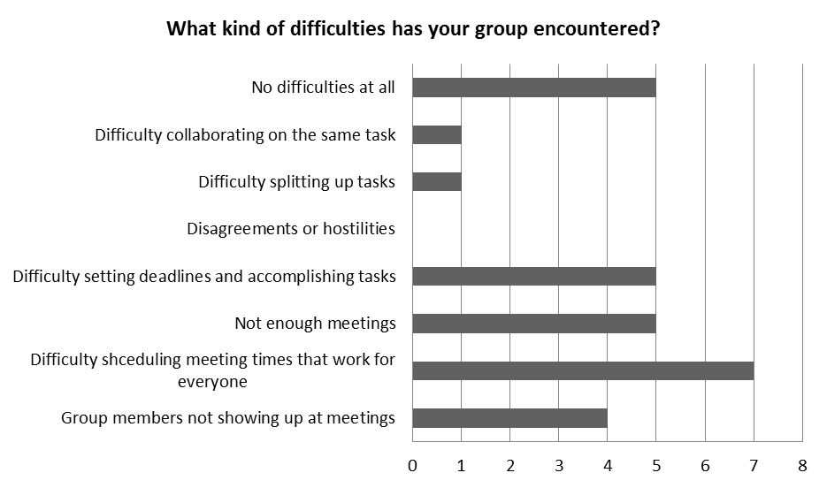

From the first survey, we also gathered useful information on actual features of a given tool. The graphs below from the survey results show what aspects of collaboration sites are most important to other research teams and what they may like to see more of for future use.

What sort of collaboration tools are you currently using?
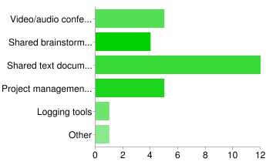

What collaboration tools do you feel your group would find helpful?
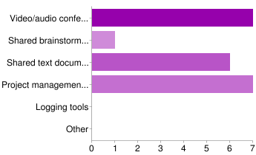

From these results from our peers, as well as our own results from our ratings, we narrowed our focus to six features which we felt were well-rounded enough to represent most collaboration sites and needs of teams. They were: Project Planning, Audio/Video Conferencing, Text Chat, Whiteboard, File Sharing, and Collaborative Document Editing.

We used this set of features to build our next survey of questions. Out of the seven that answered, we hoped to gain some insight with the simple inquiry “Do you enjoy group projects?” This turned out to be fairly inconclusive, however, with respondents answering “yes” and three answering “no.” We then asked for suggestions or advice that they would give to future students, which we took into account while gathering and finalizing our won results and suggestions. We also asked feedback on additional tools, seeking feedback on those that scored next highest to those that we picked for deep research: Scribblar, Timebridge, Diigo, Dabbleboard, and Stixy. Participants were to rate from (1-5), one being the lowest and five the highest; results were mixed and deemed inconclusive, with most scores landing on two or three. Using the features we had established before, we then asked classmates to rate each of the aspects of online tools from a (1-5) scale, one being “Totally Useless” and 5 being “Very Important”. We then took the ratings sums for each feature and established the importance of them according to the other I399 research teams. The results of the feature questions can be found in the pie chart below. Results were fairly even, and confirmed results of the earlier survey, with Project Planning being the most important aspect. Document Sharing and Collaboration were also important features, and Text Chat, Video/Audio Chat, and Whiteboard received good, albeit less, feedback as well.
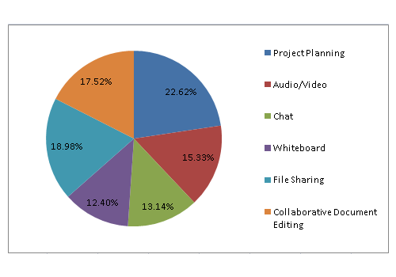
For our final video, we chose a skit-style filming with “team collaboration from 1991, 2001, and 2011” to represent the various problems with traditional collaboration, then contrast it with the functionality and ease of online collaboration tools. Our final poster displays our purpose, method, and selected results of the surveys, along with our top suggestions and contributing features and uses for those to come. With our own research, ratings, the 2 surveys, and interviews finished, the final results and suggestions are compiled in the sections ahead.

Results
Having figured out what tools to focus on, we decided to do some hands-on focus testing with several students from the I399 class. We chose 3 main tools to do our interviews/focus-tests on: Vyew, FMYI, and Stixy. Our decision to select these tools was based on the results of our surveys as well as our own experience reviewing each of the tools in our list. We ran our interviewees through several simple tasks on each tool to see how well they could grasp the interface and get their impressions of how useful they thought the tool might be. Descriptions of each tool, and what we learned about them during out interviews, follow:

Vyew
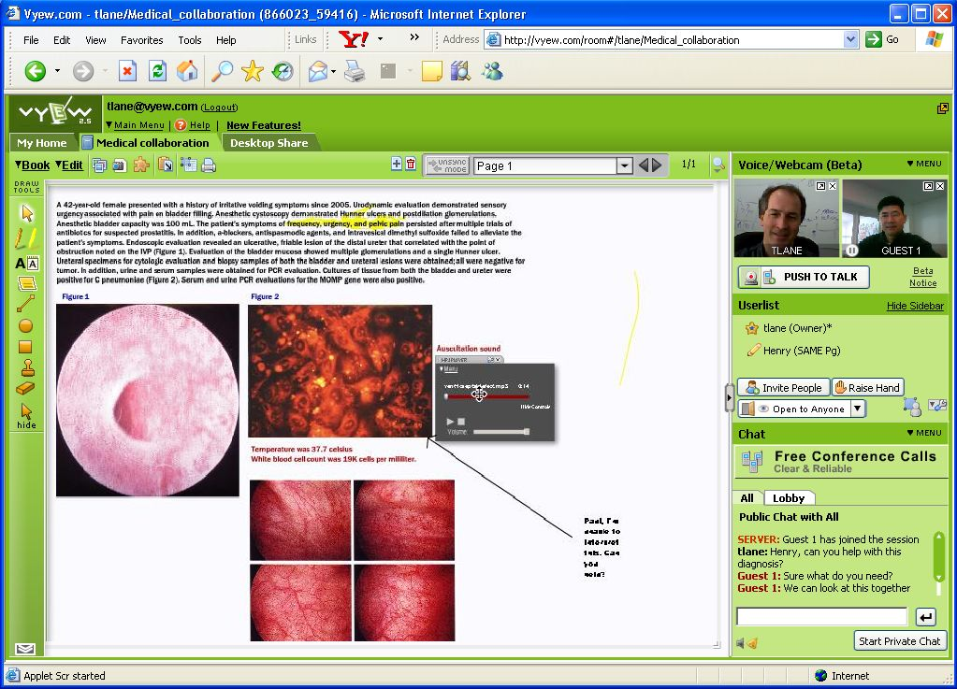
Vyew is a whiteboard site with audio/video chat, screen sharing and document sharing features. It’s pretty much tailor-made for meetings, and we thought it would be very useful for student collaboration particularly, since it doesn’t require anyone other than the host of the room to register for the site.

Findings:
Interviewee’s impressions of Vyew seemed fairly positive, but most of them had trouble with the interface. The interface isn’t at all appropriate for laptops, which unfortunately were the type of machines we were having our interviewees use it on. The webcam and chat boxes are difficult to resize, and usually are too small to comfortably use, at least on a laptop. We also found that the whiteboard went fairly unused in comparison with the webcam box and the text chat, so a majority of the screen at any time was taken up by a blank white drawing board. We also found the screen-sharing feature to be fairly unstable, and we had to refresh the page once during the interview to get the webcam box working properly.

Our interviewees liked the tool itself, but found the interface shoddy and discouraging. When asked if they could see themselves using this tool in the future, most of our interviewees said no, stating a preference for using the already-established Skype, since it’s more reliable and they would have an easier time getting their future group members to use it.

FMYI
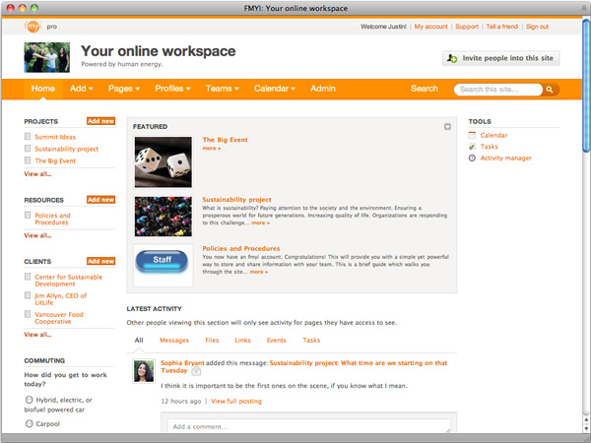
FMYI (For my Innovation) is a project-management site styled after Facebook and other social networking sites. It has very robust calendar and team features, and offers the option to assign tasks, post messages to the pages of selected group members, upload and share files, and so on. It’s used by actual businesses and offers several pricing plans to use it, one of which is free.
Findings:
Our interviews uncovered two main issues with the site: The interface, despite being social-network inspired, was still unintuitive and difficult to use. Additionally, there wasn’t any significant reason to use FMYI over Facebook for small student collaboration.

Another topic of note is that FMYI’s pricing page is very discouraging to new users. One of the first things a new user sees upon visiting the site is the pricing page. There are six versions of the site, the two most expensive require you to call FMYI’s offices to get a quote on the price, and the cheapest version (aside from the free version) is $25 a month. The free version, if the pricing page is to be believed, lacks several features that the paid versions offer, to the point where some of our interviewees felt that there wasn’t any reason to bother with the site at all. When we asked if any of our interviewees could see themselves using the site in the future, they said no, citing its similarities to the already-free Facebook and its difficult interface as the reasons why.
Stixy 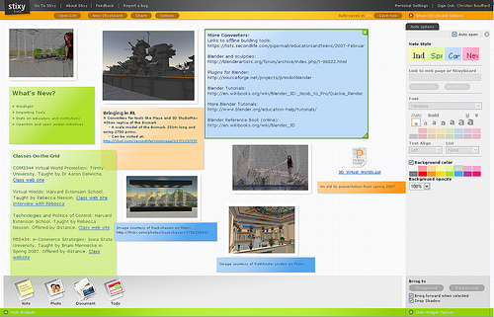
Stixy is an online bulletin-board (in the physical, post-it notes and thumb-tacks sense) that can be shared between group members online. The most notable part of this site is the high emphasis on spatial organization; everything is color-coded click and drag. There are four types of objects that can be placed on the bulletin-board: notes, photos, files, and “To do” calendar page. We selected this tool as a more lightweight alternative to the other tools we had looked at.
Findings:
Interviewees found the tool intuitive and “neat”, but useless for real collaboration. It’s a bit of a gimmick, and what’s worse is that real-time collaboration is impossible on it. If two people are accessing the same page at the same time, they will have to refresh the page repeatedly to see any changes the other person makes.

Conclusion
From our surveys, we found that student groups had the most difficulty with meetings and project management. We selected a few tools we thought people would find useful, and found that it’s a bit more difficult than we thought to find a good collaboration tool. Part of the problem is that these web-applications we were looking at are competing with entrenched tools like Skype and Facebook. This poses a difficulty in regard to student collaboration, since many students are unwilling to explain a new, unknown tool to their group members in lieu of using something already-established that there group would be familiar with.

We also learned from our interviews that interfaces and first-appearances are very important in a web-application. When evaluating a tool they know nothing about, students make their first judgements based on the first information available to them, namely the interface and whatever description the site itself provides. If the first thing they see is a shoddy interface or an intimidating pricing page, they won’t spend the time to find the underlying features that might make the site useful. This goes double for student groups, since not only is a student evaluating a tool for his own group, but he’s also evaluating how well he can convince his group members to make the effort to use it.

We think there are still several useful niches out there in student collaboration that we didn’t necessarily find a web-application to fill. A lightweight site for online meetings, for example, could do fairly well among today’s students if it managed to be intuitive enough. There’s also a need for project-planning sites among student groups as well. Most student project planning currently takes place over email and facebook, so any project-planning tool for students would have to offer more features while still remaining intuitive to use.

Recommendations for Future Work
We’re fairly happy with the list of collaboration tools we reviewed, but it’s hardly inclusive. We notably missed out on Wiggio, a popular choice at the school of informatics, and we deliberately avoided popular sites like Facebook and Twitter since we were trying to find something new. If we were to do further research, we would expand our options to include popular social networking and collaboration sites (like Facebook) as well as reviewing more unknown tools. We feel that we underestimated the use that popular sites like Facebook would have as scholarly collaboration tools.

We also would have liked to conduct interviews and focus-testing on more than just three tools, but we were limited by the time and number of interviewees we had available to us. It would be unfair to have them sit down and review dozens of tools, after all. We hardly feel that we’ve conducted a complete or even inclusive investigation of all the online collaboration tools available.

From our experiences conducting this project, we feel that there is definitely room for improvement in the realm of online collaboration. Student collaboration, in particular, is under-represented, and there are numerous unexplored possibilities for new tools to make students’ lives easier.

References

1. Vallance, Michael, Phillip Towndrow, and Charles Wiz. "Conditions for Successful Online Document Collaboration." TechTrends: Linking Research & Practice to Improve Learning 54.1 (2009): 20-23. Academic Search Premier. EBSCO. Web. 4 May 2011.

2. Douglas Roehler and Alan Levy. " U-M Online Campus Survey on Collaboration Tools: Google or Microsoft?" http://www.nextgen.umich.edu/collaboration/survey.php Dec 2010

