I399 Ubiquitous Computing

Team Members:

Niles Burke

Michael Goe

Andrew Thompson

Table of Contents

Abstract 3

Introduction 4

Statement of the Research Problem 4

Surveys 5

Research Methodologies 8

Analyzing Results 11

Application Design 13

Conclusions 13

# Abstract

The Android market constitutes an open resource for fledgling application designers. As a kind of software commons it affords designers an invaluable chance to prototype and field test new software. Numerous applications are available for download which are designed to ease basic functionality for the average user. These apps are popular among college aged students because of their versatile nature. The aim of the research described in this paper is to design an application to automate simple settings changes including volume, vibrate, and wifi on the Android smartphone.

We all have our own horror stories of phones going off during class, and the aim of the Ubiquitous Mobile App is to prevent such a situation from happening. The in-depth research discussed in this paper shows that such an application would be successful and popular among students, providing a solution to the problem of commonly overlooked settings changes. Five research methods were used to support this hypothesis: surveys, ethnographic observation, focus group, diary study, and one-on-one interview. These methods clearly support the potential utility of the proposed application and illustrate cases in which it could prevent users from embarrassment or otherwise looking unprofessional.

Potential users have expressed enthusiasm towards our proposed application. A working prototype was composed and offered to users for testing, which was received well. Google App Inventor offered us the chance to show users a nearly complete version of our application, which was integral in gauging attitudes towards our proposed final design.

# Introduction

Have you ever been in class or at a work meeting and had your phone go off to your embarrassment and create an interruption that should have been easily avoided? We all know how much of a hassle it can be to remember to change your volume and other settings on your phone when going from place to place. So that is why we decided to do some research into creating a mobile application to rid the world of this problem.

Using the GPS function of your phone the application will change the ring volume as well as turn on and off the vibrate and wifi functionality of your device when entering certain areas. It can be used to turn your volume down and vibrate on when you enter your class room or workplace and then reset those settings as you leave. We wanted to automate minor changes like these to improve the experience of owning and using an Android phone.

# Statement of the Research Problem

The problem we decided to focus on for our research project was to try to eliminate some of the hassle and nuisance associated with having a phone on your person at all times. Personal accounts indicate that this is a problem even for users who have had their phone for a long time and feel comfortable using it. Since we are so often expected to have our phones with us at all times we have become used to carrying them everywhere as a culture. To not miss important calls and messages we have ringtones that are often quite loud, however in certain circumstances it is inappropriate to cause that much noise.

Whether it’s the movie theatre, a college lecture, church, or some other situation that socially requires silence we have all observed or otherwise personally experienced the embarrassment of one’s phone ringing at an inappropriate time. Traditionally we have had to make changes in volume (and other) settings manually, reacting to situations we encounter and social spaces we enter intuitively. This leads to multiple settings adjustments for many in the different environments we encounter each day.

The reason we chose this was because it was a problem that one of our group members, Niles Burke, had been running into. He had accidentally left his phone volume up during class on a few occasions and was embarrassed when it burst into song during the lectures. Also, at times when he had remembered to turn his phone to vibrate for class he forgot to change it back when he got home and missed several calls. These various incidents are what gave him the idea for an application that would complete all of this menial work for him.

We decided that this problem would be worth investigating. We wanted to see if there were more settings, besides volume, that we could automatically change for the user so that they would not have to remember them on their own. Throughout the course of our project we encountered enthusiasm for this idea, and the information we gathered from various channels available to us indicated the design of an application to regulate settings changes would be extremely popular and useful.

# Surveys

As a means of conducting some preliminary research we did a survey of our peers to find out more about how they use smartphones in their day to day lives. We wanted to examine popular applications and try to gauge the reasons behind their popularity, as well as ask users which types of applications they enjoyed and wanted to see more of. We came up with a simple form to distribute online that would help us decide on our target demographic. We asked primarily open-ended questions to ensure participants were not influenced by our initial assumptions about smartphone use. We gained some valuable information from this survey and even more importantly ended up with even more questions from it.

The questions we had after the first survey were put into a second survey in which we asked more specific questions about precisely how users change settings throughout their day. After learning more about smartphone use habits from various users we wanted to gain more specific information about the exact number of times the average user altered their phone’s settings in a day. We were also eager to gain personal accounts of forgotten settings changes, similar to the situations we had envisioned while discussing the idea for our application.

Below are graphs of some of the more pertinent information we gained after analyzing the data from our surveys. We were able to deduce which settings changes would be important to include in the application design, as well as how often the average user adjusts these settings. We were particularly pleased that our surveys indicated an average of at least two to three changes in phone volume each day-- this strongly supported the idea that our app would be useful and offer a form of automation that would help numerous users each day. Based on the frequency reported, we deduced that wifi and vibrate settings changes would also be useful to include.

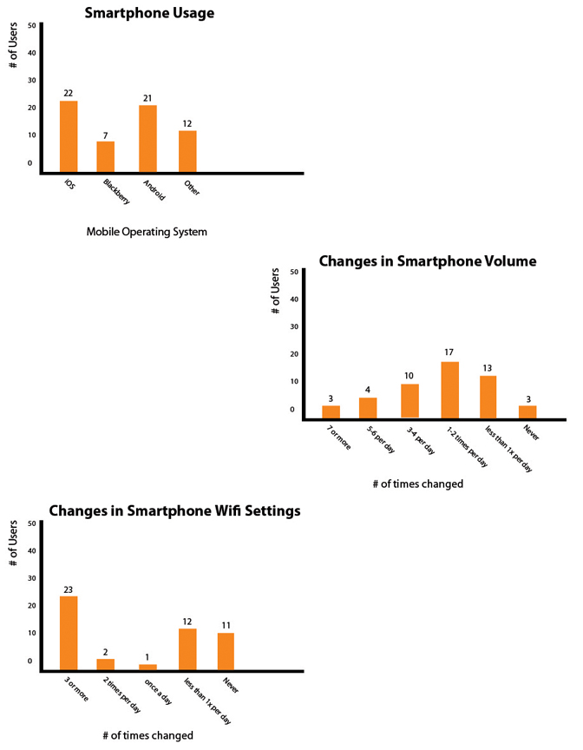

# Research Methodologies

1. Ethnographic Observation

In the interest of further understanding our target demographic, we employed numerous research methods and observational techniques. Of the four methods we employed, the first discussed below details the findings of a brief exercise in ethnographic observation. Specifically, we had our team member Michael Goe observe smartphone use over a period of three days while with friends both in at-home leisure situations and out around town.

Our findings agreed largely with the results of our surveys. The average user, from what was observed, changed their volume settings between two and four times a day. Whether this was to increase volume in the home setting and mute it while on the go or vice versa varied from subject to subject, the mentality and timing behind the change remained more or less constant— that is to say, this observation supported our hypothesis that these processes could be automated for the convenience of the user. Essentially, whether the user changes their volume one way or the other does not matter to our proposed product; only that there is, in fact, a change of some kind and that the change occurs for the same reason each day.

One thing our observations brought to light that we had not considered before was that most users seemed to change their settings in response to periods of peak cell phone use. In anticipation of such peak usage periods, the user would change their setting in some fashion— either to low volume or muted mode, or to a high volume mode. In some cases this change would coincide with the user leaving or returning home (our hypothesized moment of user volume change) but this was not so for all cases.

2. Diary Study

The second method we will discuss is a diary study. Observations regarding smartphone usage habits were recorded and studied by our team member Niles Burke. The results we analyzed from his one-week long diary study of setting changes for a smartphone aided us by providing a direct, first-hand perspective of phone usage over an extended period of time.

After taking note each day of when he changed the setting on his phone for a week we then analyzed the results and concluded that his behaviors and habits regarding the use of his own smartphone supported the theory that our application would provide a useful utility to the common user. Our team member reported that his everyday settings changes would be made easier if they were automated through an application.

Based on these findings, he changed various settings on his phone often enough that it would be much easier and less of a hassle if at certain times in the day or at certain locations (depending on the setting) his phone would automatically change its settings for him. The time it would take to set up our proposed application for use is miniscule in comparison to the time he actually spent changing settings manually.

After discussing these findings as a group we found we could more easily deduce which settings the average user changed most frequently. We wanted to be sure to include the most commonly changed settings in our application design.

3. Group Discussion

To supplement our research further we chose to hold a group discussion. Andrew Thompson spoke with a group of five smartphone users, asking them open-ended questions similar to the questions on our initial survey. We wanted to incorporate a strong emphasis on further analyzing our survey returns by asking similar questions in person to a small group of users. We believed this would help us understand the reasoning behind the responses we had previously received.

The primary weakness of the survey method was that we could not ask survey-takers why they responded in the ways that they did. By using a focus group, we could encourage users to explore their reasoning as well as enrich our own understanding of that reasoning. We could then ask further questions that expanded off of their previous answers and let the group fill in any more information that we needed as they discussed their answers. The participants reacted positively to the idea that settings changes on their phone could be made automatically. Most particularly, participants expressed a desire to automate changes in ringtone volume.

One participant related a story of their phone going off in class: the exact scenario we based the design of our application on. Another explained that they had gotten used to permanently leaving their phone on vibrate as a means of preventing such a situation from happening. A major drawback for this technique, the participant explained, was that it leads to an occasional missed call or text.

Overall, participants seemed excited when we explained our application to them. Analyzing the content of the group discussion strongly reinforced our belief that an application to automate settings changes would be popular among college students. The participants of the discussion reported multiple instances of forgotten settings changes, which agreed with our prediction.

4. Interview

The final research method we employed was a one-on-one interview conducted by our

team’s Michael Goe. The goal of this interview was to further the understanding of smartphone use that we had developed thus far by asking specific questions to a single user as well as do some user testing of our application prototypes. Most of the methods we employed left us with analytical work to do and decisions to make about how we would interpret our findings but this one actually helped us already have decisions made by its end.

By sharing our research thus far with a smartphone user outside our own group we could compare the hypotheses about phone use we had developed with the assumptions of an actual user. Essentially, we used the interview method to provide ourselves with an outside perspective on our project. This gave us a fresh look at our design and our methodology. We first showed our interview some PowerPoint slides of the prototype and as the interview progress we began making paper prototypes to lay out the app. As we showed of our initial application designs, our interviewee described things he wanted to see go into the application, and also pointed out things that should be removed. These insights were useful to further the development of our interface. Speaking with our interviewee was a valuable resource and provided us with numerous innovations regarding the design of our application. Specifically, it allowed us to formulate a stronger understanding of how to create user friendly interfaces.

# Analyzing Results

In order to analyze the information we gained through our surveys and other methods we had to temporarily suspend our own opinions about what should and should not be involved in our application. For our design to be truly successful we needed to cater to the needs of the most users possible. Above all, as we learned during the interview we conducted, we had to take steps to ensure the design was user friendly. If the application was overly complex or unintelligible in some way, users would experience difficulty setting it up and ultimately abandon using the application entirely. For an application designed around the idea of easing day-to-day phone use, ease of use in the application itself was paramount.

Luckily for us the Android platform proved to be a popular choice in operating system, which allowed us to design for a platform we had some degree of familiarity with. Also as mentioned above, the Android market is a relatively easy to access publication venue. For fledgling designers such as ourselves we believe it is important to choose our publication venue carefully, but we were also aware of the importance of choosing a marketplace populated enough to allow our application to be tested by a variety of users.

Our surveys and focus group allowed us to narrow the functionality of our application down to automating what we found to be the three most commonly changed settings: volume, vibrate, and wifi. Two of these were a simple “on or off” style change, whereas volume was a variable scale. Even with just three settings to adjust (two being simple binary changes) our app would be able to offer numerous unique settings configurations to the user without being too complex.

The user interface we designed was pieced together carefully after listening to the concerns and considerations suggested to us by various users. People who had scarcely used smartphones pointed out which kinds of help prompts would be useful to include and helped us to compose directions for use that would be succinct and understandable. More experienced smartphone users enlightened us to functionalities we could include in the app that we had not even considered on our own.

# Application Design

Once we had our survey returns analyzed and had gone through a couple iterations of our prototypes, we began to look into actually programming and creating our application. One of the reasons we chose the Android operating system was the availability of App Inventor. App Inventor is a program provided by Google that allows users to create relatively simple applications in a graphical user interface (GUI) instead of using Java code. This gave us an advantage of not having to learn any intensive programming languages. What we failed to realize, though, is that there is still a moderate level of complication present in the app we were trying to produce. App Inventor is a high level program but its functionality is greatly restricted, therefor we were unable to actually implement the features we wanted by using it. However, we believe our experience with prototyping based on research was enough for the scope of our project and if we ever come back to the project in the future with a stronger base in programming for Android we would be able to easily create and publish this application.

# Conclusions

Despite our hang-ups with Google App Inventor, we were still able to prototype our design using a simple slideshow composed in PowerPoint. This allowed us to display our application how it would look as a finished product, and gauge whether or not it would truly be successful and usable. Overall we were pleased with our findings and we managed to accrue strong evidence suggesting our application would be a worthwhile development and a successful product. Given the enthusiasm we were met with during the information-gathering phase of our project, we expect our app would flourish if released live on the Android Market.