**I399 Project: Future of books in education as we develop technology for better learning environments**

**By:**

**Tylend Dawson**

**Jongmin Lee**

**Elijah Moon**

**Becky Torrey**

We live in a world where change is frowned upon even though we know change is necessary for us to adapt to the world to survive and stay ahead of our competitors. One change that people are having difficulties with is in the way we perceive our education on the college level. People are scared of the unknown and despise this technology shift into the educational system. When these feelings first surfaced, many believed technology would not work in within the educational system. Now we are in a new day and age: the “Technology Generation.” Even now people are still despising the idea of technology getting incorporated in education, but a few are brave enough and are experimenting with this transformation. Indiana University is one of the poster schools who courageously leads the country in innovation and tries to make this technology-infused education a reality. With that being said, what would Indiana University look like in 5 years if most or all textbooks were eBooks? When pondering about this question one must take in all considerations on how this change will affect all parties like the consumers, publishers, teachers, and etc.

**Secondary Research:**

In “Digitizing Education: A Primer on eBooks”, they elaborate on what software and hardware companies want to get from eBooks. Most aim to take advantage of content that was once non-existent, but is now available in digital form. This article also offers a vast number of reasons on how eBooks add value to education. With the students and faculty becoming aware of this information they will be more willing to make this transformation to eBooks. This ranges from faculty being able to easily review large textbooks to find relevant information for the course to its amazing accessibility from anywhere in the world.

Author Michael Looney, goes on to say “eBooks can enable daily, weekly, or monthly updates via the Internet, eliminating out-of-date textbooks.” This is a great resource and attributes to have because it gives us the latest version at a faster pace unlike physical textbooks because where they want is updated until 2-4 years when the new edition comes out. Some textbooks have errors and information that is not accurate. This is a problem because students are spending a lot of money on these textbooks and to have errors and outdated information is ridiculous. With eBooks, there is no need to worry about this issue. Errors that would normally waste money and cost a lot to correct are fixed quickly with little to no cost. Companies also waste tons of money when producing new editions of textbooks. These new editions that come year-to-year have very few changes or edits to them. With that said, eBooks allow these changes to occur and customers save money and receive the most current and accurate information. That should be the main focus is to supply the customers who are the students with the best quality and updated information.

Looney also believes there are three factors that will make eBooks successful in education. He first elaborates on how content plays a role. He states, “Without electronic content, there is no eBook.” This means we need publishing companies to invest their efforts to this move. Companies such as McGraw-Hill, Addison Wesley, Harcourt and Houghton Mifflin have already started the conversion.

Secondly, he believes that eBooks must be accessible. He states, “If the process is slow or complicated, eBooks will not catch fire on campus.” The conversion has to be simple and straightforward. Customers are not likely to switch if there is a great deal of complication involved. “The learning materials need to be as easy to find, buy, obtain, and use as books bought at a conventional college bookstore or found in the campus library.” The ease of the process is one of the determinant factors for the success of eBooks in higher education.

Lastly, Looney mentions that eBooks must be readable. The readability is heavily dependent on the technology being used to view the text, whether it is on a device or software. He states, “Simple but crucial issues like the weight, size, and general look and feel of an eBook device can make or break its success.” This is why companies, such as Apple, construct their products around the design and sleekness. Customers still need to have a relationship with device, in the same or better fashion that they have with their books. If Indiana University can fulfill the content, accessibility, and readability issues that could possibly be presented, they will be one of the leading universities succeeding in the eBook transition.

Another article was published by Sam Jordison, known as “The ecological case for eBooks”. In the article, he discusses how the move should be logical considering how it benefits the planet. No longer would we have to make endure the mass extension of trees to produce the paper. Senior researcher, Emma Ritch states “a physical book purchased by a person driving to the bookstore creates twice the emissions of a book purchased online.” This is an exaggerated statement as to how eBooks are beneficial, yet it delivers an overall view of how the smallest changes can have the greatest impact.

Indiana University is strongly promoting their eText initiative to their students and faculty. Indiana University is also represented as being a pilot school for the eText transition in higher education. Indiana University UITS (University Information and Technology Services) has an entire website dedicated to promoting their audience on this new wave of learning. Even though they have a website they still need to promote this new transition more and make the students more aware. By doing this it would give the students more knowledge on the situation and would make the UITS website meaningful and useful. UITS number one goal is to drive down the cost for students. After some primary research it shows us that lower cost is critical for students on making this transition to the eBooks/Text transition. However, not only are students saving but by distributing the eTexts digitally, publishers and sellers save on printing, warehousing, and shipping cost that physical textbooks present. UITS further outlines what eTexts are and how students can benefit from them academically and financially.

Indiana University’s UITS Department describes eTexts as, “the shorthand term that describes the emerging digital version of textbooks and other educational resources. The eTexts are inclusive of content such as workbooks, problem sets, tutorials, videos, simulations, and interactive software.” With the inclusive context that eText provides, students are able to gain more insights on the material in comparison to physical textbooks. The eText has print options available as well if the user doesn’t want to read content on a device. The eTexts are accessible to Indiana University students through Oncourse. Students can typically purchase their eText a few weeks before the first day of class.

Many schools are beginning to grow interest in eBooks. In the article, “Adobe Targets Higher Education with eBook U Program”, schools such as MIT Sloan School of Management, Occidental College, Miami-Dade Community College Medical Center Campus, Mills College, Scottsdale Community College, University of Maryland University College, University of Utah’s Center for Advanced Medical Technologies, Tufts University, and University of Wisconsin have all agreed to participate as institutions who aim to adopt eBooks. This is showing us that we are getting ready for this eBook transition. With the outdated research we found it proved that society was not ready for the digital change and that we would have to move gradually into that transition. Michael Looney, Adobe’s senior director of education and government marketing, said “We selected these colleges and universities based on their interest in e-book technology and their willingness to share their experiences. The interest these colleges have been showing will be the start of the new evolution in education. When it catches on everyone will be following suit and it will be a domino effect, with that education will be changed. It will be changed from the way professors or teachers teach and interact with their students. It was also important to address a broad range of campus types. Together, we hope to better understand and meet the needs of academic administrators, professors, and students.” These schools are in the similar position as I with the eBook/Text transition. Since everyone is undertaking this new project, we can only track our progress as results begin to show. As these results come in they will be essential because other schools will and are watching to see how this transition will turn out, if it is a success we will see other schools make the transition to eBook/Text transition.

From the academic standpoint, eTexts can provide many positive attributes to improve a student’s learning environment. One being the ability to take notes and annotations on an eBook, this mode also allows you to print your notes and annotations. ETexts also provide a highlighting option that allows users to highlight text in different colors. A student could have all his “Homework” highlighted in yellow and text for “Final Exam” appear in blue. Another benefit students have is the ability to share their annotations, often referred to as Social Annotations. Professors can also post annotations for students to view. This method of learning allows all information to stay current while also reducing the amount of information lost in translation throughout the semester. Perhaps the most important attribute for Indiana University e-text Model is that it can be accessed through any device that has a web browser.

Although eBooks can have many pros, there are some cons that might influence the impact this move. In the article, “Are eBooks Cost Effective? The Pros and Cons of eBooks” published by J.D. Roth, elaborates on these beliefs. First, you can only read an eBook on an electronic device. That means you have to own the electronic device which, itself, costs money. Most people own an iPad, smartphone, or computer, which means they don’t have to pay anything for an eBook reader. However, you’re using a device that is very expensive only to read a book. Some devices, like desktop computers, are not portable and as convenient to paperback.

Secondly, eBooks are not cheap. In fact, depending on what you read they may actually be relatively expensive. In an attempt to protect the paperback industry, publishers have set obnoxiously high prices for most e-books. J.D. Roth argues that eBooks are only good for new releases when the company is trying to make big sales early (similar to the music industry when new albums are released). After industries make their quick sales in introduction phase, the price will increase and stay steady toward the maturity stage of the book. When the book finally reaches the decline phases, we can expect prices to lower again.

Another issue presented is the formatting of the text. Books that are typically older can sometimes appear in horrible formats on the e-reader. Majority of the time these texts can be downloaded for free, however it’s pointless if the format and reading legibility is bad. Only if the older book is considered to be a classic, will it appear in great format for reader.

Peggy, an eBook user, quotes “Books are a major weight factor for us, so we started downsizing during our last move and kept only those books we enjoy re-reading or which have sentimental value. She goes on to say, “This year we bought several Kindles, and I have to say, I really like it for its portability and that we can travel on R&R and have all our reading material in one small ‘container’. But when we retire and settle down, it might lose some of its attraction. I also wonder how it will hold up over time…but I guess it’s too early to tell about that.”

Peggy brings us to our third issue which elaborates on the sentimental value that books have with their owners. Some people are afraid to convert because they don’t know the future effects that implicate the usage. As technology devices continually change can we depend on having the books we treasure on them? Will they always be easily accessible? Even though Peggy is a Kindle user, she still values physical books and their importance. However, Peggy had the willingness to convert while others refute the possibility.

One of our last secondary findings was a report conducted at Indiana University in 2010 which outlined some key points that help us in our research. According to “Indiana University e-textbook Project” by Alan Dennis, Thomas Duffy, and Anastasia Morrone, “students are motivated and interested in using electronic textbooks, if they save money compared to paper textbooks. We can back this research up with our primary data, because it proves that the students were more interest in using electronic textbooks. This directly correlates to one of our main points being lower cost. With the current price of tuition, students aim to save as much money as possible and e-texts allow that to be possible.

They also discuss faculty’s role in e-text, which is a major role in trying to implement e-texts to education. When they conducted their research, they mentioned “most tried to adapt their teaching styles to use features offered by the e-textbook, but this was a learning semester”. This gives us an understanding on the situation and letting us know that there is no blue print to how teachers should and take advantage of the e-Textbook and that it is a great tool that gives them a lot of options to make it successful. Since Indiana University is one of the leading pilot schools that are trying to advance e-text usage, there must be a learning curve that is addressed. Professors that have been teaching for numerous years must be willing to switch their teaching methods so this technology can advance and higher education can improve. When professors assign an e-text as the required material, this builds awareness of the option. Some students are unfamiliar with it until they are forced to use it.

**Primary Research:**

After utilizing the secondary research we went ahead and conducted our own primary research to put it to the test. We wrote up a survey to distribute to students for we can see was this “Technology Generation” ready for the transition or would they stay timid and not want or accept change. This survey was released both digitally via SurveyMonkey.com and on paper. The paper version was given to several different groups of students: Two undergraduate Geology courses (one class with mostly freshmen and sophomores, the other with mostly juniors and seniors) that used a digital textbook. The lower-level course was a mix of majors and the higher-level course also had a mix, but there were more Geo-Science majors and Astronomy majors. We also did random sampling of students around campus, mainly from the Kelley School of Business because books are very expensive, have special editions, and are more costly than the other schools on campus and for the fact that some of the teachers are already using e-readers in some of the classes. We felt this would be great to do because we could see how participants would rather chose, especially knowing when they have a cheaper resource to choose from. The survey was as follows:

Would you rather invest in a digital book or a physical textbook?

Do you already use an eReader? If so, which one?

If you don't already use an eReader, would you buy a NOOK and/or use NOOKstudy if it was an option, like the specials with Apple? (NOOKstudy is available for use without a NOOK.)

What features would you like in a digital textbook? Check all that apply:

[ ] Underlining/highlighting

[ ] Notes in the margin

[ ] Bookmarks

[ ] Activities within and at the end of each chapter

[ ] Short videos that provide more insight into a difficult section

[ ] Immediate feedback on assignments

**Results:**

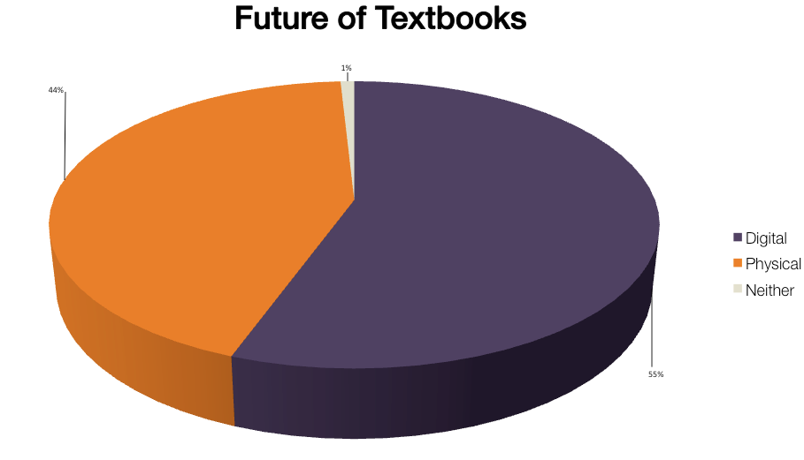

Fig. 1

With this survey we were able to collect data and see if the students preferred to have eBooks or to just have physical textbooks. This survey gave us a lot of insight. The results ended up with 55% of students preferring digital textbooks, 44% who preferred physical, and 1% who chose neither. We feel like if students were more informed on the situation like what eBooks can do for them and just overall how this would lower their cost then we would have had more digital responses and barely any physical responses.

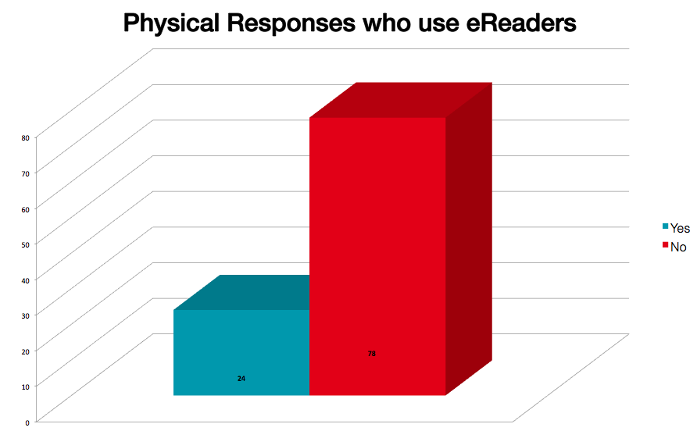

Fig. 2

We collected responses from those who answered that they preferred physical books to see if they used eReaders and which ones they used. Not surprisingly, only 3% of these students used eReaders, and all of those (barring one) were iPads.

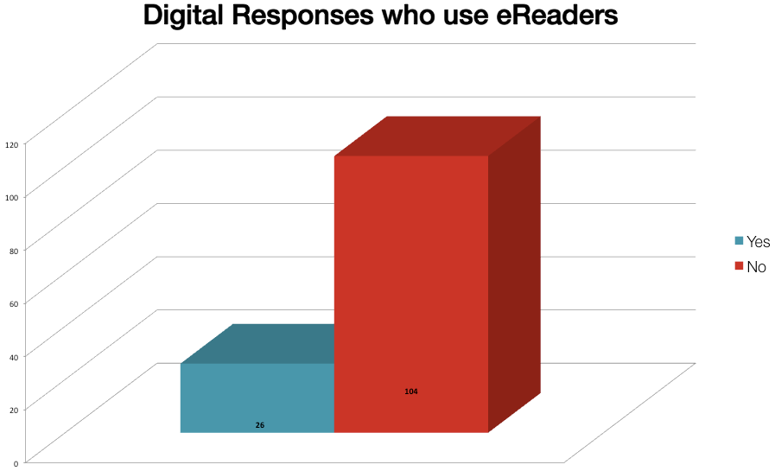

Fig. 3

We collected responses from those who answered that they preferred digital textbooks to see if they used eReaders. What we found was that only 13% of these used eReaders, also mostly iPads although there were a considerable amount of Kindles.

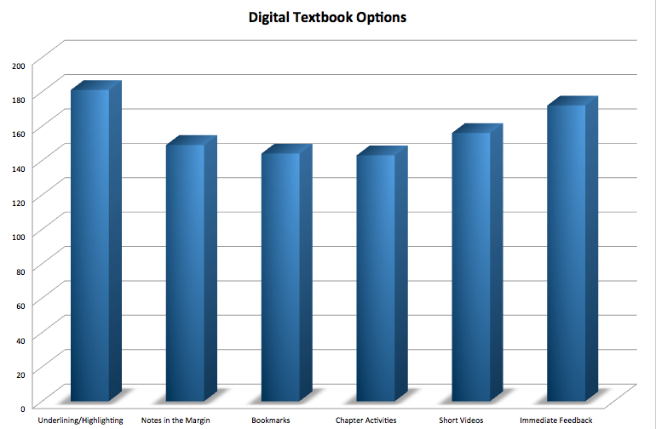

Fig. 4

The last part of the survey was a checklist of what students would like in a digital textbook. We gave them six options to choose from: Underlining and/or Highlighting, Notes in the Margins, Bookmarks, and Activities Within and/or at The End of Each Chapter, Short Videos to Explain Difficult Sections and Immediate Feedback. Out of the 300 responses we received, over half of the students wanted all of the options we gave them, but many students also commented on how they would like to print their book or chapter.

Overall some verbal responses we received were both positive and negative, but mainly positive. Some positive responses we received was like I want the cheaper option and that using an e-reader would be great because of easily they could handle it and organize their classes in. Some negative feedback we received was people saying that they would rather have a textbook because having something physical and something they can look at easily without constantly looking at a screen. Another thing they had was that they could bookmark and highlight things in a book. After some of these comments we felt some participants were confused and did not really understand what an e-reader is or what many options they could really do with it.

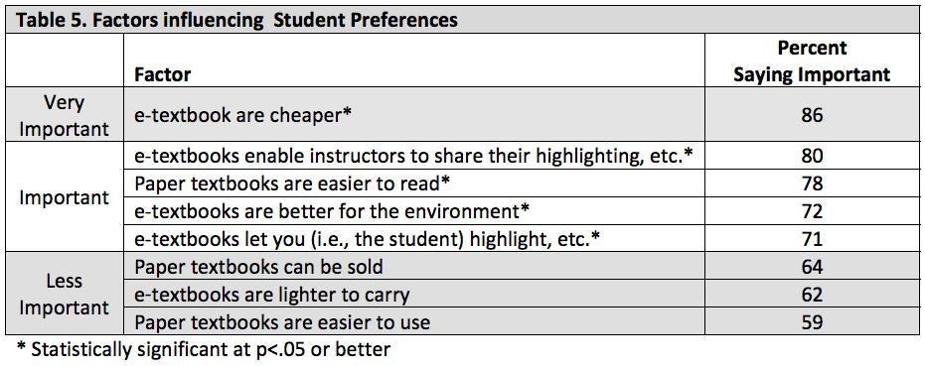

Fig. 5

This is a table from the eText Report taken in Spring 2010. It summarizes surveys similar to what we’ve done here, but their surveys were released to far more students and under different circumstances. Where we just surveyed random students and students currently using a digital textbook, they solely surveyed students using a specific type of eBook technology, namely the software that eTexts now uses. This table refers to a study of how important certain factors are for choosing a paper textbook over a digital textbook and vice versa. The most important factor was clearly price, as we also gathered from the comments in our survey. This table gives a better view into our own data as we surveyed a similar population (Kelley Business School students and miscellaneous College of Arts and Science students).

We also organized an interview with the Chief of Staff of University Information Technology Services (UITS), Nik Osbourne. We asked him about UITS’ new program eTexts and future implementation as well as current success. Osbourne very strongly believes that in five years Indiana University would have an even solider foundation as a national technological leader when eTexts gets on its feet during the Spring and Fall 2012 semesters. We asked him about specific future goals and milestones, problems with implementing the eTexts program, and steps towards fixing those problems. He began each answer by giving background on the program and then explaining each section clearly, sometimes even going on tangents. These tangents were always insightful and every word impacted the final analysis of our study.

We informally interviewed Professor Jeremy Dunning as we distributed our survey to his students. His input as a faculty member who uses a digital textbook (but not an eText, although he was a part of the committee to put the program together) was invaluable as we were unable to talk to any professor who uses an eText. We asked him questions similar to those we asked Osbourne: problems with his students using the digital textbook and what benefits he saw in comparison.

Osbourne’s top three issues with physical textbooks were cost, size and ecological impact. He considered cost to be the top priority and the other two would follow in time. Dunning had the same thought, even going as far as telling students to not buy the book if it was too expensive. For him to enlighten them on another option that is cheaper allowed more students to purchase the material since the price was more affordable and fair. With his digital book of choice being just under $80, it’s understandable as to why he told his students this. According to Osbourne, an average eText would cost about 45 dollars, just over half of the already “cut price” Geology textbook. That right there shows us how we will save money and that making this transformation will be great for every party.

To conclude, Indiana University would need to develop a great relationship with publishers through a business-to-business model. Indiana University, typically, receives qualified vendors through their Request for Proposals. Once vendors are selected they can move towards selling the eText. If each student in class sections is charged a fee, publishers will reduce the price of eTexts. The only reason textbooks are priced so high is because publishers only make new editions every 2-3 years so they want to be compensated for that gap. If Indiana University practices its negotiating power as it is done with Microsoft and Adobe in the past, we can see students purchasing eTexts at very little cost. At the moment, Indiana University has eTexts ready to purchase for 35% of list, which also allows continual access throughout the student’s academic career. As Indiana University becomes more experienced with eTexts, that percentage is likely to decrease. In regards to financial aid, students should not have a negative impact from eText fees. Like we stated before we live in a world where change is frowned upon even though we know change is necessary for us to adapt to the world to survive and stay ahead of our competitors. One change that people are having difficulties with is in the way we perceive our education on the college level. People are scared of the unknown and despise this technology shift into the educational system. That leaves us with one of our final thoughts and original question, what would Indiana University look like in 5 years if most or all textbooks were eBooks? We do not know the answer but we know if Indiana University continues to be the poster school that courageously leads the country in innovation and tries to make this technology-infused education a reality, they will have set the blue print for eBooks implemented in school. Now this is why we have to ponder and ask ourselves are we ready to overcome this barrier and stop being afraid of change for we can stay ahead of our competitors and make history by changing the education system?

**Works Cited**

Indiana University “IU Press at forefront of university press e- initiatives” Web. 12 Jan. 2012 30 Apr. 2012 <http://newsinfo.iu.edu/news/page/normal/20829.html>

Indiana University “eTexts Frequently Asked Questions (FAQ)” 30 Apr. 2012 <http://etexts.iu.edu/faq/index.php>

Indiana University “eTexts Documentation” 30 Apr. 2012 <http://etexts.iu.edu/docs/index.php>

Ted Strong "UVa E-textbook Pilot Aims to Ease Financial Strain on Students." Daily Progress. Web. 12 Feb. 2012. 30 Apr. 2012. <http://www2.dailyprogress.com/news/2012/feb/12/uva-e-textbook-pilot-aims-ease-financial-strain-st-ar-1683770/>.

Ruth Wilson “Ebook Readers in Higher Education” Ebook Readers in Higher Education. Educational Technology & Society 30 Apr. 2012 <http://www.cis.strath.ac.uk/cis/research/publications/papers/strath_cis_publication_204.pdf>

“ADobe Targets Higher Education with eBook U Program” Information Today Jul/Aug2001, Vol. 18 Issue 7 30 Apr. 2012 <http://web.ebscohost.com/ehost/detail?vid=3&hid=123&sid=5a1e48a1-235d-4b7a-85ab-be2381283251%40sessionmgr13&bdata=JnNpdGU9ZWhvc3QtbGl2ZSZzY29wZT1zaXRl#db=aph&AN=4770945>

Michael Eisenbraun “Is there a Future in ebooks?” 30 Apr. 2012 <http://www.michaeleisenbraun.com/portfolio/literary_ebooks.pdf>

Beverley Shirley, Danielle Cunniff Plumer, and Russlene Waukechon “The e-Book Revolution” 30 Apr. 2012 <http://www.txla.org/sites/tla/files/CE/docs/article.shirley%2C%20plumer%2C%20%26%20waukechon-Ebooks.pdf>

J.D. Roth "Are E-Books Cost Effective? The Pros and Cons of E-Books." Get Rich Slowly â“ Personal Finance That Makes Sense. Web. 07 Dec. 2010. 30 Apr. 2012. <http://www.getrichslowly.org/blog/2010/12/07/are-e-books-cost-effective-the-pros-and-cons-of-e-books/>.

Jordison, Sam. "The Ecological Case for Ebooks." The Guardian. Guardian News and Media, 29 Mar. 0010. Web. 30 Apr. 2012. <http://www.guardian.co.uk/books/booksblog/2010/mar/09/ecological-ebooks>.