

Informatics I-399
Spring 2012
Final Paper

Detecting earthquakes through social media, validating data with scientific findings, and providing an informational portal for all.

Tyler Roach - tjroach@indiana.edu
Brett Guiden - btguiden@indiana.edu
George Tattersall - gtatters@indiana.edu
Mentor: David Nemer - dnemer@indiana.edu

Table of Contents

- Abstract

- Introduction
  - Statement of Research Problem

- Background and Related works

- Research Methodology

- Analysis

- Results

- Conclusion and Recommendations for Future Work

Social Quake Earthquake Detector
Final Paper

- Abstract

With the recent global spread of social media outlets such as Twitter, news can travel faster than ever before. Social Quake was designed with the purpose of mining through Twitter data to analyze current earthquake activity. This project tests the validity and accuracy of reports from the masses, quickness that information is spread in times of crisis, and the role social media can play for concerned citizens across the globe. Our team chose to build a tool accessible to all that can display recent earthquakes from not only a scientific standpoint, but a social standpoint that can. In serious cases, this new social aspect could possibly save lives by displaying calls for help, and crisis information that can be posted before news outlets are able to gather and post the information needed.

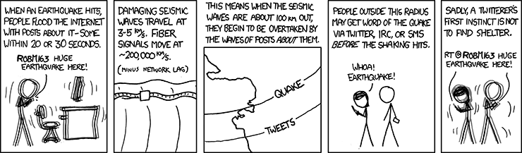
XKCD¹

- Introduction

With the astonishing amount of data that is passed around through social media outlets such as Twitter, news is becoming more and more instant. From the evolution of newsprint, then to online articles, comes a new instant form of media that is told by amateurs around the world. Any Twitter user with a public profile tweets information that can be read and shared by everyone with computer access.

Social media consists of a collection of free and relatively simple set of tools which have been used in a variety of creative and productive ways. One of social media’s greatest strengths is its ability to quickly disseminate valuable information. In times of crisis, lack of information creates panic and disorder which only exacerbates an already dangerous situation. An inspiration for the development of Social Quake was the essential roles twitter and facebook played in organizing protests which led to the overthrow of Mubarak in Egypt. The Arab Spring’s success demonstrated that what ordinary people observe and talk about has value and power, particularly in times of chaos. We wanted to see if we could harness this value to provide information about natural disasters which notoriously brings down lines of communication. We picked earthquakes as the natural disaster to study because they strike several times on a daily basis. After much discussion about the scope of our research, we concluded that using twitter to determine where and when strikes occur would be a modest first step in the field of analyzing social media activity to determine useful information for victims and relief efforts. Twitter was chosen as our social media platform because its users’ posts are more likely to be public as that is the culture and default setting of the site.

- Statement of the Research Problem
Can Twitter be used to detect when an earthquake strikes? Can Twitter be used to also detect where an earthquake strikes?

- Background and Related Work

Twitter’s posts are currently being monitored and analyzed for a variety of reasons. Perhaps the most interesting would be Indiana University’s Professor Johan Bollen’s study of Twitter’s mood to predict the stock market.² Many companies are shifting their Customer Relationship Management systems to an increasing focus on social media. Companies use what people are saying about them on social media sites to better understand the needs and wants of their consumers and to gather ideas for new products.³ Professor Richard Colbaugh from New Mexico Tech is using social media to estimate public sentiment for everything from movie reviews to Jakarta’s hotel bombings.⁴

Event detection through communication means has been a popular topic of research. Before online social data was available and large enough to study, cell tower usage was used similarly to how we are using social data now. One study, by Ashish Kapoor, Nathan Eagle, and Eric Horvitz, examined cell tower trends to detect when an earthquake occurred, and was able to estimate the epicenter of the earthquake.⁵ During their study, they were able to create various models and equations to detecting the events and then predicting a location for the event. From there they were able to use the models to translate into detecting earthquakes and predicting the seismic epicenter for them.

- Research Methodology

Research consisted of receiving three different types of data. This data was past social data, present social data, and present scientific data. To first confirm that Twitter could be used as a platform for spreading information about earthquake crisis, we used a tool called Trendistic. This online tool allowed us to search a specific keyword, then determine the percentage of tweets during a given time frame that contained the keyword. We first looked at the Japan earthquake and tsunami crisis that occurred on March 11, 2011. As seen in the chart below, less than .01% of tweets contained the word “earthquake”, and within two hours of the quake striking, over 6% of all Twitter tweets contained “earthquake”. This served as our proof of concept that Twitter can be a valid tool that spreads information quickly and accurately.

Image 1: Earthquake Trend during Japan Earthquake - Trendistic.com
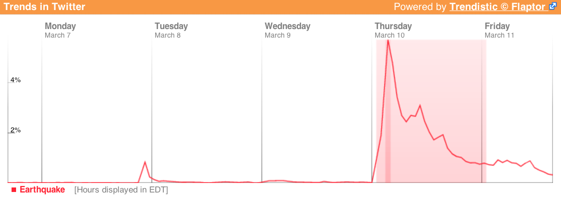

To retrieve Social Data, we relied on using Twitter’s Streaming API to pull in tweets real-time. The criteria we used was to find any tweet that contained either “quake” or “earthquake. This process was handled by an open source Python module named Tweetstream.⁶ A python script was written and adapted around the Tweetstream module. When an earthquake tweet is captured by the python script, it is placed through a couple of criteria. First, the tweet must not contain a word in an excluded word list. The excluded words list contains words that if used in the tweet, usually had no correlation with an actual earthquake. Words such as “memorial” and “ago” were excluded, as many users would tweet about past earthquakes that occurred such as, “Today we remember the Japanese Earthquake that affected so many lives one year ago.” If the tweet did not contain a word from the excluded words list, it would then be counted towards the hourly and daily tweet total. The list of words our filter searched for are listed below.

Image 2: Excluded words list
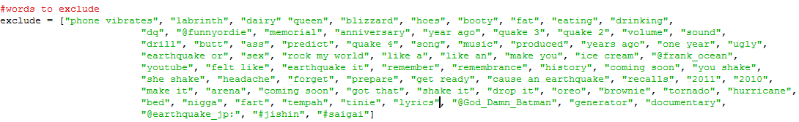

To find the location of the earthquake that these tweets are about, a key:value pair dictionary was implemented. The dictionary keys were a list of all the countries in the world and the US states, and the default value for all countries was set to 0. Each tweet received was checked to see if it contained a country listed in the dictionary. If the tweet contained a country, the country value would be raised by 1. The top 3 countries mentioned each day are the countries that are displayed on the website front-end. We originally developed a dictionary of every town in the world with a population above 15,000, however mapping this data to the correct country proved to be out of the scope of this project.. A future build should feature a more comprehensive dictionary of locations to track where earthquakes strike. A partial list of the dictionary of locations we used to keep track of which places were mentioned is shown below.

Image 3: Country Dictionary
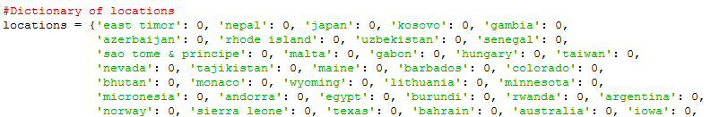

The finished linux terminal interface is shown below. This continuous script must run at all times in the background to collect real-time data and provide a backbone for the graphical website that was developed after the initial research.

Image 4: Script running in Terminal
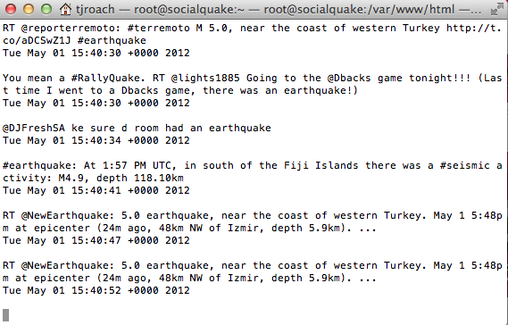

We have encountered a few technical problems with the TweetStream module which causes Social Quake after some period of time, usually between 15-30 hours. Although this is not a hurdle to overcome for this field of research, it is one that our group has not been able to overcome with the limited amount of time the script has been running. As we detect new causes for crashes, we are seeing more reliable connection times.

Our scientific earthquake data is gathered from the United States Geological Survey website (www.usgs.gov). From this website, we are pulling earthquake data from a CSV feed containing all earthquakes in a 24 hour period that are 2.5 or higher on the Richter scale. This feed is updated every 10 minutes to give accurate information about earthquakes across the globe. Our script fetches not only the magnitude of each quake, but also the region and date that the earthquake occured. A sample entry from the CSV feed is shown below. We use this scientific data on our website to both inform users and to validate Social Quake’s findings.

Image 4: Screenshot Clip of CSV Feed from USGS.gov

- Analysis

After running the script for 129 hours between the dates of March 22, 2012 and March 30, 2012, the script was stopped for analysis. First, data was gathered to find the expected range of tweets during a low activity hour. The highest total of tweets during the 129 hour run was 3,630 while the lowest total in a given hour was 161. (During earlier testing, a 6.5 earthquake in Chile on April 17, 2012 registered over 5,300 tweets in less than 25 minutes.) The total mean and median are found in the table below, as well as the standard deviation.

Table 1: Ranges of Tweets per Hour
Mean Tweets/Hr | Median Tweets/Hr | Standard deviation
628 | 514 | 471.18

Once these medium ranges were found, The top 15 hours (20%) and the bottom 15 hours were eliminated. After these filtered results, the highest tweet hour was 978 and the bottom hour was 301 tweets. While our Social Quake script may still show relatively small earthquakes on a low activity day, the data confirms that hourly tweet counts below 1,000 indicate that no significant earthquake occurred during that hour.

Next, we analyzed the accuracy of the tweets being received. For tweets that were displayed in the top 3 sections of the Social Quake website, 85% of these tweets were determined to be relevant to the current quake situation. For example, at 1:20 UTC May 1, 2012, 87% of the 50 tweets displayed related to the 3 locations of Hawaii, Japan, and California.

Testing the filtered tweets that were not categorized in a specific location was more difficult to gauge for accuracy. During different time periods of testing, tweets that related to a recent earthquake ranged anywhere from 30% to 90%. During low activity hours where quake activity was minimal, tweets were more off topic. However, the majority of quake related tweets during high activity hours were relevant to the recent earthquake. The best example of high accuracy was observed during our testing period was during a 3.8 quake that occurred March 28, 2012 in Southern California.

Image 5: Spreadsheet of Earthquake Data for March, 28, 2012
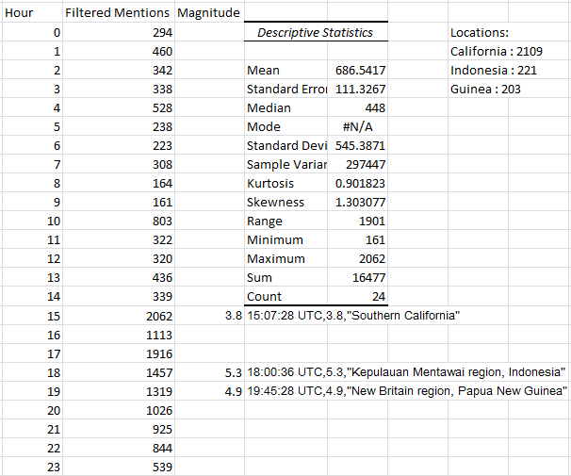
Image 6: Visual Representation of Earthquake Data for March, 28, 2012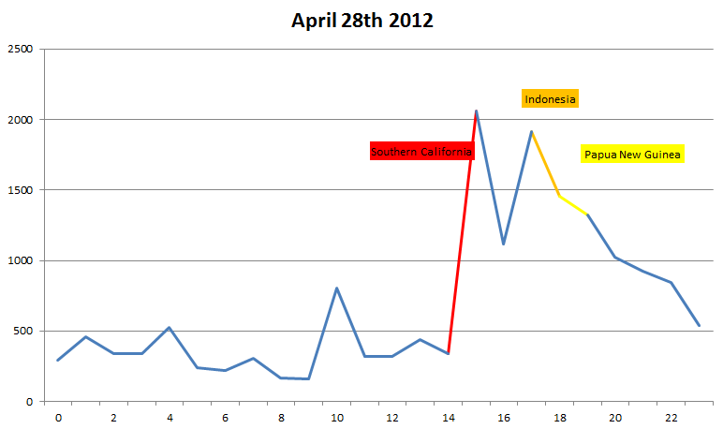

Above is a visual representation of a day from our sample. It is of Social Quake’s recording of April 28th 2012. Social Quake detected 3 earthquakes which were validated by USGS’s CSV feed. The 3.8 magnitude earthquake in Southern California at 15:07 UTC attracted 2062 filtered mentions on twitter. This was more than four times the standard deviation of our sample’s dataset. For the following hours of 16 and 17, residual earthquake activity persisted while people discussed the event on twitter. Two more subsequent, stronger earthquakes occurred later that day at 18 and 19 UTC time. Although these earthquakes were stronger and more likely to be felt, English as well as Twitter usage is less common in these regions. The first of which occurred in Indonesia with a reported magnitude of 5.3. The second followed an hour later and struck Papua New Guinea with a magnitude of 4.9.

- Results

Social Quake was able to accurately detect earthquakes during its 129 hour testing period. We consistently found that when a location made it into the top 3 most probable earthquake locations, there would be also be a matching earthquake report from the United States Geological Survey. Recent tweets shown for locations had a high percentage of relevancy and earthquake occurrences quickly showed a spike in the hourly count that could quickly alert that an earthquake happened.

The Social Quake website serves as a platform for monitoring information about earthquakes as they occur. A scared user who doesn’t know what they just felt when an earthquake strikes can go to this website and immediately see what others are saying, what Social Quake is determining, and eventually, what an official scientific source says when it is released by the USGS. Their loved ones who hear about the earthquake can also use this resource to determine the severity of the earthquake (by looking at the scientific data) and what people are saying about the aftermath on twitter. With these user’s experiences in mind, the Social Quake website organizes its social and scientific data by country. These users can utilize the filter that the Social Quake uses to read tweets more relevant to them than what a normal twitter search can offer. This filtered twitter feed is updated in real time on the left side of the website. Theoretically, survivors of the earthquake will populate the twitter feed with useful information such as working roads or where relief efforts are stationed.

The left column of the website shows the twitter feeds as mentioned earlier organized by country. The bottom of the column shows filtered tweets which couldn’t be assigned to describe a location. The center column of the website shows the social data that is outputted by the Social Quake program. At the top you can see the top three most likely locations where an earthquake has struck that day. Below that you can see a by hour total of filtered earthquake mentions in UTC time. The right column features scientific data gathered from a CSV feed from the United States Geological Survey. This data is organized by the top three most probable locations that were determined by the Social Quake program. All other 2.5+ earthquakes on the Richter scale are shown at the bottom of the page. The top of the website has an activity metric to let people know at a glance if twitter is being unusually active with earthquake mentions that day. 0-500 Tweets about the most talked about location during that day registers as low on the metric, 500-5,000 registers as medium, 5,001-9,999 tweets registers as high, and finally 10,000+ tweets registers as severe. For example, if the most tweeted about location is California with 5,345 mentions in a given day, then it would register as medium on the activity metric. We developed these thresholds by watching how spikes in activity tended to be reflected by an earthquake by the scientific data. In the future, statistical analysis should be used instead of our estimations to determine more accurate measurements of correlation.

Also in the future versions of the website, we want to help direct people to relief efforts that have been set up in the aftermath of an earthquake. Below is a screenshot of our current Social Quake website, and captions that show the different sections that allow users to analyze current earthquake activity.

Image 7: Social Quake Website - http://socialquake.cgl.indiana.edu
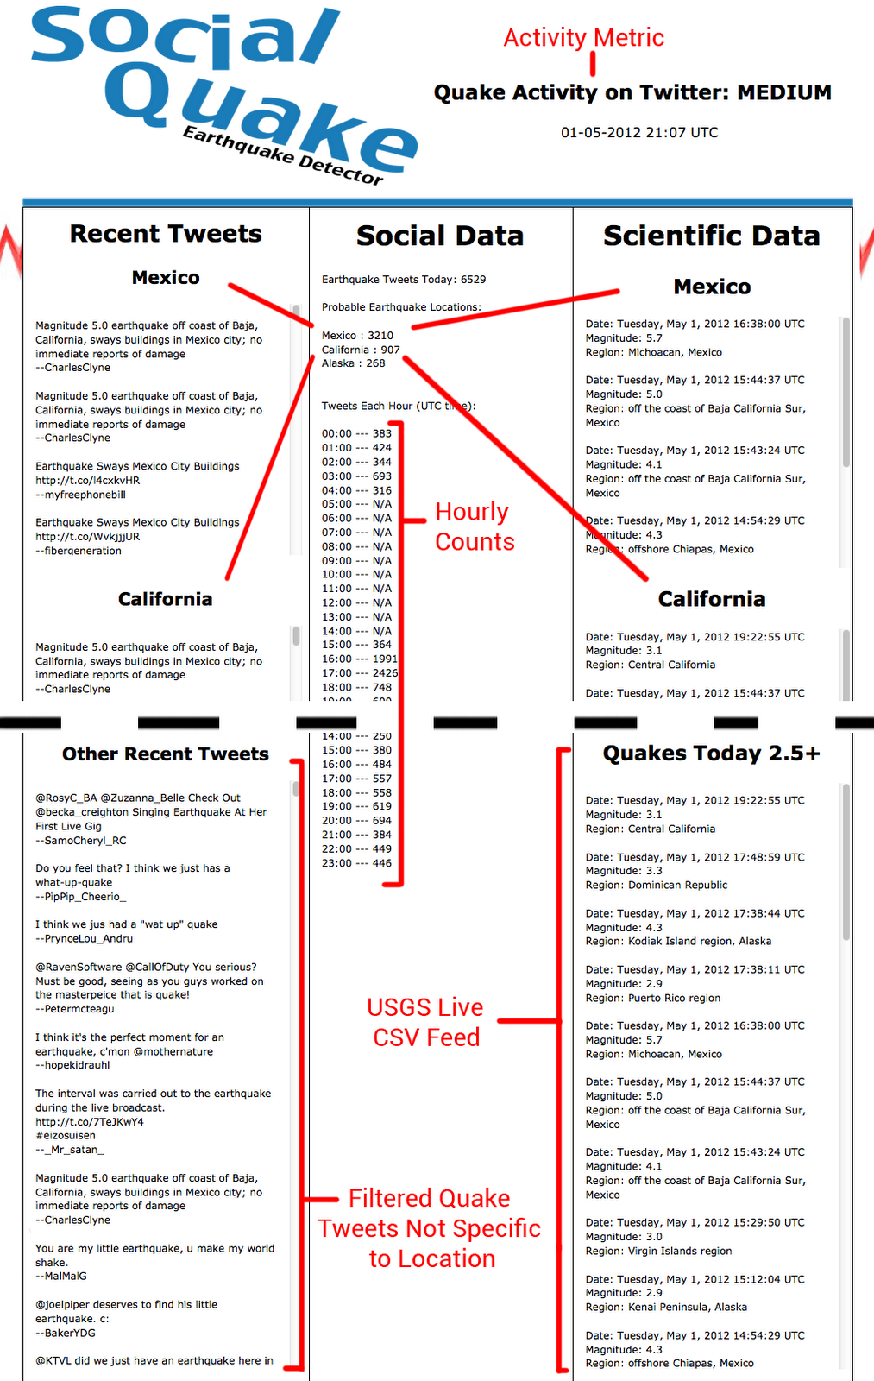
- Conclusion and Recommendations for Future Work

After the successful work we have completed in a semester's time, we are led to believe there are so many more possibilities with this system that have yet to be realized. In continuation of this project, we believe the next step would be to analyze the correlation between the tweet count for an earthquake and the magnitude of the earthquake itself. This is not as straightforward as it first may seem, as it doesn’t take into account the population density of an area, as well as the Twitter usage in the area. For example, a 3.5 earthquake that occurs in a populated area of California can reach a higher tweet count than a 6.0 earthquake in a country such as Indonesia. With enough data, a weighting system could be developed that would accurately take this bias into account.

Another area for future work would be development for more languages. Within the scope of our project, we had to limit our data set to English tweets. By doing so, we are assuming English will be used in all other countries to provide us data for earthquakes. We had considered somewhat expanding the scope by including tweets saying “earthquake” in a different language, such as the Spanish word “terremoto”. However, the drawback would be our lack of ability to identify legitimate earthquake tweets vs. illegitimate tweets. Without knowing foreign cultures and language, we could not quickly identify excluded words that should be filtered from foreign tweets.

Social Quake would also benefit from a more optimized filter. Research should be done to determine how to most accurately filter out tweets which are not related earthquakes. Also, if Social Quake is to one day be ran constantly and without supervision, the filter should be made to be dynamic. We need to figure out a way to detect when our system picks up on a popular user’s tweet (and their followers eventual retweets) which gives us a false positive reading that an earthquake is occurring. If we could dynamically filter out irrelevant trending tweets then our tool will more reliable and accurate. We didn’t encounter this problem during our 129 hours of running Social Quake, but it is a foreseeable problem we would like to guard against.

Citations

1. XKCD.com. (Artist). (n.d.). Seismic waves. [Web Graphic]. Retrieved from http://xkcd.com/723/

2. Bollen, J., Mao, H., Zeng, X. (2011). Twitter mood predicts the stock market.Journal of Computational Science, 2(1), 1-8. Retrieved from http://www.sciencedirect.com/science/article/pii/S187775031100007X

3. Jansen, B. J., Zhang, M., Sobel, K. and Chowdury, A. (2009), Twitter power: Tweets as electronic word of mouth. J. Am. Soc. Inf. Sci., 60: 2169–2188. doi: 10.1002/asi.21149

4. Colbaugh, R., & Glass, K. (2011). Estimating sentiment orientation in social media for intelligence monitoring and analysis. Intelligence and Security Informatics, 65-70. Retrieved from http://ngc.sandia.gov/assets/documents/SentimentAnalysisSocialMedia_IEEEISI2010.pdf

5. Kapoor, A., Eagle, N., & Horvitz, E. (n.d.). People, quakes, and communications: Inferences from call dynamics about a seismic event and its influences on a population. 51-56. Retrieved from https://www.aaai.org/ocs/index.php/SSS/SSS10/paper/viewFile/1180/1350

6. Python. (n.d.). Tweetstream 1.1.1. Retrieved from http://pypi.python.org/pypi/tweetstream

7. Roach, T., Guiden, B., & Tattersall, G. (2012, March 23).Social quake. Retrieved from http://socialquake.cgl.indiana.edu

