Na Hae Kim, Seonghyun Lee, Seung Han Paik, Lena Smith
INFO-I399, 29860
Final Group Research Paper
December 12, 2012

Abstract

Compare to other fields where technology has been used, there are very limited technologies existing in restaurants. We have focused to find a solution to implement higher technology in this restaurant field that is not widely distributed yet. We aimed to have a different approach to enhance overall customers’ dining experience in restaurants by providing improved technologies to employees, instead of customers. Therefore, in our project, we intended to find a way to design a technology that can help employees to offer better quality of service to their customers and improve efficiency of employees.

Introduction

As we started INFO-I399 (Research Method of Informatics and Computing), we have given an opportunity to choose our own topic, which interests us, the most. Our group wanted to have a research on something we encounter in our daily lives; something we can connect ourselves into. We all have dined at any restaurants at some point, and people have positive or negative experiences in restaurants. We wanted to use our own experience and knowledge while combining related researches on the topic. Some of us have been worked as employees of certain restaurants and combining different experience and perspective thought to be excited. Also our group agreed on how restaurant fields only have little technology compare to other fields where technology became the crucial part of each fields.

Research Methodology

For our topic of restaurant technology, we conducted both preliminary and secondary research. Prior to determining what our group was going to focus on for our project, we decided that it was necessary for us to conduct research to determine what would be a good direction for our project to go. By conducting both preliminary and secondary research, we were able to get the research and information needed to create a successful project.

First, after coming together as a group and collectively coming up with propositions for our final project, we decided to conduct some preliminary research. The preliminary research that we conducted consisted of three main research methods. These research methods were surveys, research articles, and visiting restaurants. Each of these research methods played a crucial role in the development of our concept, and were incredibly beneficial and useful based on the information we received from them.

The first preliminary research method that we focused on was surveys. Initially we thought that one survey should be sent out, and the data within the survey could be inclusive of both customers and employees. However, after attempting to create a single, uniform survey that would give us the information we were looking for, we determined that created two surveys would be more beneficial in the long run. We created a survey specifically for restaurant customers and a survey specifically for restaurant employees. Each survey contained five questions related specifically to the role that the individual plays within the restaurant.

The surveys that we created for customers and employees were created to get input from customers and employees concerning their experiences at restaurants. The two questions that we found were the most directly related to our concept were “Which type of restaurant do you visit most often?” and “In what area of implementation of restaurant technology affect you the most?” These were the two primary answers that we were looking to get answers to from this survey. From this survey, we found that the type of restaurant visited most often is a casual dining restaurant. We used this information to focus on for the type of restaurant that our concept would apply to. We also found that the lack of technology affects customers the most when it comes to waiter response time and general waiting time. This information was used to create goals for our concept to fulfill.

The second preliminary research method that we used was research articles. We decided early on that conducting research based on our initial topic would be necessary. This preliminary research was focused on purely scholarly articles pertaining to technology in restaurants. Each of us set out to learn more about technology and how it can be related to restaurants. We found information other conceptual information, the history of how technology in restaurants has advanced, and what people think of this merge between restaurant and technology. Our use of this information was to gain ideas, insights, and inspiration for how to create and proceed with our concept.

The final preliminary research method that we used for our project was visiting restaurants. We collectively came up with the idea to visit restaurants when we realized that we wanted to see what was out there for ourselves. As a team, we decided to visit multiple casual dining restaurants around Bloomington, and see what information we could find individually. Some of the restaurants that we visited, which we all considered casual dining, were Nick’s English Hut, Uptown Café, Esan Thai, Olive Garden and The Village Deli. From this information, we could gather some current technology trends in restaurants, positive and negative aspects to their technology or lack thereof, and whether or not the technology make the service better or worse for the customers. The information gathered from this experience ultimately lead to the idea for our concept, so we consider this a very beneficial and necessary aspect to our preliminary research methods.

Result and Analysis

From all of the information that we gathered from our preliminary research, we set our sights on creating and narrowing down our focus for the project. After team deliberation and research method reviews, we determined what we wanted to focus on concept on. We narrowed down our focuses into five main concept ideas. The majority of these ideas were derived directly from the information we found in our preliminary research, but also some outside creative thinking and brainstorming. The five focuses that we defined were improving wait time accuracy, communication with wait staff, payment option speed, convenience of the standard and current menu ordering system, and communication with kitchen staff. After coming up with these primary focuses, we decided that is was necessary to conduct secondary research specific to the focuses we came up with for our final concept. We focused our secondary research on two research methods. These research methods were interviews and research articles specific to our newly defined concept.

After consulting with our mentor for the semester, we decided that it would be beneficial for our research and the credibility of our project to conduct interviews. As a team, we decided that if we all went out and spoke to employees specifically about our concept and our focuses; the information that we gained from these interviews would be incredibly valuable for our final deliverable. Therefore, we collectively came out with a template containing questions that we felt we fit to ask employers without taking too much time out of their workday. Some of the questions that we asked employers were concerning length of time working at that specific restaurant, position at restaurant, technology opinions and how they relate to technology within the restaurant, and most importantly, if the focuses that we came up with would be beneficial for the restaurant.
From these interviews, we were able determine that, for the most part, the focuses that we came up with would be beneficial if they were implemented in restaurants. We also noticed that the type of restaurant largely defines whether or not technology implementation would be beneficial. We found that in small, casual, locally owned restaurant, technology was not particularly interesting or necessary for business. However, large scale, typically chains, agreed that the use and implementation of technology could be incredibly beneficial for them. Overall, the information that we gathered from these interview were helpful in that they narrowed down the level of business necessary to make the technology implement beneficial for both the customers and the employees.
Like the preliminary research articles conducted prior to narrowing down our topic, we also focused on research on research articles. However, this time we focused on research articles on current technology that was out in the field that had similar features as ours. From this information we were able to build on current technologies and expand on them to reflect on them in our final project concept. From this research, we found that there was technology out there that related to our concept. Some of the existing technology that we found was a table management system, table tracker, and a waiter paging system. From these research articles, we were able to further define our concept and improve on current technologies that were found to existing in the field already. This step was very beneficial to use, in that it allowed us the gauge the current technology in the field and improved on it to make our concept unique.
Overall, the information that we gathered from both the preliminary and secondary research was incredibly valuable and necessary for the completing of our final concept. Each individual research method provided its own benefits and uniqueness to the project that helped us create a strong overall concept. While some research methods proved to be more valuable than others, they all served an important role in the project and by coming together as a team, we were able to apply the research information directly to our final concept and deliverable.

Statement of the Research Problem
Topic:
Technology when compared to other fields has had very limited impact on restaurants. Come up with a design to incorporate technology more into restaurants and help the customers have a better dining experience.

Focus:
After conducting our preliminary research, we aimed to create and develop a new technology that satisfies following functionalities:

- More accurate estimation of wait time | - We can minimize the frustration of customers if we let them know the accurate estimation of wait time
- Improved communicating with waiter/waitress | - Sometimes it gets really hard to communicate and encounter waiter or waitress especially during busy hours  - Proper usage of electricity device will help employees during busy hours and stay connected with their customers even during absences.  - This will help to use time efficiently for both employees and customers.
- Quicker payment options | - During the busy hours, or in large restaurants, payment processing time gets delayed;  - By allowing customers to pay in their table, it can prevent them from waiting longer time to receive checks. This could be possible if employee uses hand-held device to accept payments.  - This also will help to use time efficiently for both employees and customers.
- Ability to access and order from menu at own convenience | - In some cases, it gets hard for customers to get a menu (takes longer time) due to absences of waiter or waitress.  - If customers can access menu and order from their own convenience, this will help food-ordering process.
- Orders sent instantly to kitchen staff | - The process for employees to take orders from customers and enter the orders into the system and give out the paper form of order to kitchen staff is unnecessarily time-consuming.  - If we can combine above all process into a single step, the restaurant can save much more time and serve orders faster.

Concept:
After conducting our preliminary research and secondary research, we determined that in order to create the most efficient technology for restaurants, we would need to combine several (existing or non-existing) functions and turn it into one ultimate system. This software would be used by:

- Host/Hostess | - Be able to provide accurate wait time to customers.
- Customer | - Can access menu instantly and be able to make a payment at own convenience.  - Be able to get waiters’ attention right away.
- Waiter/Waitress | - Be able to communicate better and faster with their customers  - Be able to reduce time on ordering and making a payment

Background and Related Work

Through our secondary research, we have found some supportive articles that show customers expectation of new improved technology in restaurants.

‘Restaurants Should Put Technology on the Menu’ by Ned Smith, Senior Writer on the ‘Business News Daily’
“Giving consumers what they want will be crucial for all small businesses in 2012, but particularly for restaurant owners, according to a new industry forecast. Because the recession caused 8 out of 10 consumers to cut back on nonessential spending, it is more important than ever for operators to nudge those guests into spending their discretionary dollars at their restaurants. Setting a place for technology may be one way savvy restaurateurs can lure patrons back to the table.
Consumers have developed a taste for incorporating technology in all parts of their lives, both at work and at play. And, increasingly, that includes where they eat. Although high-tech items such as wireless payment and iPad menus aren’t commonplace just yet, there is strong consumer interest in such options.
According to the National Restaurant Association’s 2012 industry forecast, nearly 4 in 10 consumers say they’d be likely to use an electronic ordering system and menus on tablet computers at full-service restaurants. About half said they would use at-table electronic payment options and a restaurant’s smartphone app to view menus and make reservations.”
Comments: As technology continues to develop and benefit people in many different forms, people expect to see more of useful technology in restaurants that can enhance their overall dining experience and solve the current problem they have with the restaurant. Especially in restaurant related fields, people expect to see improved technology that can reduce their time on waiting. The restaurant technology goal is to make the ordering and paying process to be faster and convenient.

Point of Sale (POS) Systems
‘Utilizing Restaurant Technology’ by Ed Levine
“Contrary to popular belief, POS systems are more than just hyped-up cash registers. Modern POS systems include all the hardware and software a restaurant owner needs to enter in an order, display it for kitchen staff, and even perform additional tasks such as recording inventory counts and labor costs. Like accounting software, POS systems can cost a pretty penny. Nevertheless, systems like these can take a load off any manager's shoulders.”
Comments: POS systems are exactly what our team was ultimately aiming to redesign because not only it helps for employees to get their work done but also for their customers to have better dining experience. On the other hand, since POS systems could be expensive and hard to afford for comparatively small business; therefore, our goal was to make the system simple and inexpensive so every small and big restaurants can use it. Moreover, we came up with an idea of hand-held device that allows more flexible payment process. (Because usually the POS systems can be used only on the cash register computer.)

Point of Sale (POS) Systems: Order-entry touch screens
‘Utilizing Restaurant Technology’ by Ed Levine
“With a POS system, all orders are entered using touch screen technology. All touch screens can be configured to your exact restaurant menu items and options, so entering in a guest's order is simple and intuitive.”
Comments: One of our ultimate goals was to design a handheld device which waiter/waitress can submit all orders using a touch screen technology such as iPad or iTouch. The hand-held device connects with the main computer (the cash register) so it allows immediate payment process.

Point of Sale (POS) Systems: Credit card readers
‘Utilizing Restaurant Technology’ by Ed Levine
“These days, restaurants that do not accept all major credit cards are at a serious disadvantage. Be sure your POS system comes equipped with a credit card reader. These readers can also load gift cards with money or read gift card information during transactions. “
Comments: Credit card reader is attached or programmed into our designed handheld device so when customers want to make any payment, waiter/waitress can just bring the handheld device and let the customers pay wherever they are seated.

Point of Sale (POS) Systems: Kitchen Display Systems
‘Utilizing Restaurant Technology’ by Ed Levine
“Also called KDS screens, these display monitors hang above kitchen work stations and transmit information from the order-entry screen in the front of the house (FOH) to the kitchen. By eliminating the need for paper tickets, these screens enhance accuracy, help record service times and help expedite orders from the kitchen to the guest.”
Comments: We wanted to design not only from the order-entry screen in the front of the house but also from our designed handheld device transmit order information to the kitchen staff.

Restaurant Pagers System
‘Utilizing Restaurant Technology’ by Ed Levine
“Busy restaurants often need to use some form of paging system to communicate with their guests when a table becomes available. Many restaurant staff still writes down names on a list and call the party when a table is ready. Still, modern restaurant owners decide to implement restaurant pagers at the host station, which are arguably less intrusive and more streamlined than calling out names. Pagers also give customers the freedom to wait outside or by the bar area without confusing the host or hostess. There are several paging technologies that restaurants can use to alert patrons that their table is ready. The following list represents a handful of those technologies.”
Comments: As it is mentioned in the article, modern restaurants and its owners are interested in utilizing restaurant technology to satisfice their customers and create more pleasing restaurant environment. Especially in big and busy restaurant like chain-restaurants, the function of paging system is significant. We are aiming to provide what these modern restaurant owners expect to see and satisfy their needs.

Conclusions including recommendations for future work

Our team discussed few concept design and ways to improve reducing the wait time. As a result, our team came up with an idea to implement technologies that satisfy such problems. Our concept design consisting of multiple equipment, table management system, and handheld device system is connected throughout the restaurant and the server-calling button at each table that responds to the server’s handheld device with table numbers for quicker response time.

As mentioned in the previous, by including all of the above technologies into one software that can communicate between employees and customers, all will increase the satisfaction. We anticipate that by implementing this software, all of the focuses that we determined in the earlier stages of this project will be met.

Table Management System #1
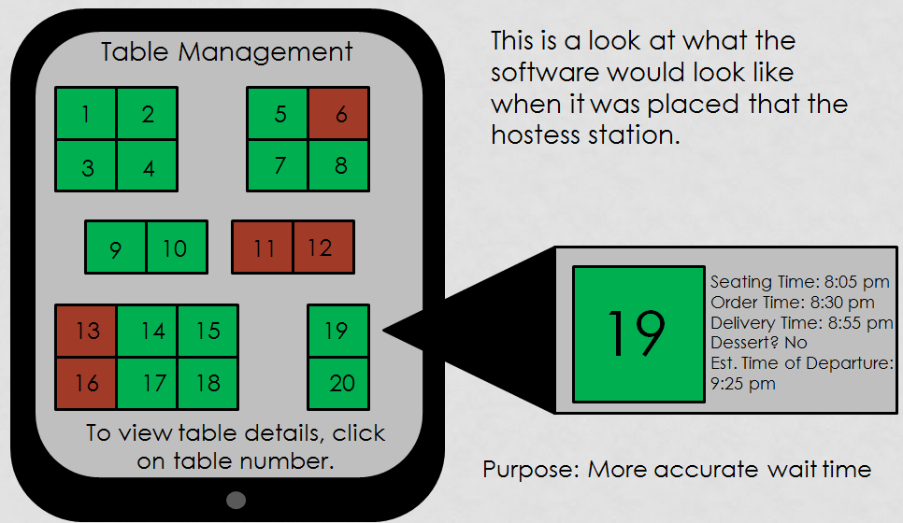
First, the table management systems that will be place at the host station consist of the overview of the restaurants with table layouts. Each table will show when the customer seated at the table, and calculates the estimate time for the customers who were waiting to receive table. It could not only show how long the customer has been seating, but also show the order time, delivery time, dessert preferences, and estimate time of departure.

Table Management System #2
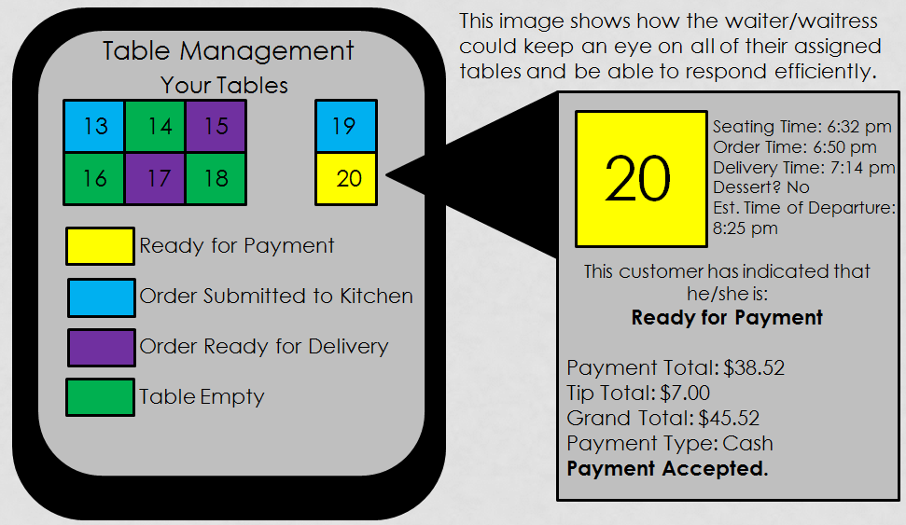
Second, each server will carry handheld devices, size of a smart phone that displays the table section of each waiter, order status of tables, and food delivery status from kitchen. In addition, this handheld device can be used as menu ordering machine, which servers do not need to come and go to the POS station to order food to kitchen. Another key feature in the devices is that it can be used as POS station where customer can pay their check at their convenience.

Paging System
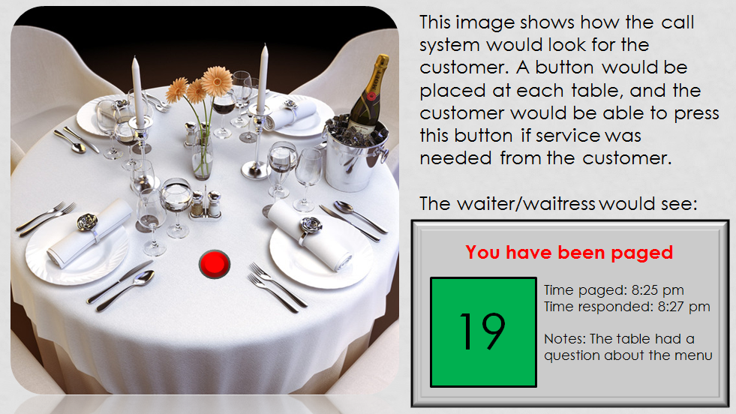
Third, each table will have a calling button that respond to the corresponding section server’s handheld device for quicker response time. The handheld device carried by a waiter/waitress shows when the button was pressed and when they responded. If possible, the wait/waitress could know what the customers would ask about.

Existing Technologies
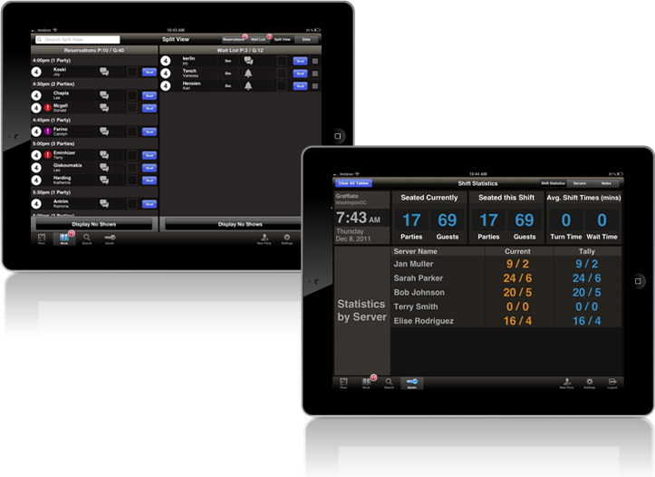
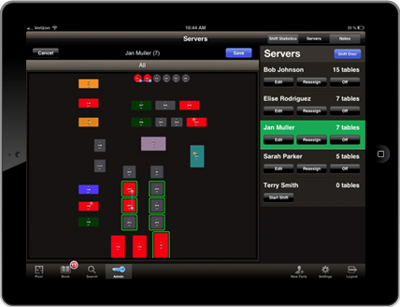This system or product has the similar features that we designed. It is called ‘CityEats Table Management Application. This application could manage the restaurant’s floor: everything from the customers’ tables, floor plan to server assignment, and update table statuses in real time from the floor of the restaurants. It could also manage reservations and wait list for their customers and collect customer information. Additionally, it could present the statistics about the restaurants’ business that help them streamline their operations. With the ‘CityEats’ table management application, the restaurant could manage more efficiently from an iPad from anywhere in the restaurant.

<Work Cited with MLA>

Smith, Ned. "Restaurants Should Put Technology on the Menu." BusinessNewsDaily.com. N.p., n.d. Web. 09 Dec. 2012.

Ed Levine, "Zagat Vs. Yelp: A Restaurant Review 2.0 Showdown”. SeriousEats.com. http://www.seriouseats.com/2008/09/zagat-vs-yelp-restaurant-online-reviews.html. Web. 09 Dec. 2012.

Krummert |, Bob. "Restaurant Technology: What Customers Expect." Restaurant Hospitality Home Page. N.p., n.d. Web. 09 Dec. 2012.

"CityEats by Food Network: Make Reservations at Our Hand-picked List of the Best Restaurants." CityEats by Food Network: Make Reservations at Our Hand-picked List of the Best Restaurants. N.p., n.d. Web. 09 Dec. 2012.

