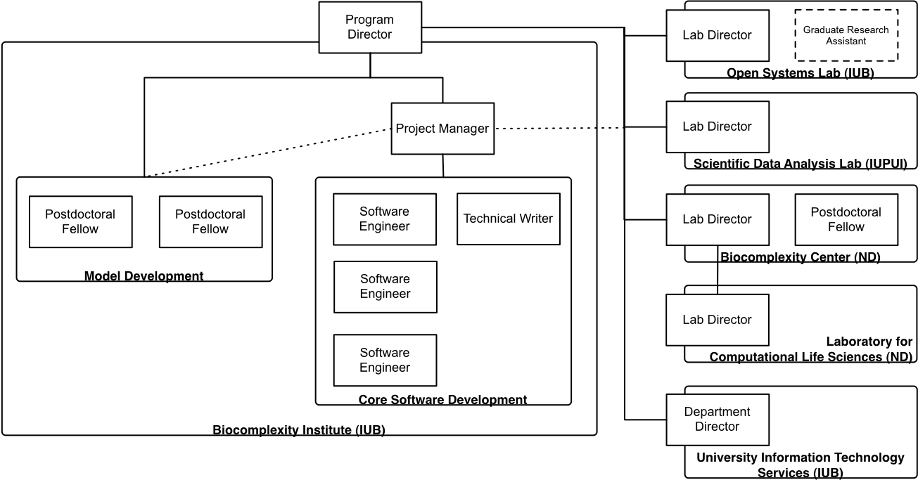
Management Plan (Dr. Alber paragraph with Jesus)

The ICSB at ND, headed by Dr. Alber, will produce sample applications that will be used for validation (Aim 3) and in the tutorials (Aim 4) and work with IUB postdocs and developers to develop numerical methods used in the TSE kernel (Aim 1). One of Dr. Alber's postdoctoral fellows will work exclusively on TSE-related development. As necessary, the core software development team will do some plug-in development and Dr. Alber's group will provide usability feedback and feature requests to help ensure the TSE is developed to meet their needs. Dr. Izaguirre from the LCLS at Notre Dame, the original development manager for CompuCell3D, will also provide consulting to Dr. Alber.

