Interaction between Seismogenic Body and Force-Supplying Body
and Precursor in Far Field

Xu Zhaoyong¹ Mei Shirong² Yang Runhai¹ Wang Jinglai¹
Zhao Jinming¹ Wang Bin¹ Hua Peizhong¹
(¹ Seismological Bureau of Yunnan Province, Kunming, 650041, P. R. of China)
(² Center for Analysis and Prediction, CSB, Beijing, 100036, P. R. of China)

Abstract
Seismogenic body and wall rock of force-supply are analogized respectively by rocks sample and block of transferring pressure in test of fracture. Their interactions are used to study precursor in far field and ultra-far field. Observation studies of stress and strain are made on them. The results show that there appears mutation or disturbance precursor of strain in the force-measuring sensor or on block of transferring pressure before rock fracture beside anomaly variation appearing in all observing points on sample. The observing points on lock of transferring pressure are 25-90 cm away from sample, which are 3-10 times of fracture sizes. It is explained that precursor anomaly is possible appearing in far places from seismogenic area. The reason forming far field precursor is primarily studied.
Key words: Seismogenic body, rock sample, wall rock, block of transferring pressure, precursor in
far field

0 Introduction
There appear anomaly variations in stress and ratio of wave velocity before major fracture of rock. However, all these observations are performed on rock samples. Due to whole collapse when rock fractures, therefore, it is hard to say that the precursor mentioned above is neither field precursor nor far field precursor. Most of previous test studies are the ones of focal physics or tectonics physics. Usually, the analogy is source, possibly as far as seismogenic area or near field area. (Scholz, C., et al, 1972; Dieteric, J. H. 1978, 1981; Ohnaka, M., 1979, 1992; Mogi. K., 1982; Yao Xiaoxin, 1989; Xu Zhaoyong et al, 1989; Ma Shengli, Ma Jin et al, 1995; Hu Yili, Xu Zhaoyong et al, 1997). So, it is hard to notice anomaly precursor in far field, even more, the reasonability of far field precursor is suspected. From the test view of rock fracture, it is no doubt that rock sample can be treated as seismogenic body, pressure machine system with steel column of transferring force or rock blocks as wall rock of force-supply. There are the problems, such as range of wall rock of force-supply, size ratio between wall rock and seismogenic body, corresponding behavior on block of transferring pressure when rock fractures, and precursory types etc. Some among them are studied primarily.

1 Theoretical Analyses
In physics, bodies of force-supply and force-acceptance are interacted, which act as action force and anti-action force. There are two force systems in the test of rock fracture. One is frame of pressure machine, the pulling pole, on which pulling force is performed, and producing pulling strain. Another is column for transferring pressure, steel anvil and rock sample, on which pressure force is performed, and producing pressure strain. Taking uniaxial test as example to analyze. The pole of machine is pulled when the piston in oil cylinder presses on element of transferring force and rock sample, showing in Fig 1a. The piston movement, on the one hand, makes element of transferring pressure and sample increase strain energy, on the other hand, makes frame of machine increase strain energy. When the rock fractures, the element of transferring pressure and sample, as well as frame of machine, release strain energy. Rock fracture can be taken as an earthquake, and vibration of frame of machine is similar to earth oscillation when earthquake occurs. The latter will be described in another paper. Generally, yield appears before, and precursor stress drop appears after the peak stress. Then there is also corresponding to stress variations on element of transferring pressure and frame of machine. Due to element of transferring pressure and frame of machine belong to different force system, the element of transferring pressure and sample located in same force system, acting as interplay, therefore, element of transferring pressure acting as force-supplying body is more reasonable. Generally, the element of transferring pressure does not collapse when the rock sample fractures. So, element of transferring pressure can be taken as wall rock of force-supply near and outside seismogenic area. Wall rock is corresponding to seismogenic body. The force-supplying body is not only the surrounding rock of, but also the one far from seismogenic body. Studying precursor in far field and ultra-far field is an observation study of stress and strain on block of transferring pressure. Because the frame of machine belongs to different force system (pulling force), it is not reasonable to study precursor of far field. As a comparison, study of strain on frame of machine make in uniaxial, but not in shear test.

2 Test Study
2.1 Method
In order to study precursor in (ultra) far field, the stress and strain observation points are put on force-supplying body, i.e. the block and column of transferring pressure. The distances of observation points from sample are about 3-10 times of sizes of rock fracture. Anomalies obtained at these points are called anomalies of force-supplying body in order to differentiate the anomaly in rock sample. The latter is usually called anomaly of seismogenic body.
Tests of uniaxial compression and single or double direct shearing are used in the study. The uniaxial compression is made in W4-100t machine. Pressure sensor is directly setup under sample, and displacement sensor is setup on side of sample to observe total displacement. The steel column of transferring pressure is connected to low side of pressure sensor, with strain gauge on it. As a comparison, strain gauges are also put on pole of frame of machine. Orientation of strain gauge is paralleled to maximum principal stress. Previous study is that all observations pass through YD-15/8 dynamic-static strain meter and then enter SC-16 light oscillometer. Afterward, a LB-2 digital strain meter made by Lab of Tectonic Physics in Geological Institute of CSB is used. There are 16 channels in LB-2 digital strain meter, sampling rate of 1-1000Hz, adjustable, resolution of 16 bite, connecting to computer with data entering. (Fig 1a)
Test of single shear is performed in triaxial machine. Size of sample is about 8x6x6cm. A stress observation point is setup about 60 cm away from sample in the direction of shearing force, and another point is setup about 25 cm away from fracture plane (20 cm from sample) in the direction of vertical to fracture plane. A YD-15/8 dynamic-static strain meter, a SC-16 light oscillometer and a SWG multi-functional seismometer are used to record. Frequency characteristic of YD-15/8 strain meter is 0-500Hz, and SC-16 oscillometer is 0-2500Hz. Gain of SWG seismometer is 0-96db, band of 0.5-20kHz, 8 selectable high-low pass filters, sampling intervals of 8μs-15s, disc recording. It can do simple processing and graph display, or save as in computer and process later. Sampling time at each point for each channel is 5ms, recording length for each channel is 8kb (40s). (Fig 2a)
Test of double shear is also performed in triaxial machine. Distribution of observation points is shown in Fig 3a. 4-5 points are setup in sample, and 4-10 points outside sample. The instrument used is same as Fig 1a.

2.2 Results
Strain (stress) variations with time in preparing fracture of uniaxial compression for sample No.2 is shown in Fig 1b. Distribution of observation points is shown in Fig 1a. In which 1 and 2 are on the steel column of transferring pressure under pressure sensor. 3 and 4 are on the pulling poles of frame of machine. 5, 6, 7 and 8 are on rock sample. 5 and 7 are paralleled to orientation of pressure, 6 and 8 are vertical to pressure. 9 is pressure sensor. It can be seen from the Fig 1b that there is a great fracture 25 seconds before the main fracture. Before the great fracture, pressure in ch 9 and compression strain in ch 1, 2, 5 and 7 increase with time. However, variations in ch 1 and 2 are less than that in ch 5 and 7. Tensile strains in ch 3, 4, 6 and 8 gradually decrease (compression strain is positive in Fig). However, variations in ch 3 and 4 are less than that in ch 6 and 8. With time elapse, 1-2 seconds before great fracture, stress raise becomes slow, and strains in ch 5, 6, 7 and 8 have sudden increase and decrease. To the occurrence of great fracture, stress in ch 9 decreases, strains in ch 5, 6 and 7 have sudden increase and decrease, ch 8 has broken. Similarly, before the main fracture, stress in ch 9 has a progress of slow increase and down, strains in ch 5, 6 and 7 have up (down) tendency first, and then obviously down or slow down, and a little of variations in ch 1, 2, 3 and 4.
Fig 1c is a time progress graph before and after main fracture corresponding to Fig 1b. It shows that strains in ch 1 and 2 have sudden ups and drops (reaching 50 με (10⁻⁶) 0.08 seconds before the main fracture. The ones in ch 3 and 4 increase (tensile strain becomes smaller, reaching 20-30 με) 0.03 seconds before. The ones in ch 5 and 7 are precursory drops and ups (reaching 300 με or more) 0.03 seconds before. The ones in ch 6 appear precursory drops 0.05 and 0.03 seconds before respectively. All these features are much clear comparing with Fig 1b.
Variation features of strains in all 6 samples are basically same. Some samples, such as No.3, have more obvious mutations of strains (Fig 1d) approaching main fracture. Strains in ch 1 and 2 appear mutations (reaching 500 με) 0.03 seconds before main fracture. The ones in ch 3 and 4 increase (tensile strain becomes smaller, reaching 20 με) 0.03 seconds before. The ones in ch 5, 6 and 7 have precursory sudden drops (reaching 2000 με or more), and then main fracture comes immediately.
Strain variations with time at each point in single shear for marble are shown in Fig 2. Recordings in SC-16 light oscillometer are shown in Fig 2b. Strains at observation points 1-4 and 5-8 are respectively before and behind marble. Ch 9 is for total displacement, ch 10 for normal stress, and ch 11 for horizontal shearing stress. Recordings in SWG seismometer are shown in Fig 2c. Chs 1-8 are for strain disturbance at observation point, ch 9 for total displacement, ch 10 for normal stress, ch 11 for horizontal shearing stress. It can be seen from Fig 2b that total displacement increases abruptly, normal stress (vertical to fracture plane) increases obviously, and shearing stress (paralleled to fracture plane) also increases clearly, when approaching main fracture. The total displacement appears fluctuation, normal stress increases slowly, and shearing stress increases tardily and tends to decrease, at the moment of main fracture. Fig 2c shows that total displacement, normal stress and shearing stress appear disturbance, a moment before main fracture. Both Fig 2b and c show that jump and disturbance of normal stress and shearing stress are same as the appearing time of anomaly variation (jump and disturbance) at observation points (1-8) before main fracture. They also show that anomaly variations (jump and disturbance) appear at points 1-8 2 seconds before main fracture. However, total displacement, normal stress and shearing stress do not appear anomalies (jump and disturbance).

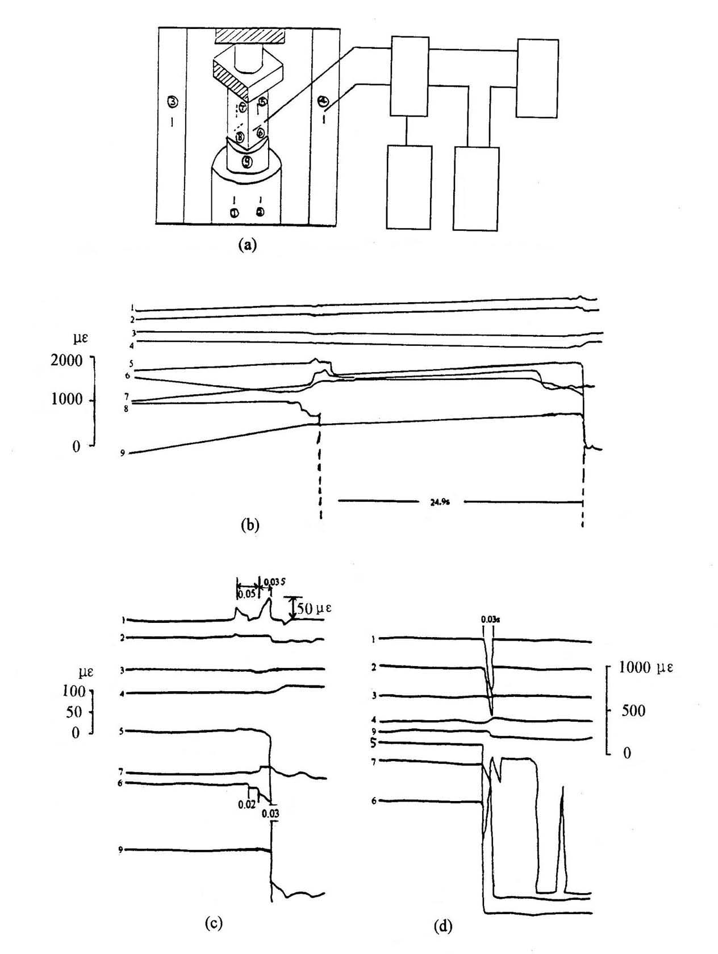
Fig1 Strain (stress) variations with time in preparing fracture for uniaxial compression
a. Diagram for sample installation and point distribution (str-strainmeter, pc-computer)
(1,2 on the block; 3,4on the pole: 5-8 on the sample, 9 is pressure sensor)
b. Whole time progress for sample No.2 in preparing fracture
c. Time progress for sample No.2 before and after main fracture
d. Time progress for sample No.3 before and after main fracture

Fig 2 Strain (stress) variations with time in preparing fracture of single shearing for marble
a. Diagram for sample settlement and distribution of observation points
(1,2,3,4 before, 5,6,7,8 behind)
b. Recordings in SC-16 light oscillometer
(dis-displacement, H.P-shear force, bro-broken line, V.P-vertical force)
c. Recordings in SWG multi-functional seismometer

