Fig. 1 Bodies in contact with each other

Fig.2 Frame for calculation of the contact force

Fig. 3 Local contact search algorithm

Fig. 4 The geometry and mesh of tube and tubesheet structure analyzed

Fig. 5 Average CPU time vs. numbers of contact nodes

Water (600 mm)

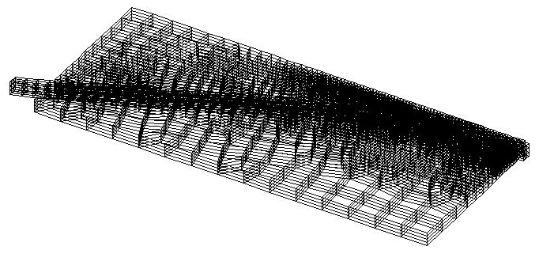
Dimensions: 20038 x 51 x 600
Loading condition: gravity force + hydraulic pressure

Fig. 6 The Northeast fault model with the Pacific plate analyzed

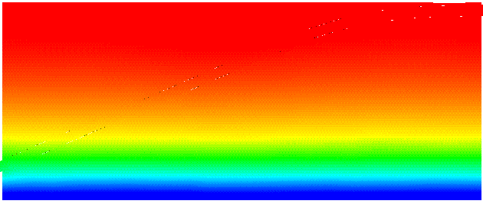
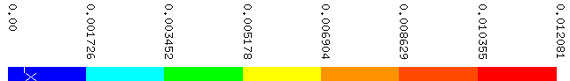

(a)

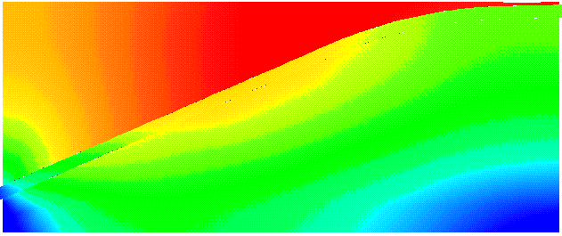
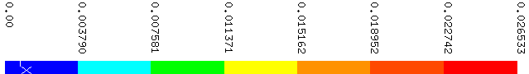

(b)

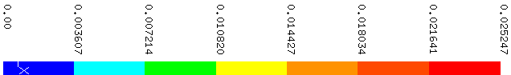

(c)

Fig. 7 Displacement distribution at different friction conditions:
(a). ; (b).;
(c). , otherwise

