Fig. 1 Bodies in contact with each other

Fig.2 Frame for calculation of the contact stress

Fig. 3 Local contact search algorithm

DOF
Fig.4 Speedup for different cases

Fig. 5 The geometry and mesh of tube and tubesheet structure analyzed

Fig. 6 Average CPU time vs. numbers of contact nodes
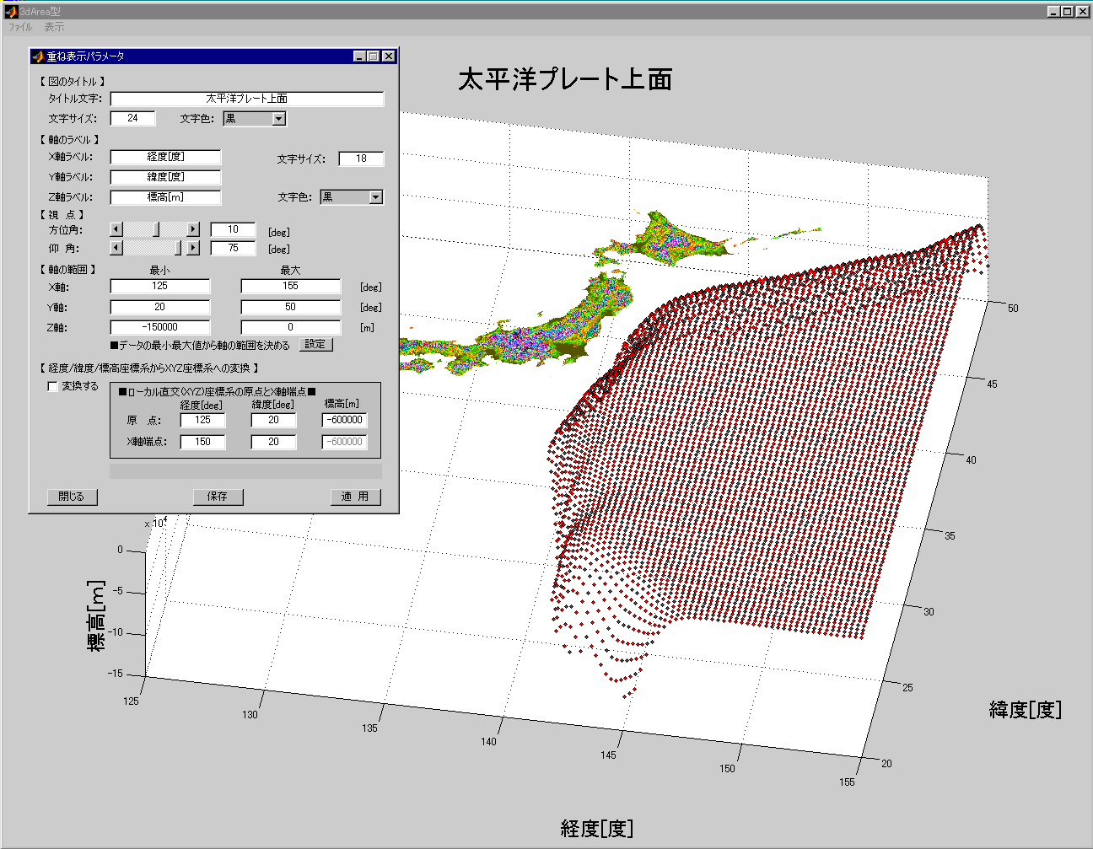

Longitude (degree)
Latitude (degree)
Depth (km)

Fig. 7 The upper surface of the Pacific plate around Japan (Kanai, 2000)

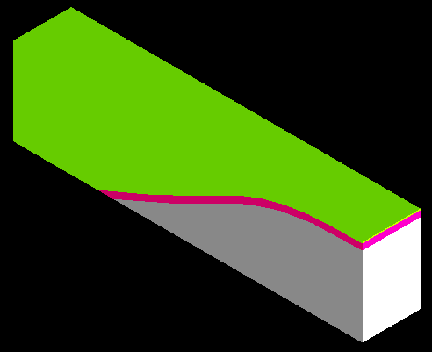
x
y
z
O

A
Ox: East longitude (deg) 146
Oy: North latitude (deg) 37.75
AB: East longitude (deg) 128
Pacific plate

B
-50km
-50km
Fig. 8 A part of the tectonic solid model of the Northeast zone of Japan (Kanai, 2000)

z
Water (600)
0
19570
y
-6360
(a)
C
D

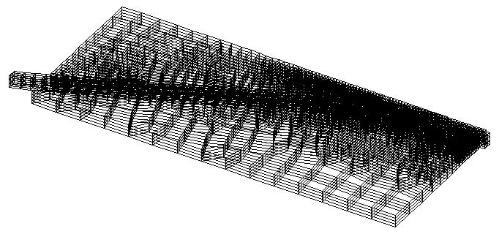
(b)
Dimensions: 19570 x 510 x 6360
Loading condition: gravity force + hydraulic pressure

Fig. 9 The mesh used for the Northeast fault model with the Pacific plate in (a) the y-z cross section (along OA in Fig. 8) and (b) the three dimensions

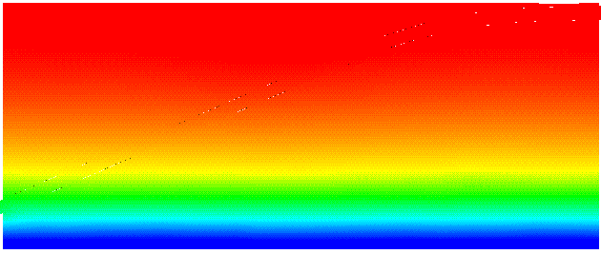
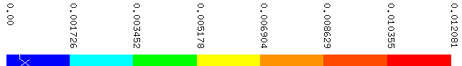

(a)

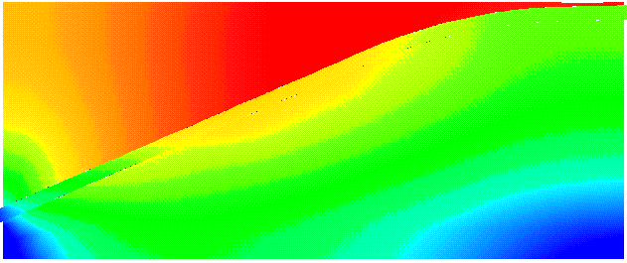
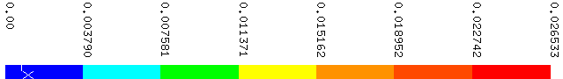

(b)

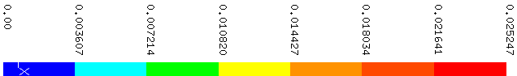

(c)

Fig. 10 Displacement distribution at different friction conditions:
(a). ; (b).;
(c). , otherwise

