Interaction between Seismogenic Body and Force-Supplying Body
and Precursor in Far Field

Xu Zhaoyong¹ Mei Shirong² Yang Runhai¹ Wang Jinglai¹
Zhao Jinming¹ Wang Bin¹ Hua Peizhong¹
(¹ Seismological Bureau of Yunnan Province, Kunming, 650041, P. R. of China)
(² Center for Analysis and Prediction, CSB, Beijing, 100036, P. R. of China)

Abstract
Seismogenic body and wall rock of force-supply are analogized respectively by rocks sample and block of transferring pressure in test of fracture. Their interactions are used to study precursor in far field and ultra-far field. Observation studies of stress and strain are made on them. The results show that there appears mutation or disturbance precursor of strain in the force-measuring sensor or on block of transferring pressure before rock fracture beside anomaly variation appearing in all observing points on sample. The observing points on lock of transferring pressure are 25-90 cm away from sample, which are 3-10 times of fracture sizes. It is explained that precursor anomaly is possible appearing in far places from seismogenic area. The reason forming far field precursor is primarily studied.
Key words: Seismogenic body, rock sample, wall rock, block of transferring pressure, precursor in
far field

0 Introduction
There appear anomaly variations in stress and ratio of wave velocity before major fracture of rock. However, all these observations are performed on rock samples. Due to whole collapse when rock fractures, therefore, it is hard to say that the precursor mentioned above is neither field precursor nor far field precursor. Most of previous test studies are the ones of focal physics or tectonics physics. Usually, the analogy is source, possibly as far as seismogenic area or near field area. (Scholz, C., et al, 1972; Dieteric, J. H. 1978, 1981; Ohnaka, M., 1979, 1992; Mogi. K., 1982; Yao Xiaoxin, 1989; Xu Zhaoyong et al, 1989; Ma Shengli, Ma Jin et al, 1995; Hu Yili, Xu Zhaoyong et al, 1997). So, it is hard to notice anomaly precursor in far field, even more, the reasonability of far field precursor is suspected. From the test view of rock fracture, it is no doubt that rock sample can be treated as seismogenic body, pressure machine system with steel column of transferring force or rock blocks as wall rock of force-supply. There are the problems, such as range of wall rock of force-supply, size ratio between wall rock and seismogenic body, corresponding behavior on block of transferring pressure when rock fractures, and precursory types etc. Some among them are studied primarily.

1 Theoretical Analyses
In physics, bodies of force-supply and force-acceptance are interacted, which act as action force and anti-action force. There are two force systems in the test of rock fracture. One is frame of pressure machine, the pulling pole, on which pulling force is performed, and producing pulling strain. Another is column for transferring pressure, steel anvil and rock sample, on which pressure force is performed, and producing pressure strain. Taking uniaxial test as example to analyze. The pole of machine is pulled when the piston in oil cylinder presses on element of transferring force and rock sample, showing in Fig 1a. The piston movement, on the one hand, makes element of transferring pressure and sample increase strain energy, on the other hand, makes frame of machine increase strain energy. When the rock fractures, the element of transferring pressure and sample, as well as frame of machine, release strain energy. Rock fracture can be taken as an earthquake, and vibration of frame of machine is similar to earth oscillation when earthquake occurs. The latter will be described in another paper. Generally, yield appears before, and precursor stress drop appears after the peak stress. Then there is also corresponding to stress variations on element of transferring pressure and frame of machine. Due to element of transferring pressure and frame of machine belong to different force system, the element of transferring pressure and sample located in same force system, acting as interplay, therefore, element of transferring pressure acting as force-supplying body is more reasonable. Generally, the element of transferring pressure does not collapse when the rock sample fractures. So, element of transferring pressure can be taken as wall rock of force-supply near and outside seismogenic area. Wall rock is corresponding to seismogenic body. The force-supplying body is not only the surrounding rock of, but also the one far from seismogenic body. Studying precursor in far field and ultra-far field is an observation study of stress and strain on block of transferring pressure. Because the frame of machine belongs to different force system (pulling force), it is not reasonable to study precursor of far field. As a comparison, study of strain on frame of machine make in uniaxial, but not in shear test.

2 Test Study
2.1 Method
In order to study precursor in (ultra) far field, the stress and strain observation points are put on force-supplying body, i.e. the block and column of transferring pressure. The distances of observation points from sample are about 3-10 times of sizes of rock fracture. Anomalies obtained at these points are called anomalies of force-supplying body in order to differentiate the anomaly in rock sample. The latter is usually called anomaly of seismogenic body.
Tests of uniaxial compression and single or double direct shearing are used in the study. The uniaxial compression is made in W4-100t machine. Pressure sensor is directly setup under sample, and displacement sensor is setup on side of sample to observe total displacement. The steel column of transferring pressure is connected to low side of pressure sensor, with strain gauge on it. As a comparison, strain gauges are also put on pole of frame of machine. Orientation of strain gauge is paralleled to maximum principal stress. Previous study is that all observations pass through YD-15/8 dynamic-static strain meter and then enter SC-16 light oscillometer. Afterward, a LB-2 digital strain meter made by Lab of Tectonic Physics in Geological Institute of CSB is used. There are 16 channels in LB-2 digital strain meter, sampling rate of 1-1000Hz, adjustable, resolution of 16 bite, connecting to computer with data entering. (Fig 1a)
Test of single shear is performed in triaxial machine. Size of sample is about 8x6x6cm. A stress observation point is setup about 60 cm away from sample in the direction of shearing force, and another point is setup about 25 cm away from fracture plane (20 cm from sample) in the direction of vertical to fracture plane. A YD-15/8 dynamic-static strain meter, a SC-16 light oscillometer and a SWG multi-functional seismometer are used to record. Frequency characteristic of YD-15/8 strain meter is 0-500Hz, and SC-16 oscillometer is 0-2500Hz. Gain of SWG seismometer is 0-96db, band of 0.5-20kHz, 8 selectable high-low pass filters, sampling intervals of 8μs-15s, disc recording. It can do simple processing and graph display, or save as in computer and process later. Sampling time at each point for each channel is 5ms, recording length for each channel is 8kb (40s). (Fig 2a)
Test of double shear is also performed in triaxial machine. Distribution of observation points is shown in Fig 3a. 4-5 points are setup in sample, and 4-10 points outside sample. The instrument used is same as Fig 1a.

2.2 Results
Strain (stress) variations with time in preparing fracture of uniaxial compression for sample No.2 is shown in Fig 1b. Distribution of observation points is shown in Fig 1a. In which 1 and 2 are on the steel column of transferring pressure under pressure sensor. 3 and 4 are on the pulling poles of frame of machine. 5, 6, 7 and 8 are on rock sample. 5 and 7 are paralleled to orientation of pressure, 6 and 8 are vertical to pressure. 9 is pressure sensor. It can be seen from the Fig 1b that there is a great fracture 25 seconds before the main fracture. Before the great fracture, pressure in ch 9 and compression strain in ch 1, 2, 5 and 7 increase with time. However, variations in ch 1 and 2 are less than that in ch 5 and 7. Tensile strains in ch 3, 4, 6 and 8 gradually decrease (compression strain is positive in Fig). However, variations in ch 3 and 4 are less than that in ch 6 and 8. With time elapse, 1-2 seconds before great fracture, stress raise becomes slow, and strains in ch 5, 6, 7 and 8 have sudden increase and decrease. To the occurrence of great fracture, stress in ch 9 decreases, strains in ch 5, 6 and 7 have sudden increase and decrease, ch 8 has broken. Similarly, before the main fracture, stress in ch 9 has a progress of slow increase and down, strains in ch 5, 6 and 7 have up (down) tendency first, and then obviously down or slow down, and a little of variations in ch 1, 2, 3 and 4.
Fig 1c is a time progress graph before and after main fracture corresponding to Fig 1b. It shows that strains in ch 1 and 2 have sudden ups and drops (reaching 50 με (10⁻⁶) 0.08 seconds before the main fracture. The ones in ch 3 and 4 increase (tensile strain becomes smaller, reaching 20-30 με) 0.03 seconds before. The ones in ch 5 and 7 are precursory drops and ups (reaching 300 με or more) 0.03 seconds before. The ones in ch 6 appear precursory drops 0.05 and 0.03 seconds before respectively. All these features are much clear comparing with Fig 1b.
Variation features of strains in all 6 samples are basically same. Some samples, such as No.3, have more obvious mutations of strains (Fig 1d) approaching main fracture. Strains in ch 1 and 2 appear mutations (reaching 500 με) 0.03 seconds before main fracture. The ones in ch 3 and 4 increase (tensile strain becomes smaller, reaching 20 με) 0.03 seconds before. The ones in ch 5, 6 and 7 have precursory sudden drops (reaching 2000 με or more), and then main fracture comes immediately.
Strain variations with time at each point in single shear for marble are shown in Fig 2. Recordings in SC-16 light oscillometer are shown in Fig 2b. Strains at observation points 1-4 and 5-8 are respectively before and behind marble. Ch 9 is for total displacement, ch 10 for normal stress, and ch 11 for horizontal shearing stress. Recordings in SWG seismometer are shown in Fig 2c. Chs 1-8 are for strain disturbance at observation point, ch 9 for total displacement, ch 10 for normal stress, ch 11 for horizontal shearing stress. It can be seen from Fig 2b that total displacement increases abruptly, normal stress (vertical to fracture plane) increases obviously, and shearing stress (paralleled to fracture plane) also increases clearly, when approaching main fracture. The total displacement appears fluctuation, normal stress increases slowly, and shearing stress increases tardily and tends to decrease, at the moment of main fracture. Fig 2c shows that total displacement, normal stress and shearing stress appear disturbance, a moment before main fracture. Both Fig 2b and c show that jump and disturbance of normal stress and shearing stress are same as the appearing time of anomaly variation (jump and disturbance) at observation points (1-8) before main fracture. They also show that anomaly variations (jump and disturbance) appear at points 1-8 2 seconds before main fracture. However, total displacement, normal stress and shearing stress do not appear anomalies (jump and disturbance).

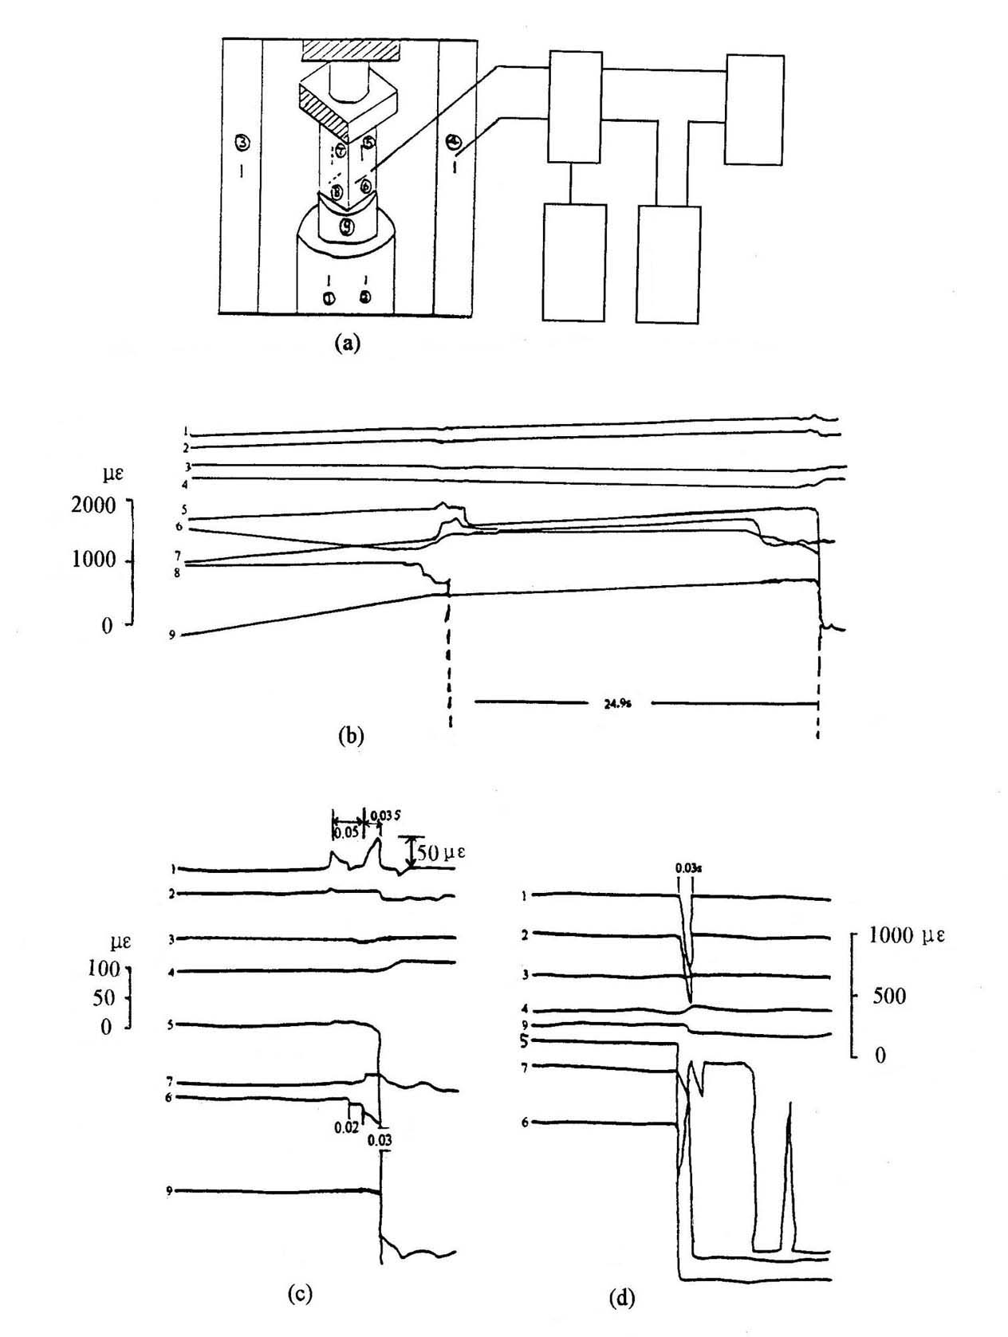
Fig1 Strain (stress) variations with time in preparing fracture for uniaxial compression
a. Diagram for sample installation and point distribution (str-strainmeter, pc-computer)
(1,2 on the block; 3,4on the pole: 5-8 on the sample, 9 is pressure sensor)
b. Whole time progress for sample No.2 in preparing fracture
c. Time progress for sample No.2 before and after main fracture
d. Time progress for sample No.3 before and after main fracture

Fig 2 Strain (stress) variations with time in preparing fracture of single shearing for marble
a. Diagram for sample settlement and distribution of observation points
(1,2,3,4 before, 5,6,7,8 behind)
b. Recordings in SC-16 light oscillometer
(dis-displacement, H.P-shear force, bro-broken line, V.P-vertical force)
c. Recordings in SWG multi-functional seismometer

Fracture tests of double shearing have been performed for 8 samples of diorite-porphyrite and limestone. Distribution of observation points is shown in Fig 3a. 1 is for displacement sensor, 2 and 3 are respectively for pressure sensor providing normal and shearing stress to sample, and 4 for velocity sensor with low frequency. 5, 6, 7, 8 and 9 are on sample, the first 4 gauges are paralleled to shearing stress. 10, 11 and 12 are on rock block of transferring pressure, which is above the pressure sensor providing shearing stress to sample. 13, 14, 15 and 16 are on rock block of transferring pressure providing normal stress to sample.
There are 3 great fractures during the process of double shearing for sample SNo.2. The interval between first and second times is 87 seconds, and the one between second and third times is 6.2 second. The last two times occur at collapse. Before the great fracture, pressure in ch 3, displacement in ch 1 increase with time, compression strains in chs 5-8 increase gradually, and strains in chs 10-12 and 13-16 increase also gradually (compression strain is positive in Fig). With time elapse, stress in ch 3 increases slowly and displacement in ch 1 increase sharply 1-2 seconds before great fracture. Vibrations in chs 4-6 strengthen, and other features are hard to see.
Fig 3b is a (magnified) diagram of time progress before and after the first great fracture. Strains in chs 5 and 6 appear jumps (reaching 30-50 με) 0.12 seconds before great fracture. Pressures in chs 3 and 2 appear jumps 0.12 seconds before and precursory drops 0.02 seconds before. Displacement in ch 1 appears sudden drop and then up 0.02 seconds before, the ones in chs 10 and 11 appear jumps (reaching 10-20 με) 0.12 seconds before and the one in ch 4 has already had a small vibration 0.02 seconds before. No other features can be seen.
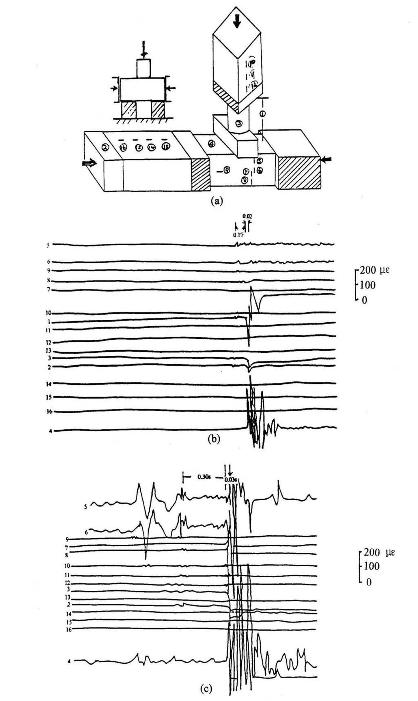
Fig 3 Strain (stress) variations with time before and after great fracture for double shearing
a. Diagram for sample settlement and distribution of observation points
（ch1 displacement; ch2-3 force; ch4 vibration; ch5-16 strain）
b. The first great fracture c. The third great fracture
Fig 3c is a (magnified) diagram of time progress before and after the third great fracture. It is clearly shown that pressures in chs 3 and 2 appear precursory drops (limited displacement amplitude in ch 1) 0.03 seconds before. Strains in chs 5-8 appear jumps (reaching 30-300 με), jumps and small fluctuation in chs 10-12 (reaching 10-20 με) and a small vibration has already existed in ch 4. There are jumps and small fluctuations in chs 2-6 and 10-12 0.3-0.6 seconds before, but are less obvious. No other features can be seen.

3. Discussion and conclusion
3.1 Certainty of precursor in (ultra) far fields
There also exists precursor anomaly in force-supplying body besides precursor anomaly on sample before fracture. Correspondingly in earthquake, there exists precursor anomaly on wall rock body (large range) besides precursor anomaly in seismogenic body. That is to say that there probably are precursors in far and ultra-far fields.
Fig 1-3 shows that anomaly variations appear at all points on sample before fracture. Meanwhile, precursor anomalies appear in force-supplying body in far distance. Mutations in axial strain in steel column of transferring pressure in chs 1 and 2 are very clear (50-500 με) in Fig 1c and d. Axial strain in pulling pole of machine in chs 3 and 4 is not clear as that in chs 1 and 2. However, it is still distinct. In Fig 2, the total displacement in ch 9, normal stress in ch 10, and shearing stress in ch 11 also show distinct mutation and disturbance before fracture. Fig 3 is the same as Fig 2. However, disturbances of strain in block of transferring pressure are not clear as in chs 1, 2 and 3. For example, the disturbances in chs 10, 11 and 12, which are paralleled to fracture plane and in extension line, are not so clear (10-30 με). The disturbances in chs 13, 14, 15 and 16, which are vertical to fracture plane, are hard to see, except that in ch 13 (10-20 με). Even if there are mutation and disturbance outside sample, they do not appear until approaching main fracture. There are only some slow variations (increase or decrease) at earlier time. These points with mutation and disturbance are 25-90 cm away from fracture plane in vertical direction, which are 3-12 times of fracture sizes. The points, in parallel direction are 30-80 cm away from fracture plane, which are 4-10 times of fracture sizes. It can be inferred that precursor anomalies are possible far away from seismogenic area. Sensors are setup according to observation points mentioned above in this test, it is possible to appear precursor anomaly in further distance. However, it is not certain because observation points have not been put there. In addition, the pulling pole of frame of machine is not directly connected to sample, and connected to sample through bottom of machine and steel anvil. However, it also often has mutation and disturbance before main fracture. It shows that precursor anomaly can appear in the place far away when sample breaks. So, it is possible to appear precursor anomaly far away from the seismogenic area before earthquake occurs. Forms of variations are probably different due to non-similar sources and features of near field. It is inferred from this that precursor anomaly could appear within the range, where is 10 or more times of fracture size. If fracture length for an earthquake is 100 km, precursor anomaly could appear in the place 1000 km, even far, away. Whether anomalies of underground water in Beitaipingzhuang in Beijing reflected earthquakes in USA or in Colombia (Yu Jinzi, Che Yongtai et al, 1998) or not, it needs study. But it does not exclude.
The results also explain that mutation and disturbance can not be observed anytime or anywhere outside sample. There are some sensitive points where can reflect anomaly, only very approaching main fracture. Reflections of anomaly have already had on sample at earlier time before, besides mutation and disturbance approaching main fracture. If it appears big ups and fluctuations, even, mutation and disturbance. It provides us a revelation differing precursor of field from the one of source. The one having lasting long-, medium-, short-term and impending precursors could be precursors of source, and the one only having short and impending features could be precursors of field.
Precursor of stress in far field can be observed in the fieldwork. First is that the magnitude is over tens με, and second is most instrument can reach or surpass the precision. Therefore, the observation study has practical significance. Of course, concrete application needs more studies.
3.2 Forming Mechanism of Precursor in (ultra) far field
The test is trying to set sensors far from sample to observe if any precursor anomaly appears. The results show, precursor anomaly can appear in far field area. Actually, it is not hard to understand. The seismogenic body does not break itself. After accepting forces and with other triggering factors reaching fracture strength, the seismogenic body breaks. Before fracturing, bearing ability decrease, and forming precursor anomaly. The seismogenic body and force-supplying body is interacted. The seismogenic body beaks when strength is not greater than stress accepted. Force-supplying body does not break when strength is greater than stress accepted. The bearing ability of seismogenic body tends to decrease before fracture (the stress-strain curve after peak stress and before main fracture is called precursory stress drop). Meanwhile, stress on force-supplying body decreases forming precursor anomaly on it. The size of seismogenic body is much smaller than that of force-supplying body. Even if both have same strength and force accepted, the stress on seismogenic body is much greater than that on force-supplying body. Therefore, seismogenic body breaks ahead of force-supplying body. The smaller the earthquake is, the smaller the size of force-supplying body is. Or, although it is as big as the size of a large earthquake, but stress drops of precursor is very small, therefore, precursors in far field are limited in small range or not obvious. Contrarily, the bigger the earthquake is, the bigger the size of force-supplying body is. Further, stress drops of precursor are probably bigger. So, size of precursors in far field can be very large, and very clear. The one with most obvious variation on force-supplying body is strain (deformation). Correspondingly, the magnified and distinct precursor is underground water, which can explain the reason that precursors in far field have been found a lot by underground water. On the other hand, the range of precursor of underground water is too big. So, it is a reason not to precisely predict the place of earthquake. Since seismogenic body and force-supplying body is interacted, then stress can adjust after an earthquake. The original seismogenic body becomes a part of force-supplying body, and original force-supplying body becomes a part of seismogenic body. This causes alteration of place of earthquake. Force-supplying body is not homogeneous, sensitivity to stress and strain is different with different strength and property. So, some place has distinct impending precursor, and some place has not.
Summing up all above, precursor anomaly impending fracture appearing in sensors and observation points outside sample can be used to infer that there exists precursor in far and ultra-far fields when earthquake occurs. However, the test study of precursor in far field is at its beginning, it needs more work.

References
Dieterrich, J. H., 1978, Preseismic fault slip and earthquake prediction, J. Geophys. Res., 83, 3940-3948
Dieterrich, J. H., 1981, Potential for geophysical experiments in large scale tests, Geophys. Res. Lett., 8653-656
Hu Yili, Xu Zhaoyong, Wang Bin et al, 1997, The variation strain field on free plane of the sample containing hard inclusion in process of fracture development, Earthquake, No.3, 162-168, in Chinese
Ma Shengli, Ma Jin and Liu Liqiang, 1995, theoretical and experimental on spatial-temporal evolution of physical field during deformation of fault system with typical geometric textures earthquake, supplement 55-65 (in Chinese)
Mogi. K., 1984, Basic studies on earthquake prediction, Proceedings on continental seismic activities and earthquake prediction for international conference (Sept. 1982, Beijing), Compiled by Scientific and Technological Bureau of CSB, Seismological Publishing House, 375-402 (in Chines)
Ohnaka, M., 1992, Earthquake source nucleation: a physical model for short-term precursors, Tectonophysics, vol.211, 149-178
Ohnaka, M., 1979, Measurements of strains and displacement near a cut surface in a stick-slip experiment as a model one of earthquake faults, Abstracts, Seismol. Soc. Japan, 1979, No.2, 150 (in Japanese)
Scholz, C., P. Molnar and Y. Johnson, 1972, Detailed studies of frictional sliding of granite and implications for the earthquake mechanism, J. Geophys. Res., 77, 6392-6406
Xu Zhaoyong, Shu Yanhua and Bao Yifeng, 1989, The Rupture characteristics of rock sample with cut crack filled by epoxy resin under uniaxial compression, Acta Geophysica Sinica, Vol. 32, supplement 1 269-274 (in Chinese)
Yao Xiaoxin, 1989, The deformation field during crack growth, Acta Geophysica Sinica, Vol. 32, supplement 1 237-245 (in Chinese)
Yu Jinzi, Che Yongtai, Zhu Qingzhong et al, 1998, Study on groundwater anomalies at Taipingzhuang well Beijing before strong earthquake occurred in ultra far place. J. Seis. Research, Vol. 21, No. 1 42-49 (in Chinese)
Zhaoyong Xu, Runhai Yang, Bin Wang et al, 1998, Burst strain disturbance - A new test study on fracture precursor, Acta Seismologica Sinica, Vol. 11, No.6, 737-744

