Fracture tests of double shearing have been performed for 8 samples of diorite-porphyrite and limestone. Distribution of observation points is shown in Fig 3a. 1 is for displacement sensor, 2 and 3 are respectively for pressure sensor providing normal and shearing stress to sample, and 4 for velocity sensor with low frequency. 5, 6, 7, 8 and 9 are on sample, the first 4 gauges are paralleled to shearing stress. 10, 11 and 12 are on rock block of transferring pressure, which is above the pressure sensor providing shearing stress to sample. 13, 14, 15 and 16 are on rock block of transferring pressure providing normal stress to sample.
There are 3 great fractures during the process of double shearing for sample SNo.2. The interval between first and second times is 87 seconds, and the one between second and third times is 6.2 second. The last two times occur at collapse. Before the great fracture, pressure in ch 3, displacement in ch 1 increase with time, compression strains in chs 5-8 increase gradually, and strains in chs 10-12 and 13-16 increase also gradually (compression strain is positive in Fig). With time elapse, stress in ch 3 increases slowly and displacement in ch 1 increase sharply 1-2 seconds before great fracture. Vibrations in chs 4-6 strengthen, and other features are hard to see.
Fig 3b is a (magnified) diagram of time progress before and after the first great fracture. Strains in chs 5 and 6 appear jumps (reaching 30-50 με) 0.12 seconds before great fracture. Pressures in chs 3 and 2 appear jumps 0.12 seconds before and precursory drops 0.02 seconds before. Displacement in ch 1 appears sudden drop and then up 0.02 seconds before, the ones in chs 10 and 11 appear jumps (reaching 10-20 με) 0.12 seconds before and the one in ch 4 has already had a small vibration 0.02 seconds before. No other features can be seen.
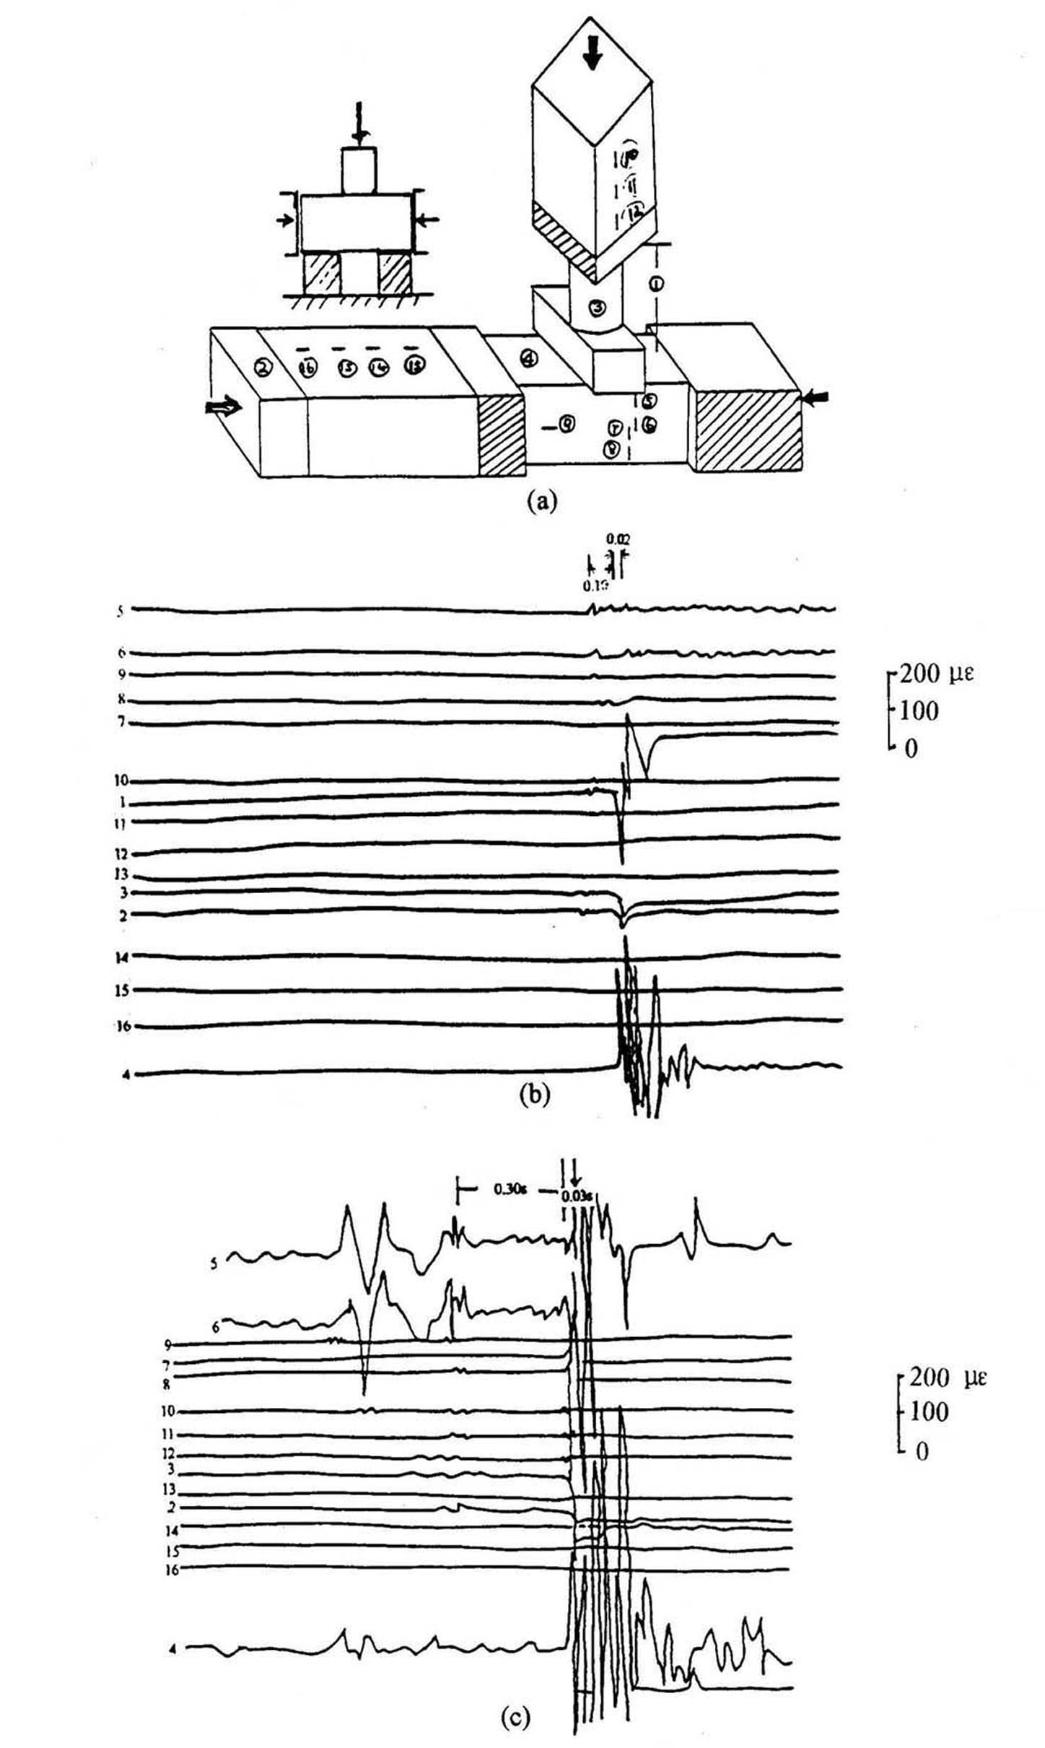

Fig 3 Strain (stress) variations with time before and after great fracture for double shearing
a. Diagram for sample settlement and distribution of observation points
（ch1 displacement; ch2-3 force; ch4 vibration; ch5-16 strain）
b. The first great fracture c. The third great fracture
Fig 3c is a (magnified) diagram of time progress before and after the third great fracture. It is clearly shown that pressures in chs 3 and 2 appear precursory drops (limited displacement amplitude in ch 1) 0.03 seconds before. Strains in chs 5-8 appear jumps (reaching 30-300 με), jumps and small fluctuation in chs 10-12 (reaching 10-20 με) and a small vibration has already existed in ch 4. There are jumps and small fluctuations in chs 2-6 and 10-12 0.3-0.6 seconds before, but are less obvious. No other features can be seen.

3. Discussion and conclusion
3.1 Certainty of precursor in (ultra) far fields
There also exists precursor anomaly in force-supplying body besides precursor anomaly on sample before fracture. Correspondingly in earthquake, there exists precursor anomaly on wall rock body (large range) besides precursor anomaly in seismogenic body. That is to say that there probably are precursors in far and ultra-far fields.
Fig 1-3 shows that anomaly variations appear at all points on sample before fracture. Meanwhile, precursor anomalies appear in force-supplying body in far distance. Mutations in axial strain in steel column of transferring pressure in chs 1 and 2 are very clear (50-500 με) in Fig 1c and d. Axial strain in pulling pole of machine in chs 3 and 4 is not clear as that in chs 1 and 2. However, it is still distinct. In Fig 2, the total displacement in ch 9, normal stress in ch 10, and shearing stress in ch 11 also show distinct mutation and disturbance before fracture. Fig 3 is the same as Fig 2. However, disturbances of strain in block of transferring pressure are not clear as in chs 1, 2 and 3. For example, the disturbances in chs 10, 11 and 12, which are paralleled to fracture plane and in extension line, are not so clear (10-30 με). The disturbances in chs 13, 14, 15 and 16, which are vertical to fracture plane, are hard to see, except that in ch 13 (10-20 με). Even if there are mutation and disturbance outside sample, they do not appear until approaching main fracture. There are only some slow variations (increase or decrease) at earlier time. These points with mutation and disturbance are 25-90 cm away from fracture plane in vertical direction, which are 3-12 times of fracture sizes. The points, in parallel direction are 30-80 cm away from fracture plane, which are 4-10 times of fracture sizes. It can be inferred that precursor anomalies are possible far away from seismogenic area. Sensors are setup according to observation points mentioned above in this test, it is possible to appear precursor anomaly in further distance. However, it is not certain because observation points have not been put there. In addition, the pulling pole of frame of machine is not directly connected to sample, and connected to sample through bottom of machine and steel anvil. However, it also often has mutation and disturbance before main fracture. It shows that precursor anomaly can appear in the place far away when sample breaks. So, it is possible to appear precursor anomaly far away from the seismogenic area before earthquake occurs. Forms of variations are probably different due to non-similar sources and features of near field. It is inferred from this that precursor anomaly could appear within the range, where is 10 or more times of fracture size. If fracture length for an earthquake is 100 km, precursor anomaly could appear in the place 1000 km, even far, away. Whether anomalies of underground water in Beitaipingzhuang in Beijing reflected earthquakes in USA or in Colombia (Yu Jinzi, Che Yongtai et al, 1998) or not, it needs study. But it does not exclude.
The results also explain that mutation and disturbance can not be observed anytime or anywhere outside sample. There are some sensitive points where can reflect anomaly, only very approaching main fracture. Reflections of anomaly have already had on sample at earlier time before, besides mutation and disturbance approaching main fracture. If it appears big ups and fluctuations, even, mutation and disturbance. It provides us a revelation differing precursor of field from the one of source. The one having lasting long-, medium-, short-term and impending precursors could be precursors of source, and the one only having short and impending features could be precursors of field.
Precursor of stress in far field can be observed in the fieldwork. First is that the magnitude is over tens με, and second is most instrument can reach or surpass the precision. Therefore, the observation study has practical significance. Of course, concrete application needs more studies.
3.2 Forming Mechanism of Precursor in (ultra) far field
The test is trying to set sensors far from sample to observe if any precursor anomaly appears. The results show, precursor anomaly can appear in far field area. Actually, it is not hard to understand. The seismogenic body does not break itself. After accepting forces and with other triggering factors reaching fracture strength, the seismogenic body breaks. Before fracturing, bearing ability decrease, and forming precursor anomaly. The seismogenic body and force-supplying body is interacted. The seismogenic body beaks when strength is not greater than stress accepted. Force-supplying body does not break when strength is greater than stress accepted. The bearing ability of seismogenic body tends to decrease before fracture (the stress-strain curve after peak stress and before main fracture is called precursory stress drop). Meanwhile, stress on force-supplying body decreases forming precursor anomaly on it. The size of seismogenic body is much smaller than that of force-supplying body. Even if both have same strength and force accepted, the stress on seismogenic body is much greater than that on force-supplying body. Therefore, seismogenic body breaks ahead of force-supplying body. The smaller the earthquake is, the smaller the size of force-supplying body is. Or, although it is as big as the size of a large earthquake, but stress drops of precursor is very small, therefore, precursors in far field are limited in small range or not obvious. Contrarily, the bigger the earthquake is, the bigger the size of force-supplying body is. Further, stress drops of precursor are probably bigger. So, size of precursors in far field can be very large, and very clear. The one with most obvious variation on force-supplying body is strain (deformation). Correspondingly, the magnified and distinct precursor is underground water, which can explain the reason that precursors in far field have been found a lot by underground water. On the other hand, the range of precursor of underground water is too big. So, it is a reason not to precisely predict the place of earthquake. Since seismogenic body and force-supplying body is interacted, then stress can adjust after an earthquake. The original seismogenic body becomes a part of force-supplying body, and original force-supplying body becomes a part of seismogenic body. This causes alteration of place of earthquake. Force-supplying body is not homogeneous, sensitivity to stress and strain is different with different strength and property. So, some place has distinct impending precursor, and some place has not.
Summing up all above, precursor anomaly impending fracture appearing in sensors and observation points outside sample can be used to infer that there exists precursor in far and ultra-far fields when earthquake occurs. However, the test study of precursor in far field is at its beginning, it needs more work.

References
Dieterrich, J. H., 1978, Preseismic fault slip and earthquake prediction, J. Geophys. Res., 83, 3940-3948
Dieterrich, J. H., 1981, Potential for geophysical experiments in large scale tests, Geophys. Res. Lett., 8653-656
Hu Yili, Xu Zhaoyong, Wang Bin et al, 1997, The variation strain field on free plane of the sample containing hard inclusion in process of fracture development, Earthquake, No.3, 162-168, in Chinese
Ma Shengli, Ma Jin and Liu Liqiang, 1995, theoretical and experimental on spatial-temporal evolution of physical field during deformation of fault system with typical geometric textures earthquake, supplement 55-65 (in Chinese)
Mogi. K., 1984, Basic studies on earthquake prediction, Proceedings on continental seismic activities and earthquake prediction for international conference (Sept. 1982, Beijing), Compiled by Scientific and Technological Bureau of CSB, Seismological Publishing House, 375-402 (in Chines)
Ohnaka, M., 1992, Earthquake source nucleation: a physical model for short-term precursors, Tectonophysics, vol.211, 149-178
Ohnaka, M., 1979, Measurements of strains and displacement near a cut surface in a stick-slip experiment as a model one of earthquake faults, Abstracts, Seismol. Soc. Japan, 1979, No.2, 150 (in Japanese)
Scholz, C., P. Molnar and Y. Johnson, 1972, Detailed studies of frictional sliding of granite and implications for the earthquake mechanism, J. Geophys. Res., 77, 6392-6406
Xu Zhaoyong, Shu Yanhua and Bao Yifeng, 1989, The Rupture characteristics of rock sample with cut crack filled by epoxy resin under uniaxial compression, Acta Geophysica Sinica, Vol. 32, supplement 1 269-274 (in Chinese)
Yao Xiaoxin, 1989, The deformation field during crack growth, Acta Geophysica Sinica, Vol. 32, supplement 1 237-245 (in Chinese)
Yu Jinzi, Che Yongtai, Zhu Qingzhong et al, 1998, Study on groundwater anomalies at Taipingzhuang well Beijing before strong earthquake occurred in ultra far place. J. Seis. Research, Vol. 21, No. 1 42-49 (in Chinese)
Zhaoyong Xu, Runhai Yang, Bin Wang et al, 1998, Burst strain disturbance - A new test study on fracture precursor, Acta Seismologica Sinica, Vol. 11, No.6, 737-744

