WebWisdom NT
version 2.1
Database for Distance Learning
Department of Information Technology  Academy of Economics  Mansfelda 4  60-854 Poznan, Poland  tel. (48)(61) 848-0549  fax (48)(61) 848-3840 |   Northeast Parallel Architectures  Center  111 College Place  Syracuse University  Syracuse, N.Y. 13244-4100  tel. (315) 443-1722  fax (315) 443-1973

October 1998
Table of contents
1. Introduction 4
2. System architecture 6
3. Logging to the database, Maintenance Tools 10
3.1. Logging to the database 11
3.2. Administrating the database 12
3.2.1. Changing database connection parameters 12
3.2.2. Incorporating images into the database 13
3.2.3. Administrating users 16
3.3. Changing default user’s properties 19
3.4. Getting help 22
4. Foilworld Manager 24
4.1. Creating foilworld 25
4.2. Deleting foilworld 26
4.3. Setting foilworld properties 26
4.4. Granting privileges to foilworld 26
4.5. Setting up foilworld owner 27
4.6. Moving foilworld to another place in the hierarchy 28
5. Presentation Manager 29
5.1. Creating new presentation 30
5.2. Editing existing presentation 38
5.3. Copying presentation to another foilworld 40
5.4. Moving presentation to another foilworld 40
5.5. Deleting presentation 40
5.6. Setting abstract for foilworld 41
5.7. Setting formatting and library attributes 41
6. Importer 42
6.1. Importing PowerPoint presentations 42
6.1.1. Phase 1 - preparation of a temporary directory 43
6.1.2. Phase 2 - incorporating contents of the temporary directory to the database 45
6.2. Importing RTF-based PowerPoint presentations 49
6.2.1. Configuration utility 49
6.2.2. Phase 1 - copying PowerPoint/HTML presentation to temporary directory 57
6.2.3. Phase 2 - generating RTF outline of the presentation 57
6.2.4. Phase 3 - compiling RTF outline and enriching HTML files 57
6.2.5. Phase 4 - incorporating HTML files to the database 65
6.3. Importing WebWisdom v.1.0 presentations 65
6.3.1. Phase 1 - copying WebWisdom 1.0 presentation to temporary directory 65
6.3.2. Phase 2 - compiling WebWisdom 1.0 presentation to HTML format 67
6.3.3. Phase 3 - incorporating contents of the temporary directory to the database 74
6.4. Importing sequences of individual foils 74
6.4.1. Editing foil data 76
6.4.2. Editing list of foils 81
6.4.3. Editing foil note 85
6.4.4. Editing foil annotation 85
6.4.5. Phase 2 - storing collection of foils in the database 86
7. Exporter 87
7.1. Dynamic exporter 87
7.2. Static exporter 91
8. Installation of the WebWisdom NT system 93
8.1. Creation of Oracle’s user account 93
8.2. Creation of database schema 93
8.3. Initial database filling 94
8.4. Installation of WebWisdom Manager 96
8.5. Installation and configuration of HTTP Server 96
8.6. Installation and configuration of dynamic Exporter (TDL templates) 98

1. Introduction
Public, mass education becomes nowadays one of the important issues, not only for schools and universities, but also for companies and their continuous education programs. The education process should be as cheap as possible, as effective as possible, and as fast as possible. As it is widely known, with standard teaching techniques it is not possible to teach a large group of people effectively, fast and cheap. Moreover, as teaching material evolves, the teachers must continuously learn a lot.
A solution to this problem can be distance teaching, by the use of Internet and its modern technologies. To this goal, on one hand effective synchronous network transmission and end-user graphical user interfaces must be provided. On the other hand, as the teaching material keeps growing, becomes more and more complicated and user interfaces become more multimedia oriented, a key issue of a distance teaching system becomes a data repository. Such repository must guarantee efficient storage of various types of data, multi-user access for authoring and retrieval, possibility to define user access privileges, ease of preparation of new courses, which employ old and new educational material.
Usually, teaching material in the repository is divided into presentations. A presentation is an ordered set of foils followed by a description. There are two kinds of descriptions: a global one - for all the foils (author name, presentation goals, keywords, abstract, purpose, etc.), and a local one - separately for each foil (title, contents, header and footer, etc.). A foil could be: an image (of any type), an unformatted text (plain text or in HTML format), formatted text (list of bullets and/or points), a program (e.g., an applet), etc.
Key issues, which should be fulfilled by a modern system for preparing and displaying presentations for courses and classes, are the following:
- preparing presentations in an efficient way, with full graphical user interface, formatting wizards, support for templates, cliparts, icons, etc.,
- displaying prepared presentations locally and remotely, by the use of intranet and Internet,
- reusing and editing previously prepared presentations,
- creating a directory (hierarchy) of presentations,
- search tools,
- storing presentations in one place and in a unified form,
- storing presentation meta-data, i.e., author name, creation and last modification dates, purpose, keywords, etc.,
- storing additional data for presentations: add-ons (i.e., addresses of repositories with additional information about presented topics), sounds, programs, applets, examples, etc.
Only the first requirement is fulfilled by existing systems, to mention for example Microsoft PowerPoint application, CorelDraw!, and Lotus Notes. The other issues mentioned above, however, up to now were not fully fulfilled by any existing software. The new WebWisdom NT system meets these requirements. The key characteristics of the system are the following:
- use of an object-relational database as a repository for presentations,
- importing presentations prepared by a presentation-editing tool, for example Microsoft PowerPoint,
- use of sets of images and/or texts prepared by any image- or text-processing tool (scanned pictures, formatted texts, text&graphics documents, HTML documents),
- use of programs written in any programming language, Java applets, interactive examples, etc.,
- consistent and unified presentation storage, regardless of the presentation type presentation, its structure, editing tool, etc.,
- storage of presentation meta-data (author name, creation date, keywords, abstract, modification history, use history, formatting and presentation attributes, general purpose, etc.),
- storage of some additional information for presentations: add-ons (lists of identifiers/addresses of Internet resources) and sounds,
- copying, moving, editing, renaming, and deleting presentations,
- composing presentation on the base of other presentations or their parts,
- managing sets of presentations by a hierarchy of folders called foilworlds,
- managing users and user privileges,
- enabling different methods of displaying presentations by the use of templates,
- exporting (i.e., displaying) presentations locally and remotely (by the use of Internet) in a form described by a given template,
- extensibility - possibility to define new templates with new attributes which will be stored in existing data structures.

The system described in this document is a result of a common project of Department of Information Technology of Academy of Economics at Poznan, Poland, and NPAC (Northeast Parallel Architecture Center) at Syracuse University, Syracuse, USA. This project is a continuation of “WebWisdom” project developed during last few years at NPAC. Main advantages of the described WebWisdom NT are the following: scaleable database-oriented repository for foils and presentations, uniform internal data format, multi-user access for teaching material preparation, user-defined templates for displaying presentations, extendible hierarchy of foilworlds and presentations, users’ access rights and privileges, extended meta-data for presentations and users, tools for managing presentations, foilworlds, users, meta-data, etc., and full graphical user interface.

2. System architecture
The WebWisdom NT system is developed around object-relational database ORACLE v. 7. The following technologies are used:
- preparing presentations by the use of presentation-editing tool Microsoft PowerPoint or (in a limited manner) any text- or image-processing tool, i.e. Microsoft WORD, CorelDraw!, Adobe PhotoShop, etc.,
- importing presentations to the database in HTML/GIF/JPEG (HyperText Markup Language / Graphical Input Format / Joint Photographic Expert Group), Microsoft PowerPoint 95/97, or RTF/PowerPoint (Reach Text Format for Microsoft PowerPoint) formats; most of popular presentation-editing tools have a possibility to export presentations in at least the first format,
- displaying presentations by the use of any HTML browser (e.g., Netscape Communicator, Microsoft Internet Explorer),
- remote access to the database by the use of Internet,
- dynamic HTML output page creation (by the use of TDL Template Definition Language, an extension of XML eXtensible Markup Language, page description language).
The architecture of the WebWisdom NT system is presented in Fig. 2.1. The system is composed of five main parts:
- Database (repository),
- Presentation Manager,
- Maintenance Tools,
- Importer with filters for GIF/JPEG pictures, PowerPoint, RTF and WebWisdom 1.0 presentations,
- Exporter with XML-based templates.
The Database is the core of the system. It is responsible for:
- storing foils (with contents: image, text, HTML text, applet, etc.),
- storing presentations (ordered set of foils and/or other presentations),
- storing foilworlds (hierarchy of presentations and/or other foilworlds),
- storing add-ons (URLs with additional information for a foil),
- storing sounds (as sequences of bytes in any known sound format) for individual foils or whole presentations,
- storing applets, images, and other forms of binary data (as sequences of bytes in a given format),
- storing source files for individual foils (e.g., PowerPoint files *.ppt separated into individual foils),
- storing meta-data about foils, presentations, and foilworlds (author, owner, privileges, descriptions, annotations, etc.),
- storing formatting parameters (preferred image size, type, location, colors, font sizes, etc.),
- storing information about users (name, identifier, password, access rights, etc.),
- checking user privileges while accessing presentations and foilworlds,
- providing efficient access for writing, updating, and reading foilworlds and presentations, as well as their parts.
Fig. 2.1. Global architecture of WebWisdom NT system
The Managers are responsible for:
- Foilworld Manager: managing hierarchy of foilworlds: creating a foilworld, copying a foilworld to another place in the hierarchy, moving a foilworld inside the hierarchy, renaming a foilworld, deleting an empty foilworld, setting an owner of a foilworld,
- Presentation Manager: managing presentations being components of foilworlds: creating presentations from parts of other presentations (compose presentation), creating a presentation from newly imported data, copying elements of a presentation to another one, renaming a presentation, deleting a presentation,
- granting access rights to foilworlds and presentations to other users,
- editing meta-data for presentations and their parts (sub-presentations and individual foils), setting and editing properties for users, foilworlds and presentations.
The Managers is equipped with easy-to-use graphical user interfaces.
The Maintenance Tools are used for:
- creating and managing users,
- loading images used for backgrounds and icons,
- setting default parameters for properties belonging to users, foils, and presentations.
These tools are also equipped with graphical user interface. They are closely integrated with presentation manager and its user interface.
The Importer (Presentation Loader) is used for:
- importing a new presentation from PowerPoint format by the use of:
- source PowerPoint file *.ppt; while reading to the database, this file is cut into pieces being individual foils;
- directory with files being a result of HTML conversion of PowerPoint format; these files are the following: images sldNNN.gif, imgNNN.gif, sldNNN.jpg, or imgNNN.jpg, and HTML files sldNNN.htm and tsldNNN.htm, where NNN=000..999 are foil numbers; if a source *.ppt file is present in the directory, it is also taken into consideration and put to the database as the presentation source;
- as above, but also with an outline of a presentation in RTF format; a special filter is used to process RTF outline to enrich *.htm files (generated originally by HTML conversion) by formatting parameters: colors, font sizes, margins, font names, font families, national characters, etc.; during filtering some database-specific properties can be also added: backgrounds, link colors, signature, abstract, etc., as well as sound files and add-on information for foils; these properties may be defined by the use of a configuration utility equipped with a full graphical user interface,
- importing a new presentation from WebWisdom 1.0 presentation by the use of special filter; the generated output is similar to processed HTML/RTF files mentioned above,
- importing a set of images (photos, pictures, etc.), HTML and ASCII texts, external URL addresses (i.e., addresses of Internet-located-elsewhere HTML pages), and their descriptions (author, date, title, etc.); there is a possibility to import WebWisdom 1.0 photo set;
- setting up parameters for the presentation being imported and its foils: author, date, default colors and fonts, signature, add-on, sound, etc.
The Exporter is composed of two parts. The first part uses TESS system (cf. TESS system documentation) for displaying a presentation by the use of Internet/intranet and standard HTML browser (e.g., Netscape Communicator or Microsoft Internet Explorer). The succeeding foils of the presentation are read from the database and being formatted by user-defined, XML-based templates. During database access, a template may take into consideration the formatting attributes stored in the database (colors, fonts, images and/or text versions, signatures, add-ons, sounds, etc.). The second part of the Exporter is used to generate a directory of HTML files corresponding to dynamically displayed pages (foils) of a presentation. These files then may be used to access contents of the presentation in traditional, static way. The generated directory can be also copied to another place/computer, stored on CD-ROM, etc.
In the next chapters the Foilworld Manager, the Presentation Manager, the Maintenance Tools, the Importer and the Exporter are presented in details.

3. Logging to the database, Maintenance Tools
The WebWisdom NT main editing application is written in Java as a stand-alone applet. The applet is invoked by special script which: (1) sets environment variables, and (2) launches Java appletviewer command with appropriate HTML file. The contents of a sample invocation script is presented in Fig. 3.1 (DOS version, file “run.bat”) and Fig. 3.2 (UNIX version, file “run”).
SET ENV=2000
set classpath=.;classes\classes111.zip;classes\symbeans.jar;classes\swingall.jar;
classes\jgl3.1.0.jar
SET PATH=%PATH;.\pm\r2h
appletviewer run.html
Fig. 3.1. Invocation script for the presentation manager, DOS version
setenv CLASSPATH .:../classes111.zip:../symbeans.jar:../swingall.jar:../jgl3.1.0.jar
setenv PATH $PATH:./pm/r2h
appletviewer run.html
Fig. 3.2. Invocation script for the presentation manager, UNIX (t)csh version
After the invocation, the system opens its main window and waits for user interaction. Two buttons are active: „Login” and „Exit” (Fig. 3.3).
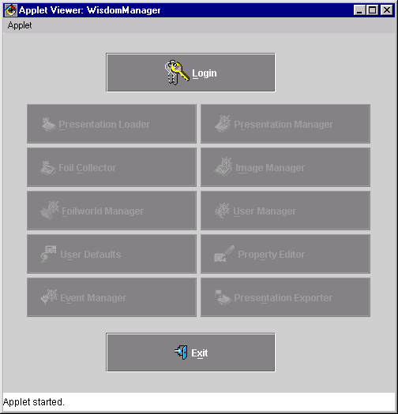
Fig. 3.3. Main window of the WebWisdom NT system, no user is logged-in

3.1. Logging to the database
To work with the database, a user must first log-in to the system by pressing the “Login” button. Pressing the “Exit” button at any time finishes connection with the database and exits to the operating system, automatically closing the window. Until the user logs-in correctly, all buttons (except “Login” and “Exit” buttons) in the main window (cf. Fig. 3.3) are disabled. After a successful log-in some buttons become enabled, depending on user’s privileges.
To log-in to the system a user must press “Login” button in the main window. As a result, a new window called “Login window” appears (Fig. 3.4). The user must enter his/her name and current password in the “user name” and “password” fields, respectively. The password does not appear directly on the screen, instead it is marked by the use of ‘*’ characters. After fixing the name and the password, the user can press “Connect” button (labeled by icon) to connect to the database. To exit the login window at any time, the user can press “Cancel button” ( icon). In such case, however, he is not connected to the database and he cannot use the Managers or the Presentation Loader in any form.
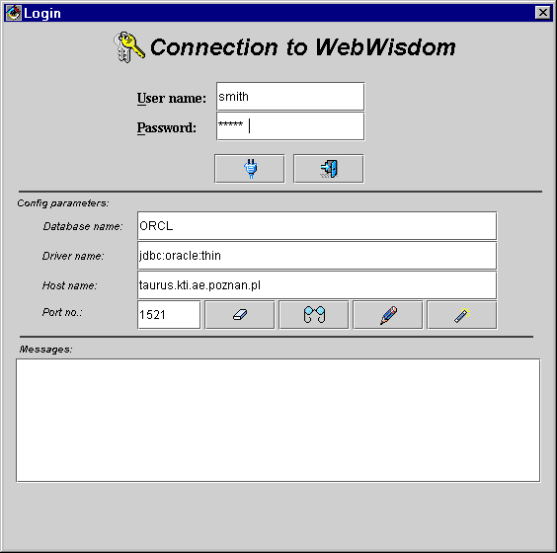
Fig. 3.4. Login window of the WebWisdom NT system
In the middle part of the window current log-in configuration is displayed. Four fields are provided: “Database name”, “Driver name”, “Host name” and “Port No.”. These fields can be used to enter: database name, driver name used to connect to the database from Java applet (default: “jdbc:oracle:thin”), DNS host name where Oracle database server is running, and the port number the applet uses to communicate with the database (default: “1521”). User can change value of any of these fields and connect with these new values. To this goal four additional buttons are provided. By the use of “Clear parameters” button ( icon) a user can erase the current contents of these fields, while by the use of “Get defaults” button ( icon) – he/she can restore the current default values for all the fields. By filling the fields with new values and pressing “Set default” button ( icon) a user can store new current default parameters. The “For advanced users only” button ( icon) is used to administrate the connection with the database management system. The meaning of this button is explained in the next section. This function is reserved only for the database administrator (cf. next section).
In the lower part of the window there is a sub-window where system messages are written. The messages concern errors while accessing the database. The most common messages are “Wrong user name/password”, “Not suitable driver”, “This configuration will be used as the default one”, and “Connection refused”, which are self-explaining.

3.2. Administrating the database
There is one special user (“admin”) who is the system administrator. This special user is not intended to work with the database, but rather used to administrate the connection with the ORACLE database management system. This user is also not visible for the WebWisdom NT users, and only the administrator knows his name and password. Once set during the installation of the system, both the name and the password cannot be changed. Using of „admin” user is explained in the next section.
Please note that all users’ passwords are verified in the database. If for some reason the database is not accessible (e.g. after entering wrong database user name or password or shutting down the database), no password can be verified and no database user or password can be corrected. In such case the administrator can change the database user and/or password by logging in as “admin” user. The “admin” user is a local user and system does not have to connect to the database to verify it. Only a person responsible for WebWisdom NT maintenance knows the “admin” user password.
There is another special user („root”) who is a master of the foilworld tree. This user is created during the installation of the system and cannot be deleted. The parameters of the „root” user can be freely changed, including user’s name and password. However, internal database identifier of this user is never changed, thus always allowing him to be foilworld master.
Different users have different privileges. After successful logging, according to user’s privileges, some buttons in the main login window are active or not, thus granting trusted users by some administrative privileges, including creating new users, changing their basic properties (passwords, log-in names, descriptions, photos, etc.), and changing access rights to foilworlds. Using of these buttons is explained in the succeeding sections.

3.2.1. Changing database connection parameters
While the log-in window is open (cf. Fig. 3.4), and the “admin” user name and password is properly set, one can administrate the database connection by pressing “For advanced users only” button ( icon). As a result, a new window appears (Fig. 3.5) where the administrator may set new name and password for the database user that is used to connect to the database.
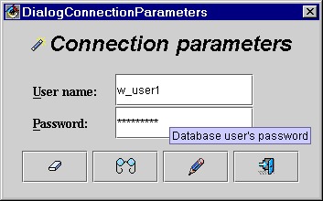
Fig. 3.5. Setting “database” user that is used to connect to the database
Two text fields and four buttons are provided in the window. The text fields are used to enter database user name and password. The „Clear parameters” button ( icon) is used to erase current contents of the fields, while the “Get defaults” button ( icon) – to restore the current default values for the fields. By filling the fields with new values and pressing “Set default” button ( icon) one can store new current default parameters. The “Exit” button ( icon) is used to close the window and go back to the login window.

3.2.2. Incorporating images into the database
If a user performs successfully log-in and he/she has granted a privilege (granting privileges will be explained in next section) to managing database images, the “Image Manager” button becomes active (Fig. 3.6). With this button the user can add images (for backgrounds, buttons, etc.) to the database.
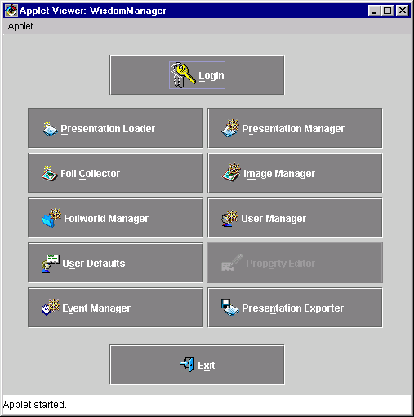
Fig. 3.6. Main window of the WebWisdom NT system after “advanced” user log-in
After pressing “Image Manager” button, a new window appears (Fig. 3.7), which enables reading images into the database. The window is composed of a tabbed panel and two typical buttons: the „Help” button (icon) is used to get some help on administrating images from the database, while the „Exit” ( icon) button is used to exit the window. After the window is closed, all the selected and stored images are accessible for the exporter and may be used as icons, buttons, backgrounds, etc.
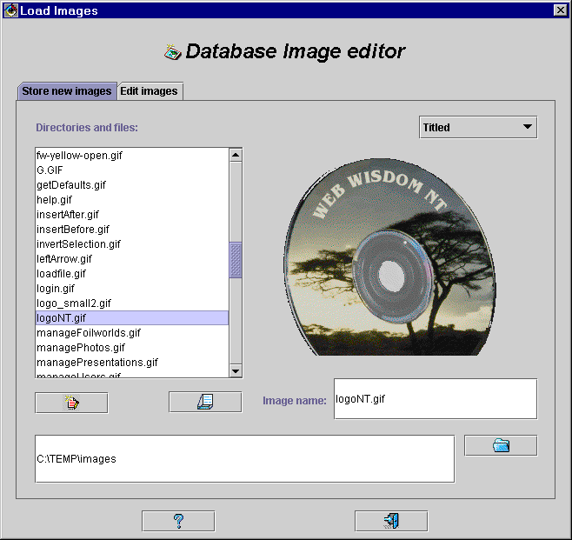
Fig. 3.7. Image manager, „Store new images” panel active
The tabbed panel is equipped in two tabs: „Store new images” tab and „Edit images” tab. One may activate a given tab by pressing its name. The „Store new images” tab (Fig. 3.7) is used to incorporate into the database the images stored in disk files. Two image storing formats are accepted: GIF (Graphic Interchange Format, including GIF89a animated pictures), and JPG (Joint Photographic Expert Group, JPEG).
Contents of the currently selected directory is displayed in „Directories and files” list located in the left part of the tab. By clicking over a directory name (including „..” parent directory) one enters this directory and displays its content in the list. By clicking over a file with GIF/JPG image a user displays the image in the right part of the window. Image can be also displayed by selecting its corresponding file name on the list and pressing „Show selected image” button ( icon). Below the image its name is displayed, as it will be stored in the database. By default this name is equal to the file name, but it can be freely changed before storing the image in the database. The “.gif” and “.jpg” extensions are not required although can be used.
A name of a currently selected directory is displayed in the text field in the bottom part of the tab. One may enter a new directory name in this field and press „Open directory” button ( icon). Content of a newly selected directory is displayed in the „Directories and files” list and a user may proceed to walk throw the displayed directory structure as it is described above.
A way of displaying an image can be changed by pull-down menu located in the right-upper part of the window. There are four possibilities:
- „Normal (1:1)” - an image is displayed in its real size; if an image is bigger than the displaying area, only its left-upper corner is displayed;
- „Scaled to fit” - an image is scaled to completely fit the displayed area;
- „Centered” - an image is displayed in its real size in the center of the displaying area;
- „Tiled” - an image is displayed in multiple copies across the displaying area.
The way of displaying an image can be also changed by clicking over the displaying area. The order of changing is the following: „Normal” → „Scaled to fit” → „Centered” → „Tiled”.
A selected image can be stored in the database after pressing „Store image in database” button ( icon). If the image name is already in use, i.e., another image has been stored already in the database under the same name, a message appears and the image is not stored.
The second tab, „Edit images”, is used to change names of already stored images and remove unused images from the database. The tab is displayed after clicking over its name (Fig. 3.8).
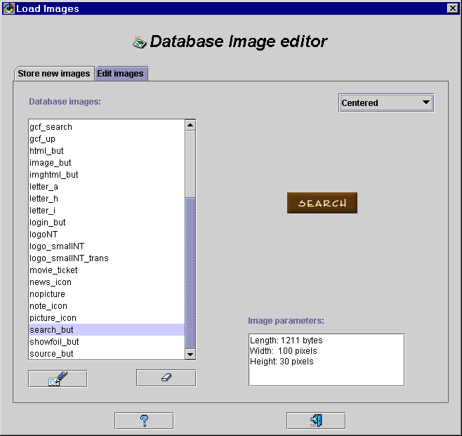
Fig. 3.8. Image manager, „Edit images” panel active
Names of images already stored in the database are displayed in „Database images” list located in the left part of the tab. By clicking over a name a corresponding image is read from the database and displayed in the right part of the window. Below the image its parameters are displayed in the „Image parameters” text field: length in bytes, and width and height in pixels. A way of displaying an image („Normal”, „Scaled to fit”, „Centered”, „Tiled”) can be changed by the use of pull-down menu similarly to the corresponding menu from the „Store new images” tab.
To edit image name, one must select it on the list and press the „Edit image name” button ( icon). A line editor is invoked to change the name (Fig. 3.9). To edit the name one should simply correct it and press the „OK” button ( icon). The name is immediately updated in the database. To exit the line editor with no change, one should press the „Exit” button ( icon). In such case no change is performed in the database.
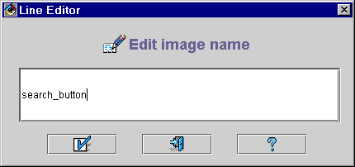
Fig. 3.9. Image manager, changing image name
To remove an image from the database a user must select its title and press the „Remove image” button ( icon). The image is immediately removed from the database. However, if the image to be removed is used in a property (i.e., as a value of any system, user, or presentation property, cf. Section 3.2.4), a message is displayed (Fig. 3.10) and the image is not removed.
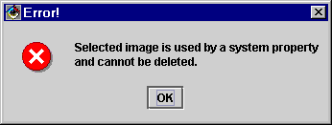
Fig. 3.10. Image manager, error message after attempting to remove a used image

3.2.3. Administrating users
After pressing “User Manager” button in the main window (cf. Fig. 3.6), a new window enabling change of basic user’s properties appears (Fig. 3.11). The window is divided in two parts. In the upper part a list of names of currently defined users is displayed. One can choose one user name by clicking on it. The selected name is displayed in different color. In the lower part six buttons are provided. The „Edit user” button (icon) is used to change parameters and privileges of an existing user. The „Add new user” button (icon) is used to define a new user. The „Delete user” ( icon) button is used to remove a selected user from the system. The „Help” button (icon) is used to get some help on administrating users from the system. The „Cancel” ( icon) button is used to exit the window with no change in user list, while the „OK” button ( icon) - to incorporate changes into the database before exiting the window.
To create a new user, one must press „Add new user” button. A new window appears (Fig. 3.12) to define the parameters for the newly created user account. These parameters include: first name, middle initials and last name, a short comment about user (field „Info”), information if user may log-in to the system (checkbox „User can login”), and for users who may login: login name (possibly different than last name), login password (with confirmation in the „Confirm password” field - the two passwords must be identical), and account expiration date (if not set, an account expires in one year from the moment of its creation). One can also set a photo of a newly created user by pressing „Add/change image” button ( icon). After pressing this button, a new window appears to select a file with a picture. The accepted file formats are GIF and JPEG. The selected photo is displayed in the upper right corner of the window. The image may be removed from the database by pressing the „Clear image” button ( icon).
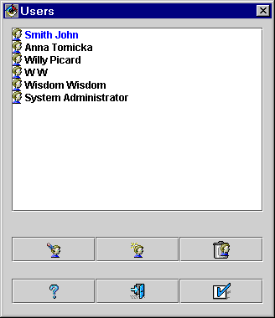
Fig. 3.11. Window for administrating users of the WebWisdom NT system
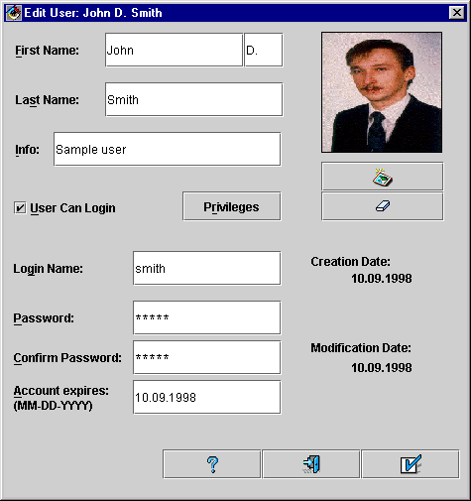
Fig. 3.12. Creating new user account
One can set privileges for the newly created user by pressing „Privileges” button. A new window appears to define user’s rights (Fig. 3.13).
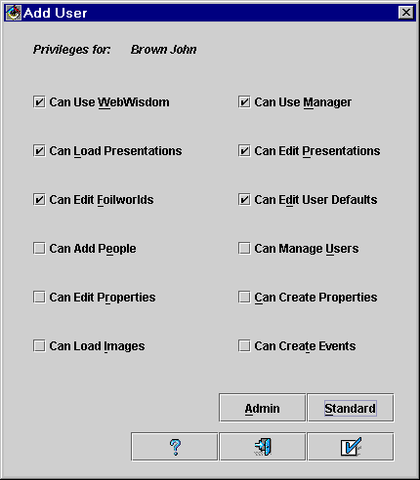
Fig. 3.13. Setting privileges for a user
One can set and reset a given privilege by clicking its corresponding checkbox. To simplify routine tasks, two buttons are provided. With the „Admin” button one can set all the privileges (i.e., administrator rights). With the „Standard” button, one set the following privileges: a user can use WebWisdom NT system, can use the Managers, can load new presentations, can edit exiting presentations, can edit foilworld structure, and can set his/her defaults. The remaining privileges are usually reserved for the administrator(s).
The three buttons located in the bottom part of the window: „Help” (icon), „Exit” ( icon) and „OK” ( icon) are standard and self-explaining. After pressing one of the two latter buttons, the window disappears.
To edit parameters of an existing user, one must press the „Edit user” button (icon) in the „users” window. The procedure of changing user parameters is similar to the one of creating a new user, except two dates are displayed below the photo: date the account was created, and date the account was modified for the last time.
To delete a user, one must press the „Delete user” ( icon) button. If the user to be deleted is an author of any presentation, he cannot be deleted. If the user to be deleted is an owner of some foilworlds, the ownership of these foilworlds and presentations contained in them is shifted to the „root” user. The same applies for user’s images. The user’s stage foilworld is deleted together with all presentations contained in it. A user cannot delete himself/herself.
By changing a state of the checkbox “User can login” one may give (or remove) a right for the user to log-in to the database. Accounts of users who cannot log-in are used mainly for administrative purposes, for example to store an information about an author of a presented picture.
By pressing “Help” button (icon) a user can display a WWW-navigator window with a description of the “Users” window and possible actions (see Section 3.4 for details).

3.3. Changing default user’s properties
After successful log-in, a user can change default values for his/her properties. By pressing “Defaults” button in the main window, a new window appears for setting new values of the properties (Fig. 3.15). There are six layers in the window, for: (1) color, (2) image, (3) image size, (4) font, (5) configuration, and (6) overall properties (Figs. 3.15a, 3.15b, 3.15c, 3.15d, 3.15e, and 3.15f, respectively).
a/ 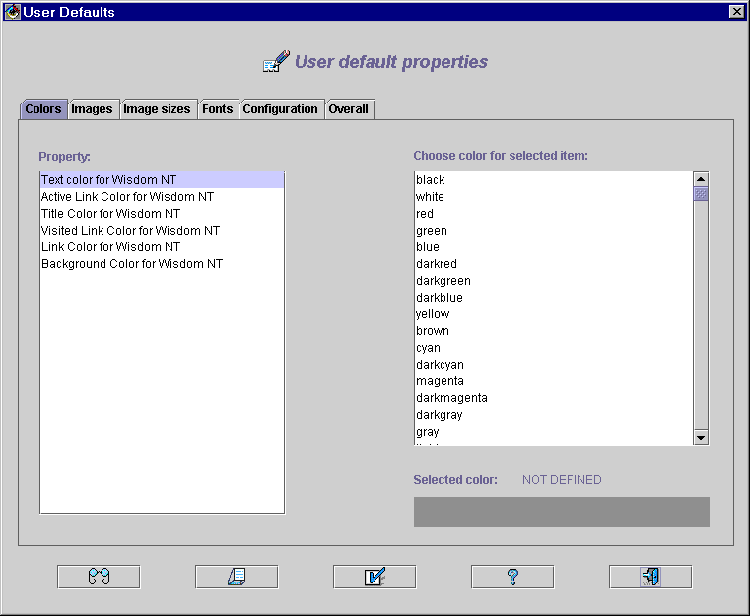 b/ 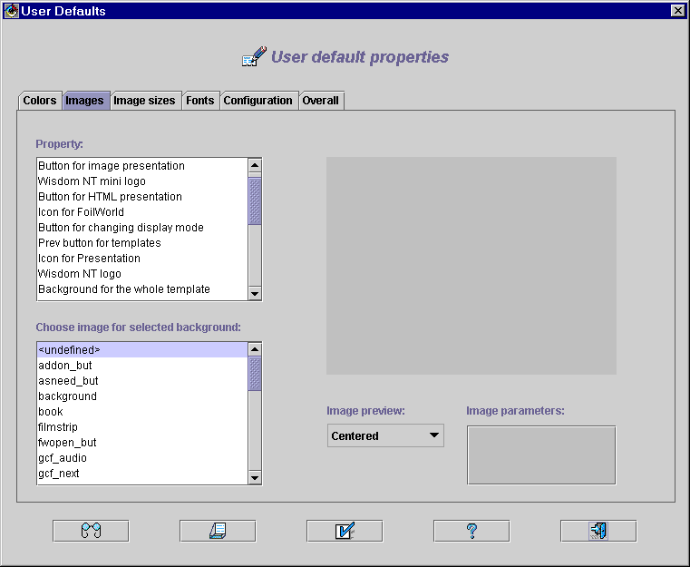
c/ 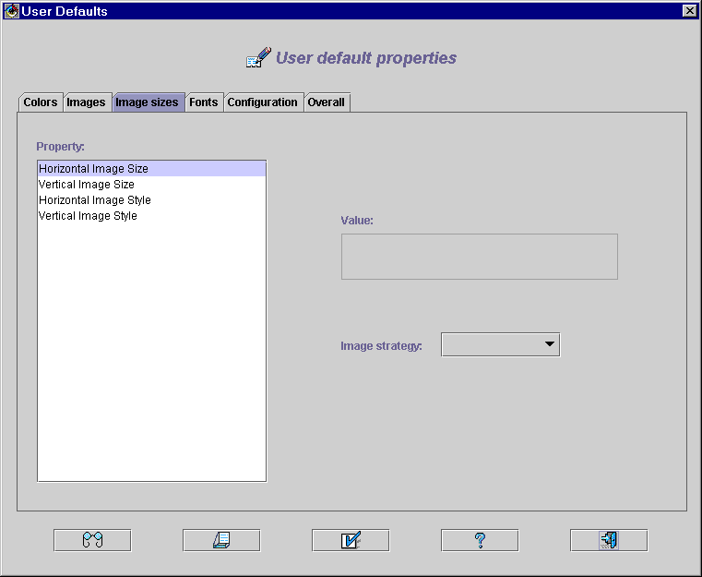 d/ 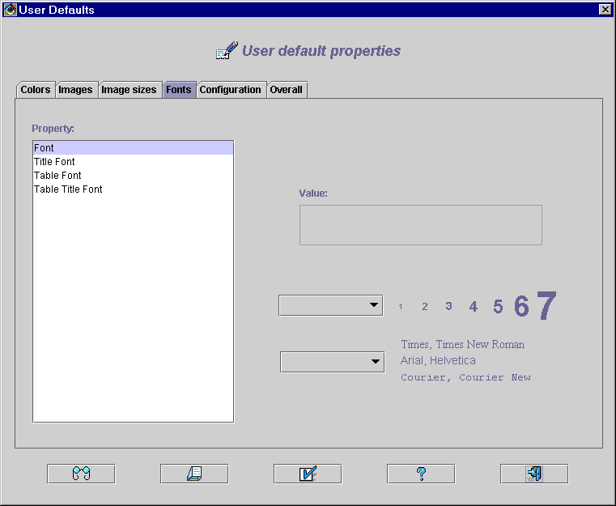
e/ 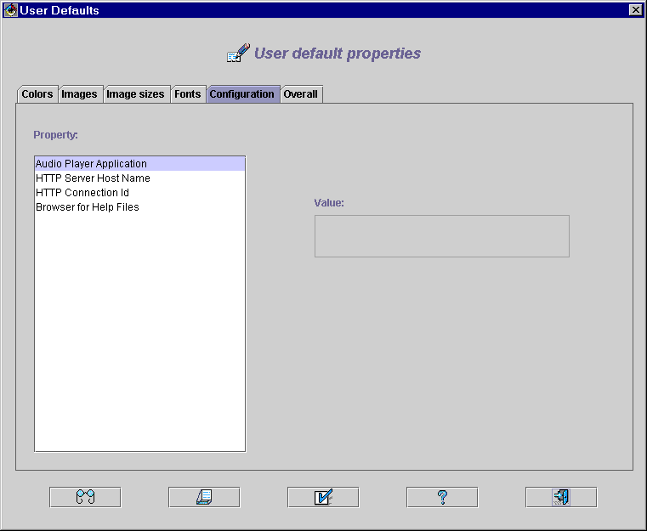 f/ 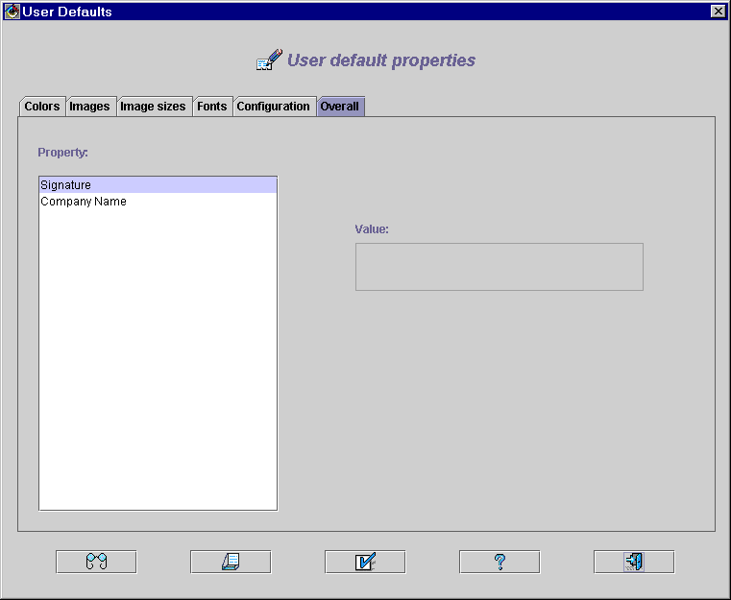
Fig. 3.15. Setting defaults for user’s properties: (a) for colors, (b) for images, (c) for image sizes, (d) for fonts, (e) for configuration parameters, and (f) - for overall properties
There are five buttons on the bottom of the window: “Get defaults” ( icon), “Reload from database” ( icon), “Save User Defaults” ( icon), “Help” ( icon), and “Exit” ( icon). The first one is used to identify default values taken into consideration if nothing is defined in the window. The order of searching for a default value is the following: foil property, if not defined - presentation property, if not defined - user property, if not defined - system property. The second button is used to discard any changes introduced since the last save and continue setting properties. The third button is used to store the new property values in the database. The last two buttons can be used to display help information and to exit from the window without saving new property values in the database.
The first layer - „Colors” - can be used to define colors for texts, links, backgrounds, etc. Property names are displayed in the upper-left corner of the window. A user can select one property at a time. The selected property is highlighted. Color names are displayed in the upper-right part of the window. The selected color is displayed in a bon in the lower-right part of the window. A name of the selected color is at the same time a value of the selected property. If a property has no value, „NOT DEFINED” label is displayed above the color box.
To fix a color for a property, one must first select property name, and then color name. The selected items are highlighted, and the selected color is displayed in the color box. Once set, the property value is remembered in a temporary buffer and can be later stored in the database by pressing „Save User Defaults” button.
To undefine a property, one must select its name in the property list and next select „<undefined>” position (the first one) in the color list. Undefined property value will be computed by the database from default system values.
The second layer - „Images” - can be used to define images for buttons and backgrounds. In the upper-left corner of the window a user can select a property to be defined. In the lower-left part of the window an image can be selected to be a value of the selected property. The image is displayed in the upper-right corner of the window. In the lower-right part of the window the following additional information is displayed about the image: size in bytes, original width and height, displaying strategy for preview in this window (image in its original size, scaled to fit the displaying area, centered and tiled). The displaying strategy can be chosen by the use of the pull-down menu „Image preview” located below the displayed image or simply by clicking over the image.
The third layer - „Image sizes” - is used to define sizes and strategies for displaying images by the Exporter. One can change a value of the selected property by moving a mouse to the „Value” field and typing a new value. Once a mouse cursor is no more above this field, its contents is stored in a temporary buffer and can be accessed any time the property is selected. By invoking pull-down menu „Image strategy” one can quickly establish a value for predefined strategies: „minimum” - no smaller than N points, N defined near-by by another property, „maximum” - no greater than N points, „exact” - size equal to N points, and „native” - original image size). Once chosen by the use of the menu, a value is stored in the temporary buffer and can be accessed later on.
The fourth layer - „Fonts” - is used to define sizes and families for the fonts used by the Exporter. The syntax of the property values is similar to the one used in HTML standard: „Size="N"”, and „Face="Family name"”, with size range limited to „1..7” and family range limited to the capabilities of the system the Exporter is running. The pull-down menus located below the field „Value” can be used for quick modification of the value.
The fifth layer - „Configuration” is used to define basic configuration parameters, mainly for the Exporter:
- name of the application to play sounds,
- name of the server where the HTTP server is running,
- connection ID to the HTTP server, and
- HTML browser for displaying the “help” texts.
The last, sixth layer - „Overall” - is used to define all properties which do not belong to any of the previously mentioned property groups. These are examples of such properties: user’s signature, company name, etc. The names, meaning and values of sample attributes are given in the table below.
Property name | Meaning | Domain | Overlay
Text color for Wisdom NT | Color for displaying texts (foil bullets) | color name | 1
Title color for Wisdom NT | Color for displaying foil titles | color name | 1
Background color for Wisdom NT | Color for foil background | color name | 1
Link color | Color for displaying links | color name | 1
Button for image presentation | Sample image drown over a button | image name | 2
Horizontal image size | Size of the foil image in pixels | 1..9999 | 3
Horizontal image style | Strategy for displaying images | native exact minimum maximum | 3
Font | Font size and family for displaying texts (foil bullets) | size=”1..7” face=”...” | 4
Title font | Font size and family for displaying titles | 1..7 | 4
Audio player application | Name of an application for playing sounds | file name | 5
HTTP server host name | Name of the host where used HTTP server is running | DNS | 5
HTTP connection ID | Connection id number of the used HTTP server | 1..9999 | 5
Browser for help files | Name of an application for displaying HTML | file name | 5
Signature | Short text displayed by the Exported below each foil | string of characters | 6

3.4. Getting help
In most of the windows “Help” button is located, making it possible to invoke contextual help system at any time (Fig. 3.15). The help text is displayed by the use of any HTML browser, for example Netscape Navigator or Microsoft Internet Explorer.
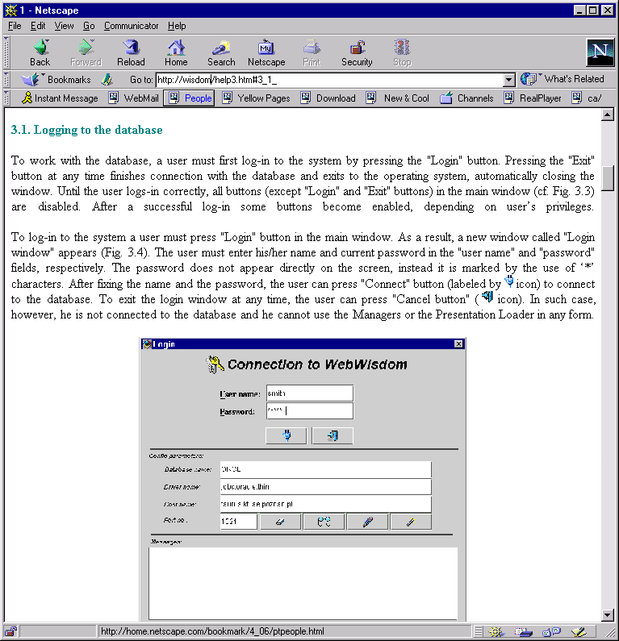
Fig. 3.15. HELP navigator window
To facilitate using help system, an interactive “Table of contexts” is provided. This utility can be accessed by pressing “Web Wisdom NT Help” link located always at the very beginning of the help page (Fig. 3.16).
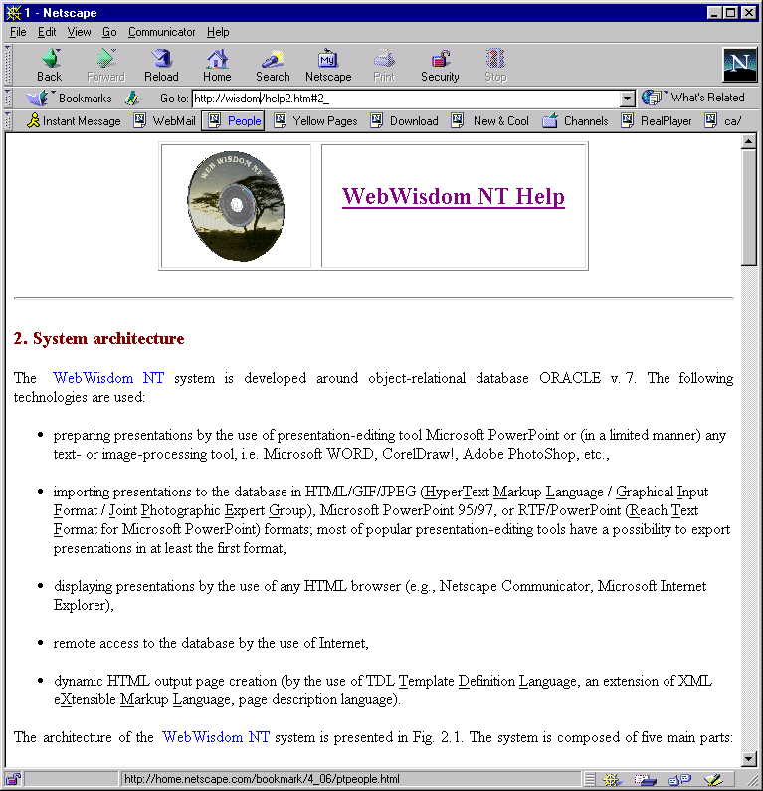
Fig. 3.16. HELP navigator window in another context with visible “Table of contents” link

4. Foilworld Manager
The Foilworld Manager is used for:
- managing hierarchy of foilworlds,
- granting access rights to foilworlds,
- creating new foilworlds.
The Manager is equipped with full graphical user interface and interactive help system.
After successful logging, the user can manipulate his/her foilworlds by pressing “Foilworld manager” button in the main window. A new window appears (Fig. 4.1) to edit, copy, move and change properties of user’s foilworlds.
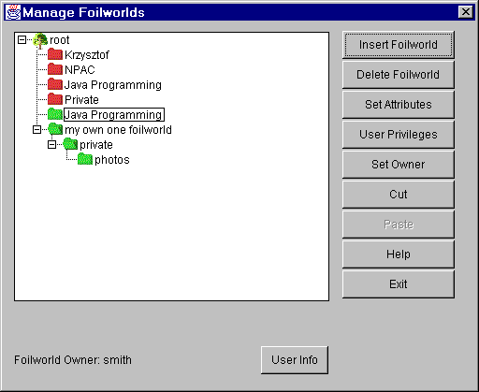
Fig. 4.1. Foilworld manager window
The hierarchy of foilworlds is displayed on the left side of the window. The foilworlds marked by green icons are fully accessible by the user (i.e., he/she has both read and write access to them). The foilworlds marked by yellow icons are accessible only in “read” mode (i.e., their contents cannot be changed by the user). The foilworlds marked by red icons are not accessible to the user (i.e., their contents cannot be neither read, nor written by the user). The contents of the foilworld or sub-foilworld can be expanded or hidden by pressing “+” and “-”icons, respectively.
In the bottom part of the window an information is displayed about an owner of the selected foilworld. By pressing the “User info” button one may display some additional information about the owner (so called visit card, Fig. 4.2).
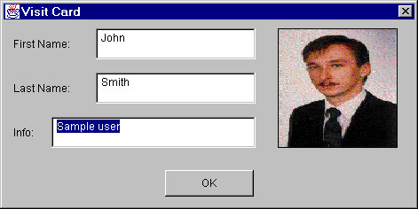
Fig. 4.2. Visit card of an owner of a selected foilworld

4.1. Creating foilworld
To create a new foilworld and place it in the hierarchy, first the parent foilworld must be selected. Then, after “Insert foilworld” button is pressed, a new window appears to set basic properties of the newly created foilworld: its name and expiration date (Fig. 4.3). The foilworld is created as a child of the previously selected parent foilworld. The “Expiration date” is a date after which the foilworld should not be used anymore. The name of the foilworld can be any string not exceeding 1024 characters.
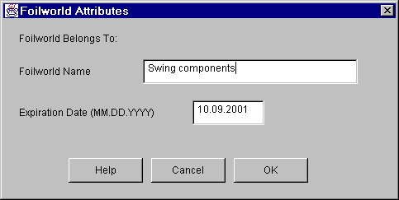
Fig. 4.3. Creating a new foilworld
“Cancel” button enables to go back to the previous window without creating any new foilworld. After pressing “OK” button the newly defined foilworld is created and placed in the hierarchy (Fig. 4.4).
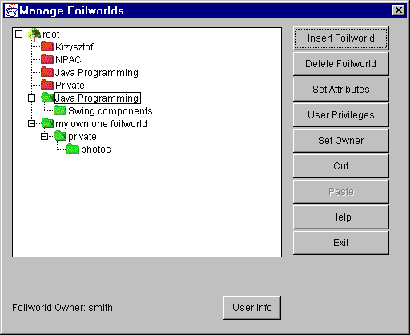
Fig. 4.4. Foilworld hierarchy after creating a new foilworld

4.2. Deleting foilworld
To delete an empty foilworld from the hierarchy, it must be selected and the “Delete Foilworld” button must be pressed. If the foilworld to be deleted is not empty or a user has no permissions to delete it, a message appears on the screen and the foilworld is not deleted.

4.3. Setting foilworld properties
To set properties of a foilworld, a user must select an appropriate foilworld and press the “Set attributes” button. A new window to define foilworld attributes appears on the screen. The contents of the window is similar to the one appearing while a new foilworld is created, except the owner’s name is displayed in its upper part (Fig. 4.5).
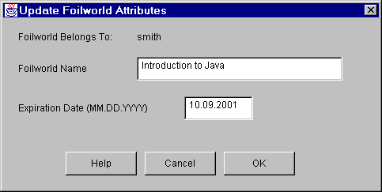
Fig. 4.5. Changing foilworld attributes

4.4. Granting privileges to foilworld
To grant foilworld access privileges to a user, the foilworld must be selected and the “User privileges” button must be pressed. A new window appears on the screen (Fig. 4.6). Read and/or write access can be granted to a particular user or all users. User’s name can be fixed by the use of a pull-down menu located in left-upper corner of the window, while current access rights - by the use of “Read” and “Write” check boxes located in right-upper corner of the window. After setting user’s name and rights, the “Grant to User” button can be used to set the selected access rights for the foilworld and the selected user. The previously set rights are overwritten by the current values. After pressing “Exit” button the window disappears.
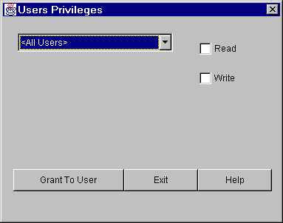
Fig. 4.6. Granting access to a foilworld to another user

4.5. Setting up foilworld owner
To set a new owner of a foilworld, the foilworld must be selected and the “Set Owner” button must be pressed. A new window appears on the screen. This window enables to set a new owner of the foilworld (Fig. 4.7). A new owner’s name can be chosen by the use of pull-down menu. After pressing “OK” button the ownership is granted to the selected user. Pressing “Exit” button leaves the window without ownership modification.
Ownership of a given foilworld can be set only by a user who is already an owner of the parent foilworld. A user can change ownership of foilworlds in his/her foilworld even if he/she is not the current owner of the children foilworlds. The “root” user is the owner of the “Root” foilworld that gathers all other foilworlds in the system. As a result the “root” user can change ownership to any foilworld.
If the new owner is different than the owner of the parent foilworld the selected foilworld belongs to, the ownership can be treated as “temporary”. The owner of the parent foilworld always has permissions to set the ownership back to his name (i.e., to take back the selected foilworld).
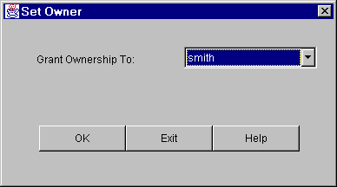
Fig. 4.7. Setting a new owner for a foilworld

4.6. Moving foilworld to another place in the hierarchy
Foilworlds can be moved inside the hierarchy by placing a foilworld in a buffer and then sending the contents of the buffer to another foilworld. This mechanism is similar to “Cut & Paste” utility well known from any text editor. To copy a selected foilworld, “Cut” button must be pressed. Next, the destination “parent” foilworld must be selected and “Paste” button must be pressed. In effect, the previously selected foilworld is placed as a direct “child” to a selected “parent” foilworld. The movement is recursive, i.e. it is performed together with all children foilworlds. To finish the manipulation on foilworlds, “Exit” button can be pressed. Note that there is no “Cancel” button, i.e., the changes made during a session cannot be rolled-back.

5. Presentation Manager
The Presentation Manager is used for:
- managing hierarchy of presentations,
- copying and moving presentations belonging to foilworlds,
- editing meta-data for presentations and their parts (sub-presentations and individual foils),
- creating new presentations,
- editing data for foils (e.g., changing foil image, HTML text, PowerPoint source foil file, etc.).
The Manager is equipped with full graphical user interface and interactive help system.
After successful log-in, the user can start manipulating his/her presentations by pressing “Presentation Manager” button in the main window. A new window appears (Fig. 5.1), which enables to edit, copy, move and change properties of user’s presentations. The window consists of three main parts:
- upper-left corner - foilworld hierarchy,
- upper-right corner - contents of the currently selected foil of a presentation or presentation abstract,
- bottom part - presentations inside the selected foilworld.
The window is equipped with a set of pull-down menu. In the upper part of the window there are three menus: “View”, “Help”, and “Exit”. The “View” menu is used to change a view for the foilworld contents: listing titles of presentations and their foils, listing names, labels, or “running” titles. An information about currently selected choice is printed above the view of the foilworld contents. By clicking over this text one can cyclically change a view in the following order: listing by title, by name, by label, and by “running” title. The “Help” menu is used to display help information about the window. The “Exit” menu is used to quit the window.
Other pull-down menus are activated by pressing right mouse button with mouse cursor over a given window element: contents of a foil, presentation title, or foil title. These menus are explained in details later in this section. Note that number of items in a given menu depends both on a context this menu is invoked in, and on user’s privileges. For example, position “add image” is hidden while there is already an image defined for a foil.
To create or edit a presentation, first a foilworld must be selected. The foilworld hierarchy (sub-window “Foilworlds”) is similar to the one displayed in the window for manipulating foilworlds (cf. Section 4). The presentations belonging to the selected foilworld are displayed in sub-window “Presentations by ...”. The presentations are displayed in tree-like form. On highest level of hierarchy all presentations that belong to the currently selected foilworld are displayed. Any of these presentations can be expanded by pressing the “+” icon near the presentation name. A presentation can be composed of foils or other presentations – sub-presentations in a recursive way. Non-expanded presentations are marked by icon, expanded – by icon, while foils are marked by one of the following icons:, , , depending on a type: regular foil, abstract, or a foil with sound data, respectively. Sub-presentations can be expanded the same way as other presentations. A user can select any of the foils or presentations. If a foil is selected, data for this foil (i.e., an image, an HTML text) is displayed in upper-right corner of the window. If a presentation is selected the graphical form of its abstract foil is displayed. A user can scroll down and up the lists of foilworlds, presentations and foils by moving a scrollbar.
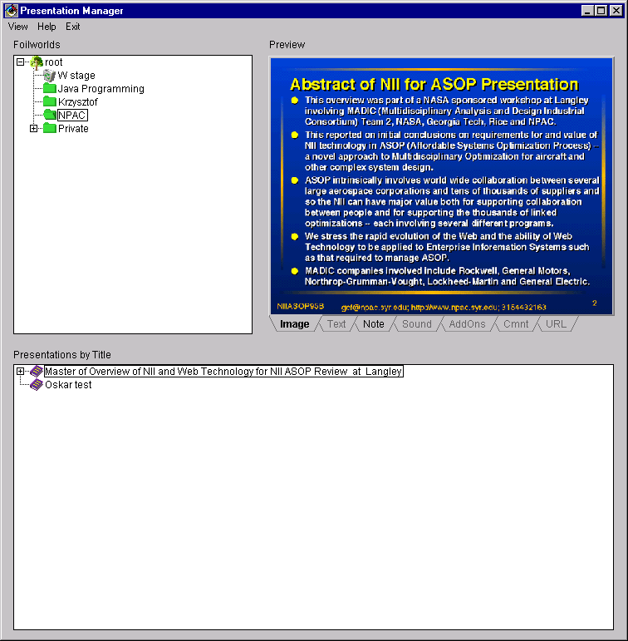
Fig. 5.1. Presentation manager window
As a foil may have different data associated with it, contents of this foil is displayed in a tabbed panel, equipped in the following tabs: “Image”, “Text”, “Note”, “Sound”, “AddOns”, “Cmnt”, and “URL”. Clicking over a tab name displays a given foil data: image, HTML text, HTML note (description), sound information, add-on information, a text of a comment for the foil, and an URL address, respectively. Tabs for currently unused (by the foil) data types are disabled.

5.1. Creating new presentation
To create a new presentation, any foilworld except “stage” should be chosen and main pull-down menu must be invoked by pressing right mouse button over sub-window “Presentations by ...”. This menu is equipped in one item “Create New Presentation”. Just after invoking this item, a new window appears on the screen with presentation properties to be set up (Fig. 5.2). A user must write the obligatory fields and may write the non-obligatory ones, according to the table below.
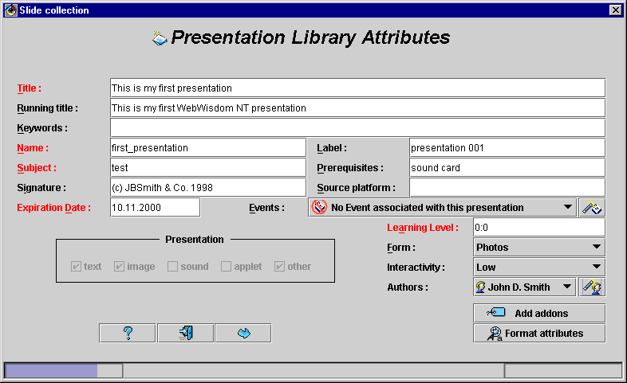
Fig. 5.2. New presentation - setting properties
Field name | Property meaning | Obligatory | Examples
Title | Title of the presentation | Yes | Java Programming Course
Running title | “Heading” title – a string of characters displayed as a window title | No | Introduction to Java Programming
Keywords | A few words describing the presentation | Yes | Internet, programming
Name | Unique, space-less string of characters which identify the presentation in the database | Yes | java001
Subject | Knowledge domain of the presentation | Yes | history, chemistry
Signature | A line of text being user’s (enterprise) signature, usually displayed at the bottom of a foil | No | © J. Smith 1998
Expiration date | Date the presentation should stop being used | yes | 31-12-2005
Label | Extended name | No | Java Course No 001
Prerequisites | What a user should know to understand the presentation | No | any programming language, e.g. C/C++
Source platform | Hardware and software requirements | No | sound card, MPEG player
Learning level | A pair age:skill; 0:0 means that learning level is undefined; age=0..99, skill=0..5 | Yes | 0:0, 20:1, 15:5
Form | A way the material is to be presented | Yes | course, example, tutorial
Interactivity | Level of interaction between a user and the system | Yes | low, middle, high
Authors | Author(s) of the presentation (a list) | yes | smith, root
Events | Events related to the presentations (a list) | no | 1998 Annual Meeting  Summer semester 1998
The events and authors related to the presentation are set by the use of pull-down lists and buttons to the right of the corresponding lists. If a list is not visible for a moment (i.e., it is not “pulled-down”), its first item is displayed. If there is no event declared for the presentation, message “No Event associated with this presentation” is displayed instead. After pressing the item of a given list, all the elements of this list are displayed in an alphabetical order. Note that at the beginning the author list is initialized with one item being the currently logged user.
After pressing the “Add event” button ( icon), a window appears on the screen to choose an event from a list of all events defined in the database (Fig. 5.3). The window is divided into two parts. In the lower part a set of buttons is provided. In the upper part a list is displayed of currently defined events. A checkbox is printed left to each event. If a checkbox is set to active, its event is placed in the event list of the presentation. Clicking over a given checkbox toggles its state from active to inactive. Currently inactive events may be hidden by pressing “Show selected only” ( icon) button located in the right-bottom corner of the window. If inactive events are set to be hidden, the “Show selected only” button is displayed with dark-gray background (cf. Fig. 5.3).
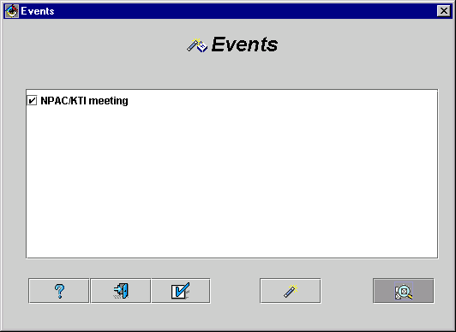
Fig. 5.3. Choosing events from event list
After pressing the “Add new event” button ( icon) one can define a new event. A new window appears to define an event (Fig. 5.4). A user must fill the fields: “Name” with event name, “Place” (where an event took place), “Comment” (user info about an event and its place), “Beginning” and “Ending” dates, “Date comment” (user info about dates, for example “Spring semester of 1998”, “Last week of March”, etc.), and “Event type” (meeting, conference, etc., in a form of a predefined, pull-down menu). Only “Event name”, both “Dates” and “Event place” fields are mandatory (their names are displayed in red), the others do not have to be filled with any text.
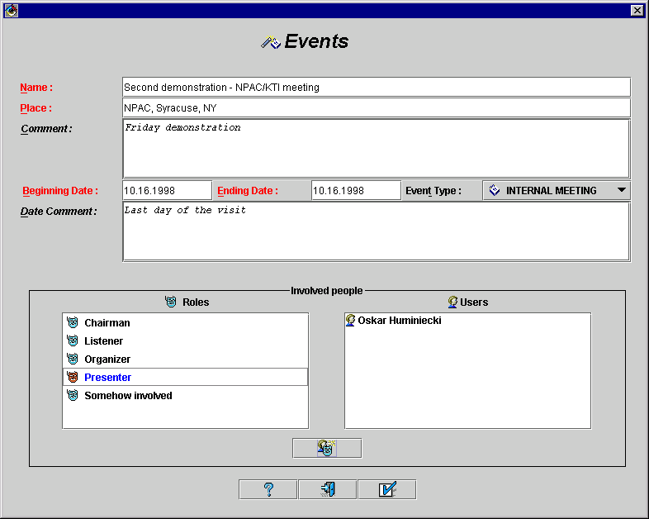
Fig.5.4. Setting a new event
One can also define people involved in the event and their roles. To perform this, he should choose a user and a role from the lists located in the bottom part of the window and press the “Add user for the selected role” button (icon). The list of roles is defined (and maybe edited) by the system administrator. Sample list from Fig. 5.4 includes the following items: “chairman”, “Listener”, “Organizer”, “Presenter”, and “Somehow involved” (i.e., any role different than the above ones). There could be a list of users associated with each role.
After defining all the parameters and choosing users involved in the event one should press the “OK” button ( icon) to store newly created event in the database. The event is automatically added to the event list of the presentation.
There is also a possibility to define an author or a set of authors of the presentation. The name of the user who is currently logged-in is added to the user list by default, and his name is displayed as a first element of the list. By pressing the “Add author” button one can change presentation author(s). A new window appears to select users from the list (Fig. 5.5). Already selected users are marked by their checkboxes set to active. By clicking over a given checkbox one may put or remove a user from the list of presentation authors.
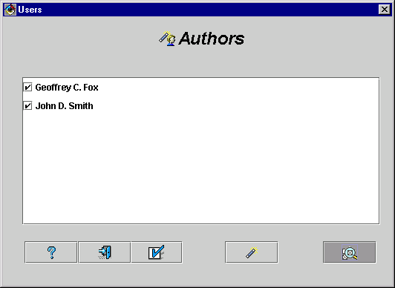
Fig. 5.5. Choosing presentation authors from user list
A new user can be added by pressing the “Add new user” button ( icon) (cf. Section 3.2.3).
A user can also add add-ons for the presentation and change its formatting properties. To add an add-on, he must press “Add addons” button (with icon) from the “Presentation Library Attributes” window. A new window appears to define parameters of a new add-on (Fig. 5.6): a title, an address in URL format, source platform (detailed requirements on hardware and software, e.g. version of the system or browser, required sound card, video stream decoder, etc.), expiration date, window attributes in which the add-on appears on the screen, and a presentation mode. The last parameter defines a way the add-on is invoked: automatic means it is started automatically when its foil or presentation is displayed (in a separate window, however), and manual - it is started by hand after clicking on its title.
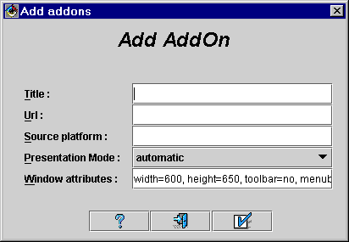
Fig. 5.6. New presentation - adding a new add-on
To change some formatting properties of a newly created presentation, a user must press “Formatting Attributes” button from the Presentation Manager window. A new window appears to set new values of the attributes. The window is similar to the one for setting default values for users’ properties (Section 3.3).
After filling all the obligatory fields in the “Presentation Library Attributes” window, a user can press “OK” button to store attributes of a newly created presentation in the database. The “Presentations by...” sub-window is parted into two separate areas: the left one is used to browse existing presentations, while in the right one contents of the edited presentation is displayed (Fig. 5.7).
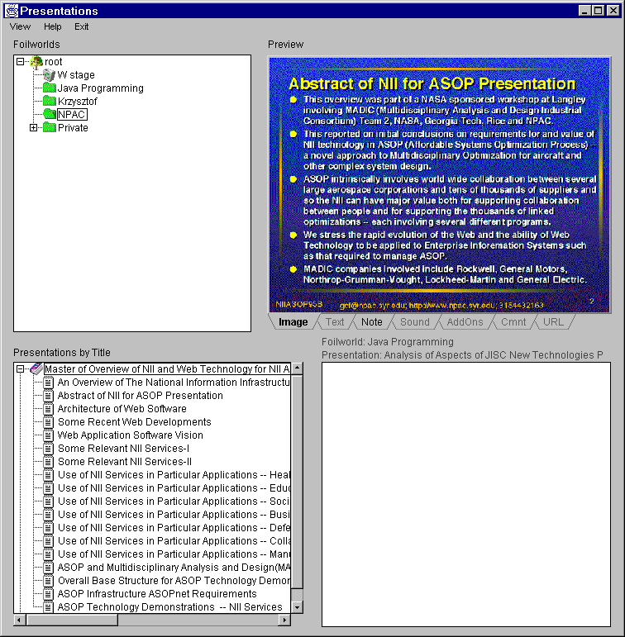
Fig. 5.7. Presentation window - creating an empty presentation
After setting library properties for the presentation, a user may copy to this presentation some foils and sub-presentations from any existing presentation, providing that he has read access to the source presentations. The foils and/or sub-presentations may be copied by setting up source foilworld and source presentation in upper-left and lower-left sub-windows, respectively, and copying marked foils/sub-presentations by choosing “Copy foil” item from pull-down menu for the “Presentations by...” sub-window. The foils/sub-presentations can be also moved from a given presentation to a new one by choosing “Move foil” item. In such a case, however, a user must have write access rights granted to the source foilworld (Fig. 5.8).
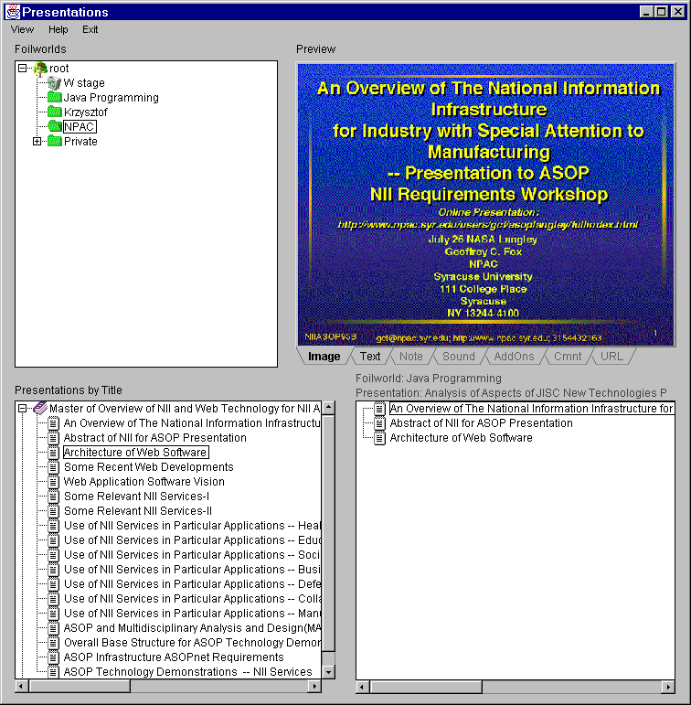
Fig. 5.8. Copying foils and sub-presentations to a new presentation
Note that presentations are copied only logically, i.e. by manipulating their references in the database. Physical educational objects related with presentations (images, texts, sounds, etc.) always exist in one copy and can be shared by multiple presentations.
A user can modify a presentation on condition he has write access to a foilworld the presentation is located. If, however, this presentation is shared by other presentations or foilworlds, a user is informed about this fact. He can decide: edit shared presentation and propagate the changes to all the places this presentation is shared, or abort changing.
Pull-down menu invoked for the lower-right sub-window is equipped in several items: “Set Hidden”, “Set unhidden”, “Set as Presentation Abstract”, “Delete”, “Move up”, “Move down”, “Insert Annotation”, and “Done edit”. By the use of the “Delete” item a user can remove the currently selected foil or sub-presentation from the current presentation. By the use of the “Move up” and “Move down” item one can change the order of foils in the presentation (Fig. 5.9).
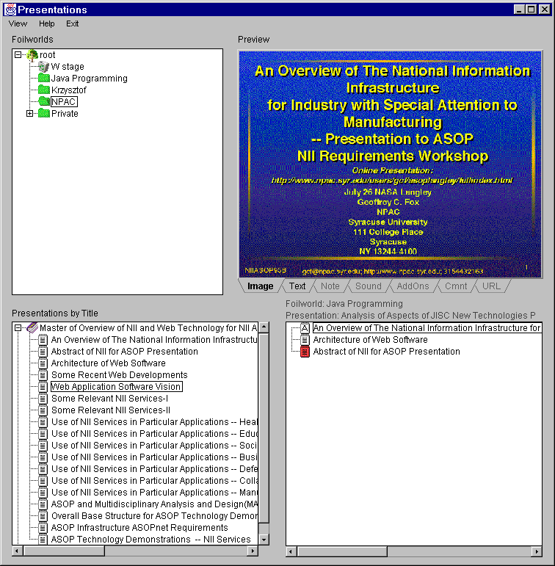
Fig. 5.9. Editing foils and sub-presentations in the presentation
By the use of “Set as Abstract” item a user can set a selected foil as an abstract for the presentation. The abstract is automatically displayed on the screen when the presentation is selected in the presentation window. The abstract may be also used by the Exporter. There is only one abstract for the presentation. If no abstract is selected by default the second foil becomes the abstract. A foil being an abstract of a presentation is marked by icon (cf. Fig. 5.9).
By the use of “Set Hidden” and “Unset Hidden” a user can mark a given foil to be visible or invisible by the Exporter. For example, the abstract foil can be hidden. Hidden foils are marked by red icons, while hidden sub-presentations - by gray icons.
If a foil has a sound associated with it, it is marked by icon.
Once the editing of the new presentation is completed, a user can choose “Done Edit” item to place the presentation in the hierarchy of foilworlds. The newly created presentation disappears from the edit sub-window and appears in the presentation sub-window. Note that there is no “Undo” possibility. Every copying and movement of any foil and/or sub-presentation cannot be rolled-back.
Choosing the “Exit” item from the “Exit” menu removes the window from the screen. All the changes are incorporated into the database.

5.2. Editing existing presentation
The editing of any existing presentation is similar to creation a new one, except a user uses “Edit presentation” item after selecting the presentation in the presentation sub-window. The presentation to be changed is copied to the edit sub-window. After completing the editing process, the modified version of the presentation is stored back in the foilworld hierarchy by choosing “Done exit” item.
During the editing process, foil data may be altered. Data editing is also invoked by pull-down menu obtained by clicking with the right mouse button over a given data type. For most of the data there are three possibilities: save data to a disk file, load data from a disk file, and edit data. For example, HTML text could be edited by the HTML Editor (cf. Chapter 6), image could be load from a file, etc. The most interesting future is, however, editing PowerPoint slides. The source PowerPoint file used to prepare a presentation is cut into individual slides, one slide per presentation foil, and stored in the database (cf. Section 6.1). In addition, a “master” slide is stored for the whole presentation. Each slide can be individually edited by invoking “PowerPoint Editor” item from pull-down menu for edited presentation. A new window is invoked with PowerPoint started inside to edit a slide (Fig. 5.10) with “Master Slide” definition, taken from the whole presentation, applied. PowerPoint is equipped with new menu “Wisdom” with three items: “Begin”, “Update”, and “Cancel”. At the beginning a user must activate the “Begin” item (an appropriate message is displayed in the window). After activating this item a PowerPoint slide to be edited is loaded from the database and presentation “master slide” is applied to it (Fig. 5.11). Only one slide at a time can be edited. Once the slide is edited and the window is closed by the use of the “Update” item, a foil in the database is automatically updated according to the new contents of the slide. Just before loading the slide to the database a user is asked to choose size of the image to be generated for the slide (Fig. 5.12). He should mark one of the four check-boxes with possible image sizes and press the “OK” button. The image and HTML text are then stored in the database, as well as source PowerPoint form for the slide. The editing loop can be repeated. Note that “master” foil remains unchanged.
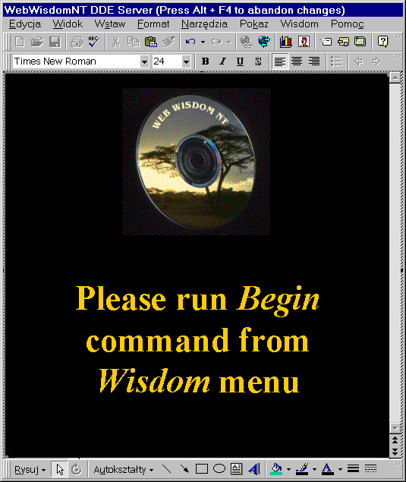
Fig. 5.10. Starting editing single slide by the use of PowerPoint
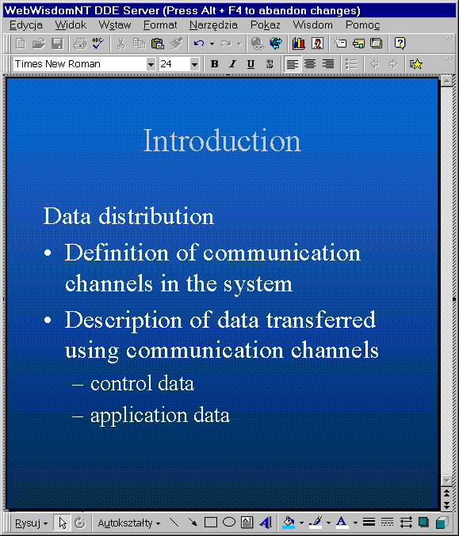
Fig. 5.11. Editing single slide by the use of PowerPoint
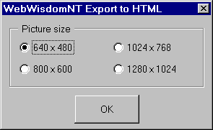
Fig. 5.10. Finishing editing single slide and choosing target image size

5.3. Copying presentation to another foilworld
A selected presentation can be copied to another foilworld by choosing “Add to Foilworld” item form pull-down menu for the “Presentations by...” sub-window. A new window appears on the screen to choose the destination foilworld (Fig. 5.13). Once the destination foilworld is chosen, a selected presentation is copied to it by pressing “OK” button. Pressing the “Cancel” button cancels copying.
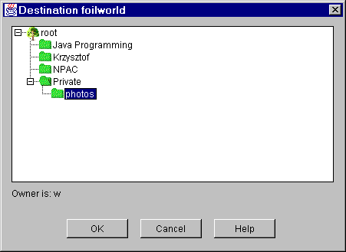
Fig. 5.13. Copying a presentation to another foilworld

5.4. Moving presentation to another foilworld
A selected presentation can be moved to another foilworld by choosing “Move to Foilworld” item. A new window appears on the screen enabling to choose the destination foilworld. The process of choosing the destination foilworld is similar as in “Copying to Foilworld” process described above, except the source presentation is erased from the source foilworld after copying is successfully completed. To perform this action a user must have write access to the foilworld, the presentation was originally located.

5.5. Deleting presentation
To delete the selected presentation, a user must choose the “Delete Presentation” item. The presentation is deleted from the current foilworld. If there are logical copies of the presentation in other foilworlds, or the presentation is used as child presentation in other presentation(s), the other copies remain unchanged. To perform this action a user must have write access to the foilworld the presentation is located.

5.6. Setting abstract for foilworld
One presentation from a foilworld is chosen as this foilworld abstract. If this foilworld is selected, an abstract foil of an abstract presentation is displayed. By default, foilworld has no abstract presentation. To declare a presentation as foilworld abstract one must select this presentation, activate pull-down menu over it and select “Set as Foilworld Abstract” item

5.7. Setting formatting and library attributes
Formatting and library attributes for a presentation and a foil may be edited by selecting this foil/presentation and choosing “Foil library attributes” (“Presentation library attributes”) or “Foil formatting attributes” (“Presentation formatting attributes”). The windows are identical with the ones invoked during creating a new presentation (cf. Section 5.1).

6. Importer
The importer is responsible for storing in the database sequences of images, URL addresses of external HTML pages, HTML and ASCII texts, and presentations either prepared by Microsoft PowerPoint or previously prepared for WebWisdom 1.0 system. There are five possible ways to import a presentation into the database:
- importing PowerPoint presentations converted to HTML format by the WebWisdom-PowerPoint Exporter,
- importing PowerPoint presentations converted both to HTML and RTF formats,
- importing WebWisdom 1.0 presentations regardless the way these presentations were originally prepared (i.e., by the use of PowerPoint, Persuasion, LaTeX, etc.),
- importing a sequence of foils being images, URL addresses, HTML or ASCII text pages.
For the first three possibilities, the importing process is divided into several phases. During the first – obligatory – phase, a temporary directory is prepared with all the files necessary to represent a presentation (including HTML text files, images, add-ons, sounds, PowerPoint sources, etc.). During the second – optional – phase, some files from the temporary directory might be automatically edited to incorporate some additional information (about formatting, sounds, add-ons, etc.). During the third – obligatory – phase, the contents of the temporary directory is read into the database into a special foilworld called “stage”. Presentations from this foilworld are not accessible for the templates and for other users as long as they are not copied to another foilworld by the Presentation Manager (cf. Sections 4 and 5).
For the last possibility, the importing process is divided into two phases – preparing a collection of slides and reading this collection to the database.
In this section importing process is described for the following data formats: original PowerPoint presentations, PowerPoint presentations converted to HTML, improved PowerPoint presentations, WebWisdom 1.0 presentations, and sequences of individual foils.

6.1. Importing PowerPoint presentations
An importing filter is provided to read into the database PowerPoint 95/97 presentation converted to HTML format, cut into individual foils, and stored in a temporary directory. After reading, the newly created presentation may be edited, copied, renamed, etc. by the use of the Presentation Manager presented in the previous chapter.
Below the two obligatory phases are presented of the importing process: (1) creating a temporary directory and HTML files to be imported, and (2) reading HTML files to the database.

6.1.1. Phase 1 - preparation of a temporary directory
To store a PowerPoint presentation in the database, first this presentation must be translated into HTML (text) and GIF/JPEG (images) formats. The files being the results of such translation are stored in a temporary directory and next can be incorporated to the database by the use of the Presentation Loader. To enable the process of translation from the internal PowerPoint format to HTML, a special module WebWisdom-PowerPoint Exporter has been developed. After installation of the module (see Chapter 8 for details on the installation process) Microsoft PowerPoint 97 main menu is extended by pull-down menu "WISDOM" (Fig. 6.1). This menu is composed of two items. The "Export to HTML" item is used to generate a temporary directory containing HTML and image versions of individual foils. In general, an exporter called by the use of this item is similar to "Save as HTML" action called from the "File" menu except the output format is an extension of HTML designed to be used directly by WebWisdom NT system. The extension consists in extending <P> and </P> tags by an attribute describing bullet level (see description of the SPT format in the last section of this chapter).
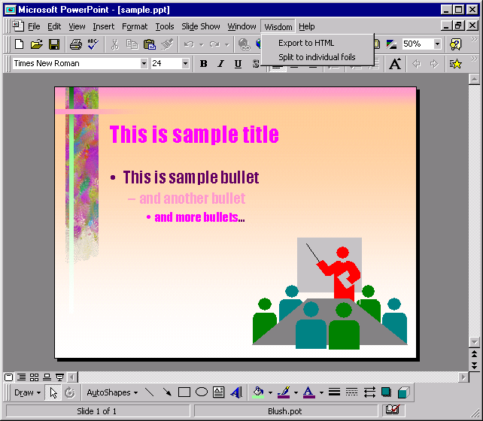
Fig. 6.1. PowerPoint 97 extended by the "WISDOM" menu
After calling "Export to HTML" action a new window is invoked (Fig. 6.2) to set two parameters for the HTML exporter: size of the images (from 640x480 points to 1280x1024 points) and location of an output directory. The image size is defined by four "radio" buttons labeled by possible dimensions. The output directory is displayed in the text field located below the radio buttons. It can be set by pressing "Browse..." button and choosing a directory from the displayed list (Fig. 6.3).
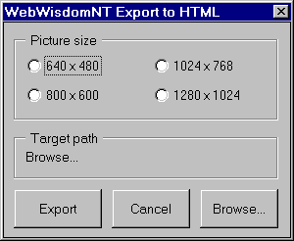
Fig. 6.2. Setting parameters for WebWisdom NT exporter
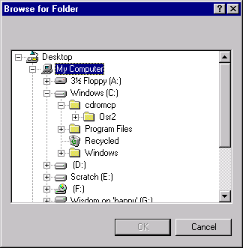
Fig. 6.3. Choosing location for the output directory
Once a directory is chosen and the "Export" button is pressed, the whole PowerPoint presentation is exported to this directory as a set of HTML files with corresponding images. The exporting process is reported on-line by the use of a progress bar. The exporting process can be interrupted in every moment by pressing the "Interrupt" button located below the bar (Fig. 6.4).
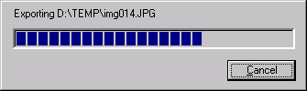
Fig. 6.4. Reporting on-line the exporting process
The exporter described above uses file name convention similar to original PowerPoint-to-HTML exporter. The foils are stored in TSLDnnn.HTM files, where nnn is current foil number, and the images - in TSLDnnn.JPG files. The SLDnnn.HTM files with text-and-graphic versions of foils are not generated, as they are not used by WebWisdom NT system. In addition, the file INDEX.HTM is generated. It is a "table of contents" of the presentation in HTML format.
The second item of the "Wisdom" menu labeled "Split to individual foils" is used to cut a PowerPoint presentation into individual foils and a "master" foil (formatting pattern for each foil of the presentation). After invoking this item a window appears (Fig. 6.5) to choose an output directory in a way described above and start the splitting process.
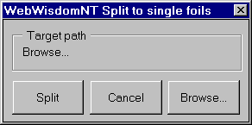
Fig. 6.5. „Split to foils” window
Once the directory is chosen and the „Split” button is pressed, each presentation foil is stored in a separate *.ppt file, and the "master" foil is stored in *.pot file. Next the foils with their "master" foil can be incorporated into the database to enable editing individual foils (cf. description of the Presentation Manager in Chapter 4).

6.1.2. Phase 2 - incorporating contents of the temporary directory to the database
The temporary directory prepared in the first phase is scanned during the second phase and its content is read into the database. To perform this task, a user must press “Load Presentation” button in the main window. As a result, a new window appears to select the temporary directory in which the prepared presentation is stored (Fig. 6.6).
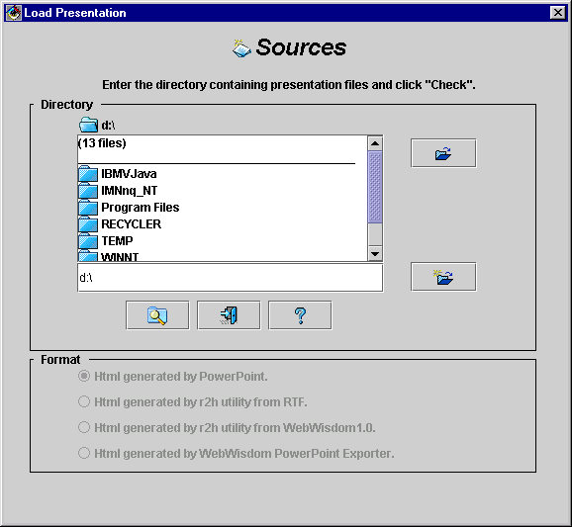
Fig. 6.6. Setting the temporary directory as an input for the second phase of importing process
In this window, a user can set up the directory by selecting its name from the list and pressing the „Explore” button ( icon), or writing a directory name manually in the text field below the directory list and pressing the „Open” button ( icon). Full name of the currently set directory is displayed above the list. Once the directory is chosen, a user should press the „Check” button ( icon) to determine the contents of this directory. If the directory contains HTML files being a processed PowerPoint presentation, a radio button “HTML generated by PowerPoint” is set to “on” and a new button „Store this presentation” ( icon) appears in the left-bottom part of the window (Fig. 6.7). A message appears near-by telling how many slides are included in the directory and whether the source PowerPoint (*.ppt) file is included. If the selected directory does not contain any HTML files being a presentation, or the presentation is not complete, a message appears “This directory does not contain coherent data”. In such case, a user should chose another directory. Note that if the temporary directory does not contain valid HTML presentation, button “Store” disappears, thus the data cannot be stored.
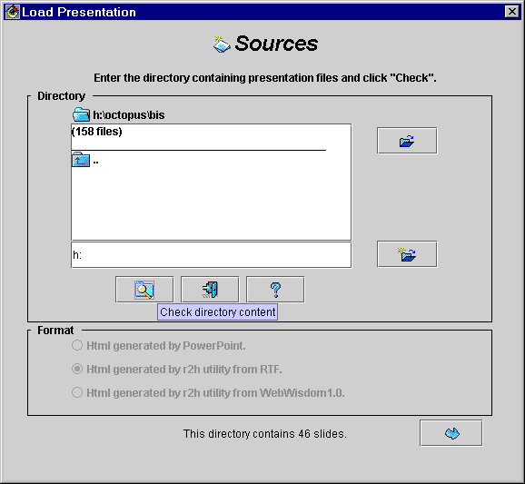
Fig. 6.7. Checking the contents of the temporary directory
If the directory content is correct, a user may press “Store” button and incorporate the presentation into the database. A new window appears on the screen to set up the presentation attributes (Fig. 6.8). This window is similar to the window for setting up the attributes for a newly created or edited presentation (cf. Chapter 5).
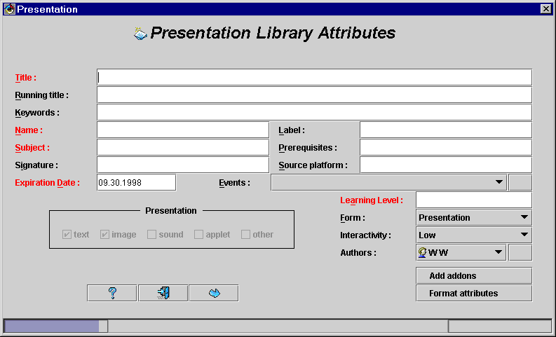
Fig. 6.8. Setting up presentation attributes
The window is composed of three parts. In the upper part there are some text fields to define values of attributes. The names of attributes with obligatory values are displayed in red. The obligatory fields are the following: title of the presentation, its name (unique, space-less string of characters being presentation identifier in the database), subject (knowledge domain of the presentation), expiration date (date the presentation should not be used anymore), and learning level (a pair of age:skill).
In the middle part there is „Presentation info” field and some buttons and pull-down lists. In the „Presentation info” field an information is provided whether the presentation contains only texts and images, or it is extended by sounds, and other elements. By the use of the „Add addon” button located in the right-middle part of the window a user can also add an add-on for a presentation (cf. Section 4.1), while by the use of the „Format attributes” button - change its formatting attributes (cf. Section 3.1).
There are two pull-down lists located in the middle part. The upper one is used to define events related to the presentation. The first event from the list is displayed near the symbol. Pressing this symbol displays the whole list in a pull-down manner. To add an event to the list one should press the „Add and create events” button located on the right of the list. A new window appears to select or define new events (cf. Chapter 4).
A list of authors of the presentation is managed in the same way. By pressing the „Add and create authors” button one can edit a list of authors of the presentation. A new window appears to declare which users are authors of the presentation (cf. Chapter 4).
After filling all the obligatory fields and pressing “OK” button ( icon), this window disappears and a new window appears instead to define attributes for the foils of the presentation (Fig. 6.9). The foil attributes may be either filled manually, i.e. by filling the fields of the window, or automatically, by copying attribute values from the presentation attributes (pressing  icon in lower-left part of the window) or from the previous foil (pressing  icon). The graphical form of a foil, i.e., an image generated by PowerPoint, is displayed in right part of the window. A user is requested to fill the following fields: title (mandatory), subject (mandatory), keywords (mandatory), form (mandatory, pull-down list), interactivity (mandatory, pull-down list), expiration date (mandatory), image style (mandatory, pull-down list with the following elements: image essential - HTML form does not contain all the information necessary to display a foil, image useful - HTML form may be used, but some information is missing, image as HTML form - no information is missing while using HTML form instead an image, and no image), hardware and software platform (optional), signature (optional), sound related to a foil (optional, pull-down list of detected sound files; default a sound file with the same number as the current foil is displayed, if it exists), and time which should be reserved to present a foil (optional, in seconds, usually related to a playing time of a sound file for a foil).
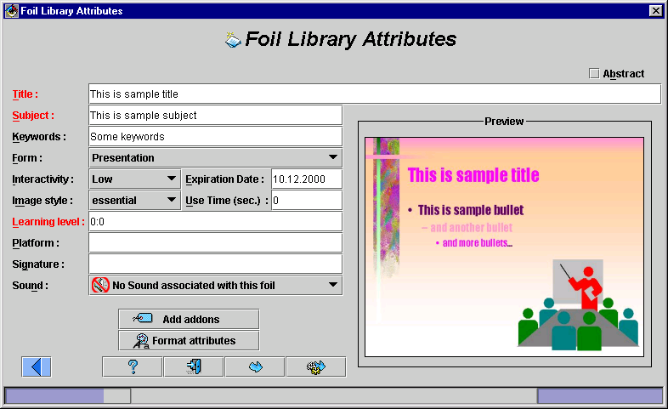
Fig. 6.9. Setting the attributes for a foil of a presentation being imported
In the upper-right corner of the window a check-box is located labeled „Abstract”. If this check-box is set to on, the current foil becomes an abstract of the presentation. If an abstract has been already set to be one of the previously defined foils, the previous selection may be overwritten here. If no foil is selected as an abstract, automatically the second foil of the presentation becomes an abstract.
In the bottom part of the window a few buttons are located. Their meaning is described below:
- “OK” button ( icon) - sending the current foil to the database, and proceeding to fill parameters for the next foil,
- “OK for all” button - sending the current foil and the remaining foils to the database, automatically setting the attribute values for each foil as equal to the values which are set for the current foil or automatically generated values – where possible,
- “Exit” button ( icon) - exiting the importer; no presentation is put to the database,
- “Add add-ons” button - defining/editing an add-on for the current foil (cf. Section 4.1),
- “Formatting attributes” button - defining formatting attributes, e.g., fonts and background images (cf. Section 4.1).
After setting the attributes for all foils of the presentation, the newly imported presentation is stored in a foilworld named “stage”. There is separate “stage” foilworld for every user. After successful reading, the presentation may be edited by the Presentation Manager, copied to another place in the foilworld hierarchy, used as a part of another presentation, etc. (cf. description of the Presentation Manager in Section 4). Note that presentations from the “stage” foilworlds cannot be edited, they must be first either copied or moved to other foilworlds.

6.2. Importing RTF-based PowerPoint presentations
An importing filter is provided to read into the database PowerPoint 95/97 presentation converted to both RTF and HTML formats and stored in temporary directory. RTF outline of the presentation is used to enrich HTML files with some information about text formatting, in general these are colors, font sizes and font types (families). Moreover, some user-defined attributes may be added to the HTML files by the use of the configuration utility. After reading, the newly created presentation may be edited, copied, renamed, etc. by the use of the Presentation Manager presented in the previous chapter.
Below, the configuration utility and the four phases of the importing process are presented: (1) creating a temporary directory and HTML files to be imported, (2) creating an outline of the presentation in RTF format, (3) compiling RTF outline and generating new improved HTML files, and (4) reading HTML files to the database.

6.2.1. Configuration utility
The compiler from RTF outline to the database internal format uses some user-defined parameters. These parameters are stored in a configuration file named “r2h.ini” located always in the temporary directory. This file has a format similar to RTF. Each command must begin with slash character ‘\’ and can be followed by any number of white spaces. If a command is followed by a parameter, this parameter must be included in ‘”’ characters and must not exceed one line. Everything that is not a command or a parameter is ignored, including all white spaces, newlines, tabs, etc. The meaning of all the configuration parameters is explained in the table below. Note that some of the commands are similar to WebWisdom 1.0 commands for formatting a foilset (for details see next section about importing WebWisdom 1.0 presentation). Some of the commands are not used while converting from RTF to HTML. These commands are printed in italics.
Configuration parameter | Meaning | Possible values | Defaults
\inputfile | name of the main translation file | file name | "course.gcf"
\outputdirectory | name of the directory with files being result of the compilation; this name must be either ended by (back)slash or null | directory name | ""
\scriptfile | name of the script for copying image files | file name | "cp_imgs"
\scripttype | type of the script for copying image files | "u*", "d*" | "unix"
\scriptcopycommand | name of the command to copy image files | "cp", "copy" | "copy"
\outputstyle | style of the generated HTML foil | "paragraphs", "bullets", "tables" | "paragraphs"
\tableattributes | HTML attributes of <TABLE> element "border=N cellspacing=N cellpadding=N width=NN%" | "*" | ""
\scale | font scaling for RTF (PowerPoint) translator, must be a number 0..1000, always taken as a percentage (100% - no scaling, 50% - divide font sizes by two, etc.) | "NNN%" | "100%"
\fonts | font family, three first characters are meaningful, possible values are: "windows" and "iso"; currently used only for Polish language and families "windows-1250" and "iso-8859-2" which differ by three national character codes | "win*", "iso" | "iso"
\links | adding PowerPoint-like table with links to previous and next foil at the end of the current foil; if this command is omitted, there is no table with links
\previous | text displayed as link to previous foil | "*" | "Previous"
\next | text displayed as link to next foil | "*" | "Next"
\graphics | text displayed as link to graphical version of a foil | "*" | "Graphics"
\contents | text displayed as link to table of contents | "*" | "Table of Contents"
\text | text displayed as link to text version of a foil | "*" | "Text"
\iconwidth | horizontal size in pixels of an icon with foil image in table of contents | "NNN" | "200"
\iconheight | vertical size in pixels of an icon with foil image in table of contents | "NNN" | "150"
\sethtmlbgfile | name of the file set as background for the text form of the foil | "*" | ""
\setimagebgfile | name of the file set as background for the graphical form of the foil | "*" | ""
\titlefontsize | font size for the title of a foil | "1..7" | ""
\intablefontsize | font size for the table inside a foil | "1..7" | ""
\bgcolor | background color for the foil | "*" | ""
\intablebgcolor | background color for the tables inside a foil | "*" | ""
\fgcolor | text color for the foil | "*" | ""
\linkcolor | link color for the foil | "*" | ""
\alinkcolor | active link color for the foil | "*" | ""
\vlinkcolor | visited link color for the foil | "*" | ""
\imagelinkcolor | link color for the foil | "*" | ""
\imagealinkcolor | active link color for the foil | "*" | ""
\imagevlinkcolor | visited link color for the foil | "*" | ""
\tablelinkcolor | link color for the foil | "*" | ""
\tablealinkcolor | active link color for the foil | "*" | ""
\tablevlinkcolor | visited link color for the foil | "*" | ""
\htmltitlecolor | title color for the text form of a foil | "*" | ""
\imagetitlecolor | title color for the graphics form of a foil | "*" | ""
\horizimagewidth | horizontal size of the foil image | "NNNN" | ""
\horizimagestyle | type of setting size of foil image; if does not set to "native", the "horizimagewidth" command parameter is taken into consideration | "maximum", "minimum", "native", "exact" | "native"
\vertimagewidth | vertical size of the foil image | "NNNN" | ""
\vertimagestyle | type of setting size of foil image; if does not set to "native", the "vertimagewidth" command parameter is taken into consideration | "maximum", "minimum", "native", "exact" | "native"
To deal with configuration files in the temporary directories, the configuration utility is provided which is equipped with full graphical user interface. Unlike other WebWisdom NT tools, this tool can be invoked as a separate applet, but usually it is invoked as a part of RTF-to-database compilation process (cf. next section). The applet used separately does not communicate with the database, and it is used only to determine the contents of a configuration file from the temporary directory. Sample invocation scripts for this applet and for UNIX- and DOS-based systems are presented in Fig. 6.10 and 6.11, respectively.
SET ENV=2000
SET CLASSPATH=.;..\classes111.zip;..\symbeans.jar;util;..\sym\classes.zip;..\sym\symclass.zip
cd \wisdom\pm\r2h
appletviewer run.html
Fig. 6.10. Invocation script for the configuration utility, DOS version
CLASSPATH=$CLASSPATH:.:/u/java/oracle/jdbc/lib/classes111.zip:/u/public/Symantec/symbeans.jar
export CLASSPATH
cd /u/public/programs/wisdom/pm/r2h
/usr/java/bin/appletviewer run.html
Fig. 6.11. Invocation script for the configuration utility, UNIX ksh-version
After applet invocation a new window appears (Fig. 6.12) to deal with configuration parameters stored in r2h.ini configuration file. As the same tool is used to define parameters for importing WebWisdom 1.0 presentation (cf. next section), some fields (used only for preparing standalone presentations or importing WebWisdom 1.0 presentations) are set as inactive. An inactive field cannot be changed, which is marked by displaying both label and contents of such field in gray. The contents of an inactive field may be, however, set automatically to a system-defined value and then used by the compiler.
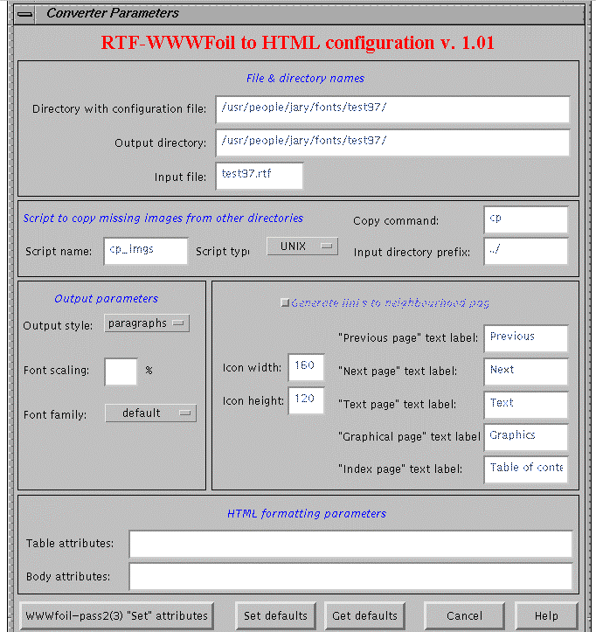
Fig. 6.12. Defining basic parameters for compiling RTF-based presentation
There are five buttons located in the bottom part of the window:
- “WWWfoil-pass2(3) “Set” attributes” button is used to define some formatting and library parameters, mainly used by the importer from WebWisdom 1.0 format (see the table with configuration parameters in Section 6.2.1),
- “Set defaults” button is used to create a new configuration file; previous version of this file – if exists – is erased; if a user has no rights to write to the selected directory, or the directory does not exists, a message is displayed on the screen and nothing is written,
- “Get defaults” button is used to read a configuration file r2h.ini from a directory pointed by “Directory with configuration file” field; if a user has no rights to read the contents of the selected directory, or the file does not exists, a message is displayed on the screen and nothing is read (i.e., all parameters remain unchanged),
- “Cancel” button is used to exit the window and continue the compilation process with no modification of configuration parameters,
- “Help” button is used to display a “help” text about the configuration utility.
As it was previously mentioned, the configuration utility may be used also in a standalone way (i.e., outside the Presentation Loader) to determine the contents of a configuration file r2h.ini in a given directory. Thus, while invoking this utility from the Presentation Loader, some fields are set as inactive – they cannot be changed by the user, but they may be used by the compiler. The inactive fields are displayed in gray.
Setting all the parameters is not necessary. The undefined values will be automatically set during compilation to compiler defaults. A given parameter is undefined if either its value is empty, or (if a parameter has a list of possible values) its value is defined as “default”.
The window is composed of six parts. In the first part labeled “File & Directory Names”, a user may set:
- a name of the temporary directory, i.e., a name of the directory to which the configuration file will be copied after pressing “Set defaults” button (or read by pressing “Get defaults” button);
- a name of an output directory, i.e., a name of a directory which will serve as a temporary directory for the r2h compiler described in the next section; files being inputs and results of the compilation are read/written to this directory; empty field means that the current directory is the temporary one;
- a name of a file being main input for r2h compiler (see next section for details).
In the second part of the window labeled “Script to copy missing images from other directories” some parameters are defined for copying by hand missing images while importing WebWisdom 1.0 presentation (for details see next section about importing from WebWisdom 1.0 system). These parameters are the following:
- script name, i.e., a name of a file which will be generated as a script to copy missing images,
- a name of a command to copy files (mainly “cp” command for UNIX and “copy” command for DOS-based systems),
- type of the script (UNIX shell script or DOS/WINDOWS “*.bat” file),
- a prefix for input file names (usually, one level down in the directory structure).

In the third part of the window labeled “Output parameters” a user may chose:
- style of the generated output (i.e., style of HTML files being results of the compilation); the possible choices are: paragraphs (lists of HTML paragraphs), bullets (HTML bulleted lists), and tables (HTML tables); note that only the first value is accepted by the database (see next section for details);
- font scaling factor, as a percentage (e.g., 100% means a font sizes are unchanged, 50% - they will be two times smaller, etc.),
- font family, used to define national font families (see the table above for details).

In the fourth part of the window labeled “Generate links to neighborhood pages” a user may:
- generate “Next”, “Previous”, “Graphical version”, “Text version”, and “Index” buttons in every HTML file being a foil; in such a case, output generated by the compiler is treated as a stand-alone, PowerPoint-like presentation, not to be imported to the database,
- set texts which are displayed on the screen over buttons while a user select a button by mouse pointer (only while displaying stand-alone presentation using standard HTML browser),
- set sizes of icons displayed in the index file (i.e., a file called “index.htm” containing a table with links to all the foils of the stand-alone presentation).
Note that these parameters are not used by the database, thus “Generate links to neighborhood pages” check-box must be off while importing a presentation to the database.
In the fifth part of the window a user may set attributes used for <TABLE> and <BODY> HTML tags while generating a stand-alone presentation. These values are not used while importing a presentation to the database.
While invoking the configuration utility from the Presentation Loader, the only active fields are: “Font scaling” and “Font family”.
By pressing “WWWfoil-pass2(3) “Set” parameters” button a user may set some additional parameters used to pre-format a presentation and/or its foils. A new window appears on the screen with six frames: “Library attributes”, “Colors”, “Images”, “Fonts”, “Links”, and “Sizes”. There are five buttons located in the bottom part of the window. By the use of “Exit&Done” button a user may store the newly defined values of the parameters in the configuration file. By pressing “Cancel” button it is possible to discard all the changes made in the window and go back to the main window of the configuration utility. Buttons “Get defaults”, “Set defaults”, and “Help” have the same meaning as for the main window.
The “Library attributes” frame (Fig. 6.13) is used to set some attributes specific for library use, e.g., a name of the presentation, author name, date of the modification, etc. These parameters are not used by the database directly (except “Title” and “Signature” parameters), although they may be used by the exporter and user-defined templates. The unused parameters are displayed in gray, while the used ones - in black. For details see a description of WebWisdom 1.0 “Set” parameters in the next section.
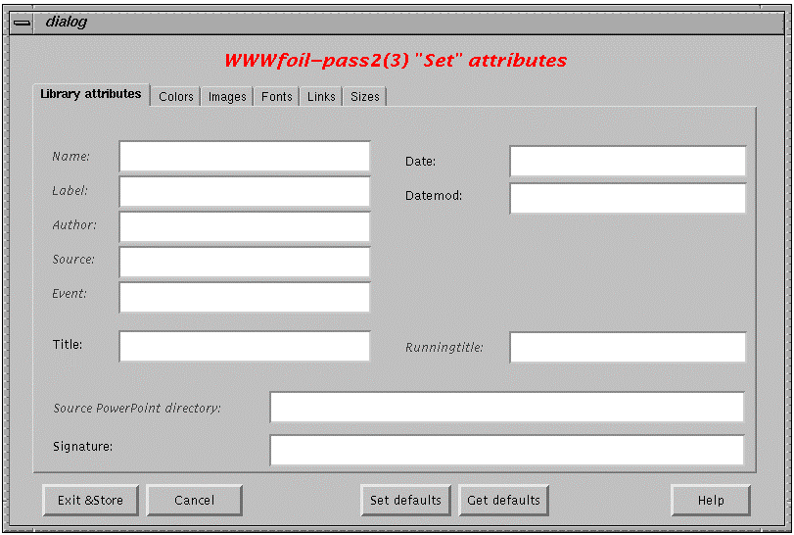
Fig. 6.13. Defining “Library” properties
The “Colors” frame (Fig. 6.14) is used to define names of colors for backgrounds and fonts (for texts inside a foil and titles). The colors are defined for text versions of foils (i.e., while displaying a text HTML version of a foil), for graphical versions (i.e., while displaying an image form of a foil), and for foils being or containing HTML tables. The color names should be defined in the database (cf. setting “Defaults” in the previous section). During compilation, these names are verified and the undefined colors are not taken into consideration.
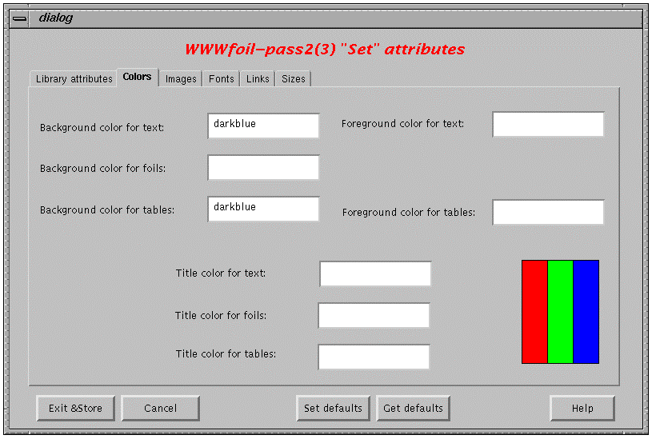
Fig. 6.14. Defining “Color” properties
The “Images” frame (Fig. 6.15) is used to define images used as backgrounds for foils. The images are defined for text versions of foils, for graphical versions, and for foils being or containing HTML tables. The image names should be defined in the database (cf. setting “Defaults” in the previous section). During compilation, these names are verified and the undefined images are not taken into consideration.
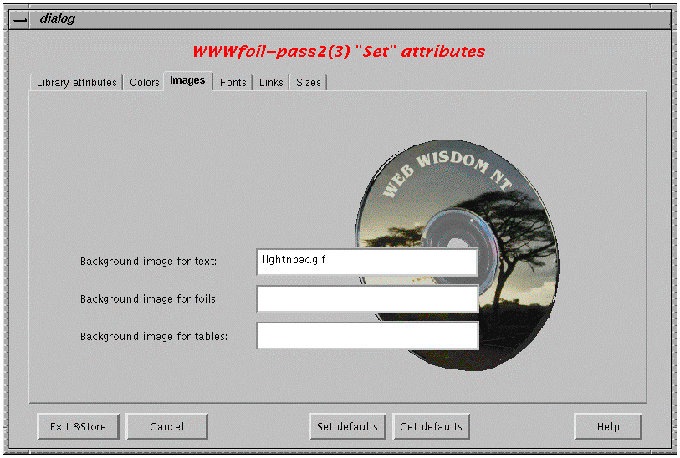
Fig. 6.15. Defining “Images” properties
The “Fonts” frame (Fig. 6.16) is used to define font sizes used to display a text inside a foil, a text inside a table, and a foil title. Font sizes are defined in HTML style as values from 1 (the smallest font) to 7 (the biggest one).
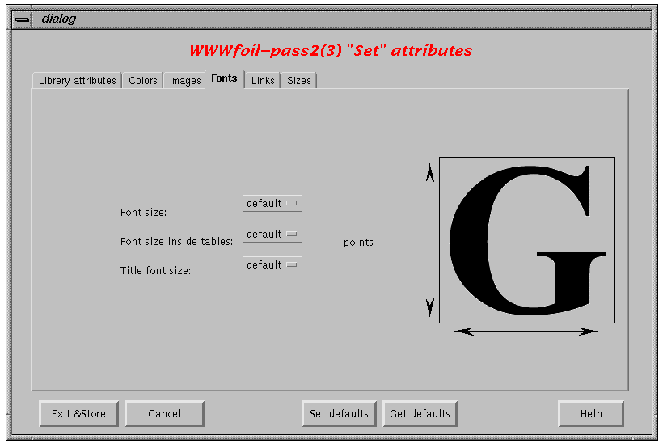
Fig. 6.16. Defining “Fonts” properties
The “Links” frame (Fig. 6.17) is used to define colors of links: un-visited, visited and active, for text, graphical, and table forms of foils. The color names should be defined in the database (cf. setting “Defaults” in the Section 2). During compilation, these names are verified and the undefined colors are not taken into consideration.
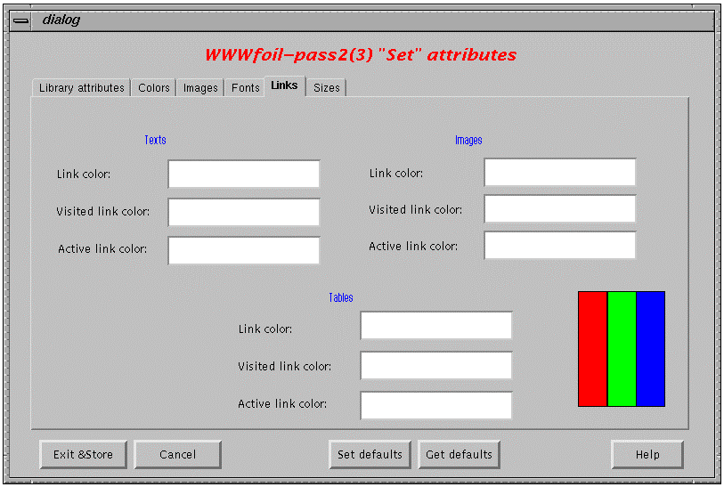
Fig. 6.17. Defining “Links” properties
The “Sizes” frame (Fig. 6.18) is used to define style of displaying images. The defined style, both for horizontal and vertical directions, should be defined as: native (i.e., an image is displayed in its original size), minimum (i.e., an image is displayed not smaller than a given size), maximum (i.e., an image is displayed not bigger than a given size), exact (i.e., an image is displayed in an exact size defined near-by). The latter three choices should be accompanied by setting a value in the appropriate “Size” field.
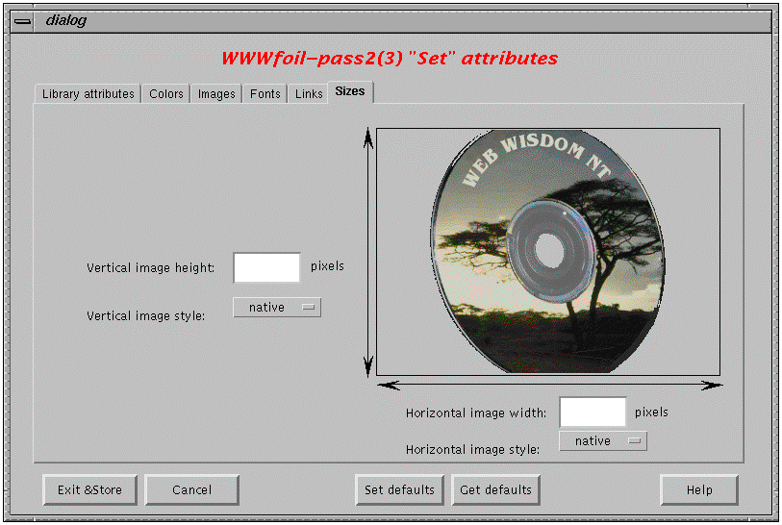
Fig. 6.18. Defining “Sizes” properties

6.2.2. Phase 1 - copying PowerPoint/HTML presentation to temporary directory
This phase is similar to the first phase of reading PowerPoint presentation (cf. Point 6.2.1).

6.2.3. Phase 2 - generating RTF outline of the presentation
Outline of the presentation in RTF (Reach Text Format) can be generated by “Save As Outline (RTF)” command from “File” menu of PowerPoint95/97.

6.2.4. Phase 3 - compiling RTF outline and enriching HTML files
A user can invoke RTF/HTML compiler to enrich the HTML files located in the directory (originally generated by PowerPoint) by some formatting information (colors, fonts, sizes, etc.) extracted from RTF file. This compiler should be run as typical DOS/UNIX executable program in the temporary directory. The main input for the compilation is an RTF file generated in the second phase. Based on this file a set of HTML files is generated: files index.htm (text and graphical index of foils), sldNNN.htm (graphical forms of foils), and tsldNNN.htm (text forms of foils). The files mentioned above overwrite the respective HTML files originally generated in the first phase. Files with images generated in the first phase - slsNNN.gif and/or sldNNN.jpg and/or imgNNN.jpg - remain unchanged. Detailed description of the performed compilation process is generated to the file named “r2h.out” in the current directory (Fig. 6.19).
Fig. 6.19. Files read and written during third phase of the importing process
Note that attributes from r2h.ini configuration file (cf. Point 6.2.1) are automatically incorporated to the database, as well as add-on definitions (files sldNNN.adi) and sounds (files sldNNN.rai and sldNNN.ra). The two latter, however, must be in the format of WebWisdom 1.0 system (for details see next section about compiling WebWisdom 1.0 presentations).
The output generated by the compiler is the following.
- file index.htm
An HTML file with index to both text and graphics forms of foils. Sample file is presented in Fig. 6.20.
- files tsldNNN.htm
It is a set of HTML files being text forms of foils. Each file exists in one of the following styles:
- “paragraphs” - an output is a set of HTML paragraphs marked by <P> tags with two attributes: bulleting level and end indicator. Tag <P L=”0”> means a paragraph is a foil title. Tag <P L=”N”> means a paragraph is a bullet of level N. There are nine bulleting levels, numbered from 1 to 9, respectively. The greater the bulleting level is, the more the bullet should be right-indented and its text should be smaller. Tag with attribute E=”1” marks the last paragraph in the file. A sample HTML file in the style “paragraphs” is presented in Fig. 6.21;
- “bullets” - an output is an HTML unnumbered list generated by the use of <UL>, <LI>, </LI>, and </UL> tags. A sample HTML file in the style “bullets” is presented in Fig. 6.22. This style is not intended to be used by the database. It is provided only for compatibility with standard PowerPoint presentations converted to HTML and can be used to generate a standalone presentation;
- “tables” - an output is an HTML table generated by the use of <TABLE>, <TD>, </TD>, and </TABLE> tags. A sample HTML file in the style “tables” is presented in Fig. 6.23. As the previous style, this style is also not intended to be used by the database.
- files sldNNN.htm
It is a set of HTML files being graphical forms of foils. A sample sldNNN.htm file and its view in HTML browser are presented in Fig. 6.24. The format of these files is similar to files being PowerPoint presentations converted to HTML format.
<HTML>
<HEAD>
<META NAME="generator" CONTENT="PowerPoint Outline(RTF)/WWWfoil to HTML converter">
<!--Global Attributes
-->
<META HTTP-EQUIV="content-type" CONTENT="text/html; charset=iso-9959-1">
<TITLE> Overview foils for NPAC Database Activity including Web March 1995 </TITLE>
</HEAD>
<BODY>
<P>
<FONT SIZE=+2> <B>
Overview foils for NPAC Database Activity including Web March 1995
</FONT> </B>
</P>
<P>
<CENTER>
<TABLE WIDTH=90% BORDER=4>
<TR> <TD VALIGN=top ALIGN=left WIDTH=80%>
<A HREF="tsld000.htm"> <B>Abstract:</B>
Four Related Information Infrastructure Thrusts at NPAC</A>
</TD>
<TD WIDTH=20% ALIGN=center>
<A HREF="sld000.htm">
<IMG SRC="sld000.gif" WIDTH=80 HEIGHT=40 BORDER=0 ALT="Graphics"></A>
</TD> </TR>
<TR> <TD VALIGN=top ALIGN=left WIDTH=80%>
<A HREF="tsld001.htm">
Integrated Database and Web Technologies at NPAC </A>
</TD>
<TD WIDTH=20% ALIGN=center>
<A HREF="sld001.htm">
<IMG SRC="sld001.gif" WIDTH=80 HEIGHT=40 BORDER=0 ALT="Graphics"></A>
</TD> </TR>
<TR> <TD VALIGN=top ALIGN=left WIDTH=80%>
<A HREF="tsld002.htm"> Four Related Information Infrastructure Thrusts at NPAC</A>
</TD>
<TD WIDTH=20% ALIGN=center> <A HREF="sld002.htm">
<IMG SRC="sld002.gif" WIDTH=80 HEIGHT=40 BORDER=0 ALT="Graphics"></A>
</TD> </TR>
</TABLE>
</CENTER>
</P>
</BODY>
</HTML>
Fig. 6.20. Sample index.htm file generated by the compiler
HTML>
<HEAD>
<META NAME="generator" CONTENT="PowerPoint Outline(RTF)/WWWfoil to HTML converter">
<!—Foil Attributes
-->
<META HTTP-EQUIV="content-type" CONTENT="text/html; charset=iso-9959-1">
<TITLE> Four Related Information Infrastructure Thrusts at NPAC </TITLE>
</HEAD>
<BODY>
<P L=0>
<FONT SIZE=4 COLOR=cyan>
Four Related Information Infrastructure Thrusts at NPAC
</FONT>
</P L=0>
<P L=1>
Use and Evaluation of Parallel Relational Databases
</P L=1>
<P L=2>
Oracle DB2 Sybase on IBM SP-2 and Oracle on nCUBE
</P L=2>
<P L=1>
High Performance Video and Multimedia Servers
</P L=1>
<P L=2>
InfoVision -- Information, Video, Simulation, Imagery on demand
</P L=2>
<P L=1>
WebWindows -- an informal collaboration of Internet developers
</P L=1>
<P L=2>
(Parallel) Web Servers enhanced with CGI scripts to support a full world-wide distributed operating environment
</P L=2>
<P L=1>
Integration of these three technologies
</P L=1>
<P L=2>
Web Interfaces to Relational Databases
</P L=2>
<P L=2 E=1>
Web Interfaces to Multimedia data with relational databases holding text indices for video
</P L=2 E=1>
</BODY>
</HTML>
Fig. 6.21. Sample tsldNNN.htm file in “paragraphs” style generated by the compiler
<HTML>
<HEAD>
<META NAME="generator" CONTENT="PowerPoint Outline(RTF)/WWWfoil to HTML converter">
<!—Foil Attributes
-->
<META HTTP-EQUIV="content-type" CONTENT="text/html; charset=iso-9959-1">
<TITLE> Four Related Information Infrastructure Thrusts at NPAC </TITLE>
</HEAD>
<BODY>
<P>
<FONT SIZE=4 COLOR=cyan>
Four Related Information Infrastructure Thrusts at NPAC
</FONT> </P>
<P>
<UL> <LI>
Use and Evaluation of Parallel Relational Databases
</LI>
<UL>
<LI>
Oracle DB2 Sybase on IBM SP-2 and Oracle on nCUBE
</LI>
</UL>
<LI>
High Performance Video and Multimedia Servers
</LI>
<UL>
<LI>
InfoVision -- Information, Video, Simulation, Imagery on demand
</LI>
<LI>
Our servers connected to ATM and ISDN access networks
</LI>
</UL>
<LI>
WebWindows -- an informal collaboration of Internet developers
</LI>
<UL>
<LI>
(Parallel) Web Servers enhanced with CGI scripts to support a
full world-wide distributed operating environment
</LI>
</UL>
<LI>
Integration of these three technologies
</LI>
<UL>
<LI>
Web Interfaces to Relational Databases
</LI>
<LI>
Web Interfaces to Multimedia data with relational databases
holding text indices for video
</LI>
</UL>
</UL>
</P>
<P> <TABLE>
<TD HEIGHT=100 WIDTH=100> <A HREF="tsld001.htm">Previous</A> </TD>
<TD HEIGHT=100 WIDTH=100> <A HREF="tsld003.htm">Next</A> </TD>
<TD HEIGHT=100 WIDTH=100> <A HREF="sld002.htm">Graphics</A> </TD>
<TD HEIGHT=100 WIDTH=100> <A HREF="index.htm">Contents</A> </TD>
</TABLE> </P>
</BODY>
</HTML>
Fig. 6.22. Sample tsldNNN.htm file in “bullets” style generated by the compiler
<HTML>
<HEAD>
<META NAME="generator" CONTENT="PowerPoint Outline(RTF)/WWWfoil to HTML converter">
<!--Foil Attributes
-->
<META HTTP-EQUIV="content-type" CONTENT="text/html; charset=iso-9959-1">
<TITLE> Four Related Information Infrastructure Thrusts at NPAC </TITLE>
</HEAD>
<BODY>
<P>
<FONT SIZE=4 COLOR=cyan>
Four Related Information Infrastructure Thrusts at NPAC
</FONT>
</P>
<P>
<TABLE border=3 cellspacing=2 cellpadding=2 width=90%>
<TR> <TD> Use and Evaluation of Parallel Relational Databases </TD> </TR>
<TR> <TD></TD> <TD> Oracle DB2 Sybase on IBM SP-2 and Oracle on nCUBE </TD> </TR>
<TR> <TD> High Performance Video and Multimedia Servers </TD> </TR>
<TR> <TD></TD> <TD> InfoVision -- Information, Video, Simulation, on demand </TD> </TR>
<TR> <TD></TD> <TD> Our servers connected to ATM and ISDN access networks </TD> </TR>
<TR> <TD> WebWindows -- an informal collaboration of Internet developers </TD> </TR>
<TR> <TD></TD> <TD> (Parallel) Web Servers enhanced with CGI scripts to support
a full world-wide distributed operating environment </TD> </TR>
<TR> <TD> Integration of these three technologies </TD> </TR>
<TR> <TD></TD> <TD> Web Interfaces to Relational Databases </TD> </TR>
<TR> <TD></TD> <TD> Relational Databases to store Web Information
fetched (cached) by internet agents </TD> </TR>
<TR> <TD></TD> <TD> Web Interfaces to Multimedia data with relational databases
holding text indices for video </TD> </TR>
</TABLE>
</P>
<P> <TABLE>
<TD HEIGHT=100 WIDTH=100> <A HREF="tsld001.htm">Poprzedni slajd</A> </TD>
<TD HEIGHT=100 WIDTH=100> <A HREF="tsld003.htm">Nast©pny slajd</A> </TD>
<TD HEIGHT=100 WIDTH=100> <A HREF="sld002.htm">Wersja graficzna</A> </TD>
<TD HEIGHT=100 WIDTH=100> <A HREF="index.htm">Spis tre˜ci</A> </TD>
</TABLE> </P>
</BODY>
</HTML>
Fig. 6.23. Sample tsldNNN.htm file in “tables” style generated by the compiler
<HTML>
<HEAD>
<META NAME="generator" CONTENT="PowerPoint Outline(RTF)/WWWfoil to HTML converter">
<!--Foil Attributes
-->
<META HTTP-EQUIV="content-type" CONTENT="text/html; charset=iso-9959-1">
<TITLE> Four Related Information Infrastructure Thrusts at NPAC </TITLE>
</HEAD>
<BODY>
<CENTER>
<TABLE WIDTH=100%>
<TR> <TD WIDTH=100% ALIGN=center>
<IMG SRC="sld002.gif"" WIDTH= HEIGHT= BORDER=0>
</TD> </TR>
<TR> <TD WIDTH=100% ALIGN=center>
<A HREF="sld001.htm"> <IMG SRC=prev.gif BORDER=0 ALT="Previous"></A>
<A HREF="sld003.htm"> <IMG SRC=next.gif BORDER=0 ALT="Next"></A>
<A HREF="tsld002.htm"> <IMG SRC=text.gif BORDER=0 ALT="Text"></A>
<A HREF="index.htm"> <IMG SRC=info.gif BORDER=0 ALT="Contents"></A>
</TD> </TR>
</TABLE>
</CENTER>
</BODY>
</HTML>
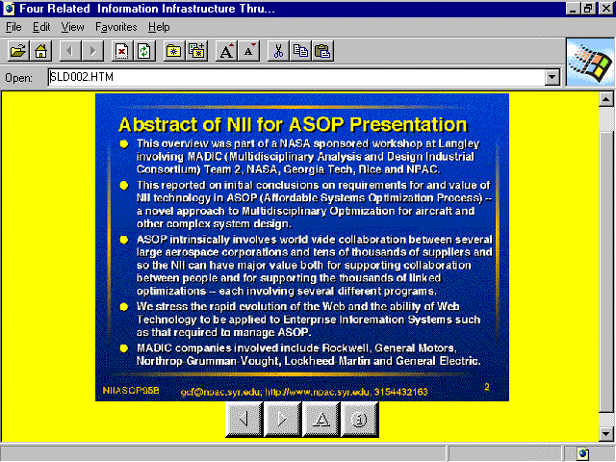
Fig. 6.24. Sample sldNNN.htm file generated by the compiler and its view in HTML browser
The parameters from the configuration file are mapped into sets of database attributes, stored in index.htm and tsldNNN.htm files. The form of each attribute is “attribute_name=attribute_value”. A definition of every attribute is included in one line of HTML file. There is a general attribute set for a presentation and an individual set for each foil. These sets are included as HTML comments in <HEAD> elements of the generated HTML files, general set in index.htm file and individual sets in tsldNNN.htm files, respectively. Examples of <HEAD> elements of these files are shown in Fig. 6.25 and Fig. 6.26, respectively.
<HTML>
<HEAD>
<META NAME="generator" CONTENT="PowerPoint Outline(RTF)/WWWfoil to HTML converter">
<!--Global Attributes
name=npacdbover
label=NPACDBover
author=Geoffrey C. Fox
runningtitle=Overview of NPAC Database Acivity
signature=Northeast Parallel Architectures Center, Syracuse University
sourcepptdir=/usr/local/archives/public/users/gcf/05/rawfoils/cps616vrml2scriptmar98
body_background_html=technics/clouds.gif
body_bgcolor=yellow
body_text=blue
font_size_title=4
font_color_title_html=cyan
body_link=magenta
body_vlink=red
body_alink=green
hor_image_width=700
hor_image_style=original
ver_image_height=550
ver_image_style=original
-->
<META HTTP-EQUIV="content-type" CONTENT="text/html; charset=iso-9959-1">
<TITLE> Overview foils for NPAC Database Activity including Web March 1995 </TITLE>
</HEAD>
Fig. 6.25. Attribute sets passed to the database via <HEAD> element in index.htm file
<HTML>
<HEAD>
<META NAME="generator" CONTENT="PowerPoint Outline(RTF)/WWWfoil to HTML converter">
<!--Foil Attributes
image=sld002.gif
sound=sld002.ra {seconds=49} {title= Abstract of CPS616-97 Lecture of February 5}
blob_style=useful
-->
<META HTTP-EQUIV="content-type" CONTENT="text/html; charset=iso-9959-1">
<TITLE> Four Related Information Infrastructure Thrusts at NPAC </TITLE>
</HEAD>
Fig. 6.26. Attribute sets passed to the database via <HEAD> element in sldNNN.htm file
Names of the attributes passed to the database and their meaning are presented in a table below. These attributes are stored in the database and may be directly accessed by the Exporter.
Name of the attribute | Type | Mapped from WebWisdom 1.0 attribute | Remarks
creation_date | global | date | may be ignored by the database if data format is not recognized properly
version_date | global | datemod | may be ignored by the database if data format is not recognized properly
Signature | global | signature | a short text which may be displayed by an exporter as a signature for every foil
body_background_image | global, foil | imagebgfile | a name of an image already stored in the database and used as background for a graphical form of a foil
body_background | global, foil | htmlbgfile | a name of a color from the database used as background color for a foil
body_bgcolor | global, foil | bgcolor | a name of a color from the database used as a value of a “bgcolor” parameter in the <BODY> HTML tag
body_text | global, foil | fgcolor | a name of a color from the database used as a value of a “text” parameter in the <BODY> HTML tag
font_size_table | global, foil | intablefontsize | size of a font while displaying tables
font_size_title | global, foil | titlefontsize | size of a font while displaying titles
font_color_title_html | global, foil | htmltitlecolor | color of a font while displaying titles for text form of a foil
font_color_title_image | global, foil | imagetitlecolor | color of a font while displaying titles for graphical form of a foil
font_color_table | global, foil | intablefontcolor | color of a font while displaying tables
table_bgcolor | global, foil | intablebgcolor | a name of a color from the database used as a background color for tables
body_link | global, foil | linkcolor | a name of a color from the database used as a color of unvisited links
body_vlink | global, foil | vlinkcolor | a name of a color from the database used as a color of visited links
body_alink | global, foil | alinkcolor | a name of a color from the database used as a color of active links
body_link_image | global, foil | imagelinkcolor | a name of a color from the database used as a color of unvisited links for graphical form of a foil
body_vlink_image | global, foil | imagevlinkcolor | a name of a color from the database used as a color of visited links for graphical form of a foil
body_alink_image | global, foil | imagealinkcolor | a name of a color from the database used as a color of active links for graphical form of a foil
body_link_table | global, foil | tablelinkcolor | a name of a color from the database used as a color of unvisited links inside a table
body_vlink_table | global, foil | tablevlinkcolor | a name of a color from the database used as a color of visited links inside a table
body_alink_table | global, foil | tablealinkcolor, | a name of a color from the database used as a color of active links inside a table
hor_image_width | global, foil | horizimagewidth | size of an image (i.e., graphical form of a foil) in horizontal direction
hor_image_style | global, foil | horizimagestyle | a way of displaying images in horizontal direction: native, minimum, maximum, parmvalue
ver_image_height | global, foil | vertimagewidth | size of an image (i.e., graphical form of a foil) in vertical direction
ver_image_style | global, foil | vertimagestyle | a way of displaying images in vertical direction: native, minimum, maximum, parmvalue
image | foil |  | in the form “image=file_name”, the file name with a foil image generated by PowerPoint is present in the temporary directory
addon | foil |  | in the form “addon=sldNNN.adi {title=*}”, for details see importing from WebWisdom 1.0
sound | foil |  | in the form “sound=sldNNN.ra {seconds=N}{title=*}{see=*}, where N is a positive integer; for details see importing from WebWisdom 1.0
blob_style | foil | criticalmissing, somemissing, nonemissing | “blob_style=asHTML” is no information is missing in text form of a foil in comparison to a graphical form; “blob_style=useful” if some information is missing, but this information is not crucial to understand a foil; this parameter is not present while an image must be displayed to understand a foil
Note that information about bulleting level is included in attributes of the <P> tag (cf. description of the “paragraph” output style above).

6.2.5. Phase 4 - incorporating HTML files to the database
This phase is similar to the second phase of reading original PowerPoint presentations (c.f. Point 6.1.2), except the “HTML/RTF PowerPoint” directory structure is automatically chosen in the window of the Presentation Loader after pressing the “Check” button.

6.3. Importing WebWisdom v.1.0 presentations
To provide backward compatibility with previous versions of WebWisdom, an importing filter is provided to read into the database error-free presentations stored in WebWisdom 1.0 directories. To import WebWisdom 1.0 presentation, some of its files are copied to a temporary directory and then compiled by an importer. The HTML files being result of the compilation are read to the database as succeeding foils of the presentation. After reading, the newly created presentation may be edited, copied, renamed, etc. by the use of the Presentation Manager presented above.
Below the three phases of the importing process are presented: (1) creating a temporary directory and copying files to be imported, (2) compiling files from WebWisdom 1.0 to HTML format, and (3) reading HTML files to the database.

6.3.1. Phase 1 - copying WebWisdom 1.0 presentation to temporary directory
During this phase a type of WebWisdom 1.0 presentation is detected (regular presentation, imported presentation, i.e. a presentation that shares some foils with other presentations, and exported list, i.e. a presentations with foils being links to external HTML pages). According to this type, some files are copied to a temporary directory. To perform these two tasks, a set of UNIX shell scripts (of type: Bourne /bin/sh or Korn /bin/ksh shell) is provided to automatically perform the following: creating the temporary directory, checking a type of WebWisdom 1.0 presentation, reading WebWisdom 1.0 files and changing their names. The variables of these scripts can be changed manually according to user’s requirements and used directory names. To automatically change names of files, which are copied by the scripts, a special program change_name is provided. This program is always invoked with two parameters. The first one is an original file name, and the second one - a file name extension. The program reads the file name, extract from it the foil number, changes this number into format NNN=000..999, adds a prefix “sld”, adds a suffix - a dot with the file extension, and finally prints the result to standard output. For example, an invocation “change_name foil3.addoinfo adi” will result in string “sld003.adi”.
The scripts perform all the necessary copying and changing of file names. The execution of the last script finishes the first phase of the importing process. Note that the names of “output” files are crucial to perform the second phase of importing. Neither the file names for images and sounds, nor the file names for addon- and sound-info can be changed. Thus, it is recommended to run the scripts to perform copying and changing file names properly, and avoid manual copying and changing file names.
To compile a whole WebWisdom 1.0 presentation pool (i.e., the existing WebWisdom 1.0 presentations stored in one consistent file system) the following steps must be performed.
- Identify a starting directory for all the WebWisdom 1.0 sub-directories with presentations. This directory is later called the HOME directory.
- For every HOME sub-directory not being a presentation, create a list of sub-directories to be parsed by compilation process. These lists must be stored in files dirs.ls, one file per directory, one sub-directory name per line, starting from presentations HOME directory.
- Create HOME/scripts sub-directory and copy to it all the files from the installation directory .../gcf/scripts.
- Ensure the wwwalias file is in HOME directory .
- Prepare directory structure by running scripts/copy.dirs.sh in every sub-directory not being a presentation, recursively, starting from HOME directory. The script will: (1) link wwwalias file from super-directory, and (2) link dirs.sh file from HOME/scripts .
- Create WisdomNT sub-directory in every presentation directory by running scripts/mkdirs.sh in every directory not being a presentation and directly containing presentations.
- Create HOME/logs subdirectory.
- While in HOME directory run scripts/copy script. This will link all the necessary executables to WisdomNT sub-directories in every presentation directory. There is no need to run it in all non-presentation directories as it calls itself recursively for every directory listed in dirs.ls files.
- While in HOME directory run scripts/clean to remove all previously compiled files from WisdomNT sub-directories.
- While in HOME directory run scripts/prep to link all the files from WebWisdom 1.0 sub-directories to WisdomNT directory for every presentation (recursively).
Note: While repeating this step one can avoid copying sounds and images by running scripts/proc script instead of scripts/prep. This script will copy only processed, options, extrainfo and similar files, possibly changed in the meanwhile.
During the first phase of the importing process the following files are copied to a temporary directory:
- for regular presentation: file named processed being a result of wwwfoil pass2(3) program; if this file is not present, the perstemp file is taken into consideration;
- for imported (scripted) presentation: file(s) *script* with localization of a script – a file defining an imported presentation;
- for “external” presentation: file original.html with URLs of presentation foils;
- file options with options (i.e. formatting and library parameters);
- file extrainfo with some additional information about the presentation;
- files NNN.gif and/or NNN,jpg with images for the presentation foils;
- files foilNNN.addoninfo with information about addons;
- files foilNNN.rainfo, foilNNN.ra with information about sounds and the sounds themselves.
During copying, the names of the files are changed according to the table below.
WebWisdom 1.0 file | Temporary file
extrainfo | beginning part of main translation file (default course.gcf)
processed | ending part of main translation file
perstemp | ending part of main translation file, if file processed could not be found
seporgimagedir/NNN.gif  seporgimagedir/NNN.jpg  seporggifdir/NNN.gif  seporggifdir/NNN.jpg | file sldNNN.gif or sldNNN.jpg - an image for foil number NNN, NNN=000..999
addon/foilMMM.addoninfo | file sldNNN.adi - information about addons for foil number MMM, MMM=0..999
audio.ra/foilMMM.rainfo | file sldNNN.rai - information about sound for foil number MMM
audio.ra/foilMMM.ra | file sldNNN.ra - sound file for foil number MMM

6.3.2. Phase 2 - compiling WebWisdom 1.0 presentation to HTML format
The second stage of the importing process is compilation. The following steps must be performed to complete this phase.
- While in HOME directory run scripts/s2p to pre-compile all the presentations being scripts (“play-lists” composed of foils originally belonging to other presentations). As a result, file course.gcf is generated compatible with a standard WebWisdom 1.0 processed file.
- While in HOME directory run scripts/e2p to pre-compile all the presentations being lists of "exports" ("exported" or "external" HTML pages). As a result, file course.gcf is generated compatible with a standard WebWisdom 1.0 processed file.
- While in HOME directory run scripts/aliases to replace {} items by texts from perswww and wwwalias files.
Note: Some items must be replaced manually while reading to the database. This includes replacing {basedirectory} to `pwd` and {npac} to "http://www.npac.syr.edu". Itmes {} being valid URLs are replaced by <A>...</A> tags with appropriate argument.
- While in HOME directory run scripts/r2h to create files which will be read directly by the database
- While in HOME directory run scripts/cpimgs to copy missing images to WisdomNT directories. If any image is copied, go back to the previous step to repeat the compilation.
- Check if everything is OK by taking a look in HOME/logs directory for “summary” log files (files being concatenation of every standard output for every executed program/shell). If an error occurs, a message about it is preceded by "####" string of characters to identify it easily by the use of any editor. Warnings are preceded by "...." string.
Copied temporary files are read by the compiling programs and processed according to the rules written in configuration file (Fig. 6.27).
Fig. 6.27. Files read and written during second phase of the importing process
As a result, a set of HTML files is created. For the whole presentation, an index,htm file is created as an index to all generated foils. For each processed foil, two HTML files: tsldNNN.htm (text form of a foil) and sldNNN.htm (graphical form, i.e. a file with direct link to a foil image) are generated. Only the first file is incorporated into the database. The second one is provided only to provide compatibility with a directory structure generated by the standard converter from PowerPoint to HTML format. Thus, the created set of HTML files can be used as a standalone presentation, in the same way the translated PowerPoint presentation can be used.
In WebWisdom 1.0 system some image files may be shared by multiple presentations. In such case, if a given image is marked as imported from other directory than a presentation default one, a special shell script (Bourne shell script for UNIX and BAT file for DOS/Windows) is generated by the r2h compiler to perform the copying (c.f. previous section). If after compilation the script is not empty, i.e. there is still at least one image file to be copied, a warning message appears after compilation. A user should then verify the generated script and run it to copy the necessary images to the temporary directory. Next, the compiler must be run once again (cf. steps 4 and 5 above) to include the newly copied images into the HTML files (this means the second phase is repeated once again). This process should be repeated until all images are included in the temporary directory, i.e. the script for copying images is empty and there is no warning message after compilation. The sample script for copying images is presented in Fig. 6.28.
!/bin/sh
#
#UNIX Bourne shell script to copy images from other directories
#
OUT_DIR=.
CP=cp

${CP} ../npacresources/june97/sandiego/cps615audio.gif ${OUT_DIR}/sld074.gif
${CP} ../npacresources/june97/sandiego/cps615f95.gif ${OUT_DIR}/sld075.gif
${CP} ../npacresources/june97/sandiego/ecs400f96.gif ${OUT_DIR}/sld079.gif
${CP} ../npacresources/june97/sandiego/ecs400s96.gif ${OUT_DIR}/sld080.gif
${CP} ../npacresources/june97/sandiego/foil_javascriptvpl.gif ${OUT_DIR}/sld081.gif
${CP} ../npacresources/june97/sandiego/foil_perlvpl.gif ${OUT_DIR}/sld082.gif
${CP} ../npacresources/june97/sandiego/woj_sls_faculty.gif ${OUT_DIR}/sld089.gif
${CP} /home/A7F/gcf/foils/npacresources/june97/vpl/compile.gif ${OUT_DIR}/sld090.gif
${CP} /home/A7F/gcf/foils/npacresources/june97/vpl/compile2.gif ${OUT_DIR}/sld091.gif
${CP} /home/A7F/gcf/foils/npacresources/june97/vpl/execute.gif ${OUT_DIR}/sld092.gif
${CP} /home/A7F/gcf/foils/npacresources/june97/vpl/execute2.gif ${OUT_DIR}/sld093.gif
${CP} /home/A7F/gcf/foils/npacresources/june97/vpl/io-summary.gif ${OUT_DIR}/sld094.gif
${CP} /home/A7F/gcf/foils/npacresources/june97/vpl/jpvs.gif ${OUT_DIR}/sld095.gif
${CP} /home/A7F/gcf/foils/npacresources/june97/vpl/jpvs2.gif ${OUT_DIR}/sld096.gif
${CP} /home/A7F/gcf/foils/npacresources/june97/vpl/kiviat.gif ${OUT_DIR}/sld097.gif
${CP} /home/A7F/gcf/foils/npacresources/june97/vpl/pvm-vm.gif ${OUT_DIR}/sld098.gif
${CP} /home/A7F/gcf/foils/npacresources/june97/vpl/ut-anim.gif ${OUT_DIR}/sld099.gif
Fig. 6.28. Sample script for copying image files from other directories
The output generated by the compiler is similar to the one generated while importing RTF-based PowerPoint presentation (cf. previous section).
The main presentation file is a set of commands in wwwfoil-pass2(3) format. The meaning of each processed command is presented in the table below.
Wwwfoil command | Meaning | Possible values | Defaults
contd | continuing previous command | "*"
titleset | command passed directly to the database | "*" | ""
signature | command passed directly to the database | "*" | ""
title | command passed directly to the database | "*" | ""
criticalmissing | command passed directly to the database
somemissing | command passed directly to the database
beginfoil | beginning of the foil definition
endfoil | ending of the foil definition
bulletN | bullet level N | "*" | ""
getimagefrom | argument of the command is copied to the <copy_images> script as source directory/file name | "*" | ""
noimageversion | command inhibits reading an image from sldNNN.gif(jpg) file
setimagebgfile  imagebgfile | name of the file set as background for the graphics form of all the foils from the presentation | "*" | ""
foilimagebgfile | name of the file set as a background for the graphics form of the foil | "*" | ""
sethtmlbgfile  htmlbgfile | name of the file set as a background for the text form of all the foils from the presentation | "*" | ""
foilhtmlbgfile | name of the file set as background for the text form of the foil | "*" | ""
intablefontsize | font size for the table inside a foil for each foil from the presentation | "1..7" | ""
foilintablefontsize | font size for the table inside a foil | "1..7" | ""
titlefontsize | font size for the foil title for each foil of the presentation | "1..7" | ""
foiltitlefontsize | font size for the foil title | "1..7" | ""
bgcolor | background color for each foil of the presentation | "*" | ""
foilbgcolor | background color for the foil | "*" | ""
intablebgcolor | background color for the tables inside a foil for each foil of the presentation | "*" | ""
foilintablebgcolor | background color for the tables inside a foil | "*" | ""
fgcolor | text color for each foil of the presentation | "*" | ""
foilfgcolor | text color for the foil | "*" | ""
htmltitlecolor | title color for each text foil of the presentation | "*" | ""
foilhtmltitlecolor | title color for the text foil | "*" | ""
intablefontcolor | text color for the table for each foil of the presentation | "*" | ""
foilintablefontcolor | text color for the table | "*" | ""
imagetitlecolor | title color for each graphical foil of the presentation | "*" | ""
foilimagetitlecolor | title color for the graphical foil | "*" | ""
linkcolor | link color for each foil of the presentation | "*" | ""
foillinkcolor | link color for the foil | "*" | ""
alinkcolor | active link color for each foil of the presentation | "*" | ""
foilalinkcolor | active link color for the foil | "*" | ""
vlinkcolor | visited link color for each foil of the presentation | "*" | ""
foilvlinkcolor | visited link color for the foil | "*" | ""
imagelinkcolor | link color for the graphical form for each foil of the presentation | "*" | ""
foilimagelinkcolor | link color for the graphical foil | "*" | ""
imagealinkcolor | active link color for the graphical form for each foil of the presentation | "*" | ""
foilimagealinkcolor | active link color for the graphical foil | "*" | ""
imagevlinkcolor | visited link color for the graphical form for each foil of the presentation | "*" | ""
foilimagevlinkcolor | visited link color for the graphical foil | "*" | ""
tablelinkcolor | link color for the “table-like” foil for each foil of the presentation | "*" | ""
foiltablelinkcolor | link color for the “table-like” foil | "*" | ""
tablealinkcolor | active link color for the “table-like” foil for each foil of the presentation | "*" | ""
foiltablealinkcolor | active link color for the “table-like” foil | "*" | ""
tablevlinkcolor | visited link color for the “table-like” foil for each foil of the presentation | "*" | ""
foiltablevlinkcolor | visited link color for the “table-like” foil | "*" | ""
horizimagewidth | horizontal size of the foil image for each foil of the presentation | "NNNN" | ""
foilhorizimagewidth | horizontal size of the foil image | "NNNN" | ""
horizimagestyle | type of setting size of foil image for each foil of the presentation; if does not set to "native", the "horizimagewidth" command is taken into consideration | "maximum", "minimum", "native", "parmvalue", | "native"
foilhorizimagestyle | type of setting size of foil image; if does not set to "native", the "foilhorizimagewidth" command is taken into consideration | "maximum", "minimum", "native", "parmvalue", | "native"
vertimagewidth | vertical size of the foil image for each foil of the presentation | "NNNN" | ""
foilvertimagewidth | vertical size of the foil image | "NNNN" | ""
vertimagestyle | type of setting size of foil image for each foil of the presentation; if does not set to "native", the "vertimagewidth" command is taken into consideration | "maximum", "minimum", "native", "parmvalue", | "native"
foilvertimagestyle | type of setting size of foil image; if does not set to "native", the "foilvertimagewidth" command is taken into consideration | "maximum", "minimum", "native", "parmvalue", | "native"
sourcepptdir | name of the directory with source PowerPoint file | "*" | ""
html | “magic” HTML characters are passed as they are written | - | -
endhtml | “magic” HTML characters are mapped into sequences &..; | - | -
name | presentation name | "*" | ""
label | presentation label | "*" | ""
author | a comment on author(s) of the presentation | "*" | ""
runningtitle | presentation extended title (heading) | "*" | ""
event | a comment on primary event related to the presentation | "*" | ""
date | creation date | "*" | ""
datemod | date of the last modification | "*" | ""
htmlline | bullet of the same level as the previous one | "*" | ""
bulletsongif | indication whether description should be displayed together with an image (photo) or separately | "on" | "off" | "off"
addsource | command ignored
abstract | command ignored
master | command ignored
script | command ignored (this command is read by the s2p compiler, in the first compilation step (cf. previous section)
abstractsource | command ignored
seealso | command ignored
bestfoilseturl | command ignored
As for importing from RTF-based PowerPoint presentations (cf. previous section), the parameters listed in the WebWisdom 1.0 command table and the configuration file are mapped into sets of appropriate database attributes. The form of each attribute is “attribute_name=attribute_value”. A definition of every attribute is included in one line of HTML file. There is a general attribute set for a presentation and an individual set for each foil. These sets are included as HTML comments in <HEAD> elements of the generated HTML files, general set in index.htm file and individual sets in tsldNNN.htm files, respectively.
Names of the attributes passed to the database and their meaning are presented in table below. Some details about attributes can be found in the previous section.
Name of the attribute | Type | Mapped from WebWisdom 1.0 attribute | Remarks
signature | global | signature | If equal to the standard one, ignored by the database (i.e., taken by the Exporter from the defaults)
body_background_image | global, foil | imagebgfile
body_background | global, foil | htmlbgfile
body_bgcolor | global, foil | bgcolor
body_text | global, foil | fgcolor
font_size_table | global, foil | intablefontsize
font_size_title | global, foil | titlefontsize
font_color_title_html | global, foil | htmltitlecolor
font_color_title_image | global, foil | imagetitlecolor
font_color_table | global, foil | intablefontcolor
body_bgcolor_table | global, foil | intablebgcolor
body_link | global, foil | linkcolor
body_vlink | global, foil | vlinkcolor
body_alink | global, foil | alinkcolor
body_link_image | global, foil | imagelinkcolor
body_vlink_image | global, foil | imagevlinkcolor
body_alink_image | global, foil | imagealinkcolor
body_link_table | global, foil | tablelinkcolor
body_vlink_table | global, foil | tablevlinkcolor
body_alink_table | global, foil | tablealinkcolor,
hor_image_width | global, foil | horizimagewidth
hor_image_style | global, foil | horizimagestyle
ver_image_height | global, foil | vertimagewidth
ver_image_style | global, foil | vertimagestyle
image | foil |  | in the form “image=file_name”, the file name with image must be present in the temporary directory
addon | foil | copied from file foilN.addoinfo | in the form “addon=sldNNN.adi {title=*}”
sound | foil | copied from file foilN.rainfo | in the form “sound=sldNNN.ra {seconds=N}{title=*}{see=*}, where N is a positive integer
blob_style | foil | criticalmissing, somemissing, nonemissing | “blob_style=asHTML” for nonemissing, “blob_style=useful” for somemissing), not present for criticalmissing
seealso | foil | seealso | ignored by the database
name | global | name
label | global | label
author | global | author
addsource | global | addsource | ignored by the database
runningtitle | global | runningtitle
event | global | event
creation_date | global | date | may be ignored by the database if data format is not recognized properly
version_date | global | datemod | may be ignored by the database if data format is not recognized properly
sourcepptdir | global | sourcepptdir | ignored by the database, although a message is printed by r2h compiler to take a look in this directory and copy manually PowerPoint source file to the temporary directory

Note that information about bullets (WebWisdom 1.0 command BulletN, where N=1..9) is included in attributes of the <P> tag (cf. description of the “paragraph” output style in the previous section).

6.3.3. Phase 3 - incorporating contents of the temporary directory to the database
The temporary directory prepared in the first two phases is passed to the third phase and its content is read into the database. This task is similar to importing PowerPoint and RTF-based presentations, except some foils may have no graphical forms, i.e., no file with an image is associated with the foil. In such a case a message “No image for this slide” is displayed while storing foils into the database.

6.4. Importing sequences of individual foils
This importer is used to collect a set of individual foils into a consistent presentation. The format and data of each foil are chosen individually. A foil may contain the following data:
- an image (a scanned photo),
- a URL address of an external location (i.e., external HTML page located elsewhere in the Internet),
- a HTML formatted text.
One can also define for each foil some meta-data:
- a short description in a form of a bulleted list. The description can be displayed by the Exporter in two ways: or together with any foil data either instead of them (separately);
- an annotation in a form of a single line of HTML text. The annotation is displayed in the table of contents of the presentation just before foil title;
- foil comment in a form of unformatted ASCII text.
To begin importing a sequence of foils, one must press, after successful login, the „Foil Collector” button ( icon) in the main window. A new window appears to perform loading process (Fig. 6.29).
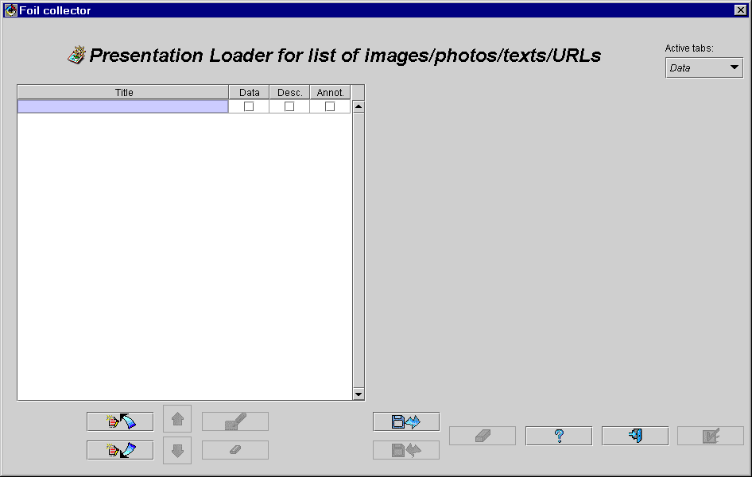
Fig. 6.29. Foil collector window just after invocation
The window is divided into three main parts. In the left-upper part, a list is displayed with titles of foils and information if a foil contains data in any form, a description and an annotation. In the right part of the window a tabbed panel is displayed with tabs displaying data for selected foil. If there is no foil yet, this panel is invisible. In the lower part of the window some buttons are located. These buttons are used for the following purposes.
- „Insert slide before” button ( icon)
Inserting one empty slide before the selected slide. The slide title is automatically set to „Slide No N”, where N is the number of currently inserted slide since invoking the window. The remaining slides (if any) are shifted down in the list.
- „Insert slide after” button ( icon)
Inserting one empty slide after the selected slide.
- „Slide up” button ( icon)
Moving the selected slide one position up in the list.
- „Slide down” button ( icon)
Moving the selected slide one position down in the list.
- „Edit slide title” button ( icon)
Changing slide title. The same action can be performed by double-clicking over a given slide title.
- „Remove slide” button ( icon)
Removing the selected slide from the list.
- „Load slides from file” button ( icon)
Loading a sequence of slide descriptions from a disk file. The supported file formats are: *.spt (native WebWisdom NT format, abbreviation of „Source, Photos and Texts”), and *.gcf (WebWisdom 1.0 photo set, originally named „processed”).
- „Save to file” button ( icon)
Saving current list of slides in a disk file. The list is stored in *.spt native WebWisdom NT format.
- „Clear all” button ( icon)
Erase (empty) current list of slides.
- „Help” button ( icon)
Invoking help system to display this text in HTML browser.
- „OK” button ( icon)
Storing contents of the prepared list of slides as a presentation in WebWisdom NT database and exiting a window.
- „Exit” button ( icon)
Exiting a window with nothing changed in the database.
At the beginning, only „Insert slide before”, „Insert slide after”, „Load from file”, „Exit” and „Help” buttons are active.

6.4.1. Editing foil data
To insert a new slide one must press one of „Insert slide” buttons. The window is filled up with new elements to store slide data (Fig. 6.30).
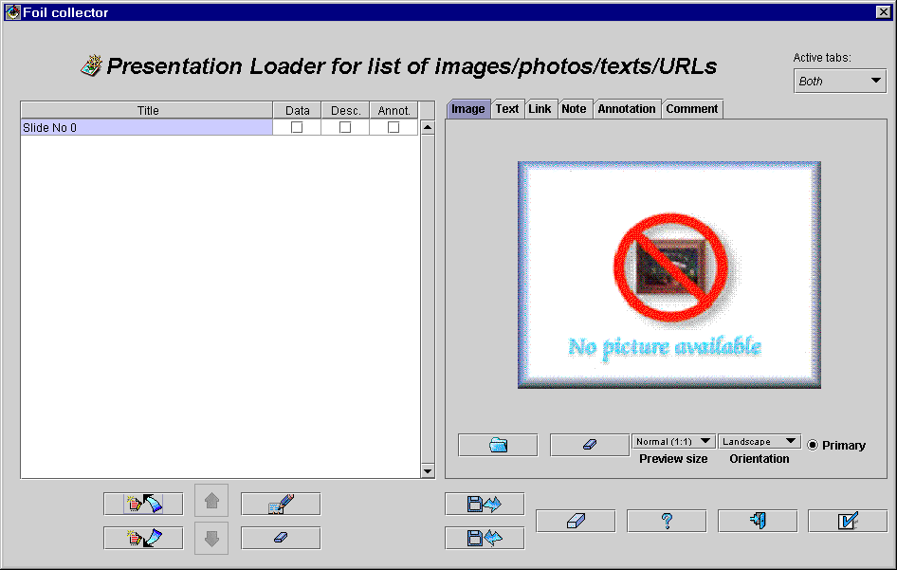
Fig. 6.30. Foil collector window while defining foils
In the left part of the window a tabbed panel is displayed to define slide data. The panel is parted into three „data” tabs and three „meta-data” tabs (only „data” tabs are displayed in Fig. 6.30). The “data” tabs are used to define three different types of foil data: images, HTML texts, and external URL links. The “meta-data” tabs are used to define some additional information for a foil: an HTML note (text displayed below the foil, for example a note on a photo), an annotation (a line of text to be appear before foil title in the table of contents of a presentation), and a comment (foil description, usually not to be displayed by the Exporter, but rather used for some administrative and search purposes). Switching between displaying data, meta-data and both panel types of is done by the use of a pull-down menu located in the left-upper corner of the window. Switching among tabs can be performed by clicking on tab names.
In every „data” tab, in lower left corner there is a checkbox „Primary”. A tab with this checkbox active is treated as primary, i.e., data defined in this tab should be used by the Exporter rather than other data. Setting „Primary” mark for another tab replaces any previous settings, thus only one data type is treated by the Exporter as primary data (the most important data).
In the first tab labeled „Image” (cf. Fig. 6.30) one may define an image related to the currently selected slide. To this goal the „Load image from file” button ( icon) is provided. After pressing this button a new window appears to find a file. Once the file is chosen and its format is correct, an image stored in the file is loaded and displayed. If no image is chosen for the moment, an icon with „No picture available” text is displayed indicating no image data exists for the selected slide.
A way of previewing the selected image can be changed by the use of two pull-down menus: „Preview size” and „Orientation”. With the first one, a user may change a way of scaling displayed image on the screen: display an image in its normal scale (1:1) (usually, as many images are bigger than the area they are displayed in, only left-upper part of the image is displayed), scale image to fit displaying area size, center image in the displaying area, and display a set of identical images, one by one. The latter two ways of displaying are reserved for rather small images (no bigger than 320x320 points, i.e., the maximum size of the displaying area). With the „Orientation” menu, one may chose among „Portrait”, „Landscape” and „Square” orientations. Some examples of using the menus are shown in Fig. 6.31. Note that these menus have no influence on a way of storing images in the database, they change only the current view.
By the use of the „Clear image” button ( icon) one may remove image from the slide. Note that only the connection between the selected slide and its image is removed, while the disk file with the image remains unchanged. Thus, the same image can be used for another slide.
With the third tab labeled „HTML” one may enter HTML bulleted list as the slide data. The text may be edited by pressing the „Edit Html text” button (icon). A new window appears to define bulleted list of HTML lines being slide description (Fig. 6.32). The window is composed of free parts. In the upper part a slide title is displayed. This title can be freely changed by simply typing or correcting its value in the „Title” text field. In the middle part of the window a list of lines being a description is displayed. Bulleting level of every line is shown by dots located left to the line text. No dot for a line means that this line is not bulleted. Note that a way of displaying bulleting text (bullets, space between a bullet and its corresponding text, etc.) depends on the Exporter and cannot be shown at the moment of definition or edition of the description.
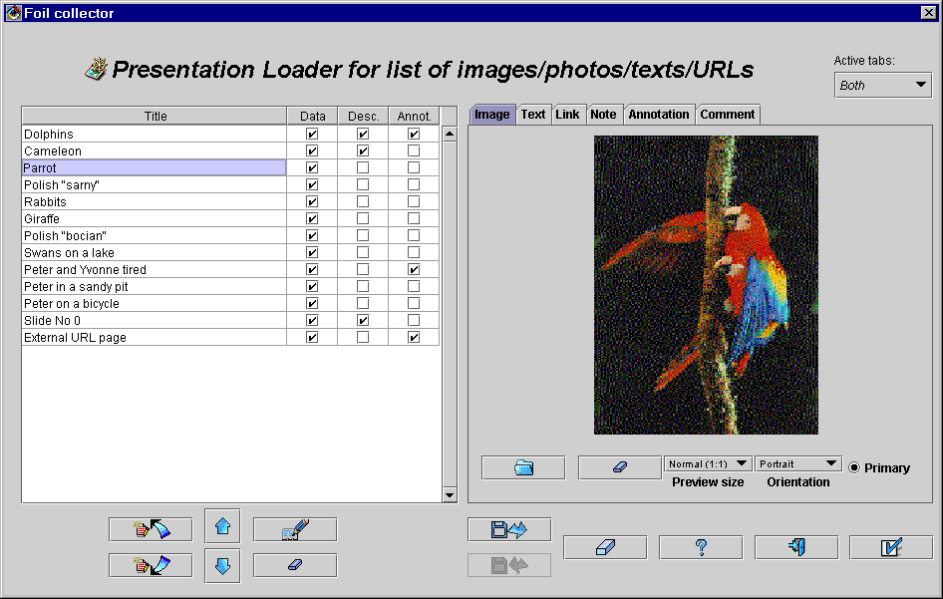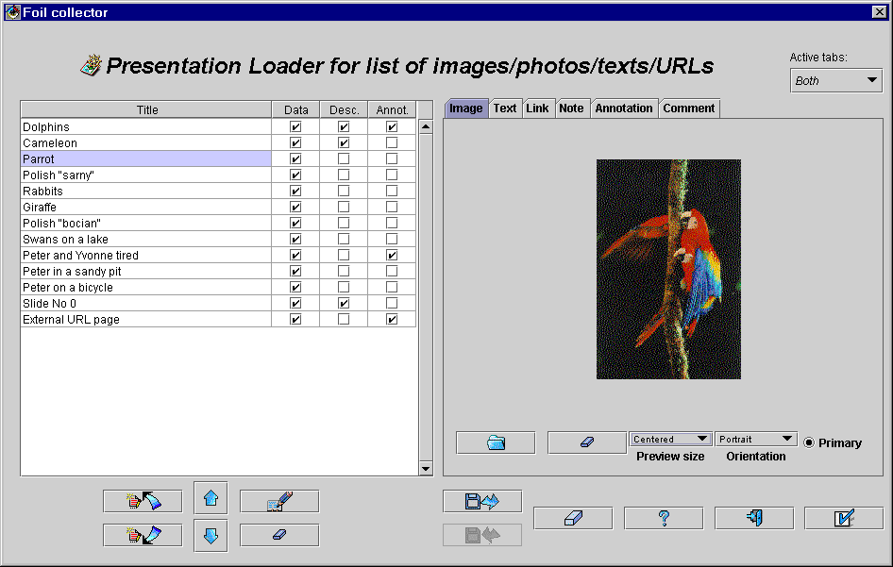
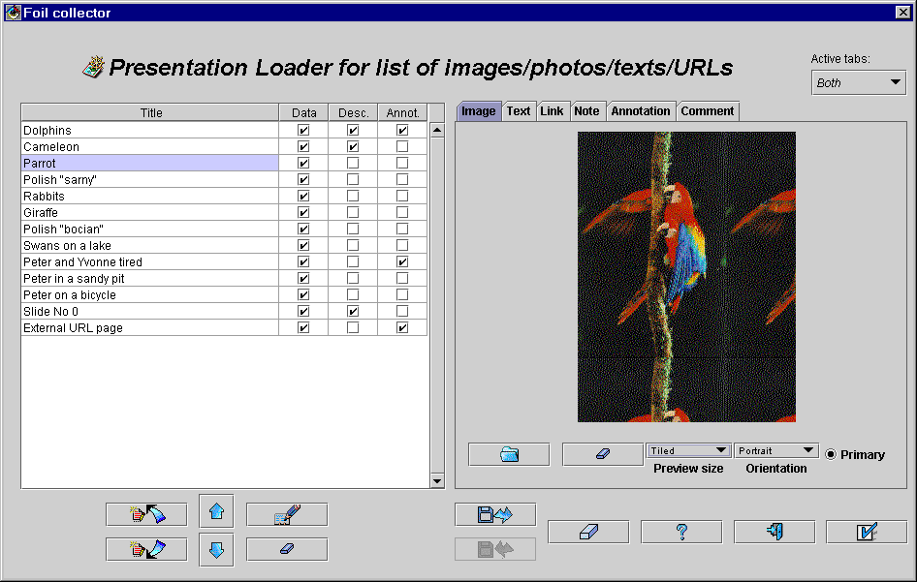
Fig. 6.31. Previewing an image in different modes
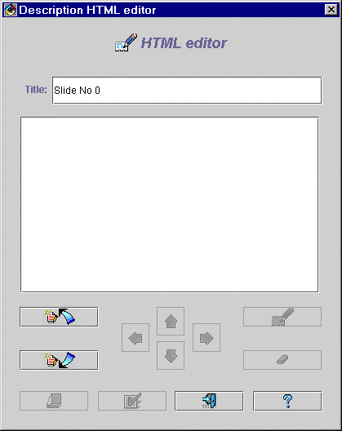
Fig. 6.32. Editing HTML slide description, current description empty
Lines to be changed are selected by clicking on them. In the lower part of the window there is a set of buttons to perform the following actions on a selected line.
- „Insert line before” button ( icon)
Inserting one empty line before the selected line. The remaining lines (if any) are shifted down in the list.
- „Insert line after” button ( icon)
Inserting one empty line after the selected one.
- „Line up” button ( icon)
Moving the selected line one position up in the list.
- „Line down” button ( icon)
Moving the selected line one position down in the list.
- „Indent level up” button ( icon)
Incrementing bulleting level for the line. Maximum bulleting level is equal to 9.
- „Indent level down” button ( icon)
Decrementing bulleting level for the line.
- „Edit line” button ( icon)
Changing line text by invoking line editor. The same action is performed by double-clicking over a line.
- „Remove line” button ( icon)
Removing the selected line from the list.
- „Preview” button ( icon)
Previewing the prepared bulleted list in HTML browser. The contents of the list is changed to a HTML-compliant text being enumerated list and displayed in a separate window to give an impression how the list will look like while displaying by the Exporter.
- „Help” button ( icon)
Invoking help system to display this text in HTML browser.
- „OK” button ( icon)
Storing contents of the prepared list of lines as a description for a selected slide and exiting a window.
- „Exit” button ( icon)
Exiting a window with nothing changed in the slide description.
At the beginning, only „Insert slide before”, „Insert slide after”, „Load from file”, „Exit” and „Help” buttons are active.
Once edited, the HTML text may be previewed by the use of „HTML preview” button ( icon). Sample Html text and its preview is presented in Fig. 6.33.
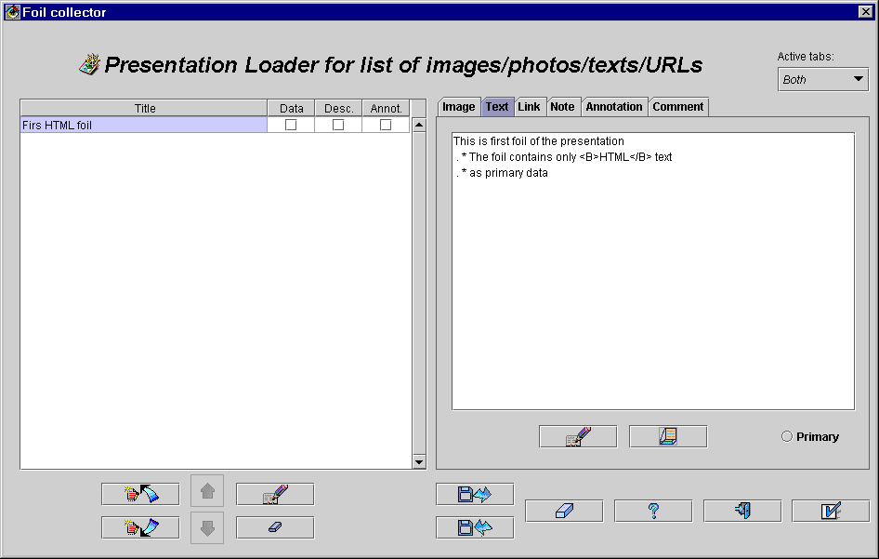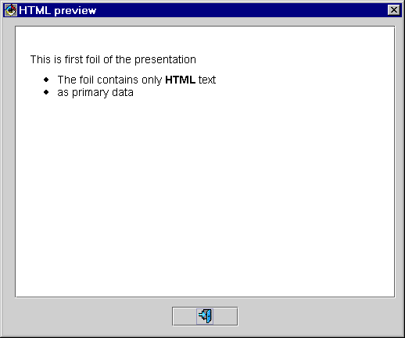
Fig. 6.33. Defining and previewing HTML text as foil data
With the third tab labeled „Link” (Fig. 6.34) one can store URL addresses of HTML pages. Only the addresses are stored in the database, while pointed HTML pages are not, although they are accessed from the remote place and displayed by the Exporter.
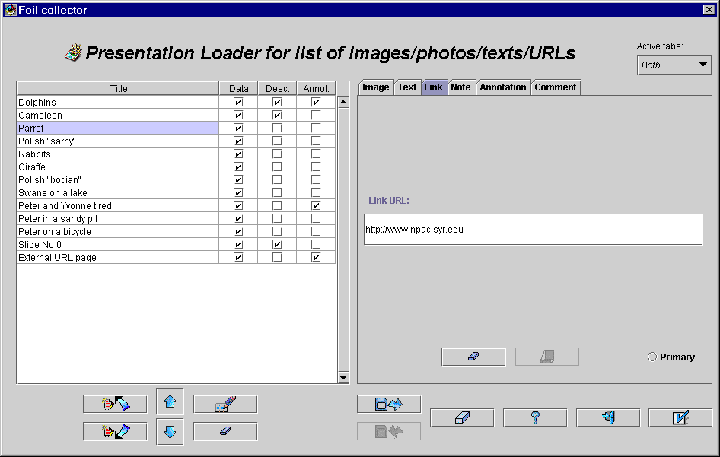
Fig.6.34. Defining URL address of an external HTML page
The URL address should be typed in the field „Link URL”. To clean it, one may press „Clean URL address” button (icon). After pressing the „Preview page pointed by URL” button ( button) a user may invoke a separate window with HTML browser to display the pointed page (Fig. 6.35). To quit this window, the „Exit” button ( icon) must be pressed.
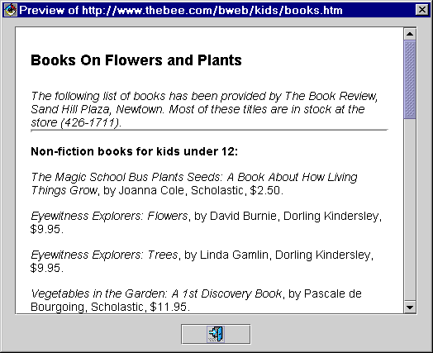
Fig. 6.36. Previewing external HTML file pointed by URL
Note that by default the „Image” tab is marked as primary data tab. To replace an image by URL address, HTML, or ASCII text, one should choose other primary data (cf. Figs. 6.33, 6.35, and 6.38) by the use of „Primary” checkbox from a given tab. Note, however, that data of more than one type can be stored in the database for a single slide, giving some freedom to the Exporter.

6.4.2. Editing list of foils
One can insert more slides by the use of „Insert slide before” and „Insert slide after” buttons. The inserted slides are collected into a presentation, and their names are displayed in the list. To change an order of slides from the list, one may press „Slide up” ( icon) and „Slide down” ( icon). After pressing one of these buttons the selected slide is replaced by a previous one (and next one, respectively), and vice-versa.
To remove a slide from the list a user must select it and press the „Remove slide” button (icon). The slide, its data, and meta-data are removed. However, as it was previously mentioned, the original disk file (the slide image/HTML/ASCII text was taken from) remains unchanged.
To edit slide title, one should either press „Edit slide title” button ( icon) or double-click over the title from the list. A new window appears (Fig. 6.37) to edit the title. This window is equipped with a text field and free buttons: „OK” ( icon), inactive as long as the title is not changed, „Exit” button ( icon), and „Help” button ( icon). Once the title is corrected, pressing „OK” button stores it back to the slide list. By pressing „Exit” button the window is closed and the title remains unchanged.
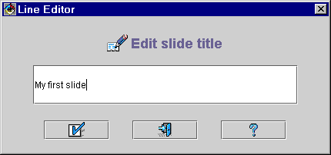
Fig. 6.37. Editing slide title
A sequence of slide definitions containing title, locations of files with data, text data, and meta-data, can be loaded from a disk file by pressing „Load slides from file” button ( icon). A new window appears to choose file location on the disk. After selecting a file and pressing „Open file” button, the contents of the file is read by Image Loader into slide list. The previous contents of the list are erased. If the list is not empty and it has not been stored into another disk file, a warning message is displayed and a decision to continue loading is left to the user.
Two file formats of files with slide lists are supported. The first one is legacy format of WebWisdom 1.0. This format was used by wwwfoil compiler, a part of WebWisdom 1.0, to generate a list of foils. The format is explained in details in the previous section concerning importing WebWisdom 1.0 presentations and it will not be presented here. The second format is SPT („Source Photos and Texts”) format designed specially for WebWisdom NT system.
The SPT format is a line-oriented, text-only format to describe slide data and meta-data. Only slide descriptions and text data are stored, while other slide data (i.e., images) are remembered as pointers to disk files. The file is read line by line, with respect to the following line format:
command : parameter
Both command and parameter are of arbitrary length. The command is a name of a command to be performed while reading the file. It does not contain spaces and is case-insensitive. There are no spaces between the command and the ‘:’ character separating it from the remaining part of the line - parameter. The parameter is interpreted according to the command. The parameter may contain any ASCII characters except newline character (ASCII code 10 and 13), which is treated as a line (and parameter) delimiter. To insert the newline character into the parameter data, one should use escape sequence ‘\n’, well known from many programming languages. To insert the slash ‘\’ character itself, the ‘\\’ sequence should be used. Other escape sequences of type ‘\n’, where n is any character not being ‘\’ and ‘n’, are replaced by the n single character.
To code bulleted list, an extension of HTML format is used. This extension consists in adding one attribute to the „<P> and „</P>” HTML tags. This attribute, named „L”, is used to code the bulleting level (one digit, 0..9). Non-bulleted part of the list is coded by „<P L=”0”>, first bulleting level - „<P L=”1”>”, etc. While using the Image Loader to generate SPT file, this coding is performed automatically by the system. However, while changing such file manually, one should take care for consistency of bulleting levels pointed by the „L” attribute.
The SPT command summary is presented in the table below. Underline once again that:
- command parameters should not exceed one line of text; to introduce newline character into a parameter, one should use ‘\n” escape sequence (cf., an example for „html” parameter),
- command parameters should not contain ‘\’ characters widely used in file names; they should rather use ‘\\’ escape sequence (cf., examples for „image” and „link” parameters),
- annotation may contain HTML formatting commands, for example <B>, <BR>, etc., although it is not recommended to hardly use them as the system (nor the Importer neither the Exporter) does not provide any checking for them (cf., an example for „annotation” parameter),
- description bulleted list may also contain HTML formatting commands under the same restriction (cf., an example for „description” parameter); bulleting levels are coded by the use of the „L” attribute for „<P>” and „</P>” tags,
- if a given command is read more than one time for a given slide, only its last occurrence in the file is taken into consideration; overriding data and attributes are not reported.
Command | Meaning | Domain | Default value | Sample values
#!SPT xxx | SPT format version, always the first line of the file | - | - | #!SPT version 1.01  #!SPT 1.0
Title | Foil title, beginning of slide definition | ASCII line | Slide No NNN | Dolphins
Title_ | Foil title redefinition | ASCII line | - | Dolphins
Image | Foil data: name of image disk file | file name | - | c:\\temp\\slide_show\\dolphins.gif
Link | Foil data: URL address of an external HTML page | URL | - | file:\\\\\\c:\\InetPub\\wwwroot\\ samples\\htmlsamp\\styles.htm  http:\\\\www.npac.syr.edu
Html | Foil data: HTML text | one multi-line of text in HTML format | - | <HTML> <HEAD> </HEAD>  <BODY><P> Some images of animals: \n <NL> <LI> dangerous <LI> wild but nice <LI> domestic </NL> <P> The photos were taken from "National Geographic".</P>  </BODY> </HTML>
Primary | Data type of primary use | image | link |  html | image | yes
Author | If before any slide definition, author(s) of a collection of slides (a presentation); if inside foil definition, author(s) of a foil data (mostly image snapper) | ASCII line | - | John Smith  Peter, Paul and Mary  J.K.Lewis
Event | Comment on an event related to a presentation / a foil | ASCII line | - | Presented at VLDB’98 conference  NPAC 05’98 annual meeting
Date | Date of creation of a presentation / a foil | dd-mm-yyyy | - | 21-09-1998
Name | Unique and space-less name of a presentation | ASCII word | - | photoset001
Label | Long name for a presentation | ASCII line | - | Photo set number 001
Heading | Text to be displayed as a presentation title by the Exporter | ASCII line | - | Photo Set 001: pictures of children
Annotation | Annotation in the table of contents of the presentation BEFORE the slide title | HTML line | - | Some images of <B>animals</B>
Note | Bulleted list of HTML lines | bulleted list of HTML lines | - | <P L=”0”> Some images of animals: </P L=”0”> <P L=”1”> dangerous </P L=”1”> <P L=”1”> wild but nice </P L=”1”> <P L=”1”> domestic </P L=”1”>  <P L=”0” E=”1”> The photos were taken from "National Geographic".</P L=”0”>
Comment | Foil meta-data: unformatted ASCII comment | multi-line of unformatted text | - | This is a foil for test purposed only
Currently composed sequence of slide definitions containing title, location of files with data, text data, and meta-data, can be stored in a disk file by pressing the „Save to file” button ( icon). A new window appears to choose file location on the disk. After selecting a file and pressing the „Open file” button, the contents of the slide list is stored in the file in SPT format described above (Fig. 6.38). The previous content of the file, if any, is erased. If the saving procedure cannot be completed for some reasons, a warning message is displayed in a separate window.
#!SPT version 1.01
author:John Smith Jr.
event:Collection of slides for WebWisdom NT NPAC Presentation
date:10-01-1998
name:wwNTpresentation
label:WebWisdom NT Presentation
heading:A presentation of WebWisdom NT v. 2.0 system

title: It's me
image: C:\\TEMP\\photos\\rykowski.gif
primary: image
annotation: A few words about me: quite tall, not to thick, brown eyes.
author: John Smith
comment: Picture taken at the school year 1995/96
date: 01-01-1995

title: NPAC starting WWW page
link: http://www.npac.syr.edu
comment: \nThis is unformatted ASCII text.\nTo change it, type in this field.\n
primary: url
annotation: Some sample slides with different data
author: John Smith

title: Sample HTML page
html: <P L=”0”> This is normal paragraph, with some letters written in\n<B>bold</B> and <I>italics</I> mode.\n</P L=”0”><P L=”1” E=”1”> <H1>\nThis line is large</H1>\nwhile these words are <U> underlined</U>.\n</P L=”1”>
primary: html
Fig. 6.38. Sample SPT file, long lines (printed in italics) wrapped for visibility reasons
The current list of slides can be erased by pressing „Clear all” button ( icon). If the list is not empty, a warning message is displayed on the screen and a decision is left to the user: to continue or not.
By pressing „Help” button ( icon) one may invoke an HTML browser with this text displayed.
The current list of slides can be stored in the database as a presentation by pressing „OK” button ( icon). After successful storing, the Image Loader window is removed from the screen. To compose and store a new presentation, this window must be invoked once again.
If some necessary meta-data are not set before „OK” button is pressed, a user is prompted to fill missing attributes with values. This procedure is described in details in the next section.
By pressing „Exit” button ( icon) one can quit the window. No change is made in the database. If the current sequence of slides has not been stored in a disk file and it is not empty, a warning message is displayed in a separate window and a decision is left to the user: to exit window and loose all the prepared data or not.
To edit slide and presentation meta-data, one must change active tabs from the tabbed panel by the use of „Active tabs” pull-down menu located in the upper-right corner of the window. After switching to meta-data tabs only, the tabbed panel is equipped with three tabs: „Note”, „Annotation”, and „Comment”.

6.4.3. Editing foil note
To edit a note, i.e. HTML-bulleted list of lines being additional foil description displayed together with main foil data (e.g., a capture below a photo), one must press the “Note” tab. Using this tab is similar to using the “Text” tab (Fig. 6.39).
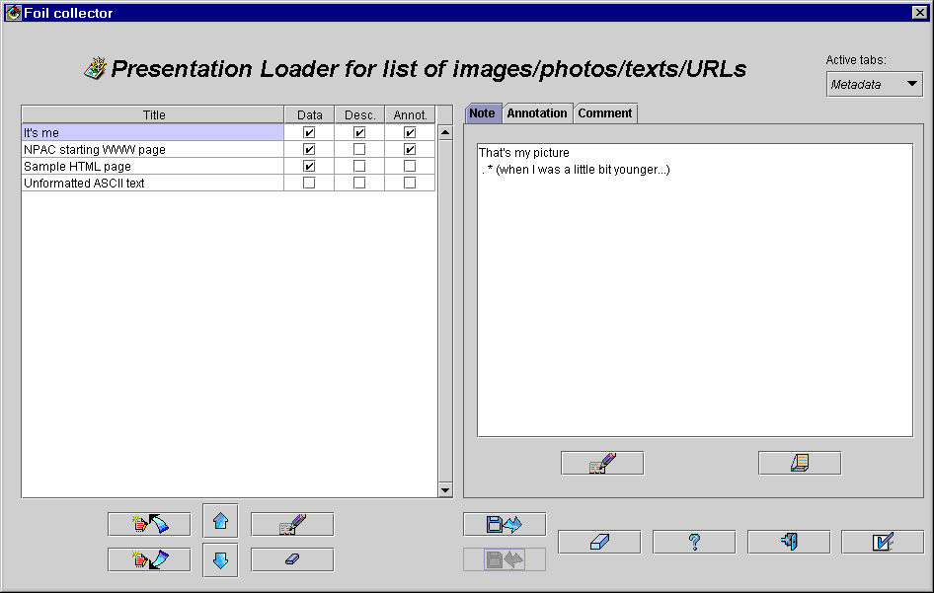
Fig. 6.39. Setting meta-data for slides, „Note” tab active

6.4.4. Editing foil annotation
To edit or display annotations one must select „Annotation” tab in the tabbed panel in the main window. In this tab a table of contents of a presentation is displayed with slide titles and slide annotations. An annotation is one line of text inserted in the table of contents just before the slide title (Fig. 6.40).
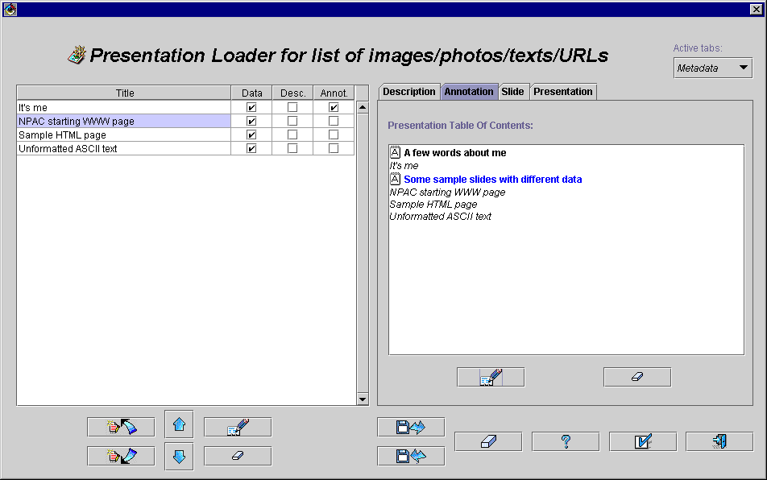
Fig. 6.40. Setting meta-data for slides, „Annotation” tab active
To distinguish among slide titles and their annotations, in the list annotation lines are preceded by icon. An annotation belonging to currently selected slide is displayed in blue color. If there is no annotation for a selected slide, this slide title is displayed in blue. To edit the annotation or to enter a new one, a user should press „Edit annotation” button ( icon) located below the list with the table of contents. After pressing the line editor is invoked to enter a new annotation or change existing one. After the change is complete, the edited/inserted annotation is displayed in the list with the table of contents.
To clear an annotation one may press the „Clear annotation” button ( icon).
With the third tab labeled „Comment” one may enter an unformatted ASCII text (Fig. 6.41) which will not be displayed by the Exporter but rather used by users to describe a foil. This tab is equipped in a text field and two buttons: ”Load text from file” and “Clear text”. The first button is used to fill the text area with contents of a given disk file, while the latter one – to clear the area. A comment may be edited by simply typing in the text area.
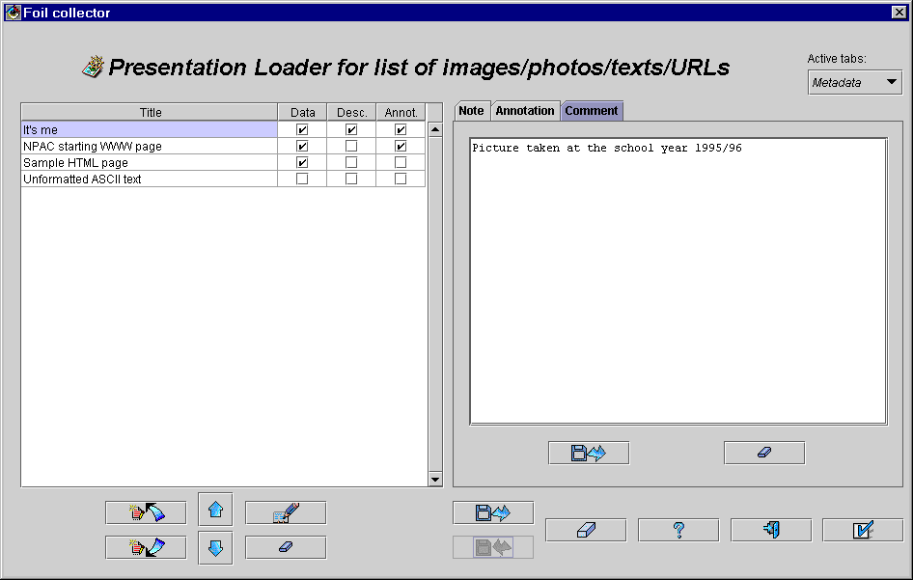
Fig. 6.41. Defining ASCII unformatted text as foil comment

6.4.5. Phase 2 - storing collection of foils in the database
This phase is invoked by pressing the “OK” button ( icon). A new window appears to define presentation attributes, and next – foil attributes for all the foils form the collection. Using of these windows is similar to incorporating PowerPoint, RTF-based, and WebWisdom 1.0 presentations (cf. Section 6.1.2).

7. Exporter

7.1. Dynamic exporter
The Exporter is based on TESS servlet-based system (cf. documentation of TESS system). Dynamic generation of foil contents is controlled by a set of templates written in TDL language. An example shown in this section is based on “cps” set of templates described in details in the documentation of the TESS system.
To read a presentation from the database, a user may use any HTML browser, e.g. Netscape Communicator or Microsoft Internet Explorer. After connecting the database, a welcome page is displayed (Fig. 7.1). A user is requested to write down his name and current password. If the name is unknown for the database, or the password is wrong, a message is displayed “Password incorrect, authorization failed”. The user must correct the name or the password and try to log-in once again.
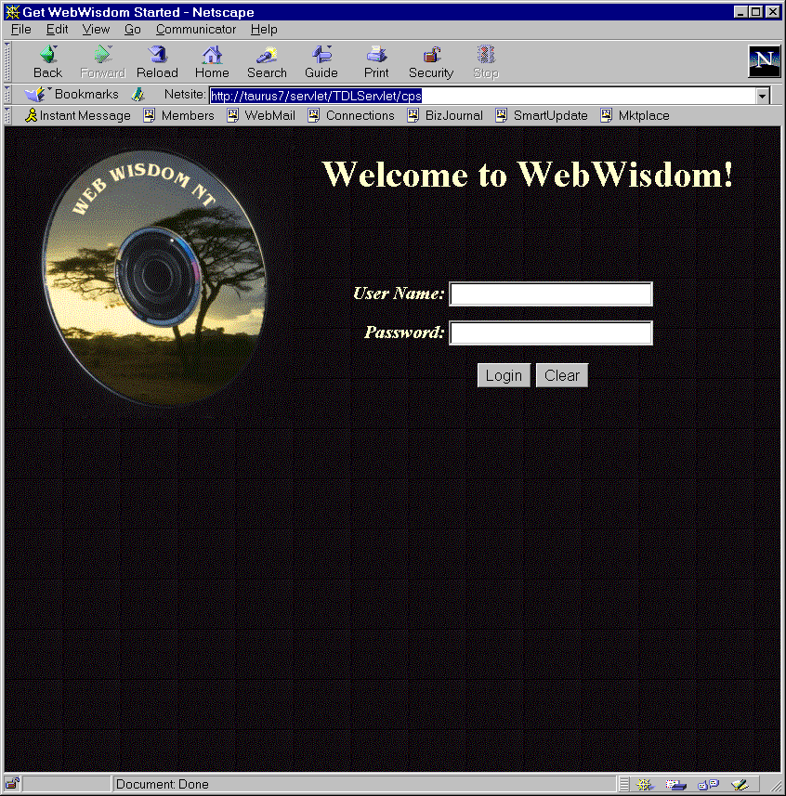
Fig. 7.1. Welcome page of “cps” template
If the name and the password are correct, a new page is invoked in which the foilworld hierarchy is displayed (Fig. 7.2).
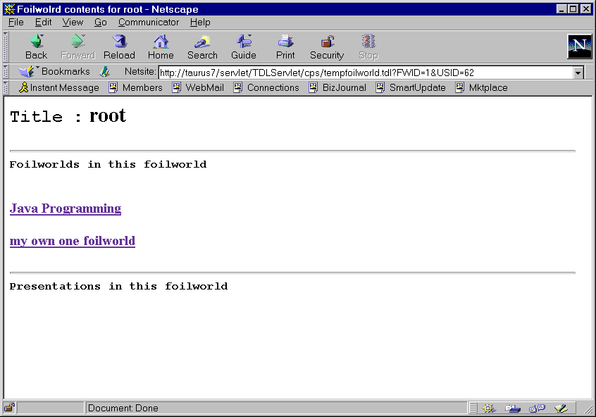
Fig. 7.2. Root of the foilworld hierarchy displayed by the template
A user may navigate in the hierarchy to find the foilworld that contains a presentation he would like to see. When a foilworld is found, the user clicks on it to display its contents. Titles of presentations from the selected foilworld are displayed (Fig. 7.3).
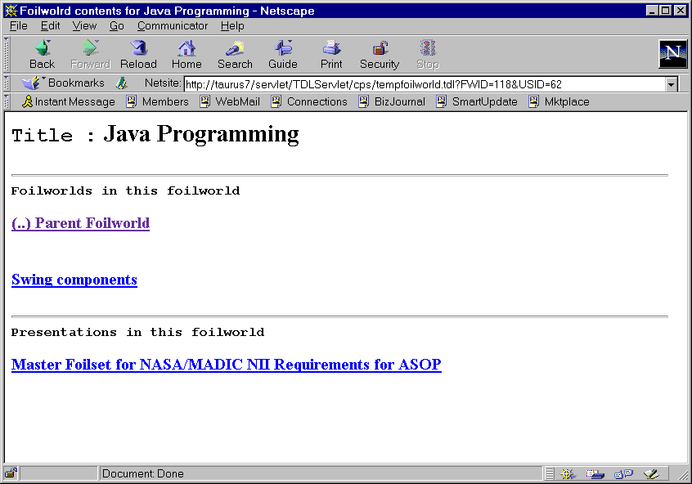
Fig. 7.3. Contents of a foilworld displayed by the template
Once a presentation is selected, its content is displayed (Fig. 7.4). Usually, foils can be displayed as images or as HTML bulleted lists. Thus, for each foil from the presentation two buttons are provided: “separate image” and “separate html”. Pressing these buttons displays image and text of a foil, respectively (Fig. 7.5 and 7.6).
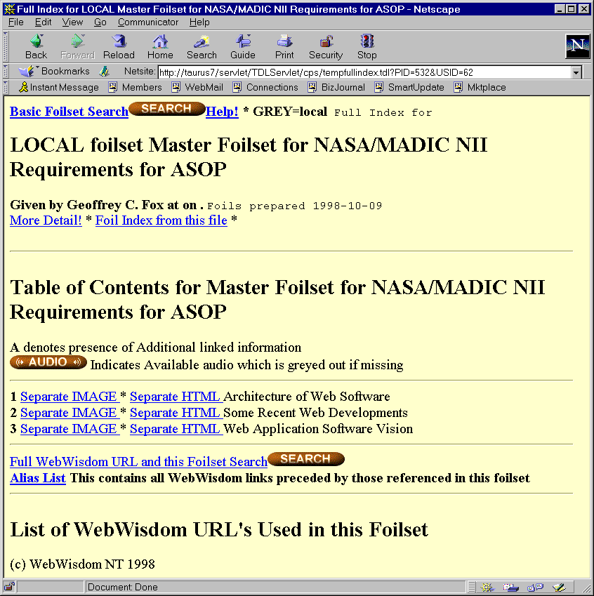
Fig. 7.4. Contents of a presentation displayed by the template
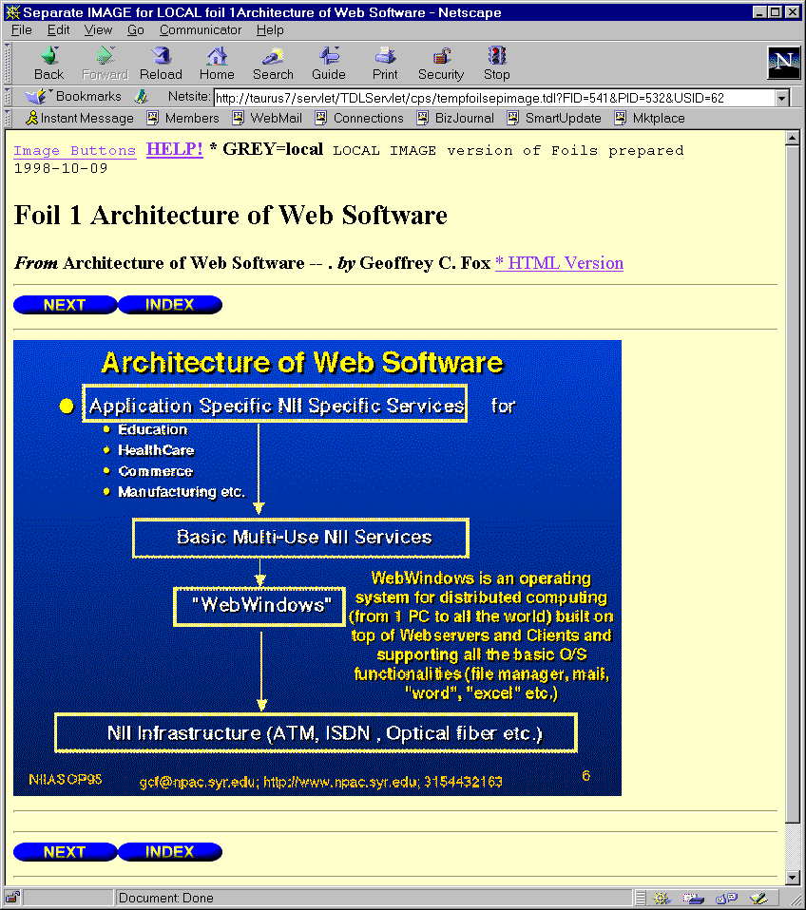
Fig. 7.5. Displaying contents of a given foil in graphical form
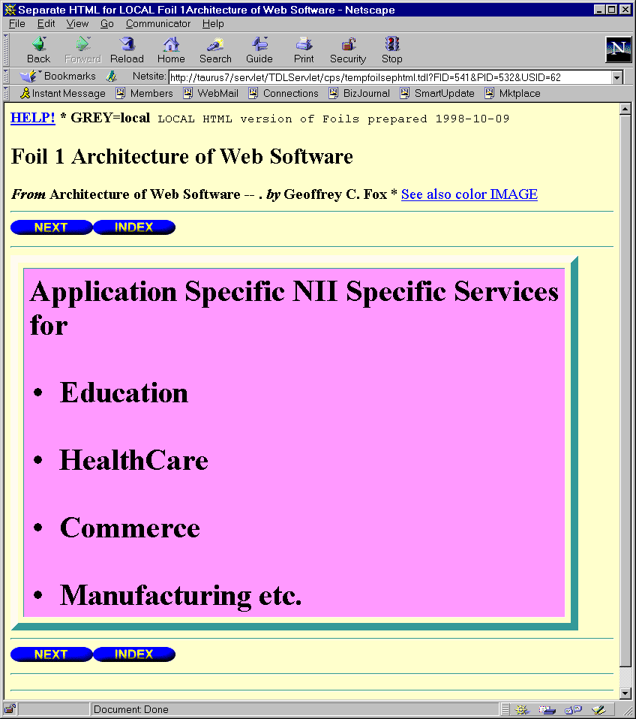
Fig. 7.6. Displaying contents of a given foil in text form
If an add-on (i.e., a URL address with additional information for the foil, cf. Chapter 5 and 6) for a selected foil is present, a frame labeled „addons” contains its title. By clicking this title, a user may invoke a new window with a page addressed by the selected add-on (Fig. 7.7).
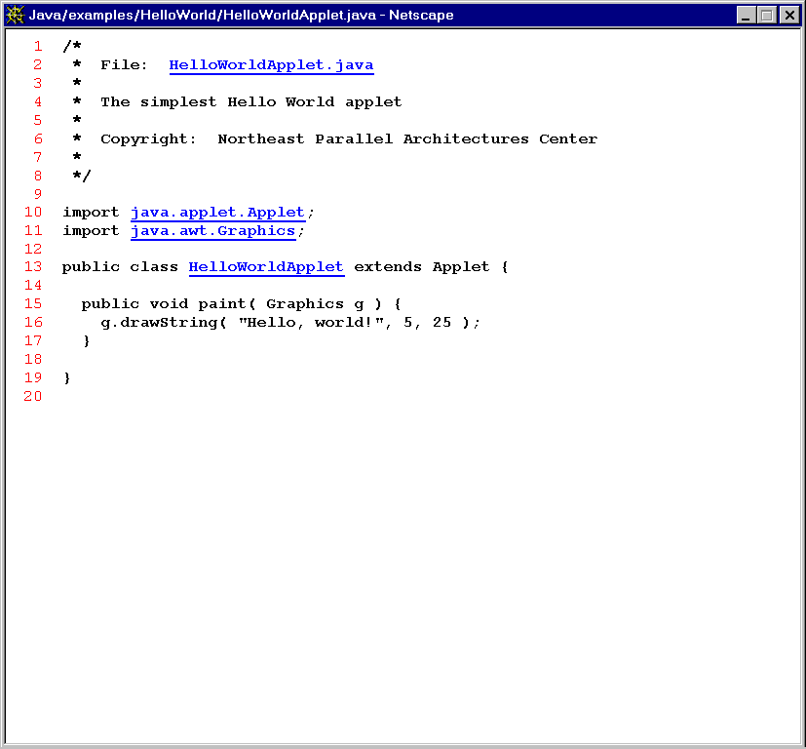
Fig. 7.7. Contents of a sample add-on

7.2. Static exporter
The Static Exporter is used to generate a directory of HTML files corresponding to a given presentation. Such static presentation may be copied to another disk or CD-ROM as a set of files grouped in one directory and next accessed with no direct network connection to the database. Thus, one may say this is an off-line mode of using the database.
The Static Exporter is invoked from the main window by pressing the “Presentation Exporter” button (cf. Fig. 3.3). A new window appears (Fig. 7.8) with three buttons: “Foilworlds”, “Presentations”, and “Exit”. The last button is used to quit the window.
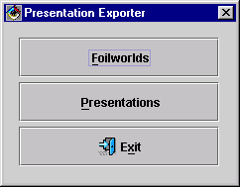
Fig. 7.8. Main window of the Static Exporter
The “Foilworld” button is used to export all the presentations from a selected foilworld, while the “Presentation” button – to export a set of selected presentations. Presentations (foilworlds) to be exported can be chosen in a window appearing on the screen after one of these buttons is pressed (Fig. 7.9). The window is equipped with five buttons: the “Help” button ( icon), the Exit” button ( icon), the “OK” button ( icon), the “Show selected only” ( icon). The first three are standard, and the last one is used to mask unselected presentations (i.e., to remove from the list currently unselected presentations). To select/deselect a presentation (a foilworld) it is enough to click over its name. Currently selected presentations are marked by the √ symbol.
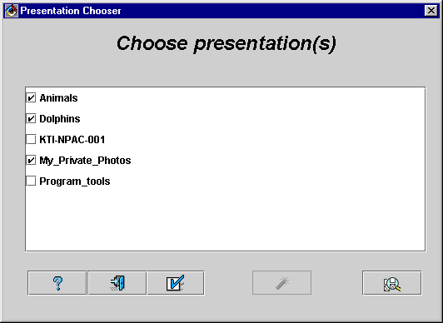
Fig. 7.9. Choosing presentations to be exported statically
After selecting presentations/foilworlds a user should press the “OK” button ( icon). A new window appears to define parameters for exporting (Fig. 7.10). HTTP address of a TESS servlet must be provided in the upper text field labeled “Servlet path:”. A name of a template to be used for exporting must be provided in the middle text field labeled “Template name:”. A name of a directory in which all the exported files will be stored should be written in the bottom text field labeled “Local directory:”. The “Choose...” button may be used for browsing directories. In the check boxes “Follow link rules:” one must declare if only a given presentation should be exported (item “This presentation only”, a presentation and all the documents (foils) stored on the same HTTP server and directly pointed by this presentation (“Allow links on server”), or a presentation and all the documents the presentation points to, regardless if they are stored locally or externally.
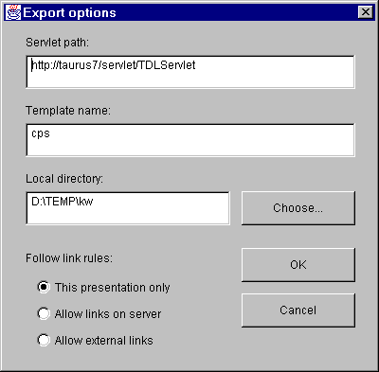
Fig. 7.10. Choosing parameters for the exporting process
After preparing the parameters a user must press the “OK” button. A new window appears (Fig. 7.11) reporting current state of the exporting process: URL address of a page that is under exporting at the moment, template and presentation names, and counter of a currently exported file.
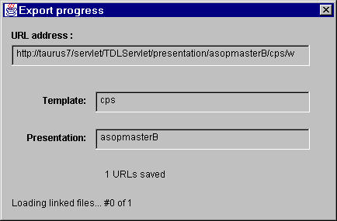
Fig. 7.11. Exporting files
Once the exporting is done, the window disappears and a message appears to inform a user the process is done.

8. Installation of the WebWisdom NT system
Installation of the WebWisdom NT system can be divided into five tasks:
- creation of Oracle user account,
- creation of database schema,
- initial database filling,
- installation of WebWisdom Manager,
- installation and configuration of Netscape Enterprise Server
- installation and configuration of WebWisdom NT Template(s).

8.1. Creation of Oracle’s user account
WebWisdom NT system operates on one database user account. The account name and password used by Wisdom Manager can be modified in the login window by a privileged user (root or admin) – see Chapter 2 for details. User account used by Exporter can be modified in the template configuration file: wisdomnt.conf - see Section 8.1.5 for details. In general, the same database user should be used for schema creation, initial database filling, and later by the Managers and the Exporter. In the succeeding description this specific database user is called “webwisdom user”.
To create a database user account for WebWisdom NT system, Oracle Security Manager can be used. Database user name and user password must be provided. User privileges should include at least “connect” and “resource” standard roles, and “unlimited tablespace” privilege.

8.2. Creation of database schema
WebWisdom database schema is created by a list of SQL commands executed from Oracle’s SQL*Plus.
Before starting the database schema creation process, database administrator should copy appropriate files into a directory accessible by SQL*Plus (e.g. .../oracle/bin). The following files should be copied:
- wisdom.sql - main scheme creation file,
- wisdom.tab - file containing table creation commands,
- wisdom.seq - file containing sequence creation commands,
- wisdom.con - file containing constraint commands.
To create the database schema, the database administrator should login to the Oracle Database System by the use of SQL*Plus as the webwisdom user and enter the following command:
Start wisdom;
If the command executes successfully, the WebWisdom database schema is created.
The next step is initial database filling described below.

8.3. Initial database filling
WebWisdom NT system requires that some initial data are entered into the database before the system can start running. Example data include: colors, mime_types, properties, root user account, root foilworld, help files, etc. Initial database filling is performed partially by SQL commands, partially by external Java programs. External Java programs are used for data-types non-manageable directly by SQL*Plus (e.g., images or HTML files).
The whole database filling procedure is divided into four steps:
step 1: filling users, colors, forms, and mime-types,
step 2: filling images,
step 3: filling properties,
step 4: filling “help” files and images.

Step 1 - filling colors, forms, and mime-types

The following files are required during this phase:
- fill1.sql,
- insert_event_types.sql,
- insert_edu_types.sql,
- insert_prop_types.sql,
- insert_mimetypes.sql,
- insert_forms.sql,
- insert_users.sql,
- insert_roles.sql,
- insert_colors.sql.
All these files should be copied to a directory which is accessible by SQL*Plus (e.g., .../oracle/bin). To complete this step user should enter the following command in SQL*Plus:
Start fill1;
During this phase the following data are entered to the database: used MIME types, used presentation forms (cf. Presentation Manager and setting properties in Section 5), and color names and their RGB definitions. After successful execution all database changes should be committed:
commit;

Step 2 - filling images

This step is performed by the use of standalone Java program StoreImage. The program reads an image file and stores image bytes into the database. This program requires four parameters: image file name, database image name, WebWisdom NT user name, and connection string (composed of database user name and password, hostname, port and database name). The database image name must be unique – no two images with the same database image name can be stored into the database. To simplify the configuration process, the program stores one image at a time and therefore is invoked many times by script images.bat. This script contains multiple lines in the following format:
set CLASSPATH=.;..\..\classes111.zip
java StoreImage File1.gif ImageName user_name user/password @ hostname:port:database
java StoreImage File2.gif AnotherImage another_user user_name user/password @ hostname:port:database
...
After successful image storing next phase – filling users and properties – can be performed.
Step 3 - filling users and properties

During this phase the following data are entered to the database:
- color and image properties used by an example template, and
- general properties.
This phase is a SQL phase and can be performed from SQL*Plus. The following command should be entered after logging in as the webwisdom user:
Start fill2;
commit;
The following files are required during this phase:
- fill2.sql,
- insert_color_image_prop.sql,
- insert_general_prop.sql.
All these files should be copied to a directory accessible by SQL*Plus (e.g. .../oracle/bin).
After successful completion of this phase, help data can be stored in the way described below.

Step 4 - filling “help” files and images

During this phase help HTML files, help images and help text files are prepared and stored in a HTTP server. The help files, images and anchors are created automatically from the documentation (i.e., this text). The documentation in Microsoft Word 97 format is first converted to HTML format. As a result, one HTML file is generated and a set of GIF images. The HTML file is parsed by help compiler (program hc.exe invoked with no parameters in the directory the HTML file is located) and divided into chapters, each chapter in a separate, HTML file. In addition, one file is generated being a table of contents of the documentation.
During help compilation a file is automatically generated labeled rc.out, that is a compilation history and list of errors and warnings. Once the compilation process is completed, one should read this file to verify if the generated files are error-free.
At this point WebWisdom NT database is ready to use. The Managers and the Exporter can be used to fill and manage the database contents and for data retrieval. See Section 8.4 for details on how to install the Manager, and Section 8.5 on how to configure the Exporter (templates).

8.4. Installation of WebWisdom Manager
To install the WebWisdom Manager (i.e., the Managers, the Presentation Loader and the Maintenance Tools) it is enough to run the “setup.exe” program located in the root directory on the configuration media (CD-ROM). After starting the program one must chose the destination directory names and locations of menus and which parts of the system should be installed. The installation process is fully automated and controlled by standard InstallShield software. No other installation procedures are needed to complete this step of the installation of WebWisdom NT system.
To start WebWisdom Manager on PC systems run.bat script should be used. To run it on IRIX systems run.sh Bourne shell script should be used.

8.5. Installation and configuration of HTTP Server
WebWisdom NT system requires that any HTTP Server with support for servlets is installed.
After successful installation of HTTP Server, required WebWisdom NT server extensions must be installed. These extensions are used by WebWisdom applications to retrieve non-trivial data types from the database (e.g., images, sounds, HTML files, PowerPoint sources, etc.). Extensions are implemented in a general way allowing retrieval of any type of data from the database.
The main server extension is getdata utility. It is a servlet written in Java which can be used to retrieve data from a database that is installed on any host in the network.
The following files form the getdata extension:
- Getdata.java,
- Constants.java.
The compiled *.class files should be copied to appropriate HTTP Server „servlet” directory. Example directory can be:
\netscape\suitespot\plugins\Java\servlets
For the extensions to be installed properly the HTTP Server should be restarted. System administrator should make sure that the HTTP Server can access required Oracle Java classes (file classes111.zip).
Getdata extension uses two configuration files:
- wisdom_users.conf – containing list of connections to databases,
- wisdom_tables.conf – containing list of table names that are excluded for getdata.
These files should be copied to appropriate Netscape Enterprise configuration directory, e.g.:
\netscape\suitespot\https-servername\config
The wisdom_users.conf file contains a list of database connections that can be used by getdata utility. The file has the following format:
Connection_identifier|user_name/password@host_name:port_no:database_name
where:
- connection_identifier is the name the connection will be identified in URL,
- user_name – user name used to access the database,
- password – password for database user name,
- host_name – host name of the server the database system is running,
- port_no – port number used by JDBC to connect to the database,
- database_name – name of the database.
For example, a file:
1|user1/password1 @ host.dns.domain.edu:1521:ORCL
second|wisdom|wpas33 @ hostname:1521:ORCL
3|test/test @ kopernik.napc.syr.edu:1521:ORCL
defines three different connections: „1”, „second”, and „3”.
The wisdom_tables.conf file contains a list of table names that should not be accessed by getdata server extension.
Contents of a sample wisdom_tables.conf file can be the following:
Users
Presentation
Foilworld
access_to_foilworld
Both wisdom_users.conf and wisdom_tables.conf can be modified “on-the-fly” without restarting the Enterprise Server.
Getdata utility can be used to retrieve data from the database by the use of standard URL addresses. Every attribute in the database can be addressed by an URL in the following format:
http://server_name/servlet/getdata/connection_id/ table_name/attribute_name/query_condition/ mime_major/mime_minor/file_name
where:
- server_name is the name of the server,
- connection_id is the connection identifier specified in the wisdom_users.conf file,
- table_name is the name of the table to be accessed (providing that it is not listed in wisdom_tables.conf file),
- attribute_name is the name of the table attribute to be retrieved,
- query_condition is an SQL-like condition in URL-encoded format,
- mime_major is the major mime type that should be returned by the server,
- mime_minor is the minor mime type that should be returned by the server,
- file_name is the file name returned by the server.
For example, the following URL:
http://host/servlet/getdata/wisdom1/image/data/iid%3d1/image/gif/a.gif
will cause the getdata to retrieve “data” attribute value from the “image” table where “iid=1” and return the result with mime type “image/gif” and file name “a.gif”.

8.6. Installation and configuration of dynamic Exporter (TDL templates)
For details on installation and using the TESS servlet-based system and TDL extensions used as the Presentation (dynamic) Exporter refer to user’s manual and technical notes for the TESS system.

The HTML conversion can be done either by the use of WebWisdom-PowerPoint Exporter, PowerPoint Assistant for PowerPoint95, or by “Save As HTML” command of PowerPoint 97.
PowerPoint outline can be generated by “Save As (RTF) Outline” command of PowerPoint95/97.
Information about colors is included only in an RTF outline generated by PowerPoint97.
From packet JDK version 1.1.6 and above.
Most buttons are labeled by icons only. A text description of a button can be obtained by moving mouse cursor over this button and waiting for a few seconds. The description will be displayed as a tip. It will hide after the cursor is moved or any mouse button is pressed. Actions related to buttons can be also executed by pressing a key, which is underlined in the button name and always explicitly pointed in the tip.
The properties for the system, users, presentations, and foils can be set individually by the use of similar windows. Template’s author should use the following rule to find a value of a given property: try to get a value for a foil property; if not defined - for a presentation property, if still not defined – for a user property, and finally if still not defined – for a system property (for the system all the properties are obligatory). This rule is valid for any property, regardless it represents a color, font size, an image, etc.
Detailed behavior depends on user-defined templates.
Usually: „Times” or „Times New Roman”, „Arial” or „Helvetica”, „Courier” or „Courier New”, and „Symbol”.
There are only examples, one can define and use other properties by the use of the Property Editor.
Other foilworlds only, not presentations.
This ability can be useful for example in the case of a teacher and some students preparing a set of presentations. The teacher creates a set of foilworlds, a separate foilworld for each student, and grants temporally an ownership to students. The students develop contents of their foilworlds and after completing their tasks they rapport to the teacher the work is done. The teacher takes back the ownership of the students’ foilworlds having now full access to the work the students have done.
For non-empty foilworlds this menu is equipped in more items (cf. next sections).
The properties for users, presentations, and foils can be set individually by the use of similar windows. In the templates, the following rule should be used to find a value of a given property: try to get a value for a foil property; if not defined - for presentation property, if still not defined - user property, and finally if still not defined – system (default) property. This rule is valid for any property, regardless it represents a color, font size, an image, etc.
Depending on a context, some items may not be active at the moment.
The Exporter does not have to respect this mark - it depends on user’s templates.
Universal Resource Locator
The original PowerPoint-to-HTML exporter also can be used, but it is deprecated because: (1) it generates files in a format that is not fully compatible with HTML, and (2) it generates no information about bulleting, which WebWisdom-PowerPoint Exporter does.
If the exporter is used for the first time and a path to an output directory has not been ever defined, the window to choose this directory is invoked automatically without pressing "Browse..." button. Next time when the WebWisdom-PowerPoint Exporter is invoked the last set directory is treated as the default one.
Pressing this button has the same effect as double-clicking over a directory name selected from the list.
These extensions are described in the next part of this section, for RTF and WebWisdom 1.0 importers. Such extensions are usually not used for original PowerPoint presentations.
The database internal format is based on HTML, thus the compiler is named “RTF-to-HTML compiler” in the remaining part of this document.
It depends on the operating system - the “/” character for UNIX and the “\” character for MS-DOS and Windows.
Next section deals with direct invocation from the level of the importer.
These parameters may be overwritten by the Presentation Loader and the Presentation Manager.
I.e. properly incorporated into the structure of WebWisdom 1.0 system by successfully passing the three stages of wwwfoil compiler.
In the UNIX operating system files are copied only logically by the use of symbolic links (“ln –s” command).
This file is usually already concatenated at the beginning of the processed file, but a check is made if these two files are consistent. If not, settings from the options file replace the corresponding ones from the processed file.
The scripts/s2p compiler cannot detect last foil of a sub-presentation pointed by "end" statement instead of foil number in "script" file. One must correct it manually by going to the pointed presentation, getting its highest foil number and replacing "end" string by this number in the "script" file.
The annotation is a HTML text, thus it is possible to format its way of displaying by the Exporter, for example by the use of <BR> (multi-line annotation), <B> (bolded annotation), <I> (annotation printed in italics), and similar HTML tags.
As it was previously mentioned, the Exporter does not have to display the description and enumerated HTML-compliant list - it depends on user’s templates.
On condition they are accessible at the moment of their presentation. As they are external pages, they are out of control by the database.
Due to some limitations of the current version of Java Swing library, some complicated HTML elements (frames, tables, large images) are not displayed properly. Hopefully this will change with a new version of this library coming soon.
Not all the WebWisdom 1.0 commands are taken into consideration during exporting from this format to SPT format used in WebWisdom NT. In particular, formatting commands (font sizes, color, backgrounds, etc.) are omitted as well as „signature” and „datemod” commands. However, data (image, HTML bulleted list, annotation) and library attributes (author, date, event comment, etc.) are interpreted correctly.
Note that the parameters in reality do not exceed one line of text. In this table they are cut into separate lines only for publishing reasons - long texts cannot be printed.

