WebWisdom.com Product Description
September 19, 1998
For more information, please contact us at 3154432163 or gcf@webwisdom.com
Web Information can be found at http://www.webwisdom.com and http://trurl.npac.syr.edu/tango

WebWisdom Core Products
- TangoInteractive Basic: General Collaboration Tool including Audio-Video Conferencing, Shared Browser, White boards, Chat rooms and selected example applications including games and simulations. TangoInteractive fully supports the powerful shared event model for collaboration and allows both client and server shared applications using API’s for essentially any language including C++, Java (Beans, Applets, Applications), and JavaScript. TangoInteractive is linked to conventional electronic mail, which can be sent to both conventional, and TangoInteractive clients.
- Buena Vista: Standalone Audio-Video conferencing tools supporting a range of audio and video codecs with bandwidth requirements appropriate for either phone line, Internet or LAN applications. Buena Vista supports multiple point to point connections.
- WebWisdom Intelligent Server: XML Database Web Interface supporting client customization and built in XML invoked filters. Instant Cache capability allows composite documents to be cached for a short time period so that they can be efficiently replicated among the clients of a TangoInteractive session.
- WebWisdom Object Manager: Java Management Tool for information objects allowing their annotation and arrangement in dynamic hierarchical fashion with storage in any relational database supporting the Java database linkage standard JDBC. Superimposes the familiar Windows or UNIX file system hierarchical information model onto information objects composable into documents by a powerful XML based object model. The Manager supports documents defined by XML templates, where documents and templates are stored in the backend database and can be interpreted by the WebWisdom Intelligent Server. The WebWisdom Object Manager also supports the personal data needed to describe people (such as teachers and students in education or training) developing and using these objects. This product can support any application areas where such an information and personal model is appropriate but WebWisdom Integrated System products support application to education and training or to collections of images. Web metadata standards are supported in personal and document object models.
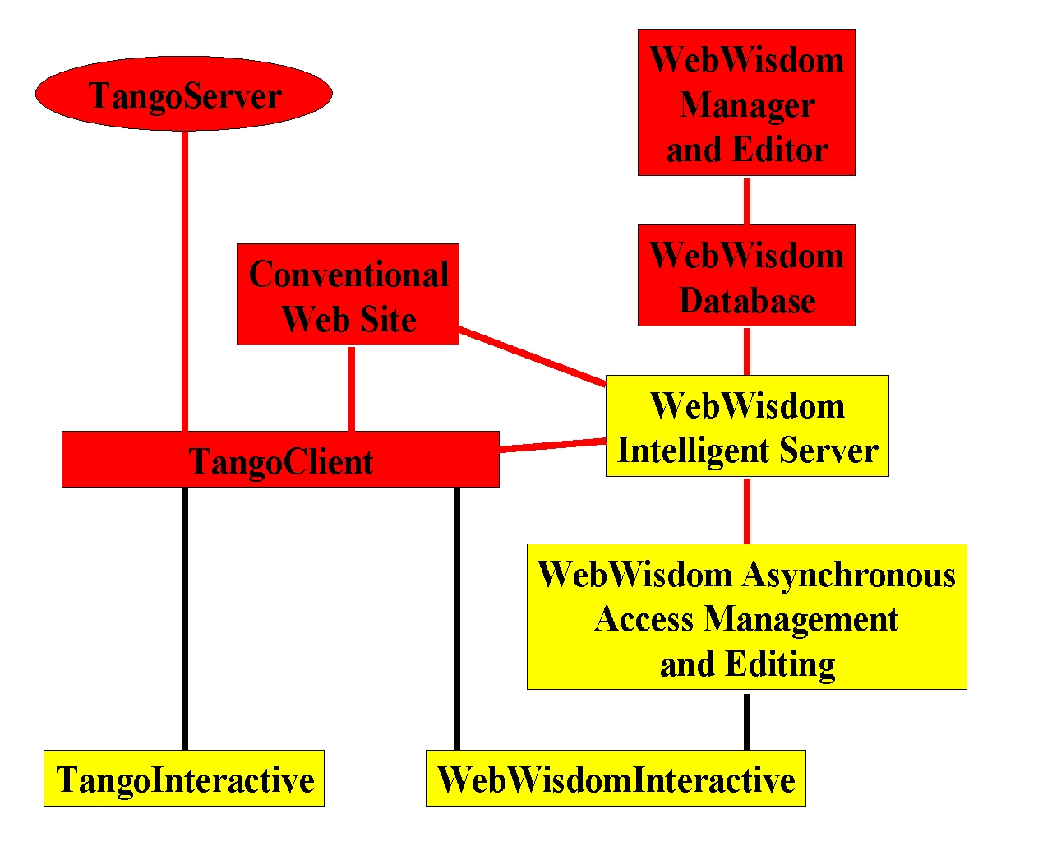

Relationship of Key WebWisdom.com Products

WebWisdom Integrated Systems
- TangoInteractive Pro: General Collaboration Tool augmenting TangoInteractive with sophisticated general tools including shared streaming multimedia, advanced chat, a shared mapping tool and games. Includes personal identity module, which is consistent with WebWisdom Asynchronous Worlds.
- WebWisdom Asynchronous Worlds: WebWisdom Intelligent Server combined with carefully designed application specific database schema supporting information objects and personnel data arranged in an interactive hierarchical fashion supported and generated by the WebWisdom Object Manager. Provides powerful managed asynchronous resource for any application for which a hierarchical XML based document model is appropriate. Available with templates for the WebWisdom Intelligent Server and database structure for the WebWisdom Manager that support particular application domains. Currently three application areas are supported:
- WebWisdom Learning World: WebWisdom Asynchronous customized for educational objects and supporting multimedia curricula
- WebWisdom Customer Support World: WebWisdom Asynchronous customized for manuals, glossaries, help pages and bug reports as seen in resources needed to support users of any sort of product.
- WebWisdom Scrapbook World: WebWisdom Asynchronous World customized for collections of images such as those coming from collections of family snapshots.
- WebWisdom Interactive: Combines TangoInteractive Pro and WebWisdom Asynchronous for fully featured synchronous and asynchronous collaborative environment. This can be customized for particular application domains as described above and again leads to three subproducts.
- WebWisdom Learning Interactive: WebWisdom Interactive customized for educational objects. This is a robust product that supports both self-paced and interactive web-based education and training. It can be used by either individual teachers to compose and deliver courses or with appropriate backend databases for all the online courses of a university.
- WebWisdom Customer Support Interactive: WebWisdom Interactive customized for manuals, glossaries, help pages and bug reports as seen in resources needed to support users of any sort of product. Initial application will be tested with the support of WebWisdom.com products.
- WebWisdom Scrapbook Interactive: WebWisdom Interactive customized for collections of images, such as those coming from collections of family snapshots. WebWisdom Photo Interactive allows families to interactively share an annotated family web archive for photos and other memorabilia.
- TangoInteractive Collaborative Computing: designed to link users and consultants of computing resources and allow shared program development, simulations, visualization and debugging. Designed to support management of central computer resources that must support geographically distributed users. The associated WebWisdom Simulation World and WebWisdom Concurrent Engineering Worlds have preliminary designs but are currently not scheduled for development. WebWisdom Customer Support World can be packaged with TangoInteractive Collaborative Computing

WebWisdom System Options
- WebWisdom Asynchronous Web Export Tool: allows export of database in WebWisdom Asynchronous to a static web site. Convenient for distribution using CDROM’s to low end systems (such as home PC’s) for which a database backend is an unnecessary complication.
- WebWisdom Lecture Recording Tools: A suite of tools supporting recording lectures in both digital (RealPlayer, Buena Vista) and analog form and importing lecture curricula and audio/video voice/image overlay in linked fashion to either a basic web site or the WebWisdom Asynchronous managed database.
- TangoInteractive Servers: One can enhance the capability of a TangoInteractive installation using multiple servers to support enhanced use of basic infrastructure. For example, one could run servers on an executive laptop or to support different classes using WebWisdom Learning World.
- TangoInteractive Logging Tool: allows logging of a TangoInteractive session for later replay. Includes archival recording of Buena Vista sessions
- TangoInteractive Security Tools: allows use of secure socket connections to provide secure operation of TangoInteractive. WebWisdom Asynchronous is packaged automatically with a conventional security system compatible with this tool.
- TangoInteractive Shared Director: allows collaborative sharing of Macromedia Director multimedia presentations.
- TangoInteractive Shared Lotus: allows synchronous collaborative sharing of selected Lotus Notes functions.
- TangoInteractive and WebWisdom Interactive Training Sessions: These are available for users, administrators or developers of either TangoInteractive Pro or WebWisdom Asynchronous World applications. Sessions can last from 2 hours to 2 days and are either offered in conventional classrooms or online using the WebWisdom.com learning products. WebWisdom.com integrated systems are packaged with appropriate training credits. The training curricula is available as a WebWisdom Learning World Module described below.
- WebWisdom Learning World Module: Curricula material developed by WebWisdom.com partners and customers will be compiled and cataloged by WUG (WebWisdom.com Users Group). Two modules – Certificates in Internetics and Computational Science developed by the Syracuse University Computer Science department - are freely available for use or as exemplars. These certificates are offered interactively by WebWisdom.org to interested students using WebWisdom Learning World.

Timelines for WebWisdom.com Training
- Available Now: TangoInteractive for users and system administrators Training Material
- October 15,1998: TangoInteractive for developers
- January 1,1999: WebWisdom Object Mangaer and Intelligent Server Developers Training
- February 1, 1999: WebWisdom Asynchronous and WebWisdom Interactive Users and Administrators Training

Timelines for WebWisdom.org Curricula
- Available Now: Internetics Certificate (4 semester course equivalent – graduate level)
- Available Now: Java for Pre-College I: Graphics Programming (1 semester course equivalent – middle or high school students with Internet experience)
- Available Now: Computational Science Introductory Certificate (1 semester course equivalent – graduate level)
WebWisdom.com System or Option Timelines
WebWisdom.com  System or Option | Prototype | Beta Release | Product Release
TangoInteractive Basic | Now | Now | Jan 1,99
Buena Vista A/V Conferencing | Now | Oct 1,98 | Jan 1,99
WebWisdom Intelligent Server | Nov 1,98 | Jan 1,99 | April 1,99
WebWisdom Object Manager | Jan 1,99 | Feb 1,99 | April 1,99
TangoInteractive Pro | Now | Now | Jan 1,99
WebWisdom Learning World | Now | Feb 1,99 | April 1,99
WebWisdom Customer Support World | Jan 1,99 | April 1,99 | July 1,99
WebWisdom Scrapbook World | Now | March 1,99 | May 1,99
WebWisdom Learning Interactive | Now | Feb 1,99 | April 1,99
WebWisdom Customer Support Interactive | Jan 1,99 | April 1,99 | July 1,99
WebWisdom Scrapbook Interactive | Now | March 1,99 | May 1,99
TangoInteractive Collaborative Computing | Dec 1,99 | April 1,99 | July 1,99
WebWisdom Web Export Tool | Jan 1,99 | Feb 1,99 | April 1,99
WebWisdom Lecture Recording Tool | Nov 1,99 | Jan 1,99 | April 1,99
TangoInteractive Server | Now | Now | Jan 1,99
TangoInteractive Logging Tool | Jan 1,99 | April 1,99 | July 1,99
TangoInteractive Security Tool | Nov 1,99 | Jan 1,99 | April 1,99
TangoInteractive Shared Director | Jan 1,99 | April 1,99 | July 1,99
TangoInteractive Shared Lotus | April 1,99 | July 1,99 | Oct 1,99

Initial Pricing of Some Major WebWisdom.com Systems and Options
(please contact WebWisdom.com for pricing of other products or options)
Note this information is preliminary and subject to change
Customer  Product | Corporate | Government | Educational
TangoInteractive Basic | $1K | 0 | 0
TangoInteractive Pro | $10K | $2K | $1K
WebWisdom Learning World | $15K | $3K | $1.5K
WebWisdom Learning Interactive | $25K | $5K | $2.5K
WebWisdom Intelligent Server | $500 | 0 | 0
These are initial license cost. Maintenance is 10% of license fee per year. This includes minor but not major upgrades. Some Training is included in these prices –for Government and educational licenses, only modest training support can be provided due to low license cost. However free on-line training sessions are offered regularly and formal onsite training can be given at reasonable prices.
Note that the beta releases of all products can be downloaded freely by any customer.

Note that TangoInteractive is not sold by the "seat" but by the numbers of installed Servers. In a typical use in education, one server does one class at one time. Thus one needs as many servers as simultaneous classes offered.

