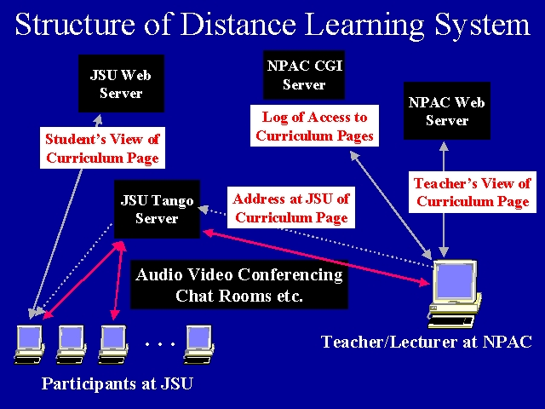

We combine several NPAC technologies to deliver this synchronous Interactive class on Web Programming.
The Java client and server TangoInteractive system (http://www.npac.syr.edu/tango) is the basic collaborative environment which acts as the "glue" or "integration" for everything else. Basic services it provides include audio-video conferencing, chat rooms and white boards. These are used for student and teacher interactions.
The curricula material consists of Web versions of traditional foils (taken largely from Powerpoint and Persuasion) together with a set of resources consisting of examples, tutorials and similar material. (http://www.npac.syr.edu/projects/jsufall97). This allows one both traditional teacher-student interactions (digital and at a distance) as well asynchronous browsing of a rich Web resource on the subject matter.
One of the specialized applications available in Tango is the WebWisdom delivery module (http://www.npac.syr.edu/user/gcf/wisdom/help)which is implemented with Perl and JavaScript and will be ported to Java, JDBC and sophisticated database support. WebWisdom currently stores over 17000 foils and 400 foilsets.
The teacher chooses material from this resource and delivers to the Tango server the URL of the selected page. This is replicated to all the client machines at Jackson State. These are PC's in this experiement but could also be classroom displays in other applications. Note that the Tango Server used in this course runs on a workstation at JSU together with a Web server that mirrors the needed curricula material. The WebWisdom delivery module maps the selected page so that it points at desired server (JSU for students there, NPAC for teacher) to maximize performance and to ensure minimal demand on network. This system allows user to select image size and font sizes so that one can adjust to client screens of different resolution.
We also log pages accessed in class to record automatically progress of class.
Many improvements in system are currently being implemented including specialized applets to support teacher-student interactivity.

