Draft
Summary of WebWisdom.com Development (Business) Plan
August 6 1997

Main Thrust of WebWisdom.com
There is general agreement that
a) Existing corporate and government (especially DoD) training markets are very large
b) Universities and other (K-12) educational institutions can be expected to make greater use of electronic delivery for both internal and external (distance education) students. This is relevant both nationally and internationally as the Global Information Infrastructure links possible providers of education/training to consumers around the world.
Both these markets (education and training) are under great pressure to reduce cost and improve their product. Computer aided instruction has been used and popularized for some 15 years but without making major impact on the cost or quality of education. WebWisdom.com's business model asserts that this will change as modern computers and information technologies are powerful enough to radically improve not only the cost and quality but also the basic mode of operation of educational institutions. WebWisdom.com will market a suite of tools that will enable purchasers to develop and deliver electronic education at a distance. These tools have been developed over the last 3 years and extensively tested in Syracuse University courses and a set of tutorials given around the world by Fox and McCracken. Note that WebWisdom.com is a technology company whereas NPAC's delivery activities are collected under a different umbrella organization WebWisdom.org that can be viewed as a prototype of the virtual university. There is not such a clear dividing line as the proposed operational model of WebWisdom.org would anticipate either nonprofit (e.g. NPAC) or for-profit (e.g. WebWisdom.com) delivery.

Strengths and Weaknesses of WebWisdom.com
Evaluating WebWisdom.com's positioning in the market, we assert
- The quality and maturity of its potential products are excellent. Compared to competition our potential products have greater breadth and much more experience behind them.
- We have prototypes (that can be demonstrated to investors and customers) of essentially all parts of our initial offering. However substantial work is needed to make system better integrated and more robust.
- We have an excellent team of developers whose visa status and attractiveness to other companies are the only concerns. We expect the opportunity to join WebWisdom.com will help keep this team in Syracuse.
- We have good contacts in University computer science arena in USA, Europe and China. However this will generate negligible sales opportunities and is mainly useful as a high profile source of references.
- We have some good DoD training contacts that could develop into substantial sales opportunities.
- In general we are weak in broad marketing and investment contacts. Note that material prepared as part of DoD and NSF projects does however include extensive high quality marketing documents.

Components of WebWisdom.com Business Model
The business model of WebWisdom.com has three components given below where we have described the first and most important above.
- Develop a system to support web based electronic education and training
- Deliver selected courses using our technology (this is commercial delivery mentioned in description of WebWisdom.org). This is a useful test and evaluation for our products.
- Explore opportunities outside the education field of the core WebWisdom technologies

The last component of our business model seems vague and unfocussed. However it is motivated by the significant interest shown in the core technologies of WebWisdom by both visitors to NPAC and by conference exhibit attendees. Further this component includes development of technologies to support healthcare which could be a business opportunity with the new InfoMall/CASE startup MindTel. We only intend to explore WebWisdom technologies outside education if it can be done without impacting our main business thrust (education and training). This in practice means that we will only explore such outside opportunities if they have clear separate funding. Through InfoMall MidHudson we are exploring some opportunities of this type.

Timeline
The timeline for WebWisdom.com is as follows:
- November 1997: Initial integrated system incorporating major improvements in Tango, delivery, authoring and database arena.
- November 1997 onwards: Market product at conferences (starting with SC97) and to initial contacts in DoD.
- March 1998: Initial sales and delivery of supportable product
- Ongoing: Develop system by use in University education and DoD training
- Ongoing: Explore targets of opportunity starting with distance learning conference in Washington in late august.

What is the WebWisdom Integrated Education and Training System?
WebWisdom is a set of Web-based education and training tools for preparing, delivering and exploring curricula. It also supplies administrative support tools for conventional and virtual classrooms.
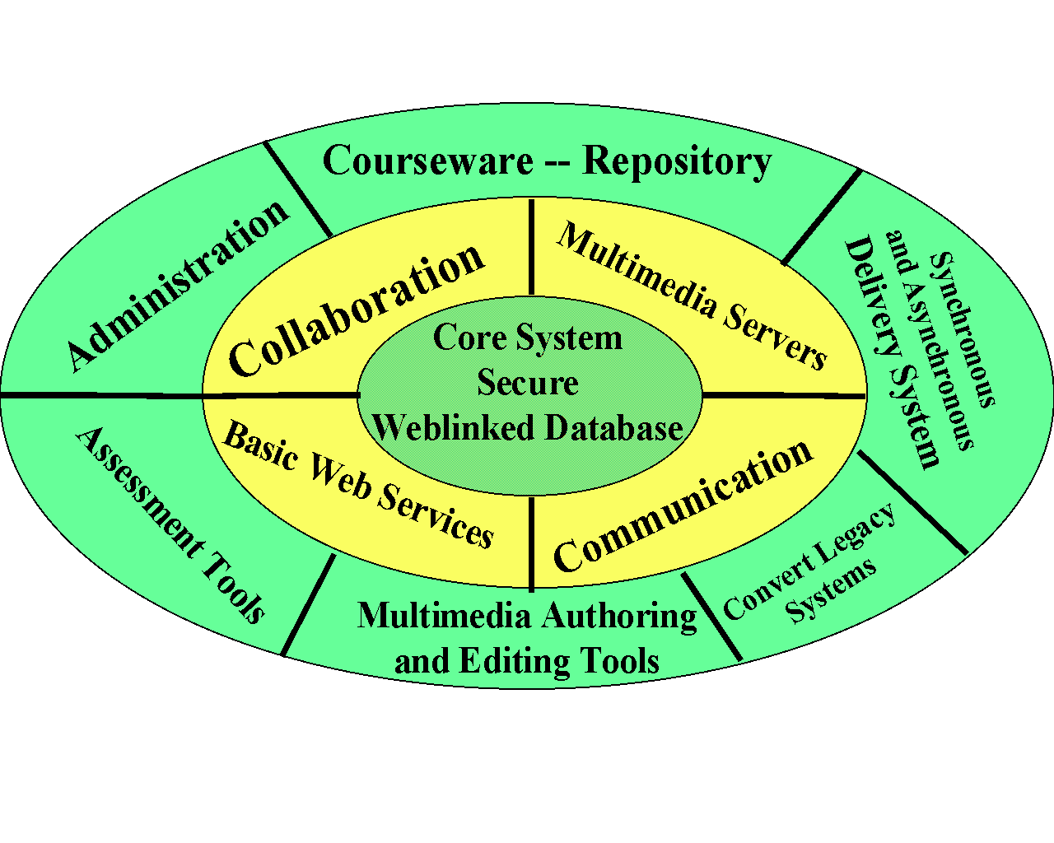WebWisdom is based on technology produced by the Northeast Parallel Architectures center (NPAC) over the last three years in a set of projects in K-12, undergraduate, graduate and government training areas. Selected technology is being re-implemented to provide greater functionality and robustness and to take advantage of the latest Web (especially Java) capabilities.
WebWisdom modules are part of an overall integrated system architecture centered on a secure web-linked database, which can either be commercial, or public domain. However the linkage between modules is kept as loose as possible so that we can take advantage of rapidly evolving Web technologies.
The database is used to store curricula material, administrative information, student homeworks, and optionally to log sessions. In addition to grades based on conventional quizzes and projects, the logging allows WebWisdom to certify the amount of time spent by each student in both synchronous and asynchronous sessions. Course material can either be conventional web pages or JavaBean or HTML displays generated dynamically from the database material. The user can customize these displays with templates.
The Tango collaboration system provides an interactive multi-room electronic learning center which links teachers, mentors and students with traditional collaborative tools -- chatroom, audio-video conferencing and shared white-board. Shared curricula viewers provide the basic support for synchronous and asynchronous learning of either specialized or general Web pages. Each virtual classroom can be configured with different capabilities and different access privileges by the WebWisdom administrator. The core database in Tango stores all the registration information for participants allowing many secure but dynamic electronic societies to use each instance of WebWisdom. One can support both Tango and the database with one or more Web Servers and so the implementation can be scaled to provide good performance for large user communities. Currently WebWisdom uses conventional HTTP servers with small custom Java server enhancements. We will migrate this to commercial Java servers when this is appropriate. General client side applications can be linked by Tango into WebWisdom and this allows customized systems for teaching in different disciplines. One optional specialized application is a shared Geographical Information System supporting three-dimensional virtual field trips. Other uses of this capability include shared simulations used successfully in teaching general science at Syracuse University. Biology instruction is illustrated by Java and VRML shared displays of data from the national "Visible Human" project.
WebWisdom can be configured with an advanced digital video server that supports either high resolution MPEG or low bit rate H263 delivery. (MPEG and H263 are standard video compression schemes) The video server is supported by the core web-linked database which stores metadata and textual indexing material that can come from close captions or user annotations. The compressed video is stored directly on the server file system and one can start the video at any point located from a search of the text index to the video material. The WebWisdom video subsystem comes with a web-based administrative asset management system. The video is delivered by a high performance distributed set of servers using multicast technology.
WebWisdom supports authoring with conventional presentation graphics such as PowerPoint, Persuasion or Framemaker and offers consistent "legacy" conversion tools that export such presentations to the Web. New material is preferably developed as a set of JavaBeans supported by an object oriented whiteboard supplied with WebWisdom. Such customized curricula can be intermixed with conventional HTML and a Java tool allows one to build up new lectures interactively as mixtures of existing "basic" presentations. The curricula material is stored either directly or indirectly (URL or pointer to video files) in the core database.
WebWisdom is fully documented and comes with a rich set of example curricula and collaborative Java applets. In particular the system already stores over 17,000 web pages from over 400 presentations developed by NPAC over the last two years.

