SYRACUSE UNIVERSITY
TECHNOLOGY TRANSFER DISCLOSURE
WebWisdom Education and Training and Related Technologies

1a. Please print or type the name(s) and title(s) of the inventor(s)/creator(s)

Geoffrey C. Fox Director of NPAC NPAC
Inventor Title Department
111 College Place 2163
Campus Address Campus Telephone
4345 City Lights Terrace, Jamesville NY 13078 (315) 682-7945
Home Address Home Telephone

Tomasz Major Jr. Researcher NPAC
Co-inventor 1 Title Department
111 College Place 3556
Campus Address Campus Telephone
113 Comstock Pl., Syracuse NY13210 (315) 423-3183
Home Address Home Telephone

Gang Cheng Senior Researcher NPAC
Co-inventor 2 Title Department
111 College Place 1118
Campus Address Campus Telephone
338 Jamesville Av., Syracuse NY 13210 (315) 479-8768
Home Address Home Telephone

Lukasz Beca GRA NPAC
Co-inventor 3 Title Department
111 College Place 5018
Campus Address Campus Telephone
143 Redfield Pl., Syracuse NY13210 (315) 425 5952
Home Address Home Telephone

Piotr Sokolowski Jr. Researcher NPAC
Co-inventor 4 Title Department
111 College Place 5735
Campus Address Campus Telephone
113 Comstock Pl., Syracuse NY13210 (315) 423-3183
Home Address Home Telephone

YuPing Zhu GRA NPAC
Co-inventor 5 Title Department
111 College Place 2483
Campus Address Campus Telephone

Home Address Home Telephone

Kivanc Dincer GRA NPAC
Co-inventor 6 Title Department
111 College Place
Campus Address Campus Telephone
Graduated (en route to Turkey)
Home Address Home Telephone

1b. Please, outline the contribution of each inventor.

Geoffrey C. Fox: Created initial idea of a Web-based curricula system. Provided technical and scientific guidance for the project and vision and ideas for continuing development. Provided intellectual lead of the design and implementation process. Provided guidance in the process of the product functional evaluation and usability analysis. Designed and implemented majority of the presentation conversion tools and the web presentation software.

Gang Cheng: Designed and implemented database support tools for WebWisdom system. Contributed to implementation of the collaborative extension of the WebWisdom system.

Lukasz Beca: Designed and implemented the JavaScript API to the TANGO system (TANGO technology is disclosed in a separate document) allowing for integration of the curricula delivery system with TANGO collaboratory

Piotr Sokolowski: Designed and implemented text gathering, text indexing, and text search tools for the WebWisdom system.

YuPing Zhu: Contributed to implementation of the implemented text gathering, text indexing, and text search tools for the WebWisdom system.

Tomasz Major: Designed and implemented Java-based, object-oriented presentation tool for the WebWisdom system

Kivanc Dincer: Designed and implemented a programming laboratory which can be used in Computer Science Instruction

Other Contributions: Note that essential to WebWisdom is that it has been extensively used by Geoffrey Fox, Nancy McCracken, Tom Scavo, Meryem Ispirli and Mohammed Saleh. This use has motivated many technical developments.

Numerical estimate of development contributions:
Geoffrey Fox: 50% , Tomasz Major: 18%, Gang Cheng: 12%, Lukasz Beca: 5%, Piotr Sokolowski: 5%, YuPing Zhu: 5%, Kivanc Dincer: 5%

2. Technology Title:

WebWisdom - a web-based curricula delivery system

- Description of Technology

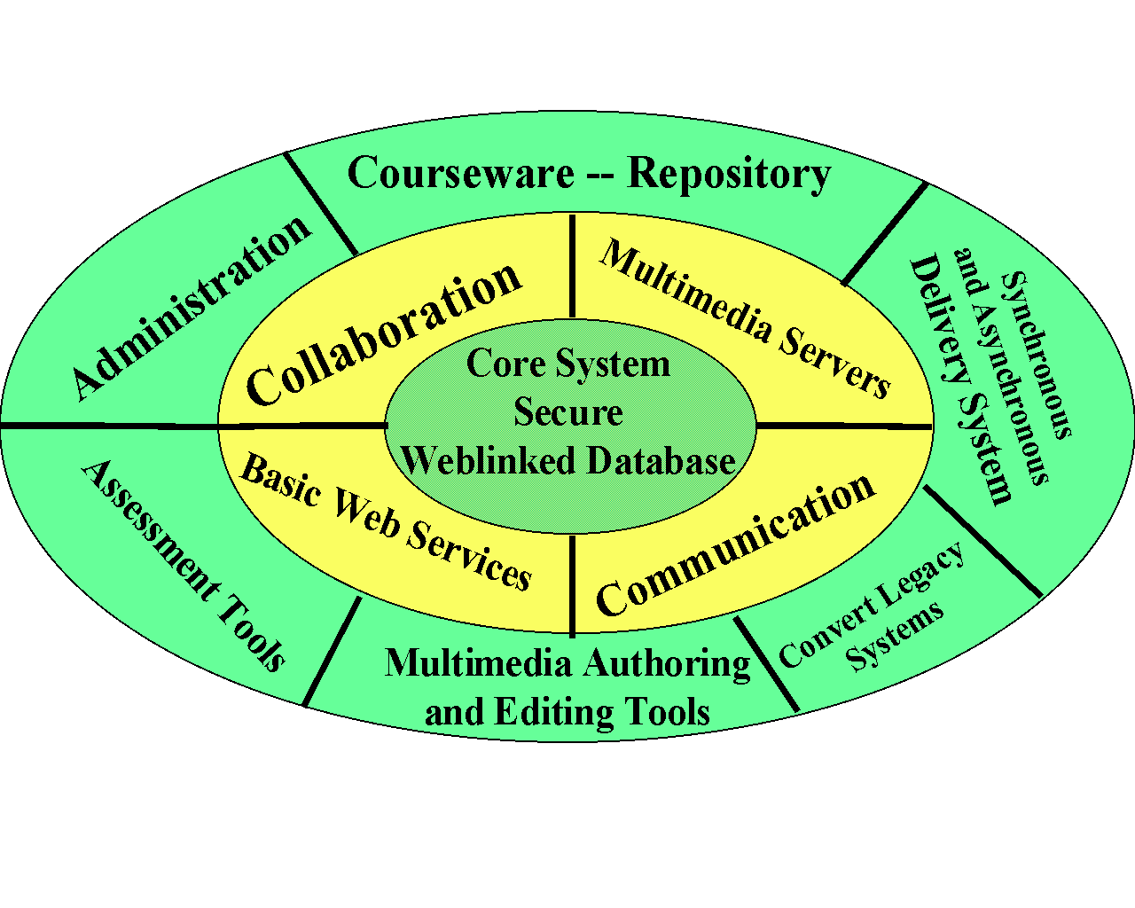 The intended architecture of the WebWisdom system is displayed on the diagram below:

This document discloses three basic components of the system:

- A complete curricula delivery system that allows an educator to automatically convert the presentation material from traditional formats such as PowerPoint or Persuasion, to place the material on an HTTP server, to organize the material and to create new presentation modules from existing components, to record audio version of the presentation and to synchronize the audio and textual delivery. Combined with TANGO, WebWisdom provides an environment for delivery of curricula over Inter- or Intranets to multiple users during synchronous sessions. Stand-alone WebWisdom allows for asynchronous, self-paced training or review sessions of the material presented in synchronous sessions. WebWisdom seamlessly integrates various Web technologies, including database backends, multimedia servers, web authoring tools, legacy presentation format converters, and browser presentation tools.

- Database backend. This component has been developed in NPAC over the period of last three years. Several web-linked database applications have been designed and implemented. As such, these applications are not subject to this technology disclosure, since they represent examples a fundamental, pervasive technology trend of linking Web with database backends. Certain software modules from these applications have direct relevance for the WebWisdom system. These modules are currently not fully integrated, but we expect that they will be re-used for implementation of the relational database back-end for the WebWisdom system. The relevant modules include:

- Web information gathering system: the module automatically collects documents from the Web, analyzes them, and, if requested, places them in the relational database
- Text search engine: using commercial technology from Oracle Corporation, the engine indexes the contents provided by the gathering system and provides sophisticated search and retrieval mechanism for the stored documents.
- A methodology to implement applications with application logic distributed between the Web-based front-end and database back-end. (We use the term “methodology” here, since the rapid changes in web/database technology, such as replacement of PL/SQL by Java, make expertise more valuable than the actual implementation code)

- Java-based authoring and presentations tool (a.k.a. WebWisdom whiteboard). This tool is being written to replace today’s presentation packages, such as PowerPoint, by a tool that will allow on-line composition and presentation of curricula material on the Web. The tool allows both stand-alone and collaborative work on the textual and graphical contents of the presentation, as well as interactive presentation of the curricula over Internet, providing the educator with tools such as dynamic highlighting and telecursor capability. This tool is still under development.

Other system components indicated in the diagram above are either subject to separate technology disclosures (TANGO, Video on Demand, Videoteleconferencing), or not yet implemented.

- What are immediate and/or further applications of the invention

WebWisdom can be applied in the fields of distance learning, corporate training, and scientific collaboration.

- Why is the invention or creation better - more advantageous - than present technology? What problems does it solve?

Currently available distance learning systems have not been consequently using Web technologies. Instead of concentrating on low-level networking technologies, WebWisdom assumes pervasive availability of Web technology and builds a complete new distance learning system using these technologies. While the existing distance learning systems were limited to custom-built networking environments, WebWisdom is addressing needs of the average Internet users. The basic advantage of WebWisdom as compared to currently available tools is much higher level of integration of various technologies into a system with coherent usage patterns.

- Is work on the invention or creation continuing? Are there limitations to be overcome or other tasks to be done prior to practical application? Are there any test data? Have products, apparatus or composition, etc., actually been made and tested?

WebWisdom prototype has been built and field-tested . The most significant, outstanding tasks are:
- The system needs to be rewritten in Java in order to improve robustness
- Design and integration of the relational database backend.
- Further development of the Java presentation tool and creation of the on-line authoring system.

The test data consists of user feedback and can be solicited from DoD institutions that have used the system.

- What further research and development is necessary or desirable before showing the invention or creation to a potential industrial licensee?

The prototype can be demonstrated to potential licensees.

8a. Names and addresses (if known) of potential manufacturers

Unknown

8b. Manufacturers presently making comparable equipment (if known)

Two Internet companies make similar products: Centra Software, Inc., Valencia Executive Plaza, 27201 Tourney Rd, Suite 201-Q, Valencia, CA 91355, (805) 260-3324), and Contigo Software, 8334 Clairemont Mesa Blvd., Suite 204, San Diego, CA 92111, (619) 278-5900.

- Has the invention or creation been disclosed to industry representatives? If yes, please, provide details, including names of companies and their representatives.

No.

- Has the invention been disclosed in an abstract, paper, talk, news story, or a thesis?

Yes.

Type of disclosure: Disclosure date:

Web site (http://www.npac.syr.edu/tango) since January ’97
Presentation, Vicksburg July 20-23, ‘97

- Is a publication or other disclosure planned in the next four months?

Yes. Paper accepted for SC97 (see attached summary)

- Has there been any public use or sale of products embodying the invention? Describe giving dates:

There were no sales. However, the system was available for access from the Web since January ’97.

- Are you aware of related developments by others? If yes, please give citations. Copies of any relevant patents or publications would be appreciated

Symposium. http://www.centra.com (this system has not been released yet)
Itinerary, http://www.contigo.com

- If the research that led to the invention was sponsored, please, complete the items below and attach a copy of the contract or agreement.

Sponsor Name: Mainly NSF and Syracuse University. New work being funded by DOD Nichols and E-Systems contracts.

