Multidisciplinary Applications
Geoffrey C. Fox
NPAC Syracuse University
gcf@npac.syr.edu
Report to NASA on technology requirements for a multidisciplinary optimization system for Aerospace Industry: http://www.npac.syr.edu/users/gcf/ASOPreport/ASOPRQD2.html

Abstract of Presentation at MAPINT 97, Dayton 16 June 97
We give a general discussion of multidisciplinary applications which distinguishes
- Multidisciplinary Problems which are typically set up as multiple linked programs -- we call these metaproblems
- Metacomputing or the linkage of multiple, typically heterogeneous, computers to solve a given problem which is often but need not be a compound metaproblem.
- Interoperable interfaces which allows a single problem to seamlessly run on any one of many different hosts
Multidisciplinary applications involve metaproblems, metacomputers and perhaps in practice most importantly metainstitutions. Usually one needs to bring organizations and disciplines together which traditionally have been separate. This is often hard -- especially in Industry where this needs to be done in a way that preserves operational systems and needs to retrain staff in significantly new ways of running an enterprise.
After these general remarks we use a NASA funded project to illustrate how multidisciplinary applications can be integrated to design and manufacture more cost-effective aeronautical systems. This project studied the implementation of an Affordable Systems Optimization Process (ASOP) which could be used by the Aerospace industry to simultaneously design product requirements, the product, and the associated manufacturing and support processes through the conceptual, preliminary and detailed design levels. Implementation of ASOP was hoped to result in a more competitive Aeronautics Industry by providing the capability to deliver quality, affordable, products to a global marketplace ahead of the competition. The combined industry-academic team involved Rockwell International, Northrop Grumman, McDonnell Douglas, General Electric, General Motors, NPAC at Syracuse University, and Georgia Institute of Technology. The team came up with a system architecture sketched below. Note that it is indeed a metaproblem with 8 separate major modules being built on top of a set of services that we expected to be available. The application modules were grouped into a Design Engine, Visualization Toolkit, Optimization Engine, Simulation Engine, Process Modeling Toolkit, Cost Modeling Toolkit, Analysis Modeling Toolkit, and Geometry Representation Toolkit. Actually even here a given module would be broken up into many sub-problems (the simulation engine includes structures and several fluid components) and so this is a complex hierarchical metaproblem. In fact I have quoted an estimate from Industry that design and manufacture of a modern (military) aircraft could involve running some 10,000 separate programs varying from a large scale MPP-based fluid simulation to the EXCEL spread sheet to estimate where to put a particular inspection port.
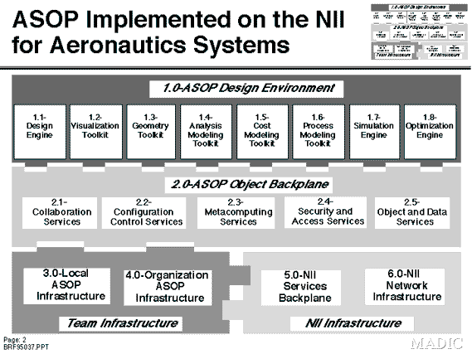
Although this work was done two years ago, its discussion of the value of the Web and Internet (Intranets) was reasonably accurate. The needed services included metacomputing as we suggested in general above; collaboration, security, object and data(base) and the critical configuration control system. The latter ensures that one is designing a single system and coordinates the work of the distributed team and computers. Many of these capabilities are available from the current Web with servers linked to databases, object brokers and as we will discuss in second talk collaboration systems.
Another example we discuss comes from Europe with an Esprit project CISPAR to link structural and fluid flow with a high performance library COCOLIB.
We use these examples to discuss the general role of HPCC and Web technologies in supporting multidisciplinary applications

