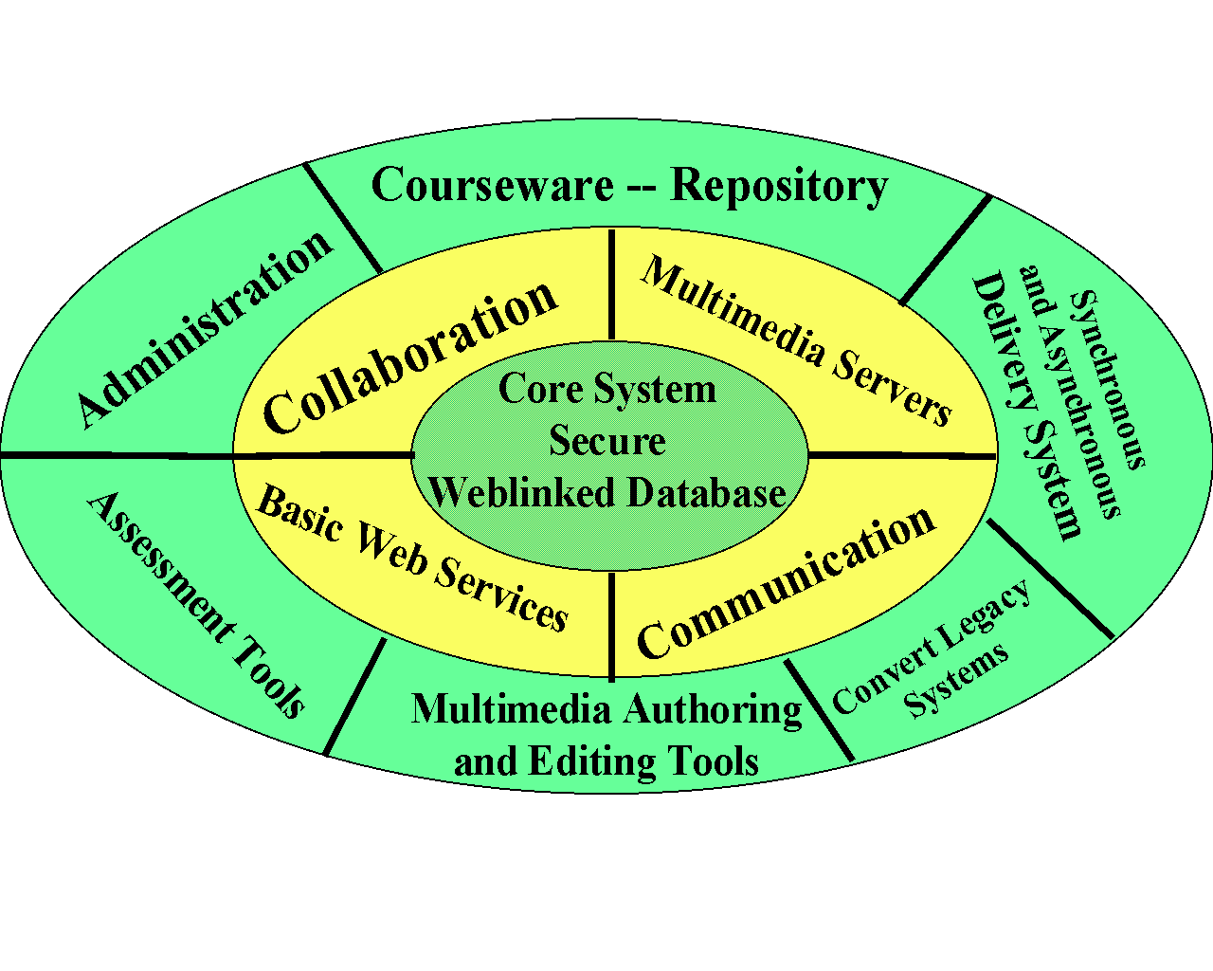
WebWisdom.com
State of the Art Web Based Education and Training Technology
WebWisdom.com is an Internet Technology company specializing in state of the art Web-based tools for education and training. Although using novel advanced concepts such as Web-linked databases, streaming Video, object oriented authoring systems and Java/JavaScript/VRML2 enhanced HTML, WebWisdom.com supplies tools that have been developed and used by educators in several real courses from K-12 to University level and from local to international distance delivery. WebWisdom.com technology includes novel assessment and electronic collaboration tools which are only possible with Web Technologies but are accessible to the broad audience as they just require student access to a typical modern home PC. WebWisdom.com products are based on systems produced by the Northeast Parallel Architectures Center over the last three years and the university prototype stores over 15,000 curricula pages in over 400 presentations. These products are basis of the WebWisdom.org virtual learning center.


WebWisdom.com systems are designed modularly with the architecture shown above and can be customized for each application. They allow you to ride the coming revolution with virtual classrooms providing better and cheaper education and training
WebWisdom.com can be contacted through InfoMall USA
3154434052 (fax 3154434741) email:infomall@npac.syr.edu

http://www.webwisdom.com

