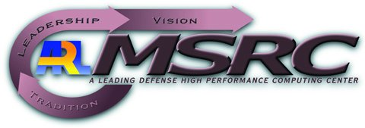
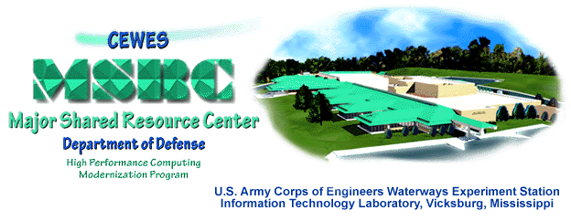
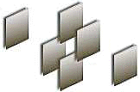
Parallel and Metacomputing Support for CMS –
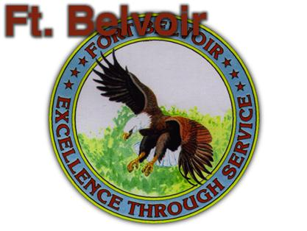
Comprehensive Minefield Simulation
D. Bernholdt, G. C. Fox, W. Furmanski,
D. Kasthuril, G. Krishnamurthy, S. Nair, H. T. Ozdemir, Z. Odcikin Ozdemir and K. Rangarajan
Northeast Parallel Architectures Center, Syracuse University, Syracuse, NY

Keith Snively and Picot Chappell
Night Vision Laboratory, Ft. Belvoir, VA

,

Demonstration Handout at Supercomputing 98, Orlando, FL, November 7-13 1998

For more information, please contact Wojtek Furmanski, (315) 443-1799, furm@npac.syr.edu or
Keith Snively, (703) 704-2070, ksnively@nvl.army.mil

CMS is an advanced DIS system under development by the Night Vision Lab at Ft. Belvoir, VA. CMS simulates a broad spectrum of mines and minefields to interact with vehicles and countermine systems, such as those provided by ModSAF, on the virtual battlefield. Modern warfare can require millions of mines to be present on the battlefield, such as in the Korean Demilitarized Zone or the Gulf War. The simulation of such battlefield arenas requires High Performance Computing support. Syracuse University is building Parallel and Metacomputing Support for CMS by porting the CMS module to Origin2000 and linking it with a collection of distributed simulators handling terrain, vehicles and visualization. The current demo illustrates initial capabilities of the system and includes: a) Parallel CMS running on Origin2000 at ARL or CEWES MSRCs; b) a set of ModSAF vehicles running at Syracuse workstations; and c) visualization front-ends including Mak Stealth and our PC/Direct3D based CMS viewer. Work is under way to provide HLA based federation support for large scale Metacomputing CMS with millions of simulation objects.
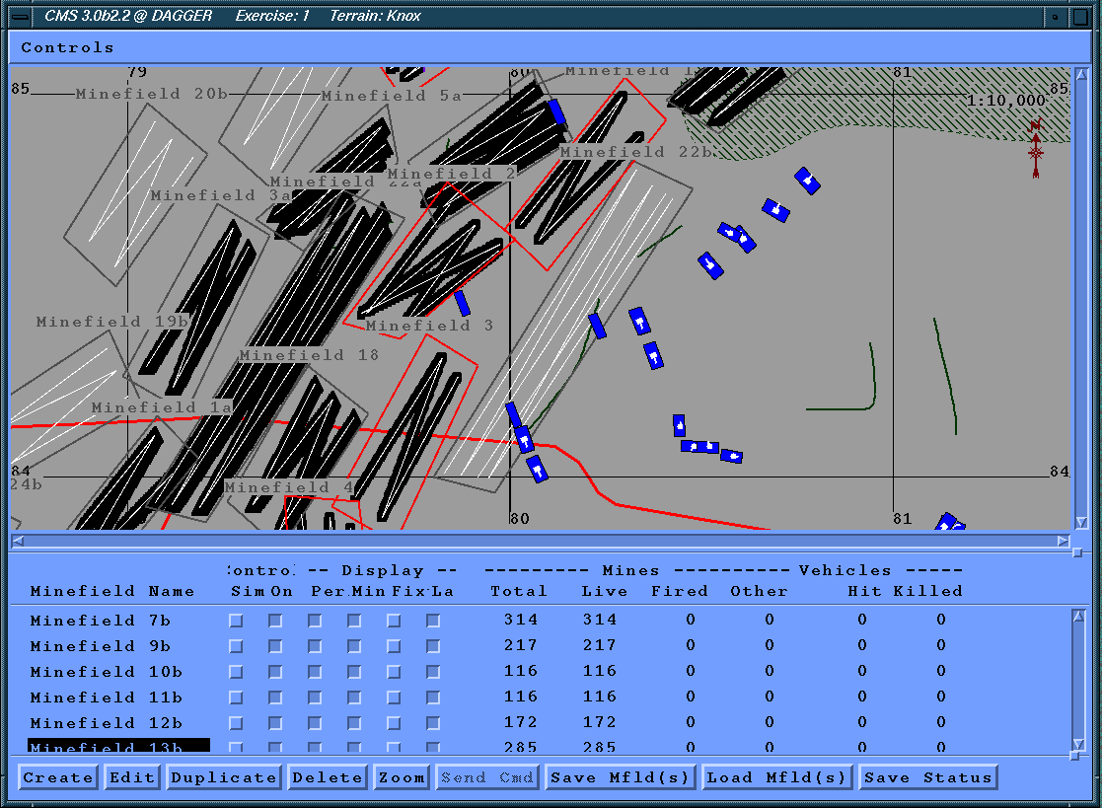
In our demo, we can construct various testing configurations and we can also run some more realistic battlefield scenarios, designed by actual Army Engineers. These scenarios, adapted for Syracuse by Ft. Belvoir, feature heavy breach operations across a fortified border region, troops movement through the lanes, sending friendly troops to protect the breach forces, and friendly/enemy interaction. Several visualization displays are available to control, monitor and analyze this sophisticated Distributed Interactive Simulation (DIS). The CMS viewer window (left) illustrates the topology of minefields and the current location of selected vehicles in one of the breach scenarios, running over the Ft. Knox terrain database and including about 30,000 mines.

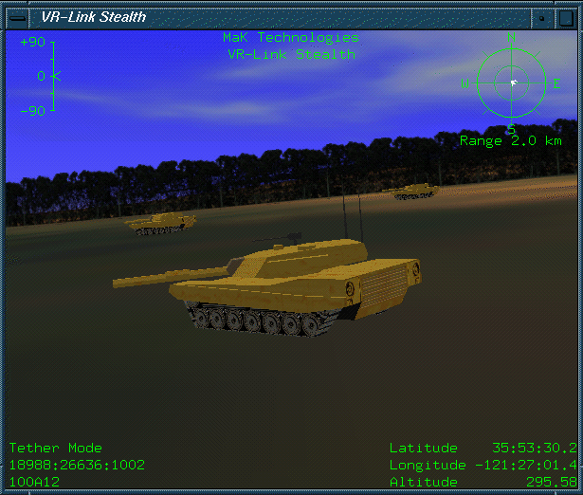
If you are a lucky owner of one of the advanced 3D renderers for DIS applications such as Mak Stealth or Paradigm/Multigen Vega, you can enjoy watching a virtual battlefield by simply tuning such a tool to the MBONE multicast address of your simulation. You can then obeserve vehicles, detonations etc. renderered in real-time in response to the Entity State (e.g. vehicle motion), Fire or Detonation PDUs, sent to the network by various simulation modules and detected by your favored viewing tool. Ft. Belvoir is using Mak Stealth and Mak Technologies kindly lent Syracuse a demo version of this system, which is available as one of the displays in our CMS demo (right). In parallel with exploring high-end rendering systems, we are also developing in-house 3D battlefield visualizer based on low end commodity PC technologies such as Direct3D (see next page, bottom).

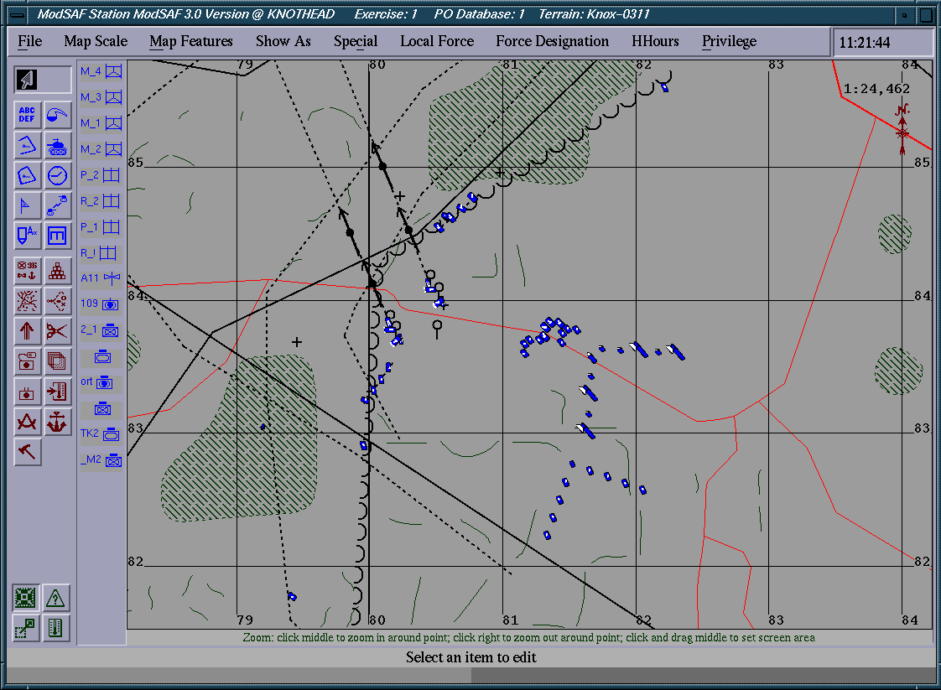
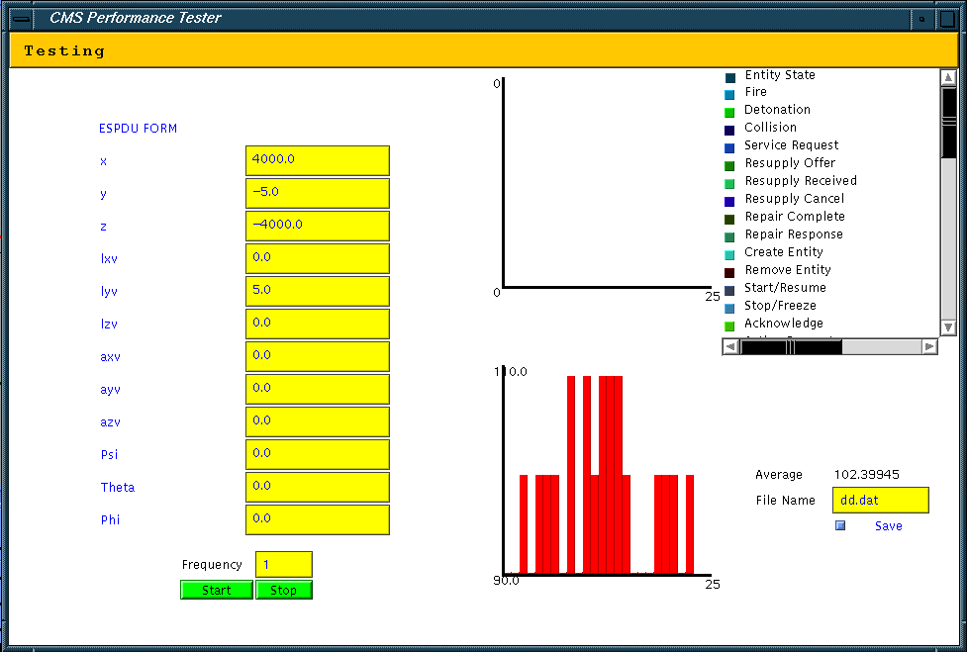
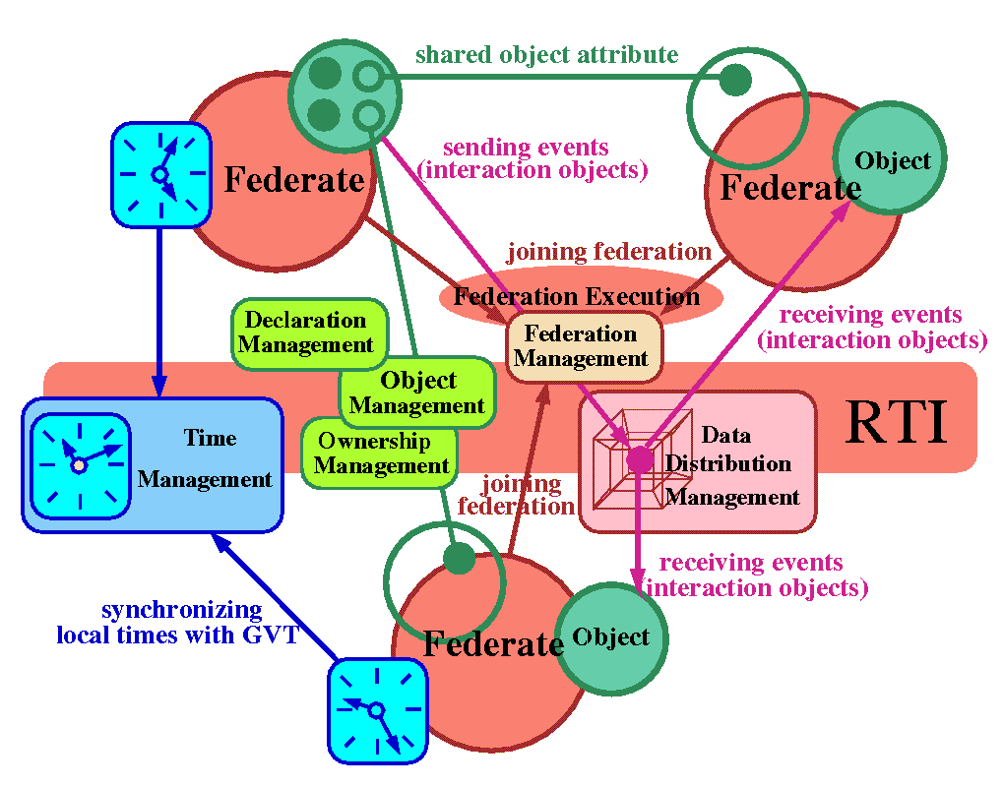
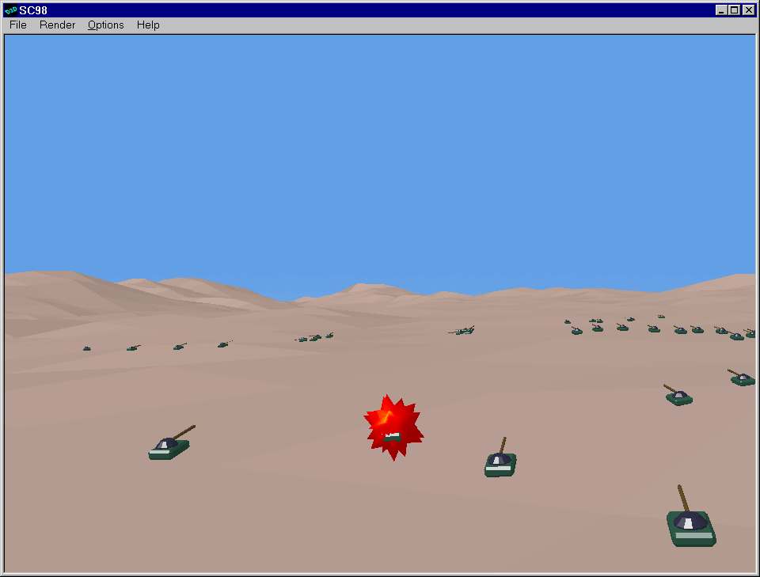
The breach operation scenario includes several types of dedicated (countermines) and regular (tanks) vehicles, engaged in a sequence of coordinated actions, some of them generated autonomously by ModSAF (Modular Semi-Automated Forces) and some others controlled interactively by the analyst. ModSAF is an advanced forces level simulation system maintained by the U.S. Army STRICOM. The scenario level command and control front-end is most conveniently offered by the ModSAF GUI window (left) which displays vehicles and essential terrain elements (such as fortified borders etc.) and it provides a set of control widgets to facilitate activation of scripted scenarios as well as interactive modification or termination of the individual scenario stages and activities.

DIS modules and displays presented so far represent a standart setup used by Ft. Belvoir for countermine R&D. At Syracuse, we are performing parallel port of CMS to Origin2000 and we also building tools for performance monitoring and analysis of Parallel CMS. Our JDIS tool (right) is written in Java and it offers the following capabilities: a) display of PDU flow on a given multicast channel; b) interactive editing and point-like emission of test probe PDUs; c) recording a PDU sequence to a file for subsequent playback; d) emission frequency control for generated and played back PDU streams; e) interactive visualization of the Origin2000 speedup, displaying Parallel CMS response to each vehicle motion PDU that triggers a tracking loop over all mines.

For more information, please check http://iwt.npac.syr.edu/demos/cms/sc98
As part of the Metacomputing CMS effort at Syracuse we are porting Parallel CMS to our commodity cluster, running on a heterogeneous mesh of Linux, NT and Solaris nodes, and managed by our WebHLA environment (below) which is an instance of our more general HPcc (High Performance commodity computing) approach. We demonstrate here one of our WebHLA tools - an NT based 3D visualizer of virtual battlefield, using Microsoft Direct3D for fast and affordable 3D graphics. Our front-end system (left) runs on NT laptops and it supports both DIS and (CORBA like) HLA. To visualize CMS terrain databases, we constructed a translator from the ModSAF CTDB format to the Direct3D .x format. 3D models for vehicles and embedded animations for mine explosions were constructed using 3D Studio MAX by Kinetix which cooperates with the DirectX platform.

Current Parallel CMS effort presented here uses DIS protocol over MBONE and is focused on porting CMS to Origin2000. The ongoing Metacomputing CMS project at NPAC is building DIS-HLA bridges and porting all application modules discussed above to our WebHLA framework. WebHLA builds a dynamic and robust Metacomputing environment on top of industry standards such as Java, CORBA, COM and XML and Defense standards such as HLA by DMSO. Our Object Web RTI (right) implements DMSO RTI 1.3 as a set of Java CORBA objects managed by our JWORB (Java Web Object Request Broker) middleware. JWORB integrates HTTP and IIOP protocols and offers seamless Web / Commodity based interactive front-ends to Metacomputing simulations. Our Object Web RTI is the first commodity based fully HLA-compliant non-DMSO implementation of RTI 1.3.

