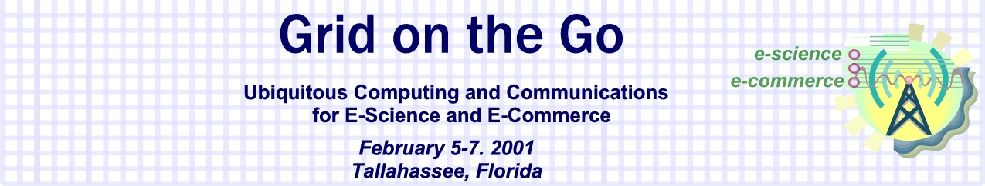

Join the nation’s leading researchers from the private and public sector as they discuss the next wave of Internet evolution as wireless devices make ubiquitous computing and communications a reality.

The “Grid on the Go” conference is focused on understanding how wireless devices (MEMS, Sensors, cell phones, broad band wireless portable computing) and optical networks will enable scientific discovery (e-science) and economic growth (e-commerce). A critical focus of the conference will be on identifying the impact these application drivers will have on the next generation of America’s information infrastructure (the Grid) currently being prototyped by leading federal research and development agencies.

Topics to be addressed include:
- Building Bridges between Private Sector R&D and Public Research-How can we work together to make our research more relevant to one another?
- Straining the Wireless Infrastructure-The Creative Engine of Science and Commerce: What are the identifiable scientific and commerce applications that will strain the ability of our current communications infrastructure?
- The Chaotic Network: What are the system integration issues between local loops, wireless, and optical networks.

Who Should Attend? : “Early adopters” from academia, the private sector, and Department of Defense interested in the future impacts of wireless technologies.

Call for Papers: If your wish to be a participant in a conference panel please submit your research paper by January 03, 2001 to X@.edu
Papers should be ~10-20 pages in length.

Location: The conference is being hosted by Florida State University with meetings located at X.

Lodging and Transportation: Lodging will be available from X, please contact Y to assure your reservations.

Registration: To register for the conference, please contact X. Registration is limited due to facilities, and will be on a first come first serve basis.

