Evaluation of
HearMe voice over IP system

Name of the tool: HearMe

URL’s to find out about it
http://www.hearme.com/

HearMe is a voice over IP application to do voice conferencing. It provides full-duplex voice communication among participants.

Today, there are three solutions for teleconferencing: First one is to use Internet as a medium. People attend conferences by using PCs. Second one is to use phone lines and phones. This type of conference is arranged by telephone companies. Third one is to use both Internet and phone lines as a medium. In this case people can attend conferences either by using PCs or phones. HearMe system is based on the third solution.

Although using only Internet for teleconferencing is cheap, the quality of voice is not satisfactory. On the other hand, the quality of voice is excellent when phone lines are used. However using phones is unaffordable for many people. Third solution combines the quality of phone lines and low cost of Internet. The idea is that the speaker will talk on the phone providing better voice quality and listeners can either use phones or PCs. In addition to its cost benefits this solution is also more convenient than the other two solutions. A phone-to-PC gateway is used to connect phone lines to Internet.

Services:
HearMe provides two types of conferences, standard and moderated. In a standard conference, everyone has the same privileges. Anyone can talk at any time. On the other hand, in a moderated conference there are three types of users, moderator, panelist and participant. Moderator is the one who has full control over the conference. He gives the permission to talk and he has the right to eject a participant from the conference and etc. Panelist has right to talk by default. Participant needs permission to talk.

HearMe provides a recording mechanism for live sessions. But unfortunately right now they do not provide any tool to replay recorded conferences. Recorded conferences are in HearMe proprietary format and one needs to write its own decoder to replay it.

Architecture:
There are three servers, talkserver, MCU, and bridgeserver. Talkserver is used to manage the conferences such as creating a conference, destroying a conference, getting information about a conference etc. Talkserver is basically used by administrators. MCU(Multi-point control unit) is the one who does the real job, getting voice packages from different people and transmitting them to appropriate recipients. In addition MCU can record the conferences. Users directly connect to the MCU. Bridge server and an IP gateway is used to include phone connections into conferences. Gateway converts analog voice signals to digital form and vice versa. Bridge server is used as a bridge between the gateway and the MCU.

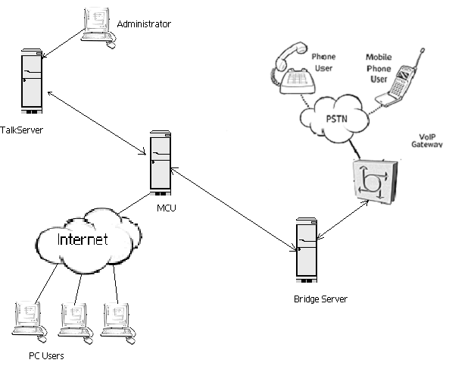

Figure 1: the architecture of HearMe voice over IP system.

Protocols:

HearMe uses industry standards in their voice over IP system. Their system architecture is based on the H.323 standard that is a recommendation from International Telecommunication Union (ITU). It sets standards for multimedia communications over Networks that do not provide quality of service. It sets standards for voice, video and data. HearMe currently uses G.723.1 for voice compression. G.723.1 is also a recommendation of ITU and widely used for Internet telephony and web conferencing. They are also using ITU G.711 for voice compression which provides better voice quality and requires higher bandwidth, but it is currently not fully functional. In addition HearMe uses session initiation protocol (SIP) to initiate sessions.

Bandwidth requirements
Each client needs 28.8 Kbps or greater Internet connection.

Client side System requirements:
The minimum system requirements for each client is
- Pentium 166MHz
- 32Mb of RAM
- Sound Blaster compatible 16-bit sound card
- Headset or speakers and microphone
- Windows 95, 98, or NT
- Internet Explorer 4.0 or later/Netscape 4.5 or later

Server side System requirements:
TalkServer:
- Pentium III @ 500MHz
- 256 MB RAM
- 10 GB disk
- 100 Mbit/sec network interface card
- RedHat Linux 6.1
- Oracle 8i

MCU:
- Pentium III @ 500MHz
- 256 MB RAM
- 10 GB disk
- 100 Mbit/sec network interface card
- RedHat Linux 6.1

BridgeServer:
- Pentium III @ 500MHz
- 256 MB RAM
- 10 GB disk
- 100 Mbit/sec network interface card
- RedHat Linux 6.1
- H.323 VoIP Gateway (ref.:Cisco AS5300)

Cost:
They sell HearMe Voice Developer's Kit for $10,000. It includes:

- Server software for TalkServer, MCU and BridgeServer.
- License files to allow service for up to 16 concurrent customers.
- HearMe Voice SDKs

Conclusion:
HearMe provides a solution for the voice conferencing over the Internet and it also allows telephone users to attend these conferences. It is relatively cheap and high quality compared to other solutions existed on the market today. Although they lack some features like replaying recorded conferences, they are on the right track and they will add those features in future releases.

