AWAIT FIGURES
------------------------------------------------------------------------------------------------------IIIB-1 Numerical (General) Relativity
Overview
This field solves numerically the deceptively innocent equation proposed by Einstein in 1915.
G_{μν} = 8πG T_{μν}
This expresses gravitation geometrically and relates the curvature of space-time (Einstein Tensor G_{μν}) to the mass distribution (stress-energy tensor T_{μν}) and the indices μ and ν run over 4 index values corresponding to time and three spatial directions. The value of the gravitational constant G is extremely small and this equation reduces to Newtonian dynamics except in regions of extreme gravitational fields. This general theory has been tested in a few well-known cases (such as the bending of light in a stellar gravity field) but has few direct verifiable consequences. Numerical study is motivated by both intellectual curiosity (surely we must try to solve the fundamental macroscopic equations of science) and phenomenological value to new tests of the theory. Recently both Europe and U.S.A. have mounted major experiments to detect the gravity waves predicted by Einstein's equations. One expects that an important source of such waves will be formed by binary black holes which are expected to be the last hurrah of many double stars as the insistently attractive force of gravity pulls their matter into an oblivion from which no information can escape. Einstein's equations can be analytically solved for single black holes in equilibrium but currently only numerical methods can address two interacting black holes. Although there are important variants of this problem such as coupled neutron stars, this field represents the case, common in fundamental science, where the challenge is essentially one very hard problem rather than a complexity stemming from a coupling of many sub-problems into a large system.
The equations treat space and time symmetrically and have a rather different structure from those coming from other fields simulating physical phenomena. One does get coupled partial differential equations as in most fields studying the physical world but they have many special features, which both distinguish this field and put it outside most of the forefront research in the algorithm and applied mathematics community. Note that as the existence of wave solutions suggests, one can view Einstein's equations as "just" a complicated nonlinear version of Maxwell's equations. Correspondingly electromagnetic systems are a useful test environment for some solution techniques. The following characteristics are particularly interesting:
- There is total freedom in choosing the coordinate system and the equations can change their nature dramatically if one uses this so called gauge freedom. Some coordinate systems can lead to non dynamical singularities and "physical intuition" and a deep understanding of this field is needed to distinguish "science", "numerical problems" and "coordinate system artifacts"
- There are many formulations of Einstein equations, depending among other things on whether the coordinate specifications are closely adapted to the dynamics. In one formulation, one sets up the equations as a constrained Hamiltonian system. This invokes classic time evolutions with 12 equations (for the six components of the spatial metric, and its six momenta) with first order time derivatives. These equations are nonlinear and their characterization into hyperbolic, parabolic or elliptic form depends to an extent on the coordinates chosen; some coordinate choices depend functionally on the field variables. There is an additional set of 4 equations (the constraints) describing the initial conditions and these represent a feasible elliptic subset of the full problem, which have been successfully addressed numerically.
- At large distances from the strong gravitational fields, one finds wave like solutions, which can be solved, by expansion around the linear limit with a natural light cone coordinate choice. These waves are the experimental measurements and this form represents the "boundary condition at infinity" needed by a solution in the interior region where the strong fields probably require a different coordinate choices.
- Most distinctive is the interior boundary condition, which is optimally posed in terms of the remarkable physics of a black hole from no information can escape. Translating this into numerically stable boundary conditions is not trivial. Physics implies no information specified inside the black hole can propagate outside. Unfortunately one does not know the so called event horizon, which represents this information barrier. One must however excise the singular region inside the black hole and this is usually done by excision at the so called apparent horizon which always lies inside the true black hole surface -- the event horizon. Remarkably, physically interesting results have been obtained in a regime where no condition at the inner boundary (simply excision) is required.

The problem becomes a set of (12) field values defined on a three dimensional spatial grid which has two holes excised -- one for each of the black holes cut off at the apparent horizon. At large distances, outgoing wave solutions are required. As the black holes move, this geometric structure changes. One is required to solve the equations in this geometry for given initial conditions and then to extract the gravitational wave structure as the black holes rotate around each other and eventually spiral into cosmic union. The unusual inner boundary conditions, nonlinear equations and well-known difficulties involving numerical propagation of waves without dissipation all contribute to the numerical challenge.

Current Situation
As with computational electromagnetics, one can in principal look at several solution approaches -- finite difference, finite element and spectral methods. Currently the finite difference method has gathered the most attention although this is not the most convenient at the inner boundary conditions. Remember that in the computational electromagnetism domain, spectral methods (the method of moments) produced the first reliable results. A large Grand Challenge "Binary Black Hole (BBH)" project recently finished and although much important progress was made, it did not produce a fully functional three dimensionally numerically stable code for the binary black hole problem. This project did use several parallel computing technologies described in other sections of the book. In fact the DAGH distributed data structure programming environment was developed as part of this Black Hole Grand Challenge. We also looked at High Performance Fortran, which seems quite attractive because the equations are naturally expressed as tensors for which Fortran 90 is an attractive language. However the compilers were not mature enough when choices had to be made and DAGH was successfully adopted by the collaboration. Still Fortran90 continued to be used and a Perl interface used to map this automatically into DAGH. This is to a large extent a programming-style question, as physicists prefer the Fortran constructs. The Fortran-to-DAGH translation via Perl also proved to be to rigid to allow fast development on the Fortran side; changes such as introducing another field variable, as would be required to investigate some other formulations, or simply to introduce new auxiliary variables required Perl-script rewriting. Adaptive meshes are important so as to be able to combine fine resolution near the holes with solutions that extrapolate with the wave solutions at long distances. This was recognized even when the proposal was initially written but adaptive meshes were not used in production during the five-year Grand Challenge project. It was hard to take the existing applied mathematics literature and correctly apply to these complex equations running in parallel. This illustrates the importance of producing more broadly useable software infrastructure to support parallel programming.
We have stressed the freedom available to choose coordinate systems and the BBH collaboration studied two very distinct choices -- the more traditional ADM formulation and a newer "hyperbolic" method developed by York from North Carolina. It is not clear what mix of Physics intuition and computer science infrastructure is most needed. Maybe a brilliant new coordinate system and ingenious physics insight to the inner boundary conditions is all that is needed. Alternatively or more likely in addition, this field needs a powerful problem solving environment supporting tensor notation, parallel adaptive meshes, reliable interpolation technology between regular meshes and irregular dynamic hole boundaries. In either circumstance, one can estimate that at least teraflop class performance will be necessary for the major computations.

Typical Results
In Figs 1 to 4, we show results from the work of Richard Matzner at Texas with four pictures showing the grazing collision of two black holes. The relative velocity is half the speed of light.
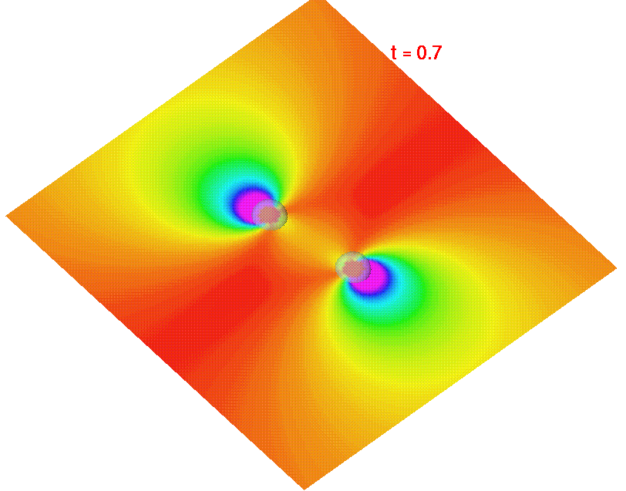
Fig. 1: The Black Holes near the Start of the Evolution. Two separate apparent horizons can be barely seen as transparent bubbles. They will become clearer on following figures.
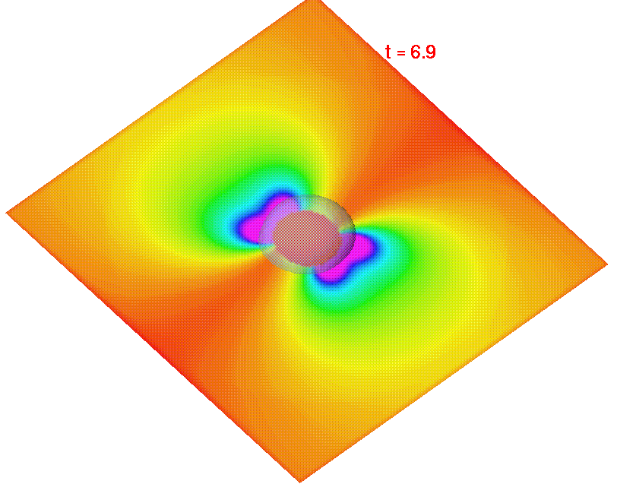
Fig 2: The Black Holes showing clearly that the separate “apparent horizons” have merged.
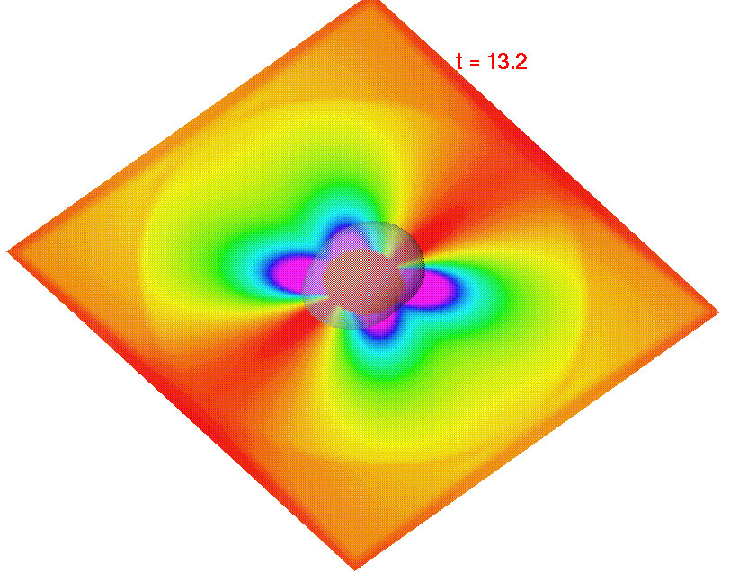
Fig 3: As simulation progresses, the apparent horizon oscillates with “undisturbed space-time” in which waves propagate at “infinity”
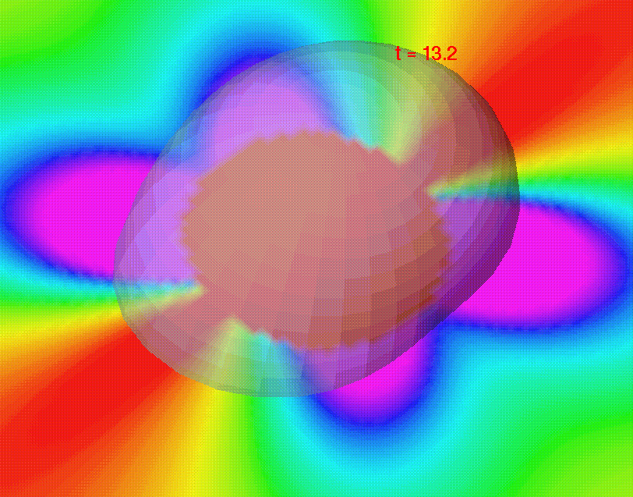
Fig 4: Close-up of apparent horizon in fig. 3.

References

Numerical Relativity: Challenges for Computational Science" Acta Numerica (1999) pp. 1-44. Numerical relativity: challenges for computational science, Gregory B. Cook, Saul A. Teukolsky

http://www.npac.syr.edu/projects/bh/ Home Page for the Binary Black Hole Grand Challenge

http://www.cactuscode.org/, Home page for the Cactus Problem Solving environment for Numerical Relativity (and other areas). This is being developed at the University of Potsdam.

“Boosted three-dimensional black-hole evolutions with singularity excision”, G. Cook et al (Binary Black Hole Grand Challenge) Physical Review Letters 80 18, 3915-3918 (1998)

“Initial data and coordinates for multiple black hole spacetimes”, Richard Matzner, Mijan Huq, and Deirdre Shoemaker, Physical Review D59 024015 (1999)

“Computational Black Holes” in Proceedings of First SIGRAV Graduate School in Contemporary Relativity and Gravitational Physics (V. Gorini, weditor) Institute of Physics Press (London, to appear 1999)

Scott Klasky, Tom Haupt, Geoffrey C. Fox , “MPI HPF and DAGH for Parallelization of Black Hole Codes”, http://www.npac.syr.edu/users/gcf/bbhdaghhpfmar97/index.html, Invited Talk at SIAM Workshop Minneapolis "Is Message Passing Obsolete" on 16 March 97.

Geoffrey C. Fox, http://www.npac.syr.edu/users/gcf/cps713nr96/index.html
Lectures on Numerical Relativity for Computational Science Class
Scott Klasky, http://www.npac.syr.edu/users/gcf/slitex/bbhklasky/index.html
Lectures on Numerical Relativity for Computational Science Class

