Typical application summary
------------------------------------------------------------------------------------------------------IIIB-3 Simulations of Earthquakes
Motivation
The importance of simulating earthquakes is intuitively obvious. For instance, the recent January 16, 1995 Kobe, Japan earthquake was only a magnitude 6.9 event and yet produced an estimated $200 billion loss. Despite an active earthquake prediction program in Japan, this event was a complete surprise. Similar and more drastic scenarios are possible and indeed eventually likely in Los Angeles, San Francisco, Seattle, and other urban centers around the Pacific plate boundary.

There are currently no approaches to earthquake forecasting, which are uniformly reliable. The field uses phenomenological approaches, which attempt to forecast individual events or more reliably statistical analyses giving probabilistic predictions. The development of these methods has been complicated by the fact that large events responsible for the greatest damage repeat at irregular intervals of hundreds to thousands of years, and so the limited historical record that has frustrated phenomenological studies. Up to now direct numerical simulation has not been extensively pursued due to the complexity of the problem and the (presumed) sensitivity of the occurrence of large events to detailed understanding of both earth constituent make up and the relevant micro-scale physics which determines the underlying friction laws. However recently good progress has been made with a variety of numerical simulations and further both earth and satellite sensors are providing an increasing volume of data, which can be used to constrain and test the numerical simulations. This field is different from most other applications in this book as it so far has made little use of parallel computing and only now is starting its own "Grand Challenges". It is thus not known how important large-scale simulations will be in Earthquake science. Maybe they will never be able to predict the "big one" on the San Andreas fault but nevertheless it is essentially certain that they can provide a numerical laboratory of "semi-realistic" earthquakes with which other more phenomenological methods based on pattern recognition, can be developed and tested. As one can use data assimilation techniques to integrate real-time measurements into the simulations, simulations provide a powerful way of integrating data into statistical and other such forecasting methods.

This field has some individually very hard simulations but it has only just started to use high performance computers. Thus the most promising computations at this stage involve either scaling up existing simulations to large system sizes with modern algorithms or to integrate several component computations with assimilated data to provide early full fault system simulations. The latter has important real-world applications in the area of responding to and planning for crises as one can carry the computations through from initial sensing of stress build up through the structural simulation of building and civil infrastructure responding to propagating waves.

Earthquake science embodies a richness present in many physical sciences as there are effects present spread over ten orders of magnitude in spatial and temporal scales. (See figure 1 below).
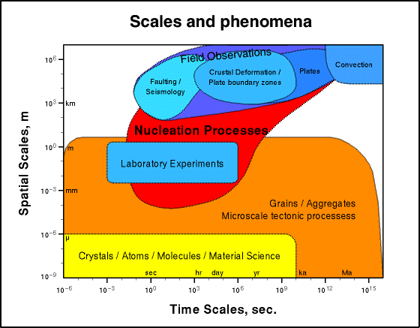
Figure 1: Spatial and Temporal Scales in Earthquake Science

Success requires linking numerical expertise with the physical insight needed to coarse grain or average the science at a fine scale to be used phenomenologically in simulations at a given resolution of relevance to the questions to be addressed. Again the nonlinear fault systems exhibit a wealth of emergent, dynamical phenomena over a large range of spatial and temporal scales, including space-time clustering of events, self-organization and scaling. An earthquake is itself a clustering of slipped fault segments as seen in studies of critical phenomena. As in the latter field, one finds (empirically) scaling laws that include the well-known Gutenberg-Richter magnitude-frequency relation, and the Omori law for aftershocks (and foreshocks). Some of the spatial scales for physical fault geometries include:
The microscopic scale (~ 10-6 m to 10-1 m) associated with static and dynamic friction (the primary nonlinearities associated with the earthquake process).
The fault-zone scale (~ 10-1 m to 102 m) that features complex structures containing multiple fractures and crushed rock.
The fault-system scale (102 m to 104 m), in which faults are seen to be neither straight nor simply connected, but in which bends, offsetting jogs and sub-parallel strands are common and known to have important mechanical consequences during fault slip.
The regional fault-network scale (104 m to 105 m), where seismicity on an individual fault cannot be understood in isolation from the seismicity on the entire regional network of surrounding faults. Here concepts such as "correlation length" and "critical state" borrowed from statistical physics have led to new approaches to understanding regional seismicity.
The tectonic plate-boundary scale (105 m to 107 m), at which Planetary Scale boundaries between plates can be approximated as thin shear zones and the motion is uniform at long time scales.

Typical Computational Problems
This field shows many different types of codes which eventually could be linked together to support either real time response to a crisis or fundamental scientific studies. The process of coordinating the field in this area is happening as a national activity in Japan where major computational resources are being deployed. There is also an International effort among several Asia-Pacific nations including USA (the so-called APEC initiative) and an American activity known as GEM for its goal to produce a "General Earthquake Model". We give three distinct computational problems below.

1) Data Assimilation
The initial simulations aimed at helping a crisis response team, would be triggered by the detection of an earthquake event by the many sensors now deployed -- especially in California. These sensors give of course incomplete information and they must be assimilated into model simulations to allow the model computations in 2) and 3) below to attempt forecasting of possible aftershock activity and the consequent damage to civil infrastructure. JPL has developed one such code disloc to process data from the large NASA-NSF-USGS SINE Sensor array. It uses finite elements and complex meshing techniques to represent the complexity of the 3 dimensional earth crust. It is shown in table 1 and described in subsection 4 below as a “problem solving environment” designed to support the earthquake community after events like those occurring in Turkey or Taiwan in 1999.

2) Earthquake Fault System Simulations -- Virtual California
With reasonable approximation, you can model the long-term evolution of stresses and strains on interacting fault segments with a Green's function approach. As in other fields this method leads to a boundary (the faults) value formulation, which looks numerically, like the long-range force problem. The faults are paneled with segments (with area of some 100 m² in definitive computations) which interact as though they were dipoles. The original calculations of this model used the basic O(N²) algorithm but a new set of codes will be using the "fast multipole" method described in chapter YY for astrophysical problems. There are interesting differences between the earthquake and gravitational applications. In gravity we get wide ranges in density and dynamical effects from the natural clustering of the gravitating particles. Earthquake "particles" are essentially fixed on complex fault geometries and their interactions fall off faster than those in the astrophysical problem.
Several variants of this model have been explored including approximations, which only keep interactions between nearby fault segments. These "cellular automata" or "slider-block" models look very like statistical physics with an earthquake corresponding to clusters of particles slipping together when the correlation length gets long near a critical point. The full Green's function approach should parallelize straightforwardly in either O(N²) or multipole formulation. However cellular automata models will be harder as we know from experience with the corresponding statistical physics case where clustering models have been extensively studied.
An interesting aspect of these simulations is that they give the "numerical laboratory" for the study of space-time patterns in seismicity information. This type of analysis was used successfully in climate field to aid the prediction of "El Nino" phenomena. These pattern analyses may or may not need large computational resources although they can involve determination of eigensolutions of large matrices which is potentially time consuming.
We show Virtual California used to help predict aftershocks and manage the consequences of actual earthquakes in fig. 2. This illustrates the concepts described in the last chapter of large simulations being used in a real time network to address problems of importance to society.

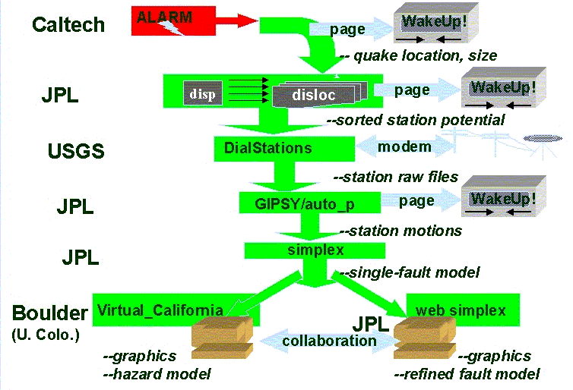
Fig. 2: Simulations used in Response to an Earthquake

3) Earthquake Engineering
The most mature computations in the field are perhaps those used to calculate the response of buildings to seismic waves. In fact Clayton in the Caltech Geophysics department performed one of the very first Caltech Cosmic Cube computations to simulate the motion of earthquake waves in the Los Angeles Basin. This wave motion can in principle be generated from the earthquake "events" calculated in the Virtual California simulations described in 2) above. The wave motion can be used as a forcing function for structural dynamics computations of buildings, roads and other civil infrastructure. These are large scale finite element problems with complex grids and a recent NSF Grand Challenge was very successful in this area.

4) Response to an Earthquake in Southern California

In this typical scenario which is the first part of fig. 2, the goal is to rapidly form a consensus among researchers concerning the characterization of the deformation field and the location, size, and direction of slip on a fault following an earthquake. This consensus can be used to guide decisions on both civil and scientific responses to the quake.

Following an earthquake in Southern California, the location and magnitude are calculated based on seismic data within minutes by Caltech/USGS, and currently are broadcast to several users via email and pagers. The information on location and magnitude could then be automatically used to define an area wherein instruments might be expected to record a signal. (disp) Data from these stations would be given priority in retrieval and analysis. In this example we will assume that the data in question is GPS data from the Southern California Integrated Geodetic Network (SCIGN) array. Retrieval in this case is done by telephone modem. As soon as the list of possibly affected stations has been generated, the database at the USGS is checked. If any of the stations on the list have not had data downloaded since the quake, computers at the USGS begin dialing the selected stations and retrieving the data.

Data from these stations would then be processed for rapid analysis to determine the measured displacements of the stations. (GIPSY) If the measured displacements are large enough, emergency and scientific personnel are notified via email and pager. These displacements are then automatically fed into an inversion routine (simplex) which solves for the best fit single fault displacement. This single fault displacement is in turn fed back into a forward elastic half space model which yields a preliminary map of displacements over the whole area. (disloc)

At this point this map is shared between various scientists and emergency personnel, using systems like Tango Interactive that allow the collaboration and interaction of multiple people viewing and manipulating the same data set over the Internet. The emergency personnel can use the preliminary map in combination with a Geographical Information System data about utilities, lifelines, etc. to help assign resources to various areas. The scientists will use the preliminary map to help design a strategy for collecting additional measurements. They can also collaborate on refining the single fault model, possibly breaking the single preliminary fault into several segments, introducing more realistic material properties, or including more data, before rerunning the inversion.

This environment permits the rapid determination and dissemination of preliminary information about the earthquake and the collaborative refining of that information following an event. The rapid dissemination of information can greatly aid both the civil and scientific response to the quake. Resources can be more efficiently allocated to the areas where they are needed, and scientific measurements can be focused to provide information critical to refining our understanding of the earthquake system. Once an acceptable model of the earthquake has been determined, various models can be used to estimate the updated earthquake hazard for adjacent areas. Since there are currently several competing models for this it will undoubtedly involve multiple runs of multiple models and significant discussion among scientific colleagues. Each of these models as well as the various pieces of the automated processes described above have been developed by different people under different assumptions, and is developed, run, and maintained on computers under the control of the developer. Technologies such as CORBA and Enterprise Javabeans allow appropriate access and security mechanisms in this complex evolving distributed system.

The 1999 Izmit Turkey earthquake provided a recent example of how a system like this could have been useful. Following that earthquake, many geoscientists got together in a series of conference telephone calls to try to piece together what had happened, and what was an appropriate response. Some participants initially only knew what had been reported in the media. Others knew of specific pieces of data concerning the earthquake or of actions being taken by various groups and individuals. It is safe to say that no one had a complete picture. Much of the conference call was devoted to informing everyone about all the pieces of data and all the various initiatives that people were pursuing or might pursue. Similar calls and emails occurred after the 1992 Landers and 1994 Northridge earthquakes. Having a system such as has been described above wherein participants could share maps, descriptions, programs, data sets, and graphs and
wherein they could interactively and collaboratively manipulate the data and programs both synchronously and asynchronously would immeasurably aid the rapid and accurate diagnosis of what has happened and what should be done next.

Computational Resource Requirements
Current evidence suggests that forecasting earthquakes of magnitude ~6 and greater will depend upon understanding the space-time patterns displayed by smaller events; i.e., the magnitude 3's, 4's and 5's. With at least 40,000 km2 of fault area in southern California, as many as 108 grid sites will be needed to accommodate events down to magnitude 3. Extrapolations based upon existing calculations indicate that using time steps of ~100 sec implies that ~108 time steps will be required to simulate several earthquake cycles. This leads to the need for teraflop class computers in this as in many physical simulations. At this stage, we cannot guess how far this class of computer will take us and the systems needed to support research, crisis managers or insurance companies assessing possible earthquake risk, may require much higher performance.

References
1) Allègre, C., J.L. Le Mouel and A. Provost, Scaling rules in rock fracture and possible implications for earthquake prediction, Nature, 297, 47-49, 1982.
2) http://shake2.earthsciences.uq.edu.au/ACES/ International collaboration within APEC for earthquake simulation
3) Ben-Zion, Y., Stress, slip and earthquakes in models of complex single-fault systems incorporating brittle and creep deformations, J. Geophys. Res., 101, 5677-5706, 1996.
4) Brown, S.R, C.J. Scholz and J.B. Rundle, A simplified spring-block model of earthquakes, Geophys. Res. Lett., 18, 2, 215-218, 1991.
5) Burridge, R and L. Knopoff, Model and theoretical seismicity, Bull. Seism. Soc. Am., 57, 341-371, 1967
6) Dieterich, J.H., A constitutive law for rate of earthquake production and its application to earthquake clustering, J. Geophys. Res., 99, 2601-2618, 1994.
7) Fisher, D. S., K. Dahmen, S. Ramanathan and Y. Ben-Zion, Statistics of earthquakes in Simple Models of Heterogeneous Faults, Phys. Rev. Lett., 78, 4885-4888, 1997.
8) Gabrielov, A., W. Newman and L. Knopoff, Lattice models of failure: Sensitivity to the local dynamics, Phys. Rev. E, 50, 188-197, 1994.
9) GEM web site (currently http://www.npac.syr.edu/projects/gem but will be moved to JPL)
10) Jaume, S.C., and L.R. Sykes, changes in state of stress on the southern San Andreas Fault resulting from the California earthquake sequence of April to June 1992, Science, 258, 1325-1328, 1992.
11) Rundle, J.B., A physical model for earthquakes, 2, Application to southern California, J. Geophys. Res., 93, 6255-6274, 1988.
12) Rundle, J.B. and D.D. Jackson, Numerical simulation of earthquake sequences, Bull. Seism. Soc. Am., 67, 1363 - 1378, 1977.
13) Rundle, J.B. and W. Klein, New ideas about the physics of earthquakes, AGU Quadrennial report to the IUGG and Rev. Geophys. Space Phys., Supplement, July 1995, pp. 283-286.
14) Rundle, J.B., A physical model for earthquakes, 2, Application to Southern California, J. Geophys. Res., 93, 6255-6274, 1988.
15) Scholz, C.H., The Mechanics of earthquakes and Faulting, Cambridge University Press, Cambridge, U.K., 1990.
16) Tiampo, K., Rundle, J.B., W. Klein and S. Gross, Eigenpatterns in Southern California seismicty, submitted to Nature, 1999.

17) Geoffrey C. Fox, Ken Hurst, Andrea Donnellan, and Jay Parker, Introducing a New Paradigm for Computational Earth Science– A web-object-based approach to Earthquake Simulations, Chapter in book to be published by AGU 2000 and edited by John Rundle.

