Grading System and Other LearningTechnologies
Ozgur Balsoy
July 2, 2000

Grading System Architecture and Technologies Involved

The Grading System (GS) architecture is implemented based on the concern of usability, performance, portability and easy installation to any machine. The involved technologies include HTML, JavaScript, Java, JDBC, SQL, SSL and a limited amount of Perl for specific local legacy systems. The below figure illustrates the architecture of the environment;

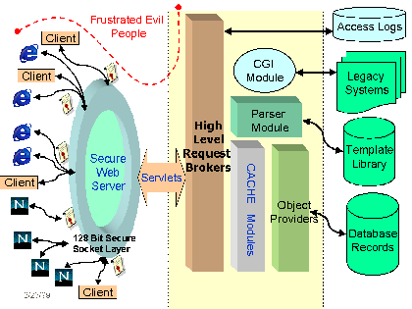
The architecture is a multi-tier architecture. In general it can be seen as a three-tier architecture. The more layers in the middle tier are especially designed in semantics of modularity and easy integration with other related projects.

The user interface is completely presented as a commodity interface. All the data access, and functionality is managed through the client browsers. The communication with the outside world is provided through dynamically produced HTML pages by the servlets. The communication channel is secured with SSL to complete other inside security mechanisms as previously mentioned.

In the middle tier, the main intelligence of the environment is placed hierarchically. The first level contains the high level functionalities to talk with the clients and to perform the operations in a more advanced level without considering the low level system dependencies like database connectivity. The relational database records are considered as the objects at this level. The second level mainly serves as a cache memory to database objects. The cache mechanism provided performance increases by decreasing accesses to the database for each operation. The objects in the cache are defined as the objects, which are kept in a single relational database table row entry and the related methods to perform on them. The last level performs low level operations like connecting to the databases and performing database-related operations. Each independent type of tables like, students, users, courses, etc., has an associated class. The last layer in the architecture is the database back-end. Since the implementation is done with Java, any suitable database supporting basic SQL standards can be chosen and the database access can be forwarded to the selected database through a JDBC bridge update in the front-end options. The parser dynamically produces HTML user interfaces through the template library stored in outside editable HTML-like files. Finally, the architecture includes the legacy systems through a cgi module.

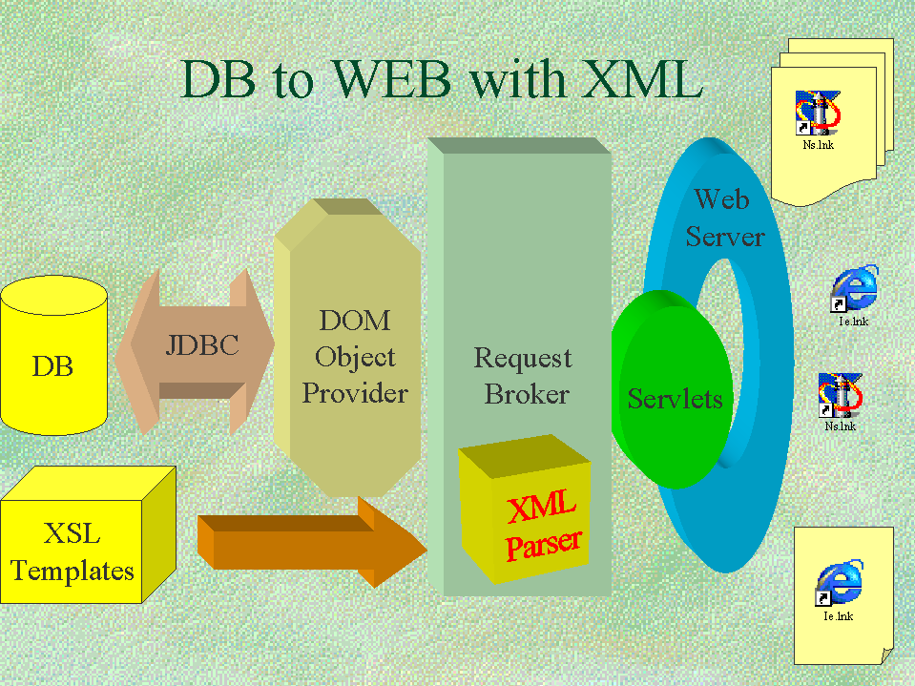

What is LTSA?

The Learning Technology Systems Architecture (LTSA) is “a high level systems architecture and layering for learning technology systems,” and a proposed architecture to IEEE 1484 Learning Technology Standards Committee (LTSC).

LTSA Component Organization
LTSA provides guidelines to learning technology systems designers, and its system components can be mapped to virtually all learning technology systems already designed, or naturally practiced. These include a father and son talk, a traditional classroom teaching, self-study, Web-based learning, flight simulation, etc. The following figure shows how a traditional classroom can be mapped to LTSA system components.

A traditional classroom (teacher, student, library, report cards) mapped to LTSA system components. The LTSA can be used in non-electronic scenarios.

GS Mapped to LTSA

The GS architecture can also be mapped to the LTSA system components. GS provides components for Behavior, Evaluation, Records Database, Knowledge Library, Delivery, and System Coach.

Instructional Management Systems (IMS) Project

The IMS Enterprise Information Model describes data structures that are used to provide interoperability of Internet-based Instructional Management systems with other Enterprise systems used to support the operations of an organization.

The objective of the IMS Enterprise Information Model is to define a standardized set of structures that can be used to exchange data between different systems. These structures provide the basis for standardized data bindings that allow software developers and implementers to create Instructional Management processes that interoperate across systems developed independently by various software developers. The major classes of Enterprise applications supported by this model are Training Administration, Student Administration, Library Management, and Human Resource systems.

Note: The scope of the IMS Enterprise specification is focused on defining interoperability between systems residing within the same enterprise or organization. The documents comprising the IMS Enterprise specification are not targeted at solving the issues of data integrity, communication, overall security, and others that are inherent hen investigating cross-enterprise data exchange.

Interoperability between GS and other LMSs

To assure interoperability between Grading System and other learning management systems, GS will use an interface based on the IMS Enterprise/Learning Resource Meta-data Information Model specifications.

- A LMS connects GS through the GS authentication module

- Request broker processes the request, uses the XML parser as needed, and forwards it to the IMS interface

- The interface queries requested objects through the DOM object provider.

- The object provider fetches objects and constructs an IMS document

- The document is sent back to the peer LMS.

The following XML document is an example of 1 person-- 1 group and a group membership for the group consisting of the person can be used between any LMS to exchange information about any persons, groups, and memberships.

<?xml version="1.0" encoding="UTF-8"?>
<!DOCTYPE ENTERPRISE SYSTEM "IMS-EP01.dtd" >
<ENTERPRISE>
<PROPERTIES>
<DATASOURCE>Florida State University</DATASOURCE>
<TARGET>Blackboard LMS</TARGET>
<TYPE>REFRESH</TYPE>
<DATETIME>2000-08-17</DATETIME>
</PROPERTIES>
<PERSON transaction="1">
<SOURCEDID>
<SOURCE>Florida State University </SOURCE>
<ID>111-22-3344</ID>
</SOURCEDID>
<NAME>
<FN>John Doe</FN>
<SORT>Doe, John</SORT>
<NICKNAME>John</NICKNAME>
<N>
<FAMILY>Doe</FAMILY>
<GIVEN>John</GIVEN>
<PREFIX>Mr.</PREFIX>
</N>
</NAME>
<DEMOGRAPHICS>
<GENDER>2</GENDER>
<BDAY>1956-02-03</BDAY>
</DEMOGRAPHICS>
<EMAIL>doe@fsu.edu</EMAIL>
<TEL teltype="1">7607504785</TEL>
<TEL teltype="2">7607503257</TEL>
<ADR>
<STREET>123 Main St</STREET>
<LOCALITY>Tallahassee</LOCALITY>
<REGION>FL</REGION>
<PCODE>32310</PCODE>
</ADR>
</PERSON>
<GROUP transaction="1">
<SOURCEDID>
<SOURCE>School of Computational Science and Information Technologies</SOURCE>
<ID>CSIT 1234 Section 1 Fall 2000</ID>
</SOURCEDID>
<DESCRIPTION>
<SHORT>Information Technologies</SHORT>
<LONG>This course surveys several software technologies of current interest for use with integrated systems in collaboration, databases, and distributed computing.</LONG>
<FULL>This course surveys several software technologies of current interest for use with integrated systems in collaboration, databases, and
distributed computing. Specific topics in the course evolve rapidly to include leading edge technologies. Currently included are Web interfaces to relational databases using JDBC, JavaScript and advanced HTML such as DHTML (Dynamic HTML) for rapid development of user interfaces, the use of CORBA to connect distributed applications, component
programming with JavaBeans, XML and security and commerce software. Some material will be taken from research projects at CSIT.</FULL>
</DESCRIPTION>
<ORG>
<ORGNAM> School of Computational Science and Information Technologies </ORGNAM>
<ORGUNIT>Computational Science</ORGUNIT>
<TYPE>Academic</TYPE>
</ORG>
<TIMEFRAME>
<BEGIN restrict="0">2000-08-26</BEGIN>
<END restrict="0">2000-12-20</END>
<ADMINPERIOD>Fall 2000</ADMINPERIOD>
</TIMEFRAME>
<ENROLLCONTROL>
<ENROLLACCEPT>1</ENROLLACCEPT>
</ENROLLCONTROL>
</GROUP>
<MEMBERSHIP>
<SOURCEDID>
<SOURCE> School of Computational Science and Information Technologies</SOURCE>
<ID> CSIT 1234 Section 1 Fall 2000</ID>
</SOURCEDID>
<MEMBER>
<SOURCEDID>
<SOURCE>Florida State University</SOURCE>
<ID>111-22-3344</ID>
</SOURCEDID>
<IDTYPE idtype="1"/>
<ROLE transaction="1" roletype="01">
<STATUS>1</STATUS>
<COMMENTS>This student has no special needs.</COMMENTS>
<FINALRESULT>
<MODE>Letter Grade requested</MODE>
<VALUES listrange="0">
<LIST>A</LIST>
<LIST>C</LIST>
<LIST>F</LIST>
</VALUES>
</FINALRESULT>
</ROLE>
</MEMBER>
</MEMBERSHIP>
</ENTERPRISE>

This document was prepared from different sources. Descriptions were used as appeared in the original documents, and examples changed as needed. For detailed information, please refer to the original documents.

References

Sen, M, Balsoy, O, Fox, G.C. and McCracken, N.J., “Course Management: A Complete Asynchronous Environment Architecture in Education,” Webnet 99 Abstracts book - p.86, WebNet 99, World Conference on the WWW and Internet, Honolulu, Hawaii
? Learning Technology Systems Architecture (LTSA) Specification, Version 4.00, http://www.edutool.com/ltsa
IMS Global Learning Consortium, Inc., http://www.imsproject.org/

