Untethered Collaboration for Remote Science Missions
Geoffrey Fox, Florida State University
Andrea Donnellan, Eric Mjolsness, John Lou Jet Propulsion Laboratory

1. Introduction
Operation and analysis of remote science missions require the assembly of multiple experts to share data from a spacecraft, discuss the implications, and make collaborative decisions. Often this collective wisdom must be assembled with no advance notice to make decisions that could be critical for increasing scientific discovery or even the health of the satellite. We propose to address this problem by combining emerging hand-held wireless technology, the latest ideas in electronic collaboration, and science portals. This is a compelling concept because the technology is available, and the proposed environment has capabilities that cannot be achieved with traditional methods. The proposed untethered collaboration environment will allow scientists with traditional workstations/PC's to share data synchronously with others using either browser enabled cell phones or hand held devices. The data can be generated on the clients from white boards or chat rooms or from servers that can be fed to and from the remote scientific mission. The system will use the latest Internet (object-web) software and can use either the public internet (wireless internet) infrastructure or dedicated links if this is needed for bandwidth or security issues. We will leverage ongoing work by Fox on collaborative portals [11], which will allow these synchronous interactions to be integrated into modern web-based interfaces to computational science (commonly called science portals) and for asynchronous and synchronous collaboration to be seamlessly integrated. The environment will allow any or all of the communicated messages to be sent securely using modern PKI (public key) technology. The proposal includes both computer science research by Fox's group combined with application requirement and system integration at JPL by Donnellan's Data Understanding Systems Group and Mjolsness’s Machine Learning Systems Group. Fox has worked extensively in this mode with JPL in the development of hypercube parallel computing while he was a professor at Caltech. Now Fox is a professor of computer science and chief technologist for distance education at Florida State University. He has been appointed as distinguished visiting scientist at JPL starting this year.
The work will build on lessons from the TangoInteractive collaboration system built for command and control and distance education applications [3,23]. This was modified to demonstrate collaboration between wireless Palm 7 and traditional PC's using a simple chat application. However we are rebuilding the collaborative portal software from scratch using several key new ideas. In particular we enable the linkage of hand held and traditional clients by minimizing browser software (TangoInteractive and our first portals used large applets in the browser) and using a personal server, which drives either PC or hand held displays. A powerful event service supports synchronous or asynchronous collaboration and integrates the client and middle tier messaging/event subsystems.
This proposal will use a collaborative portal environment currently being designed and prototyped with NSF and DoD funding. We focus here on the special needs of NASA and the real-time instantaneous requirements of remote missions. There are other fields sharing these requirements and we will consider them during our design and development. One interesting example familiar to us is the science analysis during an earthquake — another field where important events happen without warning and require the integration of real-time sensor data, remote control and multiple experts.
The proposal will use hand held devices supporting either the new WAP (Wireless Application Protocol) standards or the existing Palm query applications. We expect WAP to be of growing importance in the future and we will use both the Gateways and browsers produced by Phone.com — the industry leader. Our part of our research involving hand-held devices will focus on two major areas. First the integration of hand held devices into collaborative portals using secure communication channels driven by a personal server. This is built around XML specified interfaces using portalML designed by Fox. In the long run more important is the second research focus — namely designing the new modes of expression or visualization needed to display scientific knowledge on the small screens of hand-held devices. These devices need to be tied in collaborative mode to traditional displays on workstation clients. This research is part of the more general topic of models for scientific collaboration and how one should design collaborative distributed “scientific objects”. The research will also address the overall system architecture and in particular the processing balance between remote sensors, hand-held and traditional clients and middle-tier servers.
This proposal directly addresses program elements within the AISRP. The work will increase the scientific return on science conducted under OSS by developing the necessary tools to effectively utilize in a timely manner the ever-growing volumes of science data acquired by space missions. Rapid response, analysis, and adaptation will be made possible by exploiting advances in computer science and information technology. Additionally this proposal makes use of a unique partnership between science investigators at JPL and the computer science community at Florida State University. We will be developing cutting edge, state-of-the-art information technology tools that will improve the understanding and effectiveness of OSS scientific research endeavors. The tools developed will facilitate science data analysis and visualization, increase the utility of scientific simulations and models by allowing for enhanced capability as well as cross-validation, improve science data mining and exploration methods being developed at JPL through enhanced tools, as well as facilitate real-time planning and adaptation during missions. The tools developed here will also enhance the utility of data through data management and distribution tools and will provide near real-time science data product generation. Through the innovative developments proposed here, this work will foster interdisciplinary research by creating uniform tools that can be used across a variety of disciplines and projects.

2. Objectives and Expected Significance
We will research new distributed object and collaboration technologies to support real-time critical NASA applications. These include both deep-space missions and earth science. The technologies can be used for supporting mission operations but our focus will be on technologies that support collaborative scientific research.
The research will make contributions to both computer science and space science. Space and Earth Science will benefit directly from the ability to link experts in distributed locations to analyze and discuss the information from scientific sensors and simulations. Either hand-held devices or high-powered workstations or anything in between can host these interactions. This will allow improved real-time control of semi autonomous spacecraft such as Mars rovers or optimization of the scientific knowledge extracted from ongoing earthquake events. These two applications areas will be our foci.
Computer science research has developed object sharing as an overall framework for collaboration but we have found that we need application driven requirements to make further progress. This has been most successful in distance education [3,4] where one finds the structured teacher-student interactions and simple shared objects (web pages with lectures). Collaborative scientific research presents new research issues as the interaction between participants are less structured and one is sharing more dynamic objects – real-time data from sensors and simulation results rather than the typical static web page. There has been substantial research in collaborative visualization but these NASA Science applications pose new challenges due to the critical real-time constraints – either from a space-craft encounter or the need to track and predict aftershocks and their effect. In the non real-time case, distributed collaboration is useful but not essential; traditional mechanisms (asynchronous sharing of information, traveling to common locations) can be used. For real-time applications, internet based synchronous collaboration offers new capabilities. Further there is a clear need and value in linking the support of palmtop with conventional workstations; the experts must be linked in with what ever interface is available at the time. So again support of palmtops is not a convenience but an essential feature of this work. In visualization, research focuses on shared viewing of 3D images possibly in virtual reality mode. In this research, the focus will be shared analysis of real-time data and simulations with collaborative real-time decisions. Our project will make significant contributions to Information technology research in this area based on the unique challenges of the NASA applications.

3. Impact of Research on Knowledge in Field
The proposed work impacts research in collaborative systems from the new understanding of system architectures that support the special requirements of real-time collaborative science. This affects the “floor control” – how the scientists collaborate and the tools to support it. The sophisticated shared objects (real time data streams and simulations) will test the shared event model of collaborative objects. These allow one to customize the views of a given object so that each given gets an appropriate view. This general approach underlies the powerful shared event model but it has been hard in past work on collaborative computing and collaborative research environments to make choices as to which properties of objects to replicate and which to customize for each user. The special requirements here will allow us to discover which of the many possible computer science approaches are effective. Space Science research will be advanced by the development of the new distributed collaboration approaches to real time analysis. This will both improve existing science and enable new approaches based on the availability of powerful distributed analysis and decision-making technology.

4. Technical Approach

4.1 Technology Vision
We are building distributed computer systems whose ever-increasing capability is driven by the inexorable technology trends. These are summarized by Moore’s law that CPU performance increases by a factor of 2 every 18 months and Gilder’s law that networked bandwidth increases a factor of 3 every year. Looking in more detail, we find an explosion in wireless technology (typified by the new Bluetooth technology which initially promises around megabit local links) and many types of novel small devices such as hand-held digital assistants. These hardware developments are accompanied by remarkable new and new innovative software capabilities that are being developed largely for Internet applications. As the Internet is “just” a complex distributed system, this same hardware/software combination can be used in essentially any other computer system whether it supports a company Intranet, the NASA Space Internet or a University distance education curriculum. The success of the object web software environment is not just due to powerful hardware and innovative software concepts. Rather the establishment of community standards such as HTTP and HTML has enabled modular system development by distributed teams. The resultant systems have far greater power than those built by more traditional proprietary architectures. In this proposal we use software technologies like Java, CORBA, and XML developed for the Internet to build distributed systems to support NASA Science. We in particular integrate wireless and hand-held device support. We leverage whereever possible relevant commercial and academic standards and technologies. For instance in the wireless area, we use the WAP standards which establish transport and data protocols for small digital devices.

4.2 Computer Science: Distributed Objects and Portals
We combine two thrusts, which have been a focus of Fox’s research over the last four years. In the first we formulate scientific computing and data analysis in terms of distributed objects with a web interface. This is equivalent to building what is called a problem solving environment (PSE) using Web and distributed object technologies. [11] PSE’s have been pursued for many years with the work at Purdue [15] pioneering many important concepts. The ever-increasing power of computers and the improving capability of distributed object and web technologies are making this approach extremely attractive for users and system builders. One uses the “Object Web” (CORBA, COM, Java, XML etc.) and a browser based user interface to provide a single integrated view, or what is now termed a portal [6], to the resources and tools needed by the scientist. For this research we will start with the successful Gateway and WebFlow systems [1,8,10] developed by Fox and applied to several DoD and NSF projects. These have a classic three-tier architecture with client, brokers/servers and services in the three layers. High performance is obtained even while using Java and CORBA in the middle tier, by careful separation of control and data. The middle tier provides a flexible control layer implemented with proxies, and traditional high performance mechanisms such as Globus [12] and MPI are used for data transfer in the backend. Thus in integrating NASA applications, one does not need to modify existing programs or existing communication mechanisms. Rather proxies in the CORBA middle-tier represent these legacy system components and we have developed wizards that wrap existing systems to produce both their middle tier and client representation. The wizard generates on the client interfaces that allow parameter display and specification. These are converted to their XML internal form and streamed to the middle-tier. This takes the XML program and data specifications and constructs the necessary job submittal. A monitor tracks the job progress and will dispatch the output to the designated files or streaming interface. This is implemented by the WebFlow distributed object technology, which has a powerful dataflow and coarse grain object computing model with all interfaces defined in XML and compatible with community activities [6,13]. In this sense it is more powerful than the earlier NILE system [18] while it is less ambitious than the Common Component Architecture [7], Legion [16] and POOMA [21], which provide a fine grain, object model. Gateway is fully consistent with commodity standards (CORBA and XML) and therefore suitable for the ambitious project proposed here which aims to provide an information infrastructure for a complete application area in three radically different timeframes. We will implement early prototypes of the information infrastructure on Gateway but expect that one can better use one of the emerging set of “Object Web operating systems” such as E-Speak [9] or Ninja [19] as the basic framework. We will investigate these new possibilities over the next few months.

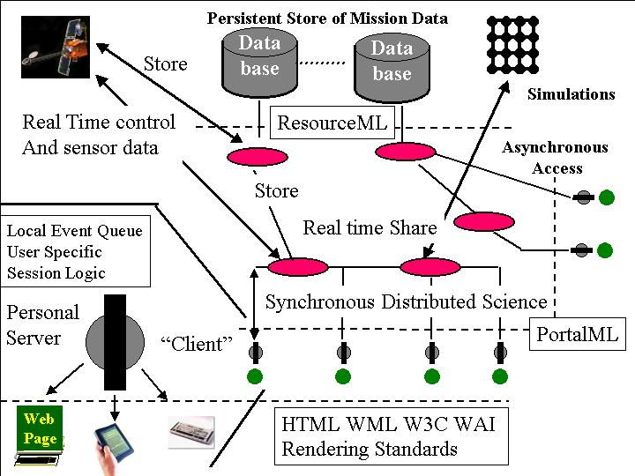
Fig 1: Collaborative Sessions showing real-time information and control; asynchronous database access and objects specified in resourceML with portalML for collaboration and other portal properties
A team from JPL has already begun to design prototype XML based metadata [5,17,22,24] for some of the earthquake sensor-based data and we have used this in a prototype PSE built for earthquake analysis. As part of this project, we will extend this design to sensor, field and simulation data in a way that we can use it to integrate different data sources into our collaboration and analysis tools. Figure 2 illustrates a typical scenario to be used in designing this earth science collaborative portal. Our PSE environment [1] fully supports XML for job and data definition and its dataflow paradigm will allow files with compatible metadata to be exchanged between application components. This will require a hierarchical metadata design and the construction of services based on available XML tools to process data in the different parts of the environment. This activity will be linked to related work in our arena (e.g. the Grid Forum [13], NCSA and NPACI) and so be important in designing science wide approaches to metadata. In figure 1, we illustrate the two key XML interfaces resourceML defining the system view of objects and portalML defining the user view. A network of server’s links to databases for persistent storage; to computers for simulation and to spacecraft (or earthquake sensors) for real-time data. This portal design uses a four-tier architecture with client – “personal server” – middle tier server – backend object structure. The personal server holds user specific logic and is used to map into the different supported user interfaces including workstation and PDA’s [20]. In this part of project we will link the JPL XML based data structures for NASA specific objects and link them into the existing portal environment. This will give a prototype space science portal to be used for the next step, which is to add collaborative capability.
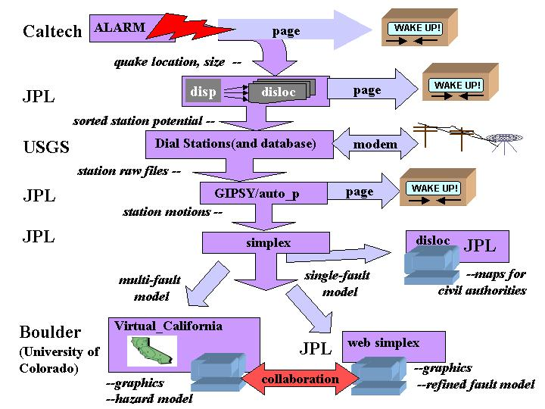
Figure 2: An Earthquake Analysis Scenario
A major concern of our DoD funded portal work is security and Gateway has been implemented using a secure CORBA broker, which interfaces to the existing DoD high performance computing Kerberos security environment. This capability will be available to the NASA applications but not a primary focus of our research as each security environment has many different detailed considerations. Our experience indicates that our architecture supports modern approaches whether PKI (public key) or Kerberos style. If one wished to “deploy” the research prototypes, then security would be a natural emphasis here.

4.3 Computer science: Collaborative Portals
This research builds on the Collaborative Portal research project at FSU and we will first review this activity which is mainly aimed at distance education and training with funding from the DoD HPC Modernization program and NSF.
We have had several successes in web-based collaboration, but discovered some problems with initial collaborative systems such as Microsoft NetMeeting, NCSA’s Habanero [23] and Syracuse’s TangoInteractive [3,4,23]. Higher speed networking and quality of service will address some of the difficulties such as variable quality in digital audio video conferencing; here we track the ANL/NCSA Access Grid project [2]. The leading commercial approaches in this area are typified by the HearMe technology, which avoids the difficult Internet quality of service issue for audio by integrating conventional teleconferencing with digital audio so that you can mix both old and new in the same collaboration. Other core collaboration functions include chat rooms and other community support functions. These are well understood and will not be the topic of our research although we do need to design good XML interfaces so that one can integrate PC chat-rooms; hand-held message displays and conventional mail as an asynchronous record of synchronous messages. Whiteboards are well understood on conventional clients but versions that are also suitable for hand-held use require more understanding of visualization on these new devices. Although an interesting topic which deserves significant research, we are content to develop two simple PDA/PC compatible whiteboards for the Collaborative Portal. Firstly we will use the standard shared event whiteboard and use simple heuristics on the PDA if a shared PC whiteboard is too large for direct display. Secondly we are modifying the VNC shared display system to share such displays as images, which are scaled down at the server before transmission to the PDA. One general approach that will make it easier to support a range of devices in our system will be the use of a control application for the Collaborative Portal whose functionality and design is similar to the popular Yahoo messenger. This has a set of control buttons and a window for chat and summary data. One launches additional applications – in particular a Web Browser for more complex tasks. This MyCollaboration mini-portal is small and so can be straightforwardly rendered on either a workstation or a PDA. This makes the problem of displaying on either device independent of issues of controlling the collaboration session and roughly “just” the (non collaborative) problem of displaying (Web) pages on a universal interface.
For this project and indeed the basic distance education project, the most interesting and challenging research issues are centered on the custom applications needed for each special type of collaboration. So far, we have been particularly successful in educational applications with their structured format but have yet to develop clearly successful collaborative science research applications, which are both robust, and of compelling value. The latter will be a major goal of this proposal, which exploits the real time nature of the problem missing in other collaborative computing areas. In our current design there is a basic infrastructure common to all types of collaborative portal that supports the basic distributed object model underlying the system. We will replace the current custom protocols and services in TangoInteractive by those available from the emerging high level distributed object infrastructure such as Ninja [19]. However initially we are basing the collaborative portal on the existing CORBA based approach used in Gateway. Our web-based approach implies that collaboration is just the service that allows sharing of web-deployed distributed objects. However this sharing must be done in several different collaboration modes; shared display and both collaboration-aware and collaboration-unaware shared event models. Previous systems have focused on one of these mechanisms and have not been able to support the needed range of collaboration. A key technical idea in our new approach is a generalized shared queued event service implemented in the “personal server” layer of the above figure. This event service federates or integrates the typically disparate event services on the clients and middle tier of such a distributed environment. We build adapters to integrate a particular capability (using an existing “legacy” event service) into this collaborative portal. For example this universal substrate allows a single archiving mechanism or a single PDA display strategy to support all collaborative applications. Previously we had to build such capabilities separately for each case. We will use XML systematically (in the portalML syntax) to define the details of the collaboration and the portal infrastructure (e.g. to define structure of the universal events) as the building blocks of the collaborative system.
For distance education, the essential collaborative application is the virtual classroom which supports shared documents with pointer and highlight, shared or personal annotation and control functions to invoke quizzes or allow students to “raise their hand”. The document is typically a PowerPoint or Web page. The PDA collaborative clients could be content with just displaying control information (from MyCollaboration applet) or some rendering of the shared document. This PDA rendering could either be a condensed VNC based “thumbnail” or a more faithful WML based version of the original document. This topic needs research in the education and training area.
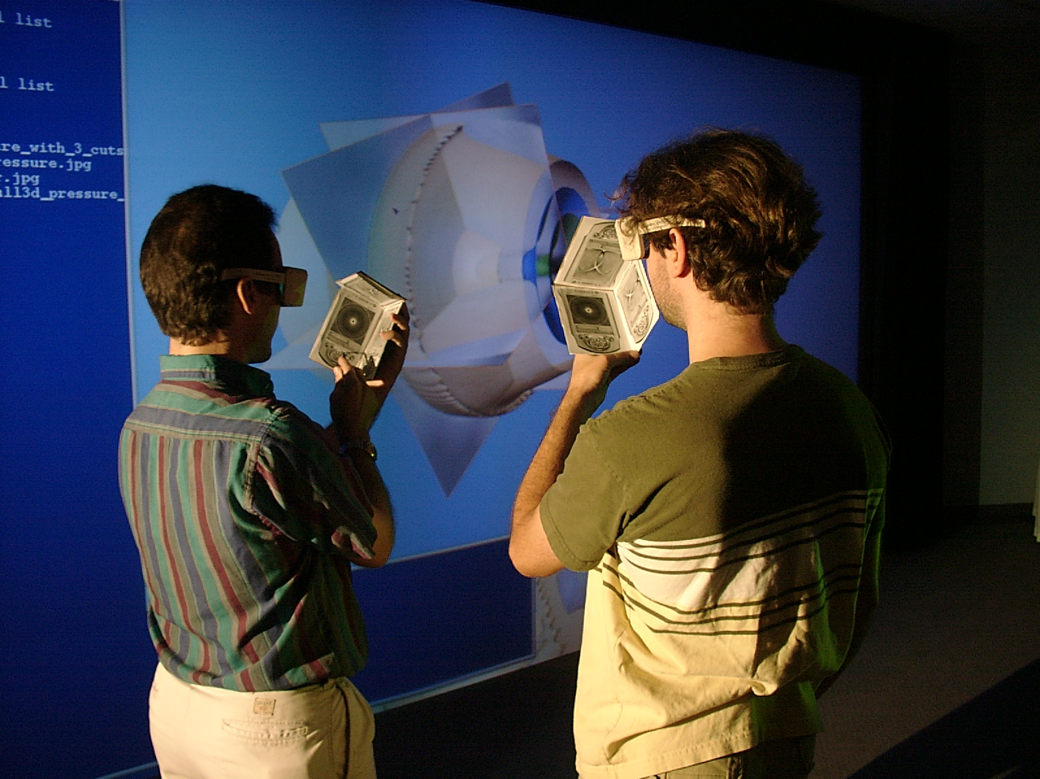
Figure 3: The concept of Erlebacher and Banks of CSIT for 3 collaborative PDA’s mounted in orthogonal planes to control a large screen display. This is shown with stereo display using CSIT’s Powerwall large screen display.
Some of this capability can be straightforwardly adapted to the NASA science problem but obviously some aspects of the virtual classroom are irrelevant to the virtual mission place whether it mimics the control room or the Science analysis environment. Quizzes would not of course be needed but instead one would have a suite of tools to support distributed decision-making. Shared documents would be relevant but rather than PowerPoint; one would see shared maps; shared visualization from the associated simulations and shared sensor data from the Science mission. We will analyze the space and earth missions sketched below and decide on key functionality of the virtual mission place. We will implement sample applications to exemplify each type of collaborative application – covering decision support, collaborative geographical information systems, scientific visualization and real time sensor data.
We believe our approach will integrate collaboration directly into the scientific analysis as we are building simultaneously both a portal and a collaborative environment. We believe this will lead the most powerful systems. Computer science research issues include not just basic collaboration technology but the special issues coming from integration of PDA’s and workstation. These include how best to visualize both data and simulation results on a PDA and which of the different collaboration modes are appropriate for the each type of shared information. In studying the system architecture, one needs to balance network bandwidth and PDA power issues to decide what processing should be performed on the server and what on the client.
There is an innovative concept developed by the visualization group at CSIT and demonstrated in figure 3. One establishes a collaboration between conventional (perhaps large screen display) client and one or more PDA’s. In figure 3, this shows 2 groups of 3 PDA’s being used to control a Powerwall display as a form of advanced 3 dimensional mouse. Each PDA screen shows a different orthogonal slice through the 3 dimensional volume. The multiple “3D mouse” sessions are independently supported by the collaborative portal and can be then linked between the different users to allow for instance multiple PDA controlled large screens and conventional clients to collaboratively examine the same image in distributed environment. This type of collaborative visualization will be examined in the context of the selected NASA applications.

4.4 Applications and Integration
We have identified two areas where the JPL team has expertise and which illustrate the NASA applications that we targeting. These are the earthquake simulation and deep space areas (in particular Mars and Europa missions). Fox and JPL have been collaborating for several years in the earthquake area and while at Caltech, Fox collaborated on a broad range of NASA applications.
At present, our capabilities are found through a variety of tools that must be integrated in order for them to reach their full potential. It is through this AISRP effort that they will be integrated. We have developed in house, a fully three-dimensional viscoelastic finite element code that includes an adaptive mesh generator that uses geometric and material properties as inputs. The code includes split nodes, or fault modeling capability, and will soon include frictional properties as well as gravity or buoyancy. We have both forward and inverse gravity codes for studying mass anomalies in solids. Other codes include vector analysis, Hidden Markov Model clustering analysis, and multiple arbitrary fault/crack inversion tools for elastic solids. Through integration into this system these tools will be of immediate use in missions particularly to Mars and Europa.
The JPL Machine Learning Systems group is developing a variety of application codes aimed at semi-autonomous scientific exploration of Mars by future rovers and other in situ spacecraft. These codes would strongly benefit from the proposed collaborative portal environment. They fall into two classes – sensor data analysis and simulations. The first class of codes is aimed at near-term phenomenological data understanding such as detecting new kinds of rocks in imagery. The second class is aimed at using deeper geological process models such as faulting, hydrothermal systems, or the emplacement of ejecta from a meteoritic impact, to guide in situ data acquisition.
For phenomenological data understanding onboard, JPL has developed spectral analyses capable of detecting carbonate minerals from infrared point spectrometer data, and also image segmentation algorithms based on visual texture and color which can discover classes of similar and different rocks in rover imagery [27]. These have been tested on imagery collected at rover field tests and on Mars. They will form the basis for a new “Algorithm Incubator for Field Science” (AIFS), which will serve to test, compare, and validate candidate algorithms for on-board science understanding. AIFS will store such data in an object database and preprocess it, serve queries which pose well-defined machine learning problems such as vector (or image) clustering and classification, systematically score alternative algorithms which have been wrapped in a compatible manner, and facilitate transition to deployment in ground station or spacecraft software environments. By connecting to a collaborative environment, AIFS will not only be able to link remote field testing with engineering computing at JPL and science computing at universities, but it will also be able to pose knotty NASA machine learning problems to a broad technical community of possible algorithm developers much as the UC Irvine machine learning problem repository does. In this way AIFS will serve NASA goals in outreach, commercial development, as well as planetary exploration itself.
For geological process modeling we propose to build on the experience of the Multirover Science Understanding System (MISUS) [28] and associated geological models. The models here include conventional rock and mineral composition models, a meteor impact and cratering model (itself composed of axially symmetric shock, excavation flow, ballistic emplacement and ejecta flow submodels implemented both in IDL and now Matlab), along with the use and adaptation of the USGS Hydrotherm code to simulate the pre-impact mineralization zones due to an underground hydrothermal system on Mars such as might result from a magmatic intrusion or a large impact event. For the magmatic intrusions we will also model the associated radial patterns of faulting analogous to Tharsis but much smaller and more numerous [29]. Finally most of these computational models are unsuitable for onboard use with present-day spaceflight computers due to their computational demands. Rather than waiting for better CPU’s, we provide a software solution using reduced approximate models in the form of stochastic grammars [30], which allow one to derive relatively efficient model inversion algorithms. The essential elements of MISUS are (a) a science simulator incorporating geological process models, (b) distributed on-board science analyses which perform approximate model inversion and deduce science goal priorities, and (c) a distributed intelligent planner which optimizes a plan for achieving science goals. By integrating MISUS with the collaborative environment, we will make it possible for the necessary wide range of geological expertise to be incorporated into geological hypothesis modeling (the MISUS science simulator and science analyses) and exploitation (the science planner) for remote exploration.
One of NASA’s special needs for a collaborative portal environment is support for particular data languages and formats in computing. To ease this burden, JPL is wrapping a number of computational analyses to read and write a “pleomorphic data” or “pleodata” model of data objects, which is an abstract syntax tree encoding regular and irregular arrays, trees, graphs, and so on [26]. There is an XML instantiation of pleodata available in the JPL Data Understanding Systems group, which translates XML/pleodata to and from a universal internal Java API similar to DOM; indirectly a C/C++ API can also be reached. These can be fitted into the XML based portalML as a particular supported distributed object type. We will ensure that the data protocols for passing regular and irregular data to and from model codes are compatible with XML/pleodata, thus expanding the range of Machine Learning Systems and Data Understanding Systems codes and datasets that will be accessible from the collaborative portal. So in the proposed work, we will use pleodata to wrap a full set of MISUS, AIFS and related application modules as distributed objects supported by portalML.
The tools developed here will integrate a variety of forward and inverse modeling codes as well as establish protocols for passing data and model inputs and outputs. They can be used for analyzing gravity, topography, radar, and vector data. Other tools integrated into the system will allow for spectral and visual analysis as well as automatic classification of data. While some of the tools will directly apply to the study of earthquakes they will be extensible to the study Marsquakes as well as recognition of unanticipated or unexpected events in any type of data.

5. Relevance to NASA OSS Programs
This project satisfies the three criteria of “Applied Information System approach” outlined in the call for proposals. Firstly the collaborative analysis environment will be generally useful throughout the OSS science program and is precisely designed to increase return from a given science effort by improving the productivity of the analysis and decision-making environment. Secondly the project builds on technology and ideas developed for collaborative portals in the related but different areas of distance education and collaborative computing. This computer science research of Fox has been funded by the DoD high performance modernization program and will be exploited in this project. Finally the third criterion calls for building strong collaboration between different fields and here we will involve earth and space scientists from JPL and academia with computer science research community. The research will involve the academic research effort at Florida State University but this is coupled strongly with state of the art industry including start-ups in the distance-learning arena. Further the collaborative portal approach is designed in a modular fashion to include commercial portal and collaboration tools. In the latter area companies like WebEx (with its IPO in August) are providing commercial implementations of tools pioneered in the academic research arena some 3 years ago.
The project technology will increase the value of space missions by allowing for more rapid and thorough science analysis to be accomplished during the missions. It will also allow for strategic redeployment or refocus of resources during missions. The technology will be broadly applicable to a variety of missions, but the focus will be on solid analysis of planetary characteristics. We will test the project tools on solid earth data but they will be immediately extensible to space science applications.

6. General Work Plan: Milestones and Management
The project will be led by FSU and the JPL collaboration will be supported by conventional meetings including those organized by the earthquake simulation GEM group. However the distributed collaboration will also be supported by regular use of electronic collaboration tools. We will start with the commercial systems from WebEx and Placeware but expect the FSU collaboration environment to be available in summer 2001. All of these systems will use commercial collaborative audio starting with the leading Lipstream and HearMe products. The effort will start by analyzing the real-time Earthquake scenario together with a simple Mars Rover mission. We will chose one collaborative application from each area, which would be a central feature of the collaborative mission place for each application. We expect that funding separate from this project will give us the base FSU collaborative portal operational by summer 2001 with PDA and workstation support. Thus we will chose collaborative modes for each chosen application and during the first year build these virtual mission place components with integration with core collaborative portal tools completed by fall 2001. During this time FSU will work with JPL on the general design of a useful collaborative decision support tool. This will be developed during the end of year 1 and then integrated as a service of the virtual mission place. Initially we will just support PC clients but early in year 2 we will complete the PDA support for these initial applications. Year 2 will start with an in depth analysis of the success of this first prototype and an analysis of further NASA applications. We will then design and build further virtual mission place components including at least one in each of the four identified types – map based, scientific visualization, sensor data and decision support. These will be tested during year 3 with refinement of the system as we learn as to which collaboration modes are needed and how best to support PDA’s. At this stage, we will return to the overall architecture issues and in scientific papers, describe the lessons from this research.

7. Contribution of PI and co-PI’s
Geoffrey Fox will lead the project and work with students on the base system architecture and building the collaborative systems. He will work with the JPL team led by Andrea Donnellan in analyzing NASA applications to first derive requirements and produce the prototype systems planned in this project. Donnellan who leads the Data Understanding Systems group at JPL will work on the NASA Science requirements and demonstration applications with Eric Mjolsness who heads the Machine Learning Systems group at JPL. Donnellan will be responsible for the real-time earthquake example we have chosen as our first application. She already works with Fox in this area as part of the GEM simulation group led by John Rundle from Colorado.
Fox is currently associate director of the new school of Computational Science and Information Technology (CSIT) at Florida State University. This School is devoted to interdisciplinary education and research and is expected to grow to about 30 faculty. It will offer graduate degrees in this area. CSIT has excellent facilities centered on a large modern IBM SP system with over 2-teraflop performance when fully installed in fall 2001. The school’s facilities include several Sun servers especially suitable for object web servers. CSIT is planning an early installation of Bluetooth wireless infrastructure in the offices and lecture rooms. Thus these facilities support simulation, software infrastructure as well the wireless components of this proposal.

References
- Erol Akarsu, Geoffrey Fox, Tomasz Haupt, Alexey, Kalinichenko, Kang-Seok Kim, Praveen Sheethaalnath, and Choon-Han Youn, Using Gateway System to Provide a Desktop Access to High Performance Computational Resources, Proceedings of HPDC-8 Conference, Redondo Beach Ca., Aug 3-6, 1999, IEEE Press.
- Argonne National Laboratory NCSA Alliance Access Grid Digital Conferencing System,
http://www-fp.mcs.anl.gov/fl/accessgrid/default.htm
- Bernholdt D.E., Fox G.C., Malluhi Q., Markowski R., McCracken N., Mitra D., Podgorny M., Scavo T., Synchronous Learning at a Distance: Experiences with Tango, Proceeedings of SC98 Orlando, IEEE. http://www.npac.syr.edu/projects/training/Papers/sc98/
- Bernholdt D.E., Fox G.C., McCracken N., Podgorny M., Network-Based Remote Collaboration and Training: Progress and Plans, Internal technical report http://www.npac.syr.edu/Projects/DoD/white-paper-collab-train-990510.html
- Jon Bosak and Tim Bray, XML and the Second-Generation Web, Scientific American May 99, http://www.sciam.com/1999/0599issue/0599bosak.html
- Computing Portals Community Activity http://www.computingportals.org/
- DoE Common Component Architecture for Scientific Objects http://www.acl.lanl.gov/cca-forum/
- Donnellan, A., Fox, G.C., Hurst K., Parker J., “Introducing a New Paradigm for Computational Earth Science – A web-object-based approach to Earthquake Simulations”, a chapter in AGU monograph on Physics of Earthquakes, edited by John Rundle and published by AGU in 2000. http://www.new-npac.org/users/fox/documents/gempapermarch00
- E-Speak project at Hewlett-Packard, http://www.e-speak.hp.com/
- Fox, G. C., and Furmanski, W. "High Performance Commodity Computing," chapter in “The Grid: Blueprint for a New Computing Infrastructure”, C. Kesselman and I. Foster, editors, Morgan Kaufmann, 1998
- Fox, G.C. “Portals and Frameworks for Web Based Education and Computational Science”, Proceedings of the Second International Conference on the Practical Application of Java, Editor Omer Rana, Manchester England April 12-14 2000, http://www.practical-applications.co.uk/PAJAVA2000/index.html and http://www.new-npac.org/users/fox/documents/pajavaapril00/
- Globus Metacomputing Toolkit, home page: http://www.globus.org
- Grid Forum Community activity http://www.gridforum.org/
- Habanero Home Page at NCSA - http://havefun.ncsa.uiuc.edu/habanero/
- Houstis E. N., Rice J. R., Weerawarana S., Catlin A. C., Papachiou P., Wang K. Y., and Gaitatzes M.. PELLPACK: A Problem Solving Environment for PDE Based Applications on Multicomputer Platforms. ACM Transaction on Mathematical Software, 24:30-73, 1998.
- Legion object based worldwide virtual computer http://www.cs.virginia.edu/~legion/
- Moore R. NPACI Data Intensive computing activity, http://www.npaci.edu/DICE/
- NILE Scalable Solution for Distributed Processing of Independent Data http://www.nile.cornell.edu/
- Ninja project at University of Berkeley, http://ninja.cs.berkeley.edu/
- Pebbles PDA Project http://www.cs.cmu.edu/afs/cs.cmu.edu/project/pebbles/www/index.html
- POOMA Scientific Object Oriented Computing environment http://www.acl.lanl.gov/ PoomaFramework/
- SCIGN XML Data distribution http://milhouse.jpl.nasa.gov/scign/analysis/description_2.0.0.html
- Tango Interactive Collaboration System home page http://www.npac.syr.edu/tango
- Williams R.D., XML based scientific metadata system XSIL, Caltech http://www.cacr.caltech.edu/SDA/xsil/index.html
- VNC or Virtual Network Computing at http://www.uk.research.att.com/vnc/.
NASA Application References
- Alexander Gray, Benjamin Bornstein, Eric Mjolsness, “The Pleodata Language and Representation”, http://perspiration.caltech.edu/bioinformatics/pleo.html
- Martha S. Gilmore, Rebecca Castaño, Tobias Mann, Robert C. Anderson, Eric D. Mjolsness, Roberto Manduchi, and R. Stephen Saunders, “Strategies for autonomous rovers and Mars”, Journal of Geophysical Research – Planets, to appear.
- Tara Estlin, Tobias Mann, Alexander Gray, Gregg Rabideau, Rebecca Castaño, Steve Chien, and Eric Mjolsness'', “An Integrated System for Multi-Rover Scientific Exploration'', AAAI Conference 1999.
- Robert C. Anderson, James M. Dohm, Matthew P. Golombek, Albert F.C. Haldemann, Brenda J. Franklin, Kenneth L. Tanaka, Juan Lias, Brian Peer, "Primary Centers and Secondary Concentrations of Tectonic Activity Through Time In The Western Hemisphere Of Mars", Journal of Geophysical Research, under review
- Eric Mjolsness, “Symbolic Neural Networks Derived from Stochastic Grammar Domain Models”, in Connectionist Symbolic Integration, eds. R. Sun and F. Alexandre, Lawrence Erlbaum Associates, 1997.

