T.120
By Ahmet Uyar
March 27, 2001
ITU T.120 is an umbrella standard designed for real-time data conferencing. In a typical T.120 data conference, an application can be shared among all participants while one person having the control, file transfers can be done between two or more participants, a virtual whiteboard can be shared and annotated. T.120 can be used by itself or with other ITU standards such as H.323 and H.320.

Benefits: T.120 compliant systems should be interoperable. Interoperability tests are done by IMTC. T.120 supports broad range of transport options, including PSTN, ISDN, and LANs. It supports any kind of network topology, star topology with a single MCU, multiple cascaded MCUs or a simple daisy chain.

Architecture: T.120 has a clean multi-layered architecture and provides an elegant abstraction between the layers. Since, it is an umbrella standard, every layer is defined as a separate standard.
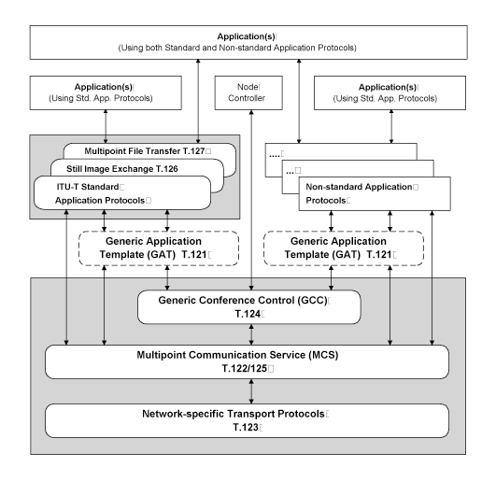
The lower level layers (T.122, T.123, T.124, and T.125) specify an application-independent mechanism for providing multipoint data communication services to any application that can use these facilities. The upper level layers (T.126 and T.127) define protocols for specific conferencing applications, such as shared whiteboarding and multipoint file transfer.

Transport Stacks T.123: T.120 requires a reliable data delivery. T.123 specifies transport profiles for different networks such as PSTN, TCP/IP, ISDN.

Multipoint Communication Service (MCS) - T.122, T.125: T.122 defines the multipoint services available to the developer, while T.125 specifies the data transmission protocol. Together they form MCS, the multipoint "engine" of the T.120 conference. In a conference, all MCS’s forms a domain while logically connecting together. If the star topology is implemented, all MCS’s connect to one MCU.
A critical feature of MCS is its being able to have multiple data channels. This is useful when an application wants to use multiple channels for different tasks, for example, one channel can be used for annotations and the other can be used for file transfer. In addition, data can be sent with different priorities, for example, while annotations are sent with a high priority, a file transfer can be done with a low priority. Moreover, MCS provides tokens which can be used for control purposes. For example, when sharing the control of an application, whoever has the token can control the application.

Generic Conference Control (GCC) - T.124: Generic Conference Control provides a comprehensive set of facilities for establishing and managing the multipoint conference. Using mechanisms in GCC, applications create conferences, join conferences, and invite others to conferences. As endpoints join and leave conferences, the information base in GCC is updated and can be used to automatically notify all endpoints when these actions occur. GCC also provides conference security. This allows applications to incorporate password protection or "lock" facilities to prevent uninvited users from joining a conference.

Generic Application Template (GAT) - T.121: T.121 provides a template for T.120 resource management that developers should use as a guide for building application protocols. GAT's functionality is considered to be generic and common to all application protocols. GAT's services include enrolling the application in GCC and attaching to MCS domains. GAT also manages channels, tokens, and capabilities on behalf of the application.

Still Image Exchange and Annotation (SI) - T.126: T.126 defines a protocol for viewing and annotating still images transmitted between two or more applications. This capability is often referred to as document conferencing or shared whiteboarding.

Multipoint Binary File Transfer - T.127: T.127 specifies a means for applications to transmit files between multiple endpoints in a conference. Files can be transferred to all participants in the conference or to a specified subset of the conference

Node Controller: The Node Controller manages defined GCC Service Access Points (SAPs). This provides the node flexibility in responding to GCC events. Most of these GCC events relate to establishing conferences, adding or removing nodes from a conference, and breaking down and distributing information. The Node Controller's primary responsibility is to translate these events and respond appropriately.

Current implementations
WebEx, Microsoft NetMeeting, SGI SGIMeeting, VCON MeetingPoint, Lotus SameTime, Sun SunForum, HP Visual Conference, PictureTel LiveShare Plus, CuseeMe.

Conclusion:
As far as I see, T.120 is well designed for data conferencing. It is mature and has a clean multi-layer architecture. In addition, a lot of conferencing products on the market today support it. Moreover, I do not know any other competitive standard for data conferencing. In my opinion, when developing web conferencing products, T.120 should be considered seriously. One solution can be to support both SIP and T.120.

References:
1. A Premier on T.120 Series Standards from DataBeam http://www.lotus.com/products/sametime.nsf/standards/8DDB25B6C08E70E5852566640072FCD2
2. Microsoft NetMeeting web page. http://www.microsoft.com/windows/NetMeeting/Corp/reskit/Chapter10/default.asp
3. 3Com standards web page: http://www.3com.com/solutions/convergence/defined/conv_standards_dc.html

