Cover Letter

Cover Page

INTELLIGENT SYSTEMS: NRA2-37143

Title: Distributed Intelligent Data Understanding

Principal Investigator Name: Dr. Andrea Donnellan

Department: Data Understanding Systems Group

Institution: Jet Propulsion Laboratory

Address: Mail Stop 126-347, 4800 Oak Grove Drive

City: Pasadena State: CA Zip: 91109-8099

Country: USA E-mail: andrea.donnellan@jpl.nasa.gov

Telephone: 818-354-4737 Fax: 818-393-5244

Co-Investigators:
Name Institution Telephone Electronic Mail
Geoffrey Fox Florida State University 315-443-2163 fox@csit.fsu.edu
John Rundle Univ. Colorado, Boulder 303-492-564 rundle@hopfield.colorado.edu
Robert Granat Jet Propulsion Laboratory 818-393-5353 granat@aig.jpl.nasa.gov
Michael Turmon Jet Propulsion Laboratory 818-393-5370 turmon@aig.jpl.nasa.gov
Michail Zak Jet Propulsion Laboratory 818-393-5351 michail.zak@jpl.nasa.gov

Budget (in $K):

1st Yr.: $579.3K 2nd Yr.: $587.1K 3rd Yr.: $597.7K
Total: $1,764.1K

Requested Start Date: January 1, 2001 Requested Duration: 3 years

Technical Area Proposing Under: TA-2 Intel. Data Understanding, TA-3 Human-Cent. Comp.
(TA choices: 1) TA-1 Automated Reasoning, 2) TA-2 Intelligent Data Understanding, 3) TA-3 Human-Centered Computing, or 4) TA-4 Revolutionary Computing.

Authorizing Official: __________________________ Jet Propulsion Laboratory__
Michael J. Sander Institution
Director, Technology &
Applications Programs

Table of Contents
Cover Letter 1
Cover Page 2
Table of Contents 3
Abstract and Technical Plan 4
Abstract 4
Introduction 5
Research Objectives 5
Scientific Relevance 6
Technical Approach 6
Simulations 6
Hidden Markov Modeling 8
Motion Pattern Analysis 11
Quantum State Behavior 13
Software Infrastructure for Data Understanding 13
Expected Significance 16
Anticipated Results 17
References 17
Management Plan 19
Cost Plan 20
Budget Summary 23
Budget Explanation 24
Curent and Pending Support 25
Personnel 32

Abstract and Technical Plan

Abstract
We will develop a computational framework for carrying out automated distributed analysis of large complex datasets. This work will have immediate science benefits as well as enable NASA to prepare for and reap scientific understanding from future high data volume missions. Through this proposal we specifically address both the intelligent data understanding and human-centered computing sub-elements of this NRA. We have assembled a world-class team to carry out this work, which will be approached from two fronts. We will focus on fundamental mathematical and computational techniques to detect interesting correlations and patterns in data, and will also develop a software infrastructure built around the concept of a collaborative portal to allow rapid and effortless sharing of information, retrieval of data, model development and validation. This work will automate science understanding of large complex datasets. Without automated intelligent data analysis it will be impossible to gain scientific insight from the large volumes of data being collected now and in the future. Through this work we will advance three algorithms for complex interacting time dependent systems, with an initial focus on earthquakes. In using earthquake systems and related data as a testbed we will address one of NASA’s six strategic questions, which asks how we can develop predictive capabilities for natural disasters.

Introduction
We will develop a computational framework for carrying out automated distributed analysis of large complex datasets. The focus of this study will be on earthquake systems and data, however, tools developed under this proposal will be broadly applicable to data collected for other complex time dependent systems. Examples include, but are not limited to solar activity, cyclones, and astrophysics. In using earthquake systems and related data as a testbed we will address one of NASA’s six strategic questions, which asks how we can develop predictive capabilities for natural disasters. It will also enable NASA to prepare for and reap scientific understanding from future high data volume missions. We specifically address the intelligent data understanding and human-centered computing sub-elements of this NRA.
We will approach this work from two fronts. We will focus on fundamental mathematical and computational techniques to detect interesting correlations and patterns in the data. We will also develop a software infrastructure built around the concept of a collaborative portal to allow rapid and effortless sharing of information, retrieval of data, model development, and validation. The models can then be used to develop an analytical and predictive understanding of natural disasters or other natural phenomena, thus moving beyond the current, more descriptive approaches now routinely employed. Without such tools it will be impossible to construct the more complex models and simulations necessary to reduce future losses from major natural disasters. Without automated intelligent data analysis it will be impossible to gain scientific insight from the large volumes of data being collected now and in the future.
This work will automate science understanding of large complex data sets. It will streamline investigations and will allow for understanding of complex systems, whose interactions are too subtle to be understood by direct observation of the data. Development of these techniques will free scientists to focus on hypothesis generation allowing for significant advances in our understanding of complex systems such as earthquakes. The tools developed here may also be used for real-time decision making in crisis mode (e.g. earthquakes, volcanoes, planetary encounter) and will aid in adaptive experiment deployment.

Research Objectives
Specifically in this work we will advance three algorithms for complex interacting time dependent systems, with an initial focus on earthquakes. In addition we will develop the computational infrastructure required to support use of these techniques. Earthquake related data can be found in the form of position time series acquired from geodetic data such as Interferometric Synthetic Aperture Radar (InSAR) or Global Positioning System (GPS) data. Using these techniques it is possible to observe the motion of a point located on the earth. Points everywhere on the earth are constantly moving as a result of tectonic plate motion and earthquakes that perturb the state of stress in the crust, which responds according to elastic, frictional, and viscous behavior. Therefore, position time series can be treated at trajectories describing how the crust deforms, while seismic data provide information about the earthquakes. Earthquakes can be divided into classes of events and our research aims to determine what classes exist and how they interact with one another. These methods will produce a physical understanding of how earthquake fault systems interact.

Scientific Relevance
Numerous analytic approaches have been applied to the study of earthquakes. The earthquake system responds on multiple temporal and spatial scales and the full cycle may take hundreds of thousands of years to repeat making it difficult to directly study and model the system. Until about the early 1980’s observational approaches were primarily applied to the study of earthquakes. This occurred first in the collection of seismic data and later through the collection of surface crustal deformation data. The data sets were sparse, however, tectonic deformation models were developed to describe the data. During the last decade the amount of data has increased by several orders of magnitude, in large part due to the collection of space-based data such at GPS and InSAR. Future measurements will include gravity, and other geopotential data. These data are enabling the construction of physically-based, sophisticated, realistic models and simulations of the complete earthquake cycle.
Because the earthquake system is so complex with interactions occurring on multiple time and space scales a nonlinear systems approach must be applied that meshes with the more traditional numerical modeling. Developing an understanding of earthquake systems will only arise through this comprehensive systems approach to the data and modeling. By developing a physical and statistical understanding of how earthquake systems behave we will be able to greatly improve disaster forecasting as well as be better able to design future experiments.
The problems addressed for the study of earthquakes are not unlike problems encountered for solar physics, planetary science, and astrophysics. Therefore the techniques developed here will be extensible to a wide variety of problems.

Technical Approach
We will develop our machine learning techniques using both data and earthquake simulations. The complexity of earthquake systems requires the development of cutting edge stable machine learning and pattern recognition algorithms. We will test the methods using simulated and real data. Many machine learning algorithms work very well for simple cases with few possible solutions. However, for problems with many possible solutions, the results can vary dramatically depending on initial conditions. With no guarantee of optimality or reproducibility, a machine learning algorithm is of very limited use to science. We will develop innovative new and improved stable machine learning algorithms that produce quality, reproducible solutions to difficult science problems. Geophysical problems and earthquakes in particular provide a challenging target domain for these improved algorithms.

Simulations
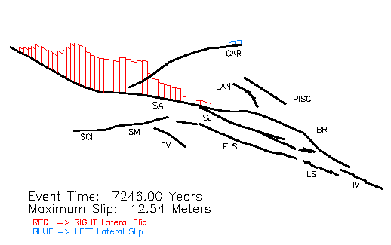
As a basis for understanding space-time patterns of earthquake dynamics through observations of surface displacement and strain, we will use an updated version of the Virtual California (VC) simulation (Rundle et al., 2000). In this simulation of a high dimensional fault system in southern California, the observed network of real faults, together with their nonlinear dynamics, is modeled as a driven system. The simulations include physical processes that are known to be important in the dynamics of the earthquake generation process, including 1) Transfer of stress from one fault to another by means of elastic, viscoelastic, and other interactions; 2) Frictional and/or other material instabilities acting on the fault surface that prevent stress from becoming larger than a spatially (and possibly temporally) varying threshold value σ^{F}(x,t), resulting in sudden, overdamped sliding to a new state of displacement; 3) Persistently increasing stress accumulation due to action of the tectonic plates driven by convection forces in the earth's mantle; 4) The detailed three-dimensional geometry of the fault surfaces themselves, leading to new dynamical modes of arising from excitation and inhibition of activity on one fault due to another; and 5) unmodeled sub-grid scale processes that must be treated as noise. The wide separation of space-time scales suggests that if our objectives are to understand the space-time correlations in simulations and real data, the neglect of elastic wave fields in the stress transfer computations will not be important. Approximate wave-field calculations by both Ward's and Rundle's groups have shown strongly supported that conclusion. To carry out these simulations, one defines a fault geometry in an elastic medium, computes the stress Greens functions Tijkl(x-x',t-t') (i.e., stress transfer coefficients), assigns frictional properties to each fault, then drives the system via the deficit in slip relative to the long term offset on the fault. It has been shown that the elastic interactions produce mean-field dynamics in the simulations. A computational limitation of these simulations arises because the stress transfer computation is of order N², and is thus very computer intensive. In future work , we would very much like to reduce this to an Order (N) or N log N problem at worst by the use of a fast multipole algorithm of the kind that has been used successfully in astrophysical N-body problems, and in computational fluid dynamics models. Figure 1
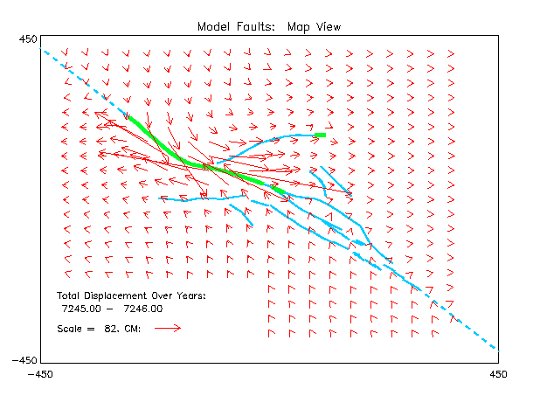
As an example of the kinds of detail that are becoming possible, we show simulations from a discrete element model having 215 segments representing the primary active faults shown in Figure 1. Using methods described in references (Rundle et al., manuscript submitted), in which frictional parameters are assigned to each fault segment, and in which the model is driven by the accumulation of plate tectonic forces, we compute synthetic earthquake histories for many thousands of model years. The spatial slip distribution among the various faults for one of these simulated great earthquakes events is shown above, where red represents right-lateral strike-slip, and blue represents left-lateral strike slip. The event is similar to the actual 1857 Fort Tejon event near Los Angeles (Figure 2, at left). Surface deformations can also be computed that strongly resemble displacements seen in the southern California region, these are shown above.
The model represents a highly complex, nonlinear system with a large number of hidden internal states. Analysis of the dynamics of the simulation is aided by application of the methods of Hidden Markov Modeling, Trajectory Analysis, and Quantum State behavior. In particular, recent work (Rundle et al., 2000) has shown that the patterns of impulsive activity (earthquakes) in strongly correlated nonlinear threshold systems can be understood by modeling the system as pure phase dynamics, which can in turn be mapped into a quantum dynamical system. It was shown in previous work (Rundle et al., 2000) that the synthetic seismicity can be forecast via construction of quantum-like pattern states (Karhunen-Loeve correlation eigenpatterns) whose norm represents a space-time probability. Similar pattern states have now been constructed for observed data in southern California using Feynman-Kac propagator methods (Tiampo et al, in press, 2000).
In very recent work using the VC simulation, we have shown that surface displacement and strain data can be used to define space-time patterns and to calculate forecast probabilities as well. Based on these recent results, it appears that a variety of space-time deformation data, such as obtained by the systems NASA/JPL has developed for deployment in southern California, may hold the key to understanding the dynamical implications of earthquake patterns and to forecasting earthquakes in active seismic regions.

Hidden Markov Modeling
Real-world processes generally produce observable outputs that can be characterized as signals. A problem of fundamental interest is characterizing such signals in terms of signal models. One such signal model which has enjoyed success in a number of domains is the hidden Markov model (HMM, Rabiner 1989). In the HMM framework, the real-world data is assumed to have been generated by an underlying stochastic process. This stochastic process can be described by a system which is at any time in one of a set of N distinct states. Each state is described by a probability distribution of its observable output, and by the probability of the system being in the same state, or in each of the other states, at the subsequent point in time.
What makes the HMM framework useful for real-world applications is that fact that it is possible to:
(1) Efficiently compute the probability of the observation sequence, given the model.
(2) Choose a corresponding state sequence which best explains the observations, given the observation sequence.
(3) Adjust the model parameters so as to maximize the probability of the observation sequence, given the model.
Given the observations and a few selected model parameters, it is possible to objectively calculate a model for the system that generated the data, as well as to interpret the observed measurements in terms of that model. Furthermore, because the model includes the probability of each state transitioning to each other state at the next time step, it possesses predictive power (i.e., the state of the model at the last observed point in time is known, so the probable state and output at the next point in time is also known).
In a geophysical setting, the observation sequence would consist of measurement data (for example, seismicity measurements in some geographic area, or GPS measurements of ground displacement). The HMM could be used in a number of ways to explore the data:
(1) To find clusters of self-similar events in the data. These clusters would be composed of observations which are interpreted as being generated by the same model state. Clustering of the data is useful to objectively classify known types of geophysical events, as well as to identify previously unsuspected similarities between different events.
(2) To find time relationships between events. Since the model includes transitions between states in time, it is possible to see which types of events are likely to lead to other types of events, and equally importantly, which types of events are unlikely to lead to other types of events.
(3) To find unusual events which are not explained well be the model. These may be unusual because of measurement error, noise, or data corruption, in which case successful identification can be used for data cleaning. Alternatively, they may be previously unknown kinds of events which were overlooked amidst the volume of data.
However, using HMM-based methods to explore data generated by complex physical systems is particularly challenging, as the resulting model must be both consistent and scientifically meaningful. Standard HMM methods suffer from a local maxima problem; that is, the quality of the result can be dependent on the initial conditions. As well, when employing the standard the correct number of states to use in the model must be chosen in advance, rather than being derived automatically from the data. In addition to these algorithmic challenges, large and complex data sets can make model calculation a numerically and computationally challenging task. However recent advances, including large-scale numerical methods, simulated and deterministic annealing (Ueda and Nakano, 1998), and automated state number determination (Smyth 2000), can be applied to this problem to make HMM-based analysis a valuable tool for analysis of geophysical and other scientific data.
Preliminary work using a prototype deterministic anneal HMM method has already yielded some promising results. Application of the method to GPS ground displacement data collected in the Southern California region demonstrated that the method is able to separate the time series of data into distinct classes that correspond to known physical events. Figure 3 shows an example of this kind of analysis on GPS data collected in the city of Claremont, California. The data used in the analysis has three components: east-west displacement, north-south displacement, and vertical displacement. Using a five state model, the method is able to determine states before and after the Hector Mine earthquake of October 1999 that are clearly separated. These states are distinct in turn from a period in 1998 in which draining from a well caused displacement in the vertical direction. Sharp movements in the north-south direction were also isolated as a separate class.
Figures 4–6 show the results of the same method applied to seismicity data taken from the Southern California Earthquake Center's catalogue of seismic events, including all events between 1960 to 1999 with a magnitude greater than four. The data used in the analysis had five components: latitude, longitude, depth, magnitude, and time until the next event. Figure 4 shows a class of earthquakes which includes several major events, including the Hector Mine and Landers earthquakes. Figure 5 shows a class of earthquakes of relatively large magnitude and a long time until next event. Figure 6 shows the transition probabilities for the class portrayed in Figure 5. Note that the next event is most likely to belong to the class of large earthquakes, designated as class 16. While the relationship between these two classes has not yet been fully investigated, these examples do demonstrate the potential of this kind of analysis
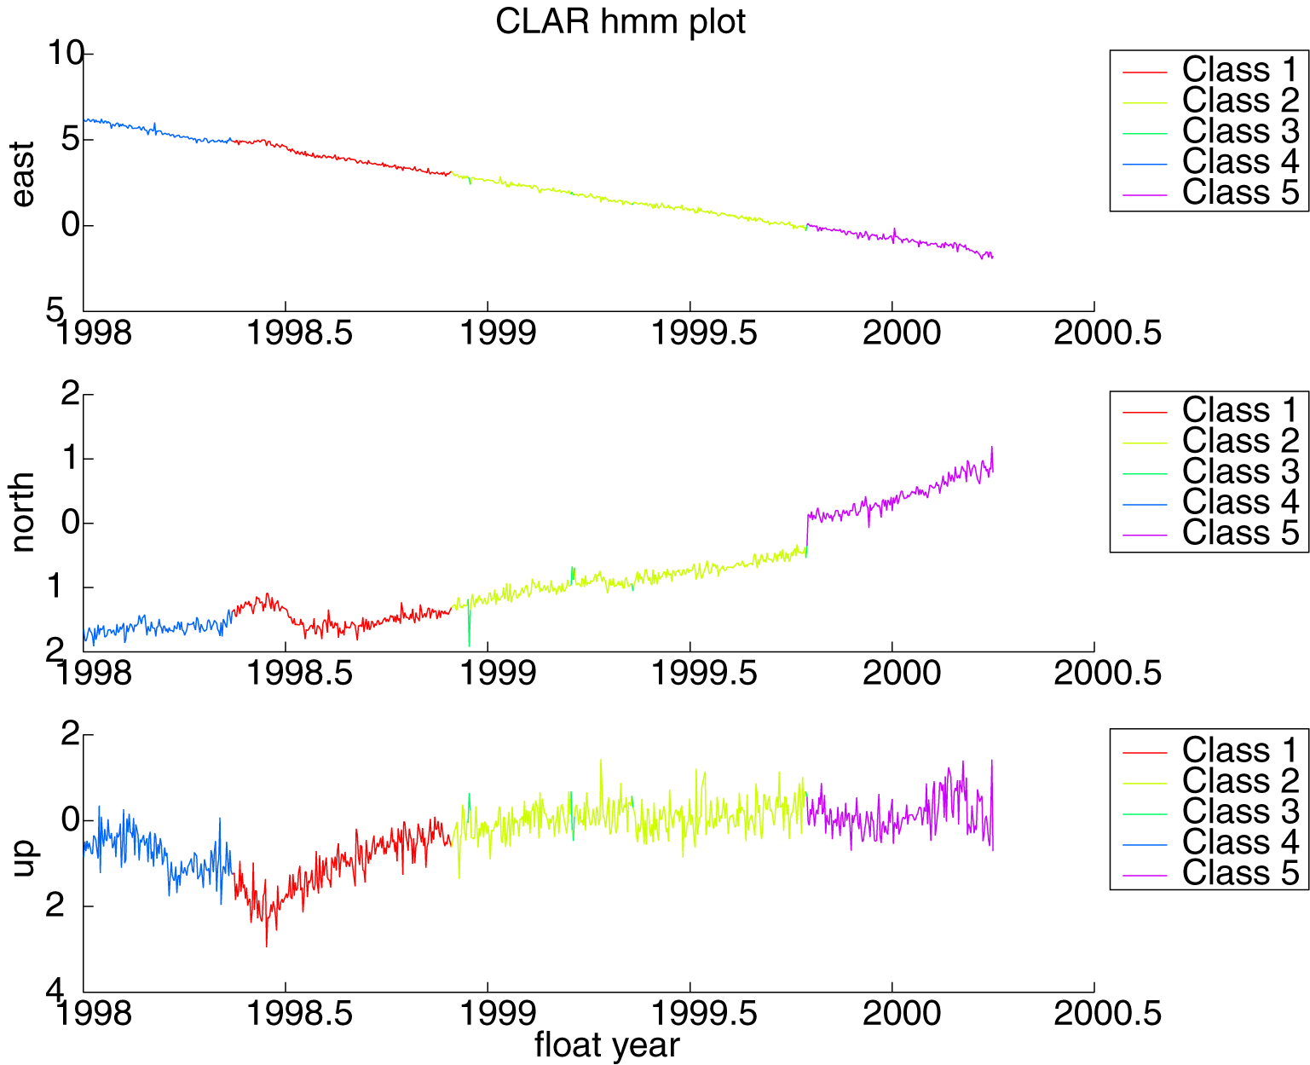
Figure 3: HMM analysis results for Claremont, California GPS receiver.

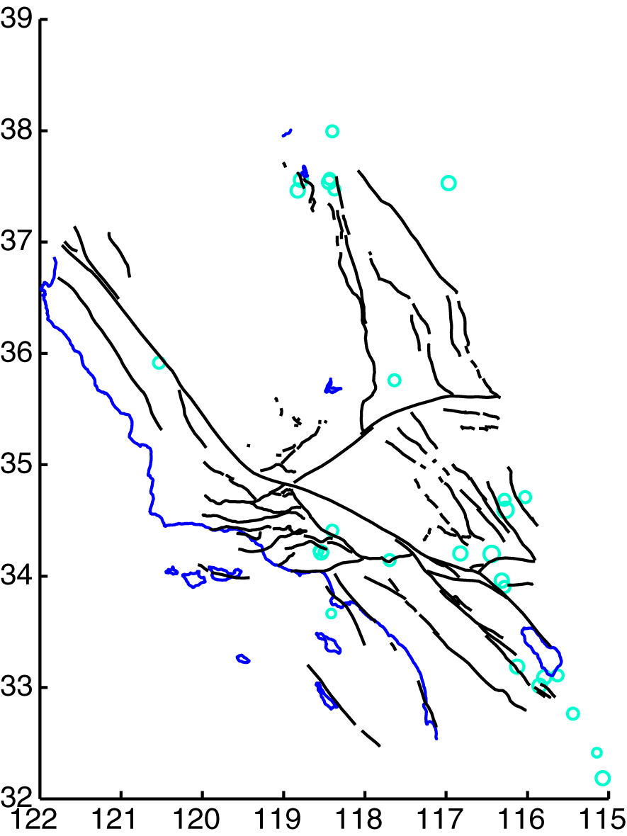
Figure 4: HMM analysis results for Southern California seismicity data for Class 16. Class 16 means: lat=35 long=117.4487 depth=7.1 mag=5.1 days to next event=0.052. Class 16 sqrt(variances): lat=1.7 long=1.4 depth=4.7 magnitude=0.86 days to next event=0.083.
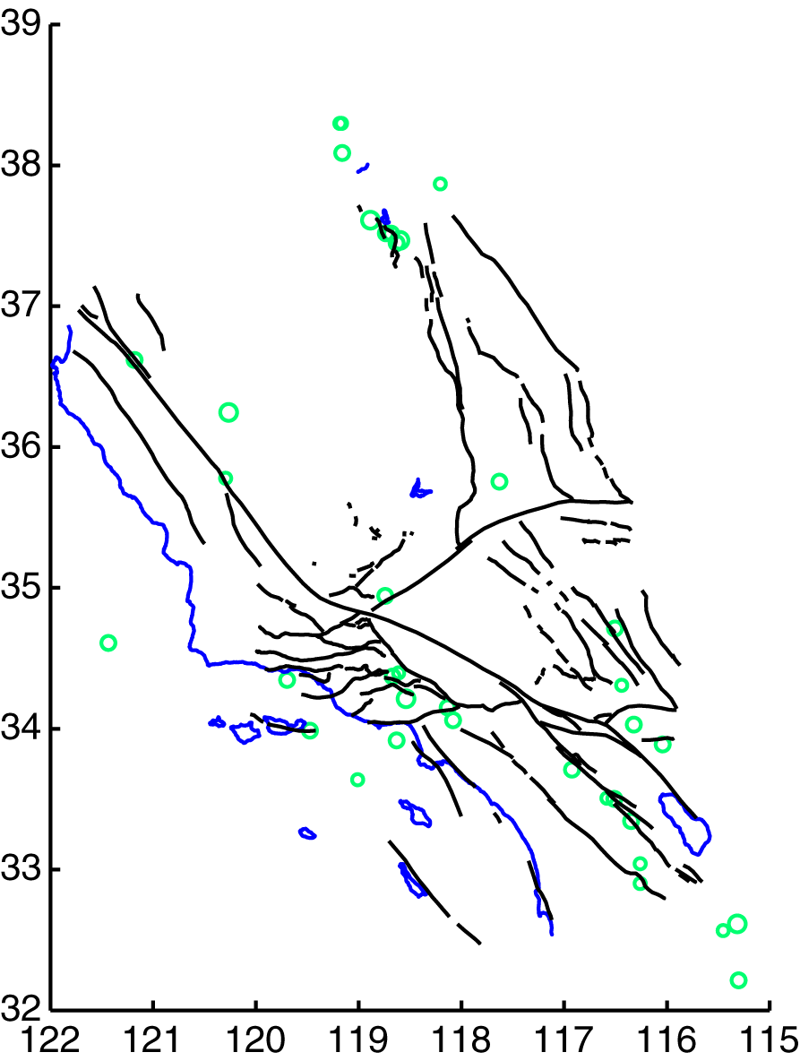
Figure 5: HMM analysis results for Southern California seismicity data for Class 14. Class 14 means: lat=36 long=118.0364 depth=7.2 mag=5 days to next event=2.2. Class 14 sqrt(variances): lat=1.8 long=1.8 depth=5.8 magnitude=0.76 days to next event=1.7.
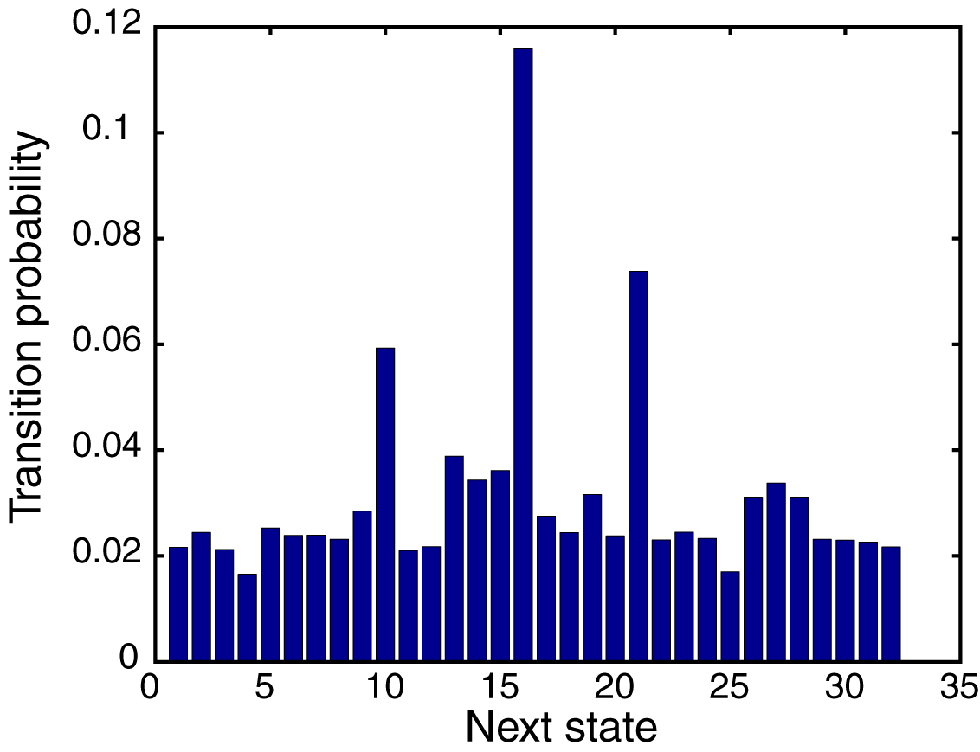
Figure 6: HMM analysis results (transition probabilities) for Southern California seismicity data for class 14.

Motion Pattern Analysis
The proposed work on trajectory analysis relies partly upon a general state-space framework for modeling, tracking, clustering, and predicting object dynamics. The fundamental advantage offered by this framework is the ability to model objects as having an internal state which changes dynamically in time according to a noisy differential equation; this provides much more modeling realism than a traditional feature-vector approach. The introduction of this internal state, furthermore, allows efficient computations because variable dependencies are localized in time.
State-space models like Kalman filters (e.g., Van Trees 1968) have long been used to model temporal dynamics. For example, in panel (a) of the Figure 7, below, the true object state (e.g., position and velocity) propagates through time as a vector $u_{t}$; the observer sees only a noisy version of this, $z_{t}$. When the hidden variables are discrete, one recovers the HMMs of the previous section. If the state is position and velocity, it is natural to assume that $u_{t}$ is governed by the usual Newtonian differential equation, which allows a model structure to be assumed. Classical methods offer efficient means of estimating $\left\{u_{t},t=1\text{.}\text{.}\text{.}T\right\}$ given $\left\{z_{t},t=1\text{.}\text{.}\text{.}T\right\}$: inferring the true position and velocity from noisy measurements. This is done in a statistical framework by maximizing the posterior probability
$P(u_{t},t=1\text{.}\text{.}\text{.}T|z_{t},t=1\text{.}\text{.}\text{.}T)$ [*]
which is determined by various assumed model parameters.

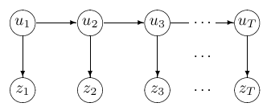 | 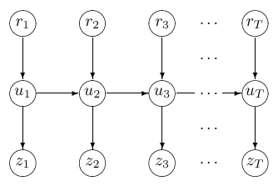
(a) Hidden variable motion model | (b) Motion model with forcing term
Figure 7: Two motion models
Very recently with the advent of Bayesian probabilistic networks it has become clear how to learn structure and parameters of the differential equations governing a specific process (Gharamani and Roweis 1999, Blake and Isard 1998), or to learn model complexity such as state-space dimension (Smyth 2000). For example, the distribution $P(u_{t}|u_{t−1})$ telling how the hidden state evolves may itself be learned from data. This is done in the same maximum a posteriori (MAP) framework used to learn just the position $\left\{u_{t},t=1\text{.}\text{.}\text{.}T\right\}$ in [*]. It then becomes possible to fit an entire state-space model to the sequence of position sequences given by a GPS sensor, for example. The goodness-of-fit of the model is given by the posterior probability, and this provides the beginnings of an objective mechanism for determining if motion patterns from two sensors are indeed the same. Similarly, the posterior probability [*] also provides an objective means of determining the model complexity: stop adding model parameters when the posterior probability, or quality of fit, begins to decline.
Automatic model selection mechanisms may be used to objectively choose among various models. This machinery allows objective and principled choice of a best-fit model given the data available; fitted mathematical models can then confirm or undermine a scientific hypothesis. Models may be exchanged among investigators and refined over time, allowing for development of widely-accepted models for various object classes (Turmon et al., 1999).
The state-space formulation allows the modeler to consistently extend the models to incorporate more complex data-gathering scenarios (Gharamani and Hinton 1998) as well. For example, in panel (b) of Figure 7, exogenous inputs $r_{t}$ are inserted into the state-space model as variables known to have an influence on the evolving state. Such flexibility provides more opportunities to link the models to physical theory. This feature, unobtainable in the feature-vector approach, falls out as a natural consequence of the state-space/Bayes-net scheme.
These recent theoretical advances in data modeling and inference can be brought to bear fruitfully on the geophysical data described here. Time series representing sensor trajectories form the base objects for model training. These time series may, as described above, be broken into clusters exhibiting similar motion patterns, i.e., differential equations with similar parameters or initial conditions, which would correspond to different physical structures. Existing clustering techniques, on the other hand, have been based on the so-called feature-vector representation of an object. In the trajectories setting, this would be obtained by concatenating all temporal observations into one vector. However, the vector representation loses information about locality in time, e.g., smoothness of trajectories. This locality is essential in dealing with the “curse of dimensionality” inherent in a naive application of the feature-vector approach to clustering in the motion analysis problem. Locality allows design of efficient analysis algorithms via local updating of arbitrary state-space model variables: this is the generalization of classical Kalman filtering algorithms. The state-space modeling approach allows a more physically meaningful clustering, as well as a computationally tractable one.

Quantum State Behavior
The issues of context pose intractable computational difficulties for classical algorithms. To attack this problem a special class of quantum recurrent nets simulating Markov chains with absorbing states is introduced (Zak, in press). The absorbing states are exploited for pattern recognition. Each class of patterns is attracted to a unique absorbing state. Due to quantum interference patterns, each combination of patterns acquires its own meaning. It is attracted to a certain combination of absorbing states which is different from those individual attractions. This fundamentally new effect can be interpreted as formation of a grammar, i.e., a set of rules assigning certain meaning to different combinations of patterns. It appears that there exists a class of unitary operators in which each member gives rise to a different artificial language with associated grammar. The challenge of the work is to find such quantum grammar that would fit the synergetics of earthquakes.

Software Infrastructure for Data Understanding
We will develop a web-based Problem Solving Environment to support the mix of detailed simulations, data analysis and machine learning used in our proposed approach to Intelligent Systems. This work will be build on an existing effort (the “Garnet Portal”) being developed by co-PI Fox for several related activities. A portal for our purposes is just a Web interface to any application – the term comes from commercial activities where community portals like Yahoo and Enterprise Information portals (like Lotus Notes) are very well known. The terms “portal”, “Grid Computing Environment” or “Problem Solving Environment” reference the same concept focusing on different issues – the technology, the support of distributed resources and the application emphasis respectively. As shown in Figure 8, below, Garnet is built around a rather standard multi-tier architecture with back-end objects supported by middle tier brokers, which are accessed by clients that can vary from web clients to personal digital assistants
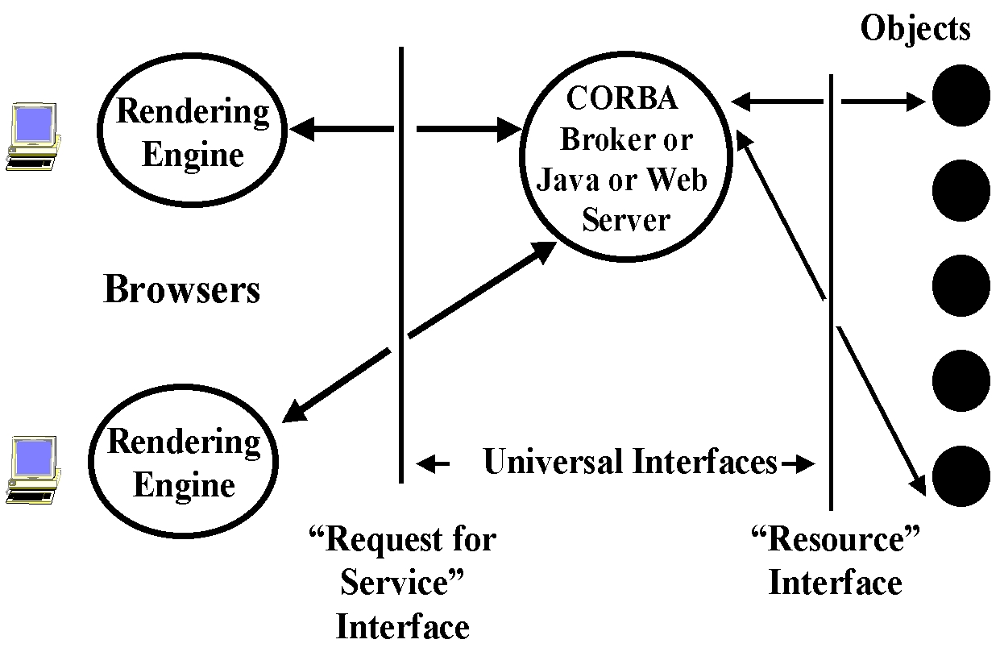
Figure 8: Basic 3 Tier Architecture showing two XML interfaces and rendering engine which can vary from a wall to wall display to a WAP (wireless application protocol) browser in a cell phone.
The Garnet system has several important architectural features
- Systematic use of distributed object technology with all object properties defined in XML even though we support all major object models; Java, CORBA, COM and SOAP (pure Web XML). The objects in our case are the computers, networks, data sources and software components. This “resource interface” defined above is termed resourceML.
- Identification of key services including object persistence, look-up and access, security and collaboration, which are important in many portals and provided as general capabilities.
- Integration of multiple services from different sources by the use of an integrated event bus with adapters. Events (time stamped messages) record all object state changes (including their invocation and property values) and hence dynamically link the components of a portal and statically record any session for later play back. All events are defined in XML and stored persistently in back-end databases. The event system federates several typically different sources: user-interface mouse and keyboard client events, coordination events in the middle tier and UNIX interrupts or job status messages from back-end.
- Support of user customization through a “user-specific server” shown in Figure 9, below. This supports local code, which is kept out of the browser so that one can drive a variety of display devices. This is supported by a second XML interface portalML (or the request for service interface) and is shown in Figure 9 illustrating a collaborative session
- The collaborative capability includes both real-time synchronous and asynchronous modes.
- The security service was designed to support the DoD High Performance Computing program and is built around Kerberos. However other security models can be supported and for instance public key based systems are rather easier to implement.
- The current Garnet infrastructure allows the automatic wrapping of simple programs allowing convenient parameter specification and submittal to multiple machines. It has also supported larger problem solving environment integrating multiple applications.
- Currently the infrastructure is being upgraded to support both education and computing portals with integration of the collaborative capability originally developed for distance education.

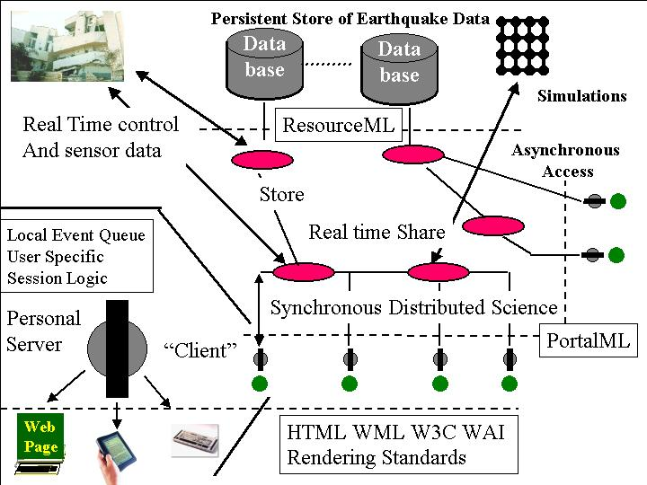
Figure 9: A Synchronous analysis of an Earthquake Event
For this proposal, we will use the base infrastructure (which mixes commercial event service and audio video modules with other services built at FSU) and extend it to support the special needs of distributed analysis of large datasets. These needs fall into four major research areas.
- Definition of the object structure in XML for data, simulations and analysis components.
- Support of data streams from either real-time sensors or large data banks. Garnet avoids well-known performance difficulties with Java, CORBA and SOAP by manipulating “proxies” in the middle tier. Thereby one has the full power of object technology for control messages, which can be implemented with proxies while one uses native mechanisms where high performance large volume data transfer is needed. However this strategy is not trivial to design and implement but will be necessary to analyze large datasets.
- Support of special data-mining and simulation objects needed for this type of problem. Here we can use existing approaches for the “large back-end simulations” such as Virtual California. These will be wrapped and provided web-based interfaces for specifying parameters. Data streams will be changed to an XML syntax (extending the ideas of Caltech’s XSIL system) to enable interoperability.
- The data-mining will need interactive support for which Java (or C++) applications supported by the personal server seem most attractive. These will be accessed by queries defined in portalML and interact with the backend using resourceML. Note we build software in Java but data streams in XML unless they are in a pure Java environment where we would use RMI. Distributed object access typically requires that one leave the Java world and so XML will be used as the interface between different models.
The research issues will not only involve the four specific modules above but the implications of these new capabilities on the existing architecture and services. For instance, the support of interactive data analysis will require extension of the event service to allow integration of front and backend data-mining components and to enable collaborative research. Note the base Garnet system is not complete yet but we expect it to be functional by May 2001 using existing DoD and NSF funding. Thus in this proposal, we just address the needed enhancements for Intelligent System data anaysis.

Expected Significance
Earthquakes in urban centers are capable of causing enormous damage. The Federal Emergency Management Agency (FEMA) issued a national earthquake risk report on September 17, 2000 estimating an annualized earthquake loss to the nation’s building stock of $4.4 billion per year. The recent January 16, 1995 Kobe, Japan earthquake was only a magnitude 6.9 event and yet produced an estimated $200 billion loss. Despite an active earthquake prediction program in Japan, this event was a complete surprise. The 1989 Loma Prieta and 1994 Northridge earthquakes were also unexpected and caused billions of dollars of damage as well as loss of lives. Future similar scenarios are possible in Los Angeles, San Francisco, Seattle, and other urban centers around the Pacific plate boundary.
NASA has recently committed a great deal of effort and funding to develop the means to observe and characterize the movements of the earth's crust that arise from plate tectonics leading to catastrophic earthquakes and more missions are expected in the future. Recent research indicates that the phenomena associated with earthquakes occur over many scales of space and time. Understanding the dynamic processes responsible for these events will require not only a national commitment to develop the necessary observational datasets, but also the technology required to use these data in the development of sophisticated, state-of-the-art numerical simulations and models. The models can then be used to develop an analytical and predictive understanding of these large and damaging events, thus moving beyond the current, more descriptive approaches now routinely employed. Approaches emphasizing the development of predictive models and simulations for earthquakes will be similar to methods now used to understand global climate change, the onset of the El Niño-Southern Oscillation events, and the evolution of the polar ozone depletion zones.
One of the six major questions in the NASA Administrator's strategic outlook asks how we can develop predictive natural disaster models. These events (e.g. volcanic eruptions) are potentially catastrophic if not flagged quickly and reliably. The simulation, datamining, and pattern recognition software to be developed in this program will be directly applicable to early warning systems. Our approach is based on the development of simulations, data assimilation, general pattern recognition, and datamining. By integrating these concepts within an object-oriented framework based on open standards, we can provide a blueprint for the design of fully autonomous continuously monitoring systems of heterogeneous assets that will underpin much of NASA’s solid earth science needs in the future.

Anticipated Results
Our work will provide methods and tools for reaping scientific understanding of large and complex datasets, with an immediate specific application to earthquake systems. Machine learning techniques will be advanced such that highly complex and dimensional systems can be automatically analyzed. Development of these tools are necessary to handle the large volumes of data presently online and increasing in the future. A direct benefit of this work will be an improved understanding of earthquakes and other natural systems. Earthquakes in urban centers are capable of causing enormous damage.
NASA has recently committed a great deal of effort and funding to develop GPS and InSAR methods to observe and characterize the movements of the earth's crust arising from plate tectonics leading to catastrophic earthquakes. Understanding the dynamic processes responsible for these events will require not only a national commitment to develop the necessary observational datasets, but also the technology required to use these data in the development of sophisticated, state-of-the-art numerical simulations and models. The scientific benefits reaped from future InSAR missions and GPS networks will be greatly increased by development of the methods and framework proposed here.

References
Blake, A. and Isard, M. Active Contours: Visual Tracking of Shapes in Motion. Wiley, 1998.
Fox, G.C. "Portals and Frameworks for Web Based Education and Computational Science", Proceedings of the Second International Conference on the Practical Application of Java, Editor Omer Rana, Manchester England April 12-14 2000.
Fox, G.C., Akarsu E., Furmanski W., Haupt T., "WebFlow -- High-level Programming environment and Visual Authoring Toolkit for High Performance Distributed Computing" in Proceedings of SC98, Orlando, November 1998.
Fox, G.C., Ken Hurst, Andrea Donnellan, and Jay Parker, "Introducing a New Paradigm for Computational Earth Science - A web-object-based approach to Earthquake Simulations", a chapter in AGU monograph on Physics of Earthquakes, edited by John Rundle and published by AGU in 2000.
Gharamani, Z. and Hinton, G. (1998). “Variational learning for switching state-space models.” Technical report submitted to Neural Computation.
Gharamani, Z., Roweis, S. T. (1999). “Learning nonlinear dynamical systems using an EM algorithm.” Adv. Neur. Inform. Proc. Systems, vol. 11, MIT Press.
Pallickara S. “Garnet Event Service” http://aspen.csit.fsu.edu/users/shrideep/mspaces/ .
Rabiner, L. R. (1989). "A tutorial on hidden markov models and selected applications in speech recognition." P. IEEE, vol. 77, no. 2, 257-286.
Rundle, J.B., W. Klein, K. Tiampo, and S. Gross, Linear pattern dynamics in nonlinear threshold systems, Phys. Rev. E., 61, 2418-2431, 2000.
Rundle, J.B., W. Klein, K.F. Tiampo, and S.J. Gross, Dynamics of seismicity patterns in systems of earthquake faults, pp. 127-146, AGU Geophysical Monograph #120 "Geocomplexity and the Physics of Earthquakes", ed. J.B. Rundle, DL Turcotte, W. Klein, AGU, Washington, DC, 2000.
Rundle, P.B., J.B. Rundle, K.F. Tiampo, J.S. Martins, S. McGinnis and W. Klein, Nonlinear network dynamics on earthquake fault systems, submitted to Physical Review Letters, 2000.
Smyth, P. (2000). “Model selection for probabilistic clustering using cross-validated likelihood.” Statistics and Computing, in press.
Tiampo, K.F., J.B. Rundle, S. McGinnis, S. Gross and W. Klein, Observation of systematic variations in non-local seismicity patterns from southern California, pp. 211-218, AGU Geophysical Monograph #120 "Geocomplexity and the Physics of Earthquakes", ed. J.B. Rundle, D.L. Turcotte, W. Klein, AGU, Washington, DC, 2000.
Tiampo, K.F., J.B. Rundle, S. McGinnis, W. Klein and S.J. Gross, Analysis of space-time seismicity patterns in southern California with implications for earthquake forecasting, submitted to Nature, 2000.
Turmon, M., Mjolsness, E., Gluzman, V. and Ramsey, L. (1999). “A language for probabilistic modeling of scientific data.” In Proc. Second Conf. Highly Structured Stochastic Systems.
Ueda, N. and Nakano, R.,"Deterministic annealing em algorithm." Neural Networks, vol. 11, no. 2, 271-282, 1998.
Van Trees, H.L., Detection, Estimation, and Modulation Theory, part I. Wiley, 1968.
Williams R.D., XML based scientific metadata system XSIL, Caltech http://www.cacr.caltech.edu/SDA/xsil/index.html.
Zak, M., Quantum Model of Emerging Grammars, Int. J. Chaos, Solitons, and Fractals, July 2000.

Management Plan
Andrea Donnellan is the PI of this proposal and will oversee all aspects of the work being carried out. She has a good track record working with all of the investigators. Each task is well defined. The external collaborators, Geoffrey Fox, and John Rundle are both distinguished visiting scientists in the Data Understanding Systems Group that Donnellan supervises and both make frequent visits to JPL. Rundle will carry out the simulations along with Donnellan and will support one month of his time a postdoc, and a graduate student. Geoffrey Fox will develop the computational infrastructure and will devote one month of his time to the proposal. A postdoc, graduate student, and undergraduate student will also work on developing the computational infrastructure. Robert Granat will devotone-half of his time to the project developing the Hidden Markov Modeling methods. This work will develop into part of his Ph.D. thesis. Michael Turmon and Michail Zak will each devote 25% of their time to the project working on the trajectory analysis and quantum state behavior respectively. Kenneth Hurst will incorporate the geodetic time series and seismicity into the above models and will devote 15% of his time to the project. Should the investigators prove successful on other proposals as well there are several additional members of the Data Understanding Systems group who are very capable of working on this project to complete the work.

Cost Plan

Budget Summary

Budget Explanation
We are requesting a total of $1,764,100 for this work. Most of the costs will be devoted to salaries as outlined in the management plan and in the budget breakdowns. We also request funds for travel for Rundle and Fox to visit JPL and for trips to two meetings per year. We expect to publish our work and therefore request a nominal journal page charge.
This project dovetails nicely with other ongoing projects. Some of the computer codes (e.g. the finite element code) are being developed under separate projects, but will be incorporated into the infrastructure developed here. We have science funding and products developed here will have immediate applications as a result. In addition, the funded science projects will in effect drive and focus the development effort outlined in this proposal. The software systems developed here are quite flexible and will be easily extensible to a range of science problems.

Curent and Pending Support
Investigator: Andrea Donnellan
Support: Current
Project/Proposal Title: Presidential Early Career Award
Source of Support: NASA – Solid Earth and Natural Hazards
Total Award Amount: $500,000
Location of Project: Jet Propulsion Laboratory
Period covered: 10/96 – 9/01
Work Years Committed to the Project: 0.1
Support: Current
Project/Proposal Title: Automated Data Analysis for Geodetic Sensor Networks
Source of Support: NASA – Cross Enterprise Technology Development
Total Award Amount: $305,000.
Period Covered: 11/99 – 9/01
Location of Project: Jet Propulsion Laboratory
Work Years Committed to the Project: 0.25
Support: Current
Project/Proposal Title: Development of Fully 3-D Finite Element Model for Crustal Deformation
Source of Support: NASA – Solid Earth and Natural Hazards
Total Award Amount: $570,000
Period Covered: 12/99 – 9/02
Location of Project: Jet Propulsion Laboratory
Work Years Committed to the Project: 0.25
Support: Current
Project/Proposal Title: Response of the Ventura Basin to the Northridge Earthquake
Source of Support: Southern California Earthquake Center
Total Award Amount: $20,000
Period Covered: 1/00 – 12/00
Location of Project: Jet Propulsion Laboratory
Work Years Committed to the Project: 0.01
Support: Current
Project/Proposal Title: Autonomous Systems in Extreme Environments Workshop
Source of Support: NASA – Solid Earth and Natural Hazards
Total Award Amount: $15,000
Period Covered: 4/00 – 4/01
Location of Project: Jet Propulsion Laboratory
Work Years Committed to the Project: 0.04
Support: Current
Project/Proposal Title: Autonomous Systems in Extreme Environments Workshop
Source of Support: National Science Foundation
Total Award Amount: $14,367
Period Covered: 9/00 – 8/01
Location of Project: Jet Propulsion Laboratory
Work Years Committed to the Project: 0.04
Support: Pending
Project/Proposal Title: Distributed Intelligent Data Understanding (this proposal)
Source of Support: NASA – Intelligent Systems Program
Total Award Amount: $1,764,100
Period Covered: 1/01 – 9/03
Location of Project: Jet Propulsion Laboratory
Work Years Committed to the Project: 0.15

Investigator: Andrea Donnellan (Continued)
Support: Pending
Project/Proposal Title: Untethered Collaboration for Remote Science Missions
Source of Support: NASA (Ross-2000 NRA)
Total Award Amount: $450,000.
Period Covered: 01/01/01 through 12/31/03
Location of Project: Florida State University
Work Years Committed to the Project: 0.05

Investigator: Geoffrey C. Fox
Support: Current
Project/Proposal Title: Data Parallel SPMD Programming Models from Fortran to Java
Source of Support: National Science Foundation
Total Award Amount: $116,109.
Location of Project: Florida State University
Period covered: 12/01/99 through 11/30/01
Work Years Committed to the Project: 0.02
Support: Current
Project/Proposal Title: ERDC PET Support
Source of Support: Nichols Research Corporation
Total Award Amount: $340,289.
Period Covered: 03/27/00 through 03/26/01
Location of Project: Florida State University
Work Years Committed to the Project: 0.02
Support: Current
Project/Proposal Title: ASC CY5 IC (on-campus)
Source of Support: Nichols Research Corporation
Total Award Amount: $184,496.
Period Covered: 05/13/00 through 05/12/01
Location of Project: Florida State University (on campus)
Work Years Committed to the Project: 0.02
Support: Current
Project/Proposal Title: ASC CY5 IC (off-campus)
Source of Support: Nichols Research Corporation
Total Award Amount: $175,503.
Period Covered: 05/13/00 through 05/12/01
Location of Project: Florida State University (off-campus)
Work Years Committed to the Project: 0.02
Support: Current
Project/Proposal Title: PET Activities Subcontract for the Army Research Lab MSRC
Source of Support: Raytheon Company
Total Award Amount: $92,014.
Period Covered: 08/10/00 through 08/09/01
Location of Project: Syracuse University
Work Years Committed to the Project: 0.02

Investigator: Geoffrey Fox (Continued)
Support: Current
Project/Proposal Title: Development of Collaboration Technology for Educ. (ETC/NCSA)
Source of Support: University of Illinois
Total Award Amount: $139,000.
Period Covered: 10/01/99 through
Location of Project: Florida State University
Work Years Committed to the Project: 0.02
Support: Current
Project/Proposal Title: Education Outreach & Training Team-Graduate Student Educ. (EOT)
Source of Support: University of Illinois
Total Award Amount: $64,393.
Period Covered: 10/01/99 through
Location of Project: Florida State University
Work Years Committed to the Project: .02
Support: Pending
Project/Proposal Title: Untethered Collaboration for Remote Science Missions
Source of Support: NASA (Ross-2000 NRA)
Total Award Amount: $450,000.
Period Covered: 01/01/01 through 12/31/03
Location of Project: Florida State University
Work Years Committed to the Project: 0.02
Support: Pending
Project/Proposal Title: Distributed Intelligent Data Understanding (this proposal)
Source of Support: NASA – Intelligent Systems Program
Total Award Amount: $1,764,100
Period Covered: 1/01 – 9/03
Location of Project: Jet Propulsion Laboratory
Work Years Committed to the Project: 0.05

Investigator: John Rundle
Support: Current
Project/Proposal Title: Analysis of time Dependent Fault Interactions and Stress Transfer in Southern California Using Viscoelastic Coulomb Failure Functions
Source of Support: NASA – Solid Earth and Natural Hazards
Total Award Amount: $236,453
Location of Project: University of Colorado
Period covered: 7/97 – 7/01
Work Years Committed to the Project: 0.12
Support: Current
Project/Proposal Title: Interpretation of Geodetic Crustal Strains Using Massive Parallel Supercomputer Simulations of Nonlinear Dynamic Models
Source of Support: Department of Energy
Total Award Amount: $613,118
Location of Project: University of Colorado
Period covered: 11/97 – 11/00
Work Years Committed to the Project: 0.15

Investigator: John Rundle (Continued)
Support: Current
Project/Proposal Title: KLE Analysis of SCIGN GPS Data
Source of Support: NASA – Solid Earth and Natural Hazards
Total Award Amount: $170,984
Period Covered: 1/00 – 12/02
Location of Project: University of Colorado
Work Years Committed to the Project: 0.08
Support: Current
Project/Proposal Title: Automated Data Analysis for Geodetic Sensor Networks
Source of Support: NASA – Cross Enterprise Technology Development
Total Award Amount: $305,000.
Period Covered: 11/99 – 9/01
Location of Project: Jet Propulsion Laboratory
Work Years Committed to the Project: 0.05
Support: Current
Project/Proposal Title: Development of Fully 3-D Finite Element Model for Crustal Deformation
Source of Support: NASA – Solid Earth and Natural Hazards
Total Award Amount: $570,000
Period Covered: 12/99 – 9/02
Location of Project: Jet Propulsion Laboratory
Work Years Committed to the Project: 0.05
Support: Current
Project/Proposal Title: Research and Workshop Activities
Source of Support: Southern California Earthquake Center
Total Award Amount: $20,000.
Period Covered: 6/99 – 1/02
Location of Project: University of Colorado
Work Years Committed to the Project: 0.05
Support: Pending
Project/Proposal Title: Analysis and Interpretation of Multi-Scale Phenomena in Crustal Deformation Processes Using Numerical Simulations of Complex Nonlinear Earth Systems
Source of Support: Department of Energy
Total Award Amount: $382,000
Period Covered: 11/00 – 10/03
Location of Project: University of Colorado
Work Years Committed to the Project: .15
Support: Pending
Project/Proposal Title: Distributed Intelligent Data Understanding (this proposal)
Source of Support: NASA – Intelligent Systems Program
Total Award Amount: $1,764,100
Period Covered: 1/01 – 9/03
Location of Project: Jet Propulsion Laboratory
Work Years Committed to the Project: 0.08

Investigator: Robert Granat
Support: Pending
Project/Proposal Title: Real Time Earthquake Location Using Kirchoff Reconstruction and Pattern Recognition
Source of Support: JPL – Director’s Research and Discretionary Fund
Total Award Amount: $182,700
Location of Project: Jet Propulsion Laboratory
Period covered: 01/01 – 09/01
Work Years Committed to the Project: 0.5
Support: Pending
Project/Proposal Title: Distributed Intelligent Data Understanding (this proposal)
Source of Support: NASA – Intelligent Systems Program
Total Award Amount: $1,764,100
Period Covered: 1/01 – 9/03
Location of Project: Jet Propulsion Laboratory
Work Years Committed to the Project: 0.5
Support: Pending
Project/Proposal Title: Machine Assisted Discoveries in Massive Data Streams: IS Technology for the National Virtual Observatory
Source of Support: NASA – Intelligent Systems Program
Total Award Amount: $1,410,000
Period Covered: 1/01 – 9/03
Location of Project: California Institute of Technology
Work Years Committed to the Project: 0.15

Investigator: Michail Zak
Support: Pending
Project/Proposal Title: Quantum Recurrent Nets for Analog Computing
Source of Support: NASA – Intelligent Systems Program
Total Award Amount: $866,700
Period Covered: 1/01 – 9/03
Location of Project: Jet Propulsion Laboratory
Work Years Committed to the Project: .5
Support: Pending
Project/Proposal Title: Distributed Intelligent Data Understanding (this proposal)
Source of Support: NASA – Intelligent Systems Program
Total Award Amount: $1,764,100
Period Covered: 1/01 – 9/03
Location of Project: Jet Propulsion Laboratory
Work Years Committed to the Project: 0.25

Investigator: Kenneth Hurst
Support: Pending
Project/Proposal Title: Distributed Intelligent Data Understanding (this proposal)
Source of Support: NASA – Intelligent Systems Program
Total Award Amount: $1,764,100
Period Covered: 1/01 – 9/03
Location of Project: Jet Propulsion Laboratory
Work Years Committed to the Project: 0.15

Investigator: Michael Turmon
Support: Current
Project/Proposal Title: Reusable Pattern Recognizers for Solar Imagery
Source of Support: NASA – Office of Space Science
Total Award Amount: $620,000
Location of Project: Jet Propulsion Laboratory
Period covered: 10/99 – 9/01
Work Years Committed to the Project: 0.4
Support: Current
Project/Proposal Title: Automated Recognition of Active Regions for SoHO/MDI
Source of Support: NASA – SoHO Guest Investigator
Total Award Amount: $119,000
Period Covered: 10/99 – 9/01
Location of Project: Jet Propulsion Laboratory
Work Years Committed to the Project: 0.1
Support: Pending
Project/Proposal Title: ObjectiveFlow: Trainable Dynamic Models for Science Object Trajectories
Source of Support: NASA – Cross Enterprise Technology Development Program
Total Award Amount: $841,000
Period Covered: 12/00 – 9/03
Location of Project: Jet Propulsion Laboratory
Work Years Committed to the Project: 0.25
Support: Pending
Project/Proposal Title: Evolution of Magnetic Fields and Variations of Solar Irradiance
Source of Support: NASA – Living With a Star
Total Award Amount: $240,000
Period Covered: 12/00 – 9/02
Location of Project: UCLA
Person-Months Per Year Committed to the Project. Cal: 0.10
Support: Pending
Project/Proposal Title: Statistical Object ID, Tracking, and Analysis
Source of Support: NASA – AISRP
Total Award Amount: $399,000
Period Covered: 12/00 – 9/03
Location of Project: Jet Propulsion Laboratory
Work Years Committed to the Project: 0.15
Support: Pending
Project/Proposal Title: Distributed Intelligent Data Understanding (this proposal)
Source of Support: NASA – Intelligent Systems Program
Total Award Amount: $1,764,100
Period Covered: 1/01 – 9/03
Location of Project: Jet Propulsion Laboratory
Work Years Committed to the Project: 0.25

Investigator: Michael Turmon (continued)
Support: Pending
Project/Proposal Title: Machine Assisted Discoveries in Massive Data Streams: IS Technology for the National Virtual Observatory
Source of Support: NASA – Intelligent Systems Program
Total Award Amount: $1,410,000
Period Covered: 1/01 – 9/03
Location of Project: California Institute of Technology
Work Years Committed to the Project: 0.15
Support: Pending
Project/Proposal Title: Solar Image Analysis with Reusable Pattern Recognizers
Source of Support: NASA – IS
Total Award Amount: $680,000
Period Covered: 1/01 – 9/03
Location of Project: Jet Propulsion Laboratory
Person-Months Per Year Committed to the Project. Cal: 0.25

The pending grant for Trainable Dynamic Models, if awarded, would enhance and generalize the analysis possible on this proposal beyond what has been described here.

Personnel
We have assembled a word-class team to carry out this work. Dr. Andrea Donnellan is supervisor of the Data Understanding Systems group at JPL. She was winner of the Presidential Early Career Award for her work on earthquakes and development of observational systems in 1996. Professor Geoffrey Fox is a leader in scientific computing and advanced information technology. Professor John Rundle is an expert in the study of complex systems and is a physics professor and Director of the Center for Chaos and Complexity at the University of Colorado. Dr. Kenneth Hurst is an expert in geodetic analysis and the study of earthquakes. Robert Granat, Dr. Michail Zak, and Dr. Michael Turmon are all experts in machine learning and statistical analysis. Dr. Michael Turmon has just received the Presidential Early Career Award for his work on the application of cutting edge information technology methods, resulting in a new understanding of solar physics.
Andrea Donnellan Curriculum Vitae

Education
Ph.D., Geophysics, California Institute of Technology (1991)
M.S., Geophysics, California Institute of Technology (1988)
B.S., Geology, Ohio State University, with honors and distinction in geology (1986)

Professional Experience
Supervisor, Data Understanding Systems Group (1999–present) and Principal Researcher in Advanced Technology R&D (2000–present), Jet Propulsion Laboratory
Research Professor, Department of Earth Sciences, University of Southern California (1999–present)
Research Scientist, Satellite Geodesy and Geodynamics Systems Group, Jet Propulsion Laboratory (1997–1999)
Member of Technical Staff, Satellite Geodesy and Geodynamics Systems Group, Jet Propulsion Laboratory (1993–1997)
Visiting Associate, Seismological Laboratory, California Institute of Technology, (1995–1996)
National Research Council Resident Research Associate, NASA Goddard Space Flight Center (1991–1993)
Graduate Research Assistant, California Institute of Technology (1986–1991)
Research Assistant, Institute of Polar Studies, Ohio State University (1983–1986)
Geochemistry Group, Sohio Research and Development (1985)
Thin Section Laboratory Technician, Ohio State University (1983)

Professional Activities
Solid Earth Science Vision Task Force for NASA HQ (2000-present)
US Rep. to the International Science Board of the APEC Cooperation on Earthquake Simulations (2000–present)
American Geophysical Union (AGU) nonlinear geophysics committee (2000–present)
JPL SESPD Science Advisory Group to Charles Elachi (1994–present)
Sensorweb steering committee (1999-2000)
Plate Boundary Observatory steering committee (1999–present)
General Earthquake Models (GEM) program planning and other committees (1998-present)
Convenor NSF/NASA Sponsored Autonomous Systems in Extreme Environments Workshop (1999)
AGU 2000 and 2001 Spring Meeting program committee geodesy section chair (2000–2001)
AGU Geodesy representative for education and outreach (1999)
Southern California Earthquake Center (SCEC) Crustal Deformation Working Group (1993–present)
Southern California Integrated GPS Network (SCIGN) Coordinating Board (SCEC rep: 1994–1998; NASA rep: 1999–present); proposal committee chair (1994–1997); convenor of 1995 and 1997 network design workshops; phase I of the network design committee
UNAVCO Field Operations Working Group, Chair (1995–1997)
Member American Geophysical Union (1986–present); Seismological Society of America (2000–present)
Development Oversight of SCEC GPS Educational Modules (1996–present)
Panel member National Earthquake Hazards Reduction Program External Research Program (1994–1999)

Selected Awards
Southern California Earthquake Center Outreach Award for Education (1998)
Presidential Early Career Award for Scientists and Engineers (1996)
National Research Council Postdoctoral Fellowship (1991–1993)
Outstanding Student Paper Award, Geodesy Section, Fall AGU Meeting (1990)

Selected Publications
Hurst, K.J., D. Argus, A. Donnellan, M.B. Heflin, D. Jefferson, G.A. Lyzenga, J.W. Parker, F.H. Webb, J.F. Zumberge, The Co- and Immediate Post-seismic geodetic signature of the 1999 Hector Mine Earthquake, Geophys. Res. Lett., in press.
Fox, G.C., K. Hurst, A. Donnellan, and J. W. Parker, Introducing a New Paradigm for Computational Earth Science—A Web-Object-Based Approach to Earthquake Simulations, Geocomplexity and the Physics of Earthquakes, American Geophysical Union Monograph, 2000.
Lyzenga, G.A., W.R. Panero, A. Donnellan, The Influence of Anelastic Surface Layers on Postseismic Thrust Fault Deformation, J. Geophys. Res., 105, 3151–3157, 2000.
Hager, B.H., G.A. Lyzenga, A. Donnellan, and D. Dong, Reconciling Rapid Strain Accumulation with Deep Seismogenic Fault Planes in the Ventura Basin, California, J. Geophys. Res., 104, 25,207–25,219, 1999.
Argus, D., M.B. Heflin, A. Donnellan, F.H. Webb, D. Dong, K.J. Hurst, G.A. Lyzenga, M.M. Watkins, and J.F. Zumberge, Shortening and Thickening of Metropolitan Los Angeles Measured and Inferred Using Geodesy, Geology, 27, 703–706, 1999.
Donnellan, A. and G. A. Lyzenga, Fault afterslip and upper crustal relaxation following the Northridge earthquake, J. Geophys. Res., 103, 21,285–21,297, 1998.
Donnellan, A. and F.H. Webb, Geodetic observations of the M 5.1 January 29, 1994 Northridge aftershock, Geophys. Res. Lett., 25, 667–670, 1998.
Bawden, G., A. Donnellan, L. Kellogg, D. Dong, J. Rundle, Geodetic measurements of seven decades of hortizontal strain near the White Wolf fault, Kern County California: I. Observations, J. Geophys. Res., 102, 4957–4976, 1997.
Grant, L. B., and A. Donnellan, 1855 and 1991 surveys of the San Andreas fault: Implications for fault mechanics, Bull. Seism. Soc. Am., 84, 241–246, 1994.
Bills, B. G., S. L. de Silva, D. R. Currey, R. S. Emenger, K. D. Lillquist, A. Donnellan, and C. B. Worden, Hydro-isostatic deflection and tectonic tilting in the central Andes: Initial results of a GPS survey of Lake Minchin, Geophys. Res. Lett., 21, 293–296, 1994.
Donnellan, A., B. H. Hager, and R. W. King, Discrepancy between geologic and geodetic deformation rates in the Ventura basin, Nature, 366, 333–336, 1993.
Donnellan, A., B. H. Hager, R. W. King, and T. A. Herring, Geodetic measurement of deformation in the Ventura basin region, southern California, J. Geophys. Res., 98, 21,727–21,739, 1993.
Geoffrey Charles Fox
Phone: 850-644-4587, Fax: (850) 644-0098 Email: fox@csit.fsu.edu
Computational Science and Information Technology
Florida State University
400 Dirac Science Library
Tallahassee Florida 32306-4130

Education:
B.A. in Mathematics from Cambridge Univ., Cambridge, England (1961-1964)
Ph.D. in Theoretical Physics from Cambridge University (1964-1967)
M.A. from Cambridge University (1968)

Professional Experience:
- Professor of Computer Science, Florida State University
- Associate Director of School for Computational Science and Information Technology -- director of Computational Infrastructure Laboratory
2000- Chief Technologist of Office of Distributed and Distance Learning, FSU
1990- Professor of Computer Science, Syracuse University
1990- Professor of Physics, Syracuse University
1990-2000 Director of Northeast Parallel Architectures Center
1979-1990 Professor of Physics, California Inst. of Tech.
1986-1988 Associate Provost for Computing, California Inst. of Tech.
1983-1985 Dean for Educational Computing, California Inst. of Tech.
1981-1983 Executive Officer of Physics, California Inst. of Tech.
1974-1979 Associate Professor of Physics, California Inst. of Tech.
1971-1974 Assistant Professor of Physics, California Inst. of Tech.
1970-1971 Millikan Research Fellow in Theoretical Physics, Caltech
1970 Visiting Scientist, Brookhaven National Laboratory, Long Island
1969-1970 Research Fellow at Peterhouse College, Cavendish Lab.,Cambridge
1968-1969 Research Scientist, Lawrence Berkeley Lab., Berkeley, Calif.
1967-1968 Member of School of Natural Science, Inst. for Advanced Study,
Princeton, New Jersey

Awards and Honors
Senior Wrangler, Part III Mathematics, Cambridge (1964)
Alfred P. Sloan Foundation Fellowship (1973-75)
Fellow of the American Physical Society (1990)

Journal Editor: Concurrency: Practice and Experience (John Wiley, Inc.)

Selected List of Publications
Donnellan, A., Fox, G.C., Hurst K., Parker J., “Introducing a New Paradigm for Computational Earth Science – A web-object-based approach to Earthquake Simulations”, a chapter in AGU monograph on Physics of Earthquakes, edited by John Rundle and published by AGU in 2000. http://www.new-npac.org/users/fox/documents/gempapermarch00
Fox, G.C. “Portals and Frameworks for Web Based Education and Computational Science”, Proceedings of the Second International Conference on the Practical Application of Java, Editor Omer Rana, Manchester England April 12-14 2000, http://www.practical-applications.co.uk/PAJAVA2000/index.html and http://www.new-npac.org/users/fox/documents/pajavaapril00/
Erol Akarsu, Geoffrey Fox, Tomasz Haupt, Alexey, Kalinichenko, Kang-Seok Kim, Praveen Sheethaalnath, and Choon-Han Youn, Using Gateway System to Provide a Desktop Access to High Performance Computational Resources, Proceedings of HPDC-8 Conference, Redondo Beach Ca., Aug 3-6, 1999, IEEE Press. http://www.osc.edu/~kenf/theGateway/ and http://www.npac.syr.edu/users/haupt/WebFlow/
Fox, G "Internetics: Technologies, Applications and Academic Fields" Invited Chapter in Book :Feynman and Computation", edited by A.J.G. Hey, Perseus Books (1999)
Fox, G., Scavo T., Bernholdt D.,Markowski R.,McCracken N.,Podgorny M., Mitra D. and Malluhi Q., "Synchronous Learning at a Distance: Experiences with TangoInteractive", in Proceedings of SC98, Orlando, November 1998.
Fox G.C., and Podgorny M, "Real Time Training and Integration of Simulation and Planning using the TangoInteractive Collaborative System", in Proceedings of International Test and Evaluation Workshop on High performance Computing, July 1998, Aberdeen Maryland.
Fox, G.C.,Akarsu E., Furmanski W., Haupt T., "WebFlow -- High-level Programming environment and Visual Authoring Toolkit for High Performance Distributed Computing" in Proceedings of SC98, Orlando, November 1998.
Fox, G, Bozkus, Z., Choudhary, A., Haupt, T., and Ranka, S. "A compilation approach for Fortran 90D/HPF compilers on distributed memory MIMD computers," in Proceedings of the Sixth Annual Workshop on Languages and Compilers for Parallel Computing. Lecture Notes in Computer Science, Springer-Verlag, pp. 200--215. U. Banerjee, D. Gelernter, A. Nicolau, and D. Padua (editors).
Fox, G. C., Messina, P., Williams, R., Parallel Computing Works!, Morgan Kaufmann, San Mateo Ca, 1994.
Fox, G. C. "Parallel Computing and Education," Daedalus, Journal of the American Academy of Arts and Sciences, Vol. 121, No. 1, pps 111-118, Winter 1992. C3P-958, CRPC-TR91123.
Fox, G.C., Johnson, M.A., Lyzenga, G.A., Otto, S.W., Salmon, J.K., Walker, D.W., Solving Problems on Concurrent Processors, Vol. 1, Prentice-Hall, Inc. 1988; Vol. 2, 1990.

Summary of Interests
Fox has worked in a variety of applied computer science fields with his work on computational physics evolving into contributions to parallel computing initially involving the hypercube architecture. He has worked on the computing issues in several application areas – currently focusing on Earthquake Science. Over the last three years, his major activity has been the use of Object Web technologies to build collaboration systems and their application in an integrated approach to synchronous and asynchronous distance education. He has led activities to develop prototype high performance Java and Fortran compilers and their runtime support. His research group has pioneered use of CORBA and Java for both collaboration and distributed computing. He helped set up the Java Grande forum to encourage use of Java in large-scale computations. Fox is a proponent for the development of computational science and its follow on "Internetics" as an academic discipline and a scientific method. These are the academic underpinning of the new school CSIT (Computational Science and Information Technology) at Florida State University. At CSIT, he is director of the Computational Science Laboratory which is currently installing an IBM SP parallel computer, which will have nearly 700 CPU’s and a peak performance over 2 Teraflops.
JOHN B. RUNDLE

Education
Ph.D., Geophysics, UCLA (1976)
M.S., Geophysics, UCLA (1973)
B.S.E., Engineering Physics, Princeton University (1972), magna cum laude

Professional Experience
Professor, Department of Physics, and Fellow, Cooperative Institute for Research in Environmental Sciences, University of Colorado (1996–)
Director, Colorado Center for Chaos & Complexity, (1997-
Associate Professor, Department of Geology, and Fellow, Cooperative Institute for Research in Environmental Sciences, University of Colorado (1993–1996)
Physicist, Lawrence Livermore National Laboratories (1990–1993)
Member of Technical Staff, Sandia National Laboratories (1977–1990)
Visiting Scholar, Condensed Matter Theory Group, Department of Physics, Boston University (1988–1989, concurrent with above)
Visiting Associate, Calif. Institute of Technology (1981–1984, concurrent with above)
Postdoctoral Fellow, U. Calif. Los Angeles (1976–1977)
Teaching Fellow, Department of Physics, University of Illinois (1974–1974)

Honors and Awards
Phi Beta Kappa, Princeton University, 1972
Tau Beta Pi, Princeton University, 1972
Sandia National Laboratories: Exceptional Contribution Award for Fundamental Research ($2500 Award)
US Geological Survey, Branch of Geologic Risk Assessment, Best Paper 1989 (with G. King & R. Stein, $500 Award)
Association Lecturer, International Association of Seismology and Physics of the Earth's Interior, Wellington, NZ, 1994.
Best Paper, US Department of Energy 1996 Basic Energy Science, Office of Geosciences Program Review, Berkeley, California.
Distinguished Visiting Scientist, Jet Propulsion Laboratory, 1996-present

Recent Publications
Rundle, J.B., W. Klein, S. Gross, and D.L. Turcotte, Boltzmann fluctuations in numerical simulations of nonequilibrium threshold systems, Phys. Rev. Lett., 75, 1658- 1661, 1995.
Rundle, J.B., D.L. Turcotte and W. Klein, editors, Reduction and Predictability of Natureal Disasters, Santa Fe Institute Studies in the Sciences of Complexity, Addison-Wesley, 296 pp, 1996.
Rundle, J.B., W. Klein and S. Gross, Dynamics of a traveling density wave model for earthquakes, Phys. Rev. Lett., 76, 4285 - 4288, 1996.
Klein, W., J.B. Rundle and C. Ferguson, Scaling and nucleation in models of earthquake faults, Phys. Rev. Lett., 78, 3793-3796, 1997.
Rundle, J.B., W. Klein, S. Gross and C.D. Ferguson, The traveling density wave model for earthquakes and driven threshold systems, Phys. Rev. E, 56, 293-307, 1997.
Rundle, J.B. E. Preston, S. McGinnis, W. Klein, Why earthquakes stop: Growth and arrest in stochastic fields, Phys. Rev. Lett., 80, 5698-5701, 1998.
Ferguson, CD, W. Klein and J.B. Rundle, Spinodals, scaling, and ergodicity in a model of
an earthquake fault with long-range stress transfer, Phys. Rev. E., 60, 1359-1373,
1999.
Rundle, JB, W. Klein, K. Tiampo and S. Gross, Linear pattern dynamics in nonlinear threshold systems, Phys. Rev. E., 61, 2418-2431, 2000.
Book: JB Rundle, D.L. Turcotte, W. Klein, Geocomplexity and the Physics of Earthquaeks, Geophysical Monograph 120, American Geophysical Union, Washington, DC, 2000 (with 3 authored papers therein).
KF Tiampo, JB Rundle, S. McGinnis, S. Gross and W. Klein, Analysis of space-time
seismicity patterns in southern California with implications for earthquake
forecasting, Nature, submitted, 2000.
PB Rundle, JB Rundle, KF Tiampo, J.S. de sa Martins, S. McGinnis, W. Klein, Nonlinear
network dynamics on earthquake fault systems, Phys. Rev. Lett., submitted,
2000.

Robert A. Granat

Interests Image processing and understanding. Inteligent data analysis, large scale
data mining. Autonomous systems.

Education University of California, Los Angeles, Los Angeles, CA
M.S. Electrical Engineering (Signal Processing). 10/98.
California Institute of Technology, Pasadena, CA
B.S. Engineering and Applied Science, with honors, 3/96.

Experience Jet Propulsion Laboratory, Pasadena, CA
Machine Learning Systems Group. 4/96-present
Key research and development roles in a number of projects, including time series data analysis, large scale unsupervised learning, algorithm based fault tolerant computing, and sub-pixel change detection in images.
University of California, Los Angeles, Los Angeles, CA
Imaging Systems Laboratory. 10/97-10/98
Developed a real time method for imaging dynamic ionospheric electron densities, for use with relocatable over-the-horizon radar (ROTHR).
California Institute of Technology, Pasadena, CA
Computational Vision Group. 4/95-3/96
Implemented and tested a model independent motion and structure recovery algorithm for use on video sequences.
California Institute of Technology, Pasadena, CA
Plasma Physics Group. 3/94-3/95
Investigated a laser induced fluorescence (LIF) based method of detecting impurities in large tokamaks.

Papers Granat, R.A. and H. Na, 2000, Estimating dynamic ionospheric changes without a priori models, Radio Science, 35, 2, pp. 341–349.
Turmon, M. and R.A. Granat, 2000, Algorithm-based fault tolerance for spacebourne computing: basis and implementations, Proc. IEEE Aero.Conf.
Turmon, M. and R.A. Granat, 2000, Software-implemented fault detection for high-performance space applications, Proc. Dep. Net. Sys., pp. 107–116.

Skills Excellent C and Matlab programming/software engineering skills.
Experienced with UNIX systems: HP, SGI, and Sun workstations,
massively parallel supercomputers (Cray, Intel, and HP machines).

Honors NASA Achievement Award
National Merit Scholar
National Science Scholar

MICHAEL TURMON October 2000
Address: M/S 126-347; Jet Propulsion Laboratory; Pasadena, CA 91109. E-mail turmon@jpl.nasa.gov; tel +1-818-393-5370; fax +1-818-393-5244.
Education: PhD 1995, Electrical Engineering, Cornell University, Ithaca, NY. BSEE 1987, BSCS 1987, MSEE 1990, Washington University, St. Louis, MO.
Present Position: Senior Member of the Technical Staff, Jet Propulsion Laboratory, California Institute of Technology, Pasadena, CA, since August 1995.
Current Research Interests: Model-driven statistical image processing, software systems for statistical analysis of scientific data, solar physics applications, performance assessment of neural networks, relations between statistics and information theory, remote sensing.
Other Professional Activities: Co-I on two spacecraft: SoHO/MDI (1996-98) & CNES Picard (1999-). SoHO/MDI Guest Investigator Award (1996-98). Co-I on Spheris SMEX mission proposal, 2000. Organizer of workshops at JPL on solar active regions (1998) and at NIPS on Bayesian Analysis Software (2000). NIPS program committee (1996). Referee to various conferences and journals.
Experience: 1. Visiting Scientist, Jet Propulsion Laboratory, June 1995–August 1995. Developed algorithms and software for recongizing volcanoes in Magellan imagery. 2. Research Assistant, Cornell University, 1990–1995. Investigated the learning potential of neural networks. 3. Research Assistant, Washington University, 1987–1990. Developed algorithms for estimating the mean and spectrum of a random process.
Honors: Presidential Early Career Award, 2000. NASA Exceptional Achievement Medal, 1999. Best Paper by Young Researcher, 1998 Computational Statistics Conference. NSF Graduate Fellow.
Selected Recent Publications (out of over 25 articles):
M. Turmon, E. Mjolsness, V. Gluzman, and L. Ramsey. “A language for probabilistic modeling of scientific data.” In Proc. Second Conf. Highly Structured Stochastic Syst., pp. 298–300, August 1999.
J. Pap, M. Turmon, S. Mukhtar, R. Bogart, R. Ulrich, C. Frölich and Ch. Wehrli. “Automated recognition and characterization of solar active regions based on the SoHO/MDI images.” In Proc. 31st ESLAB Symposium, 1997.
M. Turmon and S. Mukhtar. “Recognizing chromospheric objects via Markov chain Monte Carlo.” In Proc. IEEE ICIP-1997, vol. III, pages 320--323, 1997.
M. Turmon, S. Mukhtar and J. Pap. “Bayesian inference for identifying solar active regions.” In H. Mannila, D. Heckerman and D. Pregibon, eds., Proc. Third Conf. on Knowledge Discovery and Data Mining. MIT Press, 1997.
M. Turmon and T. L. Fine. “Generalization in feedforward neural networks.” In IEEE 1995 International Symposium on Information Theory, 1995.
M. Turmon and M. I. Miller. “Maximum-likelihood estimation of constrained means and Toeplitz covariances with application to direction-finding.” IEEE Trans. on Signal Processing, 42(5):1074–1086, 1994.
Michail Zak Curriculum Vitae
4800 Oak Grove Drive
Mail Stop 126-347
Pasadena, CA 91109
Phone: (818) 393-5351
FAX (818) 393-5244
Email: michail.zak@jpl.nasa.gov

Dr. Michail Zak is a senior research scientist in the Ultracomputing Technologies Research Group at the jet Propulsion Laboratory, California Institute of Technology. He has been with JPL since 1977 and his research interests include nonlinear dynamical system theory, chaos theory, quantum information processing, neural networks, and complex systems theory. He introduced a new concept – terminal attractors/repellers – in the theory neurodynamics, which significantly improved the performance of neural networks in tasks that include global optimization, learning and pattern recognition. He developed a new neurodynamical architecture, which can store and retrieve stochastic patterns with prescribed probabilistic structures. His recent work in nonlinear dynamics has opened up a new area: a dynamical approach to information processing, and in particular, modeling the brain activity. Based upon temporal and spatial self organization of dynamical systems implemented by dynamical attraction, convection, diffusion, and dispersion, many important elements of information processing such as associated memory, pattern recognition, and generalization were developed. Recently he introduced quantum analog computing – a new direction in quantum algorithms. Dr. Zak is the author of over 150 scientific and technical papers, and research monographs.

Selected Publications
From instability to intelligence, Monograph (550p) Springer-Verlag, 1997.
Quantum analog computing, Chaos, Solitons, Fractals, Vol. 10, No. 10, pp. 1583-1620, 1999.
Physical invariants of biosignatures, Physics letters A, 255, pp. 110-118, 1999.
Non-Lipschitz approach to quantum mechanics,— Chaos, Solitons, Fractals, vol. 9, No. 7 pp 1183-1198, 1998,
Quantum model of emerging grammars, Chaos, Solitons and Fractals, July 2000.
Received: from eis-msg-021.jpl.nasa.gov (eis-msg-021.jpl.nasa.gov [137.78.160.201])
by jerusalem.jpl.nasa.gov (8.9.3/8.9.3) with ESMTP id RAA05435
for <andrea@aig.jpl.nasa.gov>; Wed, 11 Oct 2000 17:42:43 -0700 (PDT)
Received: from mailer.csit.fsu.edu by eis-msg-021.jpl.nasa.gov with ESMTP for andrea.donnellan@jpl.nasa.gov; Wed, 11 Oct 2000 17:42:42 -0700
Received: from dirac.csit.fsu.edu (dirac.csit.fsu.edu [144.174.128.44])
by mailer.csit.fsu.edu (Postfix) with ESMTP id A7FD023A01
for <andrea.donnellan@jpl.nasa.gov>; Wed, 11 Oct 2000 20:42:41 -0400 (EDT)
Received: from localhost by dirac.csit.fsu.edu (AIX4.2/UCB 8.7) id UAA70648; Wed, 11 Oct 2000 20:42:41 -0400 (EDT)
Message-Id: <200010120042.UAA70648@dirac.csit.fsu.edu>
Reply-To: Geoffrey Fox <fox@csit.fsu.edu>
To: Andrea Donnellan <andrea.donnellan@jpl.nasa.gov>
Subject: Distributed Intelligent Data Understanding
Date: Wed, 11 Oct 2000 20:42:41 -0400
From: Geoffrey Fox <fox@mailer.csit.fsu.edu>
X-UIDL: 66d902e9580cfb47c27571d740970435
Dear Andrea
It is my pleasure to commit support to the Intelligent Systems
proposal of which you are PI. I see opportunities where my existing
computer science activities can help NASA develop new capabilities.
Correspondingly your proposal shows new application requirements which will
further enhance my software architecture.

Geoffrey Fox

Geoffrey Fox gcf@cs.fsu.edu or fox@csit.fsu.edu
Phones Cell 315-254-6387 FSU Office 850-644-4587 FAX 850-644-0098
Message-Id: <200010121804.MAA12437@terra.colorado.edu>
Date: Thu, 12 Oct 2000 12:11:38 -0600
Subject: Letter
From: "John Rundle" <rundle@cires.colorado.edu>
To: Andrea Donnellan <andrea@aig.jpl.nasa.gov>
October 12, 2000

Dr. Andrea Donnellan
Supervisor, Data Understanding Systems Group
MS 126-347
Jet Propulsion Laboratory
4800 Oak Grove Drive
Pasadena, CA 91109-8099

Dear Andrea,

I am most interested in participating in the proposal, "Distributed
Intelligent Data Understanding", Principal Investigator A. Donnellan, with
Co-Investigators GC Fox, JB Rundle, R. Granat, M. Turmon, M. Zak and K
Hurst. The research proposed here is of direct applicability and relevance
to many of the other research projects that I am undertaking now, so I
expect that there will be the opportunity for considerable synergy among
these projects.

Please let me know if I can help this project in any other ways.

Sincerely,

John B. Rundle
Professor of Physics
Director, Colorado Center for Chaos & Complexity
Fellow, CIRES
University of Colorado, Boulder, CO and
Distinguished Visiting Scientist, Jet Propulsion Laboratory
-------------------------------------------------
John B. Rundle
Director, Colorado Center for Chaos & Complexity
Professor, Department of Physics
Fellow, CIRES
The University of Colorado
Boulder, CO 80309

Email: rundle@cires.colorado.edu
Tel: (303) 492 5642
FAX: (303) 492 5070
From: Robert Granat <granat@aig.jpl.nasa.gov>
Message-Id: <200010120529.WAA00942@ozymandias.jpl.nasa.gov>
Subject: Re: Fwd: Participation in your IS proposal
To: donnellan@jpl.nasa.gov (Andrea Donnellan)
Date: Wed, 11 Oct 2000 22:29:40 -0700 (PDT)
In-Reply-To: <4.2.0.58.20001011164627.00ac8870@aig.jpl.nasa.gov> from "Andrea Donnellan" at Oct 11, 2000 04:46:41 PM
X-Mailer: ELM [version 2.5 PL1]
MIME-Version: 1.0
Content-Type: text/plain; charset=us-ascii
Content-Transfer-Encoding: 7bit
X-UIDL: 4b645f5612d66644b24e578177e6c5e6
Status: RO

Dear Dr. Donnellan:

I acknowledge that I am identified by name as a Co-Investigator on the
proposal, "Distributed Intelligent Data Understanding" that is submitted
by Dr. Andrea Donnellan to the Intelligent Systems NASA Research
Announcement, and that I intend to carry out all responsibilities
identified for me in this proposal. I understand that the extent and
justification of my participation as stated in this proposal will be
evaluated during peer review in determining the merits of this proposal.

Sincerely,

Robert Granat

--
Robert Granat
Jet Propulsion Laboratory
Data Understanding Systems Group
Mail Code 126-347
4800 Oak Grove Drive
Pasadena, CA 91109

granat@aig.jpl.nasa.gov

818-393-5353 FAX 818-393-4218

Received: from [137.78.90.118] (franz.jpl.nasa.gov [137.78.90.118])
by jerusalem.jpl.nasa.gov (8.9.3/8.9.3) with ESMTP id QAA05102
for <andrea@aig.jpl.nasa.gov>; Wed, 11 Oct 2000 16:39:01 -0700 (PDT)
Mime-Version: 1.0
X-Sender: turmon@jerusalem.jpl.nasa.gov
Message-Id: <v0422080db60aaa390d23@[137.78.90.118]>
Date: Wed, 11 Oct 2000 16:38:18 -0700
To: Andrea Donnellan <andrea@aig.jpl.nasa.gov>
From: Michael Turmon <turmon@aig.jpl.nasa.gov>
Subject: Participation in your IS proposal
Content-Type: text/plain; charset="us-ascii" ; format="flowed"
X-UIDL: 7bcd2426c4f134cc349834c35758330c

Dear Dr. Donnellan:

I acknowledge that I am identified by name as a Co-Investigator on the proposal, "Distributed Intelligent Data Understanding" that is submitted by Dr. Andrea Donnellan to the Intelligent Systems NASA Research Announcement, and that I intend to carry out all responsibilities identified for me in this proposal. I understand that the extent and justification of my participation as stated in this proposal will be evaluated during peer review in determining the merits of this proposal.

Sincerely,

Dr. Michael Turmon

* - - - - - - - - - - - - - - - * - - - - - - - - - - - - - - - - - - *
Michael Turmon Michael.Turmon@jpl.nasa.gov
Data Understanding Group http://www-aig.jpl.nasa.gov/home/turmon
4800 Oak Grove Dr.; M/S 126-347 tel +1 818 393 5370
JPL/Caltech fax +1 818 393 5244
Pasadena, CA 91109 lack of charisma can be fatal
_______________________________________________________________________

X-Sender: mzak@mail2.jpl.nasa.gov
X-Mailer: QUALCOMM Windows Eudora Pro Version 3.0.5 (32)
Date: Thu, 12 Oct 2000 10:12:38 -0700
To: donnellan@jpl.nasa.gov
From: Michail Zak <Michail.Zak@jpl.nasa.gov>
Subject: Proposal Participation
Mime-Version: 1.0
Content-Type: multipart/mixed; boundary="=====================_971395958==_"
X-UIDL: 1e0d7181421b503748ebdecfc31df097

Dear Dr. Donnellan:

I acknowledge that I am identified by name as a Co-Investigator on the proposal, "Distributed Intelligent Data Understanding" that is submitted by Dr. Andrea Donnellan to the Intelligent Systems NASA Research Announcement, and that I intend to carry out all responsibilities identified for me in this proposal. I understand that the extent and justification of my participation as stated in this proposal will be evaluated during peer review in determining the merits of this proposal.

Sincerely,

Dr. Michail Zak

