Analysis and Forecasting of Space-Time Patterns in Multiscale, Complex Earthquake Fault Systems: Information Technology for the Integration of Theory, Experiment, Simulation and Phenomenology of Complex Systems

People Involved: John B. Rundle, U. Colorado
Geoffrey Fox, FSU
Andrea Donnellan, JPL
Steve Ward, UC Santa Cruz
Louise Kellogg, UC Davis
Bill Klein, BU & LANL

ABSTRACT:

Earthquakes represent one of the principal natural threats to cities and infrastructure in all parts of the world, including the United States. Damage from a single one of these great events is expected that may exceed $1 trillion, with many thousands of lives lost. We present a proposal to integrate theory, experiment, phenomenology, and simulation with the objective of analyzing and predicting the evolution of earthquake seismicity patterns, leading in the optimistic scenario to more reliable methods for earthquake forecasting. To meet this objective on the multiple time and spatial scales required, we will research and test new problem solving environments that support the evolving datamining, artificial intelligence and other computational techniques for the study of complex systems. Although focusing on the earthquake problem, the information technology insights should be broadly applicable to other complex systems including severe weather events and many world ecosystems from the Internet to coupled biological systems.

Introduction, Rationale and Impact: Earthquakes in urban centers are capable of causing enormous damage. The recent January 16, 1995 Kobe, Japan earthquake was only a magnitude 6.9 event and yet produced an estimated $200 billion loss. Despite an active earthquake prediction program in Japan, this event was a complete surprise. Similar scenarios are possible in Los Angeles, San Francisco, Seattle, and other urban centers around the Pacific plate boundary. It has been estimated that a repeat of the 1906 San Francisco earthquake on the northern San Andreas fault, or a repeat of the 1857 Fort Tejon earthquake near Los Angeles, may well cause in excess of $1 trillion in damages, together with many thousands of casualties and deaths. It is therefore imperative that new IT-based simulation methods be brought to bear on the critical problem of earthquake forecasting and prediction so that new approaches can be proposed, evaluated, and validated.
Thousands of years of largely phenomenological analyses have not produced reliable methods for earthquake prediction and forecasting. We cannot expect to replace traditional approaches by direct simulation for there are currently too many unknowns in the physics and today we know no practical ways of linking the needed simulations running from microscopic friction (~ 10-6 m to 10-1 m) to macroscopic fault zone (~ 10-1 m to 102 m) scales. Rather we need to explore methods that integrate the best possible simulations with phenomenological methods that are explored on both simulations (where we know the answer) and experimental data. New sensors such as TERRASCOPE and SCIGN are giving us remarkable increases in available data, which suggest the application of large-scale datamining. Further we can use data assimilation methods familiar from computational meteorology to integrate simulations with experimental data. Thus we suggest that the most promising computational approaches to earthquake forecasting must integrate support for simulations, analysis of experimental data, their assimilation and for advanced arttificial intelligence or datamining (phenomenology).
Technologies developed in this proposal include analysis tools for correlated spatially distributed multi-component time series. The problem solving environment will focus on the earthquake problem but the produced ideas and artifacts will support any field which can be abstracted as a similar Complex System. The Santa Fe Institute with whom we are independently working on this problem has popularized this concept. Complex Systems are formed from collections of evolving linked members whose detailed dynamics are either unknown or impractical to fully study. One analyses these systems using ideas and techniques motivated by mathematical, physical or biological applications where the system is computationally or theoretically understood. For example, our recent research on the formation and evolution of space-time patterns in complex nonlinear systems strongly suggests that understanding the observable patterns holds the key to understanding the often-unobservable dynamics. Our work has shown that patterns of activity relating to large destructive earthquakes may be detectable in earthquake-related data, allowing us to relate the patterns to the underlying dynamics through recently developed numerical simulation technology. The problem is unsolved since the patterns are not uniquely related to the underlying dynamics, but are instead the result of statistical correlations in activity induced by the underlying dynamics. As will be apparent below, we believe that our research may very likely lead to a new class of practical earthquake forecast algorithms, based on these new approaches, as well as on ensemble forecast methods using simulations. And while the scientific focus of our research will be on earthquakes, our results will have broad applicability to other complex nonlinear systems in which the space-time patterns of activity are observable but the underlying dynamics is hidden from view.
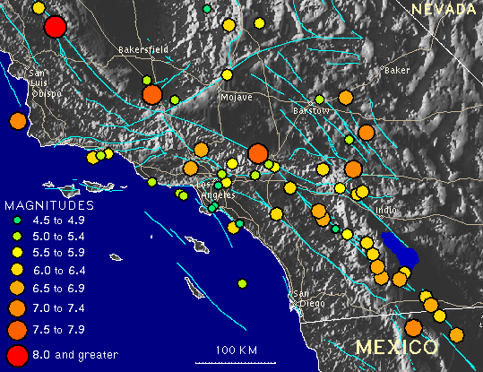
Earthquakes and Space-Time Patterns: Major earthquakes in a seismically active area such as southern California recur near a given location at intervals of hundreds of years or more. Typically, these events have source dimensions of 10 - 300 km. The inertial dynamics of the rupture processes associated with generation of elastic waves takes place on a time scale of seconds to tens of seconds in fault zones that have a thickness of millimeters to meters. This enormous separation of both space and time scales is characteristic of the earthquake problem, and of many other driven complex systems as well. Approximate epicentral locations for the historic events that have occurred in southern California since 1812 (circles), together with a map of the major faults (blue lines) in the region are shown in figure 1. The locations of future earthquakes must at this time be considered unknown.
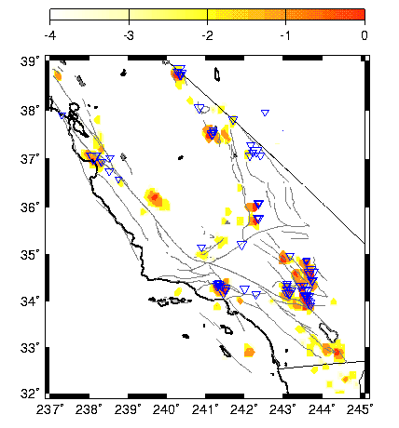
In figure 2 (right) we have applied a new "Pattern Dynamics" (PD) AILS-type data processing methodology to instrumental earthquake data recorded by regional seismic networks since 1932. The data is in the form of a record of some 60,000+ earthquakes of magnitude greater than 3.0, the completeness level of the catalog. In the figure, the colored regions locate sites of enhanced probability for earthquakes larger than magnitude M> 5 that developed over the years 1989-1999. Some of these regions are associated with the actual events of M>5 that occurred during 1989-1999, but other colored regions are as yet unoccupied by large events. The latter represent forecasts for future major events over the next ~ 10 years. Retrospective studies of this method using random catalogs and statistical likelihood ratio tests indicates that the PD method has considerable forecast skill. We also point out that the occurrence of large events will as a consequence substantially alter the pattern of colored anomalies. When a major earthquake occurs, there is then a need to rapidly re-compute the pattern probabilities so as to detect the possible locations of subsequent large triggered events, thus helping to evaluate rapid changes in seismic risk.
PD can be considered to be a type of AI method, and was developed using numerical simulations. The method is focussed on studying the apparent dynamics of the observable space-time patterns to gain an understanding of the true, underlying dynamics. PD is a method to process data and is not a model, and was developed by mapping the space-time correlations in activity into the mathematics of pure phase dynamical systems, an example of which is Quantum Mechanics. Here the observable earthquake activity represents the "wave function", and the underlying dynamics is associated with "hidden variables". The advantage of the PD method is that relative probabilities can be readily defined once the isomorphism to phase dynamics is established. The connection to datamining is that PD is a type of "sensory method" that detects patterns in underlying, noisy data. As part of our proposed research, we plan to automate the PD method so that the patterns revealed can be fed into response software that will allow early warning of future events.
Other innovative methods of analysis under development by our groups for space-time patterns in complex systems are based on Hidden Markov Modeling (HMM), Trajectory Analysis, and Quantum State Behavior. For example, in the HMM framework, the real-world data is assumed to have been generated by an underlying stochastic process. This stochastic process can be described by a system which is at any time in one of a set of N distinct states. Each state is described by a probability distribution of its observable output, and by the probability of the system being in the same state, or in each of the other states, at the subsequent point in time. Given the observations and a few selected model parameters, it is possible to objectively calculate a model for the system that generated the data, as well as to interpret the observed measurements in terms of that model. Furthermore, because the model includes the probability of each state transitioning to each other state at the next time step, it possesses predictive power. Description of the other pattern analysis methods will be deferred to the full proposal.

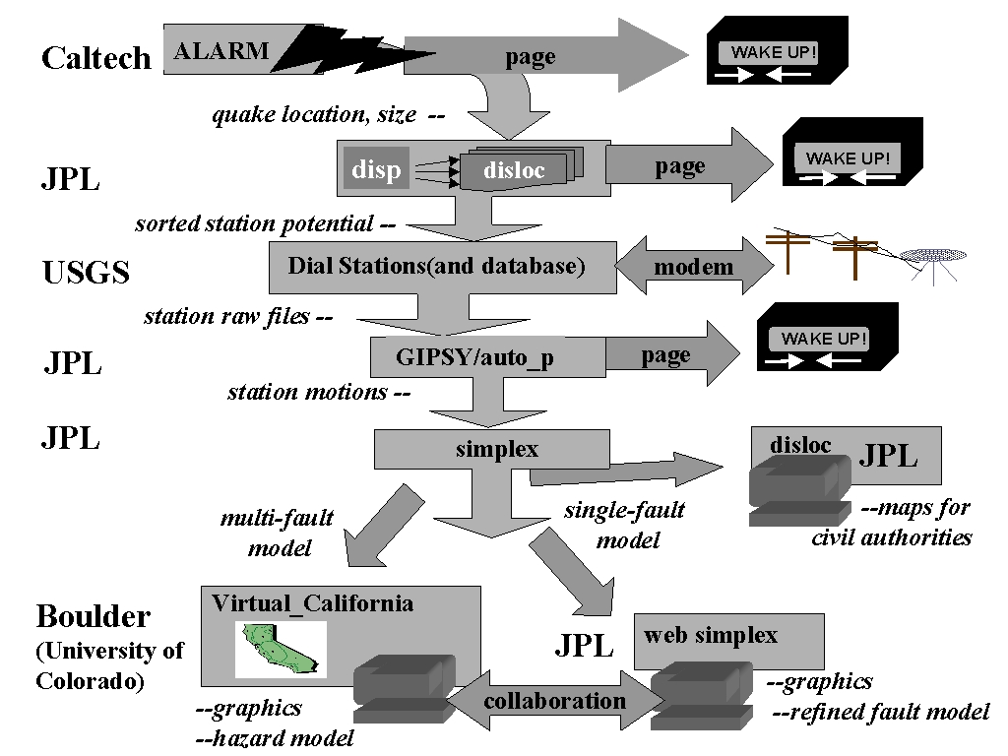
Computational Science and IT Issues: The problems of complex earthquake pattern detection, analysis, and interpretation are attractive targets for computer science, as a result of both the intrinsic richness of the applications and the societal importance, and because the use of computers is not yet too extensive, so modern approaches and infrastructure can be used without major distraction from existing legacy approaches. The wide geographic distribution of sensors, scientists and earthquakes means that there is an immediate application of emerging concepts such as computational grids to link large-scale simulations, data and people in a distributed fashion. The computer science research focuses on the issues on building an integrated computational environment that can support collaborative distributed scientific research for this field in a way that can be generalized to other Complex Systems. Our environment is aimed at fields that are characterized by rich space and time dependent data and simulations that cannot reliably be used in forecasting without both data assimilation and phenomenological analysis typified by the HMM and PD methods described above. Application to world ecosystems is a natural extension and indeed the PD method for earthquakes was motivated by its successful use in El Nino predictions. One important characteristic of such Complex systems are large events -- mammoth earthquakes, hurricanes or even dramatic stock market crashes. These requires distributed collaborative systems for the management of these crises but also the scientists studying this field must interact with the sensors and decide on needed simulations in real-time and from where ever they are when "the big one" strikes. This real-time collaboration must be integrated with the more traditional multi-year or multi-decade studies needed to delineate and understand the fundamental principles of the field.
Thus the IT challenge is the construction of a problem solving environment that supports simulation, data storage and access, datamining and data assimilation. This environment must support synchronous real time and longer-term largely asynchronous collaboration. We need to support the rapid prototyping of new algorithms both for the basic simulations (where we developing new fast multipole methods and understanding the difficult problems in data assimilation) and datamining where we must support both the analysis of the results of simulations, pure experimental data and their assimilation. These issues have been tackled individually but we believe the integration of simulation, experiment and phenomenology with real-time constraints offers critical new challenges.
We will use an existing collaborative portal (the Garnet system built at FSU) as the basis of the computational environment. Fox co-chairs (with Dennis Gannon and Mary Thomas) the Grid Forum and Java Grande national activities in the area of Grid Computing Environments. Currently this group is compiling best practices and we will incorporate the standards and features coming out from Grid Forum in our work. The collaborative model has similar features to the popular WebeX commercial system but has been designed to support more general applications -- including collaborative scientific analysis. The base Garnet system will be completed during 2001 and so here our research will focus on the use of the Garnet infrastructure (which has carefully defined XML interfaces for resources, services and user requests) for supporting Complex Systems research. An important feature of Garnet is the use of a small Java command center (similar in structure to the Yahoo Messenger) which runs on either hand held devices, PC's or workstations. Thus we support collaboration involving users with any mix of these interfaces -- a critical capability for supporting real-time analysis. As well as support of hybrid interfaces, critical research areas will involve designing general services to support the different approaches to datamining and the integration of simulations and data analysis. We expect that some of the interactive data analysis will be best-implemented client side and we will develop a client side Java analysis suite. We will study how best to architect the system with client and server support that is compatible with PDA and PC use.
Earthquake Simulations of Coupled Fault System Models: Physical processes that are known to be important in the earthquake generation process include 1) Transfer of stress from one fault to another by means of elastic, viscoelastic, and other interactions; 2) Frictional and/or other material instabilities acting on the fault surface that prevent stress from becoming larger than a spatially (and possibly temporally) varying threshold value σ^{F}(x,t), resulting in sudden, overdamped sliding to a new state of displacement; 3) Persistently increasing stress accumulation due to action of the tectonic plates driven by convection forces in the earth's mantle; and 4) The detailed three-dimensional geometry of the fault surfaces themselves, leading to branching, scale-invariant geometric structures, and new dynamical modes of behavior arising from excitation and inhibition from the dynamical influence of one fault upon another. These physical processes exist at all scales, and the parameters that describe their physical effects must be considered scale-dependent quantities whose values must be obtained from observations. However, since numerical simulations, or even laboratory experiments, can only be carried out over a limited range of scales, there will of necessity be some minimum scale at which the physics must be considered as unmodeled sub-grid scale processes, which must be treated as either random or correlated noise. At the present time, it is not possible to compute elastic wave fields for arbitrary ruptures at anywhere near the resolution needed to accurately specify the stress transfer. However, the wide separation of space-time scales suggests that if our objectives are to understand the space-time correlations in simulations and real data, the neglect of elastic wave fields in the stress transfer computations will not be important. Approximate wave-field calculations by both Ward's and Rundle's groups have shown that the inclusion of such time-space dependent stress transfer does not alter the underlying space-time patterns and correlations of activity that we study in our simulations.
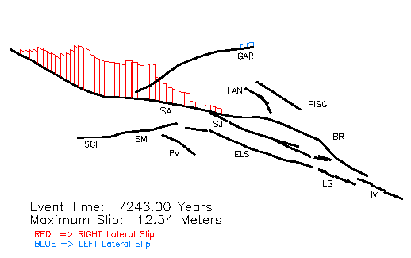
As an example of the kinds of detail that are becoming possible, we show simulations from a discrete element model having 215 segments representing the primary active faults shown in figure 1. Using methods described in references [*], in which frictional parameters are assigned to each fault segment, and the model is driven by the accumulation of plate tectonic forces, we compute synthetic earthquake histories for many thousands of model years. The spatial slip distribution among the various faults for one of these simulated great earthquakes events is shown at right, where red represents right-lateral strike-slip, and blue represents left-lateral strike slip. The event is similar to the actual 1857 Fort Tejon event near Los Angeles.
Proposed Tasks:
Improvement of Pattern Analysis Techniques for analyzing data and the results of simulations using methods from statistical physics, together with theoretical investigations of pattern-based datamining technologies (J. Rundle, U. Col., A. Donnellan, JPL, G. Fox, FSU, R. Granat, JPL, W. Klein, BU)
Improving and Optimizing Earthquake Simulation Technology via the introduction of Fast Multipole Methods (John Lou, JPL) and other acceleration algorithm techniques (S. Ward, UCSC, J. Rundle, U.Col, L. Kellogg, UC D)
Development and use of Data Assimilation Methodologies including the use of adjoint compilers developed at JPL (John Lou, JPL) to improve forecast power and performance of simulations and to accelerate the introduction of ensemble forecasting.
Construction of a Computational Environment for pattern-based and ensemble forecasting, and integrating data analysis and modeling with pattern dynamics analyses and other datamining methods (G. Fox, FSU, J Rundle, U. Col., A. Donnellan, JPL). In particular, the environment must be capable of responding effectively on all time scales described above, and must be able to support in an extensible and integrated manner further developments in earthquake simulation software, data assimilation methods, finer-grain pattern analysis, and ensemble forecasting.
Linking the Computational Environment with software technologies for shared collaboration and interfacing with non-specialists and other professionals, particularly at the time of a major earthquake (G. Fox, FSU). An important component of this research will be the integration and improvement of visualization software. In the best case, this environment may enable the development of an adaptive observation technology, particularly relevant at the time of a major earthquake.

Management and Budget: a sentence or two here will suffice. we will leverage activities of JPL. we will have letters from JPL and USGS menlo park.

