Words on Interoperability
Interoperability will be implemented by using distributed object technology combined with development of object API's that conform with emerging standards. There are several approaches to distributed objects -- CORBA, COM, Java, and SOAP representing four major camps. We will define our object API's in XML and dynamically map this specification into the chosen object model. This strategy was successfully used in the Gateway portal, which currently uses a CORBA middle tier but has used a pure Java solution with the same objects. The maturing of Enterprise Javabean technology would prejudice us to the Java solution as we like the good software engineering properties of this language.
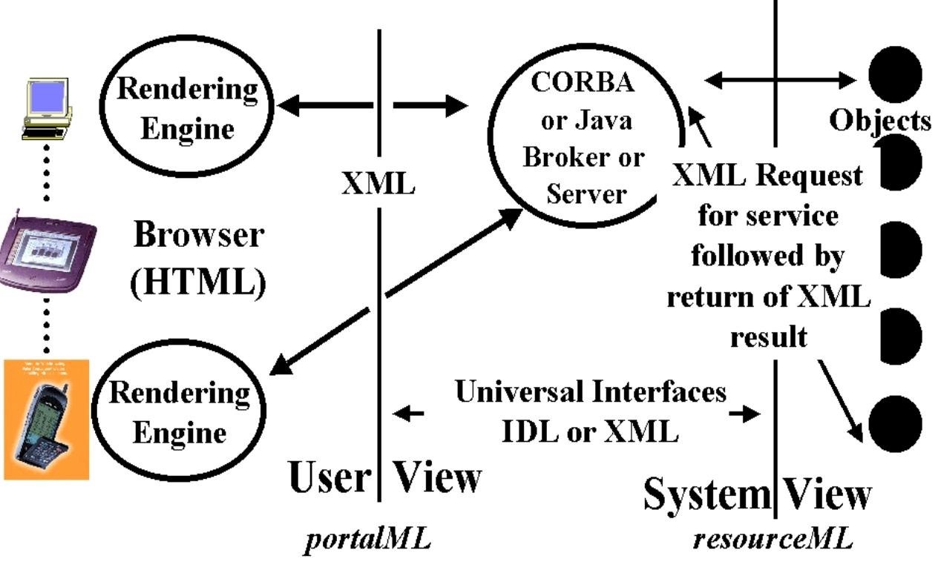
Fig: Basic 3 Tier Architecture showing two XML interfaces portalML and resourceML with a rendering engine which can vary from a wall to wall display to a WAP (wireless application protocol) browser in a cell phone.
We use two separate XML interfaces to isolate the middle tier from the client and back end resources. The XML Object API's will be customized to this application but build on several community standards. These include the Grid Forum (http://www.gridforum.org ) for distributed computing issues and the international ACES collaboration for application specific standards. Fox is co-leader of the Grid Computing Environment (Portal) working group and the ACES computational environment group. We will coordinate our work with emerging activities such as the geology XML specification work at CSIRO (http://www.ned.dem.csiro.au/XMML/). Also our general API structure will be consistent with the recent impressive work by the education community on learning objects. (http://www.imsproject.org)

References
- Donnellan, A., Fox, G.C., Hurst K., Parker J., “Introducing a New Paradigm for Computational Earth Science – A web-object-based approach to Earthquake Simulations”, a chapter in AGU monograph on Physics of Earthquakes, edited by John Rundle and published by AGU in 2000. http://www.new-npac.org/users/fox/documents/gempapermarch00
- Erol Akarsu, Geoffrey Fox, Tomasz Haupt, Alexey, Kalinichenko, Kang-Seok Kim, Praveen Sheethaalnath, and Choon-Han Youn, Using Gateway System to Provide a Desktop Access to High Performance Computational Resources, Proceedings of HPDC-8 Conference, Redondo Beach Ca., Aug 3-6, 1999, IEEE Press.

