The Gateway System - Desktop Access to High Performance Computational Resources

The Gateway system offers a programming paradigm implemented over a virtual Web of accessible resources. A Gateway application is based around a computational graph visually edited by end-users, using Java applets. A module developer, a person who has only limited knowledge of the system on which the modules will run, write modules. They not need concern themselves with issues such as: allocating resources, how to run the modules on various machines, creating inter-module connections, sending and receiving data between modules, or how to run several modules concurrently on a single machine. The Gateway system hides the configuration, management and coordination mechanisms from the developers, allowing them to concentrate developing their modules.

The goals of the Gateway system are:
- To provide a problem-oriented interface (a Web portal) to more effectively utilise HPC resources from the desktop via a Web browser.
- This “point & click” view hides the underlying complexities and details of the resources and creates a seamless interface between the user’s problem description on their desktop system and the heterogeneous resources.

The HPC resources include computational resources such as supercomputers or workstation clusters, storage, such as disks, databases and backing store, collaborative tools, and visualisation servers.

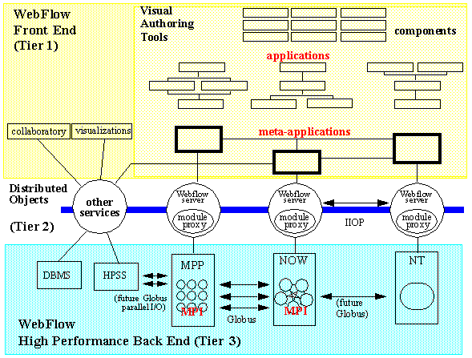
Figure 1: Three-Tier Architecture of Gateway [Fox]

Gateway is implemented as a three-tier system, as shown in Fig. 1.
- Tier 1 is a high-level front-end for visual programming, steering, run-time data analysis and visualization, as well as collaboration. This tier is built on top of the Web and OO commodity standards.
- Tier 2 is middleware and based on distributed, object-based, scalable, and reusable web servers and Object brokers.
- Tier 3 consists of back-end services, such those shown in Figure 1.

The middle tier of the architecture is based on a network of Gateway servers. The user accesses the Gateway system via a portal Web page emanating from the secure gatekeeper web server. The portal implements the first component of the Gateway security, user authentication and generation of the user credentials that is used to grant access to resources. The web server creates a session for each authorised user and gives permission to download the front-end applet that is used to create, restore, run, and control user applications.

The main functionality of the Gateway server is managing user sessions. A session is established automatically after the authorised user is connected to the system by creating a user context that is basically an object that stores the user applications. The application consists of one or more Gateway modules.

The Gateway modules are CORBA objects conforming to the JavaBeans model. The applications functionality can be embedded directly in the body of the module or, more typically the module serves as a proxy for a specific backend services. The Gateway servers also provide a number of generic services, such as access to databases and remote file systems. The most prominent service is the job service that provides secure access to high performance compute servers. This service is accessed through a metacomputing API, such as the Globus toolkit API.

To interoperate between with Globus there must be at least one Gateway node capable of executing Globus commands. To enable this interaction at least one host will need to run a Globus and Gateway server. This host serves as a “bridge” between two domains. Here, Globus is an optional, high performance (and secure) back-end, while Gateway serves as a high-level web accessible visual interface and a job broker for Globus.

References

Gateway – http://www.npac.syr.edu/users/haupt/WebFlow/demo.html

FOX - Erol Akarsu, Geoffrey Fox, Tomasz Haupt, Alexey Kalinichenko, Kang-Seok Kim, Praveen Sheethaalnath, and Choon-Han Youn, Using Gateway System to Provide a Desktop Access to High Performance Computational Resources, 8th IEEE International Symposium on High Performance Distributed Computing (HPDC-8), Redondo Beach, California, August, 1999

