4.1 Introduction to Application Cluster
In the first and last chapters of this book, we have described how parallel computers and large-scale simulations have and will have profound impact on many fields. Here we assume this motivation and in Section II (chapters 4 through 8) try to answer the following question:
I have an application -- can it be parallelized and if so, how should this be done and what are appropriate target hardware architectures; what is known about clever algorithms and what are recommended software technologies?
Most of the answers to these questions are implicitly described in other parts of this book and we attempt to aid the reader's identification of where to go by combining an exposition of general principles with several case studies. The latter consists of in depth discussions in chapters 6, 7 and 8 of computational fluid dynamics, energy and environmental studies and cosmology. We also present in chapter 5 a set of 20 short discussions of applications illustrating interesting features of their computational structure. An overview of our chosen applications in Sec. 5.1 is followed by a special section 5.2 describing Poisson’s equation in detail. This is not a “real” application like the others in our selection but acts as a simple prototype for discussing general issues. So we now step through the thought processes involved in analyzing a given application and in this way illustrate certain general characteristics that are useful in classifying the issues involved in parallelizing general applications. We first review Poisson’s equation and revisit the discussions of chapter 2 from an application rather than a parallel programming perspective

4.2 Application Characteristics in a Simple Example
Simple 2D electrostatic problems can be reduced to solving Laplace's or Poisson's equation and as described in Sec. 5.2, this is often solved numerically by finite difference methods. These could involve adaptive meshes and hierarchical multigrid methods but in the simplest formulation are set up as a regular grid of field values where the basic iterative update links two dimensional nearest neighbors as in fig. Appl/1.
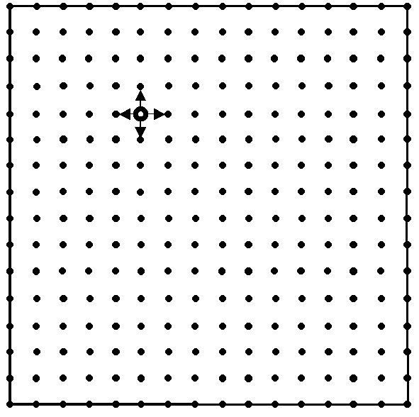
Fig. Appl/1: 16 by 16 Two Dimensional Mesh with an illustration of basic nearest neighbor update used in Jacobi's method of section 5.2
If the points are labeled by an index pair (i,j), then Jacobi's method defined precisely in Eqn. (Gropp.4), can be written
φ _{New}(i,j) = (φ _{Left} + φ _{Right} + φ _{Up} + φ _{Down} ) / 4 (Appl-1)

corresponding to the stencil given below where the subscript Left corresponds to index pair (i-1,j) etc.
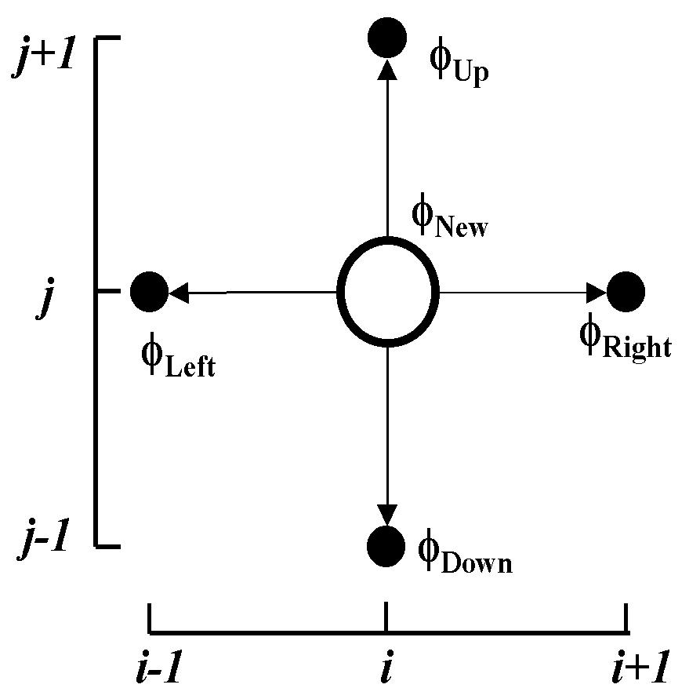
Fig. Appl/2: Stencil for
Jacobi Iteration of Fig. Appl/1

Such problems would usually be parallelized by a technique that is often misleading called "domain decomposition" or "data parallelism". As these terms already have particular meaning in the algorithm and parallel programming fields respectively, we can use the term block data decomposition, which is essentially the nomenclature used in HPF. In this problem, parallelism is achieved by exploiting the feature that we can view the problem as an algorithm (Appl-1) applied to a set of data points. Parallelism is naturally found for such problems by dividing the domain up into parts and assigning each part to a different processors as seen in fig. Appl/3. For problems coming from nature this geometric view is intuitive as say in a weather simulation, the atmosphere over Kansas evolves independently from that over Florida and so can be simulated on separate processors. This is only true for short time extrapolations – eventually information flows between these sites and their dynamics are mixed. Of course it is the communication of data between the processors (either directly in a distributed memory or implicitly in a shared memory) that implements this eventual mixing.
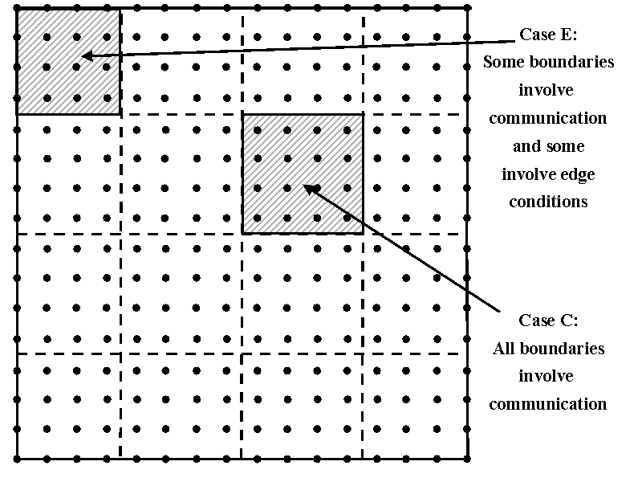
Fig. Appl/3 16 by 16 Mesh Divided among 16 Processors with a two dimensional grid chopped into rectangular sub-domains
Block data decompositions typically lead to a SPMD (Single Program Multiple Data) structure with each processor executing the same code but on different data points and with differing boundary conditions. In this figure, the “edge” (case E) processor has a mix of conventional and communication boundaries while in the “general” case C, a processor is “in charge” of 16 points with communication at the four edges providing the necessary boundary data. As described in Sec. (Gropp), one often uses a set of halo grid points seen in Fig. Appl/4, to represent these communicated values. This type of data decomposition implies the so-called “owners-compute” rule. Here we imagine each data point as being owned by the processor to which the decomposition assigns it. The owner of a given data-point is then responsible for performing the computation that “updates” this data location. This produces a common scenario where parallel program consists of a loop over iterations divided into compute-communicate phases:
- At the start of each iteration, first communicate any outside data values needed to update the data locations owned by this processor.
- Perform update of locations with each processor operating without need to further synchronize with other machines.
This general structure is preserved even in many complex physical simulations with fixed albeit irregular decompositions. Dynamic decompositions introduce a further step where data locations are migrated between processors to ensure load balance but this is usually still followed by similar communicate-compute phases. The communication phase naturally synchronizes the operation of the parallel processors and provides an efficient barrier point which naturally scales.
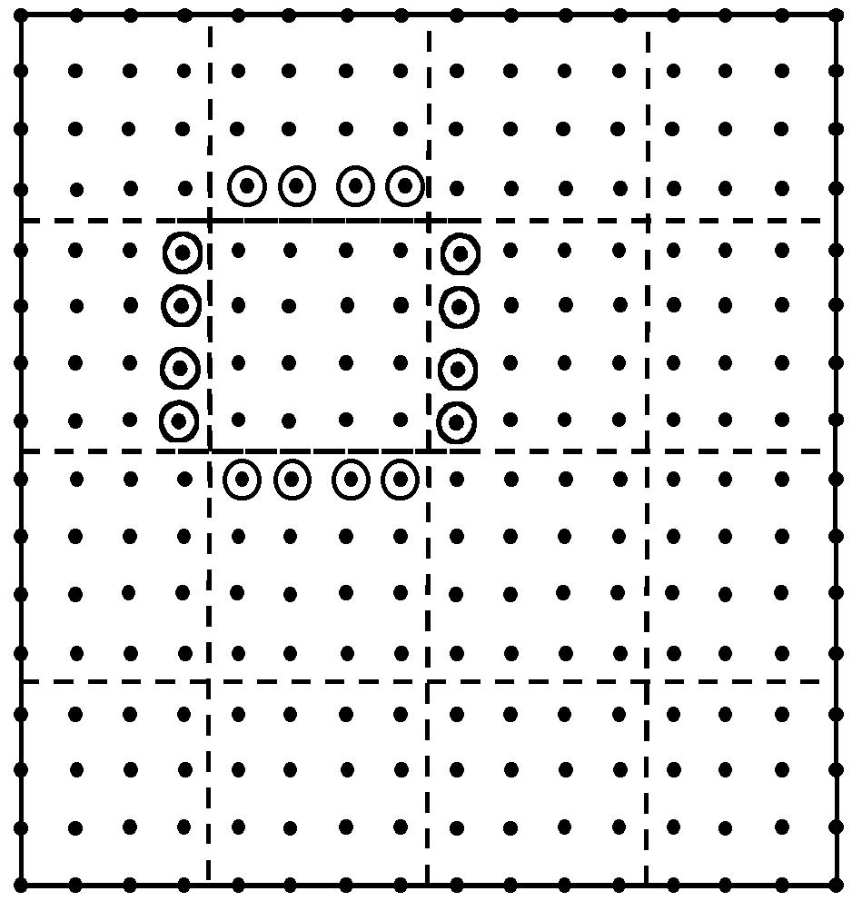
Fig Appl/4: Communication Structure for Poisson Equation Example. The circled communicated points form the halo or ghost grid points.

4.3 Communication Structure in Jacobi’s Method for Poisson’s Equation
On a distributed memory machine, the geometrically local structure of the linked entities of fig. Appl/1, leads to a classic communication structure with the communication volume proportional to surface area (in 2D this is the sides of the rectangle) of each sub-domain while computation is proportional to volume. Further in this case and most such cases, one can usually "block" the communication to transmit all the needed points in a few messages. Chapter 2 explained why this was important to reduce effect of latency of messaging system. We can use this example to produce some good rules of thumb to allow estimates of the performance of many parallel programs.
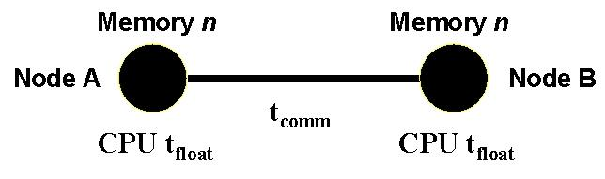
Fig. Appl/5: Parameters determining performance of loosely synchronous problems.

As shown in fig. Appl/5, we characterize the node of a parallel machine by a parameter t_{float}, which is time taken for a single floating point operation. t_{float} is of course not very well defined as depends on the effectiveness of cache, possible use of fused multiply-add and other issues. This implies that this measure will have some application dependence reflecting the goodness of the match of the problem to the node architecture. We let n be the grain size – the number of data locations owned by a typical processor. n is 16 in the trivial example of fig. Appl/3 but in a realistic example would be larger and limited by the memory of each processor. For a hypothetical 10³ by 10³ by 10³ 3D grid solved on a 1000 processor machine, n would of course be 10⁶. Communication performance – whether through a shared or distributed memory architecture – can be parameterized as
Time to communicate N_{comm} words = t_{latency} + N_{comm} t_{comm} (Appl-2)
This ignores issues like bus or switch contention but is a reasonable model in most cases. t_{latency} varies from around 1μs on shared memory machines like the SGI Origin to 40μs between remote notes on the IBM SP2. t_{comm} is time to communicate a single word and this is in range 0.1 to 0.01μs per word. For large enough messages (N_{comm} in range from 100 to 1000 or larger), the latency term can be ignored and we will set t_{latency}=0 in the following. We can generalize the above problem to N_{proc} processors arranged in an √N_{proc} by √N_{proc} grid with a total of N grid points and the grain size n = N/N_{proc}.
Then first considering load balance, we can write the sequential execution time
T(1) = (√N - 2)² t_{calc}, where this notes that boundary points are fixed
and only (√N – 2) by (√N – 2) array of internal points need to be updated. Further
t_{calc} = 4 t_{float} is time to execute the basic update (Appl-1)
The parallel execution time is governed the “interior” processors with n points to be updated. Thus
T(N_{proc}) = n t_{calc}, and the speed-up is given by
S(N_{proc}) = T(1) / T(N_{proc}) = N_{proc} (1 – 2/(nN_{proc})^{1/2})² (Appl-3)
The speedup S(N_{proc}) is less than N_{proc} because not all the processors update the same number of points. However it is a small edge effect decreasing as either n or N_{proc} becomes large.
More important in this case is the communication overhead, which adds to T(N_{proc}) a term 4√n t_{comm} illustrated in fig. Appl/6 for the cases n = 16 and n = 64. The communication term is an edge effect proportional to √n which decreases in importance as n increases compared with the computation term 4n t_{float}. More precisely, we now find the full speed up formula:
S(N_{proc}) = N_{proc} (1 – 2/(nN_{proc})^{1/2})² (1 + t_{comm}/(√n t_{float})) (Appl-4)

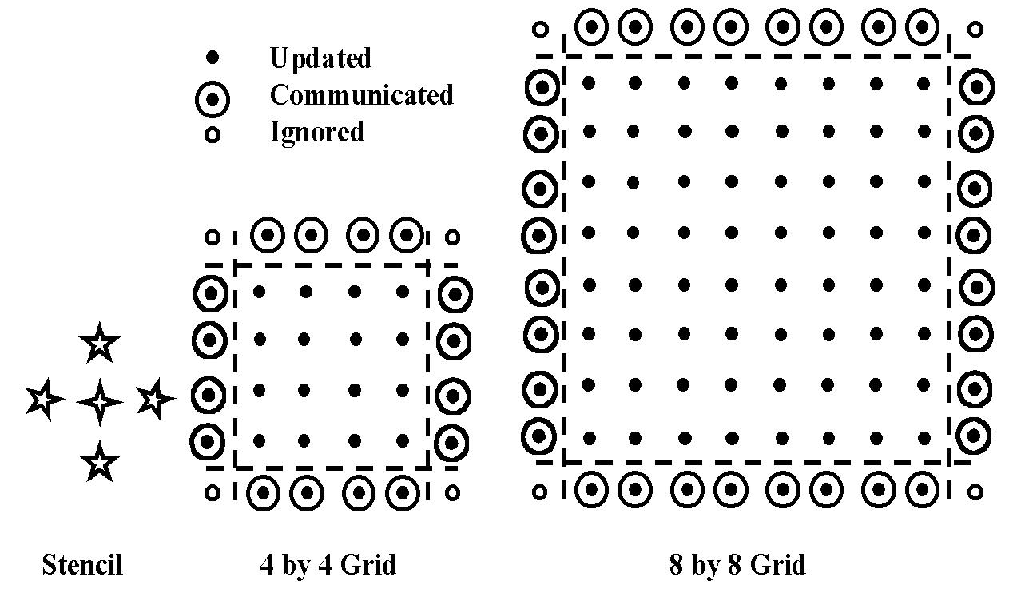
Fig Appl/6: Communication Structure for 5-point stencil and two different grain sizes

Realistic values for t_{comm}/t_{float} are in range of 10 to 100, and so the communication overhead dominates in Equ. (Appl-4). For an intermediate value t_{comm}/ t_{float} = 50, we need the grain size n to be greater than 250,000 grid points to reduce communication overhead below 0.1. We can generalize the above analysis most conveniently using the notation that
S(N_{proc}) = ε N_{proc} = N_{proc} /(1 + f ), (Appl-5)
which defines efficiency ε and overhead f. The communication part of the overhead f_{comm} is given in Equ. (Appl-4) as

f_{comm} = t_{comm}/(√n t_{float}) (Appl-6)

This equation can be generalized to essentially all problems we will later term loosely synchronous. Then in each coupled communicate-compute phases of such problems, one finds that the overhead takes the form:
f_{comm} = constant . t_{comm}/(n^{1/d} t_{float}) (Appl-7)
Here d is an appropriate (complexity or information) dimension, which is equal to the geometric dimension for partial differential based equations or other geometrically local algorithms. The most important case is the 3D value d=3 when n^{1/d} is just surface/volume in three dimensions. For full matrix problems, one finds the value d=2 for the best decompositions such as those used in SCALAPACK described in chapter 18.
Applying Equ. (Appl-5), we find that S(N_{proc}) increases linearly with N_{proc} as long as N_{proc} is increased with fixed f_{comm} which implies fixed grain size n, while t_{comm} and t_{float} are naturally fixed. This is scaled speedup where the problem size N = n N_{proc} also increases linearly with N_{proc}.
The continuing success of parallel computing even on very large machines can be considered as a consequence of Equs. (Appl-5) and (Appl-7). The formula for f_{comm} (whose numerical value we could aim to keep around 10% or lower) only depends on local node parameters and not on the number of processors. Here we consider the grain size n as reflecting the amount of local memory.
This simple problem is perhaps the one where the parallel issues are most obvious; however it is not the one where the parallel performance is easiest to obtain as the small computation load of the update Equ. (Appl-1) makes the communication overhead relatively more important. There is a fortunate general rule that as one increases the complexity of a problem, the computation needed grows faster than the communication overhead and we will illustrate this below. Jacobi iteration does perhaps the smallest communication for problems of this class. However it has one of largest ratios of communication to computation and correspondingly high parallel overhead.
Note one sees the same effect on a hierarchical (cache) memory machine, where problems like Jacobi Iteration for simple equations can perform poorly as the number of operations performed on each word fetched into cache is proportional to number of links per entity and this is small (4 in the 2D mesh considered above) for this problem class.

4.4 Communication Overheads for More General Update Stencils
It is instructive to consider in detail how the above analysis is altered as one changes the update formula of Equ. (Appl-1). Consider first using fourth order differencing to approximate ∇² in Poisson’s equation. Then as illustrated in Fig. Appl/7, we need to communicate twice as many points into halo cells. However the overhead f_{comm} is not changed significantly from its value of Equ. (Appl/6) for the computation needed to update each point is also doubled and the ratio of communication to computation is roughly unchanged.
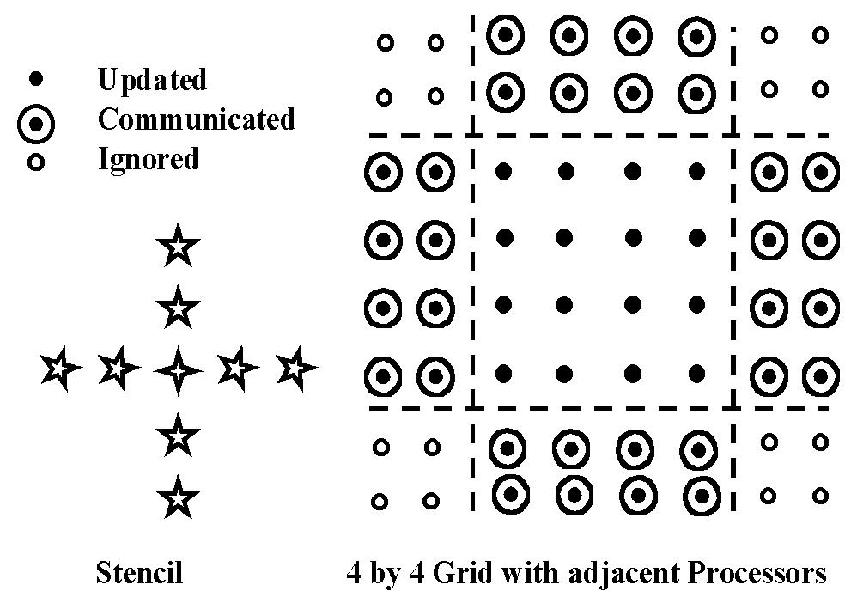
Fig Appl/7: Communication Structure for 9-point stencil

We can now systematically increase the size of the stencil and find how f_{comm} changes. In the case explained below, where the grid points are replaced by particles, this corresponds to ratcheting up the range of force between the particles.
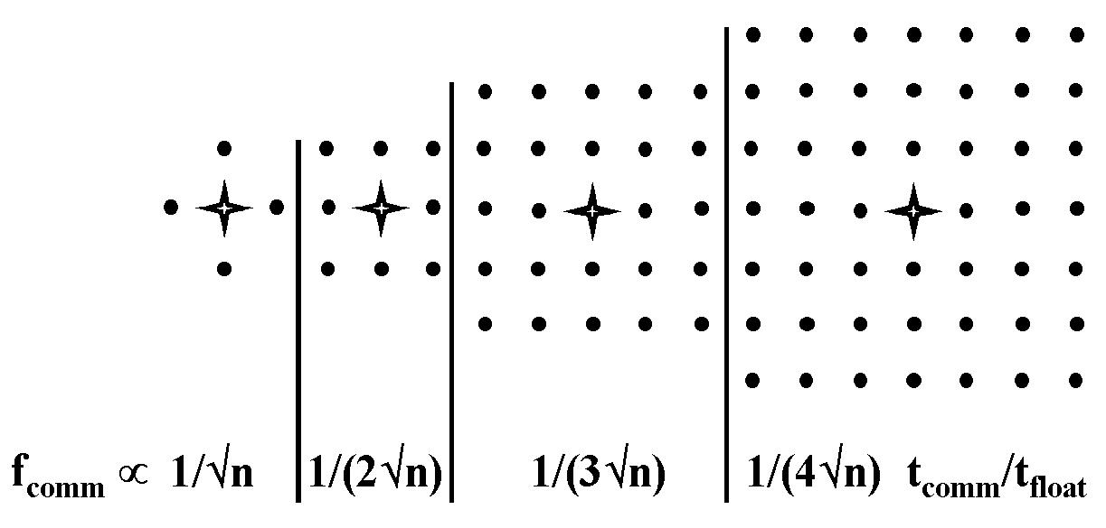
Fig Appl/8: Communication Structure as a function of stencil size
We find that the communication overhead decreases systematically as shown in fig. Appl/8 as the range of the force increases. For a range of l (measured in units of grid spacings), one finds in this 2D case,
f_{comm} ∝ t_{comm}/(l √n t_{float}) (Appl-8)
In the interesting limit of an infinite range ( l→∞) force, one finds that in any geometric dimension
f_{comm} ∝ t_{comm}/(n t_{float}) (Appl-9)
which is of the general form of Equ. Appl-7 with complexity dimension d=1. This is the best-understood case where the geometric and complexity dimensions are different. The overhead formula of Equ. (Appl-9) corresponds to the computationally intense O(N²) algorithms for evolving N-body problems. The amount of computation is so large that the ratio of communication to computation is extremely small. This observation is at the heart of the success of special purpose machines such as GRAPE from the university of Tokyo (http://grape.c.u-tokyo.ac.jp/grape/). The one teraflop GRAPE 4 won the Gordon Bell prize twice and the GRAPE 5 took the cost effectiveness award in 1999 (at $7 per megaflop). The 200 teraflop GRAPE 6 will be completed soon. The modest memory and communication needs of the N body problem are some of the reasons enabling these powerful machines, which outperform any of the more general-purpose parallel computers.

4.5 Applications as Basic Complex Systems

Above we already showed how one could discuss the parallel issues for several different problems (here particle dynamics and local discretization for partial differential equations). This is generally true as the parallel issues depend not on the detailed science or numeric algorithm but on overall characteristics of the application.
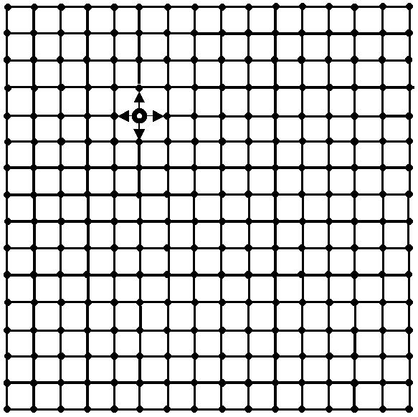
Fig Appl/9: A Simple basic complex system with a set of entities with nearest neighbor linkage to at most four others.

So it makes sense to generalize the above discussion in terms of both general principles applicable to very many parallel computing problems and special features of the particular two-dimensional structure seen in Poisson's Equation. It is useful to think of an application as a "complex system" or a linked set of entities and this way of thinking can relate the parallelelization strategy of seemingly very different problems. In particular, many other applications have a similar computational structures to the Laplace or Poisson Equation of the previous sections.
Consider first the 2D Ising Model, where the mesh of fig. Appl/9 is now not an array of discretized field values but a fixed grid of spins with a nearest neighbor connection for the interaction (forces) between them. The Ising model has a similar geometric structure to Equ. (Appl-1) but the physics and numerical procedure show many differences from Laplace's equation. The grid points in the Ising model are physically real spins where as in the Poisson case, the grid points are artifacts of the numerical procedure. The nearest neighbor local connection in the Ising case corresponds to a physical force law while it follows from the differencing approximation to a partial derivative in Poisson's case.
Further the usual numerical approach to the Ising Model uses a Monte Carlo method rather than a differential equation to express the dynamics of the system. Further the iterative process is not a perturbative solution to an exact Matrix problem as in Poisson’s equation. Rather the iterator counts Monte Carlo sweeps as one accumulates integration points to decrease the statistical error, which is inversely proportional to the square root of the number of sweeps. However these differences which are so important to the underlying science do not affect very much many of the issues that come up in discussing appropriate parallelization strategies and the needed hardware and software systems. Even closer to our Poisson equation would be an application the solved a simple wave equation (or Maxwell's equations) in a two dimensional domain. Here we see an identical computational structure with the perturbative iteration in the sparse matrix solution replaced by stepping through a discretized time variable. Yet another essentially identical structure can be found in cellular automata problems.

We can extend this very simple problem is several ways and some of these are explored in Sec. (Gropp). For instance finite element problems have a similar mesh which can be quite irregular (compared to the uniform geometry of most finite difference problems) and this brings load balancing to the fore as an important issue. Particle dynamics problems with a short-range force can exhibit similar structure as discussed for fig. (Appl/8) but with a dynamic irregular structure and a variable number of links per entity. An obvious and important generalization of the Poisson structure is to higher dimensions with three and even four-dimensional structures. Here we have already stated in Equ. Appl-7, a general form for the communication overhead. This equation applied for d=3 shows an overhead decreasing like n^{1/3} – slower than for the 2D case discussed in detail above. This suggests values like n ≈ 10⁶ are needed in 3D in order to match as good a performance as the much smaller n ≈ 10⁴ in 2D. Note that in chapter 5, we describe two physics examples – numerical relativity and computational QCD where the basic mesh is four-dimensional. The many partial differential equation applications in chapters 5,6 and 7 also always have a richer structure at each grid or finite element mesh point than the single value of Poisson’s equation. For instance QCD has 3 by 3 complex matrices representing “gluons” and vectors representing quarks. Computational fluid dynamics is formulated in terms of 5 degrees of freedom at each point. In these examples there is much more computation involved in the basic update replacing Equ. (Appl-1) but as we have explained that actually tends to reduce the parallel overheads as communication tend to scale like the number of degrees of freedom at each point. The computational update time complexity per point increases faster than this.
So we have seen that is helpful to consider many problems as linked entities arranged in one, two three or higher dimensional geometries. This linkage was "short-range" (a few links per entity) in the examples we discussed but one of course finds examples that span the gamut of possibilities. Particles interacting by a long-range gravitational force illustrate a case with many links per entity. This example using the simple O(N²_{particle}) algorithm discussed at the end of Sec. 4.4 has very different properties from the short-range case. In particular the performance of this problem is excellent on both distributed and hierarchical memory machines. There are many (of order N_{particle}) computations for any point stored in cache and even though the communication appears heavy in a distributed memory machine, the above analysis shows a low ratio of communication to computation. This type of long-range problem is found in a variety of fields, which are far from particle dynamics but still have the same computational structure. We give one interesting example of an O(N²_{particle}) algorithm in chapter 5 – the Greens function approach to the simulation of earthquakes. Such partial differential equation solvers become integral equations over the domain boundaries with the full linkage between the element mesh on the boundary. Some applications involving determination of correlation function also have this fully connected structure between the points in the computation.
The N body example can be used to illustrate another important point. Namely a given physical problem can look quite different depending on the numerical formulation. As described in chapter 8, the natural O(N²_{particle}) algorithm is often not the best approach to the simulation of gravitating particles, and for large problems, one usually adopts the so called fast multipole method with O(N_{particle}) or O(N_{particle}logN_{particle}) ) behavior. A simpler application illustrating the same issue is Laplace's equation, which can often be solved by either iterative local methods such as Jacobi or conjugate gradient, or by the FFT (Fast Fourier Transform). In both cases the obvious approach has a simpler complex system structure while the fast algorithm has a more complicated tree structure. This emphasizes that a computational scientists use their skill to convert a given application into a numerical system and it is the structure of the latter that determines the key parallel computing issues.

4.6 Time Stepped and Event Driven Simulations
Above we have noted the rich spatial or geometric structure of applications. Two rather distinct simulation methods, time-stepped and event-driven, correspond to different temporal structures. Most of the examples in this book correspond to the time stepped case where the entities in a complex system are evolved together and synchronized globally either by the concept of time or something essentially equivalent like an iteration or Monte Carlo sweep. This is of course very reasonable, as it is "how nature works". In the early days of parallel computing, there were concerns that the global synchronization implied by the time-stepped approach would lead to uncontrollable overheads. This is not true, for it can be seen that as described at the end of Sec. 4.2 for the simplest nearest neighbor Laplace equation, global time synchronization is implied by the local synchronization of neighboring nodes, either by exchanging messages or the equivalent shared memory mechanism. This synchronization mechanism is itself fully parallel (with no "hotspots" in proper implementations) and so introduces no serious parallel computing overheads. Such efficient synchronization is present in all such problems where there is a time or iteration count to provide algorithmic synchronization. Then correct implementation of such an algorithm with natural synchronization points, implies that the parallel program needs no special additional synchronization.
The military makes substantial use of event-driven simulations in the field of Forces Modeling and we give an example if this in Sec. (Furmanski). Here one tends not to simulate systems in terms of their fundamental constructs (atoms, grid-points etc.) but rather in terms of macroscopic constructs such as vehicles, mines, battalions etc, in the war gaming example. These system components are naturally formulated in terms of objects interacting with events, which are queued (often in a distributed fashion) and executed either in real time (the natural case when there is "hardware in the loop") or according to a global virtual time. Here we do see potentially serious problems with the overhead of global synchronization and very ingenious techniques (such as variants of the Time Warp system with "optimistic" simulation and rollback) have been developed. The particular minefield simulation CMS application described in Sec. (Furmanski) was successfully parallelized because the different entities in the simulation are largely independent.
Currently one of the most powerful parallel event-driven approaches is the SPEEDES system from Metron Corporation discussed in Sec. (Furmanski) but currently there are only overall frameworks like HLA and RTI defined in this field. No software system enjoys the universal acceptance and relatively clear methodology for getting good performance shown by MPI in the time-stepped case.
Circuit simulation is an interesting application area, which can be tackled by either simulation technique. Obviously a circuit has a natural time, which can be iterated over with at each step every device component being updated. This approach can be inefficient as on most of iterations, only a tiny fraction of the components are active. The event-driven approach can then be the most effective approach to circuit simulations as one automatically only updates those devices affected by queued events. This analysis is clear for sequential machines but the difficult parallelism of event-based systems makes the parallel situation less clear.

4.7 Temporal Structure of Applications
It has been found useful to divide the temporal structure of numerical systems into four broad areas
- Synchronous: Here each point can be evolved in synchronous mode as is natural on a SIMD machine. The temporal synchronization is on a point by point basis. Most of the simple examples discussed above are of this type.
- Loosely Synchronous: Here the temporal synchronization is on a sub-domain basis and this is the natural form of SPMD (Single Program Multiple Data) implementations such are all HPF and most MPI programs. This is the dominant case for today's major applications as essentially any serious geometrical or other irregularity converts a problem, which is in its simplest mode synchronous to loosely synchronous form. In particular finite element problems, or finite difference codes with adaptive meshes are loosely synchronous. Domain decomposition in chapter 7 has this structure, as does the fast multipole approach to particle dynamics in chapter 8. The simple O(N²_{particle}) particle dynamics algorithm is however synchronous.
- Asynchronous: Event driven simulations fall into class which include those problems which are not formulated in terms of a stepped time or iterator associated with each system entity. As discussed above, asynchronous problems can be very hard to parallelize whereas in principle loosely synchronous applications always run efficiently if they are large enough.
- Pleasingly Parallel: The time or iteration evolution structure of a problem can impact greatly the appropriate software and hardware architecture. However there is one important special case where this is not true -- namely cases where the entities in the system are essentially disconnected. Then each entity can be evolved more or less separately and there is no significant synchronization overhead whatever the differences between the entities. One typically uses a "farm" architecture with worker nodes somehow getting given chunks of the simulation (entities) to do as they finish their previous assignment. This has very non-trivial application dependent implementation issues but such problems will always parallelize well if the problem is large enough. Good examples of this problem class come from the Internet where both large web servers and the backend of database search engines such as Inktomi are of this type. Note this problem class was more crudely termed "embarrassingly parallel" in the past.

4.8 Summary of Parallelization of Basic Complex Systems
So let us take stock of where we are. Problems are set up as computational or numerical systems and we have discussed one set of such systems, which consist of a space of linked entities. These we termed "basic complex systems" and characterized them by their possibly dynamic spatial (geometric) and temporal structure. We have noted the difference between the structure of the original problem and that of computational system derived from it. We can summarize much of the past experience in parallelizing applications by the conclusion
Synchronous and Loosely Synchronous problems perform well on large parallel machines as long as the problem is large enough. For a given machine, there is a typical sub-domain size (i.e. the grain size or size of that part of the problem stored on each node) above which one can expect to get good performance. There will be a roughly constant ratio of parallel speedup to N_{proc} if one scales the problem with fixed sub-domain size and total size proportional to N_{proc}.
Unfortunately although this assertion is probably true in most important cases, it has proven very difficult to design and implement productive programming environments that allow the user to realize this goal. That is why we need to write this book even though in principle success is guaranteed …….

4.9 Metaproblems
Several applications can be solely discussed in terms of computational systems, which fall into the basic complex system type discussed above. However this description is often incomplete although it does properly describe key computational modules that are part if not all of the complete application. More generally, one finds metaproblems, which are built up from multiple modules that each can be classified as basic complex systems. Such metaproblems are particularly interesting today, as many of them are the natural applications for computational grids. One tends to run basic complex systems on classic shared or distributed memory machines as these have the required low latency and high bandwidth communication. Separate modules in a metaproblem can often be run on geographically separated machines, as they tend to have much less stringent communication requirements that those needed in the simulation of basic complex systems. Important examples of metaproblems are:
- The 3-way linkage of data store, simulation and visualization subsystems forms one of the most generic metaproblems, which is seen in many different disciplines. Sec. (Argonne) describes an application of this type with their synchrotron light source.
- Multidisciplinary Applications: As discussed in chapter 20, there is a growing trend in modern engineering to sophisticated system-wide optimization. For aircraft design, one might simultaneously optimize over fluid flow, structural, acoustic and electromagnetic properties. Each of these corresponds to a separate module in the discussion above. The new DoD initiative in SBA (Simulation Based Acquisition) would need such metaproblems and we illustrate this type of application in fig. Appl/10.
- An early success of the CASA gigabit network was the simulation of a coupled ocean-atmosphere metaproblem and there is general understanding that such approaches are essential for reliable long-range climate forecasts.
- The forces modeling community often builds such metaproblems where each component is a separate focused simulation. For example in the example of Sec. (Furmanski), one simulation engine is used to describe mine fields and another describes squads of vehicles. You can imagine that these simulations have interesting interactions. In this field, metaproblems are called federations and the basic simulations are termed federates. As mentioned above, this community has recently adopted sophisticated software standards (RTI for Run Time Infrastructure and HLA for High Level (object) Architecture) to support the federation of multiple event driven simulations.
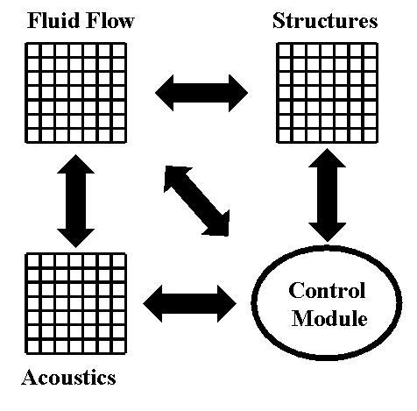
Fig. Appl/10. The linked modules in a typical metaproblem. We show three large-scale parallel modules which can be expected to execute individually on massively parallel systems. The control module is logically separate and may not need high performance computing.

Note that basic complex systems often have huge potential for parallelism with a complex 3D simulation perhaps exhibiting a billion independent degrees of freedom, which are candidates for data parallel systems. Metaproblems are different as one typically has but a few independent modules and further the linkage of these modules is often timed asynchronously and so naturally supported by different software concepts than the data parallel sub components. So this way one finds a metaproblem with each module using internally MPI, OpenMP, HPF or equivalent while the modules are linked together thorough channels using perhaps IIOP (CORBA) or RMI (Java). We discuss these different software models more completely in terms of problem solving environments in chapter 14.

