Tango Beans API Documentation

Version 1.0

Lukasz Beca
beca@npac.syr.edu
Northeast Parallel Architectures Center at Syracuse University
September 11, 1998
Table of contents
1 Introduction 3
2 Tango Concepts 3
3 Installation 4
4 Tango Beans API Components 5
4.1 TangoBean 5
4.1.1 Properties 6
4.1.2 Events 6
4.1.3 Methods 7
4.2 ObjectPipe 8
4.2.1 Events 8
4.2.2 Methods 9
5 Working with Tango Beans API 9
5.1 Connection setup 10
5.2 Event flow 12
5.3 Access to the session state information 13
5.4 Runtime/Design time execution modes 13
6 Tools and Resources 14
6.1 Java IDE 14
6.2 Netscape browser with Tango plug-in 14
6.3 Digital signature 15
7 Development process 15
8 Simple Example 17
8.1 Choosing necessary components 17
8.2 Embedding Tango Bean API components 18
8.3 Connecting components 19
8.3.1 Connection from objectPipe1 to tangoBean1 19
8.3.2 Connection from button1 to objectPipe1 20
8.3.3 Connection from objectPipe1 to textArea1 21
8.4 Adding necessary modifications 22
8.5 Testing 23
8.6 Applet signing and packaging 23
8.7 Running in Tango 24

Introduction
Tango Interactive is a generic environment for building collaboration systems. It provides session and user management for collaborative applications. Moreover, it enables adding new applications using provided APIs. Tango Beans API is another form of API for Tango. It is based on JavaBeans architecture – component technology for Java. The component technologies enable developers to create independent and reusable pieces of software, which can be assembled into fully functional applications. There are already hundreds of JavaBeans components available. Since they follow the same standard they can be connected one with each other to create new applications. Another important feature of JavaBeans components is that they can be manipulated visually. It makes software development easier and faster than using traditional methods. The developer can build new applications without writing the code, reusing functionality implemented in the encapsulated pieces of software. Tango Beans API is a set of components that conform to JavaBeans standard. Using this set of components collaborative applications can be created, which operate in Tango environment. Tango Beans define generic interfaces that enable communication with other components. They are designed in a way that makes possible easy definition of interactions with other application components. Those operations can be performed in application builders which are

The main goal of Tango Beans API is to enable easy creation of collaborative applets and applications using visual programming tools. Such tools are often a part of integrated development environments (IDE) for Java such as Visual Café, Visual Age, JBuilder or BeanBox. Tango Beans API provides full functionality offered by low level Tango API i.e. the communication between members of the collaborative session and the access to essential system state information. All this functionality is implemented in JavaBeans components that communicate easily with standard components. Implementation is based on JavaBeans standard version 1.01 available at http://java.sun.com/beans/docs/index.html.

This document describes how Tango Beans can be used to create collaborative applications and applets. It starts with introduction of several basic Tango concepts necessary for understanding the rest of text. Then we move to the description of Tango Beans API installation. In the next sections all Tango Beans components are described including detailed information about their properties, events and methods. Afterwards essential tools and resources are enumerated and development process of the collaborative application is described. Finally simple example is presented that shows how Tango Beans API can be used to construct the collaborative applications in application builder environment. The impatient readers should go directly to the example and then read the rest of the material.

Tango Concepts

Application is a collaborative tool used by the user to communicate with other users. Chat or Whiteboard are examples of Tango application. Tango system can communicate with applets, Java script applications and applications that run outside Netscape browser as Tango applications. Tango applications can be created using appropriate APIs available at Tango web site. Currently APIs for applets, Java script applications, C/C++ applications, and LISP applications exist.

NOTE: In further text we will refer to both Java applets and Java applications simply as applications. I will make the distinction between those two types of applications only when necessary.

Session is a set of Tango applications of the same type that exchange information between each other. Each application belongs to different user. Exchange of information is achieved by sending and receiving messages e.g. chat session enables exchange of text information between chat applications that are started in the same session. The communication between applications in the same session is provided by the Tango system, mechanisms for such communication are available in form of API. The session can be established using Tango Control Application (see Control Application documentation).

Participant is a user that takes part in the session. Participant exchanges information with other participants using applications. Each participant can have only one application running in a session. A user can be a participant in many sessions at the same time.

Master is a participant that has special privileges in the session. Master controls the state of the session, approves new session participants or starts applications for other participants. The user that started session becomes the master of the session. The master status can be transferred to other users.

Installation
Although Tango Beans API can be used as a regular set of classes that are accessed in the application code, it was designed especially for the use in integrated development environments that enable visual creation of the applications from the components. Tango Beans API components conform to JavaBeans specification so that the development tools designed to work with JavaBeans can detect automatically events, methods and properties supported by Tango Beans. Access to this information is possible if the Tango Beans API is installed properly in your IDE:

- Download the jar file with Tango Beans API: The jar file with Tango Beans API is available at http://tango.npac.syr.edu/tango/Developers_pages/TANGO_APIs/tango_apis.html
- Import the Tango Beans API into IDE: The Tango Beans API components must be imported to the development environment so that they can be used to create the applications. They should be simply added to the component library of the development environment. For example in Symantec Visual Café environment you should use “Component into Library” operation from “Insert” menu, in Sun BeanBox “Load Jar” operation should be used from “File” menu. Nearly all development environments have corresponding operations for importing components into the component library. If properly installed, two Tango Beans component should appear in Component Library. Figure 1 shows state of the Visual Café Component Library after Tango API was loaded. TangoBean and ObjectPipe components are visible in Tango Beans folder.

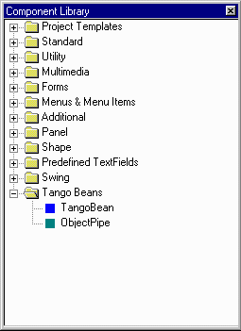
Figure 1: Tango Beans installed in Visual Café Component Library
After successful installation, Tango Beans can be used as any other components already installed in Component Library. Now process of constructing collaborative application can be started.

Tango Beans API Components
This section describes in detail all components of Tango Beans API. It focuses on the functions of each component in the context of collaborative application. It also examines properties, events and methods exposed by those components.

TangoBean
TangoBean is a main component that makes the application collaborative. When embedded in application and initialized correctly, TangoBean turns a regular application into a Tango application - see section 2 for definition of Tango application. Its main function is to integrate the application with Tango system and enable control over the application from Tango Control Application. It means that the application will be able to receive events from Tango system and send its own events to Tango system. Also the application will be started and terminated by Tango Control Application. Finally, the application will be able to retrieve information about current state of the session and will receive notifications about changes in this state.

In order to provide described functionality TangoBean must communicate with Tango system and with components of the application. With support of ObjectPipe components, TangoBean intercepts events that should be sent to other applications in the session and forwards them to Tango - see Figure 2. It also accepts events from Tango system and sends them to appropriate application components. Communication pipes are described in detail in next section. Only one TangoBean component in the application is allowed. The application with two TangoBeans will not work properly.
Figure 2: Event flow when the application with TangoBean is placed in Tango environment
TangoBean always runs in one of three modes: Tango mode, testing mode, and design mode. In Tango mode all events received by TangoBean are forwarded to Tango system as in Figure 2. TangoBean enters this mode when application that contains TangoBean runs in Tango system environment. If TangoBean is unable to detect Tango system it enters testing mode illustrated in Figure 3. In this mode all messages sent to TangoBean are looped back and return to the application. In testing mode Tango system is not necessary for proper operation of the application. This mode enables application testing outside Tango environment e.g. in applet viewer or in Netscape browser. In those two modes TangoBean is invisible (hidden). Third TangoBean mode of operation is a design mode. TangoBean enters this mode when the application is being constructed in development environment. In this state the component is visible so that it can be manipulated using various application builder tools. TangoBean switches to appropriate mode automatically depending on runtime environment.
Figure 3: Event flow when the application with TangoBean is in testing mode
As a regular JavaBeans component, TangoBean has sets of properties, events and methods.

Properties
TangoBean provides access to several properties that describe current state of the collaborative session. The application can obtain information about application user name of the application, name of the session master or names of the session participants. The Tango application can also determine its master/slave status or whether it can currently use audio devices. The properties of TangoBean are read-only and cannot be modified by the application. They are modified by the Tango system to reflect the state of the collaborative session. TangoBean sends notification whenever any of those properties changes. The application designer can choose the components that should be notified when the value of the property changes. The properties are presented in Table 1. In the Property description field the name of the property is specified, as it appears in the application builder tool. This identifier is assigned to the property in BeanInfo class. Type field specifies the type of the property. Access method field contains name of the TangoBean method used to access the parameter. Connection description field contains label by which the corresponding access method can be referred to in Symantec Visual Café Interaction Vizard.
Property description | Type | Access method | Connection description
User name | String | getUserName() | Get user name
Master name | String | getMasterName() | Get master name
Master/slave status | boolean | isMaster() | Am I master?
Participants | String[] | getParticipantNames() | Get participant names
Audio status | boolean | isAudioAvailable() | Is audio available?
Table 1: TangoBean properties

‘User name’ contains the name entered by the user during the login procedure. ‘Master name’ contains the name of the session master. ‘Master/slave status’ contains the status of the application in the session. If the value of the property is true then the participant is a master of the session. Otherwise the value is false. ‘Participants’ contains list of session participant names. The last property does not describe the state of the session. Some Tango applications need exclusive access to the audio device. When such applications are running all other applications should refrain from using the audio device. ‘Audio status’ contains audio status of the Tango system. If the value of this property is ‘true’ then applications can freely use available audio devices. If the value is ‘false’ then application should stop using any audio devices.

Events
When the value of the property changes, TangoBean generates notification events. Table 2 presents events fired by TangoBean. Field Event description contains the name of the event that appears in the application builder. This name is assigned to the event in BeanInfo class. Listener field contains the name of the listener interface that accepts the event. Listener method is the name of the method called when the event is fired.
‘Master status changed’ event notifies that master of the session has changed. The ‘Participant joined/left’ event notifies about changes in the set of participants of the session. Listener for ‘Participant joined/left’ event has two methods. ‘participantJoined’ method is called when new participant joins the session. ‘participantLeft’ method is called when participant leaves the session. ‘Audio requested’ event notifies that audio status has changed. Each event contains data that provide detailed information about new state of changed property. ‘Master status changed’ event contains name of the new master and master status of the application. ‘Participant joined/left’ event contains the name of the participant that entered or left the session. ‘Audio status changed’ event contains the current audio status of the application. Table 3 contains description of event classes, data contained in events and methods for their access.
Event description | Class name | Contained data | Data type | Access method
Master status changed | MasterChangeEvent | master name | String | getMasterName()
Master status changed | MasterChangeEvent | master status | boolean | isMaster()
Participant joined/left | ParticipantsChangeEvent | participant name | String | getParticipantName()
Audio status changed | AudioRequestEvent | audio available | boolean | isAudioAvailable()
Table 3: TangoBean events - class description
Event description | Listener | Listener method
Master status changed | MasterChangeListener | masterChanged
Participant joined/left | ParticipantsChangeListener | participantJoined
Participant joined/left | ParticipantsChangeListener | participantLeft
Audio status changed | AudioRequestListener | audioChanged
Table 2: TangoBean events - listeners

Methods
TangoBean has three methods. They are presented in Table 4. The first method is used to connect new ObjectPipe to TangoBean. Argument for this method - PipeConnectEvent is created by the ObjectPipe and should not be accessed by application developer. The use of this method will be explained in section 5.1 while discussing connection setup between application components.
Method description | Method signature
Connect new pipe | void pipeReady(PipeConnectEvent connect)
Init Tango – use during initialization | void tangoInit(TLAgent tla)
Exit Tango – use during termination | void tangoExit()
Table 4: TangoBean methods

Another two methods have special tasks to carry out. tangoInit initializes communication between collaborative application and Tango system. tangoExit notifies Tango system that the application is terminated. Those two methods must be invoked in specific circumstances. See section 7 for explanation.

ObjectPipe
Object Pipe is a component that makes possible the communication between components embedded in different applications. ObjectPipe components are used when the event must be captured and distributed to the other applications in the session. In typical application one component sends events to other component in order to initiate some action. For example let’s assume that the application consists of a ‘start’ button and a timer component. When we click on the button the event is sent to the timer component which starts measuring elapsed time. If we denote ‘start’ button as component A and timer as component B then this situation is illustrated in Figure 4.
Figure 4: Usual event flow in application

In order to make the application collaborative we must be able to intercept some or all events generated in application and send them to other applications. This is the task of ObjectPipe. ObjectPipe grabs events generated by application components and makes them distributed i.e. the event generated by the click on the button is sent to all or to selected applications in the session. The applications that received the event, start their timers. In other words, ObjectPipe that intercepts the button event, distributes it, and notifies timer when such event arrives. This situation is illustrated in Figure 5. General structure of the application remains unchanged, only ObjectPipe component is placed between components A and B. Note that components A and B can be placed in different applications.
Figure 5: Event flow between components with ObjectPipe introduced
For some applications several ObjectPipe components are necessary e.g. when there are several types of events used by the application. . When several pipes are used in the application multiplexing and de-multiplexing of the events is done transparently. ObjectPipe must be connected to TangoBean to send and receive messages from Tango system. ObjectPipe is unusable when it is not connected to TangoBean. When such situation is detected it is signaled by the exception. ObjectPipe component is visible only during design time, during run time ObjectPipe components are hidden.

Events
ObjectPipe fires two types of events. One is used to connect the pipe to TangoBean object. Another is used to notify about data arrival. The events are presented in Table 5 and Table 6.
Event description | Listener | Listener method
Data arrived | PipeDataListener | dataArrived
Pipe ready to connect | ParticipantsChangeListener | pipeReady
Table 5: ObjectPipe events and corresponding listeners

‘Data arrived’ event is generated when the event from Tango arrives. ObjectPipe fires this event with encapsulated data that was received from Tango system and (indirectly) from other application in the session. Component that listens to ObjectPipe can access data contained in ‘Data arrived’ event. Another event - ‘Pipe ready to connect’- is used to register ObjectPipe in TangoBean. It contains information meaningful only for TangoBean and should not be accessed by other application components.

Methods
Event description | Class name | Contained data | Data type | Access method
Data arrived | PipeDataEvent | Content | Object | getData()
Pipe ready to connect | PipeConnectEvent
Table 6: ObjectPipe events - class description
ObjectPipe has three methods that are used for sending data. All methods are enumerated in Table 7.

Method description | Method signature | Thrown exceptions
Send data to all participants | void sendData(Object toTango) | PipeNotConnectedException  IOException
Send data to selected participants | void selectiveSendData(Object toTango) | PipeNotConnectedException  NoParticipantsSelectedException  IOException
Select participants for data send | void selectRecipients(String[] selected) | PipeNotConnectedException
Table 7: ObjectPipe methods
‘Send data to all participant’ method sends data of Object type to all applications in the same session except the sender. If the pipe is not connected to TangoBean, PipeNotConnectedException is thrown. Also, the method throws the IOException when the object passed as a parameter cannot be serialized. ‘Send data to selected participants’ method sends data to selected group of applications in the session. Recipients are selected using ‘Select participants for data send’ method. ‘Send data to selected participants’ method behaves similarly as ‘Send data to all participants’ method. It throws PipeNotConnectedException and IOException. Also, when the list of the selected participants is empty the method throws NoParticipantsSelectedException. ‘Select participants for data send’ method selects recipients that receive data when ‘Send data to selected participants’ method is executed. As in the two previous cases, ‘Select participants for data send’ method throws PipeNotConnectedException if the ObjectPipe is not connected to TangoBean.

Working with Tango Beans API
This section explains how Tango Beans API components should be used to build collaborative application. It discusses connection setup between Tango Beans and application components. It describes event flow between various elements of the application and between different applications in the session. Also, the methods of session state access are examined. Finally, behavior of Tango Beans components in different modes of operation is discussed in detail.

Connection setup
Figure 6: Connections between Tango and application components
Tango Beans components and application components must be connected with each other in order to operate properly. The connections can be established using tools provided by the application builders. For example, Visual Café offers Interaction Vizard for this purpose. Each ObjectPipe must be connected to TangoBean so that TangoBean can pass the events from local components to the Tango system and route events arrived from the Tango system to local components. Application component that is a source of the events to be distributed should be connected to ObjectPipe. ObjectPipe component should be connected to application component that is supposed to accept events. Figure 6 presents all necessary connections between application components A, B, C, and D, ObjectPipes X and Y, and TangoBean. The set of established connections enables distribution of events generated by components A and B. Components B and D accept distributed events in this example. All types of connections are described in greater detail below.

Connection Application Component to Object Pipe:
The purpose of this connection is to capture events generated by the application component – see Figure 7. ObjectPipe listens to the events that should be distributed to other applications in the session. When the event is fired, ‘Send data to all participants’ or ‘Send data to selected participants’ method must be called. As specified in Table 7, both methods have parameter of java.lang.Object type.
Figure 7: Connection from application component to ObjectPipe
In fact, Tango Beans API uses serialization mechanism to exchange data between applications so an object provided as a parameter should be serializable. This object should contain the information the developer intends to distribute among the applications running in the same session. It may be an event generated by the component or the data retrieved from the component. For example, when a user clicks on the button, the content of the text window can be sent to other applications in the session. If the event generated by one of the components is provided as a parameter, the ‘source‘ field of the event has undetermined meaning for the receiver. Because of that, it is recommended to encode the events before sending so that ‘source’ field is not included in the transmitted object. Several application components can be connected to one object pipe.

Connection Object Pipe to Application Component:
This connection enables routing distributed events to the specific application components – see Figure 8. Whenever new data arrives, the ObjectPipe fires the ‘Data arrived’ event that contains received information. For detailed description of Data arrived event see Table 6.
Figure 8: Connection from ObjectPipe to application component
The application component listens to this event and activates desired operation when the event arrives. The contained data can be retrieved and used by the component. For example, if ‘Data arrived’ event contains the java.lang.String object sent from other application it can be accessed and displayed in the text area. One ObjectPipe can be connected to several application components. All of them will receive the same ‘Data arrived’ event.

Connection ObjectPipe to TangoBean:
The purpose of this connection is to registers new ObjectPipe in TangoBean component – see Figure 9. When ObjectPipe fires ‘Pipe ready to connect’ event, the ‘Connect new pipe’ method is called on TangoBean with the event as a parameter. During registration procedure, TangoBean assigns automatically a unique number to ObjectPipe. This number is later used for event routing. When registered, ObjectPipe can send and receive messages from TangoBean. Although the communication between ObjectPipe and TangoBean is two-way the connection must be established only in one direction. All attempts to send data using ObjectPipe will cause exceptions if the ObjectPipe is not connected to TangoBean.
Figure 9: Connection from ObjectPipe to TangoBean
The described connections must be established for all ObjectPipe components, TangoBean component embedded in application and application components that are supposed to send and receive distributed events. If the connections are incomplete, the application will not work properly. With all connections established the application is ready to accept and send events through Tango system. See section 8 for step-by-step description of building Tango application.

Event flow
Event routing using pipes requires more explanation. All applications that run in the same session are generated using the same code. As a result all ObjectPipe components used in different instances of the same application have the same identifiers if they appear in the same context. For example, let’s consider the collaborative session with two participants – Mary and John. ObjectPipe component that receives events from ‘Start’ button will have the same identifier in Mary’s and John’s instances of the application. All those ObjectPipe components can be referred to as peer components. Each ObjectPipe component in any instance of the application can communicate with peer ObjectPipe components in other instances of the application. Every event that is fired in the application and is intercepted by ObjectPipe will be delivered to all or selected peers in other instances of the same application. This feature can be used to build separated transmission channels for events that trigger different actions in the target components.

When all connections are established, the events can be passed through obtained communication framework. Figure 10 presents event flow between two applications in the same session. In this section the event stands for a set of data that is sent between application components as a result of the action executed by one of the components. For example, when the user clicks on the button, the button component fires ActionEvent and information about that can be sent through Tango system to the arbitrary component in other application. Event created by component A is routed to component B as follows:
Figure 10: Event flow between applications in one session
- Component A sends event to ObjectPipe X: Application component A in Mary’s application is connected to ObjectPipe X and it can fire events that will be intercepted by the pipe.
- ObjectPipe X sends event to TangoBean: ObjectPipe X in Mary’s application encodes event received from component A. In process of encoding ObjectPipe X adds its own pipe identifier to the event data. Using established earlier connection it sends obtained event to TangoBean.
- TangoBean sends event to Tango system: TangoBean sends event to Tango system using Tango API. Tango system distributes event to all participants in session except the user that generated the event.
- TangoBean accepts event from Tango system: TangoBean embedded in the John’s application accepts the event from Tango system.
- TangoBean sends event to ObjectPipe X: TangoBean in John’s application finds the ObjectPipe registered with the same identifier as identifier extracted from the event. It is a peer of the ObjectPipe X in Mary’s application. The event is routed to this ObjectPipe.
- ObjectPipe X sends event to Component B: ObjectPipe X in John’s application sends the event to the component B using established connection. If more that one component is connected to ObjectPipe X, all of them will receive the copy of the event.

Event can be sent to all participants in the session or to the selected group of the applications. ‘Select participants for data send’ method of ObjectPipe should be used to limit the set of the event recipients. The events sent using Tango Beans API are not sent back i.e. the application that sends the event does not receive it again from Tango system.

Figure 11 illustrates the event flow in single application. Arrows labeled with numbers 1, 2, and 3 denote flow of outgoing events that are being sent to other applications in the session. Arrows labeled with numbers 4, 5, and 6 denote flow of incoming events that are being received from other applications in the session. Similar event flow takes place from the component C and to the component D.
Figure 11: Event flow in collaborative application

Access to the session state information
Tango Beans API enables access to the session state information. Applications can retrieve information about the name of the user, name of the master, master status and list of session participants. Information can be accessed in two ways. Application can ask about data of interest. For this purpose property access methods specified in section 4.1.1 can be used. However, there is another way of receiving information about session state. Application components can be registered as listeners to the control events in TangoBean object. Whenever the state of the session changes, TangoBean sends notification with appropriate update information. The application does not have to receive all control events. It can be registered only to selected events. The control listeners are described in section 4.1.2 together with control events.

Runtime/Design time execution modes
Applications constructed using Tango Beans API can be placed and executed in diverse environments e.g. Applet Viewer, Netscape browser or Tango environment. Each environment has specific needs as far as application behavior is concerned. Tango Bean API components adapt their behavior by switching to appropriate mode of operation. In the description of TangoBean and ObjectPipe their modes of operations are briefly mentioned. Here, more detailed description is presented.

TangoBean and ObjecPipe remain in design mode in development environment. At this time components are visible. They can be manipulated so that the application can be created. In this mode all messages sent to Tango are looped back in TangoBean. Situation that arises in such case is presented in Figure 12. Events sent to ObjectPipe X from component A are forwarded to TangoBean. TangoBean returns them to ObjectPipe X. ObjectPipeX notifies component B about new event arrival. Values of session state properties in design time are enumerated in Table 8. They do not contain any meaningful information but dummy values useful for tests. In design mode TangoBean does not generate control events. Such events can be generated only in Tango environment.
Figure 12: Event flow in design and testing modes
ObjectPipe and TangoBean enter testing mode when application that contains those components is executed outside Tango system environment e.g. in applet viewer or Netscape browser. In this mode ObjectPipe and TangoBean are invisible. In this way they do not hinder user interface. As in design mode all messages are looped back in TangoBean and session state properties have values as presented in Table 8. Control events are not generated by TangoBean. This mode makes possible application testing outside Tango environment. Although it does not fully simulate running in Tango environment it helps to locate and eliminate most of the errors in the application.
Property | Value
User name | test_user_name
Master name | test_mater_name
Master/slave status | False
Participants | table:  test_participant_1  test_participant_2
Audio status | True
Table 8: Values of TangoBean properties in design and testing mode

Finally, if application is started by Tango Control Application and TangoBean detects Tango environment, TangoBean and ObjectPipe enter Tango mode. In this mode ObjectPipe and TangoBean components are invisible. Messages are send and received from Tango system as described in section 5.2. Session state properties behave as specified in section 4.1.1 and control events are generated as specified in section 4.1.2.

Tools and Resources
In order to develop Tango application with Tango Beans API some tools and resources are necessary. Most of them are available on the Internet.

Java IDE
Tango Beans API is supposed to be used in integrated development environment that has support for JavaBeans components. Examples of such environments are Visual Café from Symantec and Visual Age from IBM. Also BeanBox can be used to construct applications with Tango Beans API. The API can be also used for application development without visual programming tools but then most advantages that result from using Tango Beans API are lost. In this case it is better to use regular Tango API available at http://tango.npac.syr.edu/tango/Developers_pages/TANGO_APIs/tango_apis.html.

Netscape browser with Tango plug-in
Netscape browser is required to run Tango system. If the developed application is an applet, the Netscape should have the Java AWT 1.1 version. Netscape 4.05 with AWT1.1 is optimal platform for work with Tango Beans API and with Tango system. In order to run Tango appropriate plug-in is required. See http://tango.npac.syr.edu/tango/Use_it_/use_it_.html for information about download and installation.

Digital signature
Applets developed with Tango Beans API must be signed with digital signature. Otherwise they will fail to run in Netscape browser environment. Digital signature can be obtained from the companies that provide digital authentication services, for example VeriSign - http://www.verisign.com/. With signature obtained and installed, applets can be signed with signtool - an application for object signing provided by Netscape. For detailed information go to http://devedge.netscape.com/docs/manuals/signedobj/signtool/index.htm.

Development process
This section describes Tango application development process. It assumes that the developed application is a Java applet.

Import and install Tango Beans in IDE
This step is described in detail in section 3. It enables usage of the Tango Beans API in development environment.

Develop application using available components
In this step the application with desired functionality should be created using available components including Tango Beans API. This can be done by visual manipulation of the components. Tango Beans API should be used in a way described in sections 5.1 and 5.3. Special attention should be paid to distribution of events and accessing control information. Section 8 presents example of development of a simple collaborative application.

Add Tango specific calls to your applet code
Unfortunately IDE application builder tools are not able to create Tango applications fully automatically. In order to operate properly several lines of code must be added manually in the source code of your application.

First of all, make sure that following classes are imported in your applet code:
import webwisdom.tango.TLAgentApplet;
import webwisdom.tango.TLAgent;
import webwisdom.tango.beans.TangoBean;
import webwisdom.tango.beans.ObjectPipe;
If some of those lines are missing, they should be added. Another modification must be made in applet init method:

This modification enables proper TangoBean initialization. For this purpose Tango Bean API uses lower level Tango API – class TLAgentApplet. The last modification should be made in method called when the applet is terminated, for example in destroy method of the applet. Following code must be placed there:
public void init() {
.
.
.
//those lines should be already in your code
tangoBean1 = new webwisdom.tango.beans.TangoBean();
add(tangoBean1);
.
.
.
// add following lines after “add(tangoBean1)” line
try {

TLAgentApplet tla = new TLAgentApplet(this);
tangoBean1.tangoInit(tla);

} catch(Exception e) {

System.out.println("Could not find Tango system");
}
.
.
.
}

public void destroy(){
.
.
.
tangoBean1.tangoExit();
.
.
.
}

This change enables notification for Tango that application was terminated. Tango knows when to remove participant from the session.

Another important issue is an exception handling. Some of the methods available in Tango Beans API throw exceptions. Application builder automatically generated empty exception handlers. They should be changed when specific exception handling implementation is necessary. When all modifications are completed, the applet can be executed and tested.

Test application in IDE
When the application is created it can be run directly in the IDE, Applet Viewer or Netscape browser. At this stage application errors can be discovered and corrected. TangoBean and ObjectPipe objects will enter testing mode automatically.

Prepare jar and html file with your applet
If the applet is tested and works as expected it should be packaged so that it can be started in Tango environment. This step is essential only for Java applets. All your classes must be signed and put into one jar. Signature is necessary because one of the classes that is part of Tango API needs special rights in Netscape browser (check this). Putting all classes in one jar is forced by limitation of Netscape browser, which does not load classes from several jar files. Tango Beans API classes do not have to be contained in the package. They are already provided with Tango plug-in.

Usually, the IDE will generate HTML page for the applet automatically. In order to work properly with Netscape browser, MAYSCRIPT tag must be added in generated HTML file. Without it the applet will not work in Tango environment. Here is an example of HTML page used for applet loading after modifications necessary for Netscape environment:
<html>
<head>
<title>Page with Tango applet</Title>
</head>
<body>
This is an example page with Tango applet
<p>
<applet
archive="./file_with_applet_classes.jar"
code="TApplet"
width=450
height=450
MAYSCRIPT
>
</applet>
</body>
</hmtl>
When the jar file and html page is ready, both files should be published on the Web, where they will be accessible for Tango Control Application.

Add application to Control Application configuration file
Applet must be added to the set of Tango application so that it can be used in Tango system. When added, the application can be started, finished, and managed from Tango control application. This action integrates functionally application with Tango system. The application becomes collaborative tool. The detailed instructions how to add application to Tango system can be found on the web http://tango.npac.syr.edu/tango/Developers_pages/Applet_Registration/applet_registration.html

Start application in Tango
When all steps are completed successfully the application can be tested in target environment and used as a collaboration tool.

Similar process applies to Java applications. Only signing and HTML page generation steps are not necessary. Also code must be modified so that Tango Beans API uses lower level Tango API for applications. This API should be available in the near future.

Simple Example
This section presents development of simple collaborative application with Tango Beans API employed. Using this application, users can exchange greeting and farewell messages. The message sent by one of the participants is distributed to other participant in the session. Each message will appear in text area with sender’s name added. Development of the application was carried out in Symantec Visual Café development environment but similar procedure can be employed in other application builders such as Sun Bean Box, IBM Visual Age or Borland JBuilder.

Choosing necessary components
Several standard graphical components are necessary to obtain desired functionality. The application uses two buttons. The first is used to send message ‘Hi!’ and the second is used to send message ‘See you later!’. Also the text area is needed to display accepted messages. When ‘Hi!’ button is clicked, the string: “Hi! received from “ and user name should appear in a text area. When ‘See you later!” is clicked, similarly the string: ‘See you later!’ received from “ and user name should appear. All graphical components used to build the application are standard Java graphical components. They are available in Visual Café Component Library. Figure 13 shows design window with already placed graphical components.
- 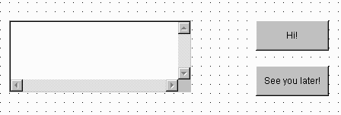
Figure 13: Applet components

Embedding Tango Bean API components
Now, when essential components are in place the Tango Beans API components can be added. They will distribute events generated by the buttons. Figure 14 presents all components in modified application. One TangoBean and two ObjectPipe objects were added. Tango Beans API components can be placed at arbitrary location, they will not be visible when the applet is started. The figure presents the components labeled with names assigned by the application builder. Visual Café assigns names to the created objects automatically. Since now the application components will be referred to using those names.

Figure 14: Applet components with assigned names
Each of the added components has specific function assigned. tangoBean1 is necessary for maintaining communication with Tango system. It will also provide user name information. objectPipe1 is used for sending events from button1 (‘Hi!’) to textArea1. objectPipe2 is used for sending events from button2 (‘See you later!’) also to textArea1. One ObjectPipe object would be enough to send strings from both buttons but the presented structure was chosen to illustrate how application can communicate using several pipes.

Connecting components
All components must be now connected to ensure proper flow of events in the application. This operation can be carried out using Interaction Wizard Visual Café environment. Three basic types of connections are described below.

Connection from objectPipe1 to tangoBean1
The connection from objectPipe1 to tangoBean1 is necessary to register the ObjectPipe in TangoBean object. The window used to create this connection is shown in Figure 15. The list of events that can be fired by objectPipe1 are enumerated in upper area of the window. The methods that can be called on tangoBean1 are enumerated in the lower area of the window. As illustrated in the figure, the event ‘pipeReady’ fired by objectPipe1 causes ‘Connect new pipe’ method to be called on tangoBean1. The appropriate entries are highlighted in the Interaction Wizard window.

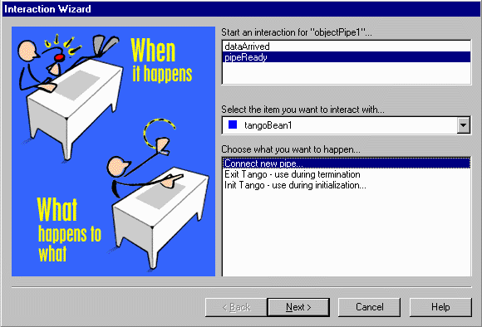
Figure 15: Connection from objectPipe1 to tangoBean1
The ‘Connect new pipe’ method has one parameter. It must be specified in another window, which appears when ‘Next>’ button is clicked. In this case, ‘pipeReady’ event is passed as a parameter. Figure 16 illustrates this assignment. When the ‘Finish’ button is clicked the connection is established. The analogous connection must be established between objectPipe2 and tangoBean1.

-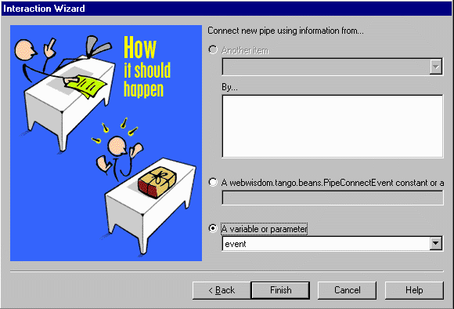
Figure 16: Parameter for ‘Connect new pipe’ method

Connection from button1 to objectPipe1
The connection from button1 to objectPipe1 is necessary to intercept and distribute to other applications the event fired by button1 (“Hi!”). When we click on the button1 (‘Hi!’) ‘Send data to all participants’ method must be called on objectPipe1 – see Figure 17. Since ‘actionPerformed’ event is fired when the button is clicked, it must be associated with ‘Send data to all participants’ method. This method accepts data to be sent as a parameter. We want to send appropriate string with user name added.

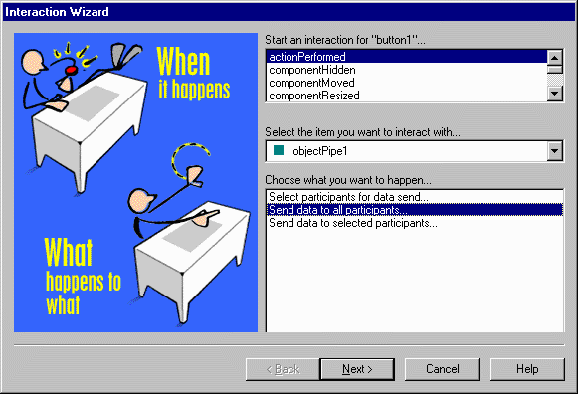
Figure 17: Connection from button1 ‘Hi!’ to objectPipe1
Figure 18 shows how the parameter value is specified. The part of the information is retrieved from tangoBean1. The method getUserName() returns the user name of the participant, which was provided during Tango login procedure. The analogous connection should be established between button2 and objectPipe2 but with different string sent, for example:

tangoBean1.getUserName() + “ says See you later!”

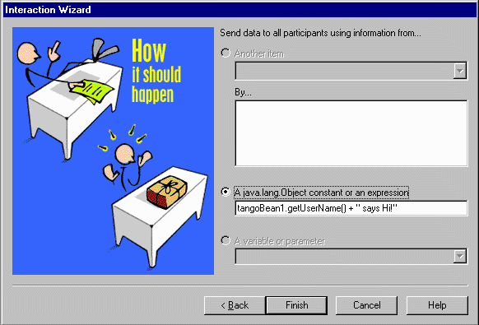
Figure 18: Parameter for ‘Send data to all participants’ method

Connection from objectPipe1 to textArea1
The connection from objectPipe1 to textArea1 is necessary to display data in the text area. When the ‘dataArrived’ event is fired by objectPipe1, ‘Append string in TextArea’ method must be called on textArea1 component. This method will add new string to the text in the text area – see Figure 19.

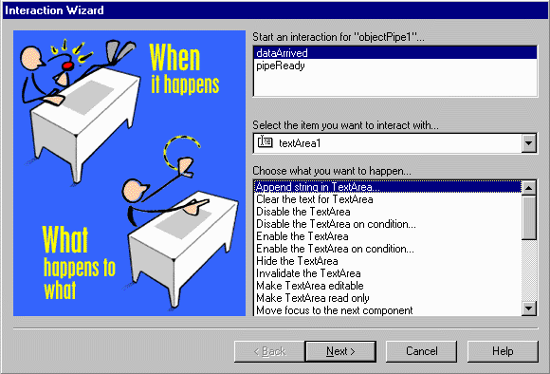
Figure 19: Connection from objectPipe1 to textArea1
The parameter of this method is of a String type. The data is retrieved from the ‘dataArrived’ event and converted to String type. The received string is concatenated with additional message. Whole message will be displayed in textArea1. The analogous connection is established between objectPipe2 and textArea1 with different message.

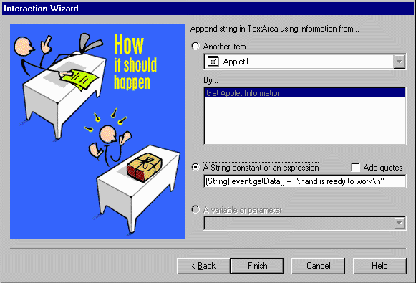
Figure 20: Parameter for ‘Append string in TextArea’ method

Adding necessary modifications
As it was explained in section 7 some modifications must be made to the auto generated source code.
First of all, two additional classes must be imported:
import webwisdom.tango.beans.TangoBean;
import webwisdom.tango.beans.ObjectPipe;
// added import
import webwisdom.tango.TLAgentApplet;
import webwisdom.tango.TLAgent;
// end of added import
Afterwards, the modification is introduced in the applet init method. The added code initializes connection with Tango system. The code between comments ‘tango initialization’ and ‘end of tango initialization was added to the code created by application builder.
Finally, we must add code that informs Tango system about termination of the applet. The new implementation of the destroy method is provided below:
public void init() {
.
.
tangoBean1 = new webwisdom.tango.beans.TangoBean();
tangoBean1.setBounds(288,96,61,40);
tangoBean1.setFont(new Font("Dialog", Font.PLAIN, 12));
add(tangoBean1);
// tango initialization – code added
try {

TLAgentApplet tla = new TLAgentApplet(this);
tangoBean1.tangoInit(tla);

} catch(Throwable e) {

System.out.println("Could not find Tango system");
}
// end of tango initialization – end of added code
.
.
}

Testing
public void destroy(){

tangoBean1.tangoExit();
}
When all connections and modifications are completed the applet can be launched from Visual Café environment. Visual Café starts an applet in Applet Viewer – see Figure 21. ‘Hi!’ and ‘See you later!’ buttons can be clicked to check if the implementation is correct. The appropriate messages appear in the text area. Note that instead of a real user name – ‘test_user_name’ string appears. This is the case when TangoBean is in testing mode. The real names of the participants will available in Tango environment. Note also that TangoBean and ObjectPipe objects are not visible.

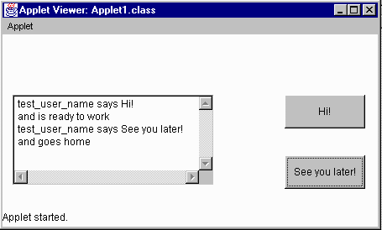
Figure 21: Applet during tests

Applet signing and packaging
The classes that contain the applet implementation should be signed and packaged into jar file. For this purpose the singtool program is used. Following command line creates TApplet.jar file with classes placed in tapplet directory. For signing, Syracuse University signature is used which is placed in D:\program files\netscape\users\beca directory.

signtool -d"\program files\netscape\users\beca" -k"Syracuse University" -Z"TApplet.jar" tapplet

Visual Café creates html page for an applet. It must be modified so that the applet can work properly in Tango environment. The applet main class must be loaded from jar file and MAYSCRIPT must be added in APPLET tag. Here is the auto generated HTML with applied modifications.
<HTML>
<HEAD>
<TITLE>Autogenerated HTML</TITLE>
</HEAD>
<BODY>
<APPLET ARCHIVE="./TApplet.jar" CODE="Applet1.class"
WIDTH=426 HEIGHT=266 MAYSCRIPT></APPLET>
</BODY>
</HTML>
Finally, the html page and jar file with applet classes are placed on http server.

Running in Tango
The application must be added to the set of Tango applications to run in the Tango environment – we must be able to start it from Tango Control Application. When it is done, the Tango system should be started. After the collaborative session is established, the messages between instances of the collaborative application can be exchanged. Figure 22 shows the example applet running under control of Tango system. This instance of application was started by Bernard, colleague of John and Mary. He received two message: one from John and one from Mary. He also sent a message to them. Note that the message sent by Bernard does not appear in the text area of the application. It is distributed only to John’s and Mary’s instances of the application. If the events should also be interpreted by the sender application, new connections should be added that link directly the buttons and text area component.

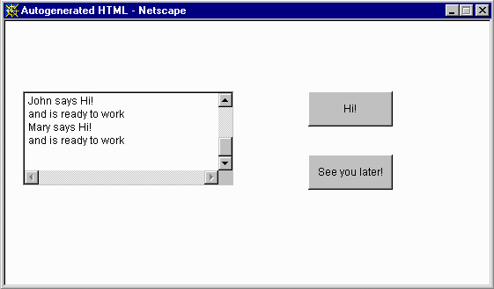
Figure 22: Applet running in Tango environment

This statement is true for Java applets and applications. Applications created in other languages have different implementation on different operating systems.

