Web Interfaces for Environmental Modeling Systems

A WebFlow Application

Tomasz Haupt
NPAC at Syracuse University

Abstract
This report describes a pilot Web-based implementation of the Landscape Management System (LMS). The Web-based implementation extends the Watershed Modeling System by adding the capability to download the input data directly from remote data repositories (such as Internet repositories and distributed databases), and to execute the simulation codes on a remote high-performance host. This makes it possible to run LMS anywhere from a networked laptop. Furthermore, our system allows for constructing complex simulations by coupling several independently developed codes into a single, distributed application. Based on the experience building this prototype, we designed an extended version of the system that can be used for Web-based management of other environmental modeling systems (such as Groundwater, and Surface-Water Modeling Systems).

The Web-based LMS is implemented as a WebFlow application. WebFlow is a modern three-tier commodity standards-based High Performance Distributed Computing (HPDC) system that integrates a high-level graphical user interface (Tier 1), distributed scalable object broker middleware (Tier 2), and a high-performance back end (Tier 3).

This project is sponsored by ERDC MSRC at Vicksburg, under the DoD HPC Modernization Program, Programming Environment and Training (PET).

Introduction

WebFlow Mission
Programming tools that are simultaneously sustainable, highly functional, robust and easy to use have been hard to come by in the HPCC arena. This is partially due to the difficulty in developing sophisticated customized systems for what is a relatively small part of the worldwide computing enterprise. Thus we have developed a new strategy - termed HPcc High Performance Commodity Computing[1] - that builds HPCC programming tools on top of the remarkable new software infrastructure being built for the commercial web and distributed object areas. This leverage of a huge industry investment naturally delivers tools with the desired properties with the one (albeit critical) exception that high performance is not guaranteed. Our approach automatically gives the user access to the full range of commercial capabilities (e.g., databases and compute servers), pervasive access from all platforms and natural incremental enhancement as the industry software juggernaut continues to deliver software systems of rapidly increasing power.

Our research addresses the need for high-level programming environments and tools to support distance computing on heterogeneous distributed commodity platforms and high-speed networks spanning across labs and facilities. More specifically, we are developing a portable system based on industry standards and commodity software components that provide a seamless access to remote resources through Web-based user interfaces or customized application GUIs.

We have successfully employed WebFlow for several classes of applications. Among the most important are: Quantum Monte Carlo simulations[2] (QS) developed within NCSA Alliance Team B (described is Section 3.1), and the Gateway system (described in Section 3.2) at ASC MSRC and Ohio Supercomputing Center.

Seamless Access to Remote Resources
As described above, one of the most important goals of the WebFlow system is to provide a seamless access to remote resources. That is, our goal is to create an illusion that all resources needed to complete the user tasks are available locally (an analogy: an NFS mounted disk or a network printer). In particular, an authorized user can allocate the needed resources without explicit login to the host controlling the resources. And by “resources” we mean all hardware and software components needed to complete the task - including but not limited to - compute engines from workstations to supercomputers, storage, databases, instruments, codes, libraries, and licenses. A critical issue in providing access to remote resources is security of access (user authentication and authorization), which is a primary concern of the Gateway system implementation and it is discussed in Section 3.2.

High-Level Graphical User Interfaces
Another of our goals is to provide user-friendly, high-level graphical user interfaces (WebFlow front end) for the user applications. We simultaneously follow several approaches, as the requirements for different applications vary greatly. For Quantum Simulations we provide a Web-accessible front end (a Java applet) that allows the user to visually compose an application from pre-existing modules following a dataflow paradigm. For the Gateway projects we will use a Web-based Problem Solving Environment[3] (an expert system) that allows the user to interactively define a problem, identify resources (both software and hardware), submit the task for execution and, finally, analyze the results.

For LMS we face different requirements. LMS applications are composed of independent modules selected by the application developers, and the end user only selects the application that best suites the problem at hand. We refer to this as the “navigate and choose” paradigm. Another unique feature of the LMS front end is that it automates the retrieval of necessary input data from Internet repositories such as the USGS Web site.

Three-Tier Architecture
To satisfy the requirements of supporting multiple front ends and a variety of back end platforms, we implement WebFlow as a three-tier system, as shown in Figure 1.

The heart of the system is the middle tier that provides a mapping between the application-independent Abstract Task Specification (ATS) and the platform-independent Resource Specification (RS). In addition, the middle tier offers a number of services that simplify the development of applications, and it provides support for interactions between usually distributed components of the application.

WebFlow applications are composed of independently developed modules. Module developers do not need to concern themselves with issues such as allocating and running modules on various machines, creating connections among modules, sending and receiving data across these connections, or running several modules concurrently on one machine. The WebFlow’s middle tier hides these management and coordination functions from the developers who have only a limited knowledge of the system on which the modules will run.

WebFlow Design

Implementation Strategy
Following our HPcc model, we build WebFlow in strict conformance to industry standards. We avoid custom protocols and follow the general trends, and whenever feasible we use commodity software components. We believe that such an approach will simplify maintenance of our system and will let us take advantage of the new developments introduced by industry. However, our solution is not unique. Web technologies are being developed at unprecedented fast pace, and competition between vendors often leads to multiple standards. We had to make choices between the competing standards (for example, we chose CORBA and not Microsoft’s DCOM or Sun’s Java RMI to implement the distributed objects), and it remains to be seen whether we made the right choice. Nevertheless, some of our choices, such as https (http over SSL) and XML, seem to be non-controversial. When there are no standards available (for example, AST or RS), we participate in creation of such standards (DATORR[4], NCSA Alliance).

Problem
Solving
Environments

Other

OO
Visual
Authoring
Tools

Data-Flow
Visual
Authoring
Tools

Custom
Application
GUI

Middle-Tier
Abstract Task Specification
Resource Specification

Back-End resources

Figure 1: Three-Tier architecture of the WebFlow system: visual authoring tools comprise Tier 1 (front end), distributed object-based, scalable, and reusable Web server and Object broker Middleware form Tier 2 (middle tier), while computational and data resources constitute Tier 3 (back end).

Master Server
Slave Server
Slave Server
Slave Server Proxy

Application Contexts

Modules

User Contexts

Figure 2: Example of WebFlow object hierarchy. See text for explanations.

WebFlow Design
WebFlow consists of objects that interact with each other through event notifications. The basic object is a WebFlow server, which is a CORBA container object (also referred to as a context). The server contains other containers and modules. The hierarchy of the containers and modules is composed to fit the application at hand. An example is shown in Figure 2. In this particular configuration we have three WebFlow servers, each running as a separate process (typically on three different hosts), one of which serves as a master, the two others as its slaves. The master server publishes its reference (IOR – Interoperable Object Reference) so that clients can connect to it and request its services. In addition, the master keeps references to its slaves (slave server proxies), which are returned to the client upon request. Within the slave WebFlow context one or more users creates his or her own contexts, which in turn contain the user applications. The application consists of modules. In this way a number of users can create several applications, each made of independent (possibly hierarchically composed) modules and WebFlow middle-tier services (cf. Figure 3). Modules and services are executable written in Java. There is no difference between the module and the service, other than that the module is provided by the user (or the application developer) and placed within the user’s application context, while the service is provided by the WebFlow system itself and implements a standard task such as job submission or access to mass storage or file manipulation. Applications differ in how the modules interact with each other. In Figure 3 we illustrate some

User 1
User 2
Application 1
Application 2
App 2
App 1
WebFlow server is given
by a hierarchy of containers
and components

WebFlow server hosts
users and services

Each user maintains
a number of applications
composed of
custom modules
and
common services
WebFlow Services

Figure 3: WebFlow server

of the possibilities. In application 1 of user 1, modules interact in the most general way: each module can invoke any public method of the other modules. In application 1 of user 2 a data-flow model is used: the modules exchange data through their input and output ports. Application 2 of user 1 consists of two modules that do not interact. They can run concurrently, and they can exchange messages “privately”, that is, without WebFlow help say, using MPI. Actually, a single module may represent a data parallel application implemented in HPF, or C++ with MPI. In LMS we use yet another way of communicating between the modules, as described in Section 4 below.

The modules (and services) are technically CORBA objects implemented in Java. However, that does not mean that the actual functionality of the module must be implemented in Java. Legacy applications can be easily encapsulated as CORBA objects and thus used as WebFlow modules (as we did in the case of LMS, see Section 4). But typically a module serves merely as proxy for services rendered by the back end. As an example, the middle tier provides the service of submitting a job using Globus[5]. To submit a job the service acts as a client to the GRAM (Globus Resource Allocation Manager) server. More specifically, it sends a request expressed in the Globus RSL (Resource Specification Language) that defines the target machine, location of executable and input files, as well as instructions what for dealing with the standard output and standard error streams. Optionally, through GASS (Global Access to Secondary Storage) both executable and input data sets can be staged prior to the execution of the job, and output files can be uploaded to a specified location after the job is completed. The Java code of the WebFlow proxy module generates the RSL command, and the WebFlow module developer never needs to see the actual application, let alone make an attempt to rewrite the application in Java.

Middle Tier
The middle tier is given by a mesh of WebFlow servers. If the client is implemented as a Java applet, one of the WebFlow servers, namely, the master server, plays the role of gatekeeper. It is accompanied by a (secure, i.e., SSL based) Web server, as shown in Figure 4.

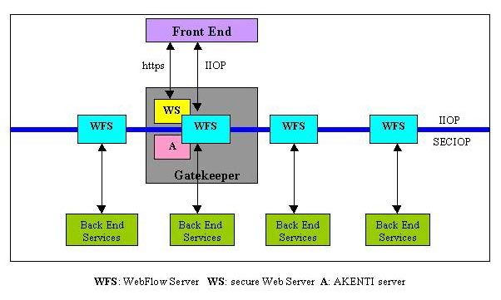

Figure 4: Architecture of the WebFlow middle tier
The user downloads the applet from the Web server (and since https protocol is used she is authenticated in this process and, optionally through the Akenti server receives authorization to use the WebFlow resources – see Section 3.2 for more details on WebFlow security). The applet reads the master server IOR, which is posted as an html document, and establishes communication with the WebFlow. Because of the Java sandbox security mechanism, the applet can communicate exclusively with the master WebFlow server, which runs on the same host as the Web server. This is the reason we introduced the proxy servers maintained by the master. The client (i.e., the applet) communicates with the remote slave WebFlow server through these proxies and constructs the WebFlow context hierarchy, as needed using WebFlow server methods. In particular, it builds an application within a selected context.

Simple applications can be run on a single WebFlow server. We have introduced a distributed middle tier, a mesh of WebFlow servers, because, in general, different hosts may have access to different resources (hardware, operating system, software, access control, etc.). As shown in Figure 5, each WebFlow server manages a particular set of user modules and services. The communication between modules on different hosts is managed transparently by the middle-tier for the user.

Figure 5: Mesh of WebFlow Servers
implemented as CORBA objects
that manage and coordinates
distributed computation.
F
ront End

Gatekeeper
Authentication
Authorization

WebFlow applications

Quantum Monte Carlo Simulations (QS)

The QS project is a part of Alliance Team B, and its primary purpose is to demonstrate the feasibility of layering WebFlow on top of the Globus metacomputing toolkit. WebFlow thus serves as a job broker for Globus, while Globus (or more precisely, GRAM – Globus Resource Allocation Manager) takes responsibility of actual resource allocation, which includes authentication and authorization of the WebFlow user to use computational resources under Globus control (Figure 6).

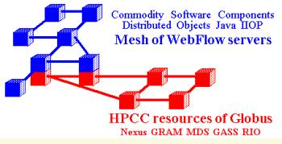
Figure6: WebFlow over Globus

The system is given by two networks: one controlled by the WebFlow (workstations) and the other controlled by Globus (HPCC resources). There must be at least one node with both WebFlow server and GRAM client installed.

This application can be characterized as follows. A chain of high-performance applications (both commercial packages such as GAUSSIAN or GAMESS or custom developed) is run repeatedly for different data sets. Each application can be run on several different (multiprocessor) platforms and, consequently, input and output files must be moved between machines. Output files are visually inspected by the researcher; if necessary, applications are rerun with modified input data sets. The output file of one application in the chain is the input of the next one, after a suitable format conversion.

GAUSSIAN and GAMES are run as Globus jobs on Origin2000 or Convex Exemplar at NCSA, while all file editing and format conversion is performed on the user’s desktop.

For QS we are using the WebFlow editor applet as the front end (Figure 7). The WebFlow editor provides an intuitive environment to visually compose (click-drag-and-drop) a chain of data-flow computations from preexisting modules. In the edit mode, modules can be added to or removed from the existing network, and connections between the modules can be updated. Once created, the network can be saved (on the server side) to be restored at a later time. The workload can be distributed among several WebFlow nodes (WebFlow servers) with interprocessor communications being taken care of by the middle-tier services. Thanks to the interface to the Globus system in the back end, execution of particular modules can be delegated to powerful HPCC systems.

The visual representation of the application is translated into the Abstract Task Specification and sent to the middle tier as an XML document. The AST itself is expressed in terms of DTD (Document Type Definition), and it is listed in Figure 8. XML documents conforming to this specification provide all necessary information to create the WebFlow context hierarchy (see Figure 9 for a simple example); the <taskspec> tag provide references for the user context, and the <task> tag describes the application context. The computational graph visually created by the user is represented by the sequence of the <module> and <connection> tags.

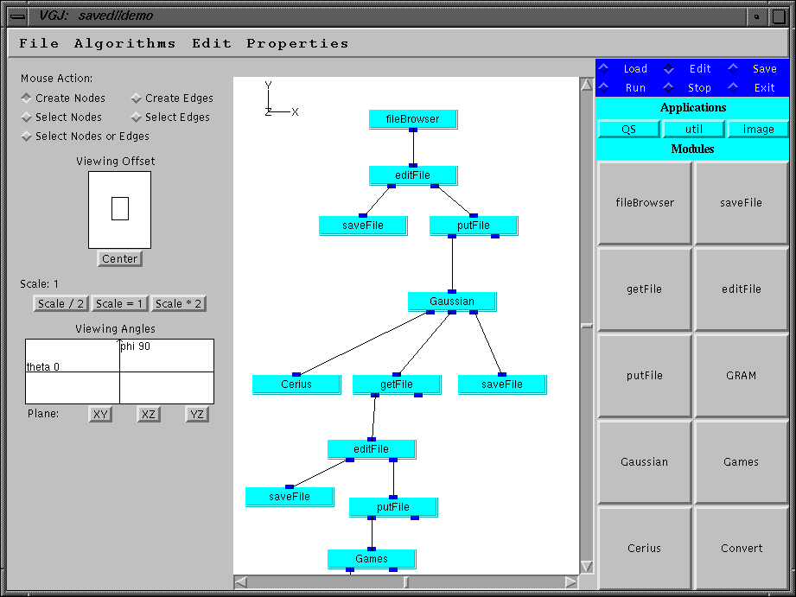

Figure7: WebFlow data-flow editor applet used as the front end for Quantum Monte Carlo simulations. It allows the user to perform interactive, visual composing of the application from pre-existing modules.
The XML document is parsed by a middle-tier service and is used to generate a Java code on-the-fly that serves as internal client for the WebFlow servers (Figure 10). This means that once the application is committed by pressing the run button nothing can be changed until the application is completed or aborted. However, since each module comes with its own front-end control panel, the parameters that the module developer made visible to the user can be modified, even at runtime.

<!ELEMENT taskspec (task)+>
<!ATTLIST taskspec
UserContextRef CDATA #REQUIRED
UserName CDATA #REQUIRED >
<!ELEMENT task ((task | module)*,connection*) >
<!ATTLIST task
AppName CDATA #REQUIRED >
<!ELEMENT module (#PCDATA) >
<!ATTLIST module
modulename CDATA #REQUIRED
host CDATA #REQUIRED >
<!ELEMENT connection (out,in)>
<!ELEMENT in EMPTY>
<!ELEMENT out EMPTY>
<!ATTLIST out
modulename CDATA #REQUIRED
eventname CDATA #REQUIRED>
<!ATTLIST in
modulename CDATA #REQUIRED
method CDATA #REQUIRED>

Figure 8: XML Document Type Definition used as the Abstract Task Specification.

<taskspec UserContextRef="IOR:000000000000001649444c3a576562466c6f772f50726f78793a312e30000000000000010000000000000030000100000000000f3132382e3233302e32312e323132000004740000000000100000000036f66c3800088f6800000002" UserName="haupt">
<task AppName=”SimpleTest”>
<module modulename="FileBrowser.1" host="localhost">
</module>
<module modulename="SaveAs.2" host="localhost">
</module>
<connection>
<out modulename="FileBrowser.1" eventname="Event101"/>
<in modulename="SaveAs.2" method="Method1"/>
</connection>
</task>
</taskspec>

Figure9 A simple XML document conforming to the DTD specification of Figure 8.

XML

A visual representation
is converted into a XML
document
XML
service

Web
Server
save
Front-End Applet
Middle-Tier

parse

ApplContext

Figure10: A visual representation of the application is translated into an XML document and sent to the middle tier. An XML parser, implemented as a service, processes the document and generates the Java code that serves as a client for the WebFlow server to create the context hierarchy, instantiate modules, and bind events.

Gateway Project

This project is performed in collaboration with ASC MSRC and the Ohio Supercomputing. Our goal is to combine the CCM Problem Solving Environment under development at OSC with secure, seamless access to resources provided by the WebFlow system. Security is the most important new aspect of WebFlow to be addressed in this project. It is required that Gateway will operate in an environment protected by Keberos5 in conjunction with SecurID technology.

Our suggested strategy is to run the client (an applet) in a keberized environment that will allow the user to generate the Keberos ticket locally without sending cleartext passwords through the networks. Then the user connects the Web Server to download the front-end applet. The Web server creates the user context in a new process on a selected host that runs with the user’s credentials. The applet will communicate with the WebFlow servers using CORBA security services implemented on top of the Keberos5. Access to the back-end services is provided by Globus GRAM-keeper linked against the Keberos5 libraries rather than the default SSL used by Globus.

LMS

Description of the Proof-of-Concept Prototype

The pilot phase of the project can be described as follows. A decision-maker (the end user of the system) wants to evaluate changes in vegetation in some geographical region over a long time period caused by some short-term disturbances such as a fire or human activity. One of the critical parameters of the vegetation model is the soil condition at the time of the disturbance. This, in turn, is dominated by rainfalls that possibly occur at that time. Consequently, the implementation of this project requires (cf. Figure11):
- Data retrieval from many different remote sources (web sites, databases)
- Data preprocessing to prune and convert the raw data to a format expected by the simulation software.
- Execution of two simulation programs: EDYS for vegetation simulation including the disturbances and CASC2D for watershed simulations during rainfalls. The latter results in generating maps of the soil condition after the rainfall. The initial conditions for CASC2D are set by EDYS just before the rainfall, and the output of CASC2D after the event is used to update parameters of EDYS.
- Visualizations of the results.

WMS
EDYS
CASC2D
DEM
Land Use
Soil
Texture
Vegetation

Figure 11: Logical structure of the LMS simulations implemented by this project

The purpose of this project was to demonstrate the feasibility of implementing a system that would allow launching and controlling the complete simulation from a networked laptop. We successfully implemented it using WebFlow with WMS and EDYS encapsulated as WebFlow modules running locally on the laptop and CASC2D executed by WebFlow on remote hosts.

Interaction between Casc2d and Edys simulations

The casc2d[6] and Edys[7] codes were developed independently of each other. We cannot provide many details on these codes as that goes beyond our expertise. Please contact the authors of the codes directly for further information. The discussion presented here is rudimentary and is concentrated on issues directly relevant to WebFlow-based implementation.

Casc2d simulates watersheds. It runs in a loop over rainfall events, and in each iteration of the loop the program simulates water flow in the area of interest. Once the simulation of the rainfall event is completed (according to some predefined criteria) the simulation switches to a “dry” mode in which the program simulates the condition of soil in the absence of precipitation. A new rainfall starts a new iteration.

Edys simulates the evolution of vegetation taking into account the soil condition at the beginning of simulation. During the simulation, it uses averaged precipitation data rather than data describing actual rainfall, event after event. Edys runs for a specified time period, and before it exits it saves its state on a disk. This means that the simulation can be resumed later.

The accuracy of the Edys simulation can be improved by coupling it with casc2d, that is, by feeding Edys with accurate data on soil condition after each rainfall. We implemented the coupling in the following way (cf. Figure 12). We start the simulation with casc2d (on a host running Unix). It reads its input files and determines the time of the first rainfall. It writes the data to the disk and starts the loop over events. However, in each iteration, before proceeding with the simulations, casc2d waits until new data on the soil condition generated by Edys are available. Technically, every ten seconds it checks the modification time of its input files∗. In the meantime, the data written by casc2d are sent to the host running Edys (a laptop running Windows NT). The received data include the date of the next rainfall. The Edys simulation is launched and continued until that date. The simulation program exits, and its output files are sent to the host of casc2d. Casc2d detects the arrival of the new data and resumes the simulations. As soon as the current is completed, casc2d saves the results to a file and begins a new iteration. The results are sent to the laptop, Edys is run until the next event, and its output is sent to the Unix host to let casc2d continue. This pattern is repeated until all rainfall events are processed. Then casc2d exits, and the final run of Edys is performed. The run terminates at a predefined date, typically 20 years after the first rainfall.

Exit
Read Data
Wait for data
Write data
Read data
Casc2d
simulation
For each rainfall event

Read data
Edys
simulation
Write data

Figure12: Exchange of data between casc2d (left-hand side) and Edys (right-hand side). It is important to note that casc2d is run only once. It pauses while waiting for the new data and quits only after all events are processed. In contrast, Edys is launched each time the data are needed.

LMS Middle Tier

This application requires two computational modules: one encapsulating EDYS to be run on WindowsNT box and the other encapsulating CASC2D to be run on a Unix workstation. Consequently, we need two application contexts, one on each machine. As usual, we also need the master server, which we place on the WindowsNT box, as shown in Figure 13, because we run the client application there. In addition, we run Web servers on both machines. They are needed primarily to exchange the data between the modules. We also publish the master IOR on the Web server on the WindowsNT side.

The servers are started manually using the java WebFlow.Server file.conf command, with a different configuration file for each servers. For the master server, we specify the full path of the file where the IOR

slave
slave server

UNIX
WinNT
Web
Server
Web
Server
WebFlow servers Servers
Client

lms.class

Data wizard

WMS

exeCasc2d

runCasc2d
runEdys

Master
server

Figure 13: WebFlow implementation of LMS

is to be stored. For the slave server, we specify the URL at which the IOR is available, and define the modules under the server control (see Figure 14). At this time the configuration files must be generated manually. We believe that in the future releases of the WebFlow system we will be able to automatically generate the configuration files from the IDL specifications.

The servers are accessed by the client code that is a part of the LMS front end. Figure 15 shows the relevant part of the code. First, the client initializes the ORB object (line 1), and then reads an IOR of the master server from the URL (line 3). For the IOR it creates a CORBA object obj (line 4) and casts it to the correct type: WebFlowContex (line 5). Now it can call methods of this object. In lines 9 and 10 it uses the method getWFServer(serverName) to retrieve references to both slave servers. It adds module “runEdys” to the ntserver context (line 11) and module “runCasc2d” to osprey4 contexts (line 12). In line 13 it casts obj p2 to type runCasc2d, as it needs to invoke one of its methods (in line 16). Then it connects the modules, event “EdysDone”, fired by module runEdys, will invoke method “runAgain()” of module runCasc2d (line 14), and event “casc2dDone”, fired by runCasc2d, will invoke method “receiveData()” of runEdys. Now everything is ready to start the execution. It is triggered by invoking method run() of module runCasc2d.

A)
Server name = master
File=D:\Jigsaw\Jigsaw\WWW\Gateway\IOR\master.ref
URL=none
Modules:==================================

B)
Server name = ntserver
File=none
URL= http://maine.npac.syr.edu:8001/Gateway/IOR/master.txt
Modules:==================================
runEdys lms.idl WebFlow.lms.runEdysImpl
C)
Server name = osprey4
File=none
URL= http://maine.npac.syr.edu:8001/Gateway/IOR/master.txt
Modules:==================================
runCasc2d lms.idl WebFlow.lms.runCasc2dImpl

Fig .14: Configuration files for A) master, B) WindowsNT slave C) Unix slave WebFlow servers
Each module is described by its name, IDL file, and Java class name that implements it.

1. ORB orb = ORB.init(args, new java.util.Properties());
2. String masterURL = args[0];
3. String ref=getIORFromURL(masterURL);
4. org.omg.CORBA.Object obj=orb.string_to_object(ref);
5. WebFlowContext master=WebFlowContextHelper.narrow(obj);
6. WebFlowContext slave;
7. try {
8. org.omg.CORBA.Object p1,p2;
9. slave1=WebFlowContextHelper.narrow(master.getWFServer(“ntserver”));
10. slave2=WebFlowContextHelper.narrow(master.getWFServer(“osprey4”));
11. p1 = slave.addNewModule(“runEdys”);
12. p2 = slave.addNewModule(“runCasc2d”);
13. runCasc2 rc=runCasc2dHelper(p2);
14. master.attachEvent(p1,”EdysDone”,p2,”runAgain”);
15. master.attachEvent(p2,”Casc2dDone”,p1,”receiveData”);
16. rc.run();
17. } catch(Exception e) {};

Figure15: Fragment of the client code

Adding new modules to the client is simply a matter of adding a few lines of code (addNewModule and narrow). If the methods of these modules are to be invoked directly from the client, add attaching events, if any.

In the next releases we plan to reuse the XML parser that we developed for the Quantum Simulations project, after which there will be no need to provide a client code in Java at all. Instead, the application will be defined by a static XML document, available from a Web server, and instantiated dynamically at runtime. More, the modification of the application will be possible just by editing the XML file without introducing any changes to the code.

Figs. 16 and 17 show the pseudocode of both modules, runCasc2d and runEdys, respectively. The simulation starts by invoking the method run() by the client.

runCasc2dImp
EdysDone
event
called from
Front-End

run(){
cT = new cas2c2Thread();
cT.start();
waitForData();
}

Class cas2dThread extends Thread{
run(){
Process p=Runtime.getRuntime().exec(Casc2dExec);
p.waitFor();
}}

runAgain(){
receiveData();
moreEvents =nextEvent(lmsStatusFile);
lastMod=(new File(testFile)).lastModified();
if(moreEvents) {
reactivateCasc2d(touchCommand);
waitForData();
} }

receiveData(){
getHTTPfile(ContentsFile,ContentsFileURL);
for i=0;i<nfiles; i++){
getHTTPfile(casc2dDir+fn, FileBaseURL+fn);}
}}

waitForData(){
waitForUpdate=true;
while (waitForUpdate) {
idle for 1 sec
newMod = (new File(testFile)).lastModified;
if(newMod>lastMod) waitForUpdate=false;
}
sendData();
fireEvent(“Casc2dDone”,ev);
}

Casc2dDone
event

sendData(){
createContents [OutContents]
copy files
from casc2Dir to OutFileBase
}

Figure 16: Pseudocode of the runCasc2d module

Module runCasc2d is started from the front end by invoking its run() method, which creates a new Java thread that runs casc2d code in a separate process. It then invokes the waitForData() method. This method waits until casc2d generates the first data set for Edys, copies the files to a location seen by the Web server, and fires event “Casc2dDone” that invokes the run() method of run Edys.

When Edys fires the “EdysDone” event, the runAgain() method of runCasc2d is invoked. This method receives data from Edys (using the Java URLconnection class to access files from the Web server on the Edys host), and executes the UNIX touch command on a selected control file. By “touching” this file we change the ‘last modified’ property of that file, and this triggers casc2d to resume its operations. The controls then go to the waitForData() method, described above.

Casc2dDone
event

receiveData(){
receiveStat(param3,param4,edysend);
receiveEDY();
run();
}
receiveStat(int, int, long){
readHTTPfile(StatFileURL);
… StartDay, DayDiff …options
writeFile(OptionsFile,options); //options.txt

receiveEDY(){
getHTTPfile(ContentsFile,ContentsFileURL);
if(ContentsFile.equals(“end”)) flag=false;
else {
for i=0;i<nfiles; i++){
… translate names *.edy -> edys expectations
getHTTPfile(EdysInDir+fn, FileBaseURL+fn);}
}

run(){
Process p = Runtime.getRuntime().exec(EdysExec);
p.waitFor();
if(flag) {
sendData();
fireEvent(“EdysDone”,ev);}
}

sendData(){
createContents [OutContents]
copy files
from EdysOutDir to OutFileBase
}
EdysDone
event

Figure 17: Pseudocode of the runEdys module

The RunEdys module is triggered by the Casc2dDone event that invokes the receiveData() method. First, a file options.txt is generated. This files defines input parameters: start date of the simulation (StartDay), number of days to be run (DayDiff), parameter 3, which is a toggle to switch the Edys visualizations on and off, and parameter 4 which defines disturbances, if any. Then the data from the Web server of the casc2d host are downloaded. Finally, the Edys code is launched. After it is completed, its output is copied to a location seen by the Web server, and the “EdysDone” event is fired.

The sendData() method (which is identical in both modules) actually does not send any data. Instead, it copies data from the Edys (or Casc2d) working directory to a document directory of the Web server (Figure18). This step could be avoided letting the codes write and read their input and output files directly from the WebServer. This would require slight modifications of these codes, and we had no access to their sources.

WinNT
Web
Server
Web
Server
UNIX

Front-end

lms.class
Write
Data wizard
Write

WMS

exeCasc2d
http
Thread in which
casc2d code is run
http

slave

runEdys

slave

runCasc2d

IIOP

master

Figure 18: Data exchange between runEdys (left-hand side) and runCasc2d (right-hand side) modules. Events are exchanged through IIOP, data sets are downloaded from Web servers.

LMS Back-End

This pilot implementation of the Web-based LMS does not require any powerful computational resources, and consequently we provided only a limited support for back-end services. In particular, we simply used Java Runtime class to run the WebFlow modules on the same host on which the WebFlow server runs. As discussed is Section 3 above, we are prepared to provide a secure access to remote, high-performance resources when it is needed.

LMS Front End

For this project we developed a custom front end implemented as a Java application (as opposed to Web-accessible Java applets used in projects described in Section 3). There are several reasons for that. One is that we were explicitly asked to do so. Second, we did it for performance reasons. Finally, the front end is an extension to the WMS system that needs to be installed on the client side, anyway. Therefore, it does not really matter if the extensions to WMS are to be downloaded as an applet each time the LMS is run, or downloaded once and stored permanently on the client machine.

The WMS program (Watershed Modeling System) is a rich collection of tools for data pre- and post- processing. Furthermore, it allows us to run the simulation locally and visualize the results. WMS is available on many platforms, including Windows 95/98/NT and numerous flavors of Unix.

We made WMS the centerpiece of our front end. We enhanced it by providing the capability to import raw data sets directly from the Internet, submitting the simulations to remote hosts and, as described above, making different simulations interact with each other. Consequently, the LMS front end consists of three parts: data wizard, WMS, and job submission. Each part is accessible by pressing the corresponding button on the LMS main panel (Figure19).

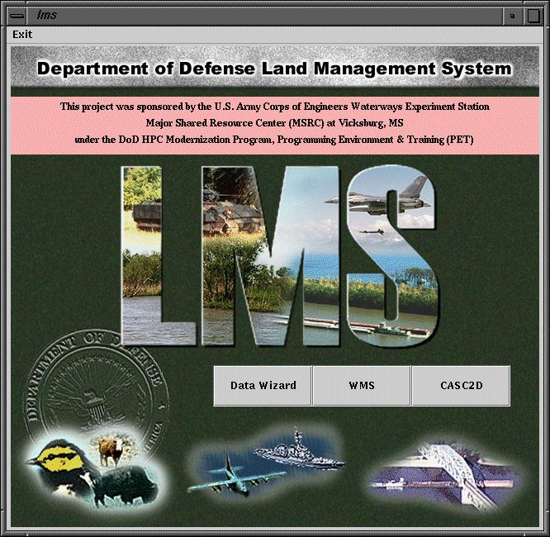

Data retrieval
Data pre- and post-processing
Simulations

Figure 19: LMS front end main panel

Data Wizard

The data wizard panel shown in Figure 20 allows us to select the data type to be retrieved (currently we support DEM and Land Use maps) and to define the region of interest. This can be done either by directly typing coordinates of the bounding box into the provided text fields, or by drawing boundaries of the region on a map. In the latter case, the position of the rectangle is automatically translated into coordinates.

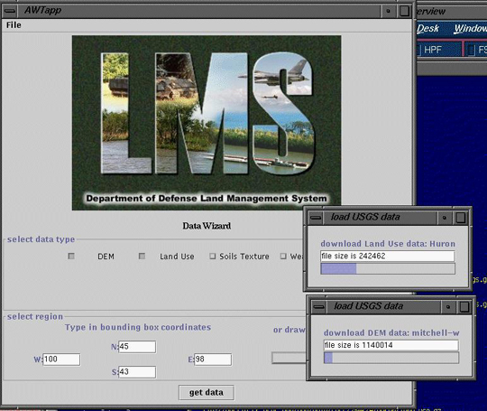
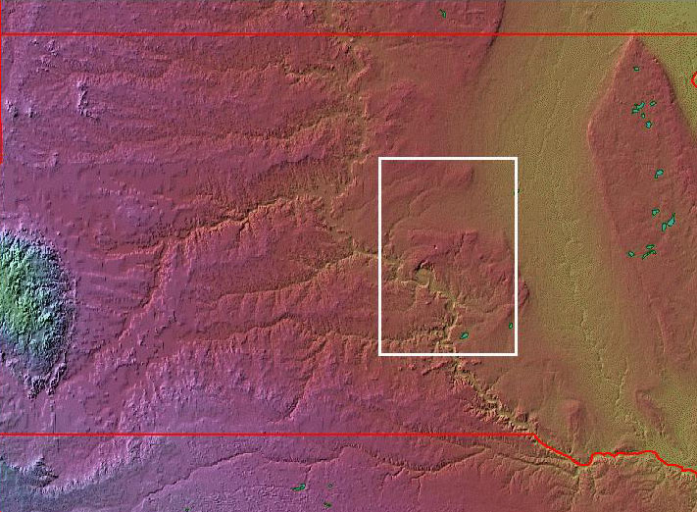
Figure 20: LMS front end data wizard panel

Next, the coordinates are translated into names of the corresponding set of maps available from the USGS web site, and the selected maps are downloaded, uncompressed, and saved in a directory accessible by the WMS package.
Figure 20: A screendump of a WMS session: in the central window just downloaded DEM data are displayed. The raw date must be pre-processed now, including selecting a watershed region, smoothing, and format conversion.

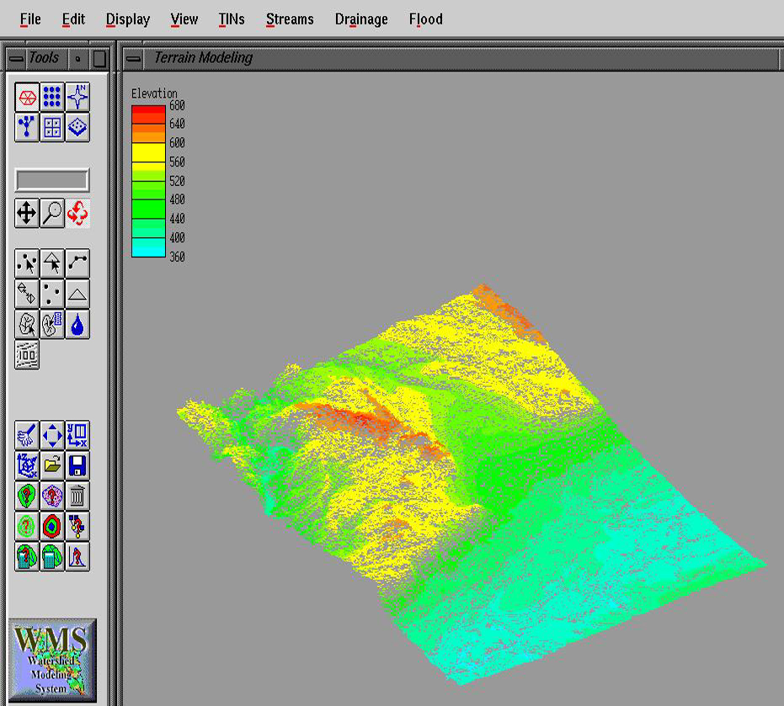
WMS
The WMS button on the main panel starts the WMS program on the local host by the using Java Runtime class in a separate thread. The WMS controls are available during the entire LMS session.

Simulations

The functionality of this part can be deduced from Section 4.3 above. Figure 21 shows the front-end panel that is used to start the simulations.
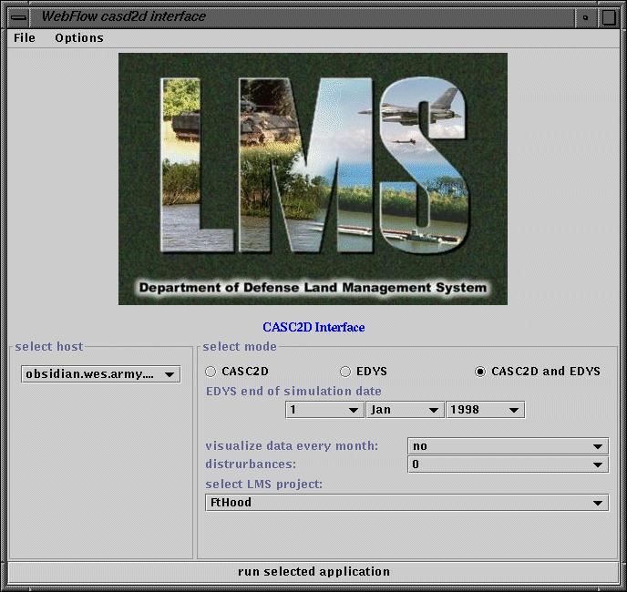
Figure 21: LMS front-end simulation panel. The controls allow for selecting the simulation mode: Casc2d alone, Edys alone, and both simulations coupled, as described in Section 4.3. In the latter case, the user also provides the end date of the Edys run, Edys visualization toggle and disturbances, the directory that contains casc2d input data files and finally the user select the host on which the casc2d simulation is to be run.

This part of the front end acts as a client to the middle-tier services, and it communicates with the WebFlow servers using CORBA IIOP.

Limitations of the prototype

The pilot implementation is focused on providing a support for CASC2D model and its interactions with EDYS. It is not difficult to extend the LMS front end (by adding new panels, buttons, choice and text fields, etc.) to add support for other models. However, this would duplicate the effort already put into WMS (and other "XMS" systems such as GMS: Groundwater Modeling System, or SMS: Surface-Water Modeling System). As a result, it would increase the cost and complexity of maintenance of LMS: any improvement or extension of WMS would have to be implemented in the LMS front-end as well.

While implementing the prototype, we postponed addressing any security issues. These are a primary focus of the Gateway project described in Sect 3.2 above.

Extended LMS

LMS users

We envision LMS to become simultaneously:
- a high-level decision support system
- a tool for the experts in the field
- a tool for training of the new users
Obviously, the requirements for these three category of users are different.

Support for advanced users

Fig.22: Support for an advanced user in LMS

The advanced user starts an LMS session at the entry page. This forces a mutual authentication of the user and WebFlow servers (using either SSL or Kerberos V protocols). Once the user is authenticated (and authorized to access the resources), her or his profile is read, so that the user does not have to set her or his preferences each time he/she logs to LMS. One of the most important user's choices is selection of the interface type: XMS or GIS based. Through the selected interface (say, WMS) the user selects the data, preprocesses them, selects computational model and submits it for execution, postprocess the data, and finally visualize it. Note, that all user activities are done through original WMS (or GIS, GMS,…) interface, and not LMS. However, WMS and other modeling system expect the raw input data be present on a local disk. Therefore, the entry page allows for launching a data wizard, which assists the user with localization, downloading, and format conversion, as needed. The advanced user is expected to know what data he or she needs for a particular model. It is feasible to build a more comprehensive support (lists of data types needed for a particular model, sources of data of a given types, say DEM, and so forth). To design such a support we need help from the application experts, as it goes beyond our expertise.

High Level Decision Support

Fig.23: Discussion Support

Decision support frame (that replaces the entry page of the advanced user) implements “navigate and choose” paradigm. All parameters (including which model is to be run) are preset by the scenario developer, possibly with some choices left to the user. Since the computational model is known, the data can be imported, and job submitted on a remote host transparently to the user (the user intervention to resolve ambiguities or set preferences may be necessary, though). The user also can define the type of output: textual, GIS map, XMS animation, or other as specified by the scenario developer.

Data Wizard

Fig.24: Downloading row input data

The advanced user knows what application he or she wants to run, and therefore knows what kind of data are to be imported. [(1) in Fig. 24] . Less advanced user will be assisted in selecting the application through the decision support frame. Again, this defines data types to be imported. For each data type (such as DEM, or LU), the data wizard will assist the user to make a selection (region, resolution, etc.). The process of selecting data results in a set of parameters that uniquely identify the data object (for example, an USGS map, entry in a database, etc). [(2)]. These parameters will be send to the middle-tier to be resolved (so that the user is always directed to the best data source without a need to upgrade the front end). The middle-tier module will return URL (or equivalent). [(3) and (4)]. The data wizard will use this URL to download the data directly to the local disk (5), and the user can bookmark this URL within LMS for future reference. We will also support a caching mechanism in order not to download data that has been downloaded before.

Proxies
The simulation to be run is selected using either XMS/GIS interface (advanced user) or the decision support frame (otherwise). [(1) in Fig. 25]. Since XMS actually launches the applications on the local machine, the original executables are replaced by proxies. The proxies forward the job submission request to the Job Wizard [(2)]. In this way we can delegate execution of the simulation to a remote host with adequate CPU power without modifying XMS software.

Job Wizard

Fig 25: Submitting a job on a remote host

The job wizard accepts request from the proxy [(3)]. If user decides to run it locally, or there is no connection to the server, the job wizard just submits the code locally. Otherwise, it sends a task descriptor (an XML document) to the middle-tier server. The server parses the XML file and responds with the list of hosts capable of running the code. [(4)]. The user selects the host and presses “submit” button [(4)]. The files specified in the XML file are uploaded to the host, and the job is submitted, again, following the instructions in the XML file. Finally, the files specified in the task descriptor are downloaded. [(5)]

The task descriptor is an XML document that describes location of the executables on different machines, location of the input files (generated by XMS/GIS and other), names of the output files, desired final destination on the front-end machine, and all other parameters and switches needed to execute the codes.

The job wizard keeps track of all job submitted, so the user my query the status of jobs (that may sleep in a batch queue), or find the data that was generated last Friday and double check input parameters.

Summary
This report describes a pilot implementation of the web-based LMS. We successfully demonstrated the feasibility of our approach. Nevertheless, the system is not mature enough to be used in a production mode, and it requires many improvements. The most important areas of the future development include:
- Secure access to resources
- Access to high-performance resources
- Resource detection
- Fault tolerance
- Simplified installation
- Extensibility; adding new application specific modules and reusable middle-tier services
- More general ways of implementing of different kinds of interactions between modules
- Customization of the front-end
- Increased functionality of the front

The obvious next steps are to take advantage of our experience by using WebFlow in other projects: Quantum Simulations and Gateway. In particular, the Gateway project is focused on providing a secure access to resources in the environment protected by Keberos5 in conjunction with SecurID technology and fault tolerance. It seems to us that solutions developed for the Gateway project will be directly applicable to LMS. Within the Quantum Simulation we have already developed methods of providing access to high-performance resources that can be used for this project.

Resource detection is an important feature that is missing in the current implementation. There are several commercial (such as Jini[8] by Sun Microsystems, Inc.) or academic (such as Ninja[9] developed at UC Berkeley) technologies available than can possibly be adopted for LMS.

Ease of installation and extensibility are other key features for turning this academic prototype into a product that can be disseminated to end users. Currently, the system is built from many freeware components coming from various vendors. This goes along with our HPcc philosophy, and we will adhere to this approach as we see it to be beneficial in the long term in terms of maintenance and future upgrades. The only area of improvement here is the simplification of the configuration procedure of these components to make them interoperate with each other. In particular, some parameters of the in-house developed components (WebFlow servers) are hardwired in the code, while they should be part of the configuration files.

Finally, we need to generalize the way in which the modules interact with each other. Our preference is to adhere to the object-oriented approach (even when the application are written in a procedural language such as Fortran). As an example, we suggest a different encapsulation of casc2d code as a CORBA object. Instead of a loop over rainfall events, it should implement a method to process a single event. Then we could add another object – a time manager – that would dispatch the work between Edys and casc2d as needed (driven by the rainfall events). Moreover, yet another object could resolve differences in temporal and spatial resolutions of maps used by these codes.

Summary
To summarize, we used WebFlow - a scalable, high-level, commodity standards-based HPDC system that integrates:

- High-level front ends for visual programming, steering, and data visualization built on top of the Web and OO commodity standards (Tier 1).
- Distributed object-based, scalable, and reusable Web server and Object broker Middleware (Tier 2)
- High-performance back end implemented using the metacomputing toolkit of GLOBUS [2] (Tier 3)

We use this system to implement the Landscape Management System extending its original WMS interface. Our extensions allow downloading data directly from the Internet and launching coupled simulations on remote hosts. The pilot implementation successfully proved the concept of the Web-based interface. We also outlined the next steps toward turning this academic prototype into a powerful “navigate and choose” tool that can boost productivity of the end users, and what is most important, the tool that provides access to necessary software and hardware anytime, anywhere, given the connection to the Internet.

Acknowledgments

This work has been funded by the DoD High Performance Computing Modernization Program CEWES Major Shared Resource Center through Programming Environment and Training (PET). Supported by Contract Number: DAHC 94-96-C-0002 with Nichols Research Corp.

The work presented in this report has been done in collaboration with Jeffrey Holland, Billy Johnson, and Clay LaHatte (CEWES, Vicksburg, MS), Fred L. Ogden (University of Connecticut), and W. Michael Childress (Shepherd Miller, Inc.).

Bibliography

1. G. Fox and W. Furmanski, "HPcc as High Performance Comodity Computing", chapter for the "Building
National Grid" book by I. Foster and C. Kesselman, http://www.npac.syr.edu/uses/gcf/HPcc/HPcc.html
2. Contact person: Lubos Mitas, NSCA, http://www.ncsa.uiuc.edu/Apps/CMP/cmp-homepage.html
3. Contact person: Ken Flurchick, Ohio Supercomputing Center, http://www.osc.edu/~kenf/Gateway
4. DATORR: Desktop Access to Remote Resources, home page http://www-fp.mcs.anl.gov/~gregor/datorr/
5. Globus Metacomputing Toolkit, home page http://www.globus.org
6. casc2d has been written by Fred Ogden, University of Connecticut, ogden@eng2.uconn.edu
7. Edys has been written by Michael Childress, Shepherd Miller ,Inc., mchildress@shepmill.com
8. Sun Microsystems, Inc., JINI Connection Technology, home page http://www.sun.com/jini/index.html
9. UC Bekeley, NinjaProject, home page http://ninja.cs.berkeley.edu/

Appendix
List of acronyms

ATS – Abstract Task Specification
ASC – Aeronautical System Center
CEWES – US Army Corps of Engineers Waterways Experimental Station
CORBA – Common Object Request Broker Architecture (Object Management Group)
DCOM – Distributed Component Object Model (Microsoft, Inc.)
DII – Dynamic Interface Invocation (a CORBA term)
DSI – Dynamic Stub Invocation (a CORBA term)
DTD – Document Type Definition (an XML term)
GASS – Global Access to Secondary Services (a part of the Globus toolkit)
GRAM – Globus Resource Allocation Manager (a part of the Globus toolkit)
GUI – Graphical User Interface
HPCC - High Performance Computing and Communications
HPcc – High Performance Commodity Computing
HPDC - High Performance Distributed Computing
HPF – High Performance Fortran
IDL – Interface Description Language (a CORBA term)
IIOP – Internet Inter-ORB Protocol (a CORBA term)
IOR – Interoperable Object Reference (a CORBA term)
LMS – Landscape Management System
MPI – Message Passing Interface
MSRC – Major Shared Resource Center
NCSA – National Computational Science Alliance
NPAC – Northeast Parallel Architecture Center at Syracuse University
ORB – Object Request Broker
QS – Quantum Simulations (a WebFlow application)
OSC – Ohio Supercomputing Center
PSE – Problem Solving Environment
RSL – Resource Specification Language (used by Globus)
RS – Resource Specification
SSL – Secure Socket Layer
USGS – US Geological Services
WMS – Watershed Modeling System
XML – eXtended Markup Language

This document describes results of a two-year effort. The first year results have been already published as an ERDC technical report. However, for the reader convenience, we repeat relevant parts of that report here.
haupt@npac.syr.edu, currently at Engineering Research Center, Mississippi State University, haupt@erc.msstate.edu
 10 second in a negligible short time as compared to an average time to complete one casc2d iteration, which is about 15 minutes on SGI O2 workstation.

