PhD Working Note #1

Thoughts on the Assuring the Statistical Integrity of Application Performance Measurements Collected in the Presence of Significant System Noise

(Or: Why Stein’s Method won’t Work)

Background
The overall goal of my research project is to develop and evaluate automatic methods for building switching functions for adaptive algorithms. The switching function is the part of the adaptive algorithm that is responsible for selecting among the algorithms it knows about the single algorithm that minimizes whatever cost is most important to the user. Typical costs are run time, memory use, disk accesses, and so on (depending upon the algorithm, it may be impossible to minimize certain combinations of costs simultaneously – these costs are said to be orthogonal). The specific algorithm that minimizes the user cost(s) of interest will vary based on the characteristics of the hardware and the characteristics of the problem being solved. Thus, Algorithm A may multiply two 1024x1024 matrices fastest on 16 processors of an IBM SP, Algorithm B works best on larger matrices, Algorithm C works best on those same matrices multiplied on a Cray T3E, and so on.
In order to make decisions switching functions must contain performance models for the adaptive algorithms they interface. These models may be either empirical or analytical. Empirical models are derived from measured performance data for each algorithm. For example, the performance of an algorithm can be directly measured for selected problems (by timing actual executions) and statistical regression can be used to fit a relationship to the data that predicts performance at locations in or near the sampled space. Analytical models are based upon theoretical relationships between hardware performance and the algorithm, and so depend upon models of performance rather than performance measurements. We are only concerned with empirical models in this document.
It is clear that the quality of a model built from measured performance data, regardless of the technique used to build that model (whether regression, machine learning, &c.). Data quality turns out to be a serious concern when using measured performance data on some computers where the performance of a given algorithm can vary by as much as 50% in consecutive executions.

Data quality in algorithm performance measurements
The data in this section are extracted from benchmark results for three distributed matrix multiplication algorithms. The algorithms are written using the PLAPACK library (Alpatov, et al. 1997)(van de Geijn 1997), and are part of an adaptive algorithm that maximizes performance as the shape of the multiplication operands varies (Gunnels, et al. 1998). PLAPACK uses the vendor-optimized BLAS (Dongarra, et al. 1990) for computations local to a processor, and uses MPI (Message Passing Interface Forum 1994) for communication between processors.
Distributed matrix multiplication is implemented in PLAPACK as an adaptive algorithm with three variants (actually, it is implemented using six variants, but we only discuss results for three). These variants are constructed to maximize performance according to the shape of the operands:
- both matrices square (variant 1)
- one matrix square, one tall and thin (variant 2)
- one matrix short and wide, one matrix square (variant 3)
Details of the algorithms and their formulation may be found in (Gunnels, et al. 1998).
The performance of three different matrix sizes was measured for each algorithm variant. Two matrices each of size $\text{128}×\text{128}$, $\text{512}×\text{512}$, or $\text{1024}×\text{1024}$ elements per processor were multiplied on 16 processors. In the text that follows the sizes are referred to adjectivally as small, medium, and large problems, respectively. The processors were organized in a $4×4$virtual topology (Alpatov, et al. 1997)(van de Geijn 1997)(Message Passing Interface Forum 1994). Since the matrix sizes are per processor, the size of the large problem on sixteen processors is $(4⋅\text{1024})×(4⋅\text{1024})$ elements per matrix. The matrices were initialized with double precision uniformly distributed random values in the open interval (0.0, 1.0).

Measurement process
Two HPC machines were used for this study: a 544-node CRAY T3E and a 125-node IBM SP. Table 2 to Table 5 in the appendix summarize the configuration of these machines when the measurements were taken.
The benchmarks were organized in sessions, with sessions repeated several times a day over several weeks. Each session consists of 25 performance measurements for each algorithm on each problem size. Performance is reported MFLOPS per processor, and is computed as $\text{MFLOPS}=2⋅(\sqrt{\text{nCpus}}⋅\text{size})^{3}\text{nCpus}⋅\text{time}⋅{\text{10}}^{6}$: size equals 128, 512, or 1024, nCpus equals 16, and time is expressed in seconds. The longest time reported by any processor for each multiplication is used to compute performance. The matrices are square with powers of two elements and uniform blocking, so there is no load imbalance. The application has each of the three multiplication algorithms in a loop; a single loop iteration uses each algorithm in turn for a single problem size. Each loop is repeated 25 times in a single execution. Jobs were executed using the batch system on each machine, and each job used processors from the production pool in normal competition with other user tasks.
Studying performance variation between the measurements in a single session provides an indication of short-term performance variability. To measure the medium-term variance, sessions were repeated four times each day according to the scheme in Table 1. Each session starts at a time based on random perturbations of fixed “seed” times for each day. Execution times were staged this way to ensure that benchmarks were run close together but not at the same time each day, avoiding biases from recurring system processes. The benchmarks were also repeated in different weeks to evaluate longer-term performance variability. Thus, the benchmarking schedule in Table 1 was repeated for the ten workdays in the two weeks spanning the end of August and the beginning of September, and in the first two weeks of October.
Table 1 Benchmark times.
 | Times (24-hour clock)
Day | Session 1 | Session 2 | Session 3 | Session 4
Monday | 1142 | 1226 | 1345 | 1413
Tuesday | 1144 | 1218 | 1340 | 1415
Wednesday | 1115 | 1211 | 1330 | 1430
Thursday | 1152 | 1248 | 1359 | 1403
Friday | 1131 | 1225 | 1309 | 1442

The timing of the benchmark sessions was accomplished using the “run no earlier than” feature of the batch schedulers. Although these jobs could usually run close to the scheduled time (within minutes), this is by no means guaranteed. There were a few sessions delayed by significant amounts of time due to system load. Overall, however, this was not a problem.

Collected Data
Analyzing the variance of each algorithm for fixed problem sizes reveals that the algorithms have roughly the same variances (although the absolute performance of algorithms two and three are lower than algorithm one). Because we are primarily interested in variance, only the results from one algorithm (V1) are shown in this section to conserve space, though all results are used in the analysis that follows. Figure 1 and Figure 2 plot the performance of algorithm one (V1) over the sampling period for all three problem sizes. A single session uses the same processors; different sessions were run at different times during the day, and so may (in most cases will) use different processors. The performance for each machine is summarized by a line that connects the median performance of each session, and by ticks on the y-axis that summarize the distribution of values achieved in all of the sessions. Missing data for the SP in these figures corresponds to sessions that were not completed due to heavy system demand or to system problems. The original measurement plan sampled each algorithm twenty-five times for each problem, but the figures report the results of only twenty-four of these. For the small and medium problems the first measurement was uniformly low and so was eliminated from consideration in all cases.
While the variance between algorithms for the same problem size is similar, the variance between problem sizes is different. On the T3E the problem sizes are ranked by increasing variance in the order large, medium, and small; the same ranking on the SP leads to the ordering large, small, and medium. In each case, variances for the small and medium problems are closer to each other than to the variance of the large problem.

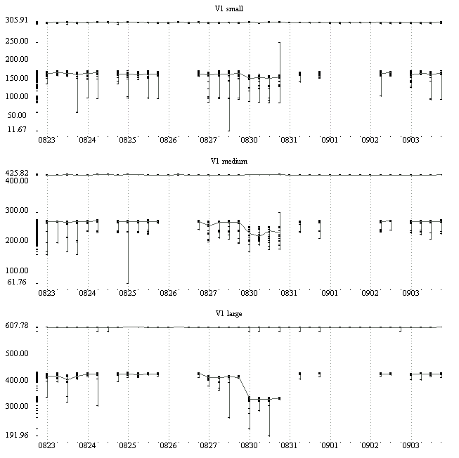
Figure 1 Performance (MFLOPS) for algorithm variant 1, IBM SP and CRAY T3E (highest performer), August and September.
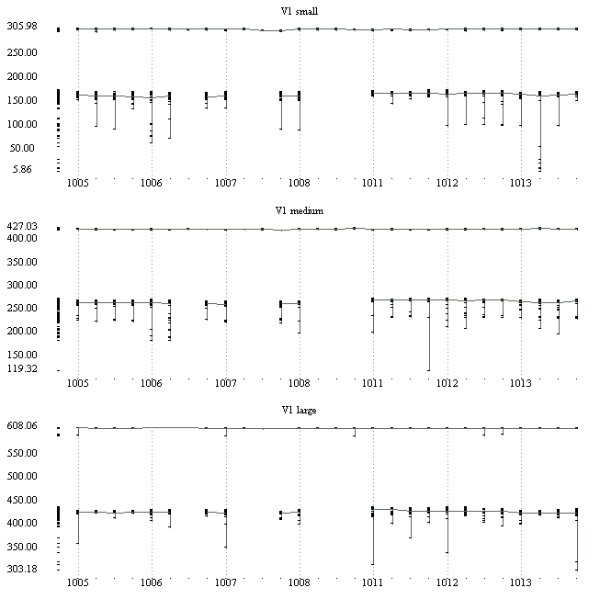
Figure 2 Performance (MFLOPS) for algorithm variant 1, IBM SP and CRAY T3E (highest performer), October.
These data show that the range of performance on the T3E is a few MFLOPS, while it is over one hundred MFLOPS on the SP. The figures also show that performance varies considerably in a single session, between sessions on the same day, and also between days. Time histories of four different sessions from the IBM SP are shown in Figure 3. These histories affirm that the presence of significant departures from the median performance varies between sessions, and also reveal that the order of departures is random.
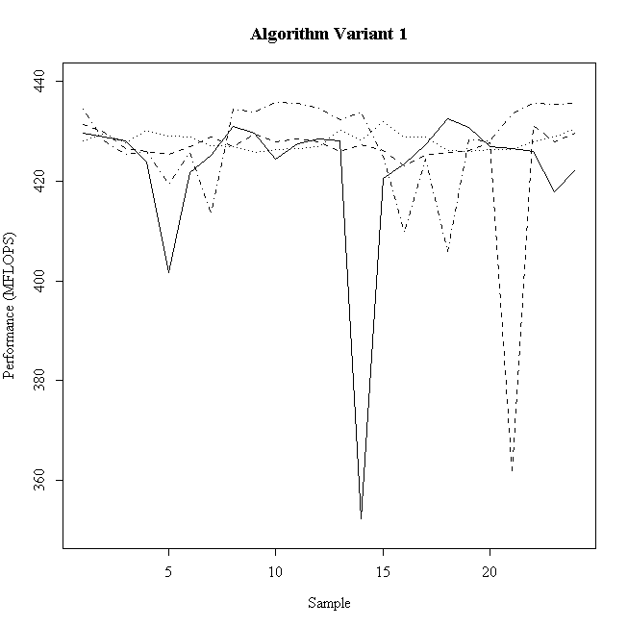
Figure 3 Benchmark session time histories for four different sessions on the IBM SP.
The distribution of performance is generally lognormal in both cases, though this trend is stronger on the T3E than the SP. About 95% of the T3E benchmark sessions pass the Kolmogorov-Smirnov one-sample test for lognormality at 95% confidence; only about 60% of the SP benchmark sessions meet the same criteria. Figure 4 shows representative histograms for lognormal sample populations on each machine; Figure 5 shows representative histograms for the non-conforming populations.
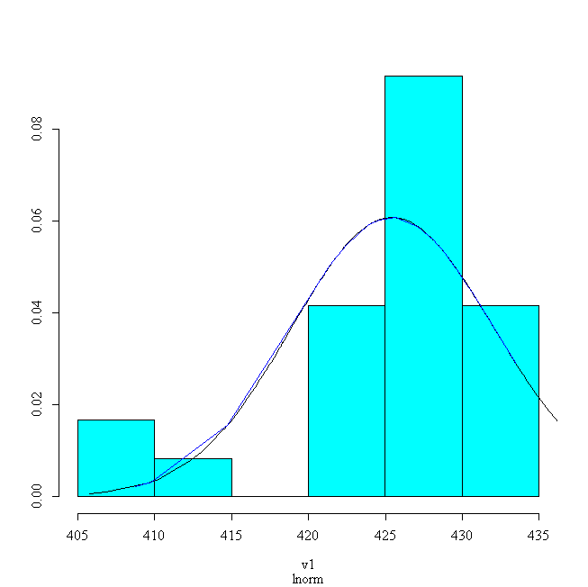 | 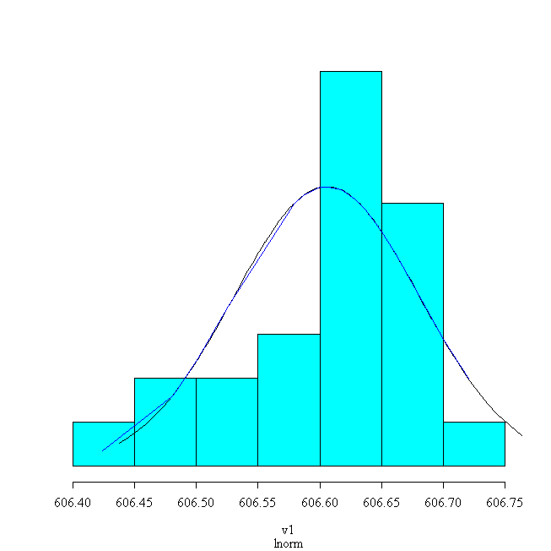
Figure 4 Lognormal distribution of performance for algorithm v1, large problem, IBM SP (left) and CRAY T3E (right).

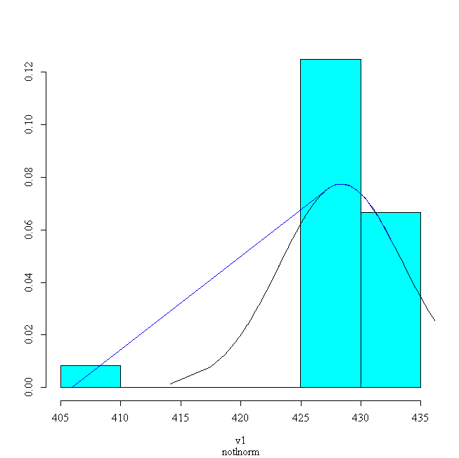 | 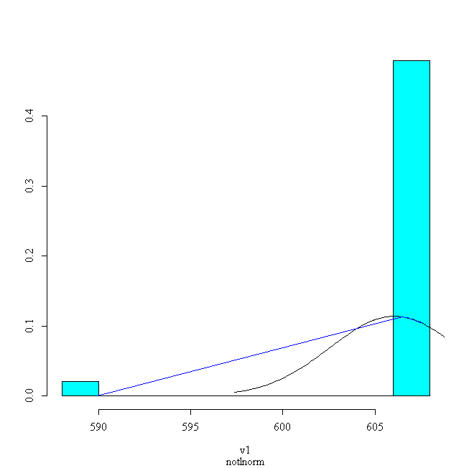
Figure 5 Non-lognormal distribution of performance for algorithm v1, large problem, IBM SP (left) and CRAY T3E (right).
These data were collected on machines while other user tasks were running (for this paper a machine on which multiple users are simultaneously running jobs is called a production machine; a machine with no user tasks other than the application being measured is a dedicated machine). Figure 6 shows a representative graph of performance for the same algorithm on the SP while no other user tasks were running. Both the range and maximum of the relative variance are smaller than for the production benchmarks, but they are still significant. They reveal that performance variation is not limited to benchmark measurements on production machines, but can extend to benchmark measurements on dedicated machines as well. Although potentially surprising, these results are consistent with other findings on IBM SPs for a different set of applications (Blackford, et al. 1998).
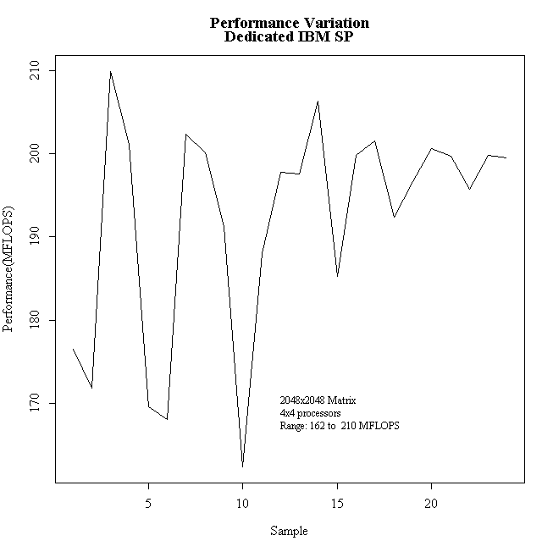
Figure 6 Performance variation on a dedicated IBM SP.

Implications for Switching Functions
In order to build a data of performance values from which a switching function can be constructed one is first tempted to simply make a series of single measurements for different problem sizes. The data in the previous section show that this is not adequate in general (the existence of a single exception proves this; the degree to which it is true could only be established, however, by evaluation of considerably more architectures). We have thus far demonstrated that the quality of performance measurements may vary considerably, even between consecutive runs on the same physical processors. This is a problem on both dedicated and production machines, and the degree to which the phenomenon is observed can vary between machines, as shown above. Thus, we cannot in general have any confidence in a single performance measurement for an algorithm.
Given the information that performance data are not to be trusted implicitly, how can performance measurements that accurately reflect the usual performance of the algorithm be captured? The way to achieve this is by repeated performance measurements. Repeated measurements allow many approaches to increasing confidence in results, including elimination of outliers and use of aggregate statistics (like means and medians). But, now we have a new question: how many measurements should be taken? This question itself leads to a complication. We actually care deeply about minimizing the number of repeated measurements required for reliable performance estimates because of the number of estimates required for building switching functions. Building empirical models requires data at locations throughout the parameter space over which the switching function is to make decisions. The density of this sampling in any single dimension will vary depending upon the power of the method used to construct the performance model. But, the parameter space is almost certainly multi-dimensional, and probably highly so. This will dramatically increase the total number of samples required. Taking multiple samples at each location only increases the amount of work required, and thus increases the costs of building each switching function. Cost can be a significant consideration when developing a performance database for training switching functions. HPC machines are often shared among many users and are heavily used. This amortizes institutional investments, but competition a large number of active users can make computer time difficult to get for any one user. The only way to make efficient use of available resources is to take the minimum number of measurements that support the desired statistical quality. This means both employing efficient sampling techniques to map the parameter space and minimizing the number of repeated samples.
Thus the question of how many repeated samples to take is important. Benchmark measurements reported in the literature for production machines are often statistical reductions of an evidently arbitrary number of runs (repeated samples are usually not taken for benchmarks on dedicated machines; as we have seen, this may not always be a wise decision). While post-collection analysis may show that averaging some arbitrary number of runs may produce data of the desired quality, the user does not know whether the cost for this quality is minimum. Would four measurements have sufficed? Setting a fixed number of sample repetitions does not admit the possibility that performance variance can be dynamic, and so one always samples for the worst case. Furthermore, fixed sampling cannot address the possibility that the machine may enter a new performance region in which the worst case may be either optimistic or pessimistic.
Thus, what we would like is a methodology that allows us to assess the quality of performance data during the collection process. This approach would determine the number of samples to be collected dynamically in response to user statements about the desired quality of the collected data.

Dynamic Sample Size Determination
When studying a population one can study either the entire population or some representative subset of the population. The subset is called a sample of the population. Sampling can be employed to reduce the costs or length of a study when the population is difficult to study completely; it can also be used when it is impossible to study the entire population. In our case the population is practically infinite and so sampling, in the form of benchmarks, is used.
Our performance measurement problem is an estimation problem. We wish to know the true, but unknown, value of the performance of an algorithm with a certain amount of confidence (Mace 1964, p. 4). Stated more formally, the goal is to know that “we are q% certain that the performance of this algorithm is within p% of X MFLOPS.” p is called the confidence interval for the estimate. If p is not zero the population statistic (the median in this example) is an estimate of the true value. The size of the confidence interval conveys the quality of the estimate. The only way to reduce p to zero in a population with nonzero variance is to study the entire population. q conveys the notion that it is possible to pick a sample that is consistent with its members but inconsistent with its parent population. As q increases so must the sample size.
The primary obstacle in estimating performance at a specific quality is variance in the measurements. Variance in experimental results in general is affected by the size of the sample, the population statistic (for example, the median is less sensitive to outliers than the mean), and the design of the experiment (Williams 1978, p. 101). The statistical design of experiments is a broad and important topic. Much of this work is focused on controlling sources of variation inherent in the experiment or materials (Mason 1989). In this work we assume, however, that appropriate timers are used and the amount of work performed can be accurately characterized, so the design of the experiment is not considered. We assume that a benchmark accurately measures performance at the time of observation. When there is significant variability between successive measurements, however, what is not known is whether any single measurement is exceptional. More than one observation is needed to determine the reliability of the performance value.
Having set the quality parameters it is now possible to estimate the size of the sample, as long as a model of the population’s distribution is known. Thus, if a population is assumed normal, and the finite population correction is ignored, then the sample size, n, can be determined as follows
$n={\left(\frac{t_{α/2}σ}{d}\right)}^{2}$,
where t is the abscissa of the normal curve that cuts off an area $α/2$ at the tails (i.e., the confidence interval), $σ$ is the standard deviation of the population, and d is the chance of catastrophic error discussed above.
Here is the main difficulty in sample size estimation (Cochran 1953, 51). The size of sample depends upon the variance (represented by the standard deviation squared term in the formula) of the population to be sampled, but the variance is not known until the population is sampled. This problem is overcome by estimating the unknown variance, and using this estimate to approximate the sample size. This estimate can be based upon guesswork, previous studies, or a pilot study. But these variance estimates are not sufficient for performance evaluation because, as shown above, the level of variance in repeated performance measurements changes between machines and over time on a single machine. Thus, even if the estimated variance is based upon detailed performance measurements conducted in the past, the calculation for n in the present does not provide any assurance that the desired confidence level has been achieved. If the variance has increased then more samples are required, while if the variance has decreased the costs of the sample may be too high.
Thus, we need a method that does not require an historical estimate of variance and that can adapt to changing variance over time. Stein has developed a method for estimating the mean of continuous normal data that does not require historical estimates of the variance (Stein 1945). The sample is collected in two parts. The first part provides an estimate of the variance, and the second part adds enough data to assure that the population statistic meets the specified quality. Stein’s technique assumes that the population being sampled is normal, so strictly speaking its application is limited to situations in which this condition is at least approximately satisfied. The method is of interest to this research because it provides a recipe for sampling that can adapt to the dynamic nature of underlying processes governing performance on production machines. The performance data presented in this paper are only approximately normal.
The first part of the sample, with n1 data values, supplies an estimate of the variance of the population. Confidence in the population statistic based only on the first part of the sample can be calculated as $d'=\frac{t_{1}σ}{\sqrt{n1}}$.
This formula relates confidence to the sample standard deviation (the square root of variance) and the number of samples. $t_{1}$denotes the t-value for n1-1 degrees of freedom and probability $1−α$, and $σ$ is the standard deviation of the n1 samples. If $d'$is less than d then n1 was a sufficiently large sample size for this population and no further sampling is required. If, however, $d'>d$, then at least
$$n2=\frac{t_{1^{2}}σ^{2}}{d^{2}}−n1$$
additional samples must be taken. If the population variance changes over time, as it does for HPC performance measurements, then the time between samples n1 and n2 must be sufficiently small to assure that no fundamental changes in the underlying processes occur.
The advantage of Stein’s method is that the estimate of population variance is made at the time the sample is taken, and so only the number of samples needed at that time need be collected. This means that as variance in repeated measurements changes over time the collection process can adapt, minimizing costs (in terms of benchmark executions) while maintaining a fixed level of quality.

Why This Doesn’t Work
Well, the method does work, but it does not help us accomplish our goals. Specifically, the method often recommended a few hundred samples per measurement for the SP, while a simple fixed sampling scheme can achieve the same quality in as few as seven samples on the same machine. Why?
Recall that Stein’s method was developed for samples from a normal population. It was mentioned earlier that these populations are largely lognormal. This distribution makes the most sense intuitively, as it allows skews toward high performance with relatively few of the very highest performers and more low performance outliers in the tails. Thus it is reasonable to suspect the non-normality of these populations as a possible culprit. This may contribute to the problems, but I do not believe it is a central cause. In fact, roughly the same portion of the sample populations pass tests for normality as lognormality (two-sided KS one sample at the 95% confidence level).
The real problem is more likely the magnitude of the low-performing outliers. Figure 5 is very revealing in this regard; it shows the tendency of the samples to be divided into two distinct populations separated by empty space. In fact, the two SP histograms have a very similar spread of performance values. The primary difference is that the lognormal sample has members between the two extremes, while the non-conforming sample does not. The implication here is that the lower-performing system states that occur occasionally are not just tails of the main population but entirely different populations. This is especially evident on the SP, where the outlier population tends to be tightly concentrated around a mean with the main population spread more widely at a higher performance level.
But Stein’s method, and other methods for sample size determination, are geared to dealing with a single, possibly noisy, population – not two separate populations. The outliers are not regarded as outliers by the method but as valid members of the population being sampled. Because they are usually very distant (relative to the spread of the main population) from the sample median, Stein’s method sees a single population with enormous variance, and so on the SP recommended sample sizes in the hundreds of samples per measurement are not uncommon.
At first glance it seems that one can fix this problem by simply removing the outliers from the sample population and then applying Stein’s method. One could probably apply this approach to the measurements taken in this paper by looking for measurements that were too far from what is expected. Unfortunately, this will not work in the general case. First, an outlier is not an outlier until it clearly is unlike the other data in a data collection (by definition). The automated methods for removing outliers assume some reasonable amount of data (usually more than 20 samples) before outlier removal is considered statistically valid. Second, outlier removal is clearly most effective on data in retrospect. In our case, we need to identify outliers as data are collected dynamically. This is only possible if we know a priori what the expected range of performance is for the algorithm and problem being measured. However, if we knew this a priori, then benchmarks would not be necessary. Outlier removal is thus not an appropriate solution.
I believe that this makes the problem we are trying to solve either very difficult or unsolvable. Certainly it is beyond what I have training to deal with. This would also explain why the problem does not appear to have been addressed by this community before.

Resolution
A simple study was done on the performance data to determine if a fixed sampling scheme was more effective than using Stein’s method. It shows that fixed sampling can achieve a median within 95% of the population median 95% of the time in five samples, and 97% of the time in seven samples. On the T3E, a fixed sample size of two was sufficient, while Stein’s method required nearly three samples on average for the same accuracy.
This seems to be a reasonable approach, and it is consistent with the state of the practice in benchmarking. It is not, however, without its difficulties. The primary problem is that this approach is not sensitive to changing conditions on the machine being measured. So, for example, even though results of these studies show that five samples are sufficient for our quality goals, there is no guarantee that conditions on the machine could not change significantly at any time in the future. This change could mean either that less or more samples are required. In the first case we are taking too many samples, so our costs are too high, and in the second case we need more samples and so are not meeting our quality goals. A fixed sampling scheme is not sensitive to these changes on the target benchmark system, and so cannot adapt to minimize benchmark costs or to ensure data quality.
In general, this problem cannot be efficiently overcome. A practical solution is to periodically take a large sample and perform a detailed analysis to make sure that the fixed sample size remains adequate, adjusting if necessary. This solution is not completely satisfactory, however, because it will not catch transient instances of poor data quality on a shorter time scale than the detailed analysis. However, this concern has to be weighed against the increased costs that detailed analysis incurs, and so a tradeoff is required.

References
Alpatov, P., G. Baker, C. Edwards, J. Gunnels, G. Morrow, J. Overfelt, and R. van de Geijn. "PLAPACK: Parallel Linear Algebra Package." Proceedings of the SIAM Parallel Processing Conference, 1997.
Bilmes, J., K. Asanovic, C. W. Chin, and J. Demmel. "Optimizing Matrix Multiply Using PHiPAC: a Portable, High-Performance, ANSI C Coding Methodology." Proceedings of the International Conference on Supercomputing, Vienna, Austria, ACM SIGARC. July 1997.
Blackford, L. S., and R. C. Whaley. ScaLAPACK Evaluation and Performance at the DoD MSRCs, DOD CEWES Major Shared Resource Center, 1998. PET Technical Report 98-33.
Brewer, E. A. "High-Level Optimization Via Automated Statistical Modeling." Proceedings of Principles and Practice of Parallel Programming, 1995. Pages 80-91.
Cochran, Willam G. Sampling Techniques. New York: John Wiley and Sons, 1953.
Demmel, J. Trading Off Parallelism and Numerical Stability, University of Tennessee, 1992. Technical Report UT-CS-92-179; LAPACK Working Note 52.
Dongarra, J., and D. Walker. "Software Libraries for Linear Algebra Computations on High Performance Computers." SIAM Review 37, 2 (June 1995): 151-180.
Dongarra, J., Du Croz, J., S. Hammarling, and R. Hanson. "A Set of Level 3 Basic Linear Algebra Subprograms." Transactions on Mathematical Software 16, 1 (1990): 1-16.
Gunnels, J., C. Lin, G. Morrow, and R. van de Geijn. "Analysis of a Class of Parallel Matrix Multiplication Algorithms." Proceedings of the First Merged International Parallel Processing Symposium and Symposium on Parallel and Distributed Processing (1998 IPPS/SPDP '98), 1998. Pages 110-116.
Mace, Arthur E. Sample-Size Determination. New York: Reinhold Publishing Corporation, 1964.
Mason, Robert L., Gunst, Richard F., Hess, James L. Statistical Design and Analysis of Experiments. Wiley Series in Probability and Mathematical Statistics. New York: John Wiley and Sons, 1989.
Message Passing Interface Forum. MPI: A Message-Passing Interface Standard, Computer Science Department, University of Tennessee, Knoxville, TN, May 5, 1994. Technical Report CS-94-230. Also appears in the International Journal of Supercomputing Applications, Volume 8, Number 3/4, 1994.
Rice, J. R. "On the Construction of Poly-Algorithms for Automatic Numerical Analysis." In Interactive Systems for Experimental Applied Mathematics, M. Klerer and J. Reinfelds. 301-313. Academic Press, 1968.
Li, J., A. Skjellum, and R. Falgout. "A Poly-Algorithm for Parallel Dense Matrix Multiplication on Two-Dimensional Process Grid Topologies." Concurrency: Practice and Experience 9, 5 (1997).
Stein, C. "A Two-Sample Test for a Linear Hypothesis Whose Power is Independent of the Variance." Annals of Mathematical Statistics 16 (1945): 243-258.
van de Geijn, R. Using PLAPACK. MIT Press, 1997.
Whaley, R. C., and J. Dongarra. "Automatically Tuned Linear Algebra Software." Proccedings of Supercomputing '98, Orlando, FL, IEEE Computer Society Press. November 7-13, 1998.
Williams, Bill. A Sampler on Sampling. Wiley Series in Probability and Mathematical Statistics. New York: John Wiley and Sons, 1978.

Appendix A
Table 2 CRAY T3E hardware configuration.
Machine | CRAY T3E
Processors | 544 DEC Alpha 21164 CPUs  (520 compute)
 | 600 MHz
Memory | 256 MB/node

Table 3 CRAY T3E software configuration.
Software | Version
Operating System | UNICOS/mk 2.0.3.18
IMSL | 3.0
CRAYlibs | 3.1.0.2
NQS | 3.3.0.5
MPT | 1.2.1.3
PLAPACK | 1.2
Compilers
C | 6.1.0.2
FORTRAN | 3.1.0.3

Table 4 IBM SP hardware configuration.
Machine | IBM SP
Processors | 125 P2SC CPUs  (122 compute)
 | 135 MHz
Memory | 512 MB/node

Table 5 IBM SP software configuration.
Software | Version
Operating System | AIX 4.3.2.x
ESSL | 3.1.0.0
Parallel ESSL | 2.1.0.0
PBS | CM 1.1.x
POE | 2.3.0.9
PLAPACK | 1.2
Compilers
C | 3.1.4
FORTRAN | 5.1.1

Much of sampling theory is derived for normal populations.
This assumption appears valid in performance evaluation where the population – all possible measurements of performance – is assumed infinite.

