Abstract

This dissertation explores the architecture of a learning environment for the perspective of interactivity and customizability. From this architecture, interactive learning tools, educational portals, distance education systems as well as adaptable learning environments with adjustable time and capability parameters may be designed.
An adaptive control system includes a user, a controller and a learning system. The information architecture is based on the abstraction of a learning system. The architecture is made up of an Application Server, a Client, and a Content Server, a three tier architecture. User events at the client and user activity at the server-side are captured and analyzed, providing updates to the users’ learning environment. Information is processed at the application server before being sent to the content server, at which time and the data maybe stored in a database.
A prototype architecture, SmartDesk, was built. The interactivity of SmartDesk was explored by adopting web benchmarking methods and content based analysis.

Information Architecture of Interactive and Customizable Learning Environments

By

Myeongjin Lee

DISSERTATION

Submitted in partial fulfillment of the requirements for
the degree of Doctor of Philosophy in Computer and
Information Science in the Graduate School of Syracuse University

May 2000

Approved _________________________
Professor Geoffrey Fox

Date _____________________________

Copyright 1990 Myeongjin Lee
All rights Reserved

Table of Contents
CHAPTER 1 – INTRODUCTION / 1
1.1 Motivation and Background / 2
1.2 Thesis Statement and Contribution / 4
CHAPTER 2 – SYSTEM / 6
2.1 Learning System / 6
2.2 Discrete Event System (Stochastic Timed Model) / 11
2.3 Conclusion / 13
CHAPTER 3 – AN INTERACTIVE CUSTOMIZABLE INFORMATION ARCHITECTURE FOR A LEARNING ENVIRONMENT / 14
3.1 Introduction / 14
3.2 Components and Services / 14
3.2.1 Components /14
3.2.2 Services /17
3.3 Architectural View on the Flow of the Interaction / 22
3.4 Conclusion / 23
CHAPTER 4 – EVENT MODEL / 25

4.1 Introduction / 25

4.2 Event Model at JINI / 26

4.3 Event Model at CORBA / 27

4.4 Event Model of Document Object Model Level 2 / 29

4.5 Java Delegation Event Model / 31

4.6 Discussion / 32

CHAPTER 5 – SMART DESK / 35
5.1 Introduction / 35
5.2 Other Learning Environment / 37
5.3 Smart Desk Features / 38
5.4 Implementation Issues / 40
5.4.1 Personalized Environment / 40
5.4.2 Adaptiveness issues / 42
5.4.3 User Tracking / 50
5.5 SD Information Architecture and Events / 51
5.6 Conclusion / 55
CHAPTER 6 – INTERACTIVITY: DEFINITION, MEASUREMENT, AND THE EXPERIMENT / 57
6.1 Background / 57
6.2 Interactivity on the Web / 57
6.3 Measurement of Interactivity at an Information Architecture for a Learning
Environment / 59
6.3.1 Introduction / 61
6.3.2 Content-Based Measurement / 64
6.3.3 User Transaction Data / 67
6.3.4 Steps to Apply the Interactivity Measurement Methods to Smart Desk / 70
6.4 Case Study: Interactivity Measurement at Smart Desk / 73
6.4.1 Technical Specification / 73

6.4.2 Web Sites Deconstructed / 74

6.4.3 Experiment / 75
6.4.4 Results / 81

CHAPTER 7 – CONCLUSION / 95
FUTURE WORK / 97
CHAPTER 8 – REFERENCES / 98
APPENDIX A. GUIDELINE OF INTERACTIVITY FEATURES AT WEB SITES / 102
APPENDIX B. WEIGHTED 2D GRAPH / 103
APPENDIX C. SOURCE CODE INFORMATION / 105
APPENDIX D. THE LEARNING SYSTEM MODELING / 107

D.1 Notation of State Automata Models / 107
D.2 System Modeling of the Learning System Using a State Automata Model / 108
D.3 Petri Net and Stochastic Petri Net Model Notation / 111
D.4 Stochastic Petri Net Modeling of the Learning System / 112

APPENDIX E. COMMON LOG FORMAT / 119

VITA / 120
List of Figures

Figure 1-1: Smart Desk Introduction, the Main Page, and an Application / 4

Figure 2-1: Learning Environment (1) / 7
Figure 2-2: Learning Environment (2) / 9
Figure 2-3: Learning Environment with Controller / 10
Figure 3-1: 3 Tier Architecture of the Learning Environment / 16
Figure 3-2: Services at the Information Architecture / 20
Figure 3-3: an Example of an Event Path / 22
Figure 4-1: Event Generation in JINI / 27
Figure 4-2: OMG Reference Model Architecture / 28
Figure 4-3: Push-Style Communication Between a Supplier and an Event Channel, and Pull-Style Communication Between a Consumer and an Event Channel / 29
Figure 4-4: Event Flow at DOM (1) / 30
Figure 4-5: Event Flow at DOM (2) / 31
Figure 4-6: Event Flow at Java / 32
Figure 5-1: Hand Mouse / 35
Figure 5-2: Smart Desk Hardware Interface / 35
Figure 5-3: Interface to Add a New Application / 39
Figure 5-4: Personalizing Process / 40
Figure 5-5: Communication between front end and server / 42
Figure 5-6: User Tracking / 43
Figure 5-7 (A): An Example of Measuring and Analyzing Mouse Inputs / 44
Figure 5-7 (B): “Word Learning” Game / 45
Figure 5-7 (C): An Example of Tracking User Events Along With Time Axis / 46
Figure 5-7 (D): An Example of Mouse Trajectory / 47
Figure 5-7 (E): An Example of Right/Wrong Answer Measurement / 48
Figure 5-7 (E’): Proportion of Right And Wrong Answer / 48
Figure 5-8: Servlets at AS / 51
Figure 5-9: User Registration / 51
Figure 5-10: Customization / 52
Figure 5-11: SD Event Model / 53
Figure 5-12: Data and Event Flow at SD / 53
Figure 5-13: Events at SD in XML / 54
Figure 6-1: Tracked Information at a Web Browser / 68
Figure 6-2: Sample GUI / 75
Figure 6-3: Sample Graph / 76
Figure 6-4: Sample Trajectory / 77
Figure 6-5: Document Map / 79

List of Diagrams

Diagram 6-1: Structure of This Thesis / 62

Diagram 6-2: How SDs are Implemented for Experiment / 70

Diagram 6-3: Process of Experiment / 71

List of Tables

Table 3-1: Services and Their Properties / 21
Table 3-2: An Example of Interaction Among Components / 23
Table 6-1: Time Spent at Each Page / 93

Table D-1: Places and Transitions / 114

Table D-2: Places and Transitions / 117

List of Graphs

Graph 6-1: Original SD / 85
Graph 6-2: P-SD1 / 86
Graph 6-3: P-SD2 / 87
Graph 6-4: Number of Hits vs. Time / 90
Graph 6-5: Transferred Data vs. Time (1) / 91
Graph 6-6:Transferred Data vs. Time (2) / 92
Graph 6-7: Total Completion Time / 93
Graph 6-8: a Learning Curve / 94
Graph D-1: State Diagram / 111
Graph D-2: Petri Net with a Basic Idea / 116
Graph D-3: Stochastic Petri Net for the Learning Environment / 119

1. Introduction

In this dissertation, we explore an information architecture based on an event system model for a personalizable and intelligently adaptive learning environment over a distributed system. Specifically, a web-based system is considered. This subject is interdisciplinary, spanning such research areas as human computer interface (HCI), cybernetics (Pask 1961), cognitive psychology (Carroll 1997), human factors engineering, and education (Adams 1976; Howe 1977), but is subsumed entirely within the computer science framework. Interactivity will be measured quantitatively and modeled in the context of information architectures defined within computer science.
Following the Introduction, Chapter 2 describes the system in general. It will define the system components, flow of events, and the learning system which is an abstraction of a learning environment. Chapter 3 introduces the interactive customizable information architecture based on the abstracted system. Chapter 4 describes the Smart Desk, an interactive learning environment; this chapter also presents learning system issues in detail. Chapter 5 discusses interactivity and its applicability to the notion of an event. Also it presents a methodology for measuring interactivity by detecting events in learning environments and by the content-based methodology. It includes the server and client side analyses. We summarize the results of the experiment performed in different Smart Desk environments, followed by the conclusions in Chapter 6.

1.1 Motivation and Background

Human Computer Interface (HCI) is a relatively new research area in computer science. It deals with how people interact with computers to achieve better task performance so it naturally covers a diverse subject area. HCI studies have characteristically been empirical from the outset; in the past these empirical studies have provided useful data through explorations of user behaviors and modeling. However, with respect to the disciplinary concerns of computer science, older methodologies are not suitable for HCI and can cause legitimacy problems for HCI’s standing within the field (Wegner 1997). Our approach is to implement an event system model which will measure the interactivity parameters of a learning system, but in contrast to older methodologies, we focus on the system rather than on users when gathering data to model an information architecture. A controller, as a subsystem between a user and a learning system, provides a flexible method to measure the interactivity of a particular learning environment.
In working with human subjects, we researched computerized learning tools and performance evaluation software, not only from the view point of computer science but also from neuropsychological and educational perspectives (Kane and Kay 1992; Rodrigues and viera da Rocha 1997). Computerized performance evaluation tools are new but rapidly growing in popularity, and the research of these tools is a burgeoning field (Kane and Kay 1992). As an example of the utility of these tools, they can be set up to exploit computational resources to yield accurate measurements of motor skills, or user response times (Kane and Kay 1992). Some of these also provide primitive user customizable environments, but are limited because they cannot be changed dynamically and are seldom customizable for specific user situations. In this aspect, computerized learning tools or software are similar to the performance evaluation tools. For the general public, ordering customized software is not easy, because the software market is supported by mass production products and services. For the software developers to cope with every possible scenario for different users is practically impossible within a conventional programming model. User performance constantly changes and the complexity of considering all possibilities is a nondeterministic polynomial(NP). This is precisely where an interaction model of programming is able to facilitate the embedding of future growth requirements and flexibilities for specific users (Wegner 1997).
Above reasons that people have different performance and reaction in their learning, leading us to develop a customized and adaptable learning environment. If we can provide a system to capture each component and its interaction in the environment, to design an information architecture to enable us to implement interactive customizable learning will follow. To further aid in learning, performance test, or even an education portal, information of interaction or events is valuable. Utilizing this information, we can diagnose and update the learning environment appropriately.
SmartDesk (see Figure 1-1) was developed as a prototype system of the information architecture. It provides tracking and analytical tools for both the server and client. SmartDesk is used to explore the flow of interaction and measurement of interactivity of a learning environment.

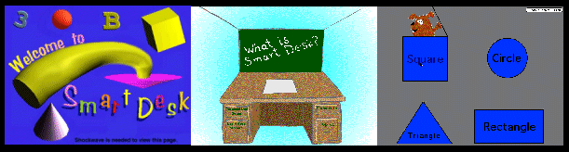
Figure 1-1 SmartDesk Introduction, the Main Page, and an Application
The first picture is the introductory page of Smart Desk(SD) and the next one with the picture of a desk is the main page. A user can choose an object with mouse, by using touch screen, or the graphic tabulate. The third picture is an example of SD application.

1.2 Thesis Statement and Contribution

In this work, we research an interactive customizable information architecture. The architecture consisting of a client, an application server, and a content server provide suitable framework as a learning environment. It also presents a superior prototype and system architecture as a learning model. Such an environment includes the theoretical formulation of interactivity based on the event model. It captures user-generated events at a client side as well as server side activities. Together the interactivity or the flow of interaction within the architecture may be measured.
Measurement of interactivity of such information architecture is extensively discussed. It allows us to look at the concept quantitatively. By using SmartDesk, client and server side analyses are performed.
Web based systems which can now be accessed and used by anyone in any place is similar in its social impact to how J. Gutenberg's printing press and movable type of the 15th century contributed to public education. They give a basis for web based learning environments to bring good quality information to the public.

2. The System

In this chapter, we abstract the components of learning processes into a learning system (Figure 2-1).
The learning system herein is conceptualized and defined using the principles of cognitive science: the basic and primary concepts are utilized to develop and implement the model within a computer science framework. Following such a model, the system itself is designed and implemented as a “discrete event system with a stochastic timed model” rather than as a “cognitive science model”. A similar approach is found in the stochastic modeling of manufacturing systems (Muppala, Woolet et al. 1991; Lu and Lin 1994; Zimmermann, Bode et al. n.d.).

2.1. Learning System

Since the beginning of cybernetics, the ancestor of computer science, the concepts and nature of a system have been extensively discussed (Pask 1961). Currently, cybernetics exists as a basis for parts of numerous other scientific subjects, even though it still stands on its own to some extent, as exemplified in such contemporary journals as Cybernetics and Human Knowing, a journal of second order Cybernetics and cyber-semiotics or Cybernetics and Systems, an international journal. For instance, the learning system is extensively discussed in cognitive science where the concepts of such a system are deeply rooted in cybernetics.

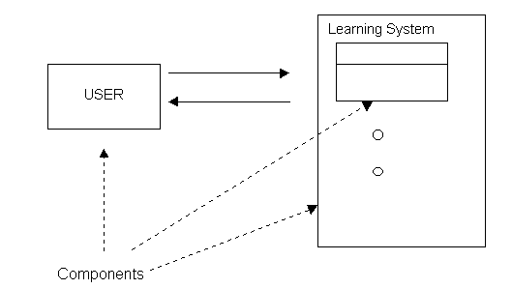
Figure 2-1. Learning Environment (1)
In a learning environment, a user and sub systems of a learning system are viewed as components. A learning system includes both hardware interfaces and software components.

The definition of a “system” is rather intuitive. Webster's Dictionary defines it as “a regularly interacting or interdependent group of items forming a unified whole.” Also, it can be defined as a combination of components that act together to perform a function not possible by any of the individual parts (IEEE Standard Dictionary of Electrical and Elecrtonic Terms). The latter definition well demonstrates the existence of a relation connecting individual components to form a whole unity (Web Dictionary of Cybernetics and System). With greater abstraction, a system may be thought of as a reference frame containing two concepts: structure and identification (Pask 1961). In the case of a learning system, a structure is a module of the software, like "Word Fun", "Phonetics", or "Learning how to add", while identification is the process of sending user-generated output into such structures. (Figure 2-2) In this work, the components and their relation will be terms used to represent each module or subsystem and the interaction amongst them, respectively.
A controller is the part of a system which interacts with other components to achieve a certain stability of the control system. Of the different control systems, learning system can be thought of as an adaptive control system (Pask 1961). The adaptive control system is able to change the relation between a user and structure to achieve a more specific object as time goes on. The learning system requires a control of user inputs with adaptive ability. In other words, inputs into the system are not raw data, but are refined and adaptive data prepared by the controller respective of each user. The controller learns the user’s behavior from the input data and in turn provides inputs into the learning system (Figure 2-3). Hence, a learning machine is an advanced instance of an adaptive control system.

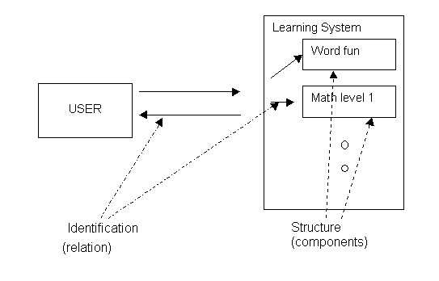

Figure 2-2. Learning Environment (2)
The structures are the sub systems in above figure. “Identification” refers to relationships amongst those structures. Input of a user can be either directly sent to a sub system or manipulated by a controller which resides in the system.

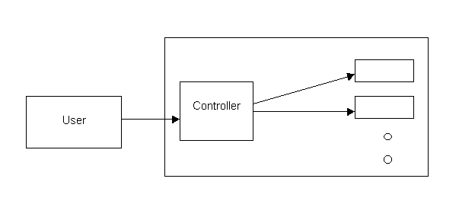
Figure 2-3. Learning Environment with Controller
A controller plays an important role in a learning environment, because conceptually it works as a moderator in learning by providing information filtering, adapting contents, or adjusting difficulties based on each user’s need.

Another concept related to the controller and the learning system is the teaching machine (Pask 1961; Adams 1976). Teaching can be thought of as controlling ones learning process. A successful learning process should be active and interactive, requiring active motivation of students as well as interaction with them. A teaching machine is a tool designed to do just this, to interact with students in order to teach or aid in their learning.
The first teaching machine was designed by S. L. Pressy around 1920. A more flexible model was subsequently introduced by Norman Crowder, followed by Skinner’s teaching machine (Chapter 4). However, problems arose for these models because they were fixed systems; i.e., we need to assume that the best teaching methods exist, because we cannot change the method after the system is built. They were also built to set a same performance level and intended for an average group of students. Later, the use of teaching machines in education was legitimized by Pask's development of an adaptive controller (1961), which addressed these problems and the belief (Skinner and Adams) that the problems of contemporary education were related to a rigid and inflexible teaching model.
We argue that a certain type of discrete event system can be used to abstract the adaptive and interactive features of a learning system. The discrete event system shall be described and modeled in the following chapters.

  - Discrete Event System (Stochastic Timed Model)

A Discrete Event System (DES) is a dynamic system whose state space is a discrete set, where the state transition mechanism is event-driven. Hence, a DES requires two properties: a discrete set and an event-driven state transition mechanism. In fact, many man-made systems, such as queueing, traffic, or computer systems are all DESs. To derive quantitative methods of analysis for a learning system, we need a DES model with more embedded features, i.e. a stochastic timed DES.
A stochastic timed DES refers to a system with timing information and an uncertainty factor regarding event prediction. This captures the crux of a learning system. One cannot know exactly what or when a learner will give a response, or submit an input to the system, but a prediction can be made based upon previous user’s learning habits. To describe the stochastic timed DES more fully, the timing mechanism in the model will need to be introduced. The timing mechanism will be described in detail in appendix D, but for now a brief idea will be noted.
A stochastic process is a collection of random variables indexed by time. When the collection of random variables is defined over a finite set and the time set is countable, it forms a discrete state and time stochastic process. The clock structure for the timing mechanism of such processes associated with events are as follows (Cassandras 1993):
The clock structure is a set
V = {V_{i} : i ∈ E} of clock sequences
V_{i} = {v_{i,1}, v_{i,2}, ..} i ∈ E, v_{i},_{k} to R⁺, k=1,2.. as E is an event set.
It is viewed as the input to the DES. The timing mechanism then interprets the structure so that an actual event sequence may be derived. Note that the sequence of events is not necessary to analyze the system because the clock sequence is coupled with the event sequence. But in analyzing the learning system, we do not have a priori information about the event sequence and need to develop a stochastic model with an uncertainty factor.
The stochastic clock structure has a stochastic clock sequence of
{V_{ik}} = {V_{i1}, V_{i2},…}, i∈ E, V_{ik} ∈ R⁺, k=1,2,…
The structure is a set of distribution functions
G = {G_{i}: i ∈ E}.
Even though the modeling of our learning system is not the purpose of this thesis, the importance of looking at event flow will become obvious later in a discussion of mechanisms of interactivity measurement. Detailed examples using Petri nets and state diagrams are given at Appendix D.

2.3 Conclusion

A system that can explain an adaptive and customizable learning process is discussed. The concept of a controller at the adaptive control system and the teaching machine provides valuable foundation to design an information architecture with interactive and customizable capabilities; with the established event system view, the information architecture is built. Components and relations of the system are well projected into the architectural view.
Also the notion of events and the flow of events are well represented in the system. Further, Discrete Event System allows us to apply the modeling methods of DES to the system (Appendix D).

- An Interactive Customizable Information Architecture for a Learning Environment

3.1 Introduction

This chapter describes the architecture of a learning environment, defines the different components of the architecture, discusses the characteristics of the components, and gives an architectural view of the flow of the interaction amongst the components. The flow of the interaction is further explored in chapter 5.
The control system discussed in chapter 2 is the basis upon which the architecture is built. A user, a controller, and the learning system are all mapped to the components of the architecture.

3.2 Components and Services (Figure 3-1)
3.2.1 Components
- Application Server (AS)
Conceptually, the Application Server (AS) is a teacher, an educator, or a controller in a learning process. Note that the teacher may be a Client component in this model if it is viewed as a user of the learning system rather than as a moderator in the learning process.
The AS serves the following three functions: to render custom interfaces, to get user inputs to process, and to update or customize the user environments (administrative process). While these 3 functions are distinguished in our discussion, they are nevertheless interrelated. For instance, getting user inputs is closely related to the process of updating the environment, since our system model updates the custom environment based upon user performances or inputs.
- to render custom interfaces
It separates data presentation from its contents. The content server has data to be presented and the AS does the rendering of such data for each client. It is also expected to be multi-tasking since it gets different requests from clients to process such requests differently.
- to get user inputs to process
Even though our system requires client-side event detection, most of the work is processed at the sever side. To have a light-weighted client and several servers help us to have various kinds of clients (Ninja 1999). The AS processes the trapped user events and sends them to a server, either to fetch more information replying to the events or to store the events at a database.
- to update or custom user environments
The AS gets registration, customization, or update requests from clients and processes them before it sends requests to a server. To supply interfaces or protocol to use pre-existing web-based software is taken care of here. Figure 4-3 shows an example of the Smart Desk’s approach to such an issue. Protocols to register, customize, or update client’s environment can vary. Smart Desk uses Servlets to render interface and to get user requests. Analysis of user event data is also performed at this stage.
- Server
A content server is the remaining component of the learning system as considered in the control system model, beside the controller or the AS. It consists of two functions. First is to communicate with a database if required, and the second, to process data from the AS or from a database. It can be viewed as an object repository,
- Client
The client is a user from the learning environment. A student or a teacher can be a client. Client generates user events which are tracked at both client and server sides. Such data can be fed into the AS for an analysis of interactivity.

Content
Server
Application
Server
Content
Server
Database

Client

Client

Figure 3-1. Three Tier Architecture of the Learning Environment

3.2.2. Services

Our information architecture provides education services among other information services. In explaining services and their properties at the architecture, we view the architecture as the middle tier (AS) and the back-end (Content Servers and databases) rather than as component-wise. The middle tier (AS) accommodates event, data-rendering, and administrative services. The back-end, which encompasses content servers and databases, will do database-related and content services. These services can be further elaborated by more specialized services or application when we implement actual systems. Described here are required services at our information architecture for the learning environment. We distinguish services and properties in our architecture. Properties are the requirements of each service. For instance, learning application service should cover repetitive games, customizable features, or internal event detection routines. Table 3-1 explains each service in detail in terms of its properties. Figure 3-2 shows instances of services and flow of events. We shall structure our discussion according to these services.
- Event Service
What services can the application programmer of an interactive learning system expect from the architecture? We have pointed out that the key element at an interactive learning system is to be able to track and analyze user (client) inputs or events. User events are captured at both client and server sides. The Internet is a particular instance of a wide area internetwork over TCP/IP protocol, and network performance does not guarantee that the client see the response of the request events right away or at least within 0.1 second. Hence, in the learning system, the event service should provide the client and server sides event measurement. Also, provisions for basic functions to analyze crude data at the AS reduce workload at the Content Server. Such functions should be designed to filter data and make data into a format ready to be stored at the database.
- Data-rendering service
This service renders different types of data to client’s interface. The back-end does not have to know the representation of data in the information processing procedure. For instance, XSL (eXtensible Style Language) can determine the presentation of an XML-document in client’s browser. DOM (Document Object Model) is, as another example, an abstract API (Application Program Interface) specifying the access of applications or programs to web documents (e.g. XML or HTML). These emerging standards as of November 1999 can be used to implement the data-rendering service. Javascripts, HTML, and Servlets were used in our prototype system. The user interface rendered by the AS should have event gathering features to be used by event service as well.
- Administrative service
Registration of users, monitoring of user activity, and the customization of user environment and software module to include pre-existing application into the learning system are handled. It is related to the data-rendering service; information from the content server for this service is processed through the data-rendering service.
- Content service
Content service concerns the repository requirement for different performance tests, batteries, or learning application. Handling various requirements such as interactive features, expecting errors from a user when the user takes on-line performance tests, or giving time to each user to get familiar with the computerized learning environment, requires a storage mechanism with management between objects provided by the file system or databases. Even though the actual implementation will vary according to information resources used, general requirements of the content service are as follows.
The repository needs to be scalable. As a user adds more application or functions, it should be able to accommodate newly added features.
To add new required features should be easy to program. Learning system will get various requirements according to users. For instance, we might want to add a “text reader” for a user with imperfect hearing. To add such new feature should not require the compiling of the entire server.
To be modular in terms of functionalities is required. When we have modules with dedicated functionalities, it will be also easy to meet the above requirement. Servlets classes are good examples.
Performance test or learning application can well be implemented over such information architecture.
- Database related service
Connection between the content server and databases is necessary in a learning environment. Most of services stated above also require database connection.

client
Analysis of
tracked user events
customization
Rendering of
User interface
registration
batteries
Repetitive game
Database related service
DB

Figure 3 –2 Services at the Information Architecture
This figure shows an example of services which needs to be provided at the information architecture for a customizable and interactive learning environment. The middle tier can be implemented at an AS. The back-end is a combination of content servers and databases.

 | Services | Properties
Middle  Tier | Event | Analysis of tracked user events, to be able to handle client and server side events.
Middle  Tier | Data-rendering | Capability of displaying user specific environment or different data types properly
Middle  Tier | Administrative | User registration, inclusion of pre existing web applications, customizability
Back-end | Content | Repository of data, scalable
Back-end | Database-related | To store and fetch data

Table 3-1 Services and Their Properties
Properties of the back-end services are requirements as a successful learning system. It is related to our content-based analysis of interactivity at a learning environment. Meanwhile, properties of the middle tier are more generic and applicable to other information architecture where a customizable and interactive system will be built on.

3.3 Architectural View on the Flow of the Interaction

Figure 3-3 shows an example of an event path with a thick line. In most cases, it is bi-directional. Table 3-2 details the interaction among components.

Content
Server
Application
Server
Content
Server
Database

Client

Client

Figure 3-3. Example of an Event Path

From->To | Client | AS | CS | DB
Client | X | .User events | X | X
AS | .Rendered interface | X | .Refined user data  .Updated user environment | X
CS | X | .User data  .User information | X | .User session data  .User information
DB | X | X | .User information  .User session data | X

Table 3-2. An Example of Interaction among Components
AS: Application Server
CS: Content Server
DB: Data Base
X : Not Applicable

3.4 Conclusion

The information architecture which we described here will be able to transform the Internet into an intelligent learning environment. Elements which compose the architecture are an Application Server, a Content Server, and a Client. We discussed interactions among components and their services.
An AS plays an important role in customization, rendering data, and tracking user inputs. Services which are provided by the AS will dramatically reduce workload of content servers and manage custom environments efficiently.
A content server can be an object repository for XML or a part of web server to talk to a database. Possibly several content servers and the AS architecture provide simple and easy-to-follow 3 tier architecture of a client-server model. Such simplicity lets current technology be applied to this model easily; several servers and simple client model, or the separation of contents and presentation of data, seems to be the future of web communication model.
When we assume that “we are building education portals in terms of Distributed Education Objects” (Fox 1999), our information architecture can provide rich features to be education portals such as adaptiveness and customizable objects.
Particularly, the use of XML will provide many benefits for our information architecture. Authors of learning software can design their own document type to be personalized to different audiences. Information will be presented in richer way. Content personalization including intelligent pull, agent accumulation, and push can be done by using the XML combined with a sophisticated repository.
Interactivity issues between client and the AS is discussed further in chapter 5, following a discussion of Smart Desk at chapter 4, a prototype system.

4. Event Model

4.1 Introduction

There have been several comparisons among CORBA (Common Object Request Broker Architecture), DCOM (Distributed Component Object Model), and JAVA/RMI (Remote Method Invocation) in terms of their architectures, interfaces, method invocations, etc (Chung, Huang et al 1997; Raj 1998). Here we will focus on the event model of each technology and compare them based on our learning system. An overall comparison will not make much sense because each technology has a different design goal.
Event services/models at CORBA, JINI, DOM (Document Object Model), and JAVA delegation model are discussed. This chapter is a supplemental to chapter 3, an Interactive Customizable Information Architecture for a Learning Environment. In the architecture chapter, event service refers to services regarding user events handling at a distributed learning system. It is not an event model. CORBA uses the term "event service" because it is implemented as one of the object services, while in fact it really describes its event model.
After we describe each event model, we will briefly discuss the event model of our architecture and how other event models can be used for our event services, and discuss the possible problems in using such models.
4.2 Event Model at JINI

The event model enables an object in one JVM (Java Virtual Machine) to register its interest in the occurrence of an event at an object possibly in a different JVM. Interfaces to define registration of such interests and reception of a notification exist to support such a model.
Notification is sent as RemoteEvent objects (Figure 4-1), which should contain, as its minimum requirement, information of event type, a reference to the object where the event happened, and a sequence number to identify the instance of the event (Sun 1999).
However, an indication of the reliability or the timeliness of such a notification is not defined. Rather, it is up to the objects that use event service.
Any single interface for the registration of event notification does not exist. Instead, there are various requirements to conform with the remote event registration model. Following is the list of requirement from the JINI distributed event specification.

1. Time expiration of event registration is required.
2. Notifications can be sent to an object that did not register for the event.
- The original registrant for an event can supply a MarshalledObject to an event source; notifications can contain arbitrary information. That is, the MarshalledObject is passed as a part of RemoteEvent object.

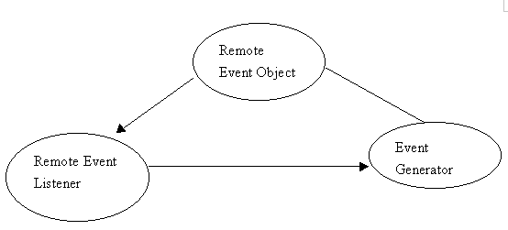
Figure 4-1. Event Generation in JINI

4.3 Event Model at CORBA

CORBA provides a comprehensive set of specifications for object services (Figure 4-2), including event services. The event service defines supplier and consumer participants. Supplier-generated events are propagated through an Event Channel to consumers. The event channel serves as a mailbox between the supplier and consumer (Pope 1997).
Two styles of access are available (Figure 4-3). In the Push style, an event notice is initiated by the supplier, while the Pull style is a request for an event notice. A Pull has an option of blocking or non-blocking when a notice is not available. The Push and Pull methods allow supplier and consumer to have other possible models than the synchronous model stemmed from the standard CORBA "request/response" communication. It even enables the design of an event queuing system, in which the supplier queues up the events and consumer will pull them, when they are required. Also event data can be generic or specific (typed) (Pope 1997; Harrison, Levine et al 1997).
One of the drawbacks for this model is that it does not support timed invocations, and standard one-way invocations might lack reliable delivery. Also, CORBA gives too much flexibility to vendors in implementing its services. As a result, it potentially lacks interoperability. Persistence is not mandatory in CORBA either, which may cause loss of events due to a network delay, for instance. Even though filtering is not our direct concern, compared with JINI, CORBA does not provide filtering of events; when there is an event notice, parties who registered for the events will get the notice regardless of their readiness or not (Schmidt and Vinoski1997).

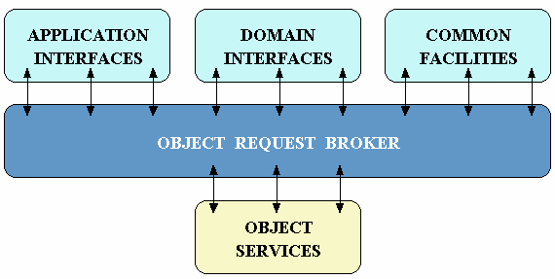
Figure 4-2. OMG Reference Model Architecture (Vinoski 1997)

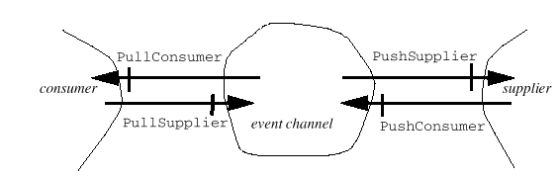

Figure 4-3. Push-style Communication Between a Supplier and an Event Channel, and Pull-style Communication Between a Consumer and an Event Channel (OMG 1999)

4.4. Event Model of Document Object Model Level 2

The event model is designed as a generic event system that has a registration of event handlers, a description of event flow through a tree structure, and a basic contextual information for each event.
A generated event from the DOM implementation is pulled into the document object model. This process is called an event flow (Figure 4-4). Each event has an EventTarget. When the event goes through the tree structure and reaches the target, event listeners who showed an interest on the event - in other words, were registered for the event - are triggered (W3C 1999).

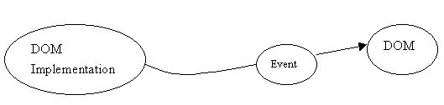
Figure 4-4 Event Flow at DOM (1)

The methods of event capturing and event bubbling further allow various ways of event processing (W3C 1999).
The interface EventTarget has methods to add/remove event listeners on the event target and to allow the dispatching of events into the implementations of event model. The EventListener interface has "handleEvent" method that is called whenever an event that the listener registered for occurs (Figure 4-5).
The Event interface provides contextual information of an event to the handler processing the event. User interface, mouse, and key events are defined as IDL too.

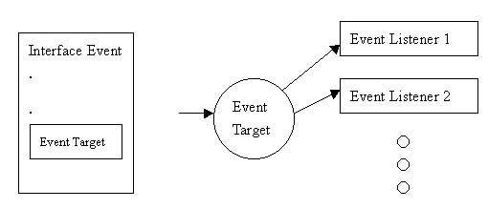
Figure 4-5 Event Flow (2)
“Event” Interface contains “Event Target” attribute. When event reaches the target, listeners which registered for the event will be fired.
______________________________________________________________________
4.5 Java Delegation Event Model

The delegation event model designates objects as event sources and listeners of events. Hence the source of the event and the event target to handle the event can be distinct.
An event listener is a particular listener of certain event type. For instance, ActionListener, MouseListener, and KeyListener are "listening" to ActionEvent, MouseEvent, and KeyEvent class respectively (Javasoft 1999).
The event source (Figure 4-6) is a component or program that generates an event. When the event occurs at the event source, an event state object is created. The event state object contains further contextual information. It is then delivered to an event listener that previously registered its interest about the event.

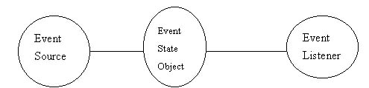
Figure 4-6 Event Flow at Java

4.6 Discussion

Each event model has different features as we described at the previous chapter. Not only features but also purposes or goals of each model may be different. Still, by focusing on what are relevant to our learning environment system, we can compare each model. As the Internet is as unregulated as itself, each technological community has its own set of terminology. We tried to follow one stream of terminology where possible.
In our system, an event generated at a source is sent to an http server. Chapter 4 and 5 explain in detail about the event capture. Captured events are sent along with other contextual information. Then the application server becomes a client of the content server, i.e., a request related to received events can be made. It is a cooperated solution among Javascript, local machine process such as NeatTools, http/CGI, and servlets.
Other event models over the distributed object system or web pass an event object that usually does not have a time stamp within the object. Also, the reliability of notification or acknowledgment mechanism is commonly not well-defined. Further, network delay among objects is not considered in any event model. Those are required in a learning system to track user sessions. Implementation of such functionality could be done by creating an extra object class to deal with it.
By implementing objects to handle reliability of event and time information, the JINI event model could be used. Furthermore, we might be able to see a distributed object learning system over PCS, Palmtop, PC, or a laser printer. In order to be usable, CORBA event model will need timed invocations and reliability of delivery of events. In DOM and Java delegation event models, an event can carry contextual information, but further time information will be required to consider network delays or amount of events (i.e. event polling). As the Internet develops, it will become desirable to employ a distributed object system. Current Internet, OLE (Object Linking and Embedding) from Microsoft's DCOM, or OMG (Object Management Group)'s IIOP (Internet Inter-ORB Protocol) (CORBA), for instance, use TCP/IP commonly. The use of the same infrastructure is a promising factor in transition. To elaborate on any further implementation is beyond our discussion.
For our system architecture, to have a dedicated event (service) object or delegated model at this stage was not a flexible solution. Instead of passing event objects, we used http/servlets model. It was light-weighted, compared to event object models. Time and data required among objects were less.

5. Smart Desk and a Learning System

5.1 Introduction

Smart Desk, a web-based interactive learning environment, was initially designed for a patient who was cognitively disabled from early brain damaging seizures. Smart Desk (SD for short) is a generic interface system, which, to some degree, can be personalized for individual users with different disabilities and can also provide user-tracking functions for future or existing applications. SD is not only an application environment but may be used as an alternative hardware interface. That is, rather than a traditional keyboard and a mouse interface set, SD can be fitted with accessing hardware specifically tailored to the sensorimotor capacities of particular users (Figure 5-1 and 5-2).

By working within the Smart Desk environment, users are able to improve their cognitive performance over time. Moreover, commercial applications such as educational software, personality assessment tests, neuropsychological tests/batteries, and user-defined applications will be able to communicate and interact with the Smart Desk environment to the extent that they are web browser compatible. In the context of a medical student’s education this includes, for example, parameters such as specific data to be recorded, representation of result data, or type of user data to be collected including history of disease, interviews, tests and personal information can be the user definable.
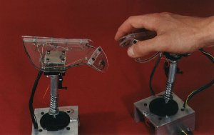

Figure 5-1. Hand Mouse (part of Smart Desk Chair built by Mike Konieczny)

The chair provides an alternative interface for the keyboard and mouse. On the board of the chair, the hand mouse from the picture is equipped with several other square buttons to provide easy access and generate analog or digital signals. This particular hand mouse can generate 10 signals from each finger and by pushing both hands, it can generate two additional signals each. The chair was built by Tim Lauring and exhibited at Siggraph 98 as a part of SD environment.
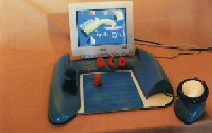

Figure 5-2 Smart Desk Hardware Interface by Matt Carbone

This interface provides additional assistance for learning subjects using the SD system; letters and objects can be mapped to games or learning languages or shapes. At the bottom of the device is a graphic tablet and by pointing with a pen, a user selects object at the screen in SD system. It works similar to a touch screen, which we also tried in SD.

Creating a generic environment provides a basis for psychiatrists and economists who look to evaluate computerized systems, educational experts who look to verify their educational system and children who require "home schooling" because of motor deficiency or geographical reasons.

5.2 Other Learning Environment

The first programmed learning environment dates back to 1926, then called the “teaching machine” (Adams 1976). It was originally invented to be an automatic test administrator. Later, Pressy added another mode for learning, after he found that the machine could teach as well if the subject was allowed to continue answering until he/she got the correct answer (Adams 1976).

In the context of instrumental psychology, as Skinner contended (Adams 1976), learning through a programmed learning environment or a teaching machine can be more effective in teaching than present-day instructional methods with classroom educational systems. Also the computerized learning environment can play a role as an auxiliary tool for the psychologist or pedagogue in the cognitive assessment process of physically disabled people where motor skills are critical factors in the testing process (Rodrigues and Viera da Rocha 1997). Within Rodrigues’ system, for each individual, a unique environment can be made which is socially and culturally tailored. Such a tailored environment is supported by the research using Piagetian showing that true cognitive ability manifests itself better when the user is familiar with the environment. This is another example of personalized and computerized educational environments within a computer science paradigm.

Interactive computer-simulated learning environments are found more often in college education. The SIMPLE learning environment is an authoring tool to make such an environment (Marcy and Hagler 1996). It is supported by relational databases, to maintain consistency of data, and has built-in tools such as replay function, refinement of crude recorded data, and answer-checking. More and more colleges now offer virtual classes which are interactive web-based classes. As another adaptable web-based courseware, Calvi (Calvi and Bra 1998) explored adaptable hypertext links that adjust themselves while the user’s learning session progresses.

Currently, web-based learning environments are being created in different fields. Children’s television station such as Nickelodeon (Nickelodeon), training software, and even employee review softwares like Computer Based Testing/Training (CBT) or Web Based Testing/Training (WBT) are getting on the Web and are providing interactive learning environments.

5.3 Smart Desk Features

SD is an interactive learning environment architecture which runs in a web browser. It provides a thorough structure for interactive learning. By expanding its subjects, just like inserting a cartridge for an electronic dictionary, the environment grows (Figure 5-3).

Given the web’s interactive nature, SD exploits the current web technologies to create interactive learning tools along with performance analysis capabilities. SD can be personalized for a user’s specific needs. This reduces the size of an environment dramatically. At the same time, through customization processes, one environment can generate as many different instances as a user will want to have.

SD contains several user-tracking mechanisms. With any user session performed in a Java application, mouse movements, clicking, dragging, and keyboard events are recorded via scripts or built-in functionalities. In the case of web software which does not support communication with other languages such as Java or Javascript to report events information, background processes can be used in the local machine to record events. More detailed ideas on these will be explained in the chapter 5.4.3. What is more, some of the results will be reflected back to the system (learning process) to improve their sessions. For example, for a six-year old learning how to add, we can start from very simple pictorial examples, then his session would be watched and adjustments of difficulty can be made later.

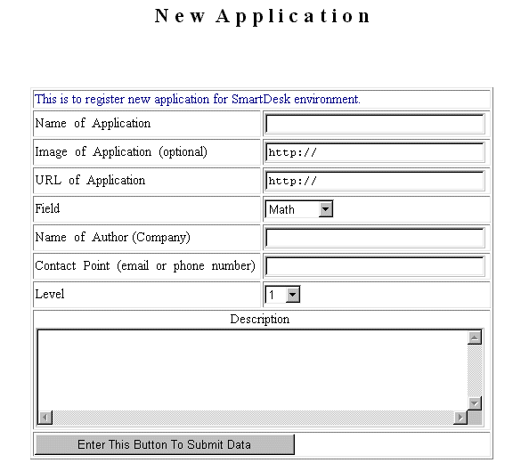

Figure 5-3 Interface to Add a New Application

5.4 Implementation Issues

5.4.1 Personalized Environment

When we don’t have much information about the users of a learning environment, creating such an environment to fit their needs is hard. Following is the approach we have taken on this issue. A new user who wants to create his/her environment will walk through an index of learning components such as tools, programs, games, or performance tests which are all classified by subjects and levels. By choosing items from the index, a user can create an environment. Later a user can update or change the environment as performance level increases or decreases. Using the same principle, the same user can have more than one environment (Figure 5-4).

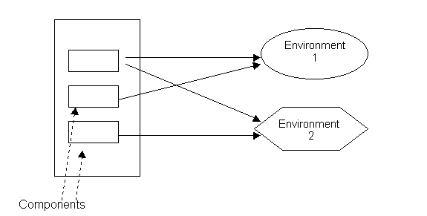

Figure 5-4. Personalizing Process

A learning environment of a user is composed of components at the learning system. Squares stands for components and other shapes mean different environments.

A personalized environment refers to the capacity for tailoring the learning system’s interface and content features to the cognitive and sensorimotor needs and capacities of particular users. Further, the ability to update gives a user challenges and stimuli by providing new components or changing levels of learning (Marcy and Hagler 1996; Rodrigues and Viera da Rocha 1997).

We provide a generic and easily updatable environment such that a user can add more tools or tests to the index so that other users can share them too, to the extent they are web-based (Figure 5-3). An interface to manipulate data is written in Java servlets, HTML, and Javascript, and is operated in a web browser. User session information, or registration, is stored at a database (Oracle) which supports web interfacing through Java DataBase Connectivity (JDBC) between servlets and the database. Also, information on learning components is itemized and stored at the database (Figure 5-5).

5.4.2 Adaptiveness Issues

Just like a 1st grader goes to the 2nd grade after one year of school, a learning environment needs to be changed as a user successfully progresses. This environment can be adjusted to upper or lower levels according to a user's performance. The adjustment may be done to each learning component without affecting other components. After a given period of time and number of learning sessions, by examining user performance, it is updated or left unchanged if necessary.

________________________________________________________________
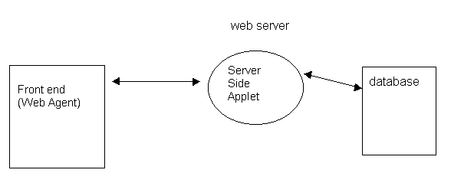

Figure 5-5. Communication Between Front end and Server

The basic structure of the communication process is three tiered (Reese 1997). Compared to a two tier architecture of client-server model, a three tier architecture has the third layer to isolate data processing at server side and maximize objects reuse.

______________________________________________________________________

The most important issue is how efficiently the learning environment is designed to gather user data so a teacher or user can know the quantitative and qualitative performance of the work accomplished. Automatically tracked information such as mouse movement and keyboard inputs is available along with results from each learning session. Tracked or traced information can reveal the performance of users. Classification of this information and measuring levels are challenging issues (Hochheiser and Shneiderman 1999); however, they are beyond the scope of a computer science analysis.

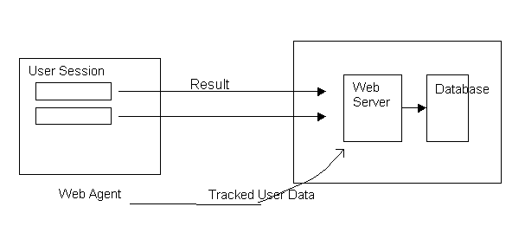

Figure 5-6. User Tracking

This figure shows how tracked data from each user session is transferred to the database at the server side.
________________________________________________________________

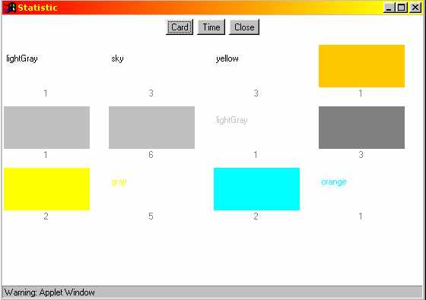

Figure 5-7 (a) an example of measuring and analyzing mouse inputs

Results from a concentration game with an option of “color-to-words” mapping. Each number below the cards signifies the number of times a user clicked the mouse during the learning session.

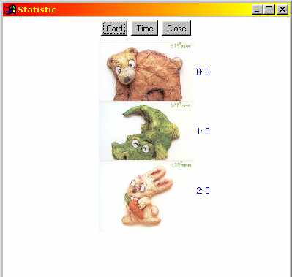

Figure 5-7 (b) “word learning” game

another example of tracked user data at the client side.

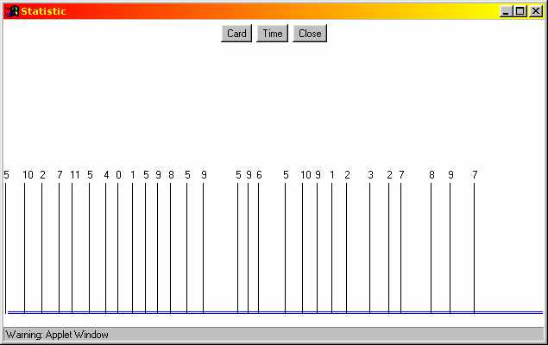

Figure 5-7 (c) an example of tracking user events along with time axis

Gap between each vertical bar (events) represents elapsed time between each event. The number above each bar means “which” card was selected. It specifies which objects were chosen.

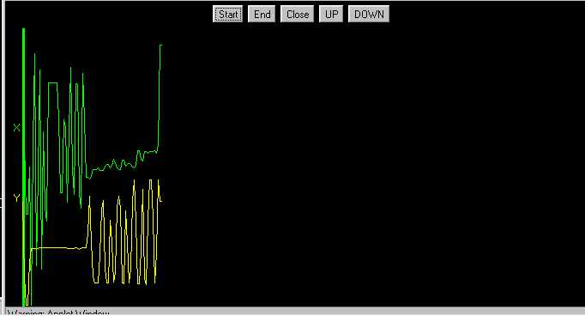

Figure 5-7 (D) an example of mouse trajectory

X and Y trajectories were recorded separately. First part of the above graph shows that there were extensive movements along with the X axis, i.e., a user moved the mouse mainly left and right. The second part of the graph shows up and down movements of the mouse.

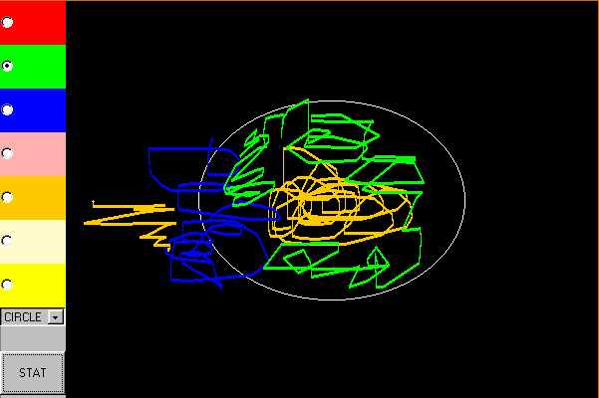
Figure 5-6 (E) an example of right-wrong answer measurement

Figure 5-7 (E’) Proportion of right and wrong answer

(E) is to fill the circle with mouse or mouse-equivalent device. (E’) is the resulting graph. Lighter part represents the percentage that a user filled in the object. In this case, it is about 80%.

5.4.3 User Tracking (Figure 5-5)

User tracking is a quantitative approach for adapting a learning environment. For measuring user performance, not only are the results or answers of assessment applications important, but also how a user interacts at each session. For example, mouse movement can tell us about a user's hand coordination at certain times in responding to certain types of information.
Generally, user tracking schemes in SD can be viewed in three categories. If learning components are written in Java and have event data tracked inside, then the tracked user session data is sent to a database residing at a server side (Figure 5-7 A – E’). A web browser also provides information on mouse movement and navigation behavior. Perl scripts and Javascripts are used for this purpose. Since Javascript version 1.2, event objects can detect “clicks”, “double clicks”, “down”, “up”, or “over” for mouse event, and “down”, “press”, or “up” for keyboard event, over the entire web browser window or document, for example. A set of Javascript functions to implement such event detection along with time information by date objects was created; Perl scripts were written to generate the javascript code automatically at the header parts of HTML files. Other applications which are not written in Java (or any other language that can record user data and send it back to a server side by communicating with a web browser and web server) can be tracked using a background process at the user’s local machine. For instance, a software successful at tracking user interactions is NeatTools, implemented by Yuh-Jye Chang (Appendix C). It can, among many other things, record mouse movement, keyboard event and time information associated with such events. In this case, after the user session, one can upload the resulting data file to a server through the web.

Smart Desk is designed as a web-based application. Specifically, it requires no client side support to run Smart Desk other than a web agent, or browser, and a background process program if required. Centralized information enables users to share the most up-to-date information, eliminating the need to worry about stale data. This gives relief to developers as well.
For classrooms, or users without Internet access, a CD-ROM version may be made available. The database components will need to be edited; and because the connection to the database is JDBC, with a few changes, local databases such as MS Access can be used instead of the centralized database at a server side. Even without a database, by using the file system of the local computer to store data, SD can be run.

5.5 SD Information Architecture and Events

Registration and Customization processes are conceptually handled by AS (Application Server, see chapter 3). At SD, Servlets play the role as AS in both processes between user requests and a content server (Figure 5-8). It is essentially an administrative service. Figure 5-9 and 5-10 show interfaces of both processes.

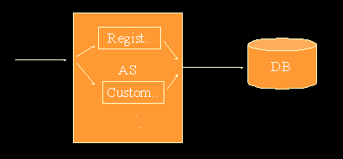

Figure 5-8 Servlets at AS

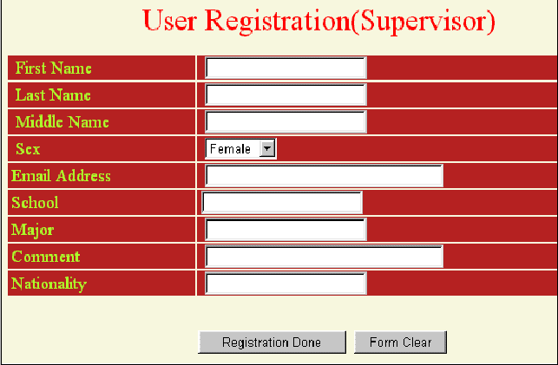

Figure 5-9 User Registration

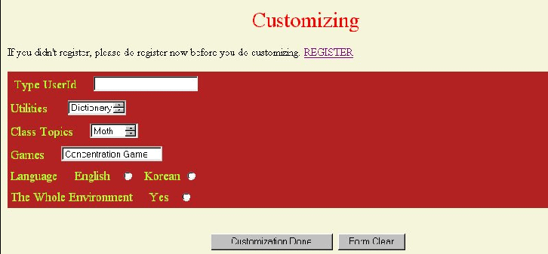

Figure 5-10 Customization

The event model of SD is depicted at Figure 5-11. Figure 5-12 shows more detailed client-server event model. In detecting user events, SD uses various methods. For a client-side event tracking or detection, Javascript and background process lurking at user’s local machine are chosen. Server-side events detection is to watch events among components at server side and user logs. To represent event data, XML (Extensible Markup Language) may be used. XML provides a noble way to describe data. It is based on extended BN (Backus-Naur) notation. Both client and server sides event data are specified at Figure 5-13 in a terse XML notation.

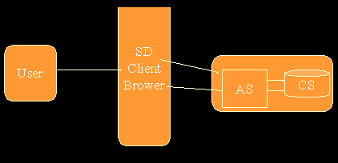

Figure 5-11 SD Event Model
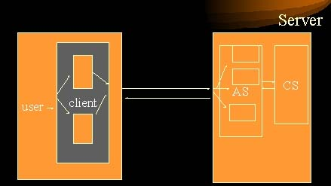

Figure 5-12 Data and Event Flow at SD

<?XML version=”1.0”?>

<!DOCTYPE DOCUMENT[

<!ELEMENT DOCUMENT (USER_SESSION) *>

<!ELEMENT USER_SESSION (NAME, DATE, C_DATA_TEXT, C_DATA_TRACK, S_DATA)>

<!ELEMENT NAME (LNAME, FNAME)>

<!ELEMENT LNAME (#PCDATA)>

<!ELEMENT FNAME (#PCDATA)>

<!ELEMENT DATE (#PCDATA)>

<!ELEMENT C_DATA_TEXT (CLIENT) *>

<!ELEMENT CLIENT (STIME, DATA, WHICH)>

<!ELEMENT STIME (#PCDATA)>

<!ELEMENT DATA (#PCDATA)>

<!ELEMENT WHICH (#PCDATA)>

<!ELEMENT S_DATA (SERVER)>

<!ELEMENT SERVER (STIME, DATA, WHICH)>

<!ELEMENT C_DATA_TRACK (T_FILE?, TITLE)>

<!ELEMENT TITLE (#PCDATA)>

<!ELEMENT T_FILE EMPTY>

<!ATTLIST T_FILE TYPE CDATA “TEXT/PLAIN”>

Figure 5-13 Events at SD in XML

5.6 Conclusion

Smart Desk provides a web-based interactive learning environment and enables users to personalize those environments. Updating or adapting their environments are possible through analyzing their prior performances in user sessions. It solves many problems in computerized education or performance tests. It can be used as a valuable tool to simulate user behaviors and observe user-environment interaction. SD is a testbed for measuring interactivity, as will be discussed in a later chapter.

6.Interactivity : Definition, Measurement, and the Experiment

Interaction is mutual or reciprocal action or influence. (Webster)

6.1 Background

When two or more subsystems or components in a system affect each other, we say that they are interacting in the system. For example, a controller interacts with a learning system through two way communication; the controller sends data to the learning system and adapts itself according to information fetched from the learning system. Then what is interactivity? Interactivity is a variable characteristic to describe communication or interactions between (sub)systems. The concept of interactivity is versatile enough to describe a communication process in general, including a social, computer, industry, economy or business system. Interactivity is a spectrum of continuum (Rafaeli and Sudweeks 1997), varying from only one way communication to two way fully interactive communication. Rafaeli et al. said, it is a likely candidate to help in explaining how groups, such as Computer Mediated Communication (CMC) groups, are bound together (Rafaeli and Sudweeks 1997).
An interactive learning system is one in which a student or a controller (chapter 2), has the ability to affect the flow of events or modify the system. A non-interactive learning system is one lacking these abilities. Examples of non-interactive learning systems are books, slides, lectures without the participation of students, or photographs.
Why consider an interactive learning system? Psychologists have studied how humans learn. Behaviorists in psychology will emphasize learning through repetition and practice. For example, in the acquisition of language, their best methods will be to read, repeat, and drill sentences and vocabulary. This trend, however, has changed since field tests proved that an interactive learner-centered approach works better (Krashen 1981). Also, theorists such as Jean Piaget (Piaget 1982) argued that learning is not filling empty containers with information, but occurs through the constructive processes of assimilation and adjustment in which the mind uses “provisional conceptualizations.”
Interactivity in the context of the Internet has become a great target among interactive multimedia designers and developers. Commonly, the degree of interactivity with certain web sites or web applications is determined by how much users participate at a particular web site. The existence of forms, e-mail links, click on ad-banners (click-through) are examples.
The Internet is a public domain, and individuals on-line also form groups and these groups interact with one another in a growing cyber culture (e.g. Geocities.com). It can be an anonymous and faceless communication or involve face to face communication, such as, off-line meeting of previous acquaintances. But certainly, the demographics of the internet are different than a real life.
Rather than focusing on demographic data, or people interacting over the net, the interactivity in this dissertation will be measured between the system and the user. Because interactivity involves many parameters (e.g. psychological aspects, contents of system, etc.) there has been hardly any effort to measure it quantitatively in web based-applications. Guidelines to enhance interactivity exist, assuming that following such rules increases degree of interactivity: to add forms, e-mail links, or click through which is another concept introduced along with ad-banner (Novak). However, these tools fail to include important information such as actual response time of requested data or transfer time of such data, not to mention any systematic model.
Here interactivity issues are discussed to explain the idea of interactivity measurement at our information architecture. Chapter 6.2 introduces interactivity measurement methods in the commercial fields of the Internet. They have developed models reflecting the interactive features of the Internet. Chapter 6.3 explains the methodology taken in this work followed by an experiment and result at Chapter 6.4.

6.2 Interactivity on the Web

Because of the commercial possibilities of the Internet, measuring user behaviors at a web site has become important. Though advertising at a web site is still in its infancy compared with other media such as mail, phone, magazine, newspaper, or TV, the advertising expenditure on the web was $ 1.03 billion as of 1998, while it was $ 0.312 billion which took the 9th place among other media according to the Direct Marketing Association and Randall (Randall 1999). Standardizing the web measurement process will be critical in successful commercial development of the web. Considering this, it is not surprising that interactivity measurement for the web advertising has been discussed and proposed before any other firleds at the web environment. The measurement methodology is worthy to note related to this work, because of its efforts to track customer access to the web advertisements. For example, cache-busting techniques allow us to track a user performance more correctly to a degree (note: a “smart” proxy server can still cache even with such techniques (Bennett n.d.)).
Creating personalized web environments through measuring interactivity are not only confined to the contents of the browser, but also to other communication media or web agents such as WebTV. WebTV has the capability to track user’s preferences and select channels automatically (Pitta 1998). Similarly, web channels provide users alternative modes of surfing. Users have a set of channels which downstream information like TV channels. In that sense, the information is passively delivered to users instead of users searching through search engines or by hypertext links. Channels may also be personalized.
The web environment presents the potential for a more interactive and enjoyable learning format by creating an instrumented learning environment. Additionally, it has been shown that the performance of a learner is improved through such formats (Wilson 1993).
While the interactive and personalizable nature of the Internet in learning is emphasized and experimented with, measurement standards do not yet exist. Even in the case of the commercial site, where standardization procedures are already occurring (Ha and James 1998), a complete set of content-based and transaction record analyses are not yet done.

  - Measurement of Interactivity at an Information Architecture for a Learning Environment

Measuring interactivity in the context of computer science covers a wide range. It can be used to evaluate the performance of an operating system by showing interaction times between two processes or a process and a user. Or it can be the interaction times or behavior of user at a software/hardware interface.
In this work, the interactive user behaviors related to the learning environment and the interactive features of the environment (the content-based analysis) are explored. The former will be referred to as user-record transaction analysis of both client and server sides and the latter, is the content-based analysis of the interactivity.
Interactive user behaviors of server-side include the time between requests and the amount of data from a user to a web server, and the trajectory at a web site. The trajectory shows when a user requested which information in what order. The user behavior can be measured by simulation too. Here, web server, a user, and the learning environment compose the controlled environment for the simulation. A sample trajectory can be chosen from a web-log file or created to implement a certain type of user behavior. Whether through simulation or real user, a web benchmarking methodology is utilized to measure the interaction between a user and the environment during a session.
A web server maintains a history of user requests at its log files. It holds valuable information to analyze both user behavior and the web server performance. Appendix E has a common log format according to NCSA (National Center for Supercomputing Applications).
The client-side’s interactive user behaviors are tracked at the interface of the learning system. The data shows user’s coordination or trajectory on the interface.

6.3.1 Introduction

Interactivity is measured by the content-based and the user transaction data analyses. The content-based analysis has 5 dimensions describing the criteria for measuring interactivity in an educational web sites:
1) Attractiveness
2) Choice
3) Adjustment
4) Information collection
5) Off-site contacts.
Similar approaches in the case of a business web site have been done by Ha and James (Ha and James 1998). Also the content-based approach as a research methodology can be found in the paper by Marcus (1993). The author described the science of the interaction and provided several dimensions to consider.

Sole content-based analysis in assessing interactivity often lacks reality and we need the user-transaction record analysis at both client and server side additionally. For example, a different arrangement of buttons on web pages affects users’ navigation patterns, while the content (the existence of buttons) may be the same. This relates to how the human perceives and processes information, which is what HCI and cognitive science examine. Another factor may be the performance of a web server; speed of a web server or network congestion can give users different impressions of interactivity at particular web sites.

Smart Desk sites are examined for the interactivity variable with the above two analyses to show differences among personalized and non-personalized environments, or adaptive and fixed environments. Diagram 6-1 shows the structure of this thesis and the scope of the experiment.

________________________________________________________________
Abstracted system
Information Architecture
Smart Desk
A user, the learning environment, and their interaction to each other

Events Flow
Information Flow
Interactivity

Content-based
Client-side
User Transaction Record
Server-side

Diagram 6-1 Structure of This Thesis

While the analysis methodology of both the content-based and the user transaction is developed, the experiment is designed to cover the content-based and the server-side analyses (shaded rectangles at this Diagram).

________________________________________________________________

6.3.2 Content-Based Measurement

Depending on the contents, or nature of a web site, the means for measuring interactivity vary. According to what a web site presents, the content-based analysis measures interactivity. That is, interactivity dimensions, or aspects, differ from commercial sites to educational sites or governmental sites. In this paper, the five dimensions of interactivity at educational web sites were defined as: attractiveness, choice, adaptiveness, information collection, and off site contacts.

In determining the interactivity dimensions, a number of design guides on various web sites are chosen and interactivity research papers are referenced. Appendix A has a detailed list.

Interactivity is measured differently when the nature of communication is different (i.e., types of web sites affect the measurement elements). The five dimensions mentioned above are chosen to capture the key elements of communication empirically (Appendix A) and theoretically (Adams 1976) of an educational web site, which may not be applied to other type of sites such as commercial sites.

The result of this analysis is visualized as a weighted 2D graph (W2D). The graph gives a quick grasp of the balance of five dimensions (Figure 6-3). Refer Appendix B for the meaning of each pole, i.e. which dimension is represented by which pole.

Attractiveness

Learning is accelerated when a student participates interactively in the learning process. The attractiveness of a web site is measured by counting curiosity arousal features: games, e-postcards, devices for collaboration or competition with other users, and reinforcement devices.

Choice

Choice is a spectrum of capability that lets users have freedom to choose his/her own learning environment or navigation pathways. It is measured by the presence of
- selection of languages,
- selection of communication capacity depending on bandwidth or internet connection types,
- personalization possibility,
- other navigation options.

Adaptiveness

Learning is an ongoing process. If a user has a learning environment and does not alter it, the environment may become obsolete as time goes on. To prevent staleness, a web site needs to be able to adjust the level of learning as a learner’s ability is changed. This will allow new applications to be added as part of a user’s educational program, and provide the user progress reports and analyses. Personalization is a necessary condition for all the above requirements.

Information Collection

Closely coupled to adaptiveness is information collection. To achieve successful adaptiveness, smart information collection means are required. In other words, information collection can be thought of as a user monitoring mechanism. On line user registration, the use of cookies, web log analysis, and user behavior recording at local computers are all counting features.

Information collection is mainly differentiated from adaptiveness because of different view points in analyzing. Information collection is performed at the communicator side in two way communication, while the adaptiveness is primarily user oriented. The communicator is a party to serve information and the user is a client.

Off site contacts

This is the most active interactivity dimension. It solicits user input and reaches out to users even when they are not at the web site. Hence, it is beyond reciprocal communication. The reciprocal communication at educational web sites is measured by the presence of a response mechanism, such as, the e-mail address of the web site’s creators; forms to request further information or to send messages; and chat rooms. In addition, an educational setting requires more active user contact mechanisms. Monthly user progress reports, newsletters, listservers, and discussion forums belong to such mechanisms.

6.3.3 User-Transaction Record Analysis

Efforts to measure interactivity in an Internet setting are themselves relatively recent, when we realize that the Internet opened to public use only in the early 90s. The Internet has formed a new communication way among people at radically fast speeds. Previous studies on the communication may not be applied here any longer, nor can conventional quantitative measurements of interactivity using data bits and speed be ported.

Methods for measuring interactivity similar to the content-based analysis approach have been the most popular. The content-based analysis provides good comprehension of a web site in terms of its interactivity features. It might be viewed as a structure or morphology of interactivity.

However, actual implementation varies from site to site. Performance of web servers or arrangement of hyperlinks affect a user’s navigational patterns greatly, caused by factors such as perception cycles, processing of visual information, or reaction times of the human being (Johnson and Dunlop 1998). Such factors cannot be considered when we approach to analyze with contents or features of web sites, which makes a weak point of the analysis. Quantitative data analysis of user transactions at a web site and a modeling of user behavior covers the weak point.

The user transaction analysis is further divided into the client and server sides. The client-side analysis is an event detection of a user at the web browser and within applications during the learning session. The server-side analysis is based on traffic between a user and a web server. The traffic entails transactions between the web server and user, network delay time (congestion), and the amount of data transferred to name just a few.

The client-side event detection is of two kinds stated previously. Figure 5-7 shows the example of tracked data during a learning session, while Figure 6-1 is the information obtained from the web browser during the learning session.

Here, a paradigm used to benchmark the web is applied to measure the server-side user transaction. In some sense, they are two sides of a coin. In determining web performance at the benchmark, three primary factors are considered: one is the user who requests information; another is the network infrastructure; and the third is the web server. Measuring the server-side user transaction is related to the above three factors of web benchmarks. In particular, the user requests represent a trajectory of user transactions. Web server performance is mainly measured by user requests, latency, and throughput. Also, web benchmarking has begun to establish methodologies and metrics in computer science on its part at the Internet, which is worth to note in developing any metrics or standards of system on the Internet.

Four classic variables exist to describe the performance of any computer system. Latency is the time between initiating a request and beginning to see its result. Throughput is the number of items processed per a unit of time; examples

are millions of instructions per second (MIPS), data bits transferred per second, or HTTP operations per day. Utilization is the fraction of the capacity of a component you are using. Finally, efficiency is a throughput divided by utilization (Killelea 1998).

________________________________________________________________
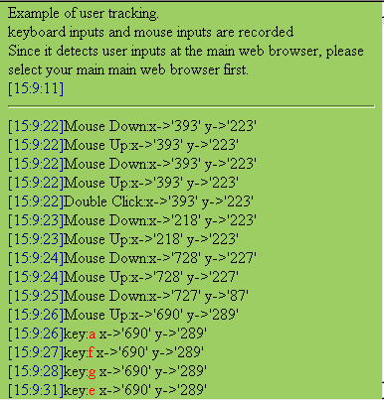

Figure 6-1 Tracked Information at a Web Browser (Netscape Communicator 4.61)

This example shows mouse and keyboard events. It detects types of events and coordinates of user inputs with the time information.

________________________________________________________________

The same variables are applied to web benchmarks. The basic idea is to measure raw throughput and the handling capacity. Response latency represents the time between a server’s recognition of an HTTP request and its response to that request. Connection-handling capacity is the maximum number of connections per a unit of time. And the server throughput is the amount of data that a server can send and receive over a unit of time (Killelea 1998).

The benchmark purpose is to generate performance statistics so that we can compare products legitimately to one another. To achieve this, constants in a system should be clearly specified. For if the only variable is the component itself between each run of tests, then any difference in results can be said to be due to the difference between the components. We adapts the web benchmark methodology to be able to compare interaction between a user and systems. First, a trajectory of a user is chosen for the analysis; then, interactivity of the trajectory is measured. That is, the number of interactions in terms of amount of information transferred and the number of requests for the information in a certain time are analyzed.

    - Steps to Apply Interactivity Measurement Methods To SmartDesk

The Smart Desk site is deconstructed for content-based analysis. And the user transaction data analysis at the server side is performed on the original SD environment and his/her personalized SD environment. The original SD environment is when a user does not personalize the SD. It is a super set of every personalized SD (Diagram 6-2).

For the second half of the interactivity measurement, user record analysis, the following method is used for experiment.

Step 1. Assume a virtual user trajectory

Step 2. Build personalized SDs to include the virtual trajectory (Diagram 6-2).

Step 3. Measure the time and transferred data to follow the virtual path for an original SD and personalized SDs.

Diagram 6-3 shows the above process as a diagram.

________________________________________________________________

Original SD Environment
Personalized SD 1

Personalized SD 2
Trajectory

Diagram 6-2. How SDs are implemented for experiment

A trajectory of a user’s learning session (the inner most circle at diagram 6-1) is a part of personalized SD1 (P-SD1), personalized SD2 (P-SD2), and the original SD environment at this particular experiment.

________________________________________________________________

________________________________________________________________

ORIGINAL SD ENVIRON-MENT
Controller: Initially to build personalized SDs around the chosen trajectory for experiment. Then it adapts the P-SDs by following the change of user behaviors.
Analyzer: content-based and the user transaction data analyses are performed.

DD
P-SD1
P-SD2
Output: results of each analysis are generated.

Diagram 6-3.Process of Experiment

It is a skeleton of experimental process. Circles stand for learning environments and squares are supporting sub systems to help experiment.

________________________________________________________________
  - Case Study: Interactivity Measurement at SmartDesk

    - Technical Specification
- Hardware : MIPS R4600 (processor speed 100 MHZ) INDY workstation

160 MB memory, IRIX Version 5.3
- Hardware and operating system where the web server resides: OS version 5.6. Sparc processor.
- Web Server: Apache http server version 1.2.5
- Scripts and application were developed for experiment (Interactivity Measurement Suite Appendix C):
- Scripts
- stat.pl : It calculates number of hits per second, data transferred per seconds, total amount of data, total transaction time, and average transferred data per transaction.
- all.pl : It adds up the number of files and amount of files at the entire web sites and classifies different extensions such as .html, .class, or .dcr.
- personalize.pl : This script creates a new personalized SD. Data to create the new SD is sent from web browser and the interface is generated by document_map.pl.
- document_map.pl : It is based on “webtester.pl” script by Darryl Burgdorf(e-mail burgdorf@awsd.com). document_map.pl shows file size, relation with other files to show structure of web sites and map of hypertext documents, and interface to make a new personalized SD.
- Header.pl
- Javascript
- Application
- Graph generator: It provides GUI to let people choose each dimension of content-based analysis and its elements along with weights on the element; then it generates a weighted 2D graph. It is written in Java as an applet.

6.4.2 Web Sites Deconstructed
- number of links in total : 67
- Amount of data at web server: average is 24,287 bytes, and the number of files is 223.
- Text files: 1,007 bytes. 68 .html files.

2. Image files: 12,181 bytes. 78 files.

3. dcr files: 352,154 bytes. 12 files

4. . class files: 2,638 bytes. 65 files.

6.4.3 Experiment

Both the content-based and the server side user transaction analyses are performed on an original SD and personalized SD respectively. As for the content-based analysis, the 5 dimensions described at chapter 5 are evaluated and represented by a weighted 2D graph (Appendix B). The graph generator which is introduced at 5.4.1 is used here. Figure 5-1 and figure 5-2 show the GUI and a sample graph generated from the picture.

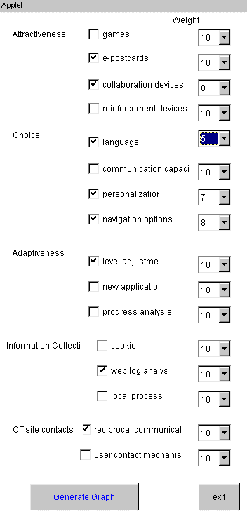
________________________________________________________________

Figure 6-2. Sample GUI

This interface is built with Java AWT. Further information on source code and URL address is provided at Appendix C. A generated graph from this sample is Figure 6-2.

________________________________________________________________

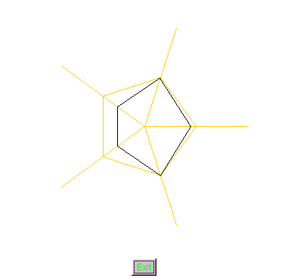

Figure 6-3 Sample Graph

Each 5 line stands for five dimensions in measuring interactivity of an educational web sites. Dotted pentagon which connects half points of each line is a helping line at background. Pentagon with solid line is an actual graph. Further explanation on this graph is at Appendix B.

________________________________________________________________

________________________________________________________________

http://sunrise.npac.syr.edu/pulsar-stat/SD/Full/TOPIC/Memory/index.html

http://sunrise.npac.syr.edu/pulsar-stat/SD/Full/new_deskpage.html

http://sunrise.npac.syr.edu/pulsar-stat/SD/Full/TOPIC/Match/index.html

http://sunrise.npac.syr.edu/pulsar-stat/SD/Full/GAME/SM.html

http://sunrise.npac.syr.edu/pulsar-stat/SD/Full/TOPIC/Match/index.html

http://sunrise.npac.syr.edu/pulsar-stat/SD/Full/Card/test.html

http://sunrise.npac.syr.edu/pulsar-stat/SD/Full/TOPIC/Match/index.html

http://sunrise.npac.syr.edu/pulsar-stat/SD/Full/GAME/SO.html

http://sunrise.npac.syr.edu/pulsar-stat/SD/Full/TOPIC/Match/index.html

http://sunrise.npac.syr.edu/pulsar-stat/SD/Full/new_deskpage.html

http://sunrise.npac.syr.edu/pulsar-stat/SD/Full/TOPIC/Letter/index.html

Figure 6-4 Sample Trajectory

It is a part of the trajectory used for an experiment. It is chosen from a web log file. Full trajectory is at Appendix C. P-SDs are built to include the trajectory. Closer look at the list of URLs will tell that it is the case of non-cached log. If a web agent has a cache, log file does not have a log of return to previous pages.

________________________________________________________________

Figure 6-3 shows part of the virtual user’s trajectory. Document map of a SD site is generated which has links from and to for each web pages (Figure 6-4) by the script document_map.pl. It helps to follow the trajectory to measure and analyze data, because it provides visual representation of relation among documents. “Think time” or “view time” or both are variables in this experiment; these variables adjust the time that a user would spend at each page. For instance, average time taken to select a link is part of the variable. If there are more links, “View time” increases. Script all.pl was used to measure amount of transferred data and time along with those variables. Domains of those variables can be values from various distributions, while same values are assumed for every link at this particular experiment. For example, picking up values from an exponential, logarithmic, or linear curve as time increases can represent the learning curve (Bailey and McIntyre 1997). Results from different values for those variables are shown at graphs 6-5 and 6-6.

Personalized SD 1 is a subset of P-SD2. Both include the selected virtual user trajectory (Figure 6-4). Such personalization schemes are intended so that relations between the size of environment and interactivity can be shown numerically.

Amounts of data transferred along with the trajectory are presented in terms of time and the number of visits.

Changes due to adaptiveness factor are shown at table 6-1. Adaptiveness is simulated by introducing new subjects to personalized SDs. As a user keeps using the personalized SD, shorter response times are expected than in early stage of using the environment. Also we can expect that more interaction is performed in a fixed time.

________________________________________________________________
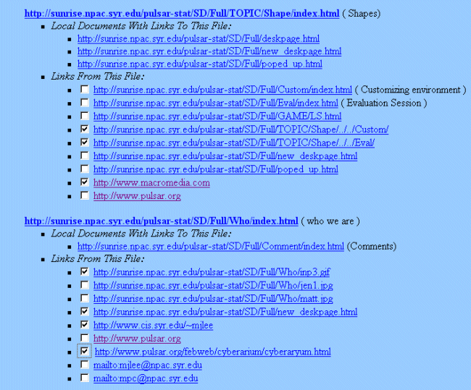

Figure 6-5 Example of Document Map

A Perl script (document_map.pl see Appendix C) builds a map of the whole web sites and make links to be selectable by adding checkboxes. When a user checks each box and sends back to a server, personalized SD is built there. For the sake of simplicity at experiment, user level information is not considered, here.

________________________________________________________________

6.4.4 Results

When the user has a personalized and adaptive environment, interactivity is noticeably increased. Interactivity is measured via the methodology developed in this work.

An invariant throughout sets of experiments is the navigation trajectory (i.e., the same user behavior is expected at the personally tailored site and the original site). This enables us to exclude the possibility that better results might be obtained from different user behaviors, or user levels.

1) Results of the content-based analysis

The content-based analysis of the original SD site is described in detail as follows, while analyses of personalized SD sites are shown as graphs only.

A. Attractiveness

The number of games is four. E-postcards and collaboration tools do not exist. Positive reinforcement devices exist in two games.

B. Choice

It does not support multi language or cultural factors. Though user can add such applications to his/her own personalized SmartDesk. No bandwidth or connection speed choice option exists either. The reason is that text based environments are offered for visually impaired users or those with slow processors, for example. SD can be personalized for each user. However no particular navigation options or tool bars are provided. Instead, a picture map is used for navigation.

C. Adaptiveness

New applications can be added by a user, and analysis tools are also part of the SD environment. In fact, this dimension of interactivity is the central idea of the SD environment.

D. Information Collection

On-site user registration, web log analysis, user behavior recording at the local computer by a background process are available in SD environment. Cookies are not used.

E. Off site contacts

E-mail links and on-line forms to send mails are only off site contacts in the SD environment.

Graph 6-1 shows the results of the content-based analysis of the original SD site. Graph 6-2 and 6-3 are two more examples of personalized environments. Compared to the graph of original SD at Graph 6-1, the graph of P-SD1 has less degree (weight) of interactivity at each dimension. It is that P-SD1 is built with less functionality and features.

P-SD2 is a super set of P-SD1 (Graph 6-2). Therefore weight at each dimension should be same or higher than that of P-SD1 at this graph. We can tell that P-SD2 has more weight on off-site-contacts dimension from the Graph 6-3.

________________________________________________________________
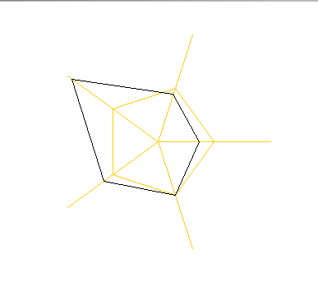

Graph 6-1. Original SD

This graph shows that attractiveness and choice are less than .5, off-site-contacts is .5 , and adaptiveness and information collection are more than .5. Appendix B explains which line is mapped to which dimension.

________________________________________________________________

________________________________________________________________
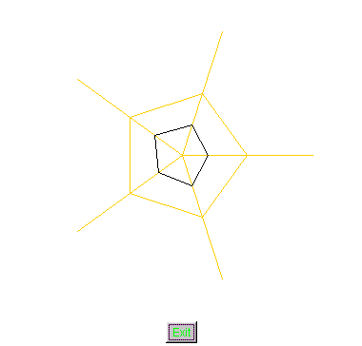

Graph 6-2 P-SD1

P-SD1 is well-balanced among five dimensions, because it is near a right pentagon.

________________________________________________________________

________________________________________________________________

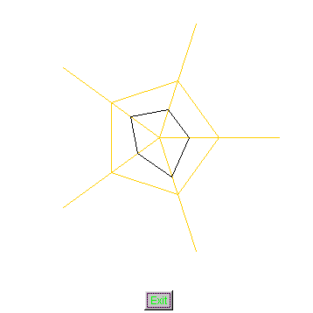

Graph 6-3 P-SD2

________________________________________________________________

2) user transaction data analysis

P-SD1

Amount of data at web server: total sum is 2,941,036 bytes (54.3% of the original SD), and the number of files is 61(27.4% of the original SD).
- Text files:18
- Image files: 4
- DCR files:6
- Class files:33

P-SD2

Amount of data at web server: total sum is 3,311,909 bytes (61.2% of the original SD), and the number of files is 81 (36.3% of the original SD).
- Text files:25
- Image files:8
- DCR files: 9
- Class files: 39

Graph 6-4 shows the number of hits per second. The X axis of the graph shows average time that a user spends at each page (10 ≤ X ≤ 120). The graph shows the time the user spends at each link to choose the next page at the trajectory, is determined as one second. That is, if there are five links at the current page, the user is supposed to spend 5/2 seconds on average to locate the link of the next page. The variable, time at each link, is important because it reflects each user’s perception ability or recognition time to locate information.

Original SD has the lowest number of page requests (hits) per second throughout the x domain. That shows personalized environments (P-SD1 or P-SD2) have more interaction with a user. For example, if we assume that a user spends 10 seconds at each page, number of hits per second is 0.027 at original SD, 0.037 at P-SD1, and 0.039 at P-SD2. When a user has a personalized learning environment, if we assume the same learning material is covered at the particular learning session, number of hits is shown to be higher. This implies that P-SDs have greater interactivity. We can also observe that as the time spent at each page increases, those numbers of hits for 3 cases are converges; i.e., if a user needs a relatively longer time at each page or if the page itself has more information, then interactivity decreases no matter how efficiently environment is personalized.

Graph 6-5 and 6-6 show amount of data transferred per second during a user’s learning session. They are differentiated by the variable, time spent at each link. In graph 6-5, the variable is one second and in graph 6-6, it is 1.5 seconds. Graph 6-5 shows that more data is transferred during the same fixed time when other conditions are fixed too, which proves that the less value for the variable brings more interaction in terms of amount of data transferred. This situation gives an idea of an adaptive environment; spending less time in locating links represents that a user is getting more familiar with the environment.

The graph 6-7 shows the total completion time of a learning session. At those personalized SDs a user finishes the same amount of learning material in 83% of time that would spend in the case of the original SD.

________________________________________________________________
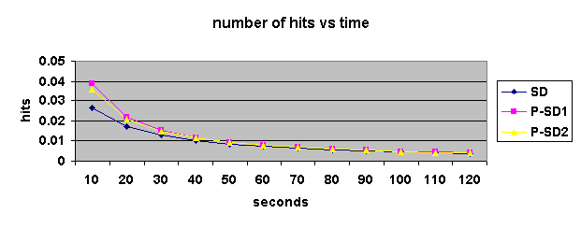

Graph 6-4. Number of Hits vs. Time

X-axis indicates the average number of seconds that a virtual user spends at each web page. Time spent to retrieve hyper-text links is assumed as one second, which is additional to the time spent at each page (X-axis). Y-axis is a number of hits per second. In other words, it means how many pages a user requested at one second.

________________________________________________________________

________________________________________________________________

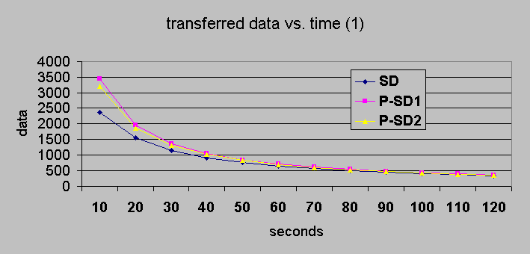

Graph 6-5 Transferred Data vs. Time (1)

X-axis of this graph is an average time spent at each page in a learning session. Y-axis is the number of bytes transferred per second. Here, one second is assumed as the time spent at each hyper-text link at each page. For instance, when ten seconds is the average time a user spends, the original SD has 2400 bytes transferred per second, P-SD1 3500 bytes, and P-SD2 3300 bytes. When a personalized environment is smaller, it shows more data transferred per second, which leads to the conclusion that a user takes less time in searching for the path in learning (refer that number of hits is higher at a personalized environment) and makes more data/information requests to a server.

________________________________________________________________

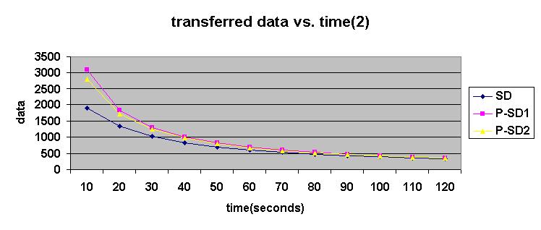

Graph 6-6 Transferred data vs. Time (2)

Graph 6-5 and Graph 6-6 are the same except that here we assume average 1.5 seconds is spent retrieving each hyper-link at pages. When we compare two graphs, transferred data per second is greater at Graph 6-5. As users becomes familiar with their learning environments or can retrieve the hyper-text links quicker, the interactivity is higher in terms of data transferred. Also a comparison between the two graphs which differ only in one variable, shows that perception capability of each user brings differences in measuring interactivity.

________________________________________________________________

________________________________________________________________
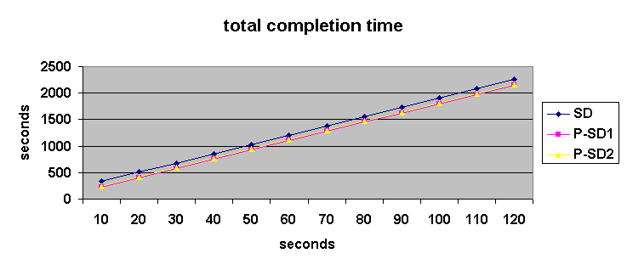

Graph 6-7 Total Completion Time

X-axis represents a time spent at each page and Y-axis shows seconds spent to finish the learning session. Those three lines have the same tangents of 17.5. The purpose of this graph is to calculate interactivity when we introduce adaptiveness variable.

______________________________________________________________________

________________________________________________________________

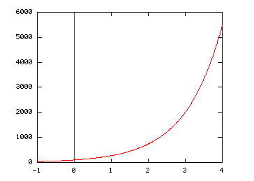

Graph 6-8. A learning curve Y = 100 * e^{x}
An exponential curve is chosen as a learning curve at this experiment. 100 is an initial rate which cuts Y-axis as X=0. At a reference list, papers that introduce more variety of learning curve can be found. X-axis is a time unit, and Y-axis can be assumed as amount of data transferred per second.
________________________________________________________________

When we assume the learning curve is exponential (Graph 6-8), we can predict more regarding to the adaptiveness aspects. Further assumption is as follows. At the exponential curve, the coefficient is 100. We can assume that it represents the initial learning rate. The domain is an elapsed time and the Y axis is a learning rate. Assume that Y axis is mapped to the transferred data during a user session. As the value of X moves from 2 to 3, Y value is 738.9 to 2,008.6. From the graph 6-5, we can read that x value of SD is 51.5 as Y value is 738.9 and 13.5 as Y value is 2,008.6, which is 171.8 % increase in the amount of data transferred while a user’s learning session is repeated. Again, at the graph 6-7, total completion time of SD decreases from 1,057.25 to 392.25. It is only 37.1% of time to finish a learning session as time unit goes on from 2 to 3. If we introduce more subjects or increase the difficulty level of a learning session at this moment, we will get better interactivity. The difference of 665 seconds leads to X value of 29.1 seconds at the total completion time graph. It is about 1,174 bytes from the graph 6-5. When we add this number to 2,008.6, that is 58.4 percentage of increase in total transferred data in a learning session. Complete comparison for SD, P-SD1, and P-SD2 for the adaptiveness issue is given at the table 6 -1.

For 3 cases in table 6-1, the total completion time is all changed from 1,057.25 to 392.25, because we assumed a virtual trajectory at the beginning. This is 58.4 % increase in transferred data for all cases if we decide to add more subjects to the learner’s environment.

________________________________________________________________

 | SD |  | P-SD1 |  | P-SD2
Time unit | 2 | 3 | 2 | 3 | 2 | 3
Time spent at each page  (Graph 6-5) | 51.5 | 13.5 | 57.5 | 19.5 | 56.5 | 18.5
Total Completion Time | 1057.3 | 392.3 | 1057.3 | 392.3 | 1057.3 | 392.3

Table 6-1 Time Spent at Each Page at Different Environments

Time unit is a value of X at Graph 6-8 learning curve. For each of SD, P-SD1, and P-SD2, when time unit shifts from 2 to 3 at the learning curve, changes at the time spent at each page are shown according to the Graph 6-5. Values for the variable is calculated by reading amount of data transferred (A) from the learning curve graph as x changes from 2 to 3, and then x values from Graph 6-5 as Y=A. Notice that total completion times are same even though the time spent at each page is different.
________________________________________________________________

7. Conclusion

The necessity of computerized learning environment on the Internet has been growing steadily. Customization of information, application-to-application communication, and interactive interface is expected not only for a web-based learning system but also other systems such as business, news and information. To transform the Internet from a collection of data into a successful learning environment, characteristics of both the Internet and the learning environment should be researched first.
A generic web based information architecture for a learning environment has been proposed throughout this paper. As a way of understanding the learning process, we abstracted the process into an adaptive control system.
System In this paradigm, the learning environment is observed as a user, a controller, and the learning system. Their interactions generate discrete events over time, and let us model the system with a Discrete Event System perspective. It opens a new possibility of observing learning systems and applying modeling methodology from DES. Each component in the system and their event flows are further used to develop our information architecture to design a customizable and interactive learning system.
Information Architecture The architecture defines its components in addition to the flow of events or information, which enables us to explain the nature of a learning system better. Components of the architecture are defined along with information services which the architecture accommodates. In addition, properties of each service are described. Such required properties are based on features that learning systems should have (the back-end tier) and functionalities that an education portal or an interactive and customizable learning system should provide (the middle tier). Well-defined information architecture can guide us in building any system based on it.
Customizability of the architecture allows the users to tailor their needs inside their learning environment. Interactivity is increased and they will not be overwhelmed by a large amount of the learning material. Adaptable architecture brings challenging and new subjects to learn into the environment. It also results in better interactivity. Measuring such interactivity in a web-based learning environment was discussed, in an effort to establish the scientific foundation of measuring interactivity as a variable.
Event Event is any form of operational or data requests or responses among subsystems. Through a through discussion regarding event and our information architecture, we observed that events at the “interaction machine” allows us to have event model with interaction model paradigm and interactive agents have greater question-answering ability than Turing machine (Wegner 1997).
Interactivity Possible modeling techniques of the learning system were introduced along with a benchmark methodology to track user-system interaction data. The importance of interactivity in learning or education has been emphasized in several fields such as education, psychology, and sociology, but measuring the value of such a variable could not be done in any of disciplines to date. By utilizing a paradigm from the computer science, the task can be accomplished with legitimacy. Our information architecture supports client and server side event detection to measure the interactivity with another important emphasis – the content based analysis. When we design user interface of a system, to enhance interactivity we need to consider what makes a user interact better, how we will measure the enhancement, and how the result of analysis will be reflected back to the system. Human Computer Interface (HCI) covers vast areas, and our concerns in designing interactive learning environment fit into the field.

HCI The architecture we discussed here provides both framework and services in terms of not only the system model but also its contents. Suggestions or design guidelines from various fields were researched at the design stage of the learning system. That is what the goal of HCI should be: to research areas to understand human behaviors such as education, psychology, or cognitive science, but in the perspective of computer science.
Education Portals Finally, we suggest a possible framework for educational portals in terms of distributed educational objects. To implement each functionality is open but the way the architecture is designed enables us to employ current technologies over a distributed system with a client server model, especially a web-based system (Fox 1999). XML will be a good choice to use at the application server from the information architecture because it is flexible in specifying object interfaces to each user and is supported by a growing number of tools.

Future Work

A complete modeling and simulation in a real time learning environment will reveal more data than the simulation performed in this work. The Modeling itself is challenging and worthwhile to do. There are a few simulators available to test a modeled system. Most of them were originally built for industrial systems but more and more fields are adopting such methodologies.
Also, in abstracting the system, considering event queues will be meaningful. That will enable the addition of concepts of sharing events or asynchronous/synchronous events into an information architecture. Such diversified event model will offer more sophisticated information architecture for a future learning environment.

7. References

Adams, J. A. (1976). Learning and memory: an introduction, the Dorsey Press.
Bailey, C. D. and E. V. McIntyre (1997). "The relation between fit and prediction for alternative forms of learning curves and relearning curves." IIE Transaction. 29: 487(9).
Bennett, D. (n.d.). "white paper: how interactive ads are delivered and measurement implication."
Calvi, L and Bra D. P. (1998). "A flexible hypertext courseware on the Web based on a dynamic link structure." Interacting with Computers 10:143(12)
Carroll, J. (1997). “Human-computer interaction: psychology as a science of design.” Annual review of psychology 48: 61(23).
Cassandras, C. G. (1993). Discrete event systems: modeling and performance analysis, Richard D. Irwin, Inc and Aksen Associates, Inc.
Chavis, S. (1997). "Bringing Interactivity Back to Learning via the Internet," computer science, UC Davis.
Chung, P. Emerald, huang, Yennun, et al. (1997). "DCOM and CORBA side by Side, Step by Step, and Layer by Layer," Bell Laboratories, New Jersey.
Dysart, J. (1998). "Interactivity makes for wonderful Web sites," Frozen Food Age. 47: 62(2).
Fox, Geoffrey (1999). "Portals for Education." http://www.npac.syr.edu/users/gcf/ncsatrainingoct99/.
Ha, L. and L. James (1998). “Interactivity reexamined: a baseline analysis of early business web sites.” Journal of broadcasting and electronic media 42: 457(1).
Harrison, H. Timothy, Levine, L. David, et al.(1997) "The Design and Performance of a Real-time CORBA Object Event Service." OOPSLA 97
Hochheiser, H. and B. Shneiderman (1999). "Understanding patterns of user visits to web sites: interactive starfield visualizations of WWW log data." Computer science. College Park, MD, University of Maryland.
Howe, M. J. A. (1977). Adult learning, psychological research and applications, John Wiley & Sons.
Javasoft (1999). The Java Tutorial , http://java.sun.com.
Johnson, Chris and Dunlop, D. Mark (1998). "Subjectivity and notions of time and value in interactive information retrieval." Interacting with computers 10:67(9)
Kane, R. L. and G. G. Kay (1992). “computerized assessment in neuropsychology:a review of tests and test batteries.” Neuropsychology review 3.
Killelea, P. (1998). Web performance tuning, O'Reilly.
Krashen, S. (1981). Second Language Acquisition and Learning, Pergamon
Lu, W. and c. Lin (1994). “Petri net model of manufacturing systems.” Acta Automatica Sinica 19.
Marcus, A. (1993). “Human communications issues in advanced UIs.” Communications of the ACM 36: 100(10).
Marcy, W. M. and M. O. Hagler (1996). “Implementation issues in SIMPLE learning environments.” IEEE Transaction on Education 39.
Marsan, M. A. (1990). “Stochastic Petri Nets: an elementary introduction.” Lecture Notes in Computer Science 424: 1-29.
Muppala, J. K., S. P. Woolet, et al. (1991). “Real-time systems performance in the presence of failures.” Computer 24: 37-47.
Nickelodeon, http://www.nick.com.
Ninja (1999), a Scalable Internet Services Project, http://ninja.cs.berkeley.edu/overview.html.
OMG (Object Management Group) (1999) CORBA services http://www.omg.org.
Outing, S. (1998). What exactly is interactivity. Editor & Publisher. 131: 7(1).
Pask, G. (1961). An approach to cybernetics, Harpers & Brothers.
Piaget, J. (1982). The Origins of Intelligence in Children, New York: International University Press.
Pitta, J. (1998). "interactivity: the great white whale." Forbes. 162: 60-61.
Pope, Alan (1997). The CORBA Reference Guide, Addison Wesley.
Rafaeli, S. and F. Sudweeks (1997). “Networked interactivity.” Journal of computer-mediated communication 2(4).
Raj, S. Gopalan (1998). "A Detailed Comparison of CORBA, DCOM and Java/RMI." http://www.execpc.com/~gopalan/misc/compare.html.
Randall, L. (1999). "non-tech industries report biggest web ad growth in 1998." Newbytes.
Reese, G. (1997). Database Programming with JDBC and Java, O'Reilly&Associates, Inc.
Rodrigues, D. and H. Viera da Rocha (1997). "Computer as an Auxiliary Tool in the Process of Cognitive Assessment of Physically Disabled People." computer science, Campinas state university.
Schmidt, C. Douglas and Vinoski, Steve (1997). "Object Interconnections." C++ Report, vol. 9, February 1997.
Sun microsystems (1999). Jini Distributed Event Specification, http://www.sun.com.
Wegner, P. (1997). “Why interaction is more powerful than algorithms.” Communications of the ACM 40: 80(12).
Wilson, S. (1993). “the aesthetics and practice of designing interactive computer events.” SIGGRAPH 93 Visual Proceedings Art Show Catalog.
W3C (1999). Document Object Model (DOM) Level 2 Specification, http://www.w3c.org.
Zimmermann, A., S. Bode, et al. (n.d.). "Performance and dependability evaluation of manufacturing systems using petri nets." Informatik. Berlin, Technische University.
Appendix A Guideline of Interactivity Feature at Web sites.
________________________________________________________________
Features | Examples | Dimension
Web Site Search Engines⁺ | Yahoo, Excite. | Choice
Information Requests^{+#} | Forms, mailing lists | Off site contacts
Text-only option buttons⁺ | Choice of 28.8K modem or T1 line. | Choice
Tools(1) Participation⁺ # | Message board, Discussion Forum, Community Group site | Off site contacts, Choice, Attractiveness
Tools(2) Communication# | E-post card, Live Chat | Attractiveness
Tools(3) Personalization# | Personal Webpages, user hobby/special site | Personalization, Attractiveness
Interactive Games⁺ | Interactive games to deliver information or for fun | Attractiveness, Choice
Downloads⁺ | Clip art, software, manual,etc. | Attractiveness
Online Surveys⁺ | Questionnaire, Polls, etc | Adaptiveness, Information Collection
Language level* | Difficulty in contents, or option for several languages | Choice
Information Storage* | Progress Report, User session recording | Off site contacts, Information Collection
Feedback mechanism# | Reporter e-mail address, article feedback mechanism | Off site contacts

Note. Table is a collection of several authors’ works. Specifically, * is by Chavis (1997), ⁺ is by Dysart (1998), and # is by Outing (1998). It should be distinguished from accessibility and it is more discussed at chapter 3.
Appendix B. Weighted 2D Graph

In the graph, a plane is divided into 5 regions by 5 main lines which emanate from the center of a right pentagon. Length of each line stands for degree of strength of elements in each dimension. A pentagon drawn out of connecting end points of the 5 main lines gives a visualization of how well each dimension is balanced in the learning environment. The length of each main line is the normalized sum of its elements in each dimension (Figure 5-5).
Each pole is mapped as attractiveness, choice, adaptiveness, information collection, and off-site contacts dimensions from the pole toward east, counter clock wise.
It is designed for easy comparison, so that, by overlapping graphs we can tell the strengths and weaknesses of a learning environment in terms of the interactivity issues.
It is categorized as 2D graph and is weighted graph. It also can be viewed as family of Polar, Radar, or Rose graph. Following is an excerpt from “Modeling and Decision Support Tools” from Institute for Manufacturing of University of Cambridge.
“Polar, or `Radar' charts are a form of graph that allows a visual comparison between several quantitative or qualitative aspects of a situation, or when charts are drawn for several situations using the same axes (poles), a visual comparison between the situations may be made. “
“Between three and eight attributes can be plotted on each chart. Many more than eight becomes confusing. Scales for each attribute are arranged radially and the points plotted on each radius are joined to generate a shape that can be visually compared with the same plot for another situation. In a gap analysis situation, the `desirable state' and the `present state' data can be plotted on the same chart to demonstrate graphically the gap between them. Similarly in a change situation where 'before' and 'after' results can be graphically compared.”
The rose graph is designed by Florence Nightingale. She wrote notes on matters Affecting the Health, Efficiency and Hospital Administration of the British Army (1858). The book included several graphs called “Coxcombs”. It looked like the pie chart, but kept angles constant and varied radius proportional to square root of frequency.

Appendix C Source Code Information

C.1. Perl Scripts as an interactivity measurement suite
Stat.pl, all.pl, personalize.pl, document_map.pl, Header.pl, and Javascript functions to perform client-side event detection with CGI scripts to get the data are available by e-mail request to mjlee@npac.syr.edu.
C.2. Graph Generator is at http://www.cis.syr.edu/~mjlee/graph/
C.3. Neattools software by Yuh-Jye Chang can be downloaded at http://www.pulsar.org
C.4. ntl file to be used to track user events as a background process at user’s local machine, can be found at http://www.pulsar.org/jen/nt.html
C.5. Trajectory
http://sunrise.npac.syr.edu/pulsar-stat/SD/Full/TOPIC/Memory/index.html
http://sunrise.npac.syr.edu/pulsar-stat/SD/Full/new_deskpage.html
http://sunrise.npac.syr.edu/pulsar-stat/SD/Full/TOPIC/Match/index.html
http://sunrise.npac.syr.edu/pulsar-stat/SD/Full/GAME/SM.html
http://sunrise.npac.syr.edu/pulsar-stat/SD/Full/TOPIC/Match/index.html
http://sunrise.npac.syr.edu/pulsar-stat/SD/Full/Card/test.html
http://sunrise.npac.syr.edu/pulsar-stat/SD/Full/TOPIC/Match/index.html
http://sunrise.npac.syr.edu/pulsar-stat/SD/Full/GAME/SO.html
http://sunrise.npac.syr.edu/pulsar-stat/SD/Full/TOPIC/Match/index.html
http://sunrise.npac.syr.edu/pulsar-stat/SD/Full/new_deskpage.html
http://sunrise.npac.syr.edu/pulsar-stat/SD/Full/TOPIC/Letter/index.html
words fun sdphrases798.dcr
http://sunrise.npac.syr.edu/pulsar-stat/SD/Full/TOPIC/Letter/index.html
http://sunrise.npac.syr.edu/pulsar-stat/SD/Full/HW_card/test.html
http://sunrise.npac.syr.edu/pulsar-stat/SD/Full/TOPIC/Letter/index.html
http://sunrise.npac.syr.edu/pulsar-stat/SD/Full/GAME/PH.html
http://sunrise.npac.syr.edu/pulsar-stat/SD/Full/TOPIC/Letter/index.html
http://sunrise.npac.syr.edu/pulsar-stat/SD/Full/GAME/PH.html
http://sunrise.npac.syr.edu/pulsar-stat/SD/Full/TOPIC/Letter/index.html
http://sunrise.npac.syr.edu/pulsar-stat/SD/Full/new_deskpage.html
http://sunrise.npac.syr.edu/pulsar-stat/SD/Full/TOPIC/Shape/index.html
http://sunrise.npac.syr.edu/pulsar-stat/SD/Full/GAME/LS.html
http://sunrise.npac.syr.edu/pulsar-stat/SD/Full/TOPIC/Shape/index.html
http://sunrise.npac.syr.edu/pulsar-stat/SD/Full/new_deskpage.html
http://sunrise.npac.syr.edu/pulsar-stat/SD/Full/TOPIC/Math/index.html
http://sunrise.npac.syr.edu/pulsar-stat/SD/Full/HW/level1.html
http://sunrise.npac.syr.edu/pulsar-stat/SD/Full/HW/circle.html
http://sunrise.npac.syr.edu/pulsar-stat/SD/Full/HW/level1.html
http://sunrise.npac.syr.edu/pulsar-stat/SD/Full/TOPIC/Math/index.html
http://sunrise.npac.syr.edu/pulsar-stat/SD/Full/new_deskpage.html
http://sunrise.npac.syr.edu/pulsar-stat/SD/Full/GAME/index.html
http://sunrise.npac.syr.edu/pulsar-stat/SD/Full/GAME/Asteroids/
http://sunrise.npac.syr.edu/pulsar-stat/SD/Full/GAME/index.html
http://sunrise.npac.syr.edu/pulsar-stat/SD/Full/new_deskpage.html
Appendix D. The Learning System Modeling

Sections D.1 and D.3 introduce notations to describe the system modeling by using state diagram and Petri net, respectively. State diagram and Petri net are equivalent and interchangeable, but by taking different approaches, we can gain a better view of the learning system.

D.1. Notation of State Automata Models

Here we follow the Cassandras’ notation (Cassandras 1993). The learning system falls into the particular category of the stochastic timed state automation (STSA) model. To describe the STSA model, a six-tuple notation is used here. The six-tuple is (ℑ, ℵ, Γ, Ρ, Ρ₀ , G), where
ℑ is a countable event set
ℵ is a countable state space
Γ(χ) is a set of feasible events, defined for all χ, χ’ ∈ ℵ, e’ ∈ ℑ, and such that Ρ( χ’; χ, e’) = 0 for all e’ ∉ Γ(χ)
Ρ₀ (χ) is the probability distribution function (pdf) P[X₀ = χ], χ of the initial state X₀
G = {G_{i}; i∈ℑ} is a stochastic clock structure.

D.2. System Modeling of the Learning System Using a State Automata Model

Assume that a user learns at a rate of (1 - A^{k} ), K=1,2, … where A is a random variable with a uniform distribution between [0,1] and k represents the number of learning sessions or days. In a learning system, A can be considered as an initial condition of a user’s learning capacity. Since the range of A is between 0 and 1, as k increases, A^{k} decreases, and (1 - A^{k} ) approaches the limit, 1, which represents an increase in the learning process. The learning process need not be represented by this equation and this is why the system modeling approach of a learning system is flexible.
The flexibility in the system modeling approach makes it possible to analyze the performance in different aspects by changing the number of variables, the equation, or the number of iterations in an experiment. Now we can write the state of the system by
χ_{k} = 1 - A^{k} . (1)
ℑ = {, }
ℵ = {0,1,2,…}
Γ(χ) = {, } for all χ ≥ 0

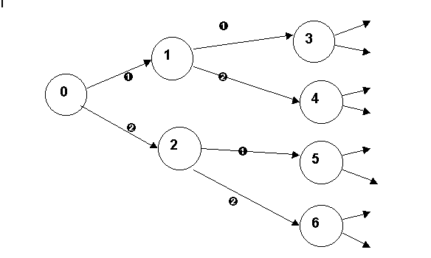
Graph D-1. State Diagram
Every state has two possible events to move to its next state. This state diagram sketches the idea of how a learning process can be mapped as a DES.

Every state has two possible outcomes. A user will either know the answer () or not know the answer (). By the chosen state equation, χ_{k} = 1 - A^{k}, as the learning session continues, the probability of  event increases, as expected.
A is a random variable here and the conditional density function (cdf) of the random variable χ_{k} Is calculated as follows.
F_{k}(x) = P[χ_{k}≤ x]
= P[ (1 - A^{k} ) ≤ x]
= P[ (1-x)^{1/k} ≤ A ≤ 1]
if (1-x)^{1/k} < 0,
F_{k}(x) = P[0≤ A ≤ 1]
If (1-x)^{1/k} > 1,
F_{k}(x) = 0
Otherwise,
F_{k}(x) = (1-x)^{1/k}
From the above cdf, the probability density function (pdf) is a derivative of cdf and may be calculated as,
-1/k(1-x)^{1/k – 1}
Finally, from the pdf, the mean and variance of the random variable A are caculated.
Mean = m _{k} = E[χ_{k}] = - ∫ x * 1/k * (1-x)^{1/k – 1}dx
= k/(k+1)
Variance = E[χ_{k} - m _{k} ]² = E[χ_{k}² ] - m _{k}²
= - ∫ [x ²* 1/k * (1-x)^{1/k – 1}]dx – (k/k+1) ²
= k² / (k+1) ²(2k+1)

D.3 Petri Net and Stochastic Petri Net Models Notation

A Petri net is a four-tuple
(P, T, A, w)
where
P is finite set of places
T is a finite set of transitions
A is a set of arcs, a subset of the set (P X T) U (T X P)
w is a weight function , w: A → {1,2,3,…}
Stochastic Petri nets (SPN) according to (Marsan 1990) are 6 tuples.
(P, T, I, O, M₀, Λ)
where
P is a set of places
T is a finite set of transitions
I and O are the sets of Input and Output arcs respectively
M₀ is the initial marking
Λ:T → R⁺ is a set of (possibly marking-dependent) firing rates associated with transition, which are random variables with negative exponential distribution. An SPN model evolves according to a given race policy: R-R (resampling), R-A (age memory), and R-E (enabling memory).
The reachability graph of a SPN is equivalent to one of the underlying Petri net. Another property of SPN that it is isomorphic to Continuous Time Markov Chains.

D.4. Stochastic Petri Net Modeling of the Learning System

A Petri net is an automaton on which a certain structure is imposed by the state transition function. This is a very general modeling methodology because any DES modeled as a finite state automata could be modeled as a Petri net. Even though a Petri net can cause potential complexity in modeling compared to state automata models, it enables us to decompose or modularize a complex system, helping us analyze a learning system in a modular way. This trait is important because the learning system itself is composed of subsystems which interact with each other. In addition, efforts to analyze real life systems which can cause an explosive number of places in its Petri net, made it realistic to use a Petri net not only as modeling tool but also as an analysis tool of complex systems.
Once a complete model is made, performance measures can be done numerically or by simulation (Zimmermann, Bode et al. n.d.). Hence, the quantitative properties of the system can be obtained. However that is the beyond the scope of this work.
In a SPN, a continuous random time is associated with each transition as its firing time. Here an exponential distribution is assumed for the firing times of transitions because of its analytical simplicity and because it is a good approximation of the real behavior. Some of transitions which appear as narrower rectangle at a graph (Graph D-3, for instance) are ones that require little or no time. A very small time is assigned to these transitions instead of getting their time from the exponential distribution.
In this chapter, two of Petri net modeling, equivalent to the state automata model which was in the previous chapter, are presented. The first graph
(Graph D-2) shows a basic idea. The second graph is a modeling of a learning system using SPN. Table1 is an explanation of each place and transition from the SPN.

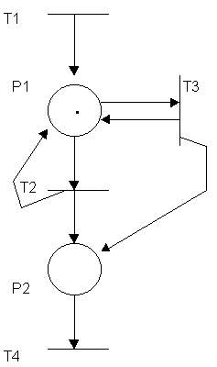

Graph D-2. Petri Net with a Basic Idea
Table D-1 and Graph D-2 describes the learning session modeling. It is simplified to introduce the concept. Graph D-3 shows more features.

P1 | A learner is solving a problem at a learning session
P2 | Finish
T1 | A learner starts learning
T2 | A learner knows the answer for the question
T3 | A learner does not know the answer
T4 | Quit

Table D-1. Places and Transitions

A representation of the place set is
P = {P1, P2}
And the transition set is
T = {T1, T2, T3, T4}
At the first Petri net, a learner enters the system by transition T1. Then the learner will be in learning session shortly; here the learner will be asked to solve a problem. If the learner knows the answer, T2 is triggered, otherwise, T3. In either case, by adding an arc at the output of each transition, situation with more than one problem can be implemented. If the learner prefers, however, the learning session can be finished through P2 and T4. Table D-1 explains the graph D-2.
The first Petri net was designed only to show the basic idea. The generalization of this concept is the stochastic Petri Net, shown next.
The stochastic Petri net model shows two kinds of transitions, as stated before. Narrower boxes represent smaller amounts of time, of the order of 0.001, while the larger boxes make transitions which require longer time. The Petri net should be interpreted as a sketch to provide the modeling of a learning system as a DES.

T1

T3 P2 T4
.
P1 P

T2 P3
T5
P6
T6 P4 P5

Graph D-3. Stochastic Petri Net for the Learning Environment

Graph D-3 models a learning session utilizing a stochastic Petri net. It features a help session with an adaptive level based on user’s performance. The whole process is maps the learner’s start to finish for a learning session till she stops. Table D-2 is an accompanying description regarding the transitions and places.

P1 | A learner is solving a problem at a learning session
P2 | Help session is provided to a learner to get the answer.
P3 | Performance can be recorded.
P4 | Performance can be recorded
P5 | A problem level needs to be adjusted if the learner keeps giving wrong answers.
P6 | A problem level can be adjusted if the learner shows good performance.

T1 | A learner starts the learning session.
T2 | A learner knows the answer.
T3 | A learner doesn’t know the answer.
T4 | Help session has been provided.
T5 | This transition is trigerred when the problem level needs to be changed.
T6 | This transition is trigerred when the problem level needs to be changed.

Table D-2. Places and Transitions from the Graph D-3

Appendix E. a Common Log Format According to NCSA (National Center for Supercomputing Applications).

- (string/integer) the client machine.
- (string/integer) the user ID if provided.
- (date) the date and time in the standard format dd/mmm/yy:hh:mm:ss.
- (integer) the time zone in the standard format +/-hhmm from GMT.
- (string) the method:GET, HEAD, POST, PUT, or DELETE
- (string) the URL that the method is acting on.
- (integer) server status code
- (integer) size of returned URL in bytes.

VITA

NAME OF AUTHOR: Myeongjin Lee
PLACE OF BIRTH: Seoul, Korea
DATE OF BIRTH: September 5, 1970
GRADUATE AND UNDERGRADUATE SCHOOLS ATTENDED:
Syracuse University, Syracuse, NY
Yonsei University, Seoul, Korea
DEGREES AWARDED:
Master of Science in Computer and Information Science,
1999, Syracuse University
Bachelor of Science in Computer Science, 1994, Yonsei University
PROFESSIONAL EXPERIENCE:
Research Assistantship, NPAC (Northeast Parallel Architecture Center),
Syracuse University, 1997 - 1999

